INFORMATION TECHNOLOGY AUDIT REPORT
MCST LIBRARY MANAGEMENT SYSTEM (MCST LMS)
Professional Audit Report - Increment 2
Lab 8: Asset Inventory and System Documentation
Audit Team / Group No. | 404NotFound
Capstone System / Build | MCST Library Management System (MCST LMS) | BLD-02: main @ 82075e8 | Local demo + Render test site
Partner Organization | MCST Library (short name to protect partner privacy)
Member 1 / Role | Justin C. Batlangao | Asset and Configuration Auditor
Member 2 / Role | Glenn Patrick B. Darriguez | Architecture and Data-Flow Auditor
Member 3 / Role | Ma. Jenifer L. Labag | Access and Evidence Auditor
Prior Approved Version | Lab 7 report v0.1 / 2026-09-19 (BLD-01: admin-overview @ 71e0d30)
Current Version / Date | v0.2 | prepared 2026-09-26 | submitted 2026-09-26
Audit / Evidence Cutoff | 2026-09-26 (Lab 8 proof valid until this date)

Master-report instruction
Use these pages to add the Lab 8 increment to the existing professional audit report. Apply prior instructor corrections, update the master version history and build register, preserve approved IDs, and submit the complete updated master unless the instructor directs otherwise.

A. Master Report Update Control

A.1 Version History Entry
Version | Date | Lab / Increment | Prepared By | Reviewed By | Change Summary
0.1 | 2026-09-19 | Lab 7 / Increment 1 | M1, M2, M3 | M1, M2, M3 | First master: engagement, org map ORG/USR, modules MOD-01..08, goals OBJ, scope SCP, proof plan EVD-09
0.2 | 2026-09-26 | Lab 8 / Increment 2 | M1, M2, M3 | M1, M2, M3 | Added asset baseline AST, architecture + trust map DEP, flows FLOW, accounts ACC, reconciliation REC-10, proof EVD-10; new build BLD-02; MOD-03..08 re-checked as wired

A.2 Final Audit Report Build Register Update
Lab | Report Section | Status | Version / Date | Instructor Action
9 | Engagement Profile and Scope | Completed | v0.1 / 2026-09-19 | Pending
10 | Asset Inventory and System Documentation | In Progress | v0.2 / 2026-09-26 | Pending
11 | Risk and Compliance Assessment | [Reserved] |  | [Approved / Revise / Pending]
12 | Control Assessment and Gap Analysis | [Reserved] |  | [Approved / Revise / Pending]
13 | Audit Findings and Recommendations | [Reserved] |  | [Approved / Revise / Pending]
14 | AI Validation Portfolio and Final Report Integration | [Reserved] |  | [Approved / Revise / Pending]

A.3 Prior Feedback Closure
Feedback ID | Prior Instructor Comment / Required Revision | Action Taken | Section / IDs Affected | Closed By / Date
FB-10-01 | No instructor feedback received yet on Lab 7 v0.1 as of 2026-09-26. | Carried Lab 7 v0.1 forward unchanged; opened v0.2 for Lab 8. | All Lab 7 sections / IDs kept | Member 1 (Justin C. Batlangao) / 2026-09-26
FB-10-02 | Build moved since Lab 7 (admin-overview to main @ 82075e8). | Recorded BLD-02 and re-checked route-to-model wiring for MOD-03..08 before trusting them. | BLD, MOD-03..08 | Member 3 (Ma. Jenifer L. Labag) / 2026-09-26

XIII. Asset Inventory and System Documentation

13.1 Asset Inventory
AST ID | Asset / Component | Type | Purpose / Related MOD | Owner / Custodian | Location / Environment | Version / Status | Criticality / Sensitivity | Evidence
AST-01 | Borrower browsers + devices | Endpoint | Open catalog, login, borrow (MOD-01, MOD-02, MOD-03) | Borrowers (USR-01, USR-02) | User side / any browser | Any modern browser / active | M + school email login | EVD-10-03
AST-02 | MCST LMS Flask app (all blueprints) | Software | Runs all MOD-01..08 pages and rules | Dev team (ORG-04) | Local demo + Render | BLD-02 main @ 82075e8 / active | H + core system | EVD-10-02
AST-03 | Jinja2 + Tailwind page templates | Software | Show catalog, desk, charts pages | Dev team (ORG-04) | Inside app / Render + local | Bundled with BLD-02 / active | M + page text only | EVD-10-03
AST-04 | PostgreSQL database (Render) | Database | Keeps books, copies, borrowers, loans, logs (all MODs) | System Admin (ORG-03) | Render cloud | Postgres managed / active | H + borrower and loan data | EVD-10-04
AST-05 | Google login (school email only) | Service | Proves user identity for MOD-01 | Access Approver (ORG-02) | Google side (outside) | OAuth2 / active | H + login tokens (never stored) | EVD-10-01
AST-06 | Tables file + DB starter (schema.sql, database.py) | Document | Makes tables at app start; source of truth | Dev team (ORG-04) | Repo / all envs | BLD-02 version / active | H + table design | EVD-10-02
AST-07 | Book CSV files (seed + bulk import) | Data | Loads many books to MOD-02 at once | Librarian staff (USR-03) | Repo + upload folder | CSV / active | L + book list only | EVD-10-02
AST-08 | Backup files (pg_dump output, backups folder) | Data | Copy of database for MOD-08 recovery | System Admin (ORG-03) | Server folder / Render disk | Per-backup date / active | H + full data copy | EVD-10-04
AST-09 | Work logs (audit_trail + system events) | Data | Who did what, for OBJ-03 trace | System Admin (ORG-03) | Inside database | Always on / active | M + actor + action only | EVD-10-03
AST-10 | Render hosting + auto backup timer | Service | Runs the site and timed backups | System Admin (ORG-03) | Render cloud | Live plan / active | H + site availability | EVD-10-04
AST-11 | Library settings + app config | Data | Loan limits, fines, due days for MOD-03 | System Owner (ORG-01) | Inside database + env | BLD-02 values / active | M + numbers only | EVD-10-05
AST-12 | Audit master files (DOCX + Excel proof) | Document | This report and clean proof lists | Lead Auditor (M1) | Group drive / controlled | v0.2 / active | M + clean samples only | EVD-10-01..05

13.2 External Services, Interfaces, and Dependencies
ID | Service / Dependency | Provider / Owner | Source -> Destination | Data / Function | Authentication / Protection | Availability / Failure Impact | Evidence
INT-01 | Google OAuth login | Google / ORG-02 | Browser -> Flask -> Google | Login proof / school email | OAuth2; tokens never saved | If down, no login; fallback: wait + retry | EVD-10-01
INT-02 | Render PostgreSQL | Render / ORG-03 | Flask -> Database | All tables read/write | DB login via env (secret, not in report) | If down, site stops; fallback: backup copy | EVD-10-04
INT-03 | CSV file upload | Librarian / USR-03 | File -> import worker -> tables | Book list (title, author, accession) | File type + header check | Bad rows skipped + logged; jobs lost on restart | EVD-10-02
INT-04 | Backup to server folder | Render disk / ORG-03 | Scheduler -> backup files | pg_dump file + log row | Server file rights | If full/fail, logged as failed; restore needs approval | EVD-10-04
INT-05 | Flask login session | App / ORG-03 | App -> browser cookie | Logged-in user + role | Signed cookie; role checks on each page | If lost, user logs in again | EVD-10-01

XIV. Architecture, Data Flow, and Trust Boundaries
Figure 2. System Context and Deployment Architecture
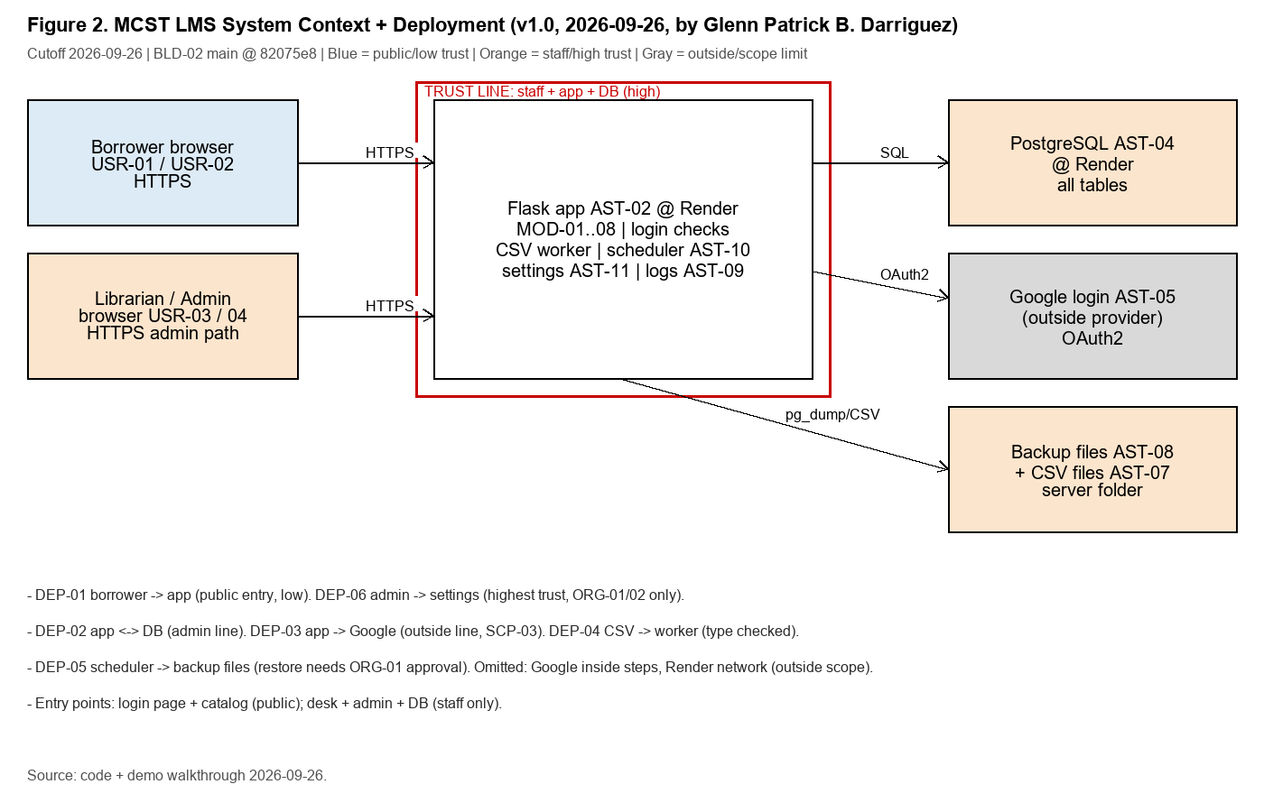

14.1 Architecture Node and Connection Register
Node / Link ID | Source / Component | Destination | Direction / Channel | Purpose / Data | Trust Boundary? | Evidence / Assumption
DEP-01 | Borrower browser (USR-01/02) | Flask app (AST-02) | Out / HTTPS | Search, login, borrow pages | Yes - public entry (low trust) | EVD-10-03
DEP-02 | Flask app (AST-02) | PostgreSQL (AST-04) | Both ways / SQL | All table reads/writes | Yes - DB line, admins only | EVD-10-04
DEP-03 | Flask app (AST-02) | Google login (AST-05) | Out / OAuth2 HTTPS | Login proof only | Yes - outside provider line | EVD-10-01
DEP-04 | CSV file (AST-07) | Import worker -> DB | In / file upload | Bulk book load (MOD-02) | No - staff path, type checked | EVD-10-02
DEP-05 | Scheduler (AST-10) | Backup files (AST-08) | Out / pg_dump | Timed DB copy (MOD-08) | Yes - admin path, needs approval to restore | EVD-10-04
DEP-06 | Admin browser (USR-04) | Settings (AST-11) | Both ways / HTTPS | Change limits/fines, backups | Yes - highest trust, ORG-01/02 only | EVD-10-05

Figure 3. Key Data-Flow Diagram
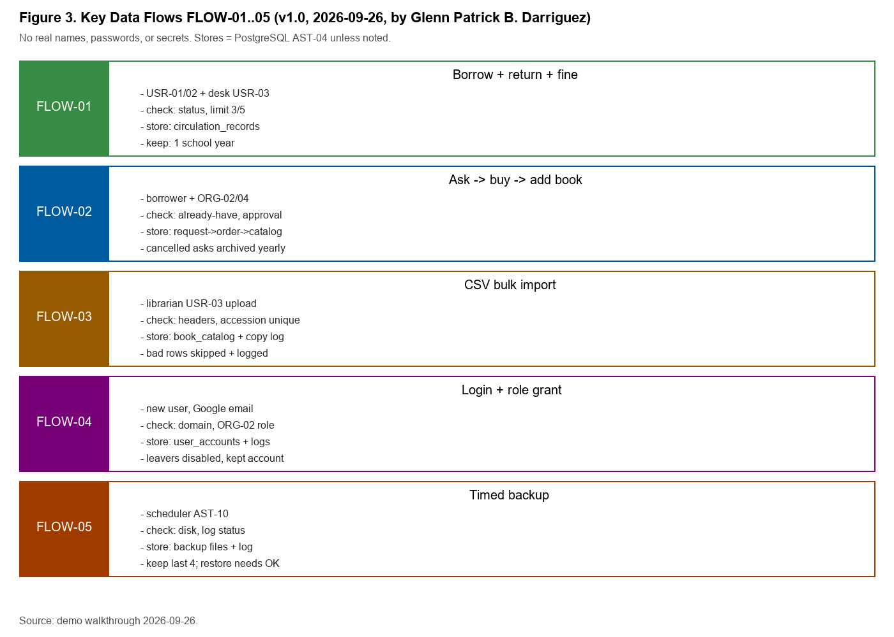

14.2 Data-Flow Register
FLOW ID | Transaction / Journey | Actor / Source | Validation / Processing | Store / Destination | Transmission / Protection | Retention / Disposal | Related IDs
FLOW-01 | Borrow + return + fine | Borrower (USR-01/02) + desk (USR-03) | Check: can borrow? (status, limit 3/5); fine = days late x rate | circulation_records + notification_log (AST-04) | Desk HTTPS; fine math in app | Loan rows kept; notices kept 1 school year then removed | MOD-03 / INT-02 / EVD-10-03
FLOW-02 | Ask -> buy -> add book | Borrower ask; librarian buy + add | Check: already-have? approve? order/deliver? unique accession | request_records -> procurement_log -> book_catalog + accession_log | Desk HTTPS; approval by ORG-02 | Request + order rows kept; old cancelled asks archived yearly | MOD-04,05,02 / EVD-10-02
FLOW-03 | CSV bulk import | Librarian uploads file (USR-03) | Check: file type, header map, title/author/accession required; bad rows skipped | book_catalog + accession_log (AST-04) | File upload HTTPS; worker thread | Source CSV kept as proof sample; jobs lost on restart (limit) | MOD-02 / INT-03 / EVD-10-02
FLOW-04 | Login + role grant | New user via Google (school email) | Check: email domain; first login makes Admin (closed after); ORG-02 gives role | user_accounts + borrowers + audit_trail | OAuth2; signed cookie | Accounts kept while enrolled; leavers disabled, not deleted | MOD-01 / INT-01 / EVD-10-01
FLOW-05 | Timed backup | Scheduler (AST-10) | Check: disk space; log status completed/failed | Backup files + backup_log (AST-08) | Server file write | Keep last 4 weekly copies; restore needs ORG-01 approval | MOD-08 / INT-04 / EVD-10-04

XV. Account, Privilege, and Documentation Reconciliation

15.1 Account and Privilege Inventory
ACC ID | Account Type / Role | Related USR / ORG | Authentication | Privilege / Access | Provision / Approval | Review / Deactivate | Logging | Evidence / Concern
ACC-01 | Student borrower | USR-01 / ORG-02 | Google school email | Own catalog, asks, loans, fines | Self-serve + ORG-02 role grant | Disabled when leaves school | Login + borrow events | EVD-10-01 / max 3 loans
ACC-02 | Faculty borrower | USR-02 / ORG-02 | Google school email | Own records, higher limits | Self-serve + ORG-02 role grant | Disabled when leaves | Login + borrow events | EVD-10-01 / max 5 loans, 30-day due
ACC-03 | Librarian desk | USR-03 / ORG-02 | Google school email + role | Desk: circulation, accession, asks, stock | ORG-02 grants; ORG-01 approves | Removed on role change; quarterly check | All writes logged | EVD-10-01 / SoD: add + lend same copy
ACC-04 | System Admin | USR-04 / ORG-02 | Google school email + Admin role | Users, settings, backups, logs | ORG-02 grants; ORG-01 approves | Removed on role change; quarterly check | All admin acts logged | EVD-10-01 / high rights, no sharing
ACC-05 | Database service account | ORG-03 (custodian) | DB login via env (secret hidden) | App read/write all tables | Given at Render setup; ORG-03 keeps | Rotated on leak/suspect; yearly | DB logs (provider side) | EVD-10-04 / secret never in report
ACC-06 | Dev / support (no standing access) | ORG-04 | No live login; clean samples only | Code + deploy only | No account by default | N/A | Deploy log (git history) | EVD-10-02 / must not hold live admin
ACC-07 | First-login bootstrap Admin | ORG-01 / ORG-02 | Auto-made on very first login | Full rights (one time) | System made; ORG-01 closed it | Closed after setup (checked) | Creation logged | EVD-10-01 / risk closed, disclosed

15.2 Inventory and Diagram Reconciliation
Check ID | Expected Population / Relationship | Source Compared | Result | Missing / Unmatched Item | Resolution / Limitation
REC-10-01 | All in-scope MOD-01..08 + INT-01..05 + envs map to an asset | Lab 7 MOD list vs AST-01..12 | Complete | - | All MODs covered; MOD-03..08 now wired in BLD-02 (was Partial in Lab 7)
REC-10-02 | Every diagram node/link has an ID and proof | Figures 2-3 vs DEP-01..06, AST | Complete | - | All nodes linked; Google inside + Render network marked as assumption (SCP-03)
REC-10-03 | Each FLOW has actor, checks, store, channel, keep-time | FLOW-01..05 vs template rule | Complete | - | All 5 flows have 8 columns filled
REC-10-04 | Lab 7 roles map to account types + approval path | ORG/USR vs ACC-01..07 | Exception | ACC-05 DB account has no named person (service) | Accepted: custodian ORG-03 + rotation rule covers it; logged as limit
REC-10-05 | Proof is dated, named source, clean, enough | EVD-10-01..05 vsLab 7 EVD-09 | Complete | - | All dated 2026-09-26 or earlier; sanitized/redacted; gaps in LOG-05 carried

15.3 Evidence Index Additions
EVD ID | Evidence Title / Description | Source / Owner | Date / Version | Related IDs | Privacy Treatment | Reliability / Limitation
EVD-10-01 | Role list + 2 approval samples + login check list (clean shots) | ORG-02 (approver) | 2026-09-26 | ACC-01..04,07 / OBJ-01 | Sanitized | Shots lack full history; demo may differ from live
EVD-10-02 | Build note BLD-02 + module wiring check + CSV sample rows | Member 3 / dev team | 2026-09-26 | AST-02,06,07 / MOD-01..08 | Redacted | Demo is not live; import jobs lost on restart
EVD-10-03 | Desk walkthrough shots: borrow->return->fine + archive->delete block | ORG-03 (desk) | 2026-09-26 | FLOW-01 / MOD-03 | Names hidden | Walkthrough only; full test is later labs
EVD-10-04 | Backup list sample + DB tables list (names, counts only) | ORG-03 (admin) | 2026-09-26 | AST-04,08,10 / MOD-08 | Aggregated | List cannot prove restore works (out of scope)
EVD-10-05 | Settings sample (normal keys only: limits, fines, due days) | ORG-01 (owner) | 2026-09-26 | AST-11 / MOD-03 | Redacted | Values may change after cutoff; changes need approval

XVI. Lab 8 Completion Checklist
Check | Completion Requirement
[X] | All in-scope modules, environments, interfaces, data categories, and user roles map to assets.
[X] | Every diagram node and connection has an ID, source, direction, purpose, and evidence or stated assumption.
[X] | Critical data flows show collection/input, validation, processing, storage, transmission, output, retention, disposal, and protection points as applicable.
[X] | User, privileged, service, database, and integration account types are documented without exposing secrets.
[X] | Asset, architecture, data-flow, account, and evidence records reconcile with the approved Lab 7 scope.
[X] | Version history, build register, feedback closure, cross-review, AI validation, and attestation are complete.

Z. Collaboration, AI Validation, and Instructor Review

Z.1 Cross-Member Challenge Record
Review ID | Prepared By | Reviewed By | Item / Section | Challenge or Check | Resolution / Evidence
REV-10-01 | Member 1 (Justin C. Batlangao) | Member 2 (Glenn Patrick B. Darriguez) | AST-02..08 vs MOD list | Challenge: 3 assets had no MOD link (settings, logs, master files). | Linked AST-09/11/12 to MOD-03/08/OBJ; re-ran scope-to-asset check: complete.
REV-10-02 | Member 2 (Glenn Patrick B. Darriguez) | Member 3 (Ma. Jenifer L. Labag) | FLOW-02 request-buy-add | Challenge: retention step missing for cancelled asks. | Added yearly archive rule for cancelled asks; checked with desk staff.
REV-10-03 | Member 3 (Ma. Jenifer L. Labag) | Member 1 (Justin C. Batlangao) | ACC-05 DB service account | Challenge: service account has no named owner (orphan risk). | Named custodian ORG-03 + rotation rule; logged as accepted limit in REC-10-04.

Z.2 Human-in-the-Loop AI Validation Log
AI ID | Tool / Purpose | Material Suggestion | Evidence / Criteria Checked | Decision | Correction / Rationale | Privacy Check
AI-10-01 | Word tool / fixing wording of AST purposes | Shorter purpose lines for AST table | Checked each line against code + demo | Revise | Kept short lines only where true; rest human-written | No private data in prompts
AI-10-02 | Word tool / double checking DEP link directions | Suggested direction labels | Checked against routes + demo | Accept | Directions matched code; kept | No private data in prompts

Z.3 Group Attestation
We certify that the Lab 8 work reflects the identified capstone build and authorized evidence. We completed the assigned work and cross-review, protected confidential information, did not treat AI output as audit evidence, and disclosed material limitations.
Member | Printed Name | Signature | Date
Member 1 | Justin C. Batlangao | Justin C. Batlangao | 2026-09-26
Member 2 | Glenn Patrick B. Darriguez | Glenn Patrick B. Darriguez | 2026-09-26
Member 3 | Ma. Jenifer L. Labag | Ma. Jenifer L. Labag | 2026-09-26

Z.4 Instructor Review
Review Area | Status | Instructor Notes
Master-report continuity and prior feedback | [ ] Approved [ ] Revise
Technical completeness and traceability | [ ] Approved [ ] Revise
Evidence, limitations, collaboration, AI validation, and professional judgment | [ ] Approved [ ] Revise

Instructor disposition and required revisions: Record the decision and detailed comments in the Instructor Notes column above or on the institution's grading sheet.

