INFORMATION TECHNOLOGY AUDIT REPORT
DATA SENSITIVITY MANAGEMENT SYSTEM
Professional Audit Report - Increment 2
Lab 8: Asset Inventory and System Documentation
INSTRUCTOR REFERENCE SAMPLE
Audit Team / Group No. | Instructor Sample Team / Reference Group 00
Capstone System / Build | Data Sensitivity Management System | DSMS v1.0 | controlled deployed test environment
Partner Organization | Enterprise Technology Services Organization (ETSO - approved pseudonym)
Member 1 / Role | Sample Auditor A | Asset and Configuration Auditor
Member 2 / Role | Sample Auditor B | Architecture and Data-Flow Auditor
Member 3 / Role | Sample Auditor C | Access and Evidence Auditor
Prior Approved Version | Lab 7 version 0.1 / September 9, 2026
Current Version / Date | Version 0.2 | September 9, 2026 | instructor reference copy
Audit / Evidence Cutoff | Evidence available through August 31, 2026

Master-report instruction
This completed instructor sample demonstrates Lab 8 as part of one controlled professional audit report. Students must replace the DSMS example with evidence from their own capstone, retain approved identifiers, apply prior feedback, and carry this version forward to the next increment.

A. Master Report Update Control

A.1 Version History Entry
Version | Date | Lab / Increment | Prepared By | Reviewed By | Change Summary
0.2 | September 9, 2026 | Lab 8 / Increment 2 | Sample Auditors A, B, and C | Cross-reviewed by all sample auditors | Added the DSMS asset baseline, architecture, data flows, account inventory, reconciliation, and evidence additions.

A.2 Final Audit Report Build Register Update
Lab | Report Section | Status | Version / Date | Instructor Action
7 | Engagement Profile and Scope | Completed - sample | 0.1 / September 9, 2026 | Reference example
8 | Asset Inventory and System Documentation | Completed - sample | 0.2 / September 9, 2026 | Reference example
9 | Risk and Compliance Assessment | Reserved |  | Pending
10 | Control Assessment and Gap Analysis | Reserved |  | Pending
11 | Audit Findings and Recommendations | Reserved |  | Pending
12 | AI Validation Portfolio and Final Report Integration | Reserved |  | Pending

A.3 Prior Feedback Closure
Feedback ID | Prior Instructor Comment / Required Revision | Action Taken | Section / IDs Affected | Closed By / Date
FB-08-01 | Keep the scope limited to DSMS rather than enterprise-wide DLP. | Marked external endpoints and enterprise enforcement as excluded. | AST, INT, DEP, FLOW; LIM-02 | Sample Auditor A / September 9, 2026
FB-08-02 | Make trust boundaries explicit. | Added deployment links and identified each boundary crossing. | Figure 2; DEP-01 to DEP-07 | Sample Auditor B / September 9, 2026
FB-08-03 | Separate factual architecture from assumptions. | Tagged logical document storage and provider internals as evidence limitations. | AST-06, INT-01 to INT-04; EVD-08-07 | Sample Auditor C / September 9, 2026
FB-08-04 | Retain the High-class recall limitation. | Linked model evidence and human-review dependency to the asset baseline. | AST-05; FLOW-02; EVD-07-05 | Sample Auditor A / September 9, 2026

XIII. Asset Inventory and System Documentation

13.1 Asset Inventory
AST ID | Asset / Component | Type | Purpose / Related MOD | Owner / Custodian | Location / Environment | Version / Status | Criticality / Sensitivity | Evidence
AST-01 | React and Vite web client | Software | User interface, upload, search, dashboard, and preview / MOD-01, MOD-06, MOD-08 | ORG-08 | Vercel hosted client / test deployment | DSMS v1.0 / active | Medium / Internal | EVD-07-02, EVD-08-01
AST-02 | Node and Express application API | Software/Service | Business logic, access decisions, audit events / MOD-01 to MOD-09 | ORG-04 | Railway API / test deployment | DSMS v1.0 / active | High / Confidential | EVD-07-02, EVD-08-01
AST-03 | Prisma data access layer | Software | Controlled application-to-database access / MOD-03 to MOD-09 | ORG-04 | API runtime | Version in release manifest / active | High / Internal | EVD-08-01, EVD-08-02
AST-04 | PostgreSQL database | Data/Service | Stores users, metadata, policies, access records, and logs | ORG-02 | Neon hosted database / test deployment | Schema for DSMS v1.0 / active | High / Restricted | EVD-08-02, EVD-08-06
AST-05 | TF-IDF and Logistic Regression model artifacts | Software/Data | Document sensitivity prediction and confidence scoring / MOD-03 | ORG-06 | Controlled model package and analytical runtime | Evaluated model / active | High / Confidential | EVD-07-05, EVD-08-03
AST-06 | Document extraction and managed content storage | Software/Data | Extracts PDF, DOCX, TXT, log, configuration, and source-code content / MOD-02 | ORG-02 | Logical DSMS storage boundary; implementation detail restricted | DSMS v1.0 / active; location limited | High / Restricted | EVD-07-06, EVD-08-04
AST-07 | RBAC, ABAC, and policy rules | Software/Document | Maps sensitivity to Public, Internal, Confidential, or Restricted access / MOD-04 to MOD-06 | ORG-02 | API and approved policy configuration | DSMS v1.0 / active | High / Confidential | EVD-07-04, EVD-08-05
AST-08 | Activity and audit log store | Data | Records upload, review, request, approval, access, and administration events / MOD-07 | ORG-05 | PostgreSQL logical log tables | Active; retention evidence incomplete | High / Confidential | EVD-07-08, EVD-08-06
AST-09 | Deployment configuration and secrets | Document/Configuration | Connects hosted client, API, database, and analytical services | ORG-08 | Controlled deployment platforms | Active; values excluded | High / Restricted | EVD-07-02, EVD-08-07
AST-10 | Research corpus and evaluation results | Data/Document | 3,420-document training/evaluation basis and ISO/IEC 25010 results | ORG-06 | Controlled research repository | Final dissertation dataset and results | High / Confidential | EVD-07-05, EVD-07-09

13.2 External Services, Interfaces, and Dependencies
ID | Service / Dependency | Provider / Owner | Source -> Destination | Data / Function | Authentication / Protection | Availability / Failure Impact | Evidence
INT-01 | Web-client hosting | Vercel / ORG-08 | Browser -> AST-01 | Static client delivery | HTTPS; provider account access | Client unavailable; direct API use not intended | EVD-07-02, EVD-08-01
INT-02 | API hosting | Railway / ORG-08 | AST-01 -> AST-02 | DSMS API and business logic | HTTPS; deployment credentials restricted | Core functions unavailable if service fails | EVD-07-02, EVD-08-01
INT-03 | Managed PostgreSQL | Neon / ORG-02 | AST-02/AST-03 -> AST-04 | Metadata, access, policy, and log records | TLS connection; secrets excluded | Processing and evidence unavailable; recovery depends on provider | EVD-08-02, EVD-08-07
INT-04 | MCP analytical services | Controlled analytical service / ORG-06 | AST-02 -> analytical endpoint | Classification or analytical support | Authenticated service path; endpoint details restricted | Classification support degraded; manual review required | EVD-07-02, EVD-08-03
INT-05 | Browser and HTTPS channel | User device / ORG-07 | USR roles -> AST-01 | Authentication, upload, preview, and access | HTTPS; session controls | User cannot operate DSMS; unmanaged-device risk remains | EVD-08-04, EVD-08-05
INT-06 | Document parsing libraries | Open-source dependencies / ORG-08 | AST-06 -> MOD-02 | Extract supported document text | Application-level validation and dependency management | Malformed/unsupported files may fail extraction | EVD-08-04
INT-07 | Office/PDF preview capability | Application library / ORG-08 | AST-06 -> MOD-06 | Controlled document viewing and watermarking | Authorized session and policy decision | Preview may fail; direct export must remain controlled | EVD-08-04, EVD-08-05

XIV. Architecture, Data Flow, and Trust Boundaries
Figure 2. System Context and Deployment Architecture
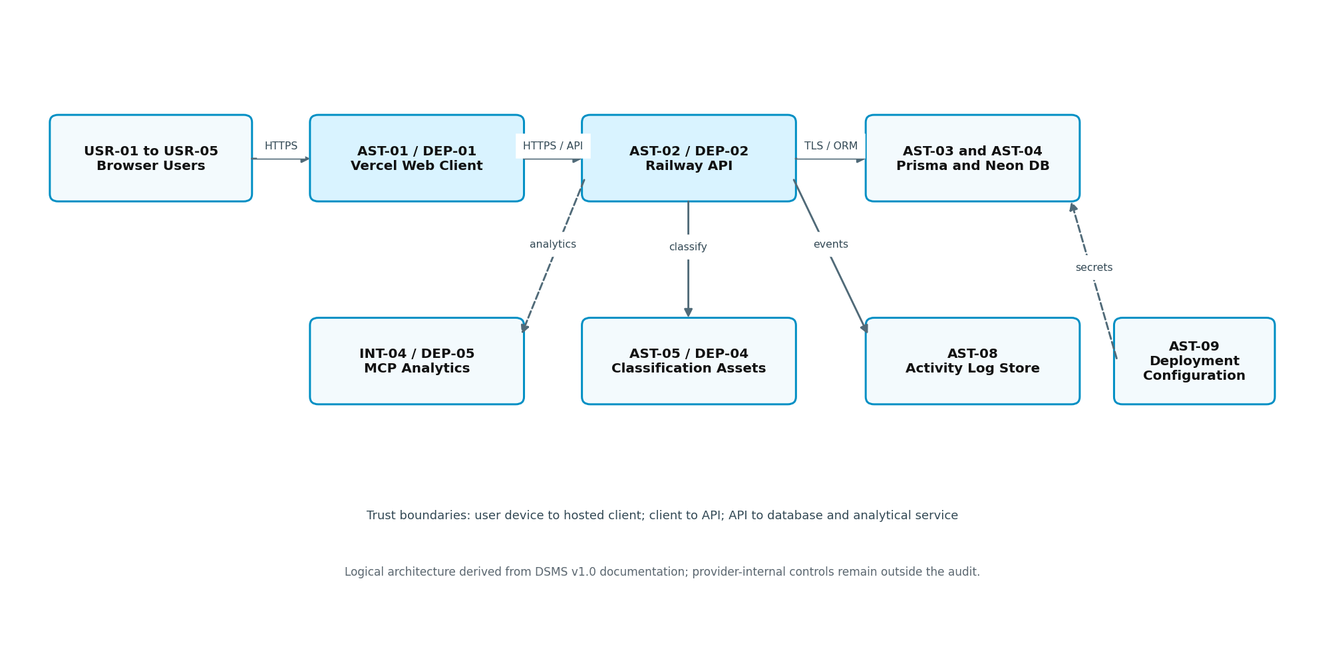
Accessible description: Browser users cross an HTTPS boundary to the hosted React client, then the Railway API. The API reaches the Prisma and Neon data tier, classification assets, MCP analytics, activity logs, and controlled deployment configuration.

14.1 Architecture Node and Connection Register
Node / Link ID | Source / Component | Destination | Direction / Channel | Purpose / Data | Trust Boundary? | Evidence / Assumption
DEP-01 | USR-01 to USR-05 | AST-01 Vercel client | Inbound / HTTPS | User sessions, uploads, searches, previews | Yes - user device to hosted client | EVD-08-01, EVD-08-04
DEP-02 | AST-01 | AST-02 Railway API | Bidirectional / HTTPS API | Commands, metadata, access decisions | Yes - client to API | EVD-08-01
DEP-03 | AST-02 through AST-03 | AST-04 Neon database | Bidirectional / TLS database connection | Users, labels, requests, policies, logs | Yes - API host to managed database | EVD-08-02
DEP-04 | AST-02 | AST-05 classification assets | Internal call / controlled runtime | Features, predicted label, confidence | Yes if separate analytical runtime | EVD-08-03; architecture assumption
DEP-05 | AST-02 | INT-04 MCP analytics | Outbound/API | Analytical request and result | Yes - application to analytical service | EVD-07-02; endpoint detail limited
DEP-06 | AST-02 | AST-08 log store | Internal database write | Event actor, time, object, decision, result | No separate boundary if same database | EVD-08-06
DEP-07 | ORG-08 deployment operator | INT-01 to INT-04 and AST-09 | Administrative channel | Release and configuration management | Yes - privileged provider consoles | EVD-08-07; provider records limited

Figure 3. Key Data-Flow Diagram
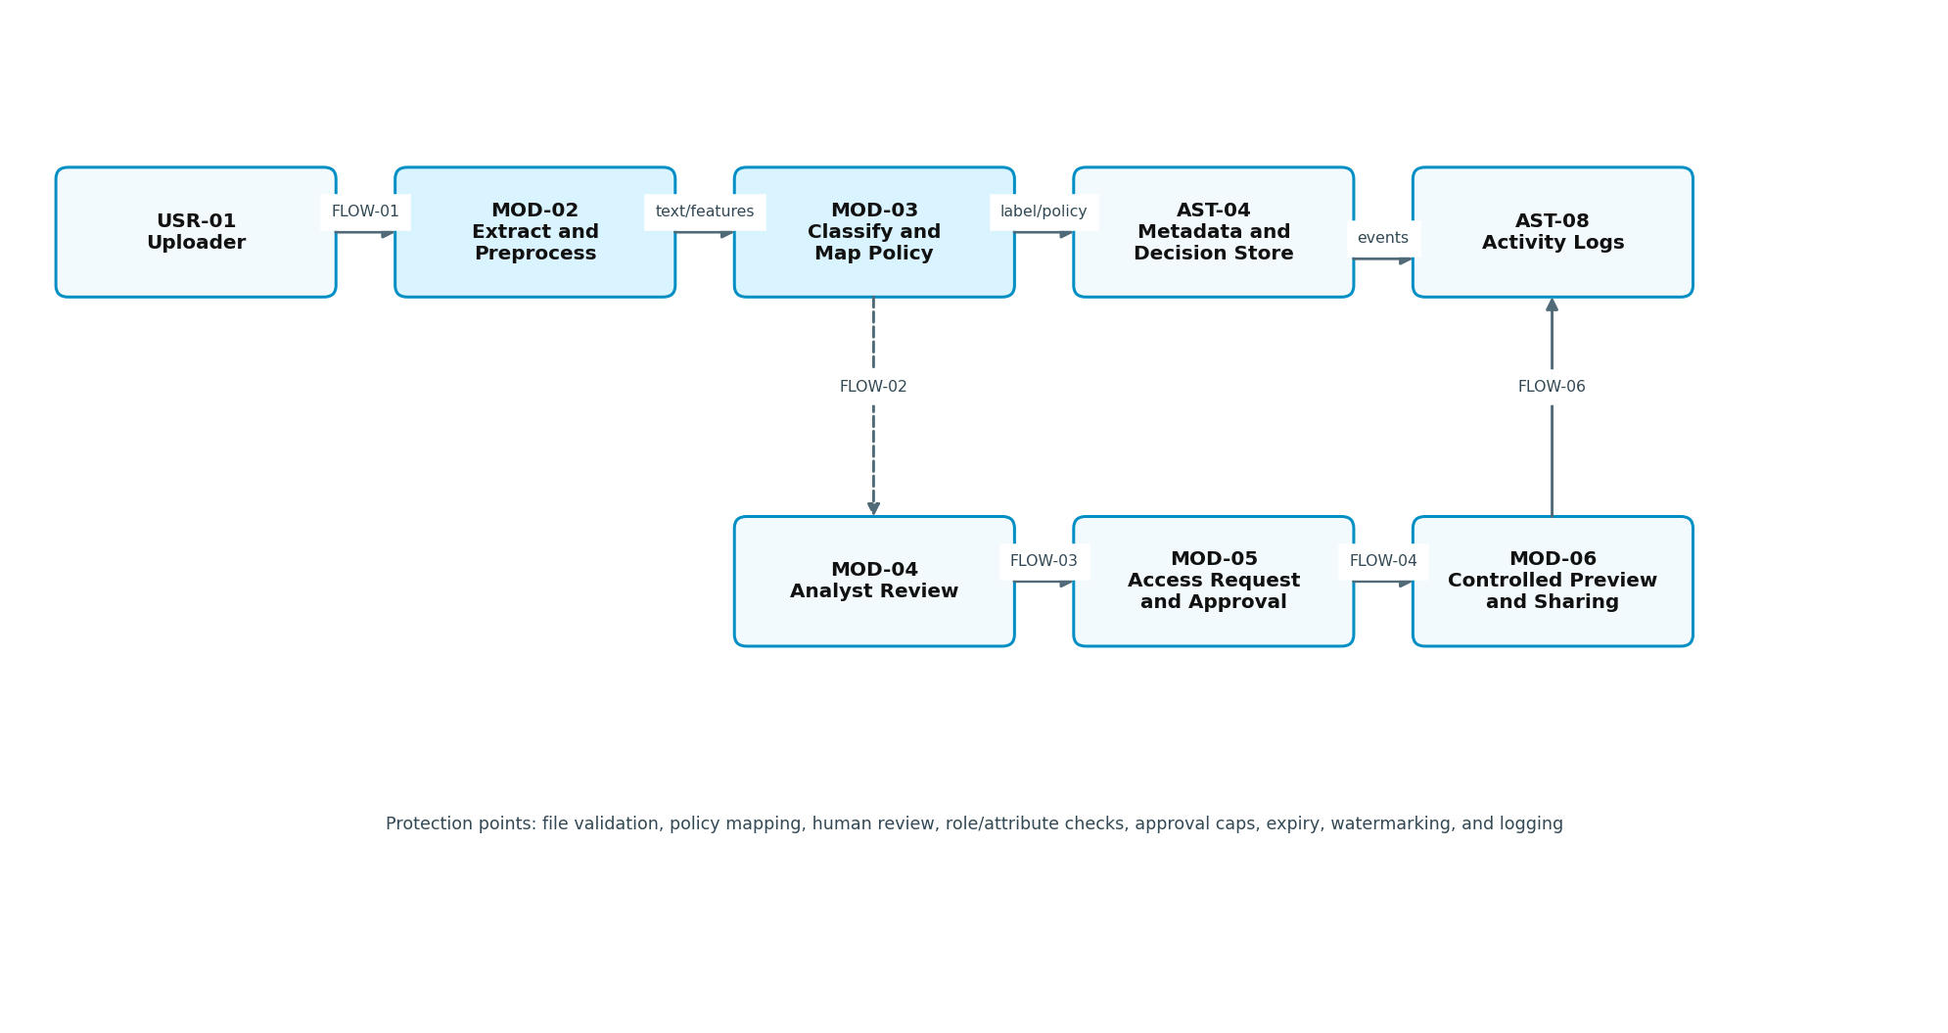
Accessible description: A document moves from upload through extraction, classification and policy mapping, optional analyst review, access request and approval, controlled preview or sharing, and activity logging.

14.2 Data-Flow Register
FLOW ID | Transaction / Journey | Actor / Source | Validation / Processing | Store / Destination | Transmission / Protection | Retention / Disposal | Related IDs
FLOW-01 | Upload and initial classification | USR-01 uploader | Type/size validation, extraction, preprocessing, TF-IDF, Logistic Regression | AST-04 metadata and AST-06 content | HTTPS; authenticated session; policy assignment | Retention policy requires later confirmation | MOD-01 to MOD-03; EVD-08-04
FLOW-02 | Low-confidence or high-risk review | MOD-03 / ORG-06 analyst | Confidence and sensitivity trigger; analyst confirms or changes result | AST-04 review record | Role-controlled review; decision logged | Review history retained with document record | MOD-04; AST-05; EVD-07-06
FLOW-03 | Access request and approval | USR-02 requester / ORG-03 approver | Role, department, owner, sensitivity, limits, and duration checks | AST-04 request/grant record | Authenticated workflow; least-privilege decision | Grant expires or is revoked; evidence incomplete | MOD-05; AST-07; EVD-07-07
FLOW-04 | Controlled document access | Approved viewer | Policy and grant validation before preview/download/link | AST-06 content; AST-08 event | Authorized session; watermark and time limit where applicable | Access event retained; link expires | MOD-06; EVD-08-05
FLOW-05 | Semantic search | Authorized user | Query processing plus authorization filtering | AST-04 metadata and allowed results | Results limited by identity and policy | Search event retention requires confirmation | MOD-08; EVD-07-10
FLOW-06 | Audit monitoring | All modules -> ORG-05 reviewer | Capture and filter administrative, review, access, and approval events | AST-08 log store and dashboard | Restricted monitoring view | Retention and completeness not independently verified | MOD-07; EVD-08-06

XV. Account, Privilege, and Documentation Reconciliation

15.1 Account and Privilege Inventory
ACC ID | Account Type / Role | Related USR / ORG | Authentication | Privilege / Access | Provision / Approval | Review / Deactivate | Logging | Evidence / Concern
ACC-01 | Operational uploader/requester | USR-01 / ORG-07 | Named account and authenticated session | Upload, own metadata, request access, permitted search | Approved user onboarding | Deactivate on role exit; periodic review planned | Upload, request, search, access | EVD-07-03, EVD-08-05
ACC-02 | Analyst | USR-03 / ORG-06 | Named account | Review confidence exceptions and labels | System owner approval | Review assignment and role change | Review decision and rationale | EVD-07-03, EVD-07-06
ACC-03 | Access approver | USR-04 / ORG-03 | Named account | Approve/reject within policy limits | Business role authorization | Periodic approval-role review | Approval, denial, duration | EVD-07-03, EVD-07-07
ACC-04 | DSMS administrator | USR-02 / ORG-04 | Privileged named account | Manage users, roles, configuration, policies | System owner approval | Privileged review and prompt deactivation | Administrative changes | EVD-07-03; segregation evidence limited
ACC-05 | Viewer | USR-05 / ORG-07 | Named account | View approved Public/Internal or granted content | Role/department assignment | Remove on transfer/exit | Preview, download, link use | EVD-08-05
ACC-06 | API service identity | AST-02 / ORG-08 | Deployment secret or managed credential | Application-to-database/service calls | Provisioned through deployment configuration | Rotate/revoke per change; schedule not evidenced | Service errors and selected calls | EVD-08-07
ACC-07 | Database connection identity | AST-03/AST-04 / ORG-04 | Restricted connection string | Application schema operations | Controlled deployment secret | Rotate and disable upon compromise | Database/provider logging not fully available | EVD-08-02, EVD-08-07
ACC-08 | Deployment operator | ORG-08 | Provider-console accounts | Deploy client/API and manage environment variables | Technical owner authorization | Review provider membership; evidence pending | Provider audit trail availability limited | EVD-08-07

15.2 Inventory and Diagram Reconciliation
Check ID | Expected Population / Relationship | Source Compared | Result | Missing / Unmatched Item | Resolution / Limitation
REC-08-01 | All nine approved MOD records map to assets | Lab 7 MOD register vs AST register | Complete | None | MOD-09 supported through AST-02/AST-04/AST-07.
REC-08-02 | Seven DATA/INT entries map to stores and flows | Lab 7 data register vs AST/FLOW | Exception | Physical document storage implementation detail | Recorded as AST-06 and limitation; verify in Lab 10.
REC-08-03 | All user roles map to account types | USR register vs ACC register | Complete | None | Five user roles and three service/technical identities recorded.
REC-08-04 | Every external dependency maps to a DEP link | INT register vs DEP register | Complete | None | Provider and administrative paths cross-referenced.
REC-08-05 | Evidence supports version and environment | Deployment records vs AST status | Exception | Provider-internal versions and recovery controls | Do not infer; request EVD-08-07 and test in Lab 10.
REC-08-06 | Asset baseline remains within scope | AST/INT vs SCP-01 to SCP-12 | Complete | Enterprise DLP endpoints excluded | Retained SCP-11/SCP-12 boundary.

15.3 Evidence Index Additions
EVD ID | Evidence Title / Description | Source / Owner | Date / Version | Related IDs | Privacy Treatment | Reliability / Limitation
EVD-08-01 | DSMS deployment architecture and release manifest | ORG-08 / controlled repository | DSMS v1.0 / August 2026 | AST-01 to AST-03; INT-01, INT-02; DEP-01, DEP-02 | Exclude URLs, tokens, and secrets | Available; reconcile with live configuration
EVD-08-02 | Database schema and Prisma model extract | ORG-04 | DSMS v1.0 | AST-03, AST-04, DEP-03, ACC-07 | Use schema only; no record contents | Available; production/provider controls not shown
EVD-08-03 | Classification component and model package inventory | ORG-06 | Final evaluated model | AST-05, DEP-04, FLOW-01, FLOW-02 | Aggregated metrics; no raw sensitive text | Available; fit/transform sequence needs reperformance
EVD-08-04 | Sanitized upload, extraction, and preview demonstrations | ORG-02 and ORG-08 | August 2026 | AST-06, INT-06, INT-07, FLOW-01, FLOW-04 | Synthetic files and redacted titles | Available; sample only
EVD-08-05 | Role, policy, access, and controlled-sharing screenshots | ORG-03 and ORG-04 | DSMS v1.0 | AST-07; ACC-01 to ACC-05; FLOW-03, FLOW-04 | Test accounts; redact identifiers | Available; historical operating population limited
EVD-08-06 | Activity-log schema and sanitized event sample | ORG-05 | Through August 31, 2026 | AST-08, DEP-06, FLOW-06 | Redact identity, IP, object name, and token data | Partial; retention and completeness need testing
EVD-08-07 | Deployment access, configuration, backup, and recovery evidence request | ORG-08 and providers | Needed as of August 31, 2026 | AST-09; INT-01 to INT-04; ACC-06 to ACC-08 | No secret values; provider report only | Partially available; independent provider evidence pending

XVI. Lab 8 Completion Checklist
Check | Completion Requirement
YES | All in-scope modules, environments, interfaces, data categories, and user roles map to assets.
YES | Every diagram node and connection has an ID, source, direction, purpose, and evidence or stated assumption.
YES | Critical data flows show input, validation, processing, storage, transmission, output, retention, disposal, and protection points.
YES | User, privileged, service, database, and integration account types are documented without exposing secrets.
YES | Asset, architecture, data-flow, account, and evidence records reconcile with the approved Lab 7 scope.
YES | Version history, build register, feedback closure, cross-review, AI validation, and attestation are complete.

Z. Collaboration, AI Validation, and Instructor Review

Z.1 Cross-Member Challenge Record
Review ID | Prepared By | Reviewed By | Item / Section | Challenge or Check | Resolution / Evidence
REV-08-01 | Sample Auditor A | Sample Auditor B | AST-06 and FLOW-01 | Is document storage a verified physical component or only a logical boundary? | Retained logical wording and added EVD-08-04/EVD-08-07 limitation.
REV-08-02 | Sample Auditor B | Sample Auditor C | DEP-04 and DEP-05 | Are the model runtime and MCP service being treated as the same component? | Separated classification assets from the external analytical interface.
REV-08-03 | Sample Auditor C | Sample Auditor A | ACC-04 and ACC-08 | Are administrator and deployment privileges independently reviewed? | Recorded separate roles but disclosed missing operating evidence.

Z.2 Human-in-the-Loop AI Validation Log
AI ID | Tool / Purpose | Material Suggestion | Evidence / Criteria Checked | Decision | Correction / Rationale | Privacy Check
AI-08-01 | ChatGPT / organize asset candidates | Treat every software library as a critical asset. | SCP register, MOD register, EVD-08-01 | Revise | Included only components material to DSMS operation, security, evidence, or dependency. | No sensitive data entered.
AI-08-02 | ChatGPT / draft architecture labels | Assume a separate object-storage provider. | EVD-07-02, EVD-08-01, EVD-08-04 | Reject | Used logical AST-06 because a separate provider was not evidenced. | Used system-level descriptions only.
AI-08-03 | ChatGPT / check reconciliation | Mark provider backup controls effective. | EVD-08-07 and scope limitations | Reject | Provider recovery remains not determined pending evidence and testing. | No provider credentials used.
AI-08-04 | ChatGPT / improve data-flow wording | Use stable IDs for actors, flows, stores, and controls. | Lab 7 IDs and EVD-08 records | Accept | Accepted after human review and cross-member reconciliation. | No raw documents entered.

Z.3 Group Attestation
This instructor reference sample demonstrates the expected Lab 8 attestation. Student groups must certify that their report reflects their own identified capstone build and authorized evidence, that all members completed assigned work and cross-review, that confidential information was protected, that AI output was not treated as audit evidence, and that material limitations were disclosed.
Member | Printed Name | Signature | Date
Member 1 | Sample Auditor A | Reference sample - not signed | September 9, 2026
Member 2 | Sample Auditor B | Reference sample - not signed | September 9, 2026
Member 3 | Sample Auditor C | Reference sample - not signed | September 9, 2026

Z.4 Instructor Review
Review Area | Status | Instructor Notes
Master-report continuity and prior feedback | Reference sample | Lab 8 is presented as a completed instructional increment.
Technical completeness and traceability | Reference sample | Students should follow the linked identifiers and evidence-based wording, not copy DSMS content.
Evidence, limitations, collaboration, AI validation, and professional judgment | Reference sample | Demonstrates sanitized evidence, disclosed limitations, cross-review, and human validation.

Instructor disposition and required revisions: Record the decision and detailed comments in the Instructor Notes column above or on the institution's grading sheet.

