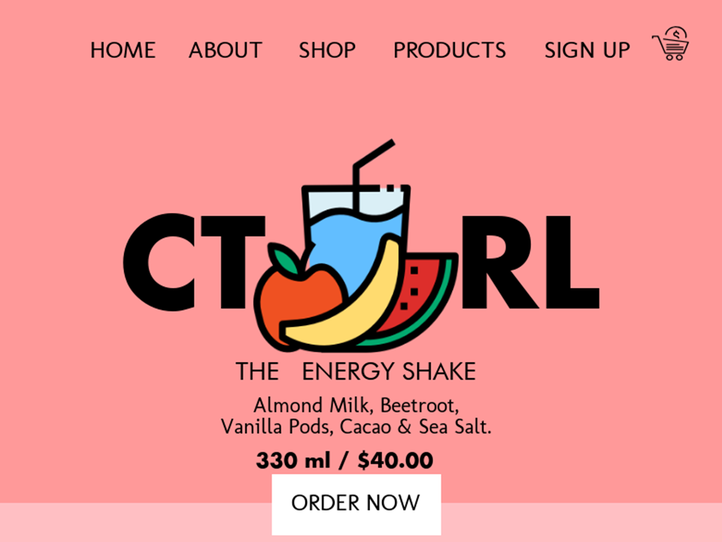CTRL

KNOW THE USER

If you want to design a successful product for people, first of all you need to understand them. Designing for everyone results in an unfocused goal that will dehumanize the profile of future users. My target user in this app is mostly the people who is concern about their health. The other target user is the people who is busy but still want to have a healthy life style. This offer a ready-made juice.

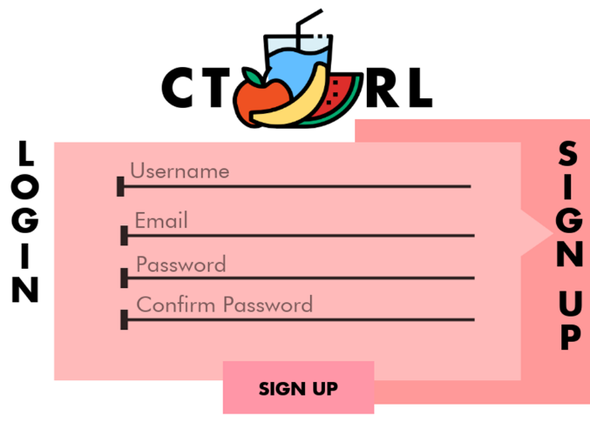

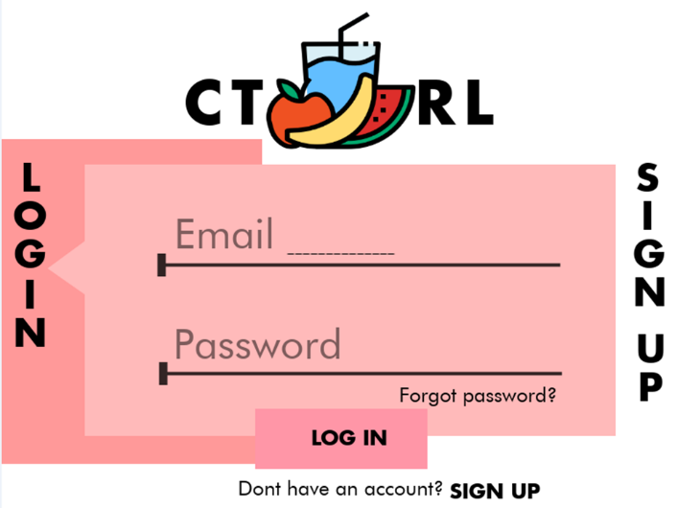

REDUCE MEMORY LOAd

I decided to create a log in page that doesn’t have a lot of buttons so that the user won’t get confuse when he/she press something wrong. The user can easily finish the task because he/she knows where to enter the certain detail.

REMIND USERS

Reminding the user is important because when the user did something wrong he/she can can undo it right away. Every pop-up message shoul contain some important messages to remind the users. The buttons must be placed away from each other to avoid errors.

