

SWP391 PROJECT REPORT
Software Requirement Specification

– Hanoi, Aug 2026 –
Table of Contents
Change Log
Definition and Acronyms
I. Overall Requirements
1. Context Diagram
2. Main Business Flow
2.1 Candidate Self-Service (BF-01)
2.2 End-to-End Recruitment (BF-02)
2.3 Business Flow Name (Code)
3. Conceptual Data Model
3.1 Entity Relationship Diagram
3.2 Entity Descriptions
3.3 Data Business Rules
4. User Requirements
4.1 Actors
4.2 Use Cases (UC)
4.3 Use Case Diagrams
4.4 Permission Matrix
5. System Functionalities
5.1 Screen Inventory
5.2 External API Inventory
5.3 Background Job Inventory
II. Functional Requirements
1. Feature Name1
1.1 SubFeature Name1.1
1.2 SubFeature Name1.2
2. User Authentication
2.1 User Register
2.2 User Login
3. System Administration
3.1 System Settings
3.2 User Management
4. Feature NameN
5. Background Job Inventory
5.1 Unlock Expired Locked Accounts (JOB-01)
5.2 Clean Up Old Audit Log Entries (JOB-02)
6. External API Inventory
6.1 HTTP Method: URL pattern (API-ID)
6.2 VnPay Webhook (API-02)
6.3 SePay Webhook (API-03)
III. Requirement Appendix
1. Business Rules
2. System Messages
3. Other Requirements

Change Log
Date | A*  M, D | In charge | Change Description
13/09/2026 | A | TinDLB | Create Report1
14/09/2026 | A | ThaiTQ | Add UCs for Cashier
14/9/2026 | A | DatPM | Add UCs for Baker
14/9/2026 | A | DatPM | Updated Section II – 3.2 for Production Management requirements and workflow.
20/09/2026 | M | TinDLB | Modified context diagram and admin use case diagram
22/09/2026 | A | DatPM | Change Description of Baker, add Use Case at 4.2 (UC-22 View Ingredient Inventory), change 4.3.3 for match team UR
12/10/2026 | M | TinDLB | Updated Definitions, 3.2 Entity Descriptions and 3.3 Data Business Rules to match BakeryManagementDB.sql (24 tables); added Cashier to 4.4 Permission Matrix; rewrote 5.1–5.3 and Appendix III.
*A - Added M - Modified D - Deleted

Definition and Acronyms
Acronym | Definition
BMS | Bakery Management System
UC | Use Case
SRS / SDS | Software Requirement Specification / Software Design Specification
POS | Point of Sale – the counter screen used by the Cashier for Offline (walk-in) orders
PO | Purchase Order – an ingredient order sent to a Supplier; one PO may be delivered in several batches under the same PO code
GR | Goods Receipt – the record of one delivery batch of a PO
COD | Cash on Delivery
Online / Offline channel | Online = order placed by a Customer on the website (COD or online payment, delivered to an address; a logged-in Customer or a Guest with basic information). Offline = walk-in order created by the Cashier at the counter (Cash or QR, no delivery)
Low stock | An ingredient whose stock is at or below its minimum threshold; it only triggers a notification and never blocks any operation
Loyalty points | Points earned by a logged-in Customer from Online orders and redeemable at checkout; Guest orders earn none
Actual Yield / Defect Qty | Quantity of good products obtained / quantity of defective products discarded when a production task is completed
Delivery staff | Person who delivers an Online order; stored only as name and phone, with no system account

I. Overall Requirements

1. Context Diagram
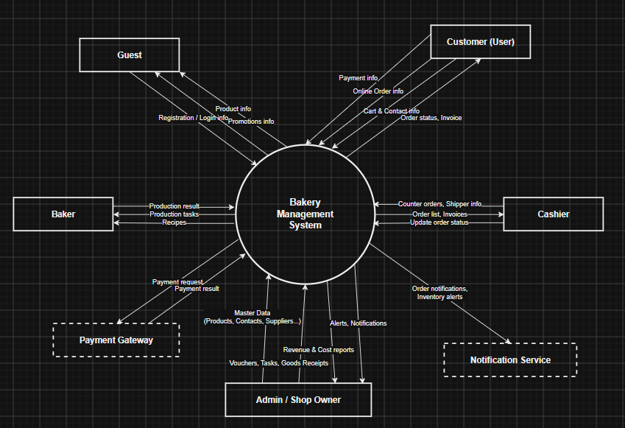

2. Main Business Flow

2.1 Guest/Customer purchase cake (BF-01)
Trigger: Guest/Customer browse products.
End condition: The order status has been updated to "Completed" in the system.
The system has automatically deducted the corresponding product quantity from inventory..

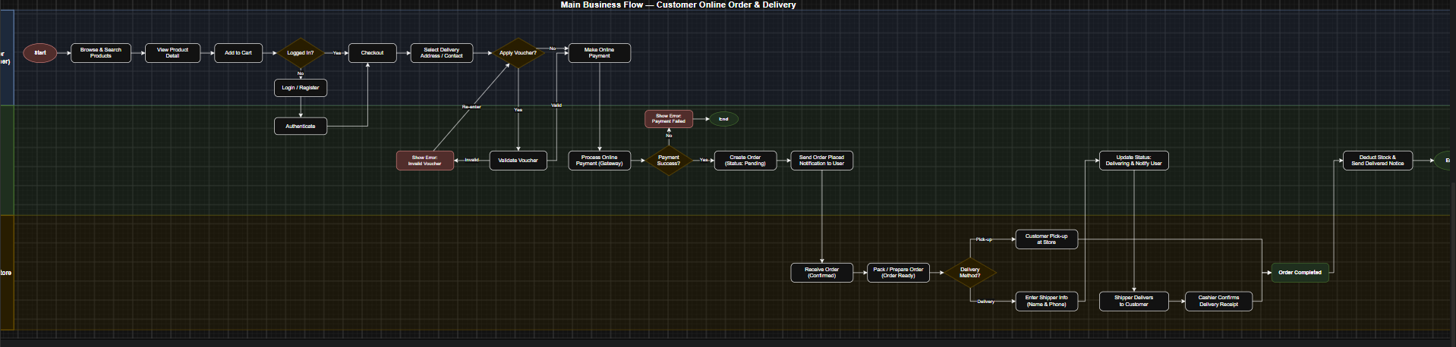

2.2 Admin assign Baker to produce cake (BF-02)
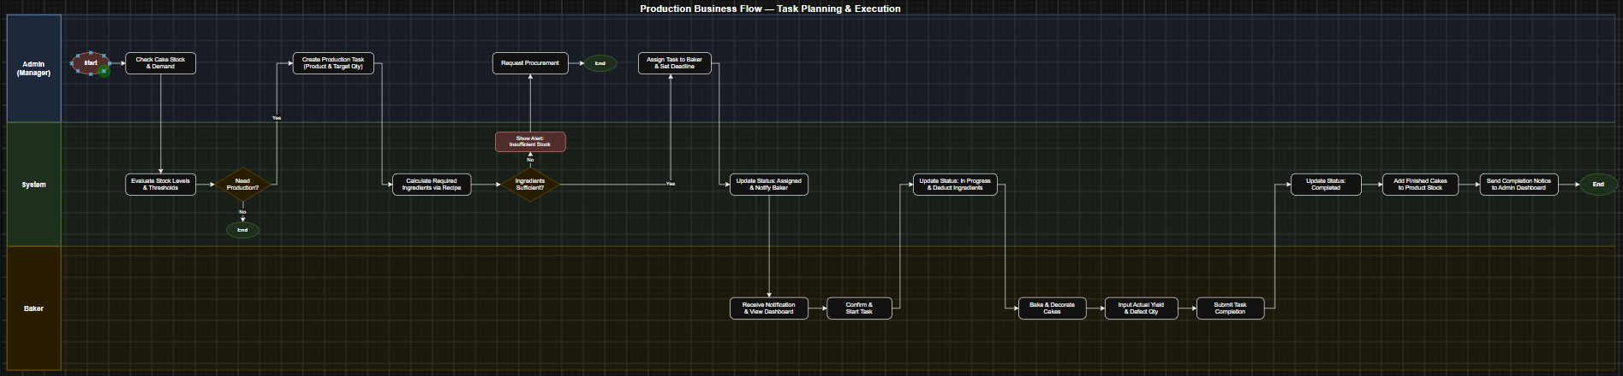

2.3 Admin adds ingredients to inventory (BF-03)
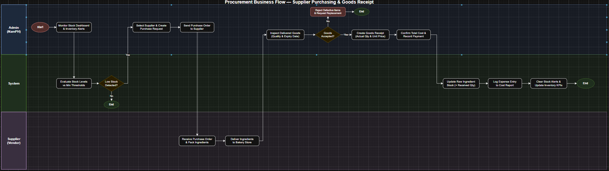

2.3 Offline customer and POS checkout (BF-04)

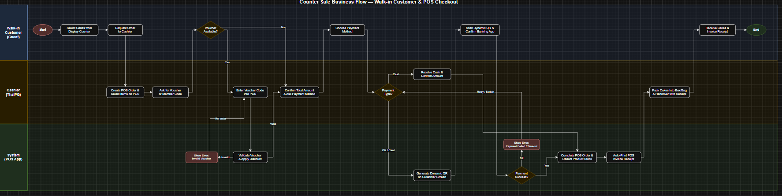

3. Conceptual Data Model

3.1 Entity Relationship Diagram
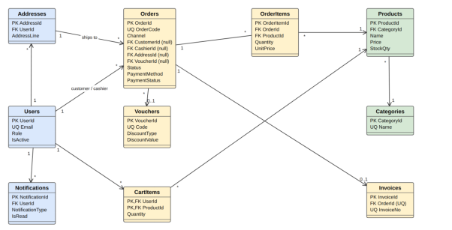
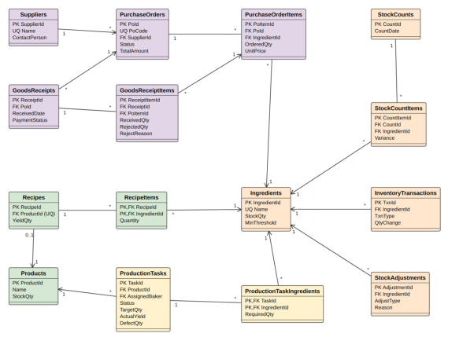

(https://dbdiagram.io/d/6aa89ed236f99825649395f9)

3.2 Entity Descriptions
Entity: User
Field | Value
Users | Accounts of all system users: Customer, Cashier, Baker and Admin (role-based, BCrypt password hash, IsActive flag, loyalty points balance of the Customer).
Addresses | Delivery addresses of a Customer; one of them can be the default address.
Categories | Groups bakery products for management and browsing.
Products | Bakery products for sale, with price, image, finished-product stock quantity and active status.
Ingredients | Raw materials with unit, current stock quantity and minimum threshold.
Recipes | Recipe of a product: the batch yield produced by one recipe run.
RecipeItems | Ingredient lines of a recipe with the required quantity.
Suppliers | Ingredient suppliers (external parties; they have no system account).
PurchaseOrders | Purchase orders to suppliers, identified by a PO code, with status Draft, Sent, Partially Fulfilled, Completed or Cancelled.
PurchaseOrderItems | Ordered ingredient lines of a PO: ordered quantity, unit price and expected date.
GoodsReceipts | One delivery batch of a PO; a PO can have several receipts. Cost covers accepted goods only.
GoodsReceiptItems | Received, rejected (with reason) and accepted quantity per ingredient of a receipt, with expiry date.
InventoryTransactions | Ledger of every ingredient stock movement (Receipt, ProductionUse, AdjustmentIn, AdjustmentOut, StockCount). Ingredient stock equals the sum of its transactions.
StockAdjustments | Manual stock increase/decrease with a reason (Correction, FoundStock, Damaged, Expired, Wastage, Other).
StockCounts | A physical stock count session performed by the Admin.
StockCountItems | System quantity, counted quantity and variance of each ingredient in a stock count.
Vouchers | Discount codes (percent or amount) with minimum order value, validity dates and usage limit.
CartItems | Items in a logged-in Customer's server-side shopping cart.
Orders | Sales orders of both channels: Online (website, COD/Online payment, delivery address) and Offline (counter, Cash/QR, no address). Online orders are placed by a logged-in Customer (saved address, loyalty points earned/used) or by a Guest with basic information (name, phone, shipping address); they also store the delivery staff name and phone.
OrderItems | Products, quantities and unit prices contained in an order.
Invoices | Invoice issued for a completed order (one invoice per order).
Notifications | System notifications: order events, low stock, production task assigned/completed and system messages.
ProductionTasks | Production job created by the Admin and executed by a Baker, with target quantity, actual yield and defect quantity.
ProductionTaskIngredients | Ingredient requirement of a production task calculated from the recipe at planning time.

3.3 Data Business Rules
Rule | Description | Enforced On
Unique email | No two users may share the same email address; the email is the login name. | Account creation and profile change
Accounts are never deleted | Accounts are deactivated (IsActive = 0), never deleted, so that orders and history stay readable. | Account deactivation
Separate order channels | Online order: payment method COD or Online, and either a logged-in Customer with a saved address, or a Guest with name, phone and shipping address (a Guest order has no loyalty points). Offline order: payment method Cash or QR, no delivery address and no guest information. | Order creation (check constraint CK_Orders_Channel_Rules)
Unique codes | OrderCode, InvoiceNo, PO code and voucher code are unique; an order has at most one invoice. | Order, invoice, PO and voucher creation
Stock is never negative | Product stock and ingredient stock must be >= 0. | Orders, production, adjustment, stock count
Inventory ledger | Every change of ingredient stock creates an InventoryTransaction; Ingredients.StockQty equals the sum of its QtyChange. | Receipt, production start, adjustment, stock count
Rejected goods | RejectedQty <= ReceivedQty and a reason is mandatory when RejectedQty > 0; rejected goods enter neither the stock nor the cost. | Goods receipt / inspection
PO and receipts | A PO can have many GoodsReceipts; its status follows the received quantities. | Goods receipt
Voucher validity | DiscountValue > 0 and EndDate >= StartDate; usable only when active, within dates, above the minimum order and under the usage limit. | Voucher creation and use
Production quantity limit | When a production task is created, the target quantity must be between 1 and the maximum quantity that the current ingredient stock allows. | Production task creation
Positive quantities | Quantities in cart items, order items, recipes, PO items and production targets must be > 0; prices and thresholds must be >= 0. | All data entry
Completed production task | A task can be Completed only with ActualYield and DefectQty recorded (both >= 0). | Production completion

4. User Requirements

4.1 Actors
# | Actor | Description
1 | Admin | Manages product categories, products, ingredients and inventory, recipes, production tasks, staff accounts, vouchers and promotions. The Admin also assigns Bakers, monitors orders, production and inventory status, receives low-stock notifications, and views revenue and production reports
2 | Baker | Production staff responsible for executing assigned baking tasks. The Baker can view recipes, required ingredients, ingredient inventory, and assigned production tasks. The Baker can start assigned production tasks, enter the actual quantity produced, and complete tasks. The system automatically updates ingredient and finished-product inventory after production completion.
3 | Cashier | In-store staff responsible for point-of-sale operations and delivery coordination. The Cashier creates counter orders, searches products, applies valid vouchers, processes cash or online payments, prints invoices, and updates order and self-delivery statuses.
4 | Customer | An authenticated member who browses products, views details, maintains a server-synchronized shopping cart, places online orders, applies vouchers, redeems loyalty points, tracks real-time delivery status, cancels pending orders, and views order history.
5 | Guest | An unauthenticated visitor who browses the public bakery catalog, searches products by keyword or category, views product details, manages a temporary local shopping cart, registers for a member account, or places quick orders via Fast Checkout without point accumulation.

4.2 Use Cases (UC)
ID | Use Case | Feature | Use Case Description
UC-01 | Login & Register | Authentication | Allows a Guest to register a Customer account and allows every registered user to log in; after login the system routes the user to the screen of their role.
UC-02 | Staff Profile | Staff Management | Allows a staff member to view and edit their own account information and change the password.
UC-03 | Category & Product Management | Master Data Management | Allows the Admin to manage product categories and products (name, image, price, status).
UC-04 | Supplier Management | Supplier & Purchasing | Allows the Admin to add, edit, view and deactivate ingredient suppliers (external parties without a system account).
UC-05 | Baker Dashboard | Production Execution | Shows the Baker the production tasks assigned by the Admin and allows opening a task with its recipe and required ingredients.
UC-06 | Login | Authentication | Allows users (Customer, Cashier, Baker, Admin) to authenticate using their credentials to access their respective role-based features and dashboards in the system
UC-07 | Manage Categories | Master Data Management | Allows the Admin to create, read, update, and delete product categories.
UC-08 | Manage Products | Master Data Management | Allows the Admin to add new bakery products, update details, or remove them.
UC-09 | Manage Recipes | Production Management | Allows the Admin to define the ingredients and quantities required to bake each product.
UC-10 | Manage Contacts | CRM | Allows the Admin to view and manage customer information (individuals and organizations).
UC-11 | Manage Suppliers | Supplier Management | Allows the Admin to add and manage information of raw material suppliers
UC-12 | Manage Ingredients | Inventory Management | Allows the Admin to view and update raw ingredient details and stock thresholds
UC-13 | Import Stock | Inventory Management | Allows the Admin to import new stock from suppliers, update inventory, and record costs.
UC-14 | Manage Production Tasks | Production Management | Allows the Admin to create daily baking tasks, calculate required ingredients, and assign them to bakers.
UC-15 | Manage Vouchers | Sales & Promotions | Allows the Admin to create discount codes and configure their usage rules (e.g. minimum order).
UC-16 | View Dashboards & Reports | Reporting | Provides a centralized summary view of the bakery's operational and financial metrics.
UC-17 | View Revenue | Reporting | Displays revenue charts and statistics based on completed customer orders over time.
UC-18 | View Cost Report | Reporting | Displays the expenses incurred from importing ingredients via Goods Receipts.
UC-19 | View Production History | Reporting | Displays a log of completed production tasks and compares planned vs actual yields.
UC-20 | View Recipes | Recipe Management | Allows the Baker to view recipes and the ingredients and quantities required for production.
UC-21 | View Assigned Production Tasks | Production Management | Allows the Baker to view production tasks assigned to them by the Admin.
UC-22 | View Production Task Details | Production Management | Allows the Baker to view detailed information about an assigned production task.
UC-23 | View Required Ingredients | Production Management | Allows the Baker to view the ingredients and required quantities for the selected production task.
UC-24 | Start Production | Production Management | Allows the Baker to start an assigned production task.
UC-25 | Enter Actual Quantity | Production Management | Allows the Baker to enter the actual quantity of products produced.
UC-26 | Complete Production | Production Management | Allows the Baker to complete an assigned production task after production is finished.
UC-27 | View Ingredient Inventory | Production Management | Allows Baker to view ingredient inventory information, including available quantity and stock status, without modifying inventory.
UC-28 | Create Counter Order | Order & Sales Management | Cashier selects products and quantities to create an order for a walk-in customer
UC-29 | Browse & Search Products | Online Shopping | Allows guests and customers to view the bakery catalog, search for bakery items by name or SKU, and filter products by category or price.
UC-30 | Manage Shopping Cart | Online Shopping | Allows both guests and logged-in customers to add items to their shopping cart, inspect item quantities, update quantities, and remove items. Guest cart data is stored locally in the browser, while Customer cart data is persisted on the server database.
UC-31 | Fast Checkout as Guest | Online Shopping | Allows a guest user to quickly place an online order by providing basic contact and shipping information without having to register an account. Orders placed via Fast Checkout do not earn member loyalty points.
UC-32 | Checkout & Place Order | Online Shopping | Allows an authenticated member to place an online order, apply discount vouchers, redeem loyalty points, choose payment methods, and accumulate new loyalty points upon delivery.
UC-33 | Track Order Status | Online Shopping | Allows the customer to view their historical orders, check detailed invoices, and track the real-time fulfillment and self-delivery status of active orders.
UC-34 | Cancel Pending Order | Online Shopping | Allows a customer to cancel an online order while it is still in PENDING_CONFIRMATION status before the bakery starts production or packaging.

4.3 Use Case Diagrams

4.3.1 UCs for Customer,Guest
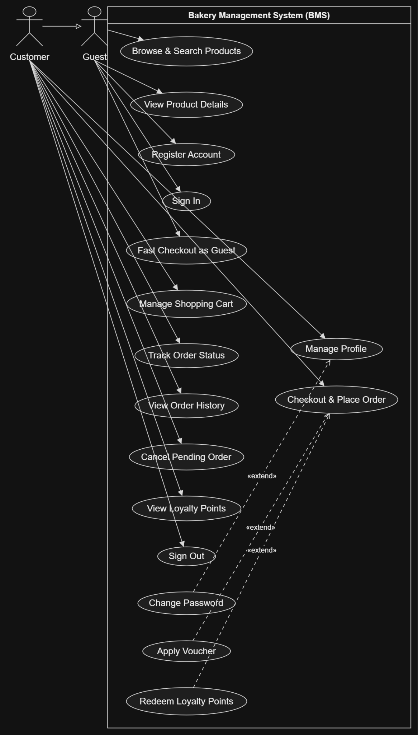

4.3.2 UCs for Admin
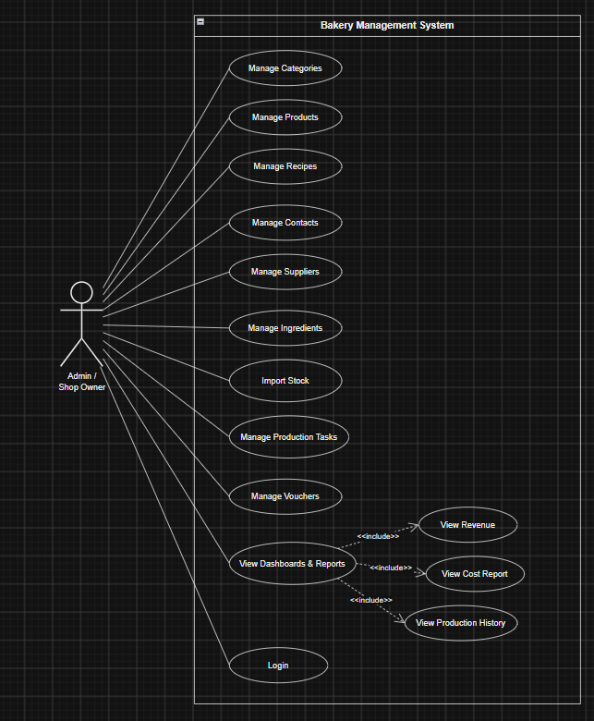

4.3.3 UCs for Baker

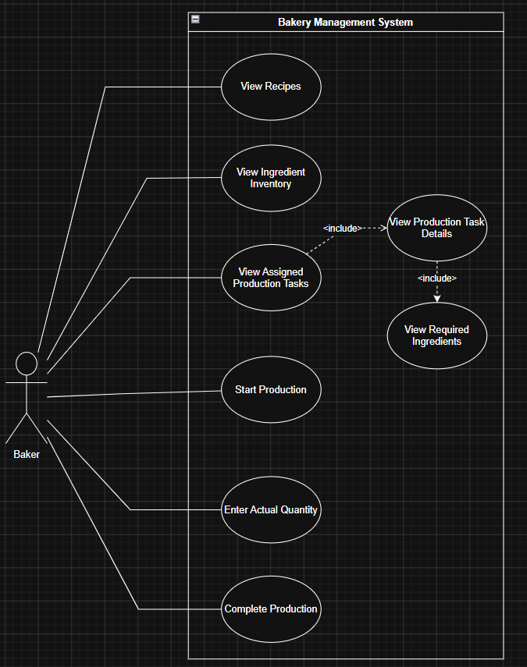
4.3.3 UCs for Cashier
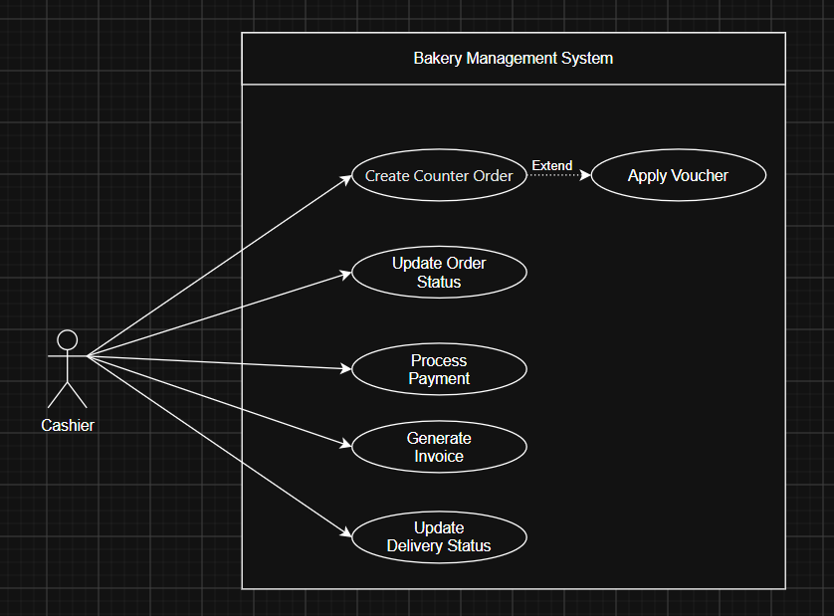

4.4 Permission Matrix
Full = unrestricted · Restricted = conditions apply (see footnotes) · No = denied
Entity | Action | Admin | Baker | Cashier | Customer
Own account / profile | View, edit, change password | Own | Own | Own | Own
User account | Register | No | No | No | No
Staff accounts | Create, deactivate | Full | No | No | No
Category, Product | Manage | Full | View | View | View active
Recipe | Manage | Full | View | No | No
Ingredient | Manage | Full | View | No | No
Supplier | Manage | Full | No | No | No
Purchase Order | Create, send, track, cancel | Full | No | No | No
Goods Receipt / Inspection | Receive, inspect, reject | Full | No | No | No
Stock Adjustment / Stock Count | Create, reconcile | Full | No | No | No
Production Task | Create, assign, cancel | Full | No | No | No
Production Task | Start, enter yield, complete | No | Own | No | No
Production History | View | Full | Own | No | No
Voucher | Manage / apply | Full | No | Apply | Apply
Cart | Add, change, remove | No | No | No | Own
Online order | Place, view, cancel pending | View | No | View | Own
Online order | Prepare, deliver, cancel | No | No | Full | No
Counter (Offline) order | Create, pay | View | No | Full | No
Invoice | Generate, print | View | No | Full | No
Notification | Receive, read | Own | Own | No | Own
Loyalty points | Earn, redeem | No | No | No | Own
Cost report, Revenue report | View | Full | No | No | No

5. System Functionalities

5.1 Screen Inventory

a. Screen Flow

b. Screen List
# | Screen Name | Feature | Description
1 | Sign In | Authentication | Allows any user to authenticate and reach their role-specific area of the system
2 | User Register | Authentication | Allows a new Candidate to create their own account

5.2 External API Inventory
# | API Name | Calling Path | Description
1 | Employee sync API | HRM System → TalentHub | allows an external HR management system to push employee records and automatically create Interviewer accounts
2 | Outbound webhook | TalentHub → External HRM | notifies an external system when a Candidate's status changes to HIRED

5.3 Background Job Inventory
# | Job Name | Group | Description
1 | Unlock expired locked accounts | Scheduled | Every 15 minutes
2 | Clean up old audit log entries | Scheduled | Daily at 2:00 AM

II. Functional Requirements

1. Feature Name1

1.1 SubFeature Name1.1

1.1.1 Screen/Function Name1
Field Name | Description
Field Name1 | Field description: data type min/max length or value, initial data, etc.
Field Name2 | …
Field Group-Name1
Field Name3 | …
Field Name4 | …
Field Group-Name2
… | …

1.1.2 Screen/Function Name2
…

1.2 SubFeature Name1.2
…

2. Cashier Profile

2.1 View & Edit Profile

2.1.1 Screen Design

2.1.2 Field Description

Field Name | Description
Email | Text, read-only (disabled). Initial value: the Cashier’s email. The email is the login name and cannot be changed.
Role | Text, read-only (disabled). Initial value: “Cashier”.
Full Name | Text, required, 2–100 characters. Initial value: current full name. Leading and trailing spaces are trimmed on save.
Phone | Text, optional. If entered: 10 digits, starting with 03, 05, 07, 08 or 09 (e.g. 0912345678). Initial value: current phone, or blank. Placeholder: “0912345678”. If left blank, the phone is stored as NULL.
Account created at | Label, read-only, format dd/MM/yyyy HH:mm.
“Lưu thay đổi” button | Validates and saves Full Name and Phone. On success the page reloads with a success message (MSG-P01).
“Đổi mật khẩu” button | Navigates to the Change Password screen.

2.1.3 Functionalities

UC Name: | View & Edit Cashier Profile
Primary Actor: | Cashier
Description: | Allows the Cashier to view their own account information and update their Full Name and Phone number.
Trigger: | Cashier clicks “Hồ sơ cá nhân” in the navigation bar.
Precondition: | PRE-01: Cashier is logged in with the Cashier role.  PRE-02: The account exists and is active.
Postconditions: | POST-01: The profile is displayed with current data.  POST-02: After a successful save, FullName and Phone are updated in the Users table.  POST-03: The login session (cookie claims) is refreshed so the new name and phone are displayed immediately, without logging in again.
Normal Flow: | 1. Cashier clicks “Hồ sơ cá nhân”.  2. System identifies the logged-in Cashier and retrieves the account from the database.  3. System displays the profile: Email, Role and creation date (read-only), Full Name and Phone (editable).  4. Cashier edits Full Name and/or Phone.  5. Cashier clicks “Lưu thay đổi”.  6. System validates the input (client side and server side).  7. System re-reads Email, Role and CreatedAt from the database (form values of read-only fields are ignored).  8. System trims and saves Full Name and Phone (blank phone is saved as NULL).  9. System refreshes the login cookie, keeping the original “Remember me” setting.  10. System records an information log entry.  11. System reloads the profile page and shows MSG-P01.
Alternative Flows: | A1. Cashier opens Change Password  - At Step 3, Cashier clicks “Đổi mật khẩu”.  - System navigates to the Change Password screen .  A2. Cashier leaves Phone blank  - At Step 8, system stores Phone = NULL.
Exceptions: | E1. Full Name is empty  - At Step 6, system displays “Vui lòng nhập họ và tên.” under the field; nothing is saved.  E2. Full Name length is invalid (< 2 or > 100)  - At Step 6, system displays the length error under the field; nothing is saved.  E3. Phone format is invalid  - At Step 6, system displays “Số điện thoại không hợp lệ (gồm 10 chữ số, bắt đầu bằng 03, 05, 07, 08, 09).”; nothing is saved.  E4. Account not found  - At Step 2 or 7, system returns a 404 (Not Found) page.
Priority: | Medium

2.2 Change Password

2.2.1 Screen Design

2.2.2 Field Description

Field Name | Description
Current Password | Password (masked), required. Initial value: empty. Must match the current password.
New Password | Password (masked), required, 6–100 characters. Must be different from the current password.
Confirm New Password | Password (masked), required. Must be identical to New Password.
“Đổi mật khẩu” button | Validates and changes the password. On success, redirects to the Profile screen with MSG-P02.
“Hủy” button | Cancels and returns to the Profile screen without any change.

2.2.3 Functionalities

UC Name: | Change Cashier Password
Primary Actor: | Cashier
Description: | Allows the Cashier to change their own password.
Trigger: | Cashier clicks “Đổi mật khẩu” on the Profile screen.
Precondition: | PRE-01: Cashier is logged in with the Cashier role.
Postconditions: | POST-01: The password hash (BCrypt) of the account is replaced by the hash of the new password.  POST-02: System records an information log entry.  POST-03: Cashier is redirected to the Profile screen with a success message.
Normal Flow: | 1. Cashier opens the Change Password screen.  2. System displays the form with three empty password fields.  3. Cashier enters Current Password, New Password and Confirm New Password.  4. Cashier clicks “Đổi mật khẩu”.  5. System validates the required fields, the length of the new password and the confirmation match.  6. System verifies the current password against the stored hash.  7. System verifies that the new password differs from the current password.  8. System hashes the new password and saves it.  9. System redirects to the Profile screen and shows MSG-P02.
Alternative Flows: | A1. Cashier cancels  - Cashier clicks “Hủy”.  - System returns to the Profile screen; the password is unchanged.
Exceptions: | E1. Required field is empty  - At Step 5, system shows “Vui lòng nhập mật khẩu hiện tại.” / “Vui lòng nhập mật khẩu mới.” / “Vui lòng xác nhận mật khẩu mới.” under the field.  E2. New password is too short (< 6 characters)  - At Step 5, system shows the minimum-length error.  E3. Confirmation does not match  - At Step 5, system shows “Mật khẩu xác nhận không khớp.”  E4. Current password is incorrect  - At Step 6, system shows “Mật khẩu hiện tại không chính xác.”; password is unchanged.  E5. New password equals current password  - At Step 7, system shows “Mật khẩu mới phải khác mật khẩu hiện tại.”; password is unchanged.  E6. Account not found  - System returns a 404 (Not Found) page.
Priority: | Medium

2.2 Change Password

3. UC-03 Category & Product Management
UC Name: | UC - 03: Category & Product Management
Primary Actor: | Admin | Create By: | TinDLB
Description: | Allows the Admin to manage product categories and products (name, image, price, status).
Trigger: | Admin opens Category Management or Product Management.
Precondition: | PRE-01: Admin is logged in.
Postconditions: | POST-01: Categories and products are created, updated or deactivated.
Normal Flow: | 1. 1. Admin opens the category/product list.  2. 2. System displays the records with status.  3. 3. Admin selects Add and enters the data (product: name, category, price, image, description).  4. 4. System validates and saves.  5. 5. Admin may edit or switch a product to Inactive.
Alternative Flows: | A1. Category has products  System does not delete it; it can be deactivated.  A2. Product used by orders or recipes  System only allows deactivating.
Exceptions: | E1. Price below 0 or required field missing  System shows validation errors.  E2. Invalid image file  System rejects the upload.
Priority: | High

9. Manage Production Tasks

9.1 Manage Production Tasks Screen

This screen allows the Administrator to:
· View Setting List: view list of current master data.
· Filter Setting List: filter master data by data types, statuses
· Search Settings: enter keyword(s) to search master data by their names or values
· Sort Setting List: sort mater data list (ascending, descending) by clicking column headers
On the screen, s/he can also
· Activate/Deactivate Setting: change status of a specific inactive/active master data
· Choose to go to the Setting Details screens for adding new or updating an existing master data by clicking the New Setting or Edit link.
Field Description
Field Name | Description
(1) | Initial values: all the active setting names with null or blank type  Hover the mouse to show the field name: “Setting Type”
(2) | Initial values: All Statuses, Active, Inactive (default value “All Status”)  Hover the mouse to show the field name: “Setting Status”
(3) | The change-status action is Activate or Deactivate depending on the current status of the relevant setting (Inactive or Active, respectively).

9.2 Functionalities

Admin

UC Name: | UC - : Manage Production Task
Primary Actor: | Admin | Create By: | Tin
Description: | Allows the Admin to create, assign, monitor, and manage production tasks for bakery products.
Trigger: | Admin clicks the "Production Task" button
Precondition: | PRE-01: Admin is logged in;  PRE-02: Products, recipes, and ingredients have been configured
Postconditions: | The production task is created or updated, assigned to a Baker, and its status is stored in the system
Normal Flow: | - Admin selects Manage Production Tasks.  - The system displays the list of production tasks.  - Admin selects Create Production Task.  - Admin selects the product and enters the planned production quantity.  - The system retrieves the recipe and calculates the required ingredients.  - The system checks available ingredient quantities.  - If sufficient ingredients are available, the system keeps the planned quantity.  - If ingredients are insufficient, the system calculates the maximum feasible quantity and adjusts the planned quantity.  - Admin selects a Baker to assign to the task.  - Admin confirms the production task.  - The system creates the task with “Planned” status.  - The assigned Baker can view the task and update its production status.
Alternative Flows: | A1. Insufficient Ingredients  - The system detects that the available ingredients are insufficient.  - The system displays a warning.  - The system calculates the maximum possible production quantity.  - The planned quantity is automatically adjusted to the feasible quantity.  - Admin can confirm the adjusted task.  A2. No Available Baker  - The system informs the Admin that no Baker is available.  - The production task cannot be assigned until an appropriate Baker is selected.
Exceptions: | E1. Invalid Production Quantity  At Step 4:  - The Admin enters a quantity that is zero, negative, or invalid.  - The system displays an error message.  - The Admin must enter a valid quantity.
Priority: | Medium

Baker

UC Name: | UC - 15: View Recipes
Primary Actor: | Baker | Create By: | Pham Manh Dat
Description: | Allows the Baker to view available recipes, including the ingredients and required quantities used for production.
Trigger: | Baker selects the Recipe section.
Precondition: | PRE-01: Baker is logged in.  PRE-02: Recipe information is available in the system.
Postconditions: | POST-01: The system displays the available recipes and the details of the selected recipe.
Normal Flow: | - Baker accesses the Recipe section.  - System identifies the logged-in Baker.  - System retrieves the available recipes.  - System displays the recipe list.  - Baker selects a recipe.  - System retrieves the selected recipe details.  - System displays the recipe information, including the required ingredients and their quantities.
Alternative Flows: | A1. No recipes are available.  - System cannot find any available recipes.  - System displays a message indicating that no recipes are available.
Exceptions: | E1. System cannot retrieve recipe information.  - System displays an error message.
Priority: | High

UC Name: | UC - 16: View Assigned Production Tasks
Primary Actor: | Baker | Create By: | Pham Manh Dat
Description: | Allows the Baker to view production tasks assigned to them by the Admin.
Trigger: | Baker selects the Production Tasks section.
Precondition: | - Baker is logged in
Postconditions: | - The system displays the production tasks assigned to the Baker, if any.
Normal Flow: | - Baker accesses the Production Tasks section.  - System identifies the currently logged-in Baker.  - System retrieves production tasks assigned to that Baker.  - System displays the list of assigned production tasks.  - Baker selects a production task to view its details.
Alternative Flows: | A1. No production task is assigned to the Baker.  - - System finds that no production task is assigned.  - - System displays a message indicating that no production tasks are currently assigned.  - - Baker remains on the Production Tasks page.
Exceptions: | E1. The system cannot retrieve production tasks.  - System displays an error message.
Priority: | High

UC Name: | UC - 17: View Production Task Details
Primary Actor: | Baker | Create By: | Pham Manh Dat
Description: | Allows the Baker to view detailed information about an assigned production task.
Trigger: | Baker selects a production task from the assigned production task list.
Precondition: | - Baker is logged in.  - The production task is assigned to the Baker.
Postconditions: | The system displays the details of the selected production task.
Normal Flow: | - Baker opens the list of assigned production tasks.  - Baker selects a production task.  - System verifies that the production task is assigned to the Baker.  - System retrieves the production task information.  - System displays the production task details, including product, planned quantity, actual quantity, status, and production dates.  - System includes the required ingredient information.
Alternative Flows: | A1. Production task is no longer available.  - System cannot find the selected production task.  - System displays a message indicating that the production task is no longer available.  - Baker returns to the assigned production task list.
Exceptions: | E1. The selected production task is not assigned to the Baker.  - System denies access to the production task details.  - System displays an appropriate error message.  E2. System cannot retrieve the production task information.  - System displays an error message.
Priority: | High

UC Name: | UC - 18: View Required Ingredients
Primary Actor: | Baker | Create By: | Pham Manh Dat
Description: | Allows the Baker to view the ingredients and required quantities for the selected production task.
Trigger: | Baker views the details of an assigned production task.
Precondition: | - Baker is logged in.  - The production task is assigned to the Baker.  - The product has a recipe.
Postconditions: | The system displays the required ingredients and their quantities for the production task.
Normal Flow: | - Baker opens the details of an assigned production task.  - System identifies the product associated with the production task.  - System retrieves the recipe of the product.  - System retrieves the ingredients and required quantities from the recipe.  - System calculates the required quantity based on the planned production quantity.  - System displays the list of required ingredients and quantities to the Baker.
Alternative Flows: | A1. The product does not have a recipe.  - System cannot find a recipe for the selected product.  - System displays a message indicating that the recipe is not available.  - System does not display the required ingredient list.
Exceptions: | E1. System cannot retrieve recipe information.  - System displays an error message.
Priority: | High

UC Name: | UC - 19: Start Production
Primary Actor: | Baker | Create By: | Pham Manh Dat
Description: | Allows the Baker to start an assigned production task.
Trigger: | Baker clicks Start Production.
Precondition: | - Baker is logged in.  - Production task is assigned to the Baker.  - Production task status is Planned.
Postconditions: | - Production task status changes to In Progress.  - System records the production start time.
Normal Flow: | - Baker opens an assigned production task.  - System displays the production task information.  - Baker clicks Start Production.  - System verifies that the production task is assigned to the Baker.  - System verifies that the task status is Planned.  - System changes the task status to In Progress.  - System records the production start time.  - System displays the updated task status.
Alternative Flows: | A1. Production task is not in Planned status.  - System detects that the current task status is not Planned.  - System does not start the production task.  - System displays an appropriate message to the Baker.
Exceptions: | E1. Production task is not assigned to the Baker.  - System denies the operation and displays an error message.  E2. System cannot update the production task status.  - System displays an error message and keeps the current task status.
Priority: | High

UC Name: | UC - 20: Enter Actual Quantity
Primary Actor: | Baker | Create By: | Pham Manh Dat
Description: | Allows the Baker to enter the actual quantity of products produced for a production task.
Trigger: | Baker enters the actual quantity after completing the production work.
Precondition: | - Baker is logged in.  - Production task is assigned to the Baker.  - Production task status is In Progress.
Postconditions: | - The actual production quantity is stored for the production task.
Normal Flow: | - Baker opens an In Progress production task.  - System displays the production task information.  - Baker enters the actual quantity of products produced.  - System validates the entered quantity.  - System stores the actual production quantity.  - System displays the updated actual quantity.
Alternative Flows: | A1. Baker changes the actual quantity before completing the task.  - Baker enters a new actual quantity.  - System validates the new quantity.  - System updates the stored actual quantity.
Exceptions: | E1. Actual quantity is empty or invalid.  - System displays an error message and asks the Baker to enter a valid quantity.  E2. Actual quantity is less than or equal to 0.  - System displays an error message and asks the Baker to enter a quantity greater than 0.
Priority: | High

UC Name: | UC - 21: Complete Production
Primary Actor: | Baker | Create By: | Pham Manh Dat
Description: | Allows the Baker to complete an assigned production task after the production process is finished.
Trigger: | Baker clicks Complete Production.
Precondition: | - Baker is logged in.  - Production task is assigned to the Baker.  - Production task status is In Progress.  - Actual production quantity has been entered.
Postconditions: | - Production task status changes to Completed.  - System records the production completion time.  - System deducts the required ingredients from ingredient inventory.  - System increases finished-product inventory based on the actual production quantity.  - System checks ingredient stock levels and notifies Admin if necessary.
Normal Flow: | - Baker opens an In Progress production task.  - System displays the production task information.  - Baker verifies the production information and actual quantity.  - Baker clicks Complete Production.  - System validates the actual production quantity.  - System changes the production task status to Completed.  - System records the production completion time.  - System calculates and deducts the ingredient quantities corresponding to the actual production quantity from ingredient inventory.  - System increases the finished-product inventory by the actual production quantity.  - System checks the remaining ingredient stock levels.  - If any ingredient is below the minimum stock level, system sends a notification to Admin.
Alternative Flows: | A1. Actual quantity differs from the planned quantity.  - System accepts the valid actual quantity entered by the Baker.  - System uses the actual quantity to update finished-product inventory.  - Production task is completed with the actual quantity.
Exceptions: | E1. Actual quantity has not been entered.  - System does not allow the Baker to complete the task and displays an error message.  E2. Production task is not in In Progress status.  - System does not allow the Baker to complete the task and displays an appropriate message.  E3. System cannot update inventory.  - System displays an error message and does not complete the production task.
Priority: | High

Customer, Guest

UC Name: | UC - : Browse & Search Products
Primary Actor: | Guest, Customer | Create By: | Nguyen Kien Trung
Description: | Allows guests and customers to view the bakery catalog, search for bakery items by name or SKU, and filter products by category or price.
Trigger: | User accesses the home page or clicks on the "Menu / Products" section.
Precondition: | - PRE-01: The system is accessible and running.  - PRE-02: At least one bakery product is marked as Active in the database.
Postconditions: | - POST-01: A list of matching bakery products, including names, prices, images, and availability status, is displayed to the user.
Normal Flow: | 1. User opens the product catalog page.  2. The system retrieves and displays all active bakery items with pagination.  3. User enters a keyword into the search bar or selects a category (e.g., Bread, Cakes, Pastries).  4. The system filters the catalog in real-time based on the criteria.  5. User selects a sorting option (Price Low-to-High, Price High-to-Low, Best Sellers).  6. The system re-renders the sorted product list.  7. User clicks on a product card to view detailed specifications.
Alternative Flows: | A1. No Matching Products Found  - 1. The system detects zero items matching the keyword or category filter.  - 2. The system displays a friendly notice: "No products found matching your search" (MSG01) and suggests best-selling items.
Exceptions: | E1. Database Connection Timeout  - 1. The system fails to retrieve catalog data.  - 2. The system displays an error message and prompts the user to refresh the page.
Priority: | High

UC Name: | UC - : Manage Shopping Cart
Primary Actor: | Guest, Customer | Create By: | Nguyen Kien Trung
Description: | Allows both guests and logged-in customers to add items to their shopping cart, inspect item quantities, update quantities, and remove items. Guest cart data is stored locally in the browser, while Customer cart data is persisted on the server database.
Trigger: | User clicks the "Add to Cart" button or opens the Shopping Cart icon.
Precondition: | - PRE-01: The target product is in Active status and has available stock (StockQuantity > 0).
Postconditions: | - POST-01: The selected items and quantities are updated in the cart.  - POST-02: Subtotal and item totals are dynamically calculated.
Normal Flow: | 1. User selects a product, sets the desired quantity, and clicks "Add to Cart".  2. The system checks whether the requested quantity exceeds the current finished-product inventory.  3. If the user is a Guest, the system saves the cart item in the browser's LocalStorage. If the user is a Customer, the system saves the cart item to the database.  4. The system updates the cart badge and displays a toast notification confirming item addition.  5. User navigates to the Shopping Cart screen.  6. User modifies item quantities or clicks "Remove" on a specific item.  7. The system recalculates the item totals and the cart subtotal.
Alternative Flows: | A1. Guest Signs In with an Existing Local Cart (Cart Merge)  - 1. A Guest with items stored in browser LocalStorage performs a successful login.  - 2. The system detects the local cart and synchronizes/merges all local items into the Customer's server database cart.  - 3. The system clears the browser LocalStorage cart data.  A2. Item Quantity Decreased to Zero  - 1. User reduces an item quantity to 0 or clicks the Trash icon.  - 2. The system prompts a confirmation modal.  - 3. Upon confirmation, the item is removed and the total is recalculated.
Exceptions: | - E1. Requested Quantity Exceeds Available Stock  - 1. User attempts to add or increase an item quantity beyond current finished-product inventory.  - 2. The system displays an alert message and caps the quantity at the maximum available stock.
Priority: | High

UC Name: | UC - : Fast Checkout as Guest
Primary Actor: | Guest | Create By: | Nguyen Kien Trung
Description: | Allows a guest user to quickly place an online order by providing basic contact and shipping information without having to register an account. Orders placed via Fast Checkout do not earn member loyalty points.
Trigger: | Guest clicks the "Fast Checkout as Guest" button from the Shopping Cart screen.
Precondition: | - PRE-01: The Guest's local cart contains at least one product with sufficient stock.
Postconditions: | - POST-01: A new order record is created with is_guest_order = True and customer_id = NULL.  - POST-02: Finished-product inventory is held temporarily.  - POST-03: No loyalty points are credited upon order completion.
Normal Flow: | 1. Guest clicks "Fast Checkout as Guest".  2. The system displays the fast checkout form.  3. Guest enters Recipient Name, 10-digit Phone Number, Delivery Address, and optional Note.  4. Guest selects fulfillment type (Store Pickup or Self-Delivery).  5. Guest chooses payment method: Cash on Delivery (COD) or VNPay Online Payment.  6. Guest clicks "Confirm Order".  7. The system validates contact details and stock availability.  8. If COD is selected: The system creates an Order with status PENDING_CONFIRMATION, holds product stock, clears the local cart, and navigates to the Order Success screen displaying the Order Code.  9. If VNPay is selected: The system holds stock, redirects the user to the VNPay gateway, and upon receiving payment confirmation, updates the order status to PAID
Alternative Flows: | A1. VNPay Payment Failure or Timeout  1. Guest cancels the transaction on VNPay or fails to complete payment within 15 minutes.  2. The system automatically releases the held product stock and marks the order as CANCELLED.  3. The system displays an error message offering the option to retry.
Exceptions: | E1. Missing or Invalid Contact Information  - 1. At Step 6, phone number is incorrectly formatted or mandatory fields are left blank.  - 2. The system highlights the invalid fields in red and displays an error message (MSG02).  - 3. The guest must correct the information to proceed.
Priority: | High

UC Name: | UC - : Checkout & Place Order
Primary Actor: | Customer | Create By: | Nguyen Kien Trung
Description: | Allows an authenticated member to place an online order, apply discount vouchers, redeem loyalty points, choose payment methods, and accumulate new loyalty points upon delivery.
Trigger: | Customer clicks the "Member Checkout" button from the Shopping Cart screen.
Precondition: | - PRE-01: Customer is logged in with an Active account.  - PRE-02: Customer's server-synced cart contains at least one in-stock product.
Postconditions: | - POST-01: An order record linked to customer_id is created.  - POST-02: Applied voucher usage count is incremented and redeemed points are deducted.  - POST-03: Product stock is held temporarily.  - POST-04: System queues point accumulation upon final delivery.
Normal Flow: | 1. Customer initiates checkout from the cart.  2. The system loads the Customer's saved profile and default delivery address.  3. Customer selects or enters delivery address and fulfillment option.  4. Customer optionally enters a Voucher Code and clicks "Apply Voucher".  5. The system validates the voucher rules (expiry, usage limits, minimum order value) and calculates the discount.  6. Customer optionally enters the number of Loyalty Points to redeem.  7. The system validates the points balance (max 50% of total order value) and recalculates the final amount payable.  8. Customer chooses payment method (COD or VNPay) and clicks "Place Order".  9. The system validates inventory, creates the Order record, holds product stock, and clears the user's cart in the database.  10. The system displays the Order Confirmation and Invoice screen.
Alternative Flows: | A1. Invalid or Expired Voucher Code  - 1. The voucher code does not exist, has expired, or the order subtotal is below the minimum order value.  - 2. The system rejects the voucher, displays a warning toast, and retains the original order subtotal.  A2. Points Exceed Maximum Limit  - 1. Customer enters points exceeding 50% of the order total or exceeding their current points balance.  - 2. The system automatically caps the input at the maximum allowed points and recalculates the discount.
Exceptions: | E1. Out of Stock During Checkout  - 1. Another order finishes the stock before the Customer confirms.  - 2. The system aborts the order creation, updates the cart with available quantities, and displays an out-of-stock warning.
Priority: | High

UC Name: | UC - : Track Order Status
Primary Actor: | Customer | Create By: | Nguyen Kien Trung
Description: | Allows the customer to view their historical orders, check detailed invoices, and track the real-time fulfillment and self-delivery status of active orders.
Trigger: | Customer clicks on "My Orders" or "Order Tracking" in the user navigation menu.
Precondition: | - PRE-01: Customer is logged in.
Postconditions: | - POST-01: The system displays order history and current fulfillment status.
Normal Flow: | 1. Customer navigates to the "My Orders" section.  2. The system retrieves all orders associated with the logged-in customer_id.  3. The system renders the order list with filters (All, Pending, Preparing, Delivering, Delivered, Cancelled).  4. Customer clicks on a specific order to view details.  5. The system displays the detailed breakdown: Order Code, ordered items, unit prices, discounts, delivery address, payment status, and current fulfillment status stepper.  6. Customer views delivery updates or downloads the electronic invoice.
Alternative Flows: | A1. Customer Has No Order History  - 1. The system detects that the customer has not placed any orders.  - 2. The system displays an empty state message with a button redirecting to the Product Menu.
Exceptions: | E1. Order Not Found or Belongs to Another User  - 1. Customer attempts to access an order URL with an invalid ID or an ID belonging to another user.  - 2. The system denies access and displays a 403/404 error notification.
Priority: | Medium

UC Name: | UC - : Cancel Pending Order
Primary Actor: | Customer | Create By: | Nguyen Kien Trung
Description: | Allows a customer to cancel an online order while it is still in PENDING_CONFIRMATION status before the bakery starts production or packaging.
Trigger: | Customer clicks the "Cancel Order" button in the Order Details view.
Precondition: | - PRE-01: Customer is logged in and owns the order.  - PRE-02: Order status is strictly PENDING_CONFIRMATION.
Postconditions: | - POST-01: The order status changes to CANCELLED.  - POST-02: All held product quantities are immediately returned to inventory.  - POST-03: Any redeemed loyalty points or single-use vouchers are restored to the Customer.
Normal Flow: | 1. Customer opens the Order Details page for an order currently in PENDING_CONFIRMATION status.  2. Customer clicks "Cancel Order".  3. The system displays a confirmation dialog requesting a reason for cancellation (e.g., Changed mind, Ordered wrong item, Delivery time unsuitable).  4. Customer selects a reason and confirms.  5. The system verifies that the order status is still PENDING_CONFIRMATION.  6. The system sets OrderStatus = CANCELLED, logs the cancellation reason, and records the cancellation timestamp.  7. The system releases the held product quantities back to the finished-product inventory.  8. If loyalty points were redeemed, the system credits them back to the Customer's balance.  9. The system displays a success message and updates the order status display.
Alternative Flows: | A1. Order Status Changed to PREPARING Before Cancellation  - 1. While the customer is on the cancellation dialog, the Cashier or Baker has already accepted the order and set status to PREPARING.  - 2. At Step 5, the system detects that the status is no longer PENDING_CONFIRMATION.  - 3. The system rejects the cancellation request and displays an alert: "The order is already being prepared by the bakery and can no longer be cancelled" (MSG-05).  - 4. The order status remains PREPARING.
Exceptions: | E1. Database Transaction Failure During Inventory Release  - 1. The system encounters a database timeout while rolling back inventory.  - 2. The system rolls back the transaction, maintains the previous status, and prompts the user to try again.
Priority: | Medium

4. Order & Sales Management

4.1 Create Counter Order

4.1.1 Screen Design

4.1.2 Field Description

Field Name | Description
Product search box | Data type: string, max 100 characters. Searches by product name; returns only Active products
Product list | Shows only products with status Active and stock > 0 (In Stock); out-of-stock products are shown dimmed and cannot be added
Quantity in cart | Data type: positive integer, min = 1, max = the product's current stock quantity
Voucher code | Data type: string, max 20 characters. System validates: exists, is Active, within valid date range, order meets minimum value, usage limit not reached
Subtotal | Auto-calculated = sum of (unit price × quantity) across all cart lines
Discount | Auto-calculated from the applied voucher (if any); 0 if no voucher is applied
Total | Auto-calculated = Subtotal − Discount
"Pay" button | Enabled only when the cart has at least 1 product; navigates to the payment screen

4.1.3 Functionalities

UC Name: | Create Counter Order
Primary Actor: | Cashier | Create By: | Thai
Description: | Allows the cashier to create an in-store order by searching for products, adding products to the cart, adjusting quantities, applying a valid voucher, reviewing the order total, and proceeding to payment.
Trigger: | Cashier selects the “Create Counter Order” function.
Precondition: | PRE-01: Cashier is logged in.  PRE-02: Active products and their stock quantities are available in the system.  PRE-03: The cashier counter is ready to create a new order.
Postconditions: | POST-01: A counter order is created and stored in the system.  POST-02: The order contains the selected products, quantities, prices, and applicable discount.  POST-03: The Cashier is redirected to the payment screen.
Normal Flow: | - Cashier selects Create Counter Order.  - The system displays the counter order screen.  - Cashier searches for a product by entering its name.  - The system displays matching active products and their stock status.  - Cashier selects a product to add it to the cart.  - The system adds the selected product with a default quantity of 1.  - Cashier adjusts the product quantity if necessary.  - The system validates that the quantity does not exceed the current stock.  - Cashier may enter a voucher code.  - The system validates the voucher.  - If the voucher is valid, the system applies the discount to the order.  - The system automatically calculates the subtotal, discount, and total amount.  - Cashier reviews the order.  - Cashier selects Pay.  - The system navigates to the payment screen.
Alternative Flows: | A1. Product is Out of Stock  - The system displays the product as unavailable.  - Cashier cannot add the product to the cart.  A2. Insufficient Stock  - Cashier enters a quantity greater than the available stock.  - The system displays an error message.  - The quantity must be reduced to the available stock or below.  A3. Invalid Voucher  - The system detects that the voucher does not exist, is inactive, expired, does not meet the minimum order value, or has reached its usage limit.  - The system rejects the voucher and displays an appropriate message.  - The order can continue without the discount.  A4. Remove Product from Cart  - Cashier removes a product from the cart.  - The system recalculates the subtotal, discount, and total.
Exceptions: | At Step 7:  - Cashier enters a quantity that is zero, negative, or invalid.  - The system displays an error message.  - Cashier must enter a valid positive integer.  E2. Empty Cart  At Step 14:  - Cashier selects Pay while the cart contains no products.  - The system prevents navigation to the payment screen.  - Cashier must add at least one product.  E3. System Error  - If the system cannot retrieve product or stock information, it displays an error message.  - The order cannot proceed until the required information is available.
Priority: | Medium

5. Background Job Inventory

5.1 Unlock Expired Locked Accounts (JOB-01)
Trigger: Scheduled — every 15 minutes
Purpose: Automatically unlocks accounts that were locked after failed sign-in attempts, once the lockout duration has elapsed
Processing steps:
1. Find all accounts with status = Locked where the lockout timestamp is more than 10 minutes ago.
2. For each account found: reset the failed sign-in count to zero, set status back to Active.
3. Log the number of accounts unlocked in this run.
Failure behavior:
Scenario | System behavior
Database unreachable | Job retries up to 3 times with 30-second intervals. If still failing, logs a critical error. Accounts remain locked until the next successful run.
No locked accounts found | Job completes immediately with no action — this is normal and expected.

5.2 Clean Up Old Audit Log Entries (JOB-02)
Trigger: Scheduled — daily at 2:00 AM
Purpose: Removes audit log entries older than the configured retention period to prevent unbounded database growth.
Processing steps:
1. Determine the configured log retention period (default: 90 days).
2. Find all audit log entries with a timestamp older than the retention threshold.
3. Delete the old entries in batches of up to 5,000 records per run — to avoid locking the database for an extended period.
4. If records remain after one batch, schedule the next batch to run 5 minutes later rather than deleting everything at once.
5. Log the total number of entries deleted and the number of batches processed.
Failure behavior:
Scenario | System behavior
Database timeout during delete | Current batch rolled back. Job logs a warning. Tries again at the next scheduled time. No data corruption.
Retention period not configured | Job uses default of 90 days and logs a warning that the setting was not found.

6. External API Inventory

6.1 HTTP Method: URL pattern (API-ID)
URL | HTTP method: URL pattern
Purpose | Purpose in one plain-language sentence
Caller | Who the caller is (which external system)
Auth | Authentication requirement (yes/no + type)

6.2 VnPay Webhook (API-02)
URL | POST: /api/v1/commerce/payment/webhook/vnpay
Purpose | Receives payment confirmation (IPN) from VNPay; triggers access grant creation
Caller | VNPay payment gateway
Auth | HMAC-SHA512 signature validation

6.3 SePay Webhook (API-03)
URL | POST: /api/v1/commerce/payment/webhook/sepay
Purpose | Receives payment confirmation from SePay; triggers access grant creation
Caller | SePay payment gateway
Auth | HMAC signature validation

7. Ingredient & Inventory Management

7.1 View Ingredient Inventory

UC Name: | View Ingredient inventory
Primary Actor: | Baker | Create By: | NamPH
Description: | Allows the Baker to view the current ingredient inventory, including available quantities, units, and stock status, in order to check whether ingredients are sufficient for production. Baker has read-only access and cannot modify inventory data.
Trigger: | Baker selects the Ingredient Inventory function.
Precondition: | PRE-01: Baker is logged in.  PRE-02: Ingredient data exists in the system.
Postconditions:
  POST-01: The system displays the current ingredient inventory. POST-02: Low-stock ingredients are identified. POST-03: No inventory data is modified.
Normal Flow: | 1. Baker selects Ingredient Inventory. 2. The system retrieves all active ingredients. 3. The system retrieves the current QuantityOnHand, Unit, and ReorderLevel for each ingredient. 4. The system determines the stock status of each ingredient. 5. The system displays Ingredient Code, Ingredient Name, Unit, Quantity On Hand, Reorder Level, and Stock Status. 6. Baker may search for an ingredient by name or code. 7. Baker may filter the list by stock status. 8. Baker views the available quantity of the required ingredients before starting production.
Alternative Flows: | - A1. No Matching Ingredient: The system finds no ingredient matching the search criteria and displays “No ingredients found.” A2. Low Stock Filter: Baker selects the Low Stock filter; the system displays only ingredients where QuantityOnHand <= ReorderLevel.
Exceptions: | - E1. System Cannot Retrieve Inventory Data: The system displays an error message and keeps the Baker on the Ingredient Inventory screen.
Priority: | high

7.2 Functionality — View Ingredient Inventory

UC Name: | View Ingredient inventory
Primary Actor: | admin | Create By: | NamPH
Description: | Allows the Admin to view all ingredients currently stored in inventory, including their available quantities and minimum stock levels.
Trigger: | Admin selects the Ingredients / Inventory section.
Precondition: | PRE-01: Admin, is logged in.  PRE-02: Ingredient information exists in the system.
Postconditions: | POST-01: The system displays the current ingredient inventory.  POST-02: Low-stock ingredients are clearly identified.  POST-03: No inventory quantity is modified by this function.
Normal Flow: | Admin selects Ingredient Inventory.  The system retrieves all active ingredients.  The system retrieves the current QuantityOnHand and ReorderLevel of each ingredient.  The system compares the current quantity with the minimum stock level.  The system displays the ingredient list.  For each ingredient, the system displays:  - Ingredient Code  - Ingredient Name  - Unit  - Quantity On Hand  - Reorder Level  - Average Cost  - Stock Status  Ingredients whose QuantityOnHand <= ReorderLevel are marked as Low Stock.  Admin may enter a keyword to search for an ingredient.  The system filters the ingredient list by Ingredient Code or Ingredient Name.  Admin may select a stock status filter.  The system displays the matching ingredients.  Admin may select an ingredient to view its details.
Alternative Flows: | A1. No Ingredients Found  - The system finds no ingredient matching the search criteria.  - The system displays:  No ingredients found.  - Admin remains on the Ingredient Inventory screen.  A2. View Low-Stock Ingredients Only  - Admin selects the Low Stock filter.  - The system retrieves ingredients  - The system displays only low-stock ingredients.
Exceptions: | E1. System Cannot Retrieve Inventory Data  - The database cannot return ingredient information.  - The system displays an error message.  - No inventory data is changed.
Priority: | high

III. Requirement Appendix

1. Business Rules
GBR-ID | Rule Statement | Applies To | Rationale | Enforced By
GB-01 | Status changes are one-way and permanent. No status may be reverted to a previous value. | Job posting status, Application status, Interview status | Prevents data integrity loss; maintains clear audit trail. | The system automatically on every status change

2. System Messages
# | Message code | Message Type | Context | Content
1 | MSG01 | In line | There is not any search result | No search results.
2 | MSG02 | In red, under the text box | Input-required fields are empty | The * field is required.
3 | MSG03 | Toast message | Updating asset(s) information successfully | Update asset(s) successfully.
4 | MSG04 | Toast message | Adding new asset successfully | Add asset successfully.
5 | MSG05 | Toast message | Confirming email of asset hand-over is sent successfully | A confirmation email has been sent to {email_address}.
6 | MSG08 | In red, under the text box | Input value length > max length | Exceed max length of {max_length}.
7 | MSG09 | In line | Username or password is not correct when clicking sign-in | Incorrrect user name or password. Please check again.
8 | ..

3. Other Requirements
…

