📊 Project Report

Sales Surge & Shopper Personas for Thrifty Burmese Ladies – Online Shop (E-commerce)

Deadline: April 4, 2025  
Dataset:

* t976582.d3_sales
* t976582.d3_customers

🧩 Step 1: Understanding the Data Structure

* Data Period: December 6, 2024 (00:07:16) to April 6, 2025 (16:24:06)
* Unique Customers: 498
* Total Orders: 3,000
* Product Categories: 6

🧹 Step 2: Data Sanitization

2.1 Data Quality Check

Sales Table (t976582.d3_sales)

* Missing Values: None
* Duplicate Rows: None

Customer Table (t976582.d3_customers)

* Missing Values: None
* Duplicate Rows: None
* Note:
  + Total Records: 500
  + Unique user_id: 500
  + Unique user_name: 459
  + Insight: 41 names appear under different user IDs – this could imply multiple accounts or shared usernames.

2.2 Outlier Detection

* Method Used: Z-score (Mean ± 2×Standard Deviation)
* Fields Checked: quantity, product_price
* Total Outliers Found: 156 rows in d3_sales

2.3 Outlier Handling

* Outliers were removed.
* Cleaned dataset saved as: T976894.cleaned_sales_datac

🔍 Step 3: Exploratory Data Analysis (EDA)

3.1 Sales Trend Over Time

* Analyzed daily revenue trends using the cleaned dataset.

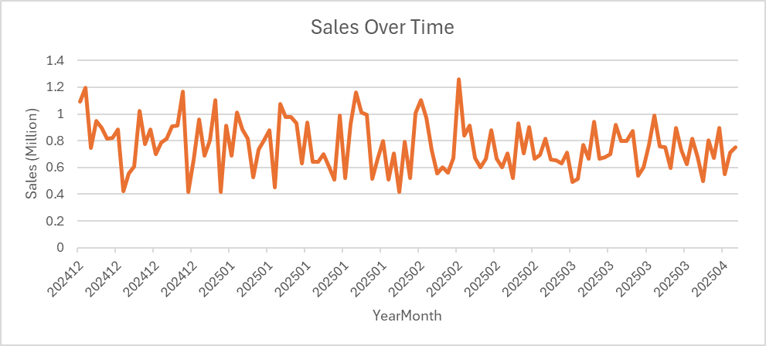

Fig-1 : Daily Revenue Trend

* Also analyzed sales by product category.

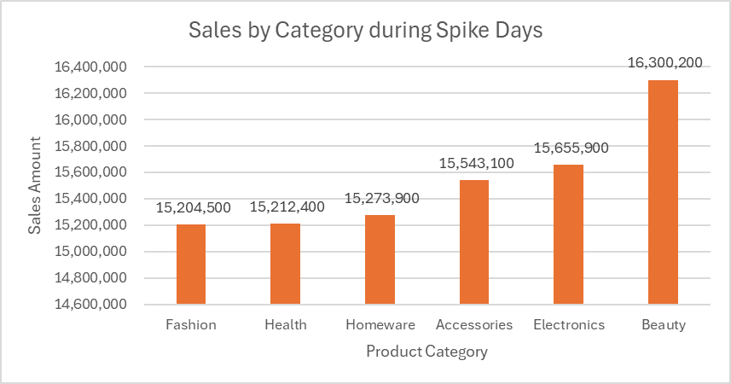Fig-2 : Revenue by Product Category

* Spike Sales Days Detected:
  + December 7, 2024
  + December 25, 2024 (Christmas Day)
  + January 26, 2025
  + February 14, 2025 (Valentine’s Day)

Fig-3 : Revenue by Product Category – Spike Days

* Top-Selling Category on Spike Days: Beauty.
* Insight: These spikes coincide with major holidays and promotional campaigns.

3.2 Customer Behavior and Product Category Insights

🛍 Contributors to Sales Spikes:

* High-spending customers were identified during spike days.
* Top Location: *Yangon* — customers from Yangon generated the highest total revenue (851,800 ).
* Top Product Categories on Key Dates:
  + Valentine’s Day: Beauty, Fashion, Homeware
  + Christmas Day: Health
  + December–January: Health, Beauty, Fashion



3.3 Shopping Pattern Analysis

🧾 Observed Behavior:

* Many customers are loyal to specific product categories, especially during promotions.
* A large portion of customers made only one purchase but spent significantly — suggesting planned or occasion-based shopping.
* Beauty is the most popular category among top spenders.
* Most of these customers spent over 80,000 MMK in a single order.

👥 Peak Customers Profile:

* Customers such as Nandar Johnson, Thiri Gray, and Nandar Rhodes showed either frequent shopping or high total spending.
* Most high spenders are female, aged 19 to 48, from cities such as Yangon, Pathein, and Mandalay.

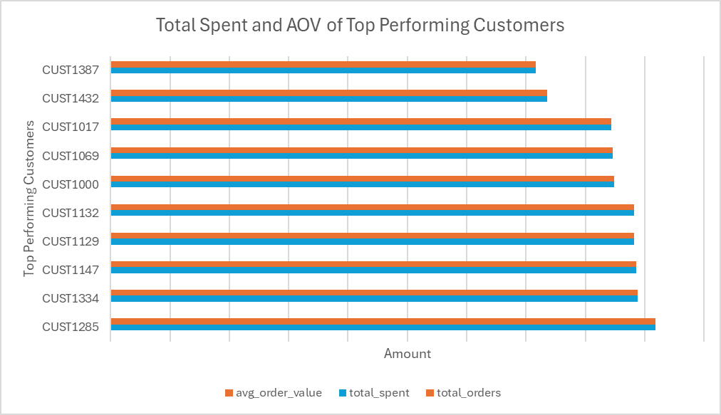

3.4 Hypothesis Testing

To determine whether customers spend significantly more on spike days compared to regular days, a two-sample t-test was conducted on the cleaned sales data. The test compared the average spending per order between spike and non-spike days.

Result:

* t-statistic: 1.90
* p-value: 0.0594

Since the p-value is slightly above the common significance level of 0.05, there is no statistically significant difference in spending between spike and non-spike days.  
This suggests that although sales volume increased on spike days, the average spend per order was not significantly different from other days.

🎯 Answering the Key Questions

1. Who’s behind these spikes?

* Frequent shoppers like Nandar Rhodes and Nandar Johnson drove up transaction counts.
* High spenders like Thiri Gray and Phyu Phyu Diaz contributed large revenue in single transactions.
* Common traits: Female, 19–48 years old, mostly from Yangon and Pathein.

2. What are their shopping patterns?

* Most customers shop only once, but spend significantly, especially around promotional events.
* Popular product categories are Beauty, Health, and Fashion.
* Spending appears intentional and seasonal, likely tied to gifting or personal care events.

3. Can we recreate the magic?

Yes! By analyzing top customer behavior, we can:

* Target similar profiles using age, location, and category preference
* Run holiday-based campaigns around Valentine’s Day, Christmas, and New Year
* Bundle and promote favorite categories like Beauty & Fashion
* Send personalized offers to re-engage past high spenders

🧠 Key Insight & Recommendation

🔍 Observed Pattern:

Customers tend to stick to specific categories during promotions and spend significantly on seasonal dates.

✅ Actionable Strategies:

* Use customer past purchase history to recommend related products.
* Offer category-based bundles during seasonal promotions.
* Utilize age and location data for targeted advertising campaigns.
* Launch personalized promotions based on favorite product categories.
* For events like Valentine’s Day or New Year, launch Beauty + Fashion bundles to drive conversion.