

**StudyBuddy**

a reliable source of information for every student

BY:

 Adryan, Martin, Raphael, Desislava, Sesil

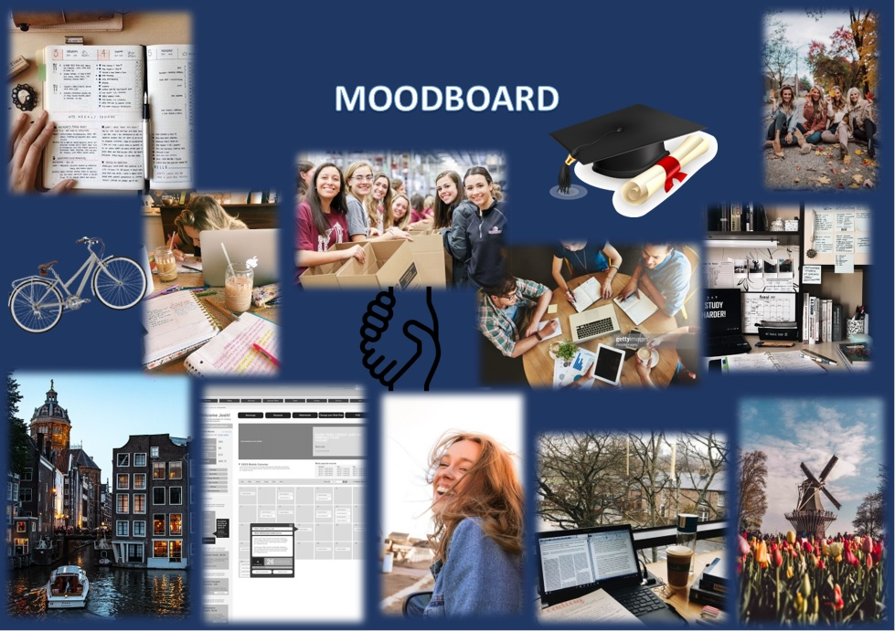

**StudyBuddy** is a tool that will benefit students especially international students. StudyBuddy consists of everything that a student would need from information regarding schoolwork, events, news, etc. What makes StudyBuddy different from other educational assistance is that our platform will consist of three sections: “Lifestyle”, “Events”, and “Contact Page”.

Description:

StudyBuddy consists of three sections. ***Section 1*** Lifestyle, will contain additional helpful information. We will provide information such as blogs, recipe books, checklists for both national and international students, and information regarding living in the Netherlands (what documents you must have, where and how to make a dutch bank account, registering for a BSN number, etc.)

***Section 2*** Events will contain options for the user to decide if he/she would like to host or to partake in an existing event. In addition, our users will be shown a map and calendar. In the map gatherings and events that are happening near the users, the area will be shown with its details such as what the event is about and which age group it is for, the calendar is an extra feature where you can mark a date for a chosen event then will be highlighted/marked, but it also shows other events besides the chosen event which will not be highlighted/marked.

***Section 3*** Contact Page is our communication section. This is where we have a nice feature of having a chat room that will allow users to contact other active students or teachers if they have questions regarding anything. Response time is fast and nobody will be left answerless.