Fontys Printers’ Website

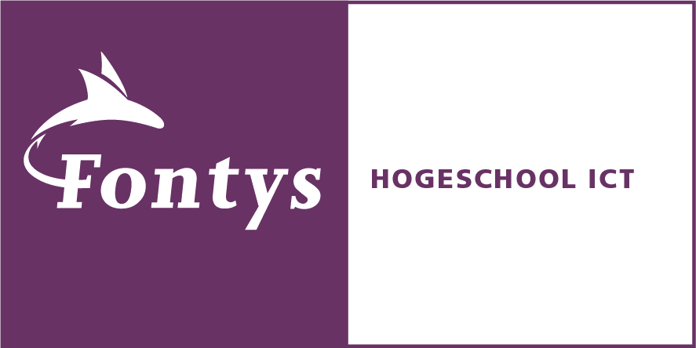

**Target users**

Our aim is to improve the Fontys website for printing; because of that, we focused on teachers and students being our target users. Since Fontys is an institution for education, we would expect our target users to have a more profound understanding in tech related matters. Our ideal target user is one that is in possession of a smartphone or a computer. We did our best to simplify the current website to broaden the range of possible users.

|  |  |
| --- | --- |
| **Student** | **Teacher** |
|  | Free Teacher Drawing, Download Free Clip Art, Free Clip Art on Clipart  Library |
| **Age:** 20  **Occupation:** Student  **City:** Eindhoven | **Age:** 36  **Occupation:** Teacher  **City:** Tilburg |
| **IT Skill Level:** Moderate | **IT Skill Level:** Advanced |
| **Goals & Motivations:** Get an internship at google, and create a start-up | **Goals & Motivations:** Promotion to director or creation of a teacher’s society |
| **Frequency of Printer Use:** Once a month | **Frequency of Printer Use:** Three times a week |
| **Problems Experienced:** Unaware of the upload option to print | **Problems Experienced:** A technical malfunction with the printer leading to said teacher needing to restart print job. |

**Sketches**

* By using sketching, we were able to come up with new ideas for the layout and navigation of the Fontys printing website. We then chose the best version to further develop prototyping.

|  |  |
| --- | --- |
|  |  |
|  |  |
|  |  |
|  |  |

**Wireframe**

* We chose to use wireframes to act as visual representations of our sketched ideas. Wireframes gave us a clear view of the layout without any undesired distractions such as colors and images. In turn, we were able to alter the position of certain elements, and come up with the design of navigation, side-tabs, and content.

|  |
| --- |
|  |
|  |

**Mock-up & Testing**

Our mock-up was created with Adobe Experience Design. It was created with an interactive navigation to allow us to perform A/B testing. The final prototype was exported to send to users for testing.

**Mock-up Link:**

[*https://xd.adobe.com/view/772cdc19-5997-43a7-a6eb-7f284c073003-227f/screen/5e8982e1-05a8-4d09-8437-a71a6bc81657?fullscreen&hints=off*](https://xd.adobe.com/view/772cdc19-5997-43a7-a6eb-7f284c073003-227f/screen/5e8982e1-05a8-4d09-8437-a71a6bc81657?fullscreen&hints=off)

Once we were in the testing stage of our prototyping process, we tested our product on 6 Fontys students. From our data gathered we were able to conclude that everyone preferred our newly designed website compared to the current one. It was said that our website is simpler and easier to use.

The tasks given to each participant:

1. Change the website’s language to English

2. Check the users’ balance

3. Top up users account balance

4. Upload files to the printer

5. Check the location of the printers

6. Check the formatting options

* Quick Note: Two mock-up versions of the website prototype were made. The difference between the two is the location of the language button. You can change between the 2 versions by clicking the *Canon* logo at the bottom right corner (This function only works on the top up page)

|  |
| --- |
|  |

**Analysis**

Here are some diagrams about the users’ performance during the tasks:

Most of the users (83%) prefer having the language button at the top right corner. According to the users “it was more comfortable and easier to find”.

All participants found it easy to check the balance, except for one. 4 of the students thought that it would be better if the balance indicator had its own row instead of being next to the username.

Despite our website being considered easier to navigate in comparison to the current website, 50% of the students still do not think that the formatting options are clear.

**Conclusion**

In conclusion, other than the issue regarding the formatting, there were not any other complaints about anything else. The other t The final prototype was exported to send to users for testing.asks were found to be challenge-free by the participants.

In addition to the tasks assigned to the participants, free time was also given to them to explore the website on their own. We are happy to inform you that the free time went smoothly as well.

Although our investigation was only held with 6 participants, we still found it to be beneficial to us and those at Fontys. It can be inferred that most students at Fontys would find our website to be better than the current except for the formatting issue that will be improved.