LAB NO. 7
CPU FUZZING
- Overview
  - Introduction to fuzzing
Fuzz testing or fuzzing is a testing technique, which consists of repeatedly running a program with automatically generated inputs that may be syntactically or semantically malformed. A fuzzer is a program which automatically injects semi-random data into a program and detects bugs. There are several ways to categorize a fuzzer:
- Generation-based or mutation-based: inputs are generated from scratch with grammar/input models or by modifying existing inputs.
- Unstructured or structured: a fuzzer can be dumb (unstructured) or smart (structured) based on whether it is aware of the input structure.
- White-, grey- or black-box: a fuzzer can be categorized based on the program structure information it is aware of.
  - Objective
In this lab, we will explore utilizing CPU fuzzing techniques to discover RTL (register transfer level) bugs in a pipelined RISC-V CPU, specifically a modified version of Pretty Secure Processor. You will implement a number of low-level CPU tasks in C and RISC-V assembly to build a CPU fuzzing engine.
Your code will run on the simulated CPU bare metal. That is, you have complete control of the hardware, and your code runs inside the CPU being tested. Your job is to write code that tests the hardware and reliably reports whether the hardware (which may have CPU bugs) is operating correctly or not.
At the end of the lab, you will use the CPU bugs you have discovered and the knowledge of return-oriented programming to build an end-to-end exploit on a Pretty Secure Processor.
  - Preparation
- OS: Ubuntu
- Tools:
- References:

- Getting started
  - Running your code
From the top of your directory, there are 2 scripts: run.sh and gdb.sh. To run a certain part, first cd into the selected part and compile it with make. Then return to the lab directory and run ./run.sh partX. Our Makefile will automatically build and link any extra files you create. You can create new C files with the .c extension and assembly source files with the .s extension. There is one restriction that you cannot create two files having the same name but one has .c and the other has .s extension, e.g., fuzz.c and fuzz.s. Note that for symbols to be exported from an assembly file they need to be marked .global.
To enable debug mode, first edit the debug.sh file and fill in SHD_DEBUG_PORT with the debug port. Then you can add --debug to the end of run.sh to start debug mode. You can now open a new terminal window and run gdb.sh. If the debug script does not work (missing riscv64-unknown-elf-gdb), you can use gdb-multiarch instead.
  - Additional concepts for Pretty Secure Processor
- Privilege level
There are 4 privilege levels in the RISC-V ISA, two of which will be used in our lab.
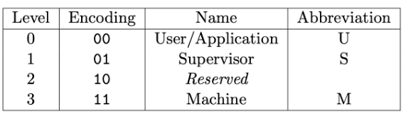
We will use the convention that level 0 (U mode) is userspace, and level 3 (M mode) is kernelspace. In this fuzzing lab, these privilege modes will be referred to as PSP_PRIV_USER and PSP_PRIV_MACHINE, respectively.
- Control and status registers (CSRs)
Control and Status Registers (CSRs for short) are special privileged CPU registers that configure how the CPU behaves. They can be read/ written with the csrr, csrw, and csrrw instructions while operating in M mode.
Instruction | Example | Usage
csrr- CSR Read | csrr x1, SOME_CSR | Read SOME_CSR into register x1.
csrw- CSR Write | csrw SOME_CSR, x1 | Write x1 into SOME_CSR.
csrrw- CSR Read and Write | csrrw x1, SOME_CSR, x2 | Read SOME_CSR into register x1 and simultaneously write x2 into SOME_CSR.

One of the most important CSRs is mepc (CSR address 0x341). When an exception occurs, the current PC of the faulting instruction will be written into mepc. mepc can be read by system software using the csrr instruction. Here is the list of CSRs you will find relevant to the lab:
Address | Name | Meaning
0x037 | utimer | Current Time (cycles)
0x200 | SOFTSERIAL_FLAGS_CSR | Returns whether data is available for reading on the serial port.
0x201 | SOFTSERIAL_IO_CSR_IN | Softserial data entering the CPU.
0x202 | SOFTSERIAL_IO_CSR_OUT | Softserial data leaving the CPU.
0x305 | mtvec | Machine Trap Vector Table Pointer
0x340 | mscratch | Scratch Register
0x341 | mepc | Exception Saved PC
0x342 | mcause | Exception Cause
0x399 | mpp | Previous Privilege Level
0xf14 | mhartid | Hardware Thread (core) ID

- Exception conditions
Whenever a RISC-V CPU encounters an exception condition (perhaps dividing by zero, a usermode program attempts to perform an illegal access, or an undefined instruction is executed), the CPU will execute a privilege transition into machine mode. The exception handler is the code in the kernel that is executed on an exception condition.
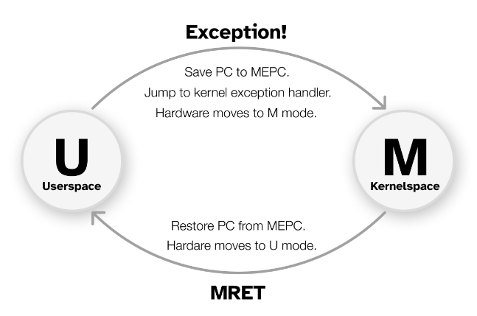
- Part 1: Mystery of the faulty CPU (1 point)
Congratulations! You landed your dream job as a CPU design engineer at the Pear Computer Company. Your manager has tasked you with using Pretty Secure Processor as the CPU for the next Pear Phone Pro.

You sent an early version of your phone out to the Maps test team so they could test the navigation algorithms. To your surprise, they reported that the new phone was producing different shortest paths than expected. The Maps team conducted a thorough review of their software, and found no possible errors – they have concluded it must be a hardware bug, and your manager agrees with them.
The Maps team provided the following example graph and expected output:
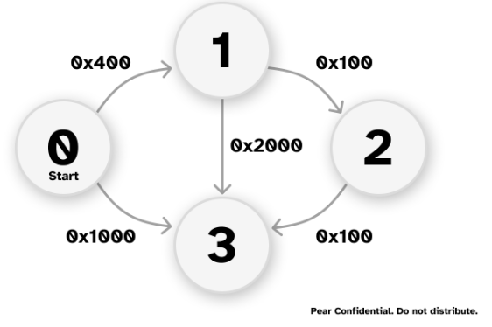
The expected output:
Distance of node 1=0x400
Path=1<-0
Distance of node 2=0x500
Path=2<-1<-0
Distance of node 3=0x600
Path=3<-2<-1<-0

The output from the faulty CPU:
Distance of node 1=0x400
Path=1<-0
Distance of node 2=0x500
Path=2<-1<-0
Distance of node 3=0x1000
Path=3<-0

The team used Dijkstra’s Algorithm to find the shortest path between the nodes. They have tracked the bug to happen at this line of code:
if(mindistance+cost[nextnode][i]<distance[i])
In this part, we will analyze the CPU to find out what is going wrong.
  - Getting familiar with the code base
cd into the part1 directory and build it with make. Run the code with ./run.sh part1 from the top directory, you should see the incorrect output as shown above.
Question 1: Open the part1 folder and answer the following questions
- Open bringup.s and read through the start method. What is the name of the C method that start jumps to when it finishes by running mret? Which CSR is used to hold that address?
- start specifies an exception handler by writing to CSR_MTVEC. What is the name of the handler? What file is it implemented in?
- linker.ld defines the memory map of the binary built by the build system. What section is the stack located in? How large is the stack?
- Open asm_offsets.h. This file is automatically generated when you compile the project. What is the offset of the mepc field of saved_regs_t? Where is saved_regs_t defined?
- Which register is used as the return address in the calling convention? Which register is used as the stack pointer?
- What privilege mode does the starter code run the CPU in, after mret in bringup.s?

  - Debugging the CPU
Let’s inspect the code from the Maps team to learn why the CPU is not finding the correct shortest path. Open dijkstra.c and navigate to line 55.
Question 2:
- Debug the CPU using the basic approach: using printf. Insert printf statements into dijkstra.c before line 55 to print the values of the operations performed by the if statement. Print all information relevant to the operation – that is, print the value of mindistance, cost[nextnode][i], their sum as computed by the CPU, and distance[i].
- Based on the printf result, record what are the inputs (e.g. values of mindistance and cost[nextnode][i]) that cause the addition instruction to return an incorrect sum? Does the operation fail for all inputs or just specific ones?

- Part 2: Fuzzing for faulty inputs (3 points)
Impressed with your ability to understand incorrect CPU behavior, your boss has assigned you a new task – to write a program that can automatically test a given CPU to see if the addition bug is present, and if so, return what inputs cause the sum to fail.
In the industry, we call such a program a regression test used to ensure that known bugs do not accidentally get reintroduced to the RTL before tapeout (when the CPU design is sent to the factory).
We assume a bug is a set of inputs a and b that, when added together, produces an output that is not equal to a+b, just like we saw with the faulty results running Dijkstra’s algorithm above. We assume that the order of operands does not matter (that is, if a+b fails, then b+a fails too). We limit the search space of operands to [0x100,0x1FF] for both a and b (that is, only consider values of a and b from 256 to 511 inclusive).
Your task is to check the addition operator for all operands in the search space and print out any operands that fail. Note that you cannot trust the CPU to perform the add instruction correctly (you can assume all other arithmetic instructions are bug-free).
Question 3:
- What is your approach for finding the operands that can trigger the bug with the add instruction? Briefly describe it.
- Navigate into the part2 folder and create two new files – fuzz.c and fuzz.h. Create a method void part2_fuzz_inputs() and modify shd.c to call your new method from shd_main. You also need to #include "fuzz.h" and define a function signature for your new method. Your method should analyze all possible sums for operands between 256 and 511 (inclusive). If it finds any inputs that fail to produce the correct sum, it should print the input pair and what the erroneous sum was. You can assume the range [0x0, 0xFF] is safe.
- Note: You can modify or create any source files you want. When using printf, use the printf in utils.h. You should use the following format specifier to print out failing operands: printf("0x%X+0x%X=0x%X,0x%X\n",a,b,a+b,expected) (where a and b are the buggy inputs, and expected is what they should have added up to). It is ok if the same inputs appear twice in swapped order (e.g. if you print both a,b,a+b,expected and b,a,b+a,expected).

- Part 3: Fuzzing for a hidden CPU backdoor (4.5 points)
Bad news! This morning, a news report came out describing in the wild cases of PearPhone kernels being compromised by a new strain of malware. This malware is somehow capable of elevating the CPU privilege level from PSP_PRIV_USER to PSP_PRIV_MACHINE, bypassing all OS restrictions. While the CPU design team believes this is impossible, your boss has a suspicion – that someone inserted a malicious backdoor into the CPU itself!
Whenever the CPU attempts to execute an undefined instruction, it is supposed to throw an exception with mcause set to EXCEPTION_CAUSE_INVALID_INST (see defines.h:51). Your boss believes the CPU backdoor is a single instruction encoded in an undefined region of the RISC-V ISA instruction encoding space that, when executed, does not throw an exception, but instead sneakily switches the privilege mode of the pipeline. An attacker who knows the encoding of this hidden instruction can use this to bypass the PearPhone OS security mechanisms.
In this part, you will write a hidden instruction fuzzer to search automatically for backdoors in the CPU that elevate your privilege level to machine mode. We will start with searching for undocumented instructions, and then study their behavior.
The following provides an overview of the intended approach for finding undocumented instructions:
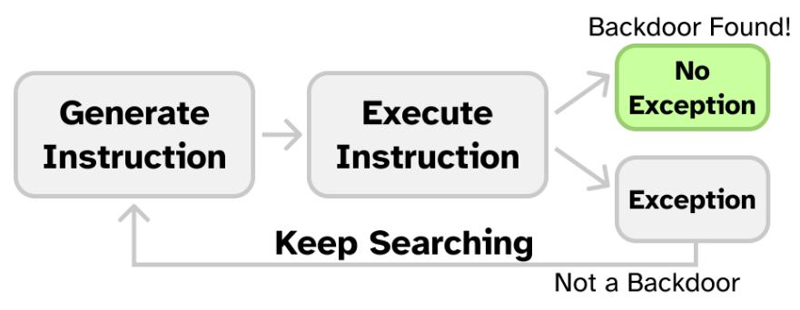
Whenever the CPU encounters an instruction it cannot execute, it will throw an invalid instruction exception. For every instruction in the search space, we attempt to execute it and watch for an exception. If any of them don’t generate an exception, we know that the CPU “understands” it as a valid opcode, and therefore it is a good candidate for being a CPU backdoor.
  - Writing an Exception Handler
Before we can search for undefined instructions, we need to be able to handle exceptions. For actually undefined instructions, trying to run them will cause the exception handler to run. For any backdoors, the exception handler will not be called (as the backdoor is decoded as a valid instruction).
Here is a description of a possible exception handler for you to implement. It saves all registers (x1-x31 and mepc, which holds the pc value of the faulting instruction), handles the exception logic (possibly changing the values of some of the saved registers), and then loads the new CPU state before finally executing mret.
Recall that you have found the file that should implement the exception handler in part1. Our implementation in the starter code only includes the first half of the exception handling that 1) creates space on the stack for a new saved_regs_t, 2) stores the registers into it, and 3) passes the address of this struct to exception.c. You can use our test method named exception_test() (defined in exception_test.s) to test your exception handler. The test method generates an illegal instruction exception and checks whether your exception handler is saving and restoring the CPU state correctly. Start by modifying shd_main to call exception_test(). You should see a line in the terminal telling you the exception handler in the starter code is incomplete.
Question 4: Read through the starter code in exception_entry.s. Your task is to implement the second half of the exception handler assembly in exception_entry.s, and fill in exception.c with any logic your code needs.
- First, remove the code that causes the handler to print TODO: You need to write the exception handler return code! and halt. Next, you should fill in the TODO’s in exception_entry.s to restore the saved state (the opposite of what the starter code does).
- Finally, fill in the TODO in exception_handler in exception.c (the C method called by the handler entry assembly) to properly handle the fault. If the exception cause was an illegal instruction, at minimum this means incrementing the saved mepc by one RISC-V instruction length to resume execution at the next assembly instruction after the undefined one. You will add more logic here in the later parts.
If implemented correctly, exception_test() should print Passed exception test!

Note: When working with assembly file, define your string at the end of the file. Otherwise, make sure your program is always 4 bytes aligned. (check!!!)
  - Searching for undocumented hidden instructions
Now that we can catch illegal instruction exceptions, it’s time to scan for backdoors. Your boss wants you to only consider the custom-0 subspace of the instruction encoding space. custom-0 has an opcode of 0001011, or 0x0B (See Table 24.1 in Volume I of the RISC-V ISA Specification on page 129). The CPU does not officially support any custom-0 instructions, so if you find one that doesn’t throw an illegal instruction exception, it is a hidden instruction!
Your boss said that while the opcode is probably custom-0, the decode stage of the pipeline is likely stealthily rejecting all instructions with this opcode whose upper immediate bits do not match some secret. You should treat this backdoor instruction as a U type RISC-V instruction, where the upper immediate bits (bits 31 to 12) are a secret, and the opcode is custom-0.
Recall the RISC-V 32I instruction encodings (Volume I Figure 2.2 on Page 16):
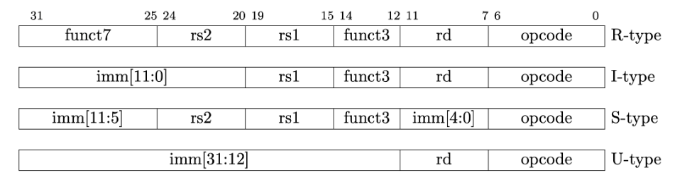
In this part, you will loop over all custom-0 instructions with different possible upper immediate bits. That is, you should generate all instructions where the opcode field (bits 6:0) is set to custom-0, and the upper bits (31:12) are set to a guessed secret value. You will execute each instruction, and then check if a CPU illegal instruction exception occurred. If it did not, you should print out the full encoding that caused no exception.
You can calculate a single instruction encoding with the following:
OP_CUSTOM0 = 0x0B # See Table 24.1 in Volume I of the ISA Spec.
def encode_instruction(secret):
return OP_CUSTOM0 | (secret << 12)

For this lab, only consider the cases where the upper immediate bits (secret value) are between 0 and 65535 inclusively.
You will need to test all possible instruction encodings in this region. If an instruction is invalid, it will trigger the execution of the invalid opcode exception handler. After executing the handler, we will return to the test code. If it is a hidden instruction, the code will just run through without executing the handler. Your key task to identify a hidden instruction will be to distinguish between the case when an exception has happened and the case when an exception has not happened. At a high level, you will need to figure out a way for the invalid opcode exception handler to communicate information to the test code. This can be done via setting flags in memory or in specific registers or many other ways. You can pick the one you like to implement. It is ok if your design decision causes your exception handler to fail exception_test as long as you are able to discover the backdoor opcode.
Note that a key challenge in this part is that you will need to test many instructions. You will not want to write the code manually. Possible solutions include generating the test code automatically with Python, or making use of self-modifying code. If you write automation scripts, make sure to include documentation of how they work in your report. (Only submitting a massive auto-generated assembly file is unacceptable).
For now, your test code runs with PSP_PRIV_MACHINE privileges (see bringup.s).
Question 5:
- Describe your design decisions for the exception handler. What does it do while trying to find the undocumented instruction? How does your exception handler communicate with the test code?
- Write a method that tries all 65536 possible custom-0 instructions, with the upper bits (bits 31 to 12) set to a value between [0,65535] inclusive. If it finds an instruction that does not throw an illegal instruction exception, it prints the opcode to serial with printf. If no instruction is found, it prints that it could not find any hidden instructions.

Note:
- Shared variables between C and asm: Recall that assembly symbols can be exported to C with the .global keyword. So, to create a variable that is shared between C and assembly, I can write the following in assembly:
.global shared_var
shared_var: .word 0x1234
And then in C refer to it with the extern keyword:
extern uint32_t shared_var;

- Emitting arbitrary instructions: You can emit an arbitrary encoding for an instruction with the .word keyword. For example, here is how to add the instruction encoded by 0x41414141 to the program:
some_asm_method:
add sp, sp, -4
.word 0x41414141
add sp, sp, 4

- Inline assembly: You may find the inline assembly gcc features to be useful.
- Recall that the CPU does have bugs with the add instruction, so be careful if your opcode enumeration code requires addition! If your approach makes use of self-modifying code, insert 5 nop instructions after your write instruction to flush the CPU pipeline. (If you try to write to an instruction and then immediately run it, a stale opcode may be in the pipeline.)

  - Elevating privileges to kernel mode
Congrats on finding a hidden instruction! Your boss, amazed at your skills, wants to see if you can figure out how to activate the backdoor. You may have noticed that even after running the backdoor, you still cannot access privileged CSRs from PSP_PRIV_USER (try it!). Attempting to load a privileged CSR when the core is booted in PSP_PRIV_USER should throw an EXCEPTION_CAUSE_ILLEGAL_ACCESS (mcause=0x00000001) exception, even if the backdoor instruction is run first.
So, why doesn’t the backdoor work?
It seems that the authors of the backdoor were even sneakier than we thought, and added another condition that must be satisfied before the backdoor instruction elevates your privileges.
Your boss took the CPU to a focused-ion beam (FIB) and found a wire connecting the decode stage to register x10 that wasn’t in the original design. Your boss suspects that x10 must be loaded with a secret value before the backdoor is called.
So far, your code has been running in PSP_PRIV_MACHINE. Before continuing, update bringup.s to start your code with PSP_PRIV_USER instead. This way, we can check to see if we gained any extra privileges by running the backdoor instruction.
Additionally, for this part you can hard-code the opcode you discovered in 5.2.
Question 6:
- Describe your approach for finding the correct x10 value.
- Write some code to try and load a privileged CSR and run it without running the backdoor instruction. You should see that the load succeeds if bringup.s starts your code in PSP_PRIV_MACHINE mode and throws an exception if it starts in PSP_PRIV_USER. Now, while running in PSP_PRIV_USER, add a call to the backdoor instruction before the CSR read. You should still see an exception being thrown, even if you ran the backdoor instruction. This is because the backdoor is not called with the correct value for x10, and so it does not change the privilege level.
- Modify your code to set x10 to values between [0,65535] inclusive before calling the backdoor. For each value in [0,65535], set x10 to the value, run the backdoor instruction discovered, and then try to load a CSR. If the CSR load succeeds, print the value of x10 out. If it fails, try another value of x10. You may need to modify your exception handler code to detect when CSR loads cause faults. When complete, your code should be able to start in PSP_PRIV_USER, call the backdoor with different x10 values until the CPU privilege level changes, and then read the contents of a privileged CSR.

Note: When a CSR load fails, the CPU throws a different kind of exception: EXCEPTION_CAUSE_ILLEGAL_ACCESS (0x00000001). You can use this to distinguish CSR load failures from illegal instruction exceptions.
  - Putting it All Together
Now we will combine your code to discover the hidden instructions. Your combined code should, in one go, search the undocumented instructions to find the backdoor instruction, fuzz the backdoor instruction for the correct x10 value, and the print both the correct opcode and x10 value to standard out.
Question 7:
- Combine your code from 5.2 and 5.3, print both the discovered opcode and x10 value to standard out.

- Part 4: Using the backdoor to exploit a system (1.5 points)
For this final part, you will combine all of the bugs you have discovered so far to exploit a Pretty Secure Processor hosting a C application running in unprivileged mode (PSP_PRIV_USER). This application is correctly written and suffers from no buffer overflow bugs during normal execution. However, the CPU suffers from the add bug as you have seen in the earlier parts of this lab. It also has the backdoor present which can be used to elevate your privileges to PSP_PRIV_MACHINE once code execution has been obtained.
The source code for this part is found in the part4 directory. We will begin by testing our exploit on a local CPU where we can run with PSP_PRIV_MACHINE privileges and use gdb for testing. First, we will manipulate the CPU to cause a buffer overflow by feeding it inputs that cause the add instruction to malfunction, bypassing the bounds check. Next, we will write some RISC-V assembly to dump a hidden secret from the CPU by reading from some special CSRs – this assembly is the code we want to run on the remote processor. Finally, we will implement a return to shellcode attack, storing the assembly we wrote in the input buffer and tricking the CPU into jumping to it by overwriting the saved return address.
This part will introduce you to several commonly used CTF tools. We will guide you through the process of using these tools to implement a software-hardware exploit on a remote server.
  - Getting started
First, cd into part4, build it with make and run it. You should see something like the following:
inputbuf is at 0x2CD4
How long is your first name: 7
How long is your last name: 5
Ok, tell me your first name: Justin
And your last name: Case
Your username is JustinCase

Play around with the inputs and get a feel for how the application works. Note that the length inputs require you to add 1 byte for the newline character. That is, if your name is Justin (6 chars), you would need to add a 7th character for the newline.
  - Redirecting control flow
Our primary objective for this part is to modify pc to point to an arbitrary address. We will accomplish this using a buffer overflow.
Open shd.c and take a look at the code. You should see the following bounds check:
if (fname_len + lname_len > sizeof(inputbuf)) {
printf("Error: Your name is too large!\n");
return;
}

This bounds check prevents the buffer from being overflown by normal inputs.
As we control both fname_len and lname_len, we can skip this bounds check by feeding in inputs that should fail the check, but instead pass (their sum is less than sizeof(inputbuf)) because of a bug in the add instruction. Revisit the bugs you found in Part 2 and pick a set of inputs that satisfy this condition and try them here. Can you bypass the name length check? (Try it in the terminal!)
Once you have found input lengths that bypass the bounds check, see if you can get the CPU to crash by feeding in a really long username. You should be able to achieve something like the following:
inputbuf is at 0x2CD4
How long is your first name: {REDACTED}
How long is your last name: {REDACTED}
Ok, tell me your first name: AAAAAAAAAAAAAAAAAAAAAAAAAAA
AAAAAAAAAAAAAAAAAAAAAAAAAAAAAAAAAAAAAAAAAAAAAAAAAAAAAAAA
AAAAAAAAAAAAAAAAAAAAAAAAAAAAAAAAAAAAAAAAAAAAAAAAAAAAAAAA
AAAAAAAAAAAAAAAAAAAAAAAAAAAAAAAAAAAAAAAAAAAAAAAAAAAAAAAA
...
AAAAAAAAAAAAAAAAAAAAAAAAAAAAAAAAAAA
And your last name: Your username is AAAAAAAAAAAAAAAAAAA
AAAAAAAAAAAAAAAAAAAAAAAAAAAAAAAAAAAAAAAAAAAAAAAAAAAAAAAA
AAAAAAAAAAAAAAAAAAAAAAAAAAAAAAAAAAAAAAAAAAAAAAAAAAAAAAAA
...
AAAAAAAAAAAAAAAAAAAAAAAAAAAAAAAAAAAAAAAAAAAAAAAA
=============================
Exception!
pc: 0x41414141
x1: 0x41414141 x2: 0x00002FF0 x3: 0x00000000 x4: 0x00000000
x5: 0x00000000 x6: 0x00000000 x7: 0x00000000 x8: 0x41414141
x9: 0x00000000 x10: 0x0000000A x11: 0x00002CD4 x12: 0x00000000
x13: 0x00000000 x14: 0x0000000A x15: 0x00000000 x16: 0x00000000
x17: 0x00000000 x18: 0x00000000 x19: 0x00000000 x20: 0x00000000
x21: 0x00000000 x22: 0x00000000 x23: 0x00000000 x24: 0x00000000
x25: 0x00000000 x26: 0x00000000 x27: 0x00000000 x28: 0x00000000
x29: 0x00000000 x30: 0x00000000 x31: 0x00000000
TODO: You need to write the exception handler return code!

Notice how we crashed with pc=0x41414141. 0x41 is the ASCII encoding for the character A. It means that our input somehow made its way into the pc register by overwriting the saved ra on the stack somewhere.
shd_main stores the return address on the stack, and restores it before exiting. Since we bypassed the buffer size check, our string was so large that it overwrote this value on the stack, meaning that when shd_main tried to return, it instead treated our input as an address and tried to jump to it.
Now open solve_part4.py. This is a Python script that uses the pwntools library to automate interacting with the processor. This script will allow us to easily send non-printable characters (like assembly bytes) into the CPU. We have filled in a starter skeleton for you to use to build your exploits. Feel free to write your exploit however you want, the starter skeleton is simply a guide.
We will use this script to automate overflowing the buffer and precisely redirecting code flow to our controlled data on the stack.
Note that while our earlier proof-of-concept (filling the buffer with AAAAAAA...) proved that we can gain control of pc, it did not tell us which part of our input eventually made its way into pc. That’s because every byte of our input is identical! (That is, we don’t know if it was the first A, one of the A’s in the middle, or the last A that made it into pc since they are all the same).
pwntools provides the method cyclic that allows us to fix this issue in a really efficient way. cyclic returns what’s called a de Bruijn sequence. The output of this is a series of unique 4 byte chunks that do not repeat (for a very long time, anyways). Give it a try:
>>> cyclic(100)
b'aaaabaaacaaadaaaeaaafaaagaaahaaaiaaajaaakaaalaaamaaanaaaoaaapaaaqaaaraaasaaataaauaaavaaawaaaxaaayaaa'

Generate a long username with cyclic and use that as your username. You should see a new crash pc value. This pc value will be the ASCII encoding of some unique part of the de Bruijn sequence. Since each 4 byte chunk is different, we now know exactly where in the input sequence pc is being read from.

For example pc could be 0x6161616F. Using this feedback, pwntools quickly allows you to look up the offset in the input string that controls pc with cyclic_find.
>>> cyclic_find(0x6161616F)
56
In this example, the offset 56 bytes into my overflow was what controlled pc.
Question 8:
- Open solve_part4.py. Fill in FIRSTNAME_LEN and LASTNAME_LEN with the inputs you found above. Fill in the argument to cyclic_find with the pc value you found using cyclic. This will fill in buf with enough A’s to stop right before what gets filled into pc.
- Now, the next 4 bytes input into buf will be put into pc when shd_main returns. These bytes must be packed as a 32-bit integer (little endian), which the p32 method will handle for you. Fill in some hex number into the p32 call, send the buf to the processor as the first and last names, and run the script – you should see a crash with pc set to that hex number.
- Once you can reliably use solve_part4.py to change pc to an arbitrary address, you are done with this part.

  - Dumping the flag
Now, we will write some assembly to read the flag from a sequence of CSRs. CSRs 0xFC0 to 0xFF0 contain a hidden secret flag that requires PSP_PRIV_MACHINE to read. The first ASCII char of the flag is stored in CSR 0xFC0, the next in 0xFC1, and so on.
Question 9:
- Create a new C or assembly file with a method that reads CSRs starting at 0xFC0 and ending at 0xFF0. If you are using assembly, don’t forget to mark your method as global with .global. For each CSR, write the value read to CSR 0x202 (the softserial output port) to display it in the terminal.
- To test your code, modify bringup.s to boot the CPU with PSP_PRIV_MACHINE, modify shd.c to call your method (add a call to it somewhere in shd_main), and run the processor. You should see an example flag printed out to the terminal.
- Once that is working, modify back bringup.s to boot the CPU with PSP_PRIV_USER. Your flag dumper should no longer work. Add a call to the backdoor instruction you discovered in Part 3 to your flag dump routine and try it again – the flag dumper should once again work.

Note: We recommend using assembly for this part. We also recommend automatically generating your assembly code with a Python script. Create a Python script called gen_dump_flag.py and fill it with print commands to output the assembly instructions you need to dump the flag.
Make sure to output a symbol and mark it as global so you can find it from C. (e.g. .global flag_dump and flag_dump: before your instructions).
  - Writing the exploit
We will now combine the primitives from 6.2 and 6.3. To recap, in 6.2 we discovered how to modify control flow (e.g., change the pc register) by causing a buffer overflow when the CPU miscomputes a bounds check with the buggy add instruction. In 6.3 we wrote some assembly code (called “shellcode”) that is able to elevate its own privileges using the CPU backdoor and dump the contents of some privileged CSRs to the console.
In this part, we will use the ability to control pc to cause the CPU to jump to our own input buffer (where the username field goes). We will fill that input buffer with the code 6.3 and send it to the CPU over serial. Then, we will use the buffer overflow to trick the CPU into jumping to the buffer, running the shellcode and granting us machine privileges.
The following figure provides an overview of this attack:
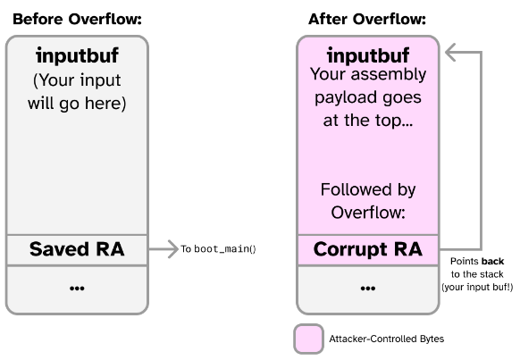
Question 10:
- Uncomment lines 24 and 25 in solve_part4.py. These lines read in a binary file called dump_flag.bin and write it into a variable called shellcode. dump_flag.bin should contain the binary values (the assembled bytes) of the code you wrote in 6.3.
- Set buf (the Python bytestring we send to the CPU) to begin with shellcode, followed by padding to make it the correct length, followed by p32(&inputbuf). This way, the CPU will attempt to execute starting at the first byte of inputbuf, which contains our shellcode variable (the flag dumper).
- Run solve_part4.py and you should see the flag printed to the console.

Note:
- You can use the following to convert the object file (.o) into a binary dump (.bin) to be used in the exploit. Assuming your assembly file containing the flag dump routine is called dump_flag.s:
make # Assemble the assembly file into a .o object
riscv64-unknown-elf-objcopy -O binary dump_flag.o dump_flag.bin # Dump the .o into a .bin

- Now, in Python, you can use the following to read your assembly code in as a bytestring:
shellcode_f=open('part4/dump_flag.bin', 'rb')
shellcode=shellcode_f.read()

