MODULE SERVER

Contents
This module has the following files:
- MODULE_SERVER.doc
- MODULE_SERVER_MEDIA.zip

Introduction
BAMRI ask you to make a minimum viable product for driver and bus scheduling system. Your task is to implement the backend with Laravel PHP Framework and interactive frontend with JavaScript to consume the backend API. The detail description and tools that you can use will be described below.

Description of project and tasks
API List:
Use provided ERD to make your database. Create dummy users on users table (password is hashed using bcrypt):
username | password
admin | passadmin
These are the list of web service endpoint that requested by the company:
- Authentication
  - Login
URL: [domain]/v1/auth/login
Description: For admin to generate and get login token using username and password. Username and password must be valid.
Method: POST
Request Parameter:
- Body:
  - Username
  - Password
Response:
- If login success:
Header: response status: 200
Body: { token } (authorization token generated by the system from logged in user id with bcrypt hashing method)
- If login failed (username or password do not match or empty):
Header: response status: 401
Body: { message: invalid login }
  - Logout
URL: [domain]/v1/auth/logout
Description: For server to make token invalid
Method: GET
Header: Authorization: Bearer {TOKEN}
Response:
- If logout success:
Header: response status: 200
Body: { message: logout success }
- If logout failed (token invalid):
Header: response status: 401
Body: { message: unauthorized user }

- Bus
  - Create new bus
URL: [domain]/v1/buses
Description: For admin to create new bus.
Method: POST
Header: Authorization: Bearer {TOKEN}
Request Parameter:
- Body:
  - Plate Number (string; required)
  - Brand (mercedes / fuso / scania; required)
  - Seat (integer; min:1; required)
  - Price Per Day (integer; min:100000; required)
Response:
- If success:
Header: response status: 200
Body: { message: create bus success }
- If input validation failed:
Header: response status: 422
Body: { message: invalid field }
- If accessed without token:
Header: response status: 403
Body: { message: forbidden }

  - Update bus
URL: [domain]/v1/buses/{bus_id}
Description: For admin to update existing bus by id.
Method: PUT
Header: Authorization: Bearer {TOKEN}
Request Parameter:
- Body:
  - Plate Number (string)
  - Brand (mercedes / fuso / scania)
  - Seat (integer; min:1)
  - Price Per Day (integer; min:100000)
Response:
- If success:
Header: response status: 200
Body: { message: update bus success }
- If input validation failed:
Header: response status: 422
Body: { message: invalid field }
- If accessed without token:
Header: response status: 403
Body: { message: forbidden }

  - Delete bus
URL: [domain]/v1/buses/{bus_id}
Description: For admin to delete existing branch by id
Method: DELETE
Header: Authorization: Bearer {TOKEN}
Response:
- If success:
Header: response status: 200
Body: { message: delete bus success }
- If accessed without token:
Header: response status: 403
Body: { message: forbidden }

  - Get all bus
URL: [domain]/v1/buses
Description: For admin to get all bus data
Method: GET
Header: Authorization: Bearer {TOKEN}
Response:
- If success:
Header: response status: 200
Body: all bus data in json { id, plate_number, brand, seat, price_per_day }
- If accessed without token:
Header: response status: 403
Body: { message: forbidden }

- Driver
  - Create new driver
URL: [domain]/v1/drivers
Description: For admin to create new driver.
Method: POST
Header: Authorization: Bearer {TOKEN}
Request Parameter:
- Body:
  - Name (string; required)
  - Age (integer; min:18; required)
  - ID Number (string; 16 character; required)
Response:
- If success:
Header: response status: 200
Body: { message: create driver success }
- If input validation failed:
Header: response status: 422
Body: { message: invalid field }
- If accessed without token:
Header: response status: 403
Body: { message: forbidden }

  - Update driver
URL: [domain]/v1/drivers/{driver_id}
Description: For admin to update existing studio by id.
Method: PUT
Header: Authorization: Bearer {TOKEN}
Request Parameter:
- Body:
  - Name (string)
  - Age (integer; min:18)
  - ID Number (string; 16 character)
Response:
- If success:
Header: response status: 200
Body: { message: update driver success }
- If input validation failed:
Header: response status: 422
Body: { message: invalid field }
- If accessed without token:
Header: response status: 403
Body: { message: forbidden }

  - Delete driver
URL: [domain]/v1/drivers/{driver_id}
Description: For admin to delete existing driver by id
Method: DELETE
Header: Authorization: Bearer {TOKEN}
Response:
- If success:
Header: response status: 200
Body: { message: delete driver success }
- If accessed without token:
Header: response status: 403
Body: { message: forbidden }

  - Get all driver
URL: [domain]/v1/drivers
Description: For admin to get all drivers data
Method: GET
Header: Authorization: Bearer {TOKEN}
Response:
- If success:
Header: response status: 200
Body: all driver data in json { id, name, age, id_number }
- If accessed without token:
Header: response status: 403
Body: { message: forbidden }

- Order
  - Create new order
URL: [domain]/v1/orders
Description: For admin to create new order. For each order, match available bus with available driver in the given date. Make sure that there is no conflicting order (one bus in 2 different dates). For example, if bus A and driver D is rented from 1 January 2018 for 5 days, both bus A and driver D cannot be ordered anymore until 5 January 2018 because it already rented from 1 January until 5 January.
Method: POST
Header: Authorization: Bearer {TOKEN}
Request Parameter:
- Body:
  - Contact Name (string; required)
  - Contact Phone (string; digits; required)
  - Start Rent Date (date; min:tomorrow; required)
  - Total Rent Days (integer; min:1; required)
Response:
- If success:
Header: response status: 200
Body: order data in json with relationship of bus and driver { id, contact_name, contact_phone, start_rent_date, total_rent_days, bus_id, driver_id, bus, driver }
- If input validation failed:
Header: response status: 422
Body: { message: invalid field }
- If order cannot be fulfilled because conflicting order or no available bus or driver:
Header: response status: 401
Body: { message: conflicting order or no available bus or driver }
- If accessed without token:
Header: response status: 403
Body: { message: forbidden }

  - Delete order
URL: [domain]/v1/orders/{order_id}
Description: For admin to delete existing order by id
Method: DELETE
Header: Authorization: Bearer {TOKEN}
Response:
- If success:
Header: response status: 200
Body: { message: delete order success }
- If accessed without token:
Header: response status: 403
Body: { message: forbidden }

  - Get all orders
URL: [domain]/v1/order
Description: For admin to get all orders data
Method: GET
Header: Authorization: Bearer {TOKEN}
Response:
- If success:
Header: response status: 200
Body: all order data in json with relationship of bus and driver { id, contact_name, contact_phone, start_rent_date, total_rent_days, bus_id, driver_id, bus, driver }
- If accessed without token:
Header: response status: 403
Body: { message: forbidden }

The complete BAMRI system should cover the following requirement:

Menu | Detail
Login | - The user can login (and logout) into the system on the start page of the application  - After login, user have access to “bus”, “driver”, and “order” menu  - Links to the authorized menu and logout link are always visible on the top part of the page while the user is logged in  - Make sure your system is preventing users to access unauthorized menu  - There must be no register feature available
Bus | - On “bus” menu, user can add new bus  - User can update and delete existing bus  - All input form is must be filled on create  - Plate Number must be a string  - Brand must be between mercedes / fuso / scania  - Seat must be integer and more or equals 1  - Price per day must be integer and more or equals 100.000
Driver | - On “driver” menu, user can add new driver  - User can update and delete existing driver  - All input form must be filled on create  - Name must be a string  - Age must be integer and more or equals 18  - ID Number must be a string and consists of 16 character
Order | - On “order” menu, user can add new order  - User can update and delete existing order  - All input form is must be filled on create  - Contact Name must be string  - Contact Phone must be string and digits  - Start Rent Date must be date and minimum date is tomorrow  - Total Rent Days must be integer and more or equals 1  - The system will match available bus with available driver.  - No bus and driver rent time can’t be overlap with other order.

ERD
You can use and improve ERD below:
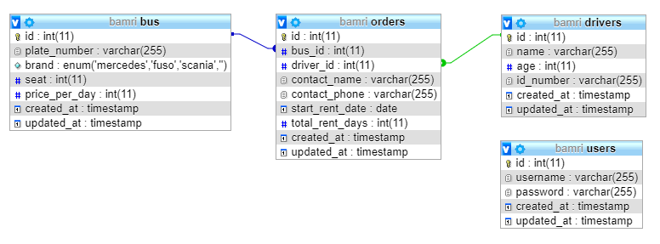

Instructions to the Competitor
- Save your files in your root directory on the server called "XX_MODULE_SERVER"
where XX is your computer number.

Create/generate a DB-diagram named “db-diagram.xxx” (xxx is the extension/type of the file eg. pdf or jpg) and put it into the directory mentioned above. Example:
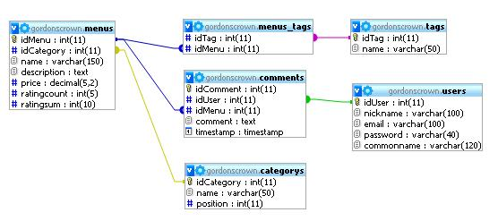

For this module, you must use one of the three available frameworks provided. Applications developed without use of any of these frameworks will not be considered. You should take advantage of the framework as much as possible.

Assessment will be done on the files and data in your database “MODULE_SERVER"

