1. **Copying CSV from Local to Cloudera**

hadoop fs -copyFromLocal Desktop/QualifData/location.csv /user/cloudera

hadoop fs -copyFromLocal Desktop/QualifData/product_category.csv /user/cloudera

1. **Creating External Table on Location**

CREATE EXTERNAL TABLE location(

id INT,

country VARCHAR(100),

region VARCHAR(100),

city VARCHAR(100)

)

ROW FORMAT DELIMITED

FIELDS TERMINATED BY ','

1. **Load the data CSV on the table we make on number 2**

LOAD DATA INPATH '/user/cloudera/location.csv' INTO TABLE bluejack_store.location

1. **Same as number two create a external table for product_category**

CREATE EXTERNAL TABLE product_category(

id INT,

product_category_name VARCHAR(100)

)

ROW FORMAT DELIMITED

FIELDS TERMINATED BY ','

1. **Load the data CSV on the table we make on number 4**

LOAD DATA INPATH '/user/cloudera/product_category.csv' INTO TABLE bluejack_store.product_category

1. **Open mysql on terminal and import insert.sql to local database mysql**

Source Data/insert.sql

1. **Import the sql to the cloudera (HIVE / IMPALA) Database**

sudo sqoop import-all-tables --connect jdbc:mysql://quickstart:3306/bluejack_store --username=root -P --hive-import --hive-database=bluejack_store

* 1. **Show the most profitable product category in 2019.**

select distinct pc.product_category_name

from product_category pc,

(

select p.product_category_id, SUM((p.product_price * (1 - p.discount)) * if(sd.is_cancelled is NULL, sd.quantity, 0)) as total

from products p

join sales_detail sd on p.product_id = sd.product_id

join sales s on s.sales_id = sd.sales_id

where YEAR(s.sales_date) = 2019

group by p.product_category_id

order by total desc

limit 1

) as x

where pc.id = x.product_category_id

**b. Show location which transaction happens the most last year.**

select

l.country as Country,

l.region as Region,

l.city as City,

count(s.sales_id) as Total Sales

from

`location` l

join

sales s on l.id = s.location_id

where

year(s.sales_date) in (

select max(year(s2.sales_date))

from sales s2

)

group by country, region, city

order by total desc

limit 1

**c. Show the most profitable product by calculating its revenue. When there is a discount cut the product price by discount. Show data with profit more than 15.000.000.**

select p.product_name

from products p,

(

select p.product_id, SUM((p.product_price * (1 - p.discount)) * if(sd.is_cancelled is NULL, sd.quantity, 0)) as total

from products p

join sales_detail sd on p.product_id = sd.product_id

group by p.product_id

having total > 15000000

order by total desc

) as x

where p.product_id = x.product_id

**d. Show customer who handled transactions more than the average of the total transactions by each customer.**

select c.customer_name, count(s.sales_id) as customerTransaction from customer c join sales s on c.customer_id = s.customer_id,

(select avg(x.customerTransaction) as avgTotalTransactionEachCustomer from

(select count(s.sales_id) as customerTransaction from customer c join sales s on c.customer_id = s.customer_id group by c.customer_id) as x

)a

group by c.customer_name, c.customer_id, a.avgTotalTransactionEachCustomer

having customerTransaction > a.avgTotalTransactionEachCustomer

e**. Show customers spending for last Christmas (December 2019). All customer who spends more than 10.000.000 will get a voucher for the next transaction with terms and condition as below**

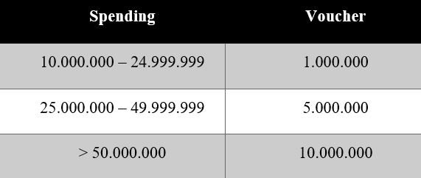

select

c.customer_name,

total,

case

when x.total >= 10000000 and x.total <= 24999999 then "1.000.000"

when x.total >= 25000000 and x.total <= 49999999 then "5.000.000"

when x.total >= 50000000 then "10.000.000"

else "0"

end as Voucher

from

customer c, (

select s.customer_id,

SUM((p.product_price * (1 - p.discount)) * if(sd.is_cancelled is NULL, sd.quantity, 0)) as total

from products p

join sales_detail sd on p.product_id = sd.product_id

join sales s on s.sales_id = sd.sales_id

where YEAR(s.sales_date) = 2019

and month(s.sales_date) = 12

group by s.customer_id

) as x

where c.customer_id = x.customer_id