|  |  |
| --- | --- |
| **Project Case** |  |
| ISYS6200  Data Warehouse |
| **Information Systems** | **O192-ISYS6200-IE01-00** |
| ***Valid on*** *Odd Semester Year 2018/2019* | **Revision 00** |

1. Seluruh kelompok tidak diperkenankan untuk:

*The whole group is not allowed to:*

* + - Melihat sebagian atau seluruh proyek kelompok lain,

*Seeing a part or the whole project from other groups*

* + - Menyadur sebagian maupun seluruh proyek dari buku,

*Adapted a part or the whole project from the book*

* + - Mendownload sebagian maupun seluruh proyek dari internet,

*Downloading a part or the whole project from the internet,*

* + - Mengerjakan soal yang tidak sesuai dengan tema yang ada di soal proyek,

*Working with another theme which is not in accordance with the existing theme in the matter of the project,*

* + - Melakukan tindakan kecurangan lainnya,

*Committing other dishonest actions,*

* + - Secara sengaja maupun tidak sengaja melakukan segala tindakan kelalaian yang menyebabkan hasil karyanya berhasil dicontek oleh orang lain / kelompok lain.

*Accidentally or intentionally conduct any failure action that cause the results of the project was copied by someone else / other groups.*

1. Jika kelompok terbukti melakukan tindakan seperti yang dijelaskan butir 1 di atas, maka **nilai kelompok** yang melakukan kecurangan (menyontek maupun dicontek) akan di – **NOL** – kan.

*If the group is proved to the actions described in point 1 above, the score of the group which committed dishonest acts (cheating or being cheated) will be “Zero”*

1. Perhatikan jadwal pengumpulan proyek, segala jenis pengumpulan proyek di luar jadwal tidak dilayani.

*Pay attention to the submission schedule for the project, all kinds of submission outside the project schedule will not be accepted*

1. Jangan lupa untuk melihat kriteria penilaian proyek yang ditempel di papan pengumuman, atau tanya asisten anda.

*Don’t forget to look at the project assessment criteria that posted on the announcement board, or ask your teaching assistant.*

1. Persentase penilaiaan untuk matakuliah ini adalah sebagai berikut:

*Marking percentage for this subject is described as follows:*

|  |  |  |
| --- | --- | --- |
| **Tugas Mandiri**  *Assignment* | **Proyek**  *Project* | **UAP**  *Final Exam* |
| 30% | 40% | 30% |

1. Software yang digunakan pada matakuliah ini adalah sebagai berikut:

*Software will be used in this subject are described as follows:*

|  |
| --- |
| **Software**  *Software* |
| Text Editor (Notepad / Notepad++ / Textpad / Sublime Text)  Microsoft SQL Server Enterprise 2016  Visual Studio Business Intelligence 2015  Microsoft Office Excel 2010  Microsoft Office Word 2010 |

## Ekstensi file yang harus disertakan dalam pengumpulan tugas mandiri dan proyek untuk matakuliah ini adalah sebagai berikut:

*File extensions should be included in assignment and project collection for this subject are described as follows:*

|  |  |  |
| --- | --- | --- |
| **Tugas Mandiri**  *Assignment* | **Proyek**  *Project* | **UAP**  *Final Exam* |
| TXT, BAK, SQL, DOCX, Folder Project (SLN, ispac, params, DTSX, DSV, DS, USER, DTPROJ, DATABASE, DIM, XML) | TXT, XLSX, BAK, SQL, DOCX, Folder Project (SLN, ispac, params, SUO, DTSX, DSV, DS, USER, DTPROJ, DATABASE, DIM, CUBE, PARTITIONS, DWPROJ, XML, ASDATABASE, CONFIGSETTING, DEPLOYMENTOPTIONS, DEPLOYMENTTARGETS) | TXT, SQL, BAK, XLSX, DOCX, Folder Project (SLN, ispac, params, SUO, DTSX, DSV, DS, USER, DTPROJ, DATABASE, DIM, CUBE, PARTITIONS, DWPROJ, XML, ASDATABASE, CONFIGSETTING, DEPLOYMENTOPTIONS, DEPLOYMENTTARGETS) |

## Soal

*Case*

**HospitalIE**

**HospitalIE** is a hospital that located in Jakarta, Indonesia. **HospitalIE** has many doctors and staffs who help serve customers. To improve the customer’s experience and efficiency of transactions, **HospitalIE** needs a database system that can analyze the operational data for decision making. Therefore, you as **HospitalIE** database administrator are asked to implement data warehousing in the shop using **Microsoft SQL Server 2016.**

After doing an interview with the CEO of **HospitalIE**, you gain lots of information. Here is the requirement obtained from the interview:

* Report for **sales transaction**, i.e. **total sales earning** and **total medicine sold**. The total sales earning is acquired from **total** of **multiplication** between the **quantity of medicine sold** and the **selling price**.
* Report for **purchase transaction**, i.e. **total purchase cost** and **total medicine purchased**. The total purchase cost is acquired from **total** of **multiplication** between the **quantity of medicine purchased**  and the **buying price**.
* Report for **subscription transaction**, i.e. **total subscription earning** and the **subscriber count**. The total subscription earning is acquired from **total** of the **benefit price**.
* Report for **service transaction**, i.e. **total service earning** and the **number of doctor**. The total service earning is acquired from **total** of **multiplication** between the **quantity of purchased treatment** and **treatment price**.
* **HospitalIE**’**s** CEO wants to see the report **monthly**, **quarterly**, and **annually.** Furthermore, the CEO wants an **ad-hoc report**,which can be generated anytime as well.
* The report must be able to be viewed in terms of **medicine**, **doctor**, **staff**, **customer**, **benefit, treatment,** and **distributor**
* For **medicine dimension** requested as follows
  + CEO needs data for make decisions about selling profit.
  + CEO needs data to analyze expenses needed to buy medicine.
  + CEO needs data to analyze how long the medicine can be stored in the hospital.
* For **doctor dimension** requested as follows
  + CEO needs data to analyze which doctor should be retired to decide how many doctors that needed to be hired in the future.
  + CEO needs data to analyze the doctor performance and their salary to decide whether the doctor is eligible for raise.
  + CEO needs data to analyze the location which has the most number of doctors to decide the location of the new branch.
* For **staff dimension** requested as follows
  + CEO needs data to analyze which staff should be retired to decide how many staffs that needed to be hired in the future.
  + CEO needs data to analyze the staff performance and their salary to decide whether the staff is eligible for raise.
  + CEO needs data to analyze the location which has the most number of staffs to decide the location of the new branch.
* For **customer dimension** requested as follows
  + CEO needs data to analyze the location which has the most number of customers to decide the location of the new branch.
  + CEO needs data to analyze which treatment that are frequently bought by the customer based on the gender to decide what kind of promo that will be issued.
* For **benefit dimension** requested as follows
  + CEO needs data to analyze the benefit that most preferred by customer and its current price to decide the price of benefit in the future.
* For **tratment dimension** requested as follows
  + CEO needs data for make decisions about selling profit.
* For **distributor dimension** requested as follows
  + CEO needs data to analyze the location which has the most number of distributors to decide the location of the new branch.
  + CEO needs data to analyze the provider of telecommunication that has the greatest number of distributors for the purpose of establishing cooperation with the provider company.

**Notes:**

* The **sales transaction** report must be able to be viewed in terms of **medicine**, **staff**,and **customer**.
* The **purchase transaction** report must be able to be viewed in terms of **medicine**, **staff**,and **distributor**.
* The **subscription transaction** report must be able to be viewed in terms of **customer**, **staff** and **benefit**.
* The **service transaction** report must be able to be viewed in terms of **customer**, **treatment** and **doctor**.
* All **master** tables, e.g. **staff**, **medicine**, **city**, **customer**, **doctor**, **treatment**, and **staff** must have at least a 1,000 data and some of the **master** table are adjusted with the given data below.
* All **header transactions** must have at least 10,000 data, meanwhile **detail transactions** are 25,000.
* **Customer** **gender** have **Male** or **Female** as its value with a varchar data type of transaction data, and will be replaced with a **M** for **Male**, otherwise is **F** on analytical data**.**
* **Customer address**,**distributor address**, **distributor phone, doctor address,** and **staff address**, can be updated and old data don’t have to be stored.
* **Doctor salary, benefit price, staff salary,** and **treatment price** can be updated, but old data must be kept.

**Instruction**

According to OLTP table and information that you gained, here are your tasks:

**Use NotePad or TextPad**

* 1. Determine the measure and the aggregate function that is used for the measure according to the requirement!
  2. Determine the dimension and the fact!
  3. Determine the attribute or field for each dimension and fact table!

**Use SQL Server Management Studio**

* 1. Create and design OLAP table based on your analysis!

**Use Microsoft SQL Server Business Intelligence Development Studio**

* 1. Create Extract, Transform and Load process for each dimension and fact table!
  2. Create Cube!

**Use Microsoft Excel**

* 1. Create Pivot table to present the information!

**Use Microsoft Word**

* 1. Document the design of the scheme and how to generate DTS fact, DTS dimension, cube, and pivot!

**HospittalIE OLTP Database Design**

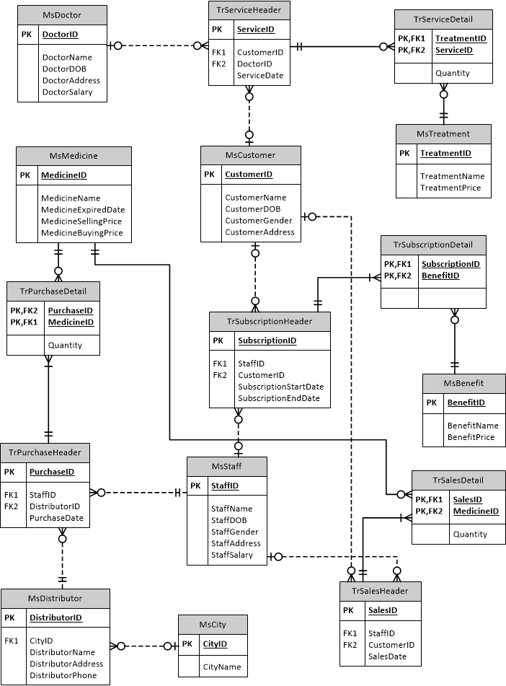

Here are the rules that you must follow to create your project:

1. Use appropriate software for this subject based on **Sistem Praktikum** that can be downloaded from Binusmaya.
2. Use the techniques taught during practicum, such as: measure, dimension, fact, DTS fact, DTS dimension, cube, pivot, data source, slowly changing, derived column, attribute column (such as: historycal, changing, or fixed), data destination, star schema, etc.
3. Collect appropriate files for this subject based on **Sistem Praktikum** that can be downloaded from Binusmaya.
4. Include the other files that can support your project, such as:
   * All files in your project
   * Other files (image, audio, video, etc.) used in your project
   * *.DOC file (documentation of your project) that contains all pages in your project, reference links of additional files (image, audio, video, etc.) used in your project, the description about how to use your application, etc
5. If there are some hidden creativities, please note them in the existing documentation because they can greatly affect your project score

**If you do not understand**, **please ask your assistant!**