**Data Warehouse Documentation   
JT – Justine Winata**

1. Analysist the ingredients we need from the question. (analysis.txt)
2. Determine and choose the measurement for the fact and dimension
3. Export OLTP Database
4. Create new OLAP Database named `OLAP_HospitallE `
5. Create all dimension table and fact table at `OLAP_HospitallE` (query_make_table.sql)
6. Open visual studio, then create new project based on `Integration Services Project` templates.

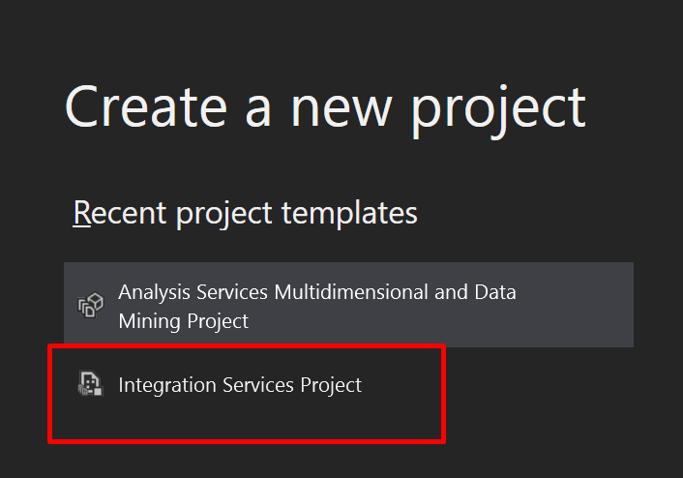

1. Create Connection Manager, Right Click and choose `New Connection Manager`

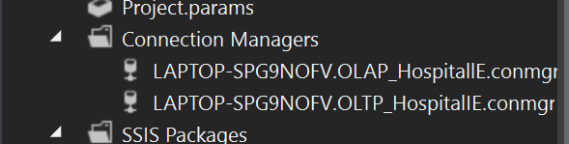

1. Choose OLEDB and select the database that we make before

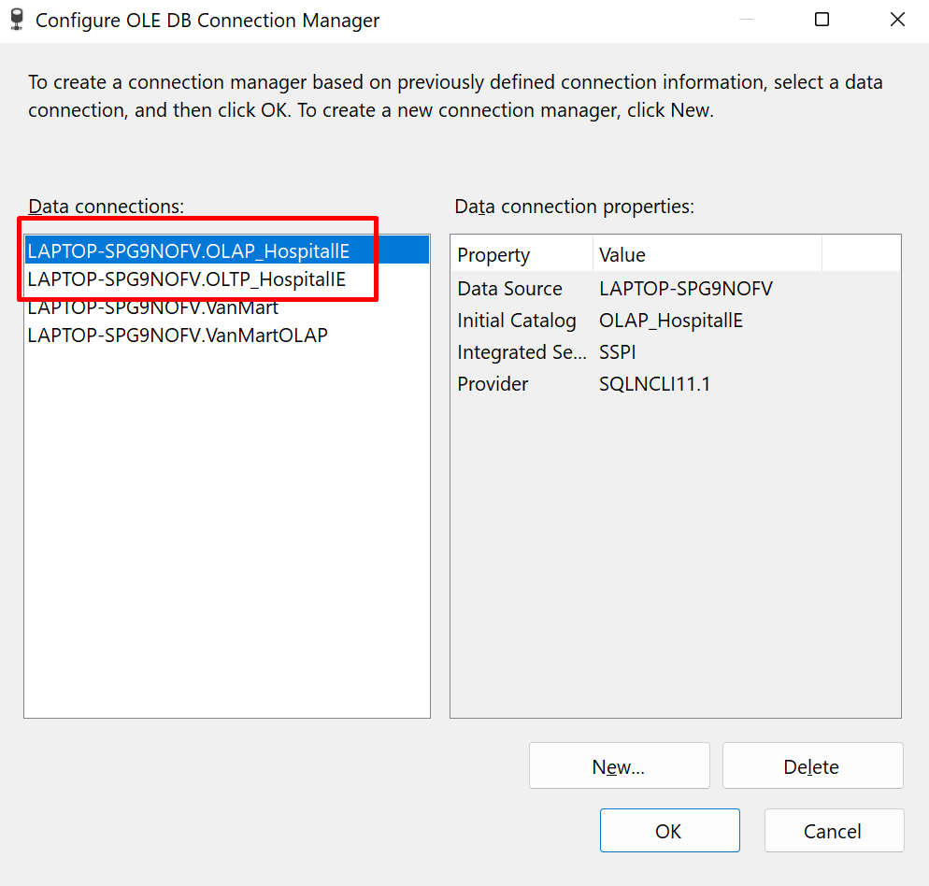

1. Create all the dimension model at SSIS Package

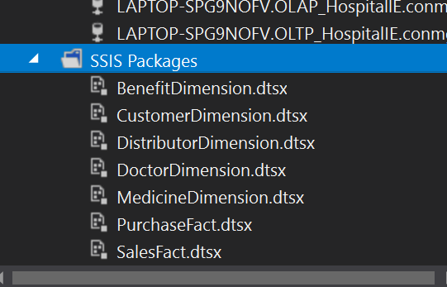

1. Choose the data flow and make the OLE DB Source

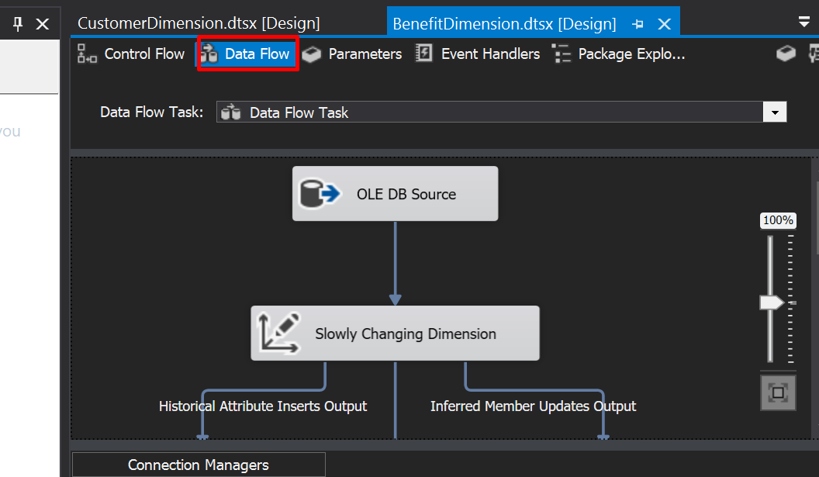

1. Choose the query from we analysis before and the data from OLTP

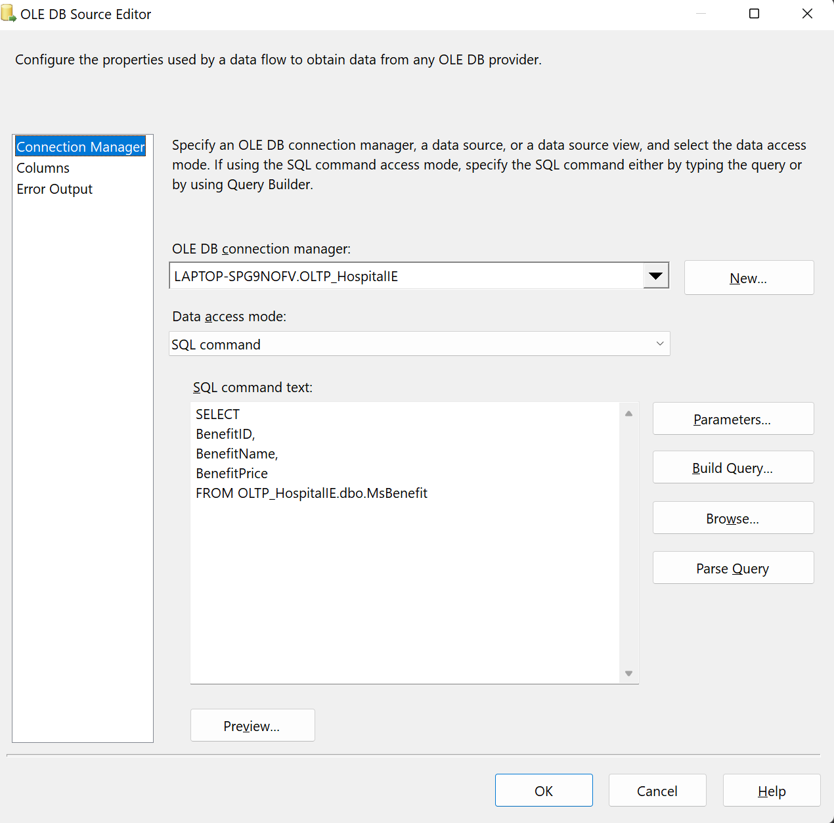

1. Then we need to make ` Slowly Changing Dimension` to put the data of OLTP to OLAP

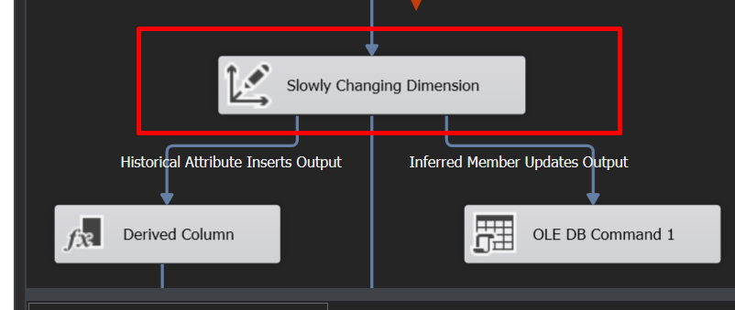

1. Choose the OLAP database and change ID to Business Key

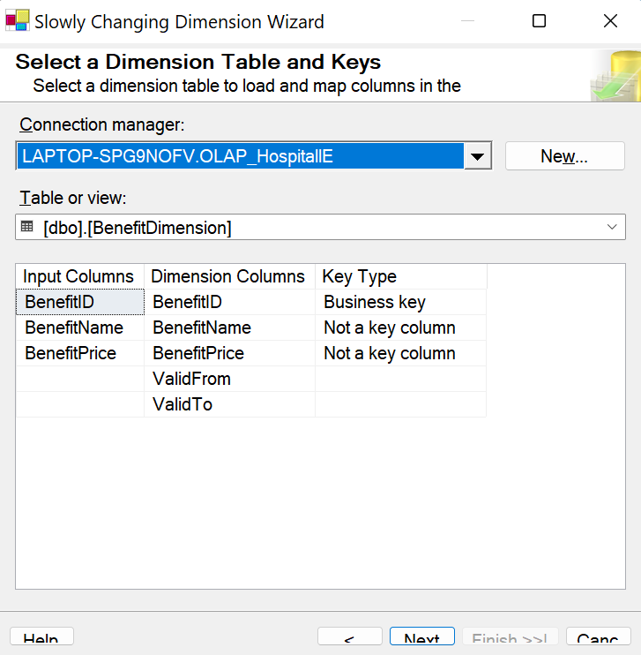

1. Change the type of column based on we analysis

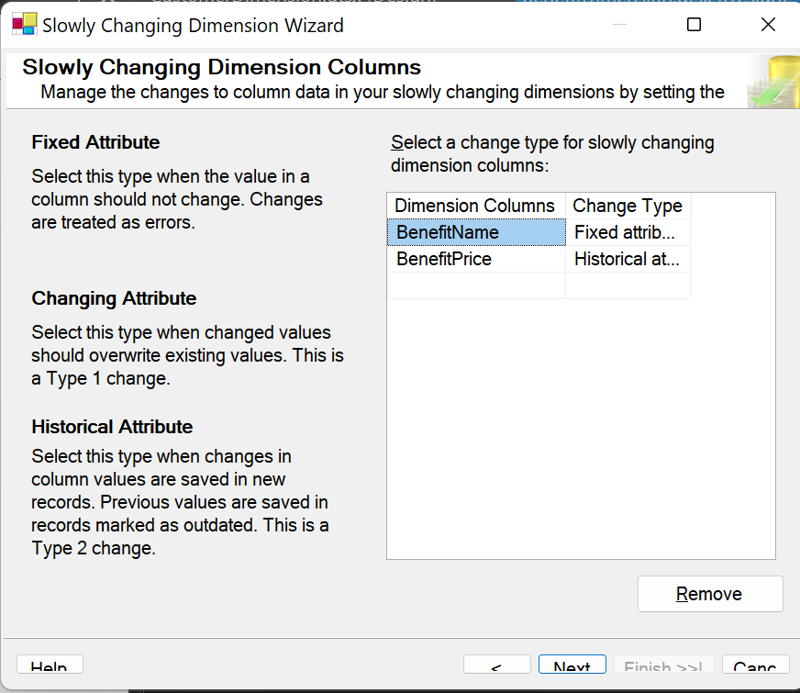

1. If you choose historical, then change the historical attribute to valid from, valid to and System::StartTime

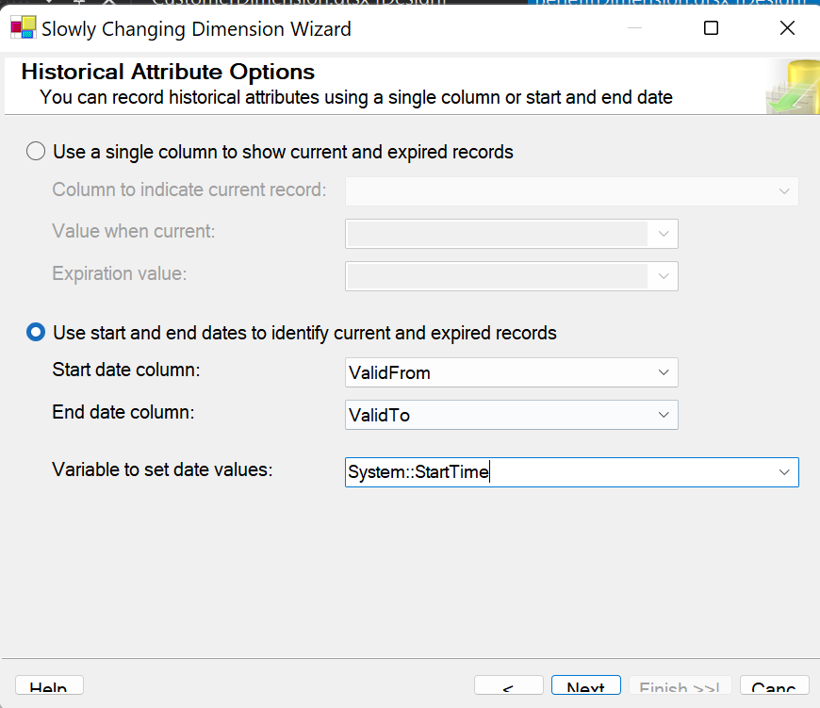

1. For time dimension create query to get the data (time_dimension.sql)
2. Then get to the Control Flow for creating SQL After Task

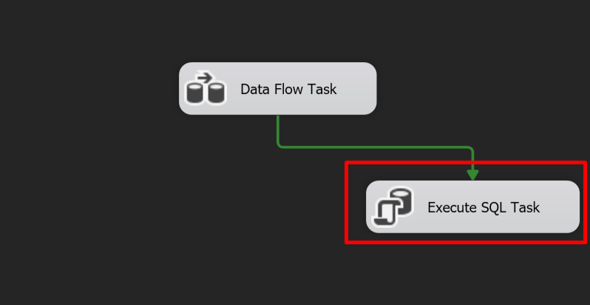

1. Then add the query for create or update the current time, so the data can’t be rendundant

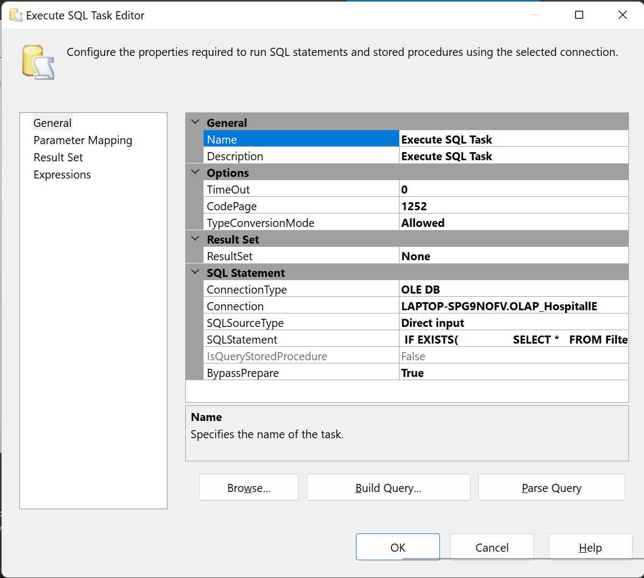

1. After that save the file and create another visual studio project with `Analysis Services Multidimensional and Data Mining Project`

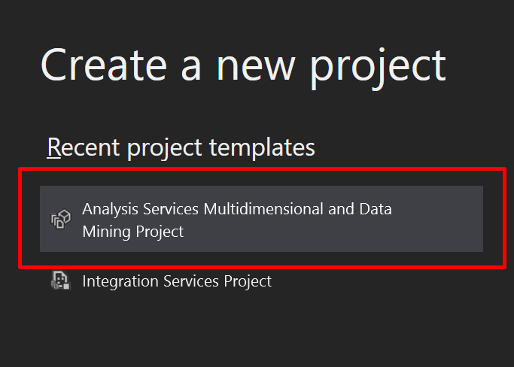

1. Create the data connection from our sql

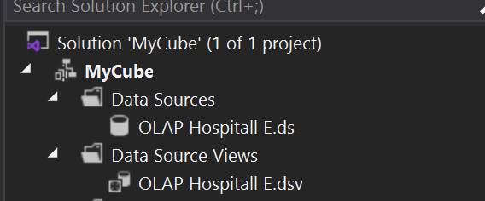

1. Then create a cube for the fact. REMEMBER When creating the cube its must depends on each fact **NOT ALL FACT**.

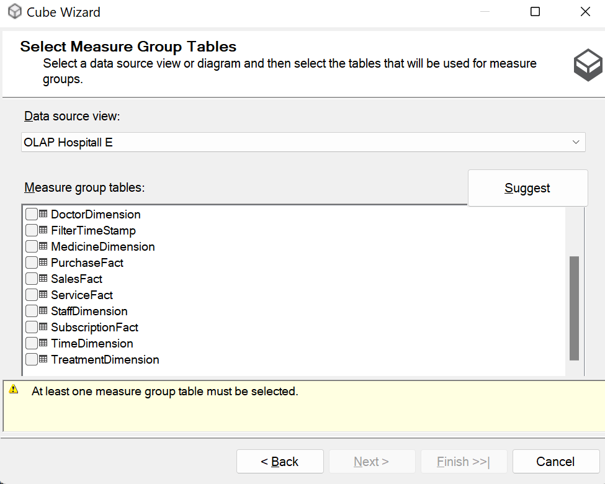

1. Don’t forget to set the dimension to get all the attributes

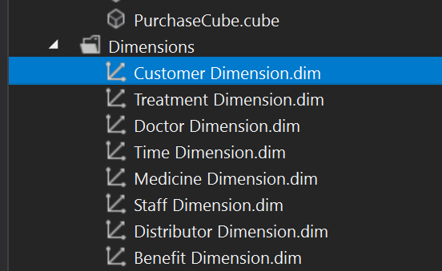

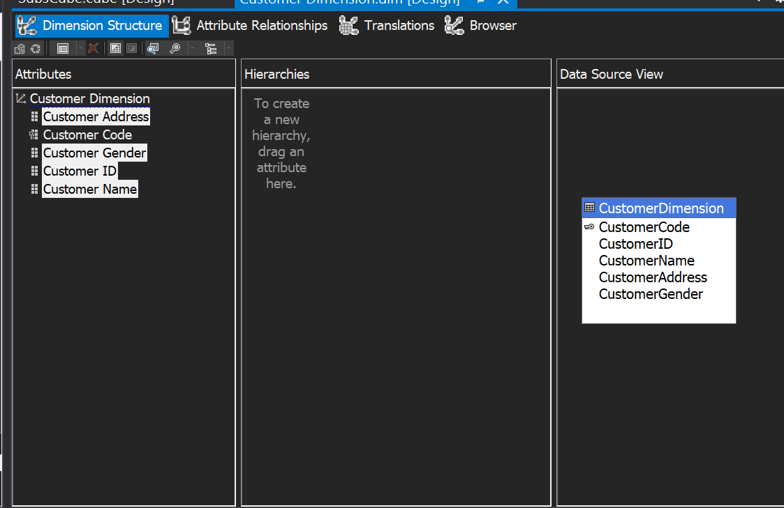

1. Then run the cube

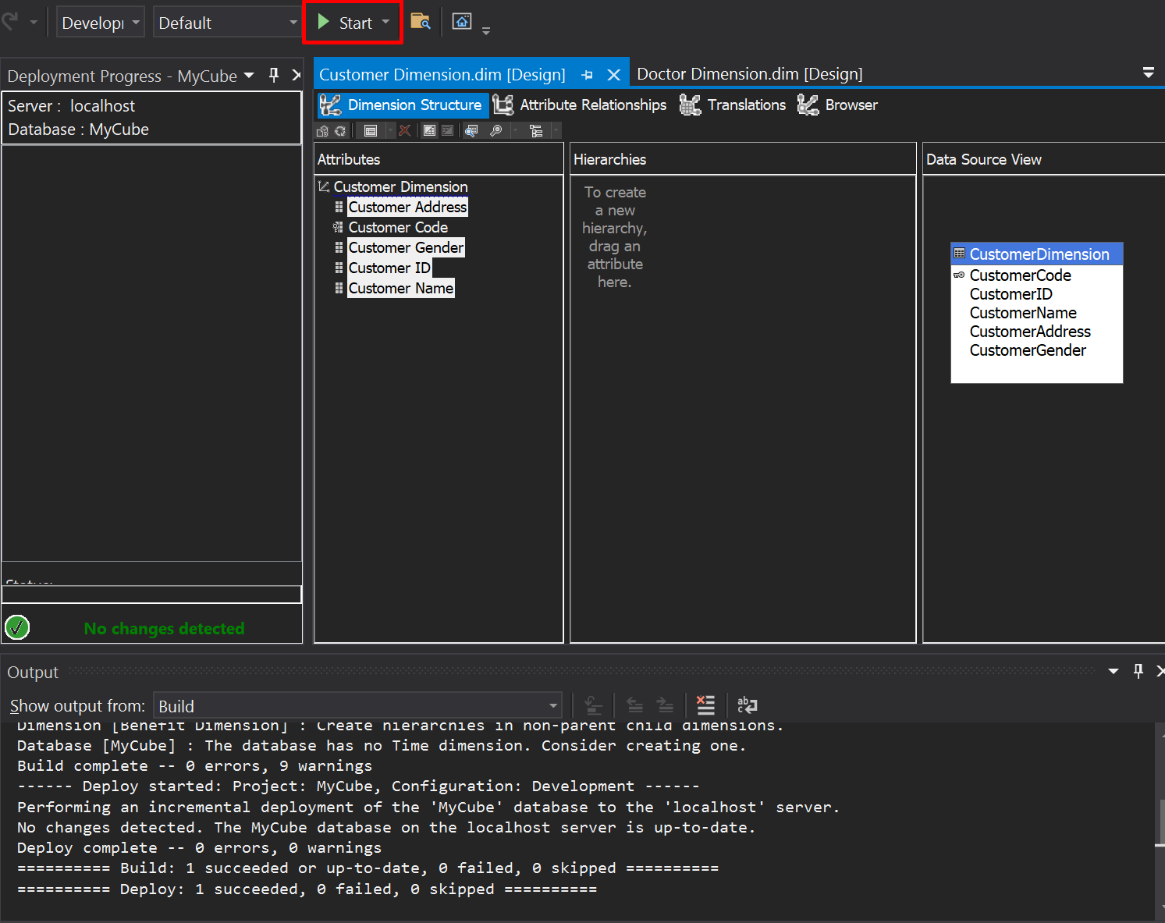

1. If succeed they will have a popup and you can get the result data from there

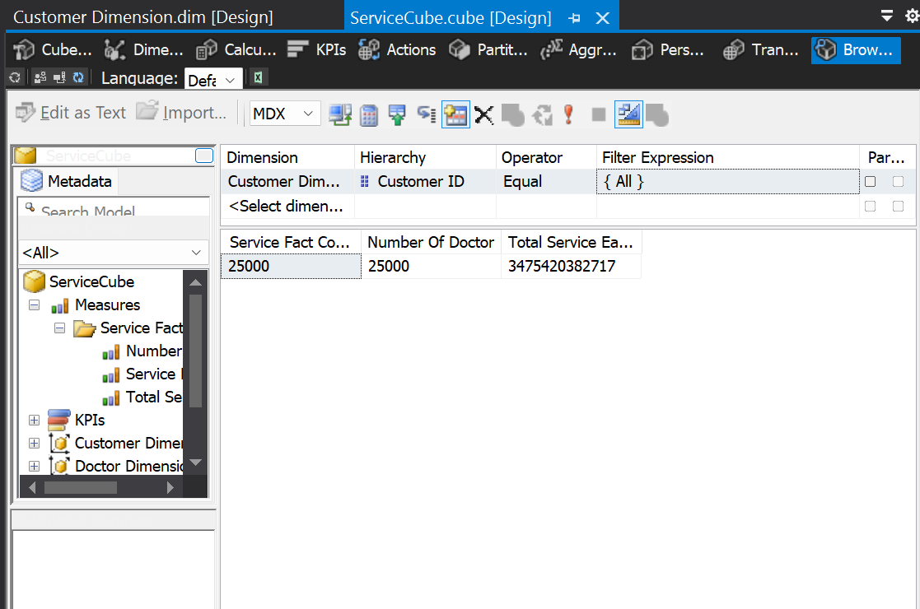

1. Open excels to make a pivot then click the data tab

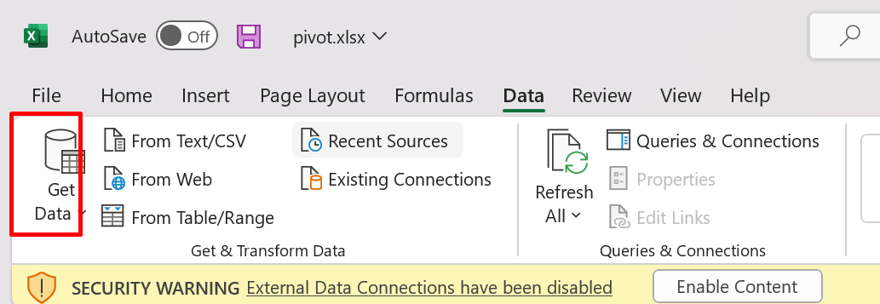

1. From there you can see the get data then click From Database -> From Analysis Server
2. Change the server name with your SQL Server name then use the `Use Window Authentication`

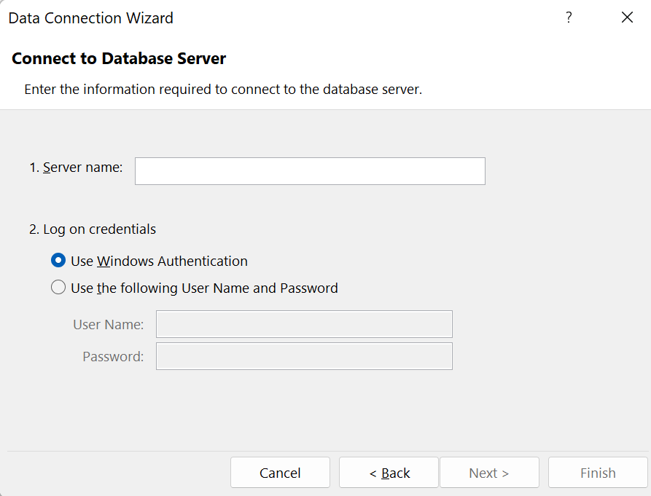

1. Choose the cube and create the pivot

