**Justine Winata – JT   
Repository :** [**https://github.com/TinTinWinata/QualifFlutter**](https://github.com/TinTinWinata/QualifFlutter)

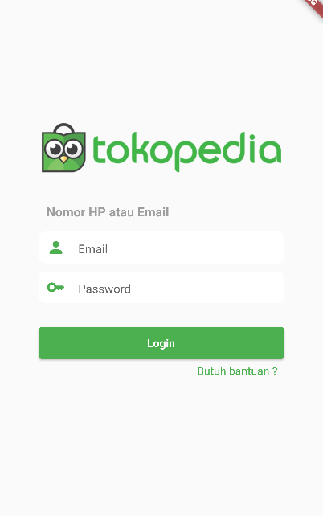

*Feature 1.1 Login Page*

Login Page Validation list :

* Required (not null)
* Length <= 3
* Password cannot be same as username

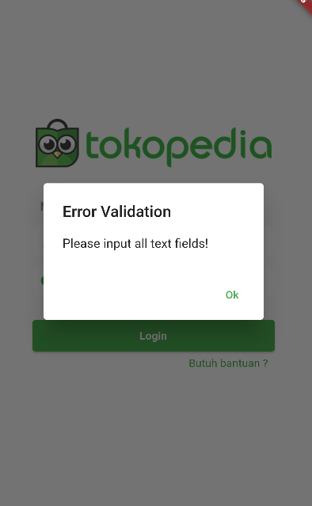

*Feature 2.1 Invalid Validation Dialog*

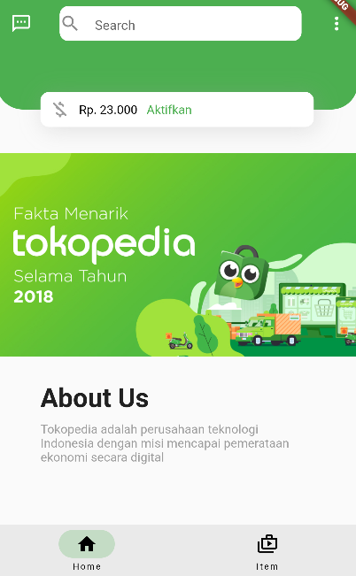

*Feature 3.1 Home Page*

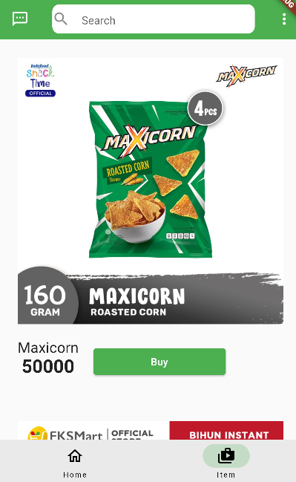

*Feature 4.1 Item Page*

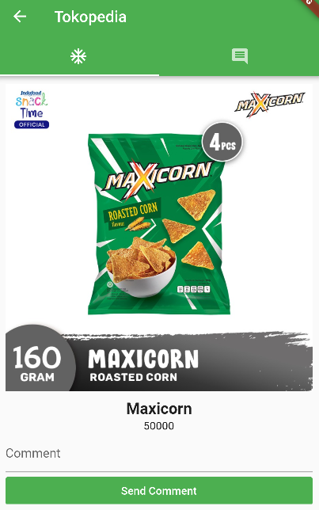

*Feature 5.1 Detail Page*

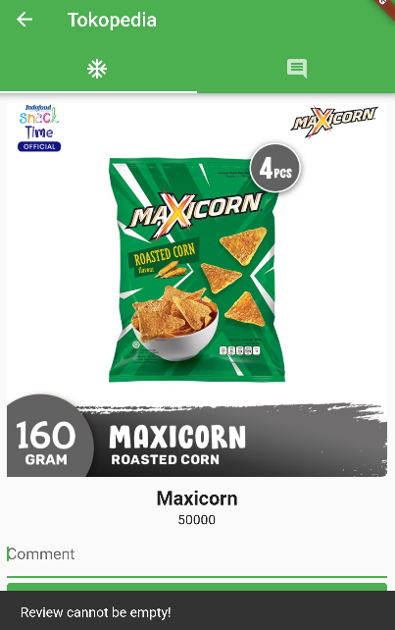

*Feature 6.1 Snake Message If validation error*

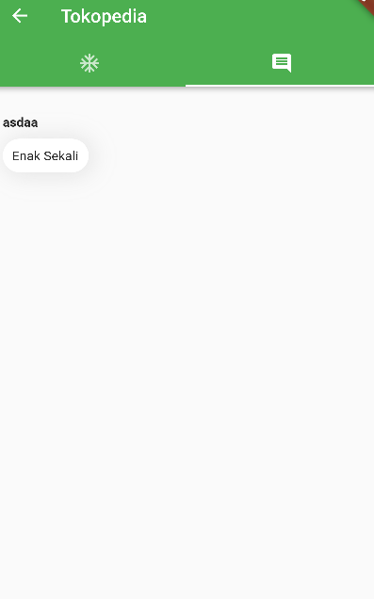

*Feature 7.1 Comment Page*

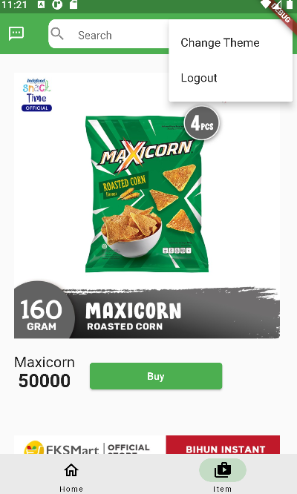

*Feature 8.1 Action Menu*

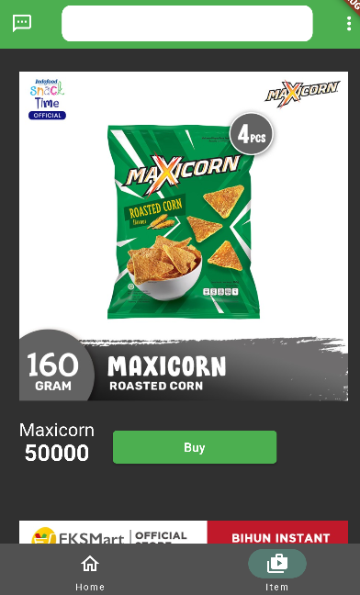

*Feature 9.1 After Change Theme*