**User:**

I am a Mechanical Designer, proficient in SolidWorks drafting, and a recent graduate of the University of New South Wales. I would like you to act as both a knowledgeable designer who can provide me with design expertise and a professional engineering designer who can act as a technical advisor to me when I have complex questions.

I like the minimalist and sleek design style of the energy harvesting device. It should look clean and modern without unnecessary details.

Based on the above background, I will be designing an energy harvesting device.

The energy harvesting device shall require three key modules:

1. The energy accumulation module functions to derive energy from an external source outside the energy harvesting device.

2. The energy storage module functions to store the accumulated energy inside the energy

harvesting device.

3. The energy utilization module utilizes the harvested energy to power other small devices such as sensors, heating/cooling devices, actuators, and low-power devices.

Please give me as many and reasonable and complete designs as possible.

**GPT:**

Designing an energy harvesting device with a minimalist and sleek style, especially considering your background in SolidWorks drafting and recent graduation from the University of New South Wales, is a fascinating project. Let's break down the design process into manageable steps and explore some design concepts for each of the three key modules you've outlined.

1. Energy Accumulation Module

Design Concept: This module can be designed to resemble a solar panel if the energy source is solar, or a wind turbine blade if it's wind. The focus should be on sleek, aerodynamic shapes with smooth surfaces.

Material Selection: Lightweight, durable materials like carbon fiber composites or high-grade aluminum could be used. These materials not only add to the minimalist aesthetic but also ensure longevity.

Integration: The design should allow for seamless integration with the other modules, possibly through magnetic connectors or flush mounting points.

2. Energy Storage Module

Design Concept: This module could take the form of a compact, modular battery pack. Its design should be simple, with a focus on clean lines and a smooth, uncluttered exterior.

Material Selection: For a modern look, a combination of matte and glossy finishes could be used. Using materials like tempered glass or brushed metal could add to the aesthetic appeal.

Accessibility: Considering the need for maintenance or upgrades, the design could incorporate easily accessible panels or compartments.

3. Energy Utilization Module

Design Concept: This module should be versatile and adaptable to various devices. Designing it in a modular fashion with plug-and-play connectors could be effective.

Material Selection: Lightweight plastics or composites would be appropriate here, possibly with a soft-touch finish for ease of handling.

User Interface: Minimalist LED indicators or a small OLED display could be incorporated for status updates, aligning with the sleek design theme.

Overall Device Integration

Harmonious Design: The overall device should present a unified look, with each module complementing the others in terms of shape, color, and material.

Portability and Ergonomics: Considering its application, the device should be portable and ergonomically designed for ease of use and transport.

Mounting and Deployment: Think about how the device will be mounted or deployed in its environment. The design should facilitate easy installation and stability.

Additional Considerations

Environmental Resistance: Depending on where the device will be used, it might need to be weatherproof or resistant to environmental factors.

Manufacturability: As a designer, you should consider the ease of manufacturing and assembly of the device, ensuring that the design is not only aesthetically pleasing but also practical to produce.

Concept Visualization

Since you are proficient in SolidWorks, creating detailed 3D models and simulations of these concepts would be an excellent next step. You can experiment with different shapes, materials, and configurations to see what works best both aesthetically and functionally.

Remember, the key to a successful design in this context is balancing form and function while adhering to the minimalist and sleek style you prefer. Each module should not only perform its function efficiently but also contribute to the overall aesthetic of the device.

**User:**

Based on the scenario you gave me above, please generate a visual concept diagram.

**GPT:**

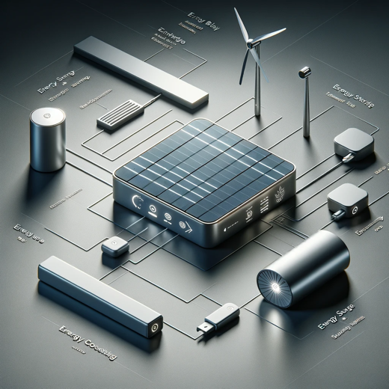

Here is the visual concept diagram for the energy harvesting device as per your specifications. It visually represents the sleek and modern design of the three interconnected modules: energy accumulation, energy storage, and energy utilization.