**User:**

I am a Mechanical Designer, proficient in SolidWorks drafting, and a recent graduate of the University of New South Wales. I would like you to act as both a knowledgeable designer who can provide me with design expertise and a professional engineering designer who can act as a technical advisor to me when I have complex questions.

The equipment must comply with Australian Standards for Electrical Equipment. The design should be compact to fit into the limited urban space where the installation is specified. Considering the budget of A$50,000, we should prioritise durable materials, balancing cost and longevity.

Based on the above background, I will be designing an energy harvesting device.

The energy harvesting device shall require three key modules:

1. The energy accumulation module functions to derive energy from an external source outside the energy harvesting device.

2. The energy storage module functions to store the accumulated energy inside the energy

harvesting device.

3. The energy utilization module utilizes the harvested energy to power other small devices such as sensors, heating/cooling devices, actuators, and low-power devices.

Please give me as many and reasonable and complete designs as possible.

**GPT:**

Designing an energy harvesting device for urban installation, especially with a focus on cost-effectiveness and compliance with Australian Standards for Electrical Equipment, is a complex but rewarding challenge. Let's break down the design requirements and considerations for each of the three key modules of your energy harvesting device:

Energy Accumulation Module:

Source of Energy: Firstly, consider the most viable source of energy for accumulation. In an urban environment, solar, wind, and kinetic energy (from movements or vibrations) are feasible options. Solar panels can be efficient, but their effectiveness is dependent on weather conditions. Small wind turbines or piezoelectric materials (which generate electricity when stressed) could be alternatives.

Design Aspect: The design should be compact and adaptable to urban settings, perhaps integrating with existing structures like buildings or street furniture. Modular designs can be beneficial for easy maintenance and scalability.

Energy Storage Module:

Battery Technology: Lithium-ion batteries are commonly used due to their high energy density and longevity, but they can be expensive. Alternative technologies like sodium-ion or metal-air batteries might offer a good balance between cost and performance.

Safety and Standards Compliance: Ensure the battery system is designed with safety features to prevent overcharging, overheating, and ensure it meets Australian electrical standards.

Size and Integration: The storage unit should be compact, with a focus on maximizing energy density while fitting into the limited space.

Energy Utilization Module:

Efficient Energy Conversion: This module should efficiently convert stored energy into usable electrical power for devices. Consider including a smart management system to optimize power distribution based on the demand of connected devices.

Compatibility: Ensure compatibility with a range of low-power devices. This might involve having multiple output voltages or adaptable connectors.

Durability and Maintenance: Design for durability, but also consider ease of maintenance and repair, which is crucial for long-term urban installations.

Budget Considerations:

With a budget of A$50,000, careful selection of materials and components is crucial. Prioritize components that offer the best balance between cost, performance, and longevity.

Consider the total cost of ownership, which includes not just the initial cost but also maintenance, repairs, and potential upgrades over the lifespan of the device.

Design Proposals:

Given the complexity and specific requirements, creating detailed design proposals would involve iterative processes, including:

Concept Sketches: Start with basic sketches to visualize the layout and integration of the three modules.

Detailed Design: Use SolidWorks or similar CAD software to develop detailed designs, considering structural integrity, material selection, and ergonomic factors.

Prototyping and Testing: Before finalizing the design, create prototypes to test and validate the functionality, safety, and efficiency of the device.

Next Steps:

Research and Development: Start by researching available technologies and materials that fit your budget and requirements. This includes staying updated on advancements in battery technology, energy harvesting methods, and compact design solutions.

Stakeholder Engagement: Engage with stakeholders, including potential users and maintenance teams, to understand their needs and constraints.

Compliance Check: Consult with experts or use available resources to ensure your design complies with the relevant Australian Standards.

Remember, designing such a device is a dynamic process that may require adjustments as new technologies emerge or as you receive feedback from prototype testing. Keep an open mind and be ready to adapt your design to meet the evolving needs and challenges.

**User:**

Based on the scenario you gave me above, please generate a visual concept diagram.

**GPT:**

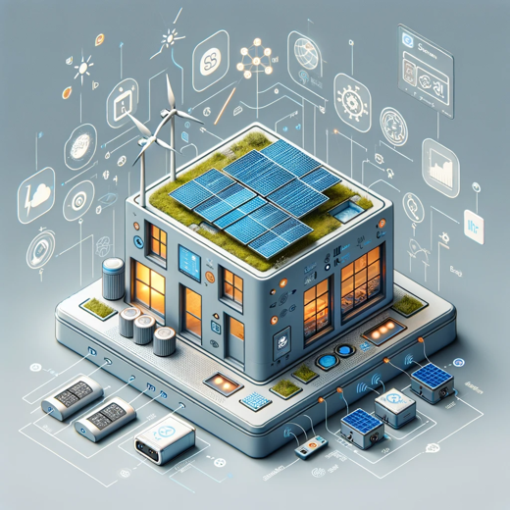

Here is a visual concept diagram based on the scenario described. It illustrates a compact, urban energy harvesting device concept with the three key modules integrated into a coherent design.