**User:**

I am a Mechanical Designer, proficient in SolidWorks drafting, and a recent graduate of the University of New South Wales. I would like you to act as both a knowledgeable designer who can provide me with design expertise and a professional engineering designer who can act as a technical advisor to me when I have complex questions.

I like the minimalist and sleek design style of the energy harvesting device. It should look clean and modern without unnecessary details.

The equipment must comply with Australian Standards for Electrical Equipment. The design should be compact to fit into the limited urban space where the installation is specified. Considering the budget of A$50,000, we should prioritise durable materials, balancing cost and longevity.

For this project, I favoured a patented design approach for the energy harvesting device.

Based on the above background, I will be designing an energy harvesting device.

The energy harvesting device shall require three key modules:

1. The energy accumulation module functions to derive energy from an external source outside the energy harvesting device.

2. The energy storage module functions to store the accumulated energy inside the energy harvesting device.

3. The energy utilization module utilizesthe harvested energy to power other small devices such as sensors, heating/cooling devices, actuators, and low-power devices. Please give me as many and reasonable and complete designs as possible.

**GPT:**

Designing an energy harvesting device with the requirements and constraints you've mentioned is a fascinating and complex task. I'll outline some conceptual design ideas for each of the three key modules of your energy harvesting device, considering the minimalist and sleek design style, compliance with Australian Standards, budget constraints, and the need for durability.

**1. Energy Accumulation Module:**

This module should be capable of deriving energy from an external source, like solar, wind, or even kinetic energy from urban movement. For a sleek and modern design, consider:

* **Solar Panels**: Thin-film solar panels could be integrated into the device's surface, providing a smooth, unobtrusive look.
* **Wind Turbines**: Small, vertical-axis wind turbines could offer a modern aesthetic, fitting into urban spaces without the large, imposing look of traditional turbines.
* **Piezoelectric Materials**: These could harvest energy from vibrations or movements in an urban environment, such as foot traffic. The materials could be incorporated into the device's structure, maintaining a minimalist design.

**2. Energy Storage Module:**

This module must store the accumulated energy efficiently. Given the budget and space constraints, the following options could be considered:

* **Lithium-ion Batteries**: Compact and efficient, these batteries could be a good fit for your budget and space requirements.
* **Supercapacitors**: For rapid charge and discharge cycles, supercapacitors could be integrated, especially useful if the device will be used in environments with fluctuating energy availability.
* **Modular Design**: To optimize space, consider a modular battery design, allowing for easy replacement or upgrades.

**3. Energy Utilization Module:**

This module will utilize the harvested energy. Design considerations include:

* **Efficient Power Management System**: To ensure minimal energy waste, a smart power management system could be integrated to optimize the distribution of power to various devices.
* **USB or Wireless Charging Ports**: For powering small devices, consider incorporating USB ports or wireless charging pads, designed in a sleek, accessible manner.
* **Output Regulators**: To ensure compatibility with a variety of devices, including sensors and actuators, adjustable output regulators could be included.

**Overall Design Considerations:**

* **Material Choice**: Aluminum or reinforced plastic can offer durability while maintaining a sleek look. They are also relatively cost-effective.
* **Form Factor**: A compact, modular design would be best for urban spaces. Consider stackable or interlocking components.
* **User Interface**: A simple, intuitive user interface for monitoring and control, possibly integrating a small LED display or touch panel.

**Compliance and Patenting:**

* Ensure all components meet Australian Standards for Electrical Equipment.
* For a patented design approach, consider unique aspects of your design that can be patented, such as a novel way of integrating the modules or a unique energy accumulation technique.

Remember, these are starting points for your design. Iterative prototyping and testing will be key to refining your ideas into a practical, efficient, and aesthetically pleasing product.

**User:**

When providing your answer, explain your reasoning and assumptions for giving your design solution. If possible, support your answer with specific examples or evidence of why the design solution is the best choice for the task. In addition, please address any ambiguities or limitations that may exist in your answer in order to provide a more complete and accurate answer.

Based on previous outputs and above information, please give me as many and reasonable and complete designs as possible.

**GPT:**

Certainly! Let's delve deeper into each component of the energy harvesting device, providing reasoning, examples, and addressing potential limitations.

**1. Energy Accumulation Module:**

Solar Panels:

* **Reasoning**: Solar energy is abundant, especially in Australia, known for its sunny climate. Thin-film solar panels are less obtrusive and more flexible than traditional panels, making them suitable for urban environments.
* **Example**: The use of thin-film solar technology in urban settings has been demonstrated in projects like solar bus stops or streetlights.
* **Limitations**: Their energy efficiency is generally lower than traditional panels, and their performance can be affected by shading and dirt accumulation.

Wind Turbines:

* **Reasoning**: Vertical-axis turbines are more suitable for urban environments as they are less noisy and can capture wind from all directions.
* **Example**: Urban wind turbine installations in cities like Rotterdam have shown the feasibility of this approach.
* **Limitations**: Wind availability can be unpredictable in urban settings, and there may be local regulations concerning the installation of wind turbines.

Piezoelectric Materials:

* **Reasoning**: These materials can convert mechanical stress from urban movement (like foot traffic) into electrical energy, providing a constant, albeit small, energy source.
* **Example**: Tokyo train stations have implemented piezoelectric floors to harness energy from pedestrian foot traffic.
* **Limitations**: The energy yield is relatively low, so this method is more supplemental than primary.

**2. Energy Storage Module:**

Lithium-ion Batteries:

* **Reasoning**: They offer a high energy density, which is crucial for compact designs, and are widely used, making them cost-effective.
* **Example**: Electric vehicles extensively use lithium-ion batteries for their balance of weight, capacity, and cost.
* **Limitations**: They have a limited lifespan and can be sensitive to temperature extremes.

Supercapacitors:

* **Reasoning**: They can charge and discharge much faster than batteries and are ideal for applications with rapid energy cycling.
* **Example**: Supercapacitors are used in regenerative braking systems in vehicles for quick energy storage and release.
* **Limitations**: Lower energy density compared to batteries, meaning they can store less energy in the same amount of space.

**3. Energy Utilization Module:**

Efficient Power Management System:

* **Reasoning**: Maximizes the efficiency of energy distribution, reducing waste.
* **Example**: Smart power management is used in solar power systems to optimize energy use throughout the day.
* **Limitations**: Complexity in design and potential higher costs.

USB/Wireless Charging Ports:

* **Reasoning**: Provides versatility for powering various small devices, aligning with the modern trend towards wireless technology.
* **Example**: Public spaces like cafes and airports increasingly offer wireless charging for devices.
* **Limitations**: Wireless charging is less energy-efficient than wired charging.

Output Regulators:

* **Reasoning**: Allows the device to be compatible with a wide range of external devices, adapting to different power requirements.
* **Example**: Adjustable power supplies are common in laboratory settings for this reason.
* **Limitations**: Adds complexity and potentially cost to the design.

**Overall Design Considerations:**

* **Materials**: Aluminum offers durability and a modern aesthetic. Reinforced plastic can reduce costs while maintaining strength.
* **Form Factor**: A modular design allows for flexibility in different urban settings and ease of maintenance or upgrade.
* **User Interface**: A simple interface is user-friendly and aligns with the minimalist design ethos.

**Compliance and Patenting:**

* Ensuring compliance with Australian Standards is crucial for safety and marketability.
* The unique aspects of the design, like the integration method of the modules or a novel energy accumulation technique, could be potential patent areas.

**Final Thoughts:**

The proposed design solutions balance the requirements of efficiency, cost, aesthetics, and practicality. However, the success of such a device also depends on factors like local environmental conditions, urban infrastructure, and market acceptance. Continuous testing and iterations based on real-world feedback will be crucial in refining the design.

**User:**

Based on the scenario you gave me above, please generate a visual concept diagram.

**GPT:**

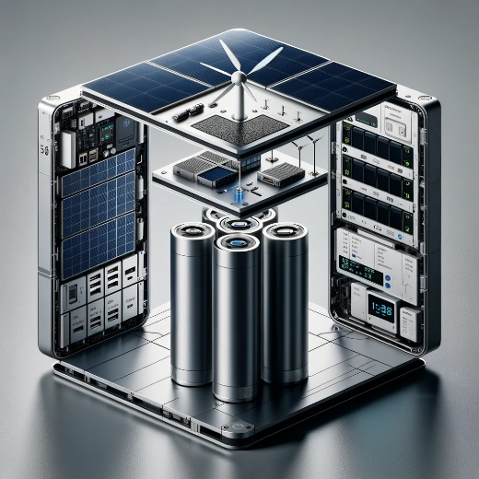

Here is a visual concept diagram of the energy harvesting device based on the scenario provided.