**User:**

I am a Mechanical Designer, proficient in SolidWorks drafting, and a recent graduate of the University of New South Wales. I would like you to act as both a knowledgeable designer who can provide me with design expertise and a professional engineering designer who can act as a technical advisor to me when I have complex questions.

The energy harvesting device is planned to be deployed in a coastal urban environment in Australia. The design needs to take into account the city where it will be applied to ensure consistent energy output throughout the year. Installation must be straightforward. In terms of maintenance, the unit should be designed to minimise the need for frequent repairs and, where necessary, key components should be easily accessible.

For this project, I favoured a bio-inspired design approach, using principles found in nature to optimise energy harvesting.

Based on the above background, I will be designing an energy harvesting device.

The energy harvesting device shall require three key modules:

1. The energy accumulation module functions to derive energy from an external source outside the energy harvesting device.

2. The energy storage module functions to store the accumulated energy inside the energy harvesting device.

3. The energy utilization module utilizesthe harvested energy to power other small devices such as sensors, heating/cooling devices, actuators, and low-power devices. Please give me as many and reasonable and complete designs as possible.

**GPT:**

Designing an energy harvesting device for a coastal urban environment in Australia, especially with a bio-inspired approach, is a fascinating and complex task. Here's a breakdown of design considerations and concepts for each of the three key modules you mentioned:

**1. Energy Accumulation Module**

**Design Consideration:**

* **Source of Energy:** Given the coastal setting, wind, solar, and tidal energy are viable sources. Bio-inspired designs could mimic the mechanisms found in nature, such as the way plants harness solar energy or how certain marine animals utilize water flow.
* **Durability:** Coastal environments can be harsh, with saltwater and strong winds. Materials must be corrosion-resistant and robust.
* **Efficiency:** The design should maximize energy capture from the available sources.

**Concept Ideas:**

* **Solar Panels with Leaf-like Structures:** Mimic the structure of leaves for optimal sun exposure throughout the day.
* **Wind Turbines Inspired by Bird Wings:** Design turbines that take cues from the aerodynamics of bird wings for efficient energy capture.
* **Tidal Flow Harnessing Inspired by Marine Life:** Utilize mechanisms similar to those used by marine life to capture energy from tidal movements.

**2. Energy Storage Module**

**Design Consideration:**

* **Capacity and Efficiency:** The storage system should have high capacity and efficiency, suitable for fluctuating energy inputs.
* **Safety and Stability:** Ensure the system is safe, with minimal risk of overheating or chemical leakage.
* **Environmentally Friendly Materials:** Consider sustainability in material selection.

**Concept Ideas:**

* **Biomimetic Battery Design:** Drawing inspiration from natural energy storage (like how camels store fat), use efficient, layered battery designs.
* **Hybrid Storage Systems:** Combine different storage methods (like batteries and supercapacitors) to balance immediate energy release with long-term storage.

**3. Energy Utilization Module**

**Design Consideration:**

* **Versatility:** Design for compatibility with a range of devices, from sensors to actuators.
* **Energy Management System:** Integrate a smart system for optimal distribution of energy based on demand and storage levels.
* **Reliability:** Ensure consistent performance under varying environmental conditions.

**Concept Ideas:**

* **Modular Output Interfaces:** Create interfaces that can adapt to different device requirements.
* **Smart Distribution Network:** Use algorithms inspired by natural systems (like neural networks) for efficient energy distribution.

**General Design Principles**

* **Modularity:** Design each module to be easily replaceable or upgradable.
* **Ease of Maintenance:** Accessible components, self-cleaning surfaces (inspired by lotus leaves), and diagnostic systems for early fault detection.
* **Aesthetics:** Consider the visual impact in an urban environment; the design should blend or enhance the urban landscape.

**Final Thoughts**

* **Prototype Testing:** Build and test prototypes to validate concepts under real-world conditions.
* **Collaboration with Environmental Experts:** To ensure the design respects local ecosystems.
* **Regulatory Compliance:** Ensure the design meets all local and national standards for safety and environmental impact.

This approach gives a comprehensive, bio-inspired, and practical solution to your energy harvesting device design challenge. Remember, real-world testing and iterative design will be key to refining these concepts.

**User:**

Based on the information I provided earlier, are there any other details I should provide regarding the design of the energy harvesting device?

**GPT:**

To further refine the design of your energy harvesting device, considering its deployment in a coastal urban environment in Australia, you might want to provide additional details in the following areas:

1. **Specific Environmental Conditions:**
   * **Climate Data:** Information on temperature ranges, humidity levels, typical wind speeds, and solar irradiance throughout the year.
   * **Tidal Patterns:** If considering tidal energy, details on tidal ranges and schedules.
   * **Pollution Levels:** Coastal cities might have specific air or water pollution concerns that could affect the device's performance or material choices.
2. **Local Urban Infrastructure:**
   * **Integration with Existing Structures:** Information on where the device will be installed (e.g., rooftops, alongside buildings, near shorelines) and any structural constraints.
   * **Aesthetic and Cultural Considerations:** Design requirements to blend with the local architecture or cultural significance.
3. **Energy Requirements:**
   * **Output Needs:** Specifics on the amount and type of energy needed (e.g., electrical, thermal) and the expected load from connected devices.
   * **Usage Patterns:** Understanding peak times and low-demand periods for energy use in the targeted area.
4. **Sustainability and Material Considerations:**
   * **Eco-Friendly Materials:** Preferences or restrictions regarding materials (e.g., recyclable, locally sourced).
   * **Lifecycle Analysis:** How long the device is expected to last and plans for end-of-life disposal or recycling.
5. **Budget and Economic Factors:**
   * **Cost Constraints:** Budget limits for both initial development and ongoing maintenance.
   * **Economic Incentives:** Any available local grants or subsidies for renewable energy projects.
6. **Regulatory and Compliance Requirements:**
   * **Local Regulations:** Any specific building codes, environmental regulations, or safety standards that must be adhered to.
   * **Certifications Needed:** Requirements for certifications or testing before deployment.
7. **Stakeholder Inputs:**
   * **Community Feedback:** If relevant, input or concerns from local communities or potential users.
   * **Collaboration with Other Experts:** Involvement of other specialists like environmental scientists, urban planners, or local authorities.
8. **Technical Specifications:**
   * **Detailed Performance Metrics:** Desired efficiency rates, durability standards, or specific technical requirements.
   * **Maintenance and Monitoring:** Details on how the device will be monitored, maintained, and what kind of data it should collect or report.

Providing this additional information can significantly aid in tailoring the design to meet specific needs and constraints, ensuring the final product is both functional and well-suited to its intended environment.

**User:**

When providing your answer, explain your reasoning and assumptions for giving your design solution. If possible, support your answer with specific examples or evidence of why the design solution is the best choice for the task. In addition, please address any ambiguities or limitations that may exist in your answer in order to provide a more complete and accurate answer.

The energy harvesting device is planned to be deployed in a coastal urban environment in Australia. The design needs to take into account the city where it will be applied to ensure consistent energy output throughout the year. Installation must be straightforward. In terms of maintenance, the unit should be designed to minimise the need for frequent repairs and, where necessary, key components should be easily accessible.

The equipment must comply with Australian Standards for Electrical Equipment. The design should be compact to fit into the limited urban space where the installation is specified. Considering the budget of A$50,000, we should prioritise durable materials, balancing cost and longevity.

Based on previous results and the above information, please give me as many, sensible and complete designs combining the 3 modules as possible.

**GPT:**

Given the constraints and requirements for your energy harvesting device, here are several design solutions, each addressing different aspects of your criteria:

**Design Solution 1: Solar-Wind Hybrid System**

Concept:

* **Energy Accumulation:** Combine small-scale vertical-axis wind turbines (VAWTs) with solar panels. VAWTs are efficient in turbulent wind, common in urban environments, and solar panels provide consistent energy on sunny days.
* **Energy Storage:** Lithium-ion batteries for high energy density and long life.
* **Energy Utilization:** An integrated inverter to convert and distribute energy to various devices.

Reasoning:

* **Efficiency in Varied Conditions:** VAWTs and solar panels can capture energy in different weather conditions, ensuring consistent output.
* **Space-Efficient:** Vertical turbines and solar panels can be mounted on rooftops, utilizing limited urban space effectively.
* **Cost-Benefit Balance:** Combining solar and wind is cost-effective and maximizes energy capture.

Limitations:

* Solar efficiency may decrease on cloudy days, and wind energy can be inconsistent. The initial cost may approach the higher end of the budget.

**Design Solution 2: Tidal Energy System (If Near Water)**

Concept:

* **Energy Accumulation:** Utilize a small-scale tidal stream generator, capturing energy from tidal movements.
* **Energy Storage:** Advanced lead-acid batteries, balancing cost and efficiency.
* **Energy Utilization:** Direct power supply to coastal facilities or feed into the local grid.

Reasoning:

* **Reliability:** Tidal movements are predictable and consistent, providing a reliable energy source.
* **Environmentally Friendly:** Minimal impact on marine life, important in Australian coastal areas.
* **Space-Efficient:** Installed underwater, it doesn’t occupy valuable urban space.

Limitations:

* Only applicable if the installation site is near tidal water bodies. The technology is emerging and may have higher upfront costs.

**Design Solution 3: Piezoelectric Energy Harvesting**

Concept:

* **Energy Accumulation:** Use piezoelectric materials in pathways or roads to generate electricity from pressure and vibrations.
* **Energy Storage:** Supercapacitors for rapid charge and discharge cycles.
* **Energy Utilization:** Power street lights or small urban devices.

Reasoning:

* **Innovative Use of Urban Space:** Harnesses energy from everyday urban activities (like walking, driving).
* **Low Maintenance:** Piezoelectric materials are durable and require minimal upkeep.
* **Cost-Efficient:** Relatively low-cost setup that integrates into existing infrastructure.

Limitations:

* Lower energy output compared to solar or wind, best suited for low-power applications.

**Design Solution 4: Bio-Inspired Solar System**

Concept:

* **Energy Accumulation:** Solar panels designed to mimic the structure of tree leaves for optimal light absorption.
* **Energy Storage:** Gel-type lead-acid batteries for a balance of performance and cost.
* **Energy Utilization:** Modular design to power urban green spaces, public Wi-Fi, or charging stations.

Reasoning:

* **Aesthetics and Efficiency:** Visually pleasing while maximizing solar exposure.
* **Urban Integration:** Enhances urban green spaces, supporting community engagement.
* **Budget-Friendly:** Uses established solar technology, keeping costs within budget.

Limitations:

* Efficiency dependent on solar exposure. May require more space than other solutions.

**General Considerations:**

* **Compliance with Australian Standards:** Each design must adhere to Australian Standards for Electrical Equipment.
* **Budget Constraints:** The chosen materials and technologies balance cost with durability and efficiency.
* **Urban Space Utilization:** Designs consider the limited space available in urban environments.
* **Maintenance and Accessibility:** Focus on minimizing maintenance needs; when necessary, components are easily accessible.

Each design proposal has its strengths and limitations. The best choice depends on the specific urban environment, available space, and the primary goal of the energy harvesting device. It's recommended to conduct a feasibility study and consult with local experts to finalize the design that best meets your needs within the specified budget.

**User:**

Based on the design 1,2,3,4 you gave me above, please generate 4 visual concept diagrams.

**GPT:**

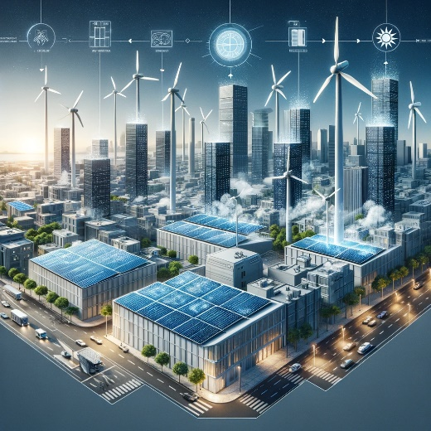

Here's the visual concept diagram for the Solar-Wind Hybrid System. Let's proceed with creating the concept diagrams for the other three design solutions.

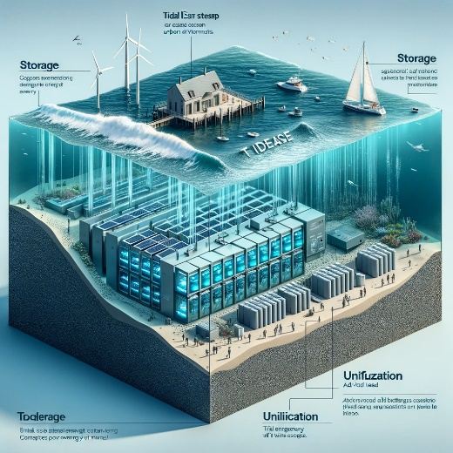

Here's the visual concept diagram for the Tidal Energy System. Now, let's create the concept diagrams for the remaining two design solutions.

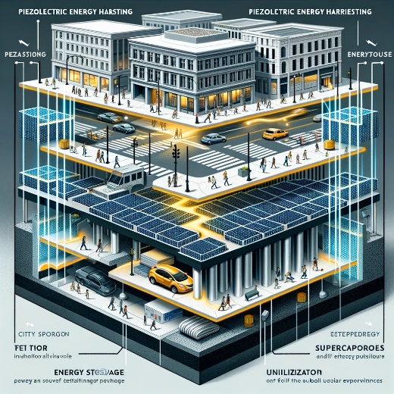

The visual concept diagram for the Piezoelectric Energy Harvesting system is ready. Let's move on to the last design solution.

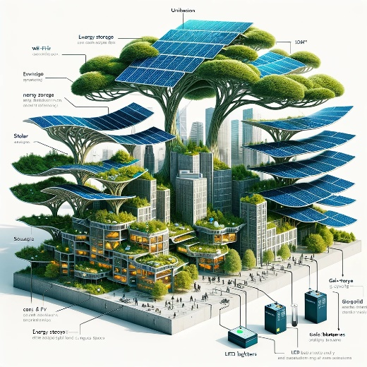

The visual concept diagram for the Bio-Inspired Solar System is now complete. With this, we have visual concept diagrams for all four design solutions.