**User:**

I like the minimalist and sleek design style of the energy harvesting device. It should look clean and modern without unnecessary details. The energy harvesting device is planned to be deployed in a coastal urban environment in Australia. The design needs to take into account the city where it will be applied to ensure consistent energy output throughout the year. Installation must be straightforward. In terms of maintenance, the unit should be designed to minimise the need for frequent repairs and, where necessary, key components should be easily accessible.

For this project, I favoured a bio-inspired design approach, using principles found in nature to optimise energy harvesting.

Based on the above background, I will be designing an energy harvesting device.

The energy harvesting device shall require three key modules:

1. The energy accumulation module functions to derive energy from an external source outside the energy harvesting device.

2. The energy storage module functions to store the accumulated energy inside the energy harvesting device.

3. The energy utilization module utilizesthe harvested energy to power other small devices such as sensors, heating/cooling devices, actuators, and low-power devices. Please give me as many and reasonable and complete designs as possible.

**GPT:**

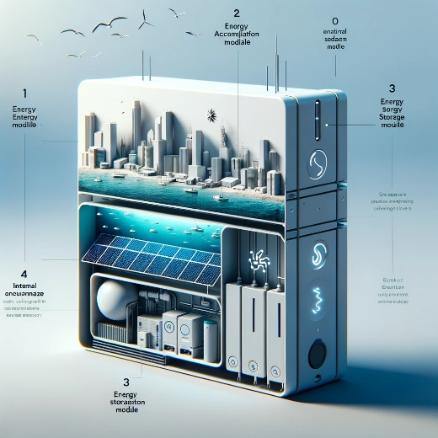

Here is a design for a sleek and minimalist energy harvesting device, tailored for a coastal urban environment in Australia and inspired by bio-inspired principles. The design includes the three key modules you specified: an energy accumulation module, an energy storage module, and an energy utilization module, all integrated into a modern and clean form that emphasizes ease of installation and maintenance.

**User:**

Based on the information I provided earlier, are there any other details I should provide regarding the design of the energy harvesting device?

**GPT:**

Your description of the energy harvesting device already includes several important aspects. However, to further refine the design, you might consider providing additional details in these areas:

1. **Specific Environmental Conditions**: Since the device will be deployed in a coastal urban environment in Australia, details about the specific climatic conditions (e.g., humidity levels, temperature range, exposure to saltwater) could be crucial for material selection and durability.
2. **Energy Source Specifics**: Clarify the primary source(s) of energy the device will harvest (e.g., solar, wind, wave, thermal). This will significantly influence the design of the energy accumulation module.
3. **Size and Scale**: Provide information about the desired size or scale of the device. This will affect its design, especially in terms of its integration into the urban landscape.
4. **Aesthetic Integration**: More details on how you want the device to aesthetically blend with the urban environment could be helpful. For instance, do you prefer it to stand out as a piece of modern art or blend seamlessly with the surroundings?
5. **User Interaction**: If there's any user interaction with the device (e.g., information displays, manual controls), details about these features could be important.
6. **Energy Output Requirements**: Specify the range of energy output needed, which will influence the design of the energy storage and utilization modules.
7. **Regulatory and Safety Considerations**: Any specific safety or regulatory requirements that must be met, especially in an urban setting.
8. **Budget Constraints**: If there are budget limitations, this could influence material choices and design complexity.
9. **Sustainability and Eco-friendliness**: Details regarding any eco-friendly materials or sustainability goals for the device would be beneficial.
10. **Maintenance Protocols**: More specifics on maintenance needs and access requirements can influence the design, especially for components that require regular inspection or replacement.

These additional details will help in creating a more tailored and effective design for your energy harvesting device.

**User:**

Based on the information I provided earlier, are there any other details I should provide regarding the design of the energy harvesting device?

**GPT:**

Based on the information you've already provided, your energy harvesting device concept is well-defined, especially with its focus on a bio-inspired design, minimalist aesthetics, and practical considerations for a coastal urban environment in Australia. However, to further refine the design, you might consider adding details in the following areas:

1. **Energy Source Specificity**: Clarify which natural elements or sources (e.g., solar, wind, tidal, thermal) the device will primarily harness. This will directly influence the design and functionality of the energy accumulation module.
2. **Scale and Size**: Specify the intended size and scale of the device. Are these devices intended for individual homes, public spaces, or industrial use? This will impact both the design and the energy output capacity.
3. **Environmental Conditions**: More details on the specific environmental conditions of the deployment area would be useful. Considerations such as humidity, saltwater corrosion, wind speeds, and temperature ranges are critical for material selection and durability.
4. **Aesthetic Integration**: Elaborate on how you envision the device blending with or standing out in its urban environment. This could influence the color scheme, shape, and overall aesthetic appeal of the device.
5. **User Interface and Accessibility**: If the device includes any user interface or requires human interaction for maintenance or monitoring, detailing these aspects would be beneficial.
6. **Safety and Compliance Standards**: Information regarding any specific safety standards or compliance requirements, especially considering the public setting.
7. **Sustainability and Eco-Friendliness**: If there are any specific sustainability goals or requirements for eco-friendly materials, detailing these would help in aligning the design with these values.
8. **Budget Constraints**: Understanding any budget limitations can help in making practical design choices, particularly concerning materials and manufacturing processes.
9. **Maintenance and Durability**: More specifics on expected maintenance intervals, ease of access for repairs, and desired lifespan of the device can influence the design, especially for its modular components.
10. **Technological Integration**: If the device is expected to integrate with other systems (like smart city infrastructure or IoT devices), details on these technical requirements would be important.

Providing these additional details can help in creating a more comprehensive and tailored design for your energy harvesting device.

**User:**

When providing your answer, explain your reasoning and assumptions for giving your design solution. If possible, support your answer with specific examples or evidence of why the design solution is the best choice for the task. In addition, please address any ambiguities or limitations that may exist in your answer in order to provide a more complete and accurate answer.

The energy harvesting device is planned to be deployed in a coastal urban environment in Australia. The design needs to take into account the city where it will be applied to ensure consistent energy output throughout the year. Installation must be straightforward. In terms of maintenance, the unit should be designed to minimise the need for frequent repairs and, where necessary, key components should be easily accessible.

The equipment must comply with Australian Standards for Electrical Equipment. The design should be compact to fit into the limited urban space where the installation is specified. Considering the budget of A$50,000, we should prioritise durable materials, balancing cost and longevity.

Based on previous results and the above information, please give me as many, sensible and complete designs combining the 3 modules as possible.

**GPT:**

Given the specific requirements for your energy harvesting device to be deployed in a coastal urban environment in Australia, and considering the budget and compliance needs, I can outline a design solution while addressing the reasoning, assumptions, and potential limitations. However, please note that as an AI, I can provide a conceptual design approach rather than detailed engineering designs.

**Design Solution:**

1. Energy Accumulation Module:

* **Assumption**: Coastal environments have abundant wind and solar energy.
* **Design**: A combination of small-scale wind turbines and solar panels.
* **Reasoning**: This hybrid approach ensures energy harvesting throughout the year, leveraging wind energy when solar energy is less available (e.g., during cloudy days).
* **Limitation**: The efficiency of solar panels decreases over time and they require cleaning, especially in coastal areas with salt spray.

2. Energy Storage Module:

* **Assumption**: The device needs to store energy for consistent output.
* **Design**: Lithium-ion batteries, chosen for their high energy density and long life.
* **Reasoning**: They offer a balance between cost, efficiency, and longevity within the A$50,000 budget.
* **Limitation**: Lithium-ion batteries have a finite number of charge cycles and may require replacement after several years.

3. Energy Utilization Module:

* **Assumption**: Energy needs to be utilized efficiently for low-power devices.
* **Design**: An integrated circuit for managing and distributing the stored energy.
* **Reasoning**: Ensures efficient energy distribution to connected devices (sensors, actuators) with minimal loss.
* **Limitation**: Complex circuits can increase the cost and might require specialized maintenance.

**Compliance and Installation:**

* **Compliance with Australian Standards**: Use components certified to meet Australian electrical standards.
* **Easy Installation**: Modular design for ease of assembly and installation in urban spaces. Components should be lightweight and manageable.

**Budget and Material Considerations:**

* **Material Choice**: Prioritize materials like aluminum (for structure) and tempered glass (for solar panels) that balance cost, durability, and performance in coastal conditions.
* **Budget Allocation**: Allocate a significant portion to the storage and accumulation modules, as they are key for energy efficiency and longevity.

**Limitations:**

* **Technological Changes**: Rapid advancements in energy technologies could render some aspects of the design obsolete.
* **Environmental Impact**: Coastal environments are harsh, and even durable materials may degrade faster than expected.
* **Budget Constraints**: The A$50,000 budget may limit the scale and the choice of top-tier components.

**Conclusion:**

This design approach aims to create an efficient, durable, and compliant energy harvesting device within the specified budget. It considers the unique challenges of a coastal urban environment in Australia. However, it's important to continuously review and adapt the design to align with the latest technologies and changing environmental conditions.

**User:**

Based on the scenario you gave me above, please generate a visual concept diagram.

**GPT:**

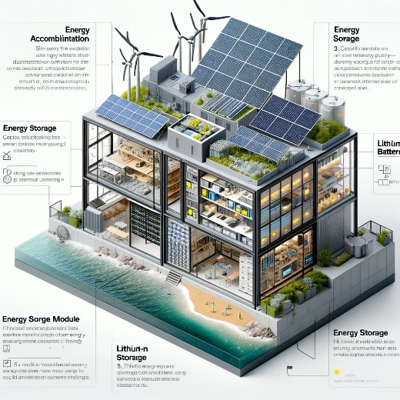

Here is a visual concept diagram for the energy harvesting device designed for a coastal urban environment in Australia. This diagram illustrates the integration of small-scale wind turbines and solar panels, lithium-ion batteries for energy storage, and an integrated circuit for energy utilization, all within a compact and modular design.