**User:**

I am a Mechanical Designer, proficient in SolidWorks drafting, and a recent graduate of the University of New South Wales. I would like you to act as both a knowledgeable designer who can provide me with design expertise and a professional engineering designer who can act as a technical advisor to me when I have complex questions. I like the minimalist and sleek design style of the energy harvesting device. It should look clean and modern without unnecessary details. The energy harvesting device is planned to be deployed in a coastal urban environment in Australia. The design needs to take into account the city where it will be applied to ensure consistent energy output throughout the year. Installation must be straightforward. In terms of maintenance, the unit should be designed to minimise the need for frequent repairs and, where necessary, key components should be easily accessible.

The equipment must comply with Australian Standards for Electrical Equipment. The design should be compact to fit into the limited urban space where the installation is specified. Considering the budget of A$50,000, we should prioritise durable materials, balancing cost and longevity.

Based on the above background, I will be designing an energy harvesting device.

The energy harvesting device shall require three key modules:

1. The energy accumulation module functions to derive energy from an external source outside the energy harvesting device.

2. The energy storage module functions to store the accumulated energy inside the energy harvesting device.

3. The energy utilization module utilizesthe harvested energy to power other small devices such as sensors, heating/cooling devices, actuators, and low-power devices. Please give me as many and reasonable and complete designs as possible.

**GPT:**

Designing an energy harvesting device for a coastal urban environment in Australia, particularly with a focus on minimalist and sleek aesthetics, functionality, and adherence to Australian Standards, is a multifaceted challenge. Let's break down your requirements and propose a conceptual design approach for each module of the device.

**1. Energy Accumulation Module**

* **Design Approach**: Given the coastal setting, the most viable energy sources could be solar, wind, or even tidal movements. A compact, integrated solar panel system could be the most straightforward option, considering the ease of installation and maintenance. Alternatively, a small-scale wind turbine designed for urban environments can be considered.
* **Materials and Aesthetics**: Utilize durable, corrosion-resistant materials suitable for coastal environments, like stainless steel or treated aluminium. The design should be sleek, with smooth lines and a modern look.
* **Compliance and Installation**: Ensure that the design meets Australian Standards for Electrical Equipment. The mounting system should be simple, allowing for easy installation on rooftops or urban structures.

**2. Energy Storage Module**

* **Design Approach**: Lithium-ion batteries are a good choice for energy storage due to their high energy density and relatively compact size. The battery unit should be modular, allowing for easy replacement or scaling.
* **Accessibility and Maintenance**: Design the battery enclosure with easy access in mind. A simple, tool-free opening mechanism can facilitate maintenance and inspection.
* **Safety and Standards**: Incorporate ventilation for heat dissipation and use materials that are fire-retardant. Compliance with safety standards is crucial, especially in an urban environment.

**3. Energy Utilization Module**

* **Design Approach**: This module should be versatile, capable of adjusting its output to power a variety of small devices. It should include standard electrical outputs and possibly USB ports for broader applicability.
* **Integration and Control**: Implement smart controls to optimize energy distribution based on the connected devices' needs. This can be done through simple embedded systems.
* **Compact and User-Friendly Design**: Keep the interface simple and intuitive. The design should complement the overall minimalist aesthetic of the entire device.

**Overall Considerations**

* **Budget Management**: Prioritize materials that offer the best balance between cost, durability, and performance. For instance, choosing high-grade solar panels for efficiency and longevity within the budget constraint.
* **Environmental Impact**: Given the coastal urban setting, consider the visual and environmental impact of the device. The design should blend seamlessly with the surroundings and not be obtrusive.

**Conceptual Sketches**

To visualize these ideas, I can provide you with a conceptual sketch of the energy harvesting device. Let's proceed with that to give you a clearer idea.

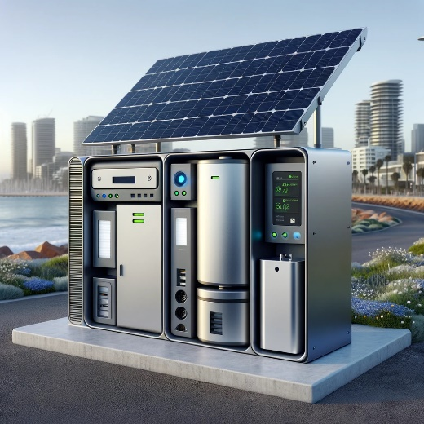

Here is a conceptual sketch of the energy harvesting device, designed with the considerations we discussed. This visualization includes the sleek and modern aesthetic, the three key modules (energy accumulation, storage, and utilization), and the overall minimalist design that blends into the urban landscape. This concept should serve as a starting point for further development and refinement according to your specific requirements and constraints.

**User:**

Based on the information I provided earlier, are there any other details I should provide regarding the design of the energy harvesting device?

**GPT:**

Your initial information provides a solid foundation for the energy harvesting device design, especially with the focus on a coastal urban environment in Australia. However, there are a few additional details you might consider providing to further refine the design:

1. **Specific Energy Source**: Clarify the primary energy source(s) for the device. Are you focusing solely on solar, wind, tidal, or a combination of these? Knowing the primary energy source will significantly impact the design, particularly the energy accumulation module.
2. **Environmental Conditions**: More details about the specific coastal conditions, like average sunlight hours, wind speed, humidity levels, and temperature ranges, would help in customizing the design for durability and efficiency.
3. **Size and Capacity Specifications**: Providing specific dimensions for the device, or at least the maximum allowable size, would be helpful. Also, clarify the expected energy output or capacity of the device.
4. **Target Devices for Energy Utilization**: Information about the types of devices or systems the energy will power (like specific sensors, actuaries, or community utilities) can influence the design of the energy utilization module.
5. **Installation and Accessibility Requirements**: Are there any specific requirements or limitations for the installation site? This includes available space, accessibility for maintenance, and integration with existing urban structures or utilities.
6. **Aesthetic and Cultural Considerations**: Since the device will be in a public urban space, does it need to align with certain aesthetic or cultural aspects of the area? This could influence the design's form and color.
7. **Sustainability and Eco-Friendliness**: If there are specific goals or standards for sustainability and environmental impact, these should be outlined. This can include materials recycling, energy efficiency standards, or carbon footprint considerations.
8. **Safety and Security Measures**: In a public space, it's important to consider the safety and security of the device. This includes tamper-proof designs, weatherproofing, and safety features to protect the public.
9. **Budget Allocation**: A breakdown of the budget allocation (e.g., how much is allocated for materials, manufacturing, installation) would help in prioritizing aspects of the design.

Providing these additional details will enable a more tailored and efficient design process, ensuring that the final product meets all your requirements and constraints.

**User:**

When providing your answer, explain your reasoning and assumptions for giving your design solution. If possible, support your answer with specific examples or evidence of why the design solution is the best choice for the task. In addition, please address any ambiguities or limitations that may exist in your answer in order to provide a more complete and accurate answer.

The energy harvesting device is planned to be deployed in a coastal urban environment in Australia. The design needs to take into account the city where it will be applied to ensure consistent energy output throughout the year. Installation must be straightforward. In terms of maintenance, the unit should be designed to minimise the need for frequent repairs and, where necessary, key components should be easily accessible.

Based on previous results and the above information, please give me as many, sensible and complete designs combining the 3 modules as possible.

**GPT:**

Creating multiple design concepts for an energy harvesting device, especially one tailored to a coastal urban environment in Australia, requires a careful balance of technical functionality, environmental considerations, and practical constraints. Here are several design concepts, each with its reasoning and potential limitations:

**Design Concept 1: Solar-Powered Energy Harvester**

* **Modules**: Solar panels for energy accumulation, lithium-ion battery pack for storage, and a smart control unit for energy utilization.
* **Reasoning**: Solar power is abundant in Australia, making it a reliable energy source. Lithium-ion batteries offer high energy density for storage.
* **Limitations**: Solar panels' efficiency can be reduced on cloudy days or if obstructed. Battery performance may degrade over time, requiring eventual replacement.

**Design Concept 2: Wind Turbine Integrated System**

* **Modules**: Small urban wind turbine for energy accumulation, supercapacitor for short-term energy storage, and an inverter for energy utilization.
* **Reasoning**: Wind turbines can harness coastal winds, which are consistent in certain areas. Supercapacitors provide quick energy release and have longer lifespans than batteries.
* **Limitations**: Wind availability can be variable, and turbines might be subject to wear in harsh coastal conditions.

**Design Concept 3: Hybrid Solar-Wind System**

* **Modules**: Combination of solar panels and a compact wind turbine, hybrid battery-supercapacitor storage system, and a multi-input energy utilization unit.
* **Reasoning**: Combining solar and wind energy can provide more consistent power output. Hybrid storage systems can capitalize on the strengths of both batteries and supercapacitors.
* **Limitations**: The complexity of managing two energy sources can increase the cost and maintenance requirements.

**Design Concept 4: Tidal Energy System**

* **Modules**: Tidal energy generator for accumulation, high-capacity battery storage, and a robust energy utilization unit designed for marine environments.
* **Reasoning**: Tidal movements are predictable and can provide a consistent energy source. High-capacity batteries can store larger amounts of energy for longer periods.
* **Limitations**: Tidal systems can be expensive and complex to install. They also require proximity to suitable tidal flows, limiting their applicability.

**Design Concept 5: Piezoelectric Energy Harvesting System**

* **Modules**: Piezoelectric materials for energy accumulation from environmental vibrations, standard battery storage, and a basic energy distribution unit.
* **Reasoning**: Piezoelectric systems can generate electricity from ambient vibrations, such as traffic or wind. They are low-maintenance and have no moving parts.
* **Limitations**: The energy output from piezoelectric materials is relatively low compared to solar or wind options.

**General Considerations for All Designs:**

* **Installation and Maintenance**: Easy installation is a key requirement, so modular designs with simple mounting systems are preferred. Components should be easily accessible for maintenance.
* **Durability and Compliance**: Materials must be corrosion-resistant and durable, especially in a saline coastal environment. Compliance with Australian Standards for Electrical Equipment is non-negotiable.
* **Aesthetic and Environmental Impact**: The design should blend into the urban landscape, maintaining a balance between functionality and visual appeal.

**Conclusion**

Each design concept has its strengths and limitations, and the choice largely depends on the specific conditions of the deployment area (like wind patterns, sunlight availability, and urban density). Further refinement would be needed based on more detailed local data and specific user requirements.

**User:**

Based on the design 1,2,3,4 you gave me above, please generate 4 visual concept diagrams.

**GPT:**

Creating visual concepts for each of the four designs would provide a clearer understanding of their potential implementations.

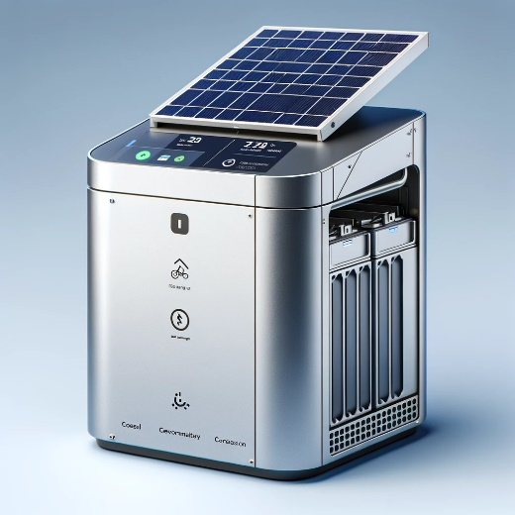

Here is the visual concept for Design 1: Solar-Powered Energy Harvester. If this aligns with your vision, we can proceed to create visual concepts for the remaining designs.

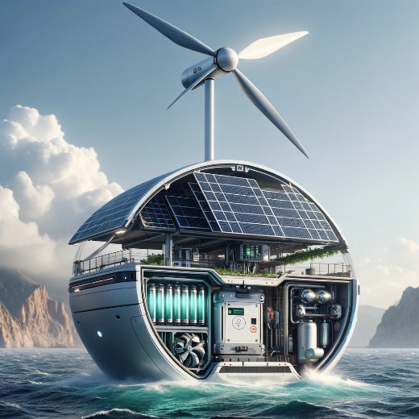

Here is the visual concept for Design 2: Wind Turbine Integrated System. We can continue with the next designs if this meets your expectations.

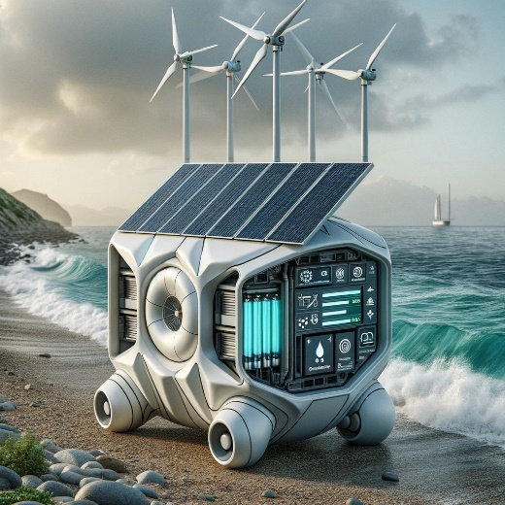

The visual concept for Design 3: Hybrid Solar-Wind System is now ready. If this visualization aligns with your vision, we can proceed to create the concept for the final design.

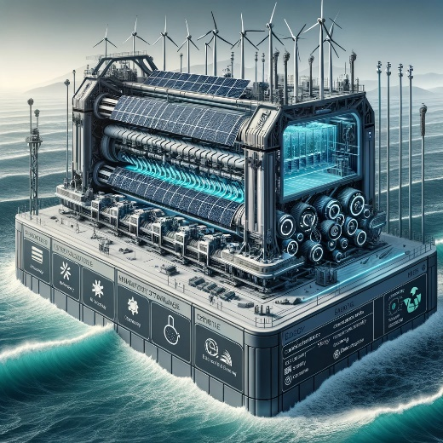

The visual concept for Design 4: Tidal Energy System is now complete. With this, we have visual concepts for all four of the initial designs. If you need further assistance or additional designs, feel free to ask.