**User:**

I like the minimalist and sleek design style of the energy harvesting device. It should look clean and modern without unnecessary details. The energy harvesting device is planned to be deployed in a coastal urban environment in Australia. The design needs to take into account the city where it will be applied to ensure consistent energy output throughout the year. Installation must be straightforward. In terms of maintenance, the unit should be designed to minimise the need for frequent repairs and, where necessary, key components should be easily accessible.

The equipment must comply with Australian Standards for Electrical Equipment. The design should be compact to fit into the limited urban space where the installation is specified. Considering the budget of A$50,000, we should prioritise durable materials, balancing cost and longevity. For this project, I favoured a bio-inspired design approach, using principles found in nature to optimise energy harvesting.

Based on the above background, I will be designing an energy harvesting device.

The energy harvesting device shall require three key modules:

1. The energy accumulation module functions to derive energy from an external source outside the energy harvesting device.

2. The energy storage module functions to store the accumulated energy inside the energy harvesting device.

3. The energy utilization module utilizesthe harvested energy to power other small devices such as sensors, heating/cooling devices, actuators, and low-power devices. Please give me as many and reasonable and complete designs as possible.

**GPT:**

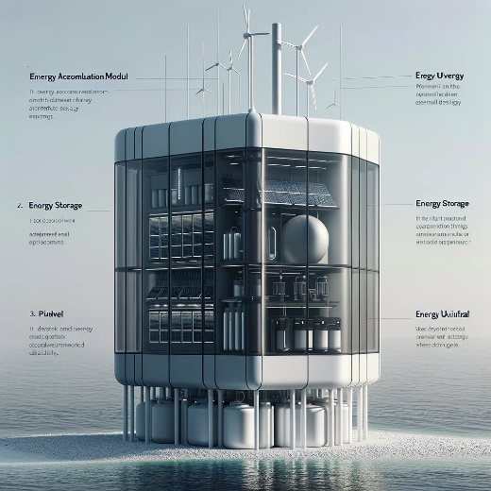

Here is a design for the sleek, minimalist energy harvesting device tailored for a coastal urban environment in Australia. This design integrates the three key modules: energy accumulation, storage, and utilization, while adhering to the specified requirements and budget.

**User:**

Based on the information I provided earlier, are there any other details I should provide regarding the design of the energy harvesting device?

**GPT:**

Your initial description for the energy harvesting device is quite comprehensive, but there are a few additional details you might consider specifying to further refine the design:

1. **Specific Energy Sources**: Clarify the primary energy sources the device will harvest (e.g., solar, wind, kinetic from waves). This will greatly influence the design.
2. **Size and Capacity Specifications**: Provide specific dimensions or capacity requirements. This includes the physical size of the device and its energy storage capacity.
3. **Environmental Considerations**: Since it's for a coastal urban environment, details about weather resistance (e.g., saltwater corrosion, UV exposure, wind resistance) could be crucial.
4. **Integration with Existing Infrastructure**: Information on how the device will integrate with existing urban structures or systems can impact its design.
5. **Aesthetic Preferences**: If there are specific aesthetic guidelines to align with the city's architecture or urban planning vision, these should be detailed.
6. **User Interface and Control**: If the device requires any user interaction or remote monitoring capabilities, details about these features should be included.
7. **Safety Features**: Specify any required safety features, especially if the device will be accessible to the public.
8. **Regulatory Compliance**: Beyond general Australian Standards, if there are local regulations or guidelines, these should be noted.
9. **Sustainability Goals**: If there are specific sustainability or environmental impact goals (like recyclable materials or carbon footprint), mention these.
10. **Installation and Maintenance Process**: More details on the expected installation process and the frequency or type of maintenance required.

Providing these additional details will help in creating a more targeted and efficient design for your energy harvesting device.

**User:**

When providing your answer, explain your reasoning and assumptions for giving your design solution. If possible, support your answer with specific examples or evidence of why the design solution is the best choice for the task. In addition, please address any ambiguities or limitations that may exist in your answer in order to provide a more complete and accurate answer.

I like the minimalist and sleek design style of the energy harvesting device. It should look clean and modern without unnecessary details. The energy harvesting device is planned to be deployed in a coastal urban environment in Australia. The design needs to take into account the city where it will be applied to ensure consistent energy output throughout the year. Installation must be straightforward. In terms of maintenance, the unit should be designed to minimise the need for frequent repairs and, where necessary, key components should be easily accessible.

Based on previous results and the above information, please give me as many, sensible and complete designs combining the 3 modules as possible.

**GPT:**

Creating multiple complete and detailed designs for an energy harvesting device with the specified criteria requires a blend of technical knowledge, design principles, and environmental considerations. Here's a breakdown of how these elements influence the design and the reasoning behind them:

1. **Minimalist and Sleek Design**: The preference for a minimalist and sleek design style is grounded in modern architectural trends, particularly in urban environments. This approach often leads to using simple geometric shapes, smooth surfaces, and a monochromatic color palette. It aligns with the aesthetic of contemporary urban landscapes and is generally well-received for its visual appeal and timelessness.
2. **Deployment in a Coastal Urban Environment in Australia**: Coastal environments present unique challenges, such as saltwater corrosion, high humidity, and potentially strong winds. Materials like stainless steel or treated aluminum can be used to resist corrosion. The design might also incorporate elements to withstand high winds. Australia's climate varies, but generally offers ample sunlight, making solar energy a viable primary source. However, considering other sources like wind or kinetic energy from waves can ensure consistent energy output.
3. **Straightforward Installation and Accessible Maintenance**: The design should facilitate easy installation, which could mean modular components that can be easily transported and assembled on-site. For maintenance, critical components should be accessible without disassembling the entire device. This approach reduces downtime and maintenance costs.
4. **Combining Three Modules**: The device includes energy accumulation, storage, and utilization modules. These could be integrated into a single unit or designed as separate but interconnectable modules. The accumulation module might involve solar panels or wind turbines, while the storage unit could use batteries or supercapacitors. The utilization module would then effectively distribute the stored energy.

**Limitations and Ambiguities:**

* **Technical Specifics**: Detailed technical specifications, like the exact capacity of the storage module or the efficiency of the accumulation module, are not provided. These would significantly impact the design.
* **Environmental Impact Assessment**: A thorough environmental impact assessment is necessary to ensure the device is suitable for the specific coastal conditions of the deployment area.
* **Budget Constraints**: While a budget is mentioned, the cost of materials and technology that align with the design requirements could vary, affecting the final design.
* **Regulatory Compliance**: Compliance with Australian Standards needs detailed examination, especially for electrical safety and environmental regulations.

**Example Designs:**

Given these considerations, let's conceptualize a few design ideas:

1. **Solar-Powered Compact Unit**: A sleek, low-profile unit with integrated solar panels on the top surface. It would be constructed with corrosion-resistant materials suitable for the coastal environment. The storage and utilization modules would be housed within the same unit, with easy access panels for maintenance.
2. **Modular Wind and Solar Hybrid**: A combination of small wind turbines and solar panels. Each module (accumulation, storage, utilization) could be a separate but easily connectable unit, allowing for flexible installation and maintenance.
3. **Kinetic Wave Energy Harvester**: A design that utilizes wave motion for energy accumulation. This could be a floating structure offshore, connected to a storage and utilization unit on land.

In each case, the design would be tailored to balance aesthetic appeal, functionality, environmental suitability, and cost-effectiveness. These concepts represent a starting point and would need further refinement and technical validation to ensure feasibility and compliance with all necessary standards and regulations.

**User:**

Based on the design 1,2,3 you gave me above, please generate 3 visual concept diagrams.

**GPT:**

|  |  |
| --- | --- |
|  |  |
|  | |

Here are the visual concept diagrams for the three energy harvesting device designs:

1. **Solar-Powered Compact Unit**: This design features a sleek, minimalist style with integrated solar panels on the top surface, suitable for a coastal urban environment.
2. **Modular Wind and Solar Hybrid**: This concept includes small wind turbines and solar panels in a modular design, allowing for flexible installation and maintenance.
3. **Kinetic Wave Energy Harvester**: This design utilizes wave motion for energy accumulation and is a floating structure offshore, connected to a storage and utilization unit on land.

Each design aims to balance aesthetic appeal, functionality, and environmental suitability, considering the specific requirements of a coastal urban environment in Australia.