**User:**

I am a Mechanical Designer, proficient in SolidWorks drafting, and a recent graduate of the University of New South Wales. I would like you to act as both a knowledgeable designer who can provide me with design expertise and a professional engineering designer who can act as a technical advisor to me when I have complex questions.

The energy harvesting device is planned to be deployed in a coastal urban environment in Australia. The design needs to take into account the city where it will be applied to ensure consistent energy output throughout the year. Installation must be straightforward. In terms of maintenance, the unit should be designed to minimise the need for frequent repairs and, where necessary, key components should be easily accessible.

The equipment must comply with Australian Standards for Electrical Equipment. The design should be compact to fit into the limited urban space where the installation is specified. Considering the budget of A$50,000, we should prioritise durable materials, balancing cost and longevity.

For this project, I favoured a bio-inspired design approach, using principles found in nature to optimise energy harvesting.

Based on the above background, I will be designing an energy harvesting device.

The energy harvesting device shall require three key modules:

1. The energy accumulation module functions to derive energy from an external source outside the energy harvesting device.

2. The energy storage module functions to store the accumulated energy inside the energy

harvesting device.

3. The energy utilization module utilizes the harvested energy to power other small devices such as sensors, heating/cooling devices, actuators, and low-power devices.

Please give me as many and reasonable and complete designs as possible.

**GPT:**

Designing an energy harvesting device for a coastal urban environment in Australia, especially with a focus on bio-inspired design, is an intriguing challenge. Here are some design considerations and ideas for each module of the device:

**Energy Accumulation Module**

1. **Solar Panels**: Utilize compact, high-efficiency solar panels for energy accumulation. In a coastal urban environment, solar energy is abundant and reliable.
2. **Wind Turbines**: Small-scale vertical-axis wind turbines can be integrated into the design. These are efficient in turbulent urban winds and have a smaller footprint.
3. **Vibration Energy Harvesting**: Leverage the ambient vibrations from urban infrastructure (like bridges or buildings) to generate energy.
4. **Bio-inspired Elements**: Mimic natural processes like photosynthesis or piezoelectric effects found in certain biological structures for innovative energy accumulation.

**Energy Storage Module**

1. **Lithium-Ion Batteries**: For high energy density and long life, though these might be costly.
2. **Supercapacitors**: Ideal for quick charging and discharging, and more durable than batteries.
3. **Modular Design**: Make the storage unit modular for easy replacement and scalability.
4. **Thermal Insulation**: Protect the storage unit from extreme temperatures, which is crucial in coastal environments.

**Energy Utilization Module**

1. **Smart Management System**: Implement a system to efficiently distribute stored energy based on demand.
2. **Modular Output Ports**: Design the device with multiple output ports for different types of small devices.
3. **Remote Monitoring**: Include IoT capabilities for remote monitoring and control of energy distribution.

**General Design Considerations**

1. **Durability and Maintenance**: Use corrosion-resistant materials to withstand coastal conditions. Design for easy access to key components.
2. **Compliance with Australian Standards**: Ensure all components and designs comply with local electrical and safety standards.
3. **Compact and Aesthetic Design**: Since it's for an urban environment, the device should be aesthetically pleasing and blend with the surroundings.
4. **Cost-Effective Materials**: Balance the use of high-quality materials with the budget constraints.

**Prototyping and Testing**

1. **CAD Modelling**: Utilize SolidWorks to create detailed models of each component and the overall assembly.
2. **Simulation**: Run simulations in SolidWorks for stress analysis, fluid dynamics (if applicable), and energy efficiency.
3. **Prototype and Test**: Build a prototype to test in real-world conditions, especially focusing on energy efficiency and durability.

These are initial concepts and ideas based on your requirements and the nature of the project. Each module and the overall system design would need to be iteratively developed and tested to ensure feasibility, efficiency, and compliance with standards and budget constraints.

**User:**

Based on the scenario you gave me above, please generate a visual concept diagram.

**GPT:**

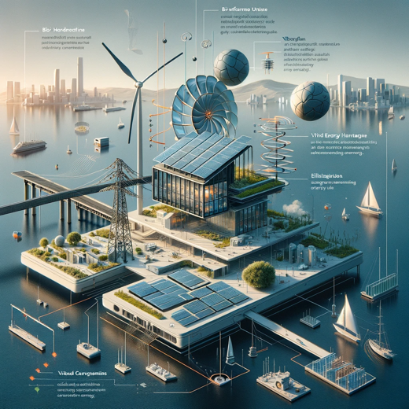

The visual concept diagram for the urban coastal energy harvesting device is ready. The diagram showcases the integration of the components such as compact solar panels, a vertical-axis wind turbine, vibration energy harvesting mechanisms, bio-inspired design elements, advanced battery units, and innovative energy utilization technology, all cohesively designed to fit into an urban coastal environment.