**User:**

The energy harvesting device is planned to be deployed in a coastal urban environment in Australia. The design needs to take into account the city where it will be applied to ensure consistent energy output throughout the year. Installation must be straightforward. In terms of maintenance, the unit should be designed to minimise the need for frequent repairs and, where necessary, key components should be easily accessible.

The equipment must comply with Australian Standards for Electrical Equipment. The design should be compact to fit into the limited urban space where the installation is specified. Considering the budget of A$50,000, we should prioritise durable materials, balancing cost and longevity.

For this project, I favoured a bio-inspired design approach, using principles found in nature to optimise energy harvesting.

Based on the above background, I will be designing an energy harvesting device.

The energy harvesting device shall require three key modules:

1. The energy accumulation module functions to derive energy from an external source outside the energy harvesting device.

2. The energy storage module functions to store the accumulated energy inside the energy

harvesting device.

3. The energy utilization module utilizes the harvested energy to power other small devices such as sensors, heating/cooling devices, actuators, and low-power devices.

Please give me as many and reasonable and complete designs as possible.

**GPT:**

Designing an energy harvesting device for a coastal urban environment in Australia involves integrating various functional and environmental considerations. Let's break down the design process into manageable steps and explore potential designs:

1. **Energy Accumulation Module**: This module should efficiently capture energy from the surrounding environment. Given the coastal setting, solar, wind, and even tidal energy could be viable sources. Solar panels or wind turbines could be integrated into the design. For a bio-inspired approach, consider mimicking the efficiency of plant leaves in capturing solar energy or the aerodynamics of bird wings for wind energy.
2. **Energy Storage Module**: This module must store energy reliably. Lithium-ion batteries are a common choice for their high energy density and durability. Alternatively, considering the bio-inspired approach, research into biomimicry in energy storage - like structures mimicking the energy storage mechanisms in living organisms - could be revolutionary.
3. **Energy Utilization Module**: This part should efficiently distribute the stored energy to power various devices. This involves designing efficient electrical circuits and possibly smart management systems that allocate power based on priority and demand.
4. **Compliance with Australian Standards**: Ensure that all components and overall design adhere to Australian standards for electrical equipment. This involves selecting materials and designs that meet safety and performance criteria under these standards.
5. **Compact and Urban-Friendly Design**: Given the space constraints, the design should be compact yet efficient. Modular designs could be beneficial, allowing for easy installation and maintenance. The equipment could be designed to integrate seamlessly into existing urban structures like buildings or lamp posts.
6. **Durability and Cost-Effectiveness**: With a budget of A$50,000, prioritize materials that offer the best balance between cost, durability, and performance. Research materials that are cost-effective yet have a long lifespan and require minimal maintenance.
7. **Bio-Inspired Design Approach**: Drawing inspiration from nature can lead to innovative solutions. For instance, the energy accumulation module might mimic the way certain plants optimize sunlight absorption, or the storage module could emulate how certain seeds store energy.
8. **Maintenance and Accessibility**: Design the device with easy access to key components for maintenance. Components that are likely to wear out or require regular inspection should be easily accessible.
9. **Environmental Impact and Sustainability**: Consider the environmental impact of the device throughout its lifecycle, from manufacturing to disposal. Using recyclable or sustainable materials can minimize the ecological footprint.

For the actual design, consider these elements:

* **Shape and Structure**: Drawing from nature, the device could have a leaf-like structure for the solar panels, with veins that channel energy, mimicking the natural energy flow in plants.
* **Materials**: Use durable materials like high-grade aluminum or composites that withstand coastal weather conditions.
* **Color and Aesthetics**: The device should blend with the urban environment. Neutral colors like gray or green could be used to complement both the natural and built environments.
* **Integration with Urban Infrastructure**: The design could be such that it integrates with existing structures, like building rooftops or alongside pathways.

Creating a detailed design would require further technical specifications and an iterative design process, involving testing and refinement based on real-world conditions and feedback.

**User:**

Based on the information I provided earlier, are there any other details I should provide regarding the design of the energy harvesting device?

**GPT:**

To further refine the design of your energy harvesting device, especially considering its deployment in a coastal urban environment in Australia, you might consider providing additional details in the following areas:

1. **Specific Energy Sources**: Clarify which natural energy sources (solar, wind, tidal, etc.) you intend to harness. This will greatly influence the design of the energy accumulation module.
2. **Size and Space Constraints**: Exact dimensions or space limitations where the device will be installed can dictate the scale of your design.
3. **Target Energy Output**: Specify the desired energy output or capacity of the device. This will help in sizing the energy accumulation and storage modules appropriately.
4. **Integration with Existing Infrastructure**: Details about the urban infrastructure where the device will be installed can influence its design. For example, if it's to be mounted on buildings, poles, or integrated into public spaces, the design may vary accordingly.
5. **Environmental Conditions**: Information about specific environmental conditions such as average sunlight hours, wind speed, humidity, and salt air exposure (important for coastal areas) will be crucial for material selection and durability considerations.
6. **End-Use Applications**: More information about the specific devices or systems (like types of sensors, actuators, etc.) that the energy harvesting device will power can help in designing the energy utilization module.
7. **Maintenance and Operational Requirements**: Any specific maintenance protocols or operational requirements, like remote monitoring capabilities or automated self-check systems, should be specified.
8. **Regulatory and Compliance Requirements**: Besides general compliance with Australian Standards, any specific local regulations or compliance requirements pertinent to the area of installation would be important.
9. **Aesthetic Considerations**: If there are any specific aesthetic requirements or preferences to align with the local urban design, these should be detailed.
10. **Safety and Security Features**: Details regarding required safety features (like tamper-proofing, weatherproofing, etc.) and security measures (like anti-theft systems) would be useful.
11. **Sustainability Goals**: If there are specific sustainability or environmental impact goals (like using recycled materials, minimizing carbon footprint, etc.), these should be mentioned.
12. **Budget Breakdown**: A more detailed budget breakdown, specifying how much can be allocated to different components (accumulation, storage, utilization) could guide material and technology choices.

Providing these details would allow for a more targeted and efficient design process, ensuring that the final product meets all necessary criteria and is well-suited to its intended environment and purpose.

**User:**

I like the minimalist and sleek design style of the energy harvesting device. It should look clean and modern without unnecessary details.

Based on previous results and the above information, please give me as many, sensible and complete designs combining the 3 modules as possible.

**GPT:**

Creating multiple, sensible, and complete designs for an energy harvesting device that combines the three key modules (energy accumulation, storage, and utilization) and aligns with a minimalist and sleek design style is a complex task. However, I can outline several conceptual designs that incorporate these elements. Each design will be tailored to look clean and modern, adhering to a minimalist aesthetic:

**Design 1: Solar Panel Leaf**

* **Energy Accumulation**: Solar panels designed in a leaf-like shape, maximizing surface area for sunlight absorption while maintaining a sleek appearance.
* **Energy Storage**: Slim, integrated battery packs along the 'stem' of the leaf, using advanced, compact battery technology.
* **Energy Utilization**: Outlets discreetly placed along the base for connecting devices. LED indicators for energy levels, blending into the design.

**Design 2: Wind Turbine Blade**

* **Energy Accumulation**: Sleek, vertical-axis wind turbine, resembling a modern art sculpture, suitable for urban environments.
* **Energy Storage**: Batteries housed within the base of the structure, designed for easy access yet concealed for aesthetics.
* **Energy Utilization**: Modular ports for energy distribution, possibly with wireless charging capabilities for nearby devices.

**Design 3: Tidal Wave Harvester**

* **Energy Accumulation**: Curved, wave-like structures installed near the shore, harnessing tidal energy with a design inspired by ocean waves.
* **Energy Storage**: Underground or base-level storage units, waterproof and resistant to salt corrosion.
* **Energy Utilization**: Energy distribution network linked to coastal facilities or street infrastructure.

**Design 4: Kinetic Energy Pads**

* **Energy Accumulation**: Pads or tiles placed in high-footfall areas, capturing kinetic energy from pedestrian movement.
* **Energy Storage**: Thin, high-capacity storage units beneath the pads, seamlessly integrated.
* **Energy Utilization**: Direct connection to nearby street lights or urban amenities for power.

**Design 5: Hybrid System**

* **Energy Accumulation**: Combination of small solar panels and mini wind turbines, designed to work efficiently in varying conditions.
* **Energy Storage**: Centralized, multifunctional battery hub with a minimalist design.
* **Energy Utilization**: Smart system to distribute energy optimally between different urban applications.

**Additional Considerations for Each Design:**

* **Material Selection**: Use of durable, lightweight materials such as carbon fiber or high-grade aluminum to maintain a modern look.
* **Color Scheme**: Neutral colors like white, gray, or black to enhance the minimalist aesthetic.
* **User Interface**: Intuitive and discreet user interfaces, possibly with touch-sensitive surfaces or hidden panels.
* **Maintenance Access**: Designated, easy-to-access maintenance points, camouflaged within the design.

Each of these designs would require detailed engineering and prototyping to ensure feasibility, efficiency, and compliance with Australian Standards, particularly in terms of safety, durability, and environmental impact. Additionally, the integration of smart technology for monitoring and management could enhance the functionality and user experience of these devices.

**User:**

Based on the design 1,2,3,4,5 you gave me above, please generate 5 visual concept diagrams.

**GPT:**

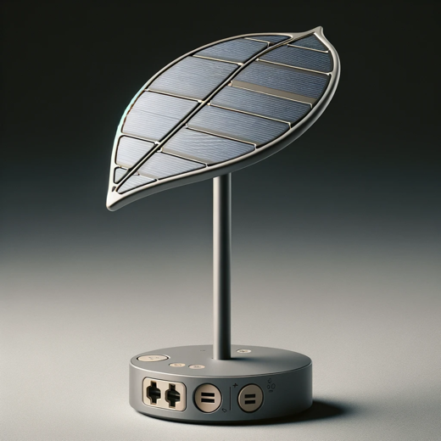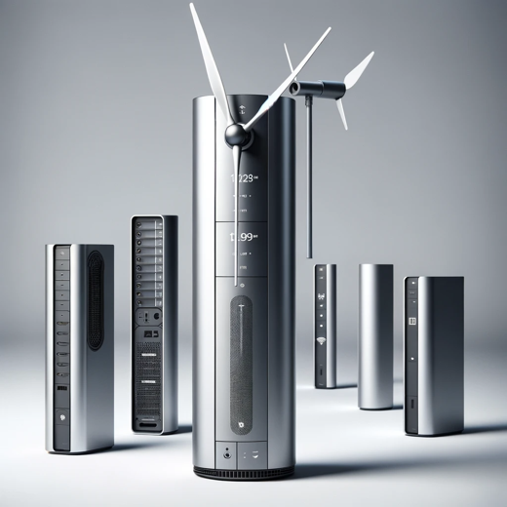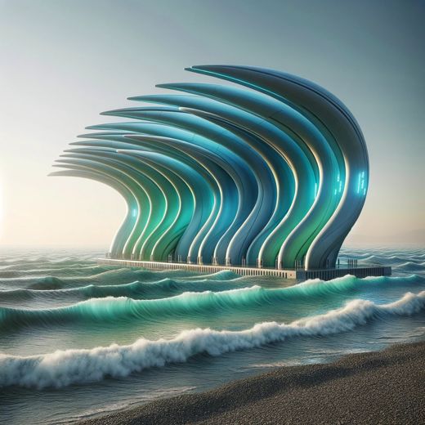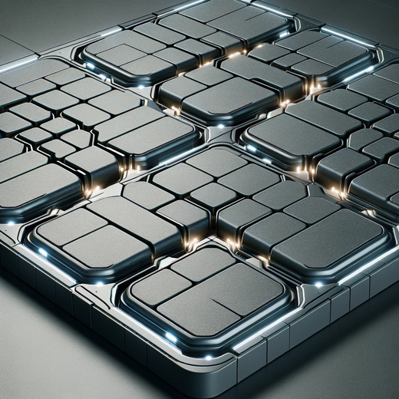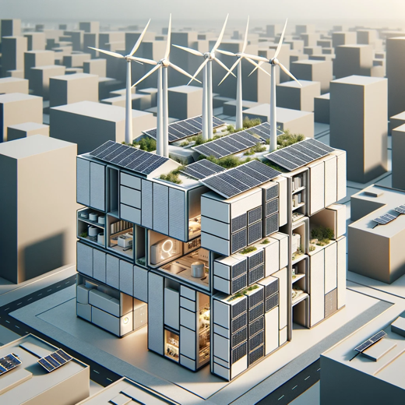

The visual concept diagrams for the energy harvesting designs have been created. Here are the visualizations for each design concept:

1. **Solar Panel Leaf**: A device shaped like a leaf with integrated solar panels and a stem-like battery pack.
2. **Wind Turbine Blade**: A vertical-axis wind turbine with a modern art sculpture aesthetic, featuring concealed battery storage and wireless charging capabilities.
3. **Tidal Wave Harvester**: A coastal energy harvesting device with wave-like structures to capture tidal energy.
4. **Kinetic Energy Pads**: Urban energy harvesting tiles that capture kinetic energy from pedestrian movement.
5. **Hybrid System**: A system that combines solar panels with wind turbines on an urban rooftop.

Each image represents a conceptual approach to combining sleek design with functionality for urban energy harvesting solutions.窗体顶端