**User:**

I am a Mechanical Designer, proficient in SolidWorks drafting, and a recent graduate of the University of New South Wales. I would like you to act as both a knowledgeable designer who can provide me with design expertise and a professional engineering designer who can act as a technical advisor to me when I have complex questions.

I like the minimalist and sleek design style of the energy harvesting device. It should look clean and modern without unnecessary details.

The energy harvesting device is planned to be deployed in a coastal urban environment in Australia. The design needs to take into account the city where it will be applied to ensure consistent energy output throughout the year. Installation must be straightforward. In terms of maintenance, the unit should be designed to minimise the need for frequent repairs and, where necessary, key components should be easily accessible.

The equipment must comply with Australian Standards for Electrical Equipment. The design should be compact to fit into the limited urban space where the installation is specified. Considering the budget of A$50,000, we should prioritise durable materials, balancing cost and longevity.

Based on the above background, I will be designing an energy harvesting device.

The energy harvesting device shall require three key modules:

1. The energy accumulation module functions to derive energy from an external source outside the energy harvesting device.

2. The energy storage module functions to store the accumulated energy inside the energy

harvesting device.

3. The energy utilization module utilizes the harvested energy to power other small devices such as sensors, heating/cooling devices, actuators, and low-power devices.

Please give me as many and reasonable and complete designs as possible.

**GPT:**

Designing an energy harvesting device, especially for a coastal urban environment in Australia, involves a multifaceted approach. Here, I'll provide guidance on each key module you mentioned, considering your requirements for a minimalist, sleek design, compliance with Australian Standards, budget constraints, and the specific urban environment.

**1. Energy Accumulation Module**

* **Design Consideration:** Since the device will be in a coastal urban area, solar panels could be an effective way to derive energy. Consider thin-film solar panels for their flexibility and sleek appearance.
* **Material Choice:** Opt for corrosion-resistant materials like anodized aluminum or stainless steel to withstand the coastal environment.
* **Integration:** Ensure the solar panels can be integrated into urban structures (like bus stops, benches, or rooftops) without being obtrusive.

**2. Energy Storage Module**

* **Battery Technology:** Lithium-ion or lithium-polymer batteries are compact and efficient for energy storage.
* **Design Aspect:** Incorporate a modular battery design for easy replacement or upgrades.
* **Protection:** Ensure robust casing to protect against environmental factors, such as humidity and salt spray.

**3. Energy Utilization Module**

* **Efficiency:** Design the circuitry for minimal energy loss during conversion and distribution.
* **Output Regulation:** Include a smart control system to regulate the output based on the requirements of the connected devices.
* **Connectivity:** Incorporate USB ports or wireless charging pads for versatility in powering devices.

**General Design Tips**

* **Aesthetics:** Adhere to a minimalist design with clean lines and a modern look. Avoid unnecessary protrusions or complex shapes.
* **Installation and Maintenance:** Design for easy installation, possibly using standard tools and techniques. Components that might need maintenance should be easily accessible.
* **Compliance:** Ensure the design meets Australian Standards for Electrical Equipment, focusing on safety and efficiency.
* **Budgeting:** Prioritize high-quality materials that offer durability. Consider the trade-off between initial cost and longevity.

**Prototyping and Testing**

* Before finalizing the design, create prototypes and test them in environments similar to your target location. This will help you understand real-world performance and necessary adjustments.

Remember, the success of such a device depends not only on its functionality but also on how well it blends into the urban landscape and meets the needs of its users. Keep iterating on your designs based on feedback and practical tests.

**User:**

Based on the information I provided earlier, are there any other details I should provide regarding the design of the energy harvesting device?

**GPT:**

Your initial brief for the energy harvesting device is comprehensive, covering key aspects such as design style, environmental considerations, technical requirements, and budget. However, to further refine the design and ensure it meets all your needs, you might consider providing additional details in the following areas:

**Specific Environmental Conditions**

* **Climate Data:** Detailed climate data for the coastal urban area, like average sunlight hours, wind patterns, and humidity levels, could influence design decisions, especially for the energy accumulation module.
* **Local Flora and Fauna:** Information about local wildlife or vegetation that might interact with or be affected by the device.

**Urban Integration**

* **Specific Urban Structures:** Identifying specific urban structures or locations where the device will be installed can influence its size, shape, and mounting mechanism.
* **Community Impact:** Considerations on how the device might affect or be perceived by the local community, including aesthetics and noise levels.

**Technical Specifications**

* **Energy Output Requirements:** Specific details about the amount of energy that needs to be harvested and stored.
* **Device Connectivity:** Requirements for connectivity with other devices or systems, such as smart city infrastructure.
* **Safety Features:** Any additional safety features that might be necessary, given the public nature of the installation.

**Sustainability and Lifecycle**

* **Material Sourcing:** Preferences or constraints regarding the sourcing of materials, focusing on sustainability.
* **Lifecycle Analysis:** Expectations regarding the lifespan of the device and its components, as well as end-of-life disposal or recycling plans.

**Regulatory and Compliance Factors**

* **Local Regulations:** Any local government or council regulations that might affect the installation or operation of the device.
* **Certification Requirements:** Specific certifications or compliance benchmarks beyond the Australian Standards for Electrical Equipment.

**Budget Allocation**

* **Cost Breakdown:** More detailed budget allocation, which could help in prioritizing different aspects of the design such as materials, technology, and manufacturing processes.

**User Interaction and Accessibility**

* **User Interface:** If the device will have an interface for user interaction, details about its functionality and design.
* **Accessibility:** Considerations for making the device accessible and usable by a diverse range of individuals, including those with disabilities.

Providing this additional information will help in creating a more targeted and efficient design, ensuring that the energy harvesting device not only meets your technical requirements but also fits seamlessly into its intended environment.

**User:**

The energy harvesting device is planned to be deployed in a coastal urban environment in Australia. The design needs to take into account the city where it will be applied to ensure consistent energy output throughout the year. Installation must be straightforward. In terms of maintenance, the unit should be designed to minimise the need for frequent repairs and, where necessary, key components should be easily accessible.

The equipment must comply with Australian Standards for Electrical Equipment. The design should be compact to fit into the limited urban space where the installation is specified. Considering the budget of A$50,000, we should prioritise durable materials, balancing cost and longevity.

Based on previous results and the above information, please give me as many, sensible and complete designs combining the 3 modules as possible.

**GPT:**

Creating multiple complete designs for your energy harvesting device within this text format is challenging, but I can outline various design approaches, each combining the three key modules (energy accumulation, storage, and utilization) while adhering to your specifications. For each design concept, I'll integrate these modules into a unified system suitable for a coastal urban environment in Australia.

**Design Concept 1: Solar-Powered Compact Unit**

* **Energy Accumulation:** Utilize high-efficiency, thin-film solar panels that can conform to urban structures.
* **Energy Storage:** Modular lithium-ion battery packs for ease of replacement and upgrade.
* **Energy Utilization:** Integrated smart circuitry to efficiently distribute energy to connected devices, with USB and wireless charging options.
* **Design Features:** Sleek, minimalistic casing using corrosion-resistant materials, easy to install on urban fixtures like bus stops or street lights.

**Design Concept 2: Wind and Solar Hybrid Unit**

* **Energy Accumulation:** Combination of small-scale vertical axis wind turbines and solar panels for diversified energy sourcing.
* **Energy Storage:** Compact, durable battery system, possibly using solid-state technology for improved safety.
* **Energy Utilization:** Adaptive energy distribution system with IoT connectivity for smart city integration.
* **Design Features:** Streamlined design with a small footprint for rooftop or pole mounting, easy access panels for maintenance.

**Design Concept 3: Kinetic Energy Harvester**

* **Energy Accumulation:** Harness kinetic energy from pedestrian foot traffic or small-scale wave motion, supplemented by solar panels.
* **Energy Storage:** Super-capacitor system for rapid charging and discharging, coupled with a long-life battery.
* **Energy Utilization:** Customizable output ports to support various urban applications, like lighting or digital displays.
* **Design Features:** Durable, non-slip surface for kinetic modules, weather-resistant housing, designed for ground-level or near-water installations.

**Design Concept 4: Modular, Scalable Unit**

* **Energy Accumulation:** Solar panels with optional add-on modules for wind or kinetic energy harvesting.
* **Energy Storage:** Scalable battery system allowing for expansion based on energy needs.
* **Energy Utilization:** Versatile energy output with remote monitoring and control capabilities.
* **Design Features:** Modular design for easy scalability, robust construction with tamper-proof enclosures, suitable for a variety of urban spaces.

**General Considerations for All Designs**

* **Compliance:** Each design complies with Australian Standards for Electrical Equipment.
* **Budgeting:** Focus on high-quality materials with a balance between cost and longevity, keeping within the A$50,000 budget.
* **Environmentally Friendly:** Use sustainable materials and design for energy efficiency.
* **Safety and Accessibility:** Ensure all designs are safe for public interaction and easily accessible for maintenance.

These concepts are starting points. Each can be further detailed and refined through iterative design processes, prototyping, and testing to ensure they meet all your requirements and integrate seamlessly into the intended urban environment.

**User:**

Based on the design 1,2,3,4 you gave me above, please generate 4 visual concept diagrams.

**GPT:**

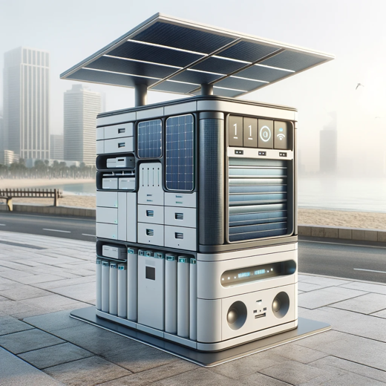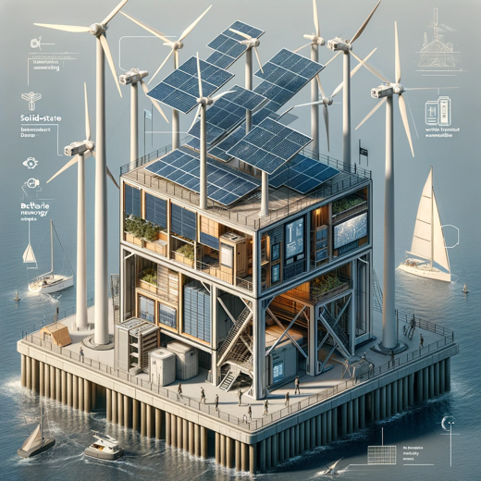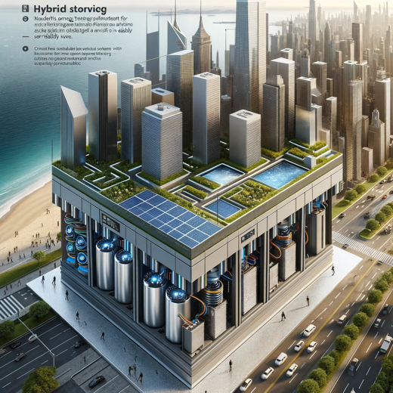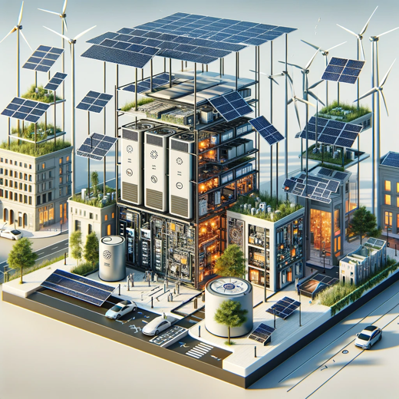

Here are the visual concept diagrams for the energy harvesting device designs:

1. Solar-Powered Compact Unit: This concept integrates solar panels into a compact design suitable for urban infrastructure like bus stops and benches.
2. Wind and Solar Hybrid Unit: A design that combines solar panels with vertical axis wind turbines, ideal for placement on urban building rooftops or along sidewalks.
3. Kinetic Energy Harvester: A street-level energy harvesting device that utilizes both kinetic and solar energy, designed for high foot traffic areas in coastal cities.
4. Modular, Scalable Unit: A scalable energy system with interchangeable solar and wind modules, featuring a sophisticated energy management unit for various urban demands.

Each diagram represents a unique approach to harvesting energy in urban coastal environments, reflecting the considerations for compactness, integration, and sustainability.