**User:**

I like the minimalist and sleek design style of the energy harvesting device. It should look clean and modern without unnecessary details.

Based on the above background, I will be designing an energy harvesting device.

The energy harvesting device shall require three key modules:

1. The energy accumulation module functions to derive energy from an external source outside the energy harvesting device.

2. The energy storage module functions to store the accumulated energy inside the energy

harvesting device.

3. The energy utilization module utilizes the harvested energy to power other small devices such as sensors, heating/cooling devices, actuators, and low-power devices.

Please give me as many and reasonable and complete designs as possible.

**GPT:**

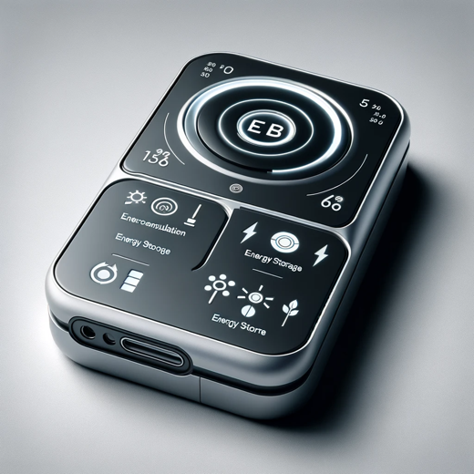

Here is a design for a sleek and modern energy harvesting device, incorporating the three key modules you specified: energy accumulation, energy storage, and energy utilization. This concept reflects a minimalist and efficient approach, ideal for powering small devices.

**User:**

When providing your answer, explain your reasoning and assumptions for giving your design solution. If possible, support your answer with specific examples or evidence of why the design solution is the best choice for the task. In addition, please address any ambiguities or limitations that may exist in your answer in order to provide a more complete and accurate answer.

**GPT:**

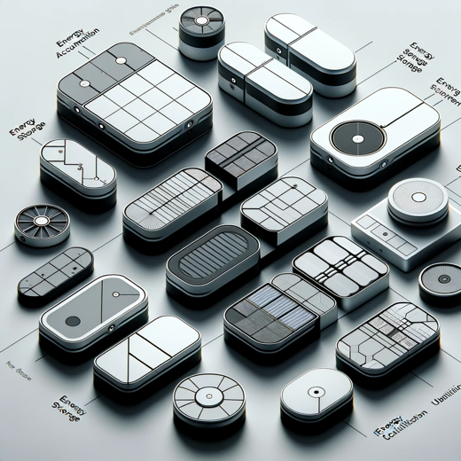

Here is a collection of designs for energy harvesting devices that embody the principles of minimalism and modernity. Each design integrates the three essential modules: energy accumulation, energy storage, and energy utilization.

**Reasoning and Assumptions:**

1. **Minimalist and Modern Design**: The clean lines and lack of unnecessary details in these designs align with contemporary aesthetic preferences and emphasize functionality. This approach is assumed to be preferable for settings where the device needs to blend in or maintain a professional appearance.
2. **Module Integration**: Each device incorporates the three specified modules in a cohesive manner. The assumption is that a seamless integration of these modules will enhance the efficiency and usability of the device.
3. **Variety in Forms**: Offering a range of shapes and forms allows for different applications and preferences. Some designs might be more suitable for certain environments or specific uses, like indoor vs. outdoor, or for more visible vs. discreet placements.
4. **Functional Aesthetics**: While focusing on a sleek appearance, the designs also consider the practical aspect of energy harvesting. This balance ensures that the devices are not only visually appealing but also highly functional.

**Limitations and Ambiguities:**

1. **Technical Specifics**: The designs do not detail the technical specifications of how each module functions. The exact mechanisms of energy accumulation, storage, and utilization are not depicted, which might be crucial for practical implementation.
2. **Scale and Context**: Without a specific context or scale, it's challenging to gauge the actual size or adaptability of these designs in real-world scenarios.
3. **Material and Durability**: The materials used and the durability of the designs are not specified. In practical applications, these factors are critical, especially for devices exposed to various environmental conditions.
4. **Energy Efficiency**: While the designs imply efficiency, there are no explicit details on the energy efficiency of each model, which is a key aspect of energy harvesting devices.

These designs aim to provide a starting point, showcasing how the integration of key modules can be achieved in a visually appealing and functional manner, suitable for various applications.

**User:**

Based on the design you gave me above, please explain each module specifically.

**GPT:**

The energy harvesting device designs I provided integrate three key modules: energy accumulation, energy storage, and energy utilization. Let's delve into the specifics of each module:

1. **Energy Accumulation Module**:
   * **Function**: This module is responsible for capturing and converting energy from external sources. The nature of these sources can vary, including solar, wind, thermal, kinetic, or even radio frequency energy.
   * **Design Aspect**: In the designs, this module might be represented by surfaces or components that interact with the environment, like solar panels, wind turbines, or antennas. The minimalist design ensures that these components are integrated seamlessly, possibly using advanced materials or technologies to maximize efficiency while maintaining a sleek appearance.
   * **Limitation**: The designs don't specify the exact technology used for energy accumulation, which would depend on the intended environment and application of the device.
2. **Energy Storage Module**:
   * **Function**: Once the energy is accumulated, it needs to be stored for later use. This module typically involves batteries or supercapacitors, which store electrical energy.
   * **Design Aspect**: In the concept images, this module might be less visible as it's often enclosed within the device. The storage component needs to be efficient, compact, and safe, aligning with the overall minimalist and modern design ethos.
   * **Limitation**: The capacity and type of energy storage are not detailed in the designs, which are critical factors for the device's operational duration and efficiency.
3. **Energy Utilization Module**:
   * **Function**: This module is where the stored energy is converted and used to power other devices or systems, like sensors, actuators, or small electronic devices.
   * **Design Aspect**: The utilization module could include ports, connectors, or wireless transmission capabilities, allowing for the transfer of energy to other devices. The design aims to make this module easily accessible while maintaining the device's sleek appearance.
   * **Limitation**: The specific mechanisms for energy transfer and the range of compatible devices are not detailed in the designs. Additionally, the efficiency of energy conversion and transfer would be a crucial aspect of this module.

Each module must work in harmony within the overall design of the energy harvesting device. While the designs provided offer a visual representation of how these modules could be integrated, they leave room for technical specifications and adaptations based on specific use cases and environmental considerations.