**User:**

I am a Mechanical Designer, proficient in SolidWorks drafting, and a recent graduate of the University of New South Wales. I would like you to act as both a knowledgeable designer who can provide me with design expertise and a professional engineering designer who can act as a technical advisor to me when I have complex questions.

Based on the above background, I will be designing an energy harvesting device.

The energy harvesting device shall require three key modules:

1. The energy accumulation module functions to derive energy from an external source outside the energy harvesting device.

2. The energy storage module functions to store the accumulated energy inside the energy

harvesting device.

3. The energy utilization module utilizes the harvested energy to power other small devices such as sensors, heating/cooling devices, actuators, and low-power devices.

Please give me as many and reasonable and complete designs as possible.

**GPT:**

Designing an energy harvesting device is an exciting and challenging project, especially considering the three key modules you've outlined: energy accumulation, storage, and utilization. Given your proficiency in SolidWorks and your background as a recent graduate in Mechanical Design, I'll provide a foundational concept for each module, keeping in mind the feasibility and effectiveness of the design.

**1. Energy Accumulation Module**

This module should be designed to efficiently capture energy from the chosen external source (e.g., solar, wind, vibration, thermal gradients). Here are some concepts:

* **Solar Panels**: If solar energy is the source, thin-film solar panels could be used for their flexibility and lightweight properties.
* **Piezoelectric Materials**: For vibration energy, piezoelectric materials can be used. They convert mechanical stress into electrical energy.
* **Thermoelectric Generators**: If harnessing thermal gradients, these devices can convert temperature differences directly into electricity.

**2. Energy Storage Module**

This module needs to safely and efficiently store the energy for later use. Considerations include:

* **Lithium-ion Batteries**: They offer high energy density and are commonly used in portable electronics.
* **Supercapacitors**: Ideal for quick charging and discharging cycles, they complement battery technology in hybrid systems.
* **Mechanical Storage Systems**: Such as flywheels, which store energy kinetically.

**3. Energy Utilization Module**

This module is crucial for effectively distributing the stored energy to power devices. Design elements might include:

* **Power Management Circuit**: It regulates the distribution of power and ensures efficient delivery to various devices.
* **Modular Connectors**: For versatility in powering different devices like sensors and actuators.
* **Voltage Regulators**: To adjust the output to meet the requirements of different devices.

**Integration and Prototyping**

* **CAD Modeling in SolidWorks**: Utilize your SolidWorks skills to create detailed models of each module, ensuring compatibility and integration.
* **Simulation and Analysis**: Use simulation tools to test and optimize the design for efficiency, durability, and safety.
* **Prototype Development**: Build a working prototype to test in real-world conditions, adjusting the design as needed.

**Design Considerations**

* **Scalability**: Ensure the design can be scaled up or down based on application needs.
* **Material Selection**: Choose materials that are durable, cost-effective, and suitable for the intended environment.
* **Efficiency**: Aim for a high energy conversion and storage efficiency.
* **Sustainability**: Consider the environmental impact of materials and the overall device.

As you proceed with your design, I'm here to provide further technical advice and to help troubleshoot any complex questions you might encounter. Remember, iterative design and testing are key to developing a successful energy harvesting device.

**User:**

When providing your answer, explain your reasoning and assumptions for giving your design solution. If possible, support your answer with specific examples or evidence of why the design solution is the best choice for the task. In addition, please address any ambiguities or limitations that may exist in your answer in order to provide a more complete and accurate answer.

**GPT:**

To provide you with comprehensive and well-reasoned design solutions for an energy harvesting device, let's delve deeper into each module, considering the principles of mechanical design, energy efficiency, and the practical constraints of such devices.

**1. Energy Accumulation Module**

Design Concepts:

* **Solar Panels (Photovoltaic Cells)**: They are a popular choice due to their ability to convert sunlight into electricity. The reasoning here is their efficiency, reliability, and the abundance of solar energy. Recent advancements have led to more efficient, flexible, and lighter solar cells, making them suitable for a variety of applications.
* **Piezoelectric Materials**: These materials generate electricity from mechanical stress, including vibrations or pressure changes. This choice is based on the ubiquity of vibrational energy in many environments, from industrial settings to ambient vibrations in urban areas.
* **Thermoelectric Generators**: They exploit temperature differences to produce electricity. This choice is pertinent in environments where thermal gradients are consistent and reliable, such as in industrial processes or environmental heat sources.

Limitations:

* Solar panels require sunlight, limiting their use in low-light conditions.
* Piezoelectric materials are efficient only in environments with consistent vibrations.
* Thermoelectric generators need a steady temperature gradient to be effective.

**2. Energy Storage Module**

Design Concepts:

* **Lithium-ion Batteries**: Chosen for their high energy density, which means they can store a significant amount of energy in a small, lightweight package. They are widely used in consumer electronics and electric vehicles, evidencing their reliability and efficiency.
* **Supercapacitors**: These are ideal for applications requiring rapid charge and discharge cycles. They complement batteries in scenarios where quick energy bursts are needed.
* **Mechanical Storage Systems (Flywheels)**: They store energy kinetically and are useful in scenarios where long-term energy storage and stability are required.

Limitations:

* Batteries have a limited lifespan and may suffer from reduced capacity over time.
* Supercapacitors, while excellent for quick energy bursts, have lower energy density compared to batteries.
* Mechanical storage systems are generally larger and more suited to stationary applications.

**3. Energy Utilization Module**

Design Concepts:

* **Power Management Circuit**: Essential for regulating the flow of energy to various devices. This module ensures that energy is not only distributed efficiently but also safely, preventing damage to connected devices.
* **Modular Connectors**: They provide the flexibility to connect a variety of devices, making the system adaptable to different applications.
* **Voltage Regulators**: Necessary to adjust the energy output to match the requirements of different low-power devices. This ensures compatibility and prevents overloading or under-powering the devices.

Limitations:

* Power management complexity increases with the number of connected devices.
* Modular connectors must be designed to accommodate a wide range of device interfaces.
* Voltage regulators add to the overall cost and complexity of the system.

**Integration and Prototyping**

* The use of SolidWorks for CAD modeling allows for precise design and simulation of components. It's an industry-standard software, ensuring compatibility with other professional tools and platforms.
* Simulations, particularly finite element analysis (FEA) and computational fluid dynamics (CFD), are crucial for predicting the performance and identifying potential failure points before physical prototyping.
* Creating a prototype is essential to validate the design in real-world conditions, allowing for adjustments based on actual performance data.

**Overall Design Considerations**

* The designs proposed here aim to balance efficiency, reliability, and practicality.
* Material choice and system architecture are geared towards ensuring durability and adaptability to different environments.
* The limitations noted are inherent to the current state of technology and material science. Future advancements may alleviate some of these constraints.

By considering these factors, the design solutions provided aim to be both innovative and grounded in practical application, addressing the current technological landscape and foreseeable challenges.

**User:**

Based on the scenario you gave me above, please generate a visual concept diagram.

**GPT:**

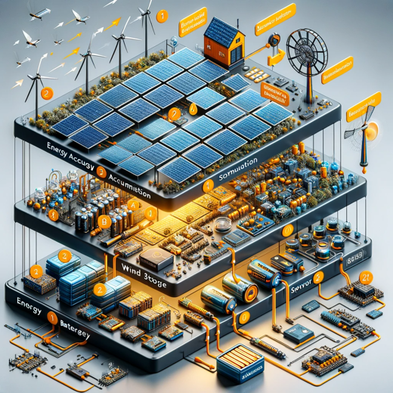

Here is the visual concept diagram for the energy harvesting device, showcasing the three modules: energy accumulation, energy storage, and energy utilization, with the flow of energy indicated.