**User:**

The equipment must comply with Australian Standards for Electrical Equipment. The design should be compact to fit into the limited urban space where the installation is specified. Considering the budget of A$50,000, we should prioritise durable materials, balancing cost and longevity.

Based on the above background, I will be designing an energy harvesting device.

The energy harvesting device shall require three key modules:

1. The energy accumulation module functions to derive energy from an external source outside the energy harvesting device.

2. The energy storage module functions to store the accumulated energy inside the energy

harvesting device.

3. The energy utilization module utilizes the harvested energy to power other small devices such as sensors, heating/cooling devices, actuators, and low-power devices.

Please give me as many and reasonable and complete designs as possible.

**GPT:**

Designing an energy harvesting device that fits your specified requirements is an intricate task that involves multiple stages of conceptualization and engineering. While I can help with generating conceptual design ideas, the detailed engineering design and compliance with Australian Standards for Electrical Equipment would require professional engineering expertise. Here are some conceptual designs for the energy harvesting device, focusing on its three key modules:

1. **Energy Accumulation Module Design Ideas:**
   * Solar Panel Integration: A compact solar panel array on the top surface, optimized for urban settings with limited sunlight exposure.
   * Wind Turbine Attachment: A small, vertical-axis wind turbine that can operate in low wind speeds, ideal for urban environments.
   * Kinetic Energy Harvester: Utilizes movement or vibrations in the urban setting (like from vehicles or pedestrians) to generate energy.
2. **Energy Storage Module Design Ideas:**
   * Lithium-ion Battery Pack: A high-density, compact lithium-ion battery for efficient energy storage.
   * Supercapacitor Integration: Supercapacitors for rapid charging and discharging, complementing the battery pack for energy storage.
   * Modular Storage Design: Allows for easy expansion or replacement of storage components as technology advances or storage needs change.
3. **Energy Utilization Module Design Ideas:**
   * Smart Control System: An integrated circuit to manage the distribution of stored energy to various devices efficiently.
   * Modular Output Ports: Various output ports (like USB, DC output) to power different types of small devices.
   * Wireless Energy Transmission: Incorporate wireless charging capabilities for compatible devices, reducing the need for cables.

Each of these modules should be designed with a focus on compactness, durability, and cost-effectiveness, adhering to your budget of A$50,000. The materials chosen should balance initial cost with long-term durability and maintenance needs.

Remember, these are high-level design ideas. Detailed designs would require iterative development, prototyping, and testing, especially to ensure compliance with Australian electrical standards and fitting the device into the limited urban space efficiently. Consulting with a professional engineer specializing in renewable energy systems would be a crucial next step.

**User:**

When providing your answer, explain your reasoning and assumptions for giving your design solution. If possible, support your answer with specific examples or evidence of why the design solution is the best choice for the task. In addition, please address any ambiguities or limitations that may exist in your answer in order to provide a more complete and accurate answer.

**GPT:**

To create a comprehensive design for an energy harvesting device that aligns with your criteria, let's delve into each module with detailed reasoning, supported by examples and addressing potential limitations:

**Energy Accumulation Module**

Design Ideas:

1. **Solar Panel Array:**
   * **Reasoning:** Solar panels are efficient, widely used, and suitable for urban environments. They provide a reliable source of energy, especially in Australia, known for its high solar irradiance.
   * **Example:** The University of New South Wales, a leader in solar energy research, has developed highly efficient solar cells, demonstrating the potential of solar technology in Australia.
   * **Limitation:** Solar panels require direct sunlight and can be less effective on cloudy days or in shaded urban areas.
2. **Vertical-Axis Wind Turbine:**
   * **Reasoning:** These turbines are compact and can operate in the turbulent wind common in urban areas. They are less noisy and have a smaller footprint compared to traditional turbines.
   * **Example:** Urban Green Energy (UGE) offers vertical-axis wind turbines specifically designed for urban environments.
   * **Limitation:** The energy output can be lower than large-scale wind turbines and inconsistent due to variable urban wind patterns.
3. **Kinetic Energy Harvester:**
   * **Reasoning:** This harnesses energy from vibrations and movements, which are abundant in urban settings (e.g., from traffic or pedestrian movement).
   * **Example:** Companies like Pavegen have developed flooring systems that convert footsteps into electricity, suitable for high-footfall urban areas.
   * **Limitation:** The energy output is relatively low and heavily dependent on the volume of movement or vibrations.

**Energy Storage Module**

Design Ideas:

1. **Lithium-ion Battery Pack:**
   * **Reasoning:** They offer a good balance between energy density, weight, and longevity. This is crucial for compact urban installations.
   * **Example:** Tesla Powerwall, a widely used home energy storage solution, employs lithium-ion batteries for their efficiency and compact size.
   * **Limitation:** Higher initial cost and the need for careful management to avoid issues like overheating.
2. **Supercapacitor Integration:**
   * **Reasoning:** Supercapacitors provide rapid energy discharge and charge cycles, complementing lithium-ion batteries for short-term energy demands.
   * **Example:** Maxwell Technologies offers ultracapacitors that are used in regenerative braking systems in vehicles, showcasing their rapid charge/discharge capability.
   * **Limitation:** Lower energy density compared to batteries, making them unsuitable for long-term energy storage.
3. **Modular Storage Design:**
   * **Reasoning:** Allows for flexibility in storage capacity and easy maintenance or upgrades.
   * **Example:** Enphase Energy's modular battery systems demonstrate how such designs can be effectively implemented.
   * **Limitation:** May increase complexity and cost of the overall system.

**Energy Utilization Module**

Design Ideas:

1. **Smart Control System:**
   * **Reasoning:** Efficiently manages the distribution and usage of stored energy, optimizing for various load demands.
   * **Example:** Smart home energy systems, like those developed by Schneider Electric, use similar technology for energy management.
   * **Limitation:** Complexity in programming and potential for software glitches or malfunctions.
2. **Modular Output Ports:**
   * **Reasoning:** Provides flexibility in powering a variety of devices, crucial for diverse urban applications.
   * **Example:** Portable solar generators often feature various output ports for versatility.
   * **Limitation:** Physical space constraints in a compact design.
3. **Wireless Energy Transmission:**
   * **Reasoning:** Reduces the need for physical connections, allowing for more flexible device placement.
   * **Example:** Qi wireless charging technology used in smartphones is an instance of such technology being effectively utilized.
   * **Limitation:** Lower efficiency and limited range compared to wired connections.

**Budget Consideration (A$50,000)**

* **Cost-effective materials** like polycarbonate for housing (durable and cheaper than metals) and standard electronic components should be used.
* **Modular design** allows for cost savings in maintenance and upgrades.

**Conclusion**

Each design idea is tailored to fit within the constraints of urban space, budget, and longevity. However, each module has inherent limitations that need to be balanced. The final design should be a hybrid system, combining these elements to optimize energy harvesting, storage, and utilization. For detailed engineering and compliance with Australian standards, collaboration with professional engineers and regulatory experts is recommended.

**User:**

Based on the scenario you gave me above, please generate a visual concept diagram.

**GPT:**

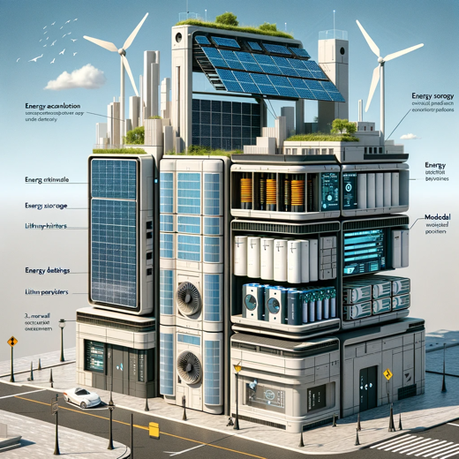

Here is a visual concept diagram reflecting the urban energy harvesting device based on the scenarios provided.