**User:**

For this project, I favoured a bio-inspired design approach, using principles found in nature to optimise energy harvesting.

Based on the above background, I will be designing an energy harvesting device.

The energy harvesting device shall require three key modules:

1. The energy accumulation module functions to derive energy from an external source outside the energy harvesting device.

2. The energy storage module functions to store the accumulated energy inside the energy

harvesting device.

3. The energy utilization module utilizes the harvested energy to power other small devices such as sensors, heating/cooling devices, actuators, and low-power devices.

Please give me as many and reasonable and complete designs as possible.

**GPT:**

Designing an energy harvesting device inspired by bio-inspired principles is an exciting and innovative approach. Here's how we can conceptualize the design:

1. **Energy Accumulation Module**: This part will mimic nature's way of gathering energy. For instance, it could be designed like leaves of a plant, using solar cells for solar energy harvesting. Another idea is to imitate how certain plants or animals capture wind or water flow for energy.
2. **Energy Storage Module**: This module should efficiently store the gathered energy. It can be inspired by the way animals store fat or how plants store energy in the form of sugars. This could be translated into a compact, high-efficiency battery system or a bio-inspired supercapacitor.
3. **Energy Utilization Module**: This part will distribute the stored energy to power devices. It could be designed to mimic the human body's circulatory system, ensuring efficient energy distribution to the connected devices.

For the overall design, consider integrating these modules into a seamless, nature-inspired form. Think about how a tree combines roots, trunk, and leaves into a functional whole. The device could have a central hub (trunk) with extendable parts (branches) that house the accumulation and utilization modules.

Each module should have a distinct but complementary design, reflecting its unique function while maintaining a cohesive aesthetic that speaks to the natural inspiration behind the project.

Let's create a conceptual illustration of this energy harvesting device. The image will showcase the three key modules with a bio-inspired design, integrating elements that resemble natural structures like leaves, branches, and organic forms.

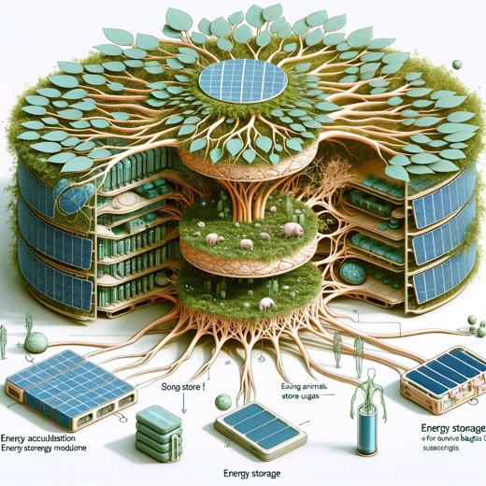

Here's a conceptual illustration of the bio-inspired energy harvesting device. This design integrates the three key modules you described: the Energy Accumulation Module, the Energy Storage Module, and the Energy Utilization Module, all within a nature-inspired structure. Feel free to use this as a visual reference for your project.

**User:**

When providing your answer, explain your reasoning and assumptions for giving your design solution. If possible, support your answer with specific examples or evidence of why the design solution is the best choice for the task. In addition, please address any ambiguities or limitations that may exist in your answer in order to provide a more complete and accurate answer.

**GPT:**

Designing a bio-inspired energy harvesting device involves integrating principles from nature with technological advancements. Let's explore various designs, each with a unique approach to the three key modules: energy accumulation, energy storage, and energy utilization. For each design, I will explain the reasoning, assumptions, and potential limitations.

**Design 1: Solar Leaf Energy Harvester**

Energy Accumulation Module

* **Design**: Mimics the structure of a leaf, using photovoltaic cells.
* **Reasoning**: Leaves efficiently capture sunlight for photosynthesis. Similarly, this module uses solar cells to harvest solar energy.
* **Limitation**: Solar energy is dependent on weather conditions and daylight hours.

Energy Storage Module

* **Design**: Bio-inspired battery resembling plant cells storing energy as starch.
* **Reasoning**: Plants store energy efficiently; a similar design in batteries can provide high energy density.
* **Limitation**: The complexity of mimicking biological storage at a molecular level.

Energy Utilization Module

* **Design**: Network of conductive veins, similar to a leaf's vein structure.
* **Reasoning**: Ensures efficient distribution of energy, like nutrients in a leaf.
* **Limitation**: The design may be complex and require advanced manufacturing techniques.

**Design 2: Wind Tree Energy Harvester**

Energy Accumulation Module

* **Design**: Branch-like structures with mini turbines.
* **Reasoning**: Trees withstand and utilize wind; similarly, these structures can capture wind energy.
* **Limitation**: Effectiveness varies with wind availability and strength.

Energy Storage Module

* **Design**: Central trunk-like battery.
* **Reasoning**: Centralized storage for easy maintenance and stability.
* **Limitation**: Limited by the capacity and life of current battery technologies.

Energy Utilization Module

* **Design**: Root-like cables distributing energy.
* **Reasoning**: Mimics roots spreading nutrients, ensures stable energy distribution.
* **Limitation**: Installation may be complex and invasive.

**Design 3: Biochemical Energy Harvester**

Energy Accumulation Module

* **Design**: Enzyme-based bio-reactors.
* **Reasoning**: Some bacteria and plants use enzymes to convert chemical energy.
* **Limitation**: Bio-reactors may require specific environmental conditions to function effectively.

Energy Storage Module

* **Design**: Organic compound storage.
* **Reasoning**: Similar to how animals store energy chemically, offers potential for high-density storage.
* **Limitation**: The technology for such storage is still emerging.

Energy Utilization Module

* **Design**: Capillary action-inspired distribution.
* **Reasoning**: Capillaries distribute nutrients efficiently; a similar design can ensure even energy distribution.
* **Limitation**: Complexity in replicating such a fine-tuned natural process.

**General Considerations and Limitations**

* **Technological Feasibility**: These designs often push the boundaries of current technology and may require significant research and development.
* **Cost**: Bio-inspired designs might be more expensive to produce than traditional designs.
* **Maintenance**: Natural structures can be complex, making maintenance and repair challenging.
* **Scalability**: Some designs might be more suited for small-scale applications and may not scale up efficiently.

These designs aim to blend nature's efficiency with modern technology, offering innovative solutions for energy harvesting. Each design has its unique strengths and challenges, providing a range of options depending on specific requirements and environmental conditions.

**User:**

Based on the scenario you gave me above, please generate a visual concept diagram.

**GPT:**

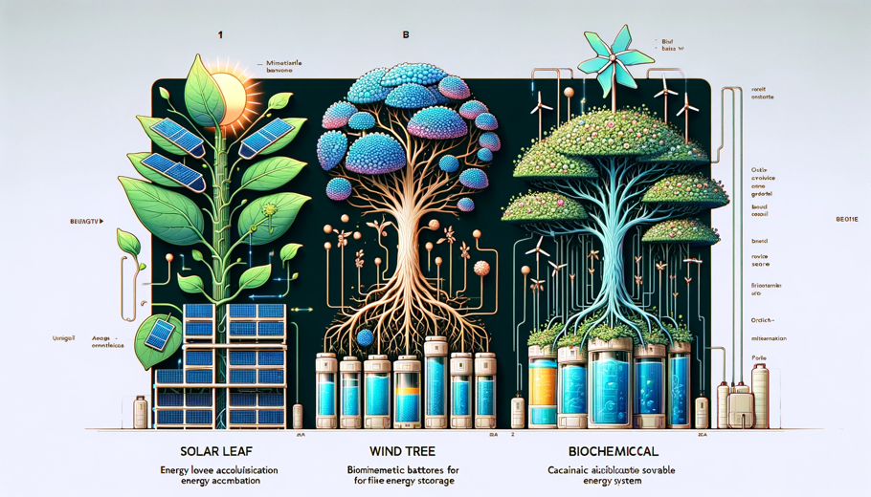

The visual concept diagram for the bio-inspired energy harvesting device is ready. It depicts the three designs: Solar Leaf, Wind Tree, and Biochemical Harvester, each with its energy accumulation, storage, and utilization modules.