**User:**

I am a Mechanical Designer, proficient in SolidWorks drafting, and a recent graduate of the University of New South Wales. I would like you to act as both a knowledgeable designer who can provide me with design expertise and a professional engineering designer who can act as a technical advisor to me when I have complex questions.

The energy harvesting device is planned to be deployed in a coastal urban environment in Australia. The design needs to take into account the city where it will be applied to ensure consistent energy output throughout the year. Installation must be straightforward. In terms of maintenance, the unit should be designed to minimise the need for frequent repairs and, where necessary, key components should be easily accessible.

Based on the above background, I will be designing an energy harvesting device.

The energy harvesting device shall require three key modules:

1. The energy accumulation module functions to derive energy from an external source outside the energy harvesting device.

2. The energy storage module functions to store the accumulated energy inside the energy

harvesting device.

3. The energy utilization module utilizes the harvested energy to power other small devices such as sensors, heating/cooling devices, actuators, and low-power devices.

Please give me as many and reasonable and complete designs as possible.

**GPT:**

Designing an energy harvesting device for deployment in a coastal urban environment in Australia is an exciting and challenging task. Given your proficiency in SolidWorks drafting and mechanical design, you are well-equipped to undertake this project. I'll provide guidance considering your expertise and the project's requirements.

**Design Considerations**

1. **Environmental Factors**: Coastal environments can be harsh due to saltwater, humidity, and wind. Materials should be corrosion-resistant, and the design should withstand these conditions.
2. **Consistent Energy Output**: Since the device will be used throughout the year, it should be capable of harvesting energy efficiently under various weather conditions.
3. **Ease of Installation and Maintenance**: The design should be simple enough to install without specialized equipment. Maintenance should be minimal, and key components must be easily accessible.
4. **Integration with Urban Environment**: The device should blend well with the urban landscape, possibly utilizing existing structures for mounting.

**Suggested Design Modules**

1. Energy Accumulation Module

* **Solar Panels**: Ideal for sunny Australian climate. Consider flexible, thin-film solar panels for ease of integration with various surfaces.
* **Wind Turbines**: Small-scale turbines can harness coastal winds. Vertical-axis turbines might be preferable for their lower noise levels and bird-friendliness.
* **Vibration Energy Harvesters**: To capture energy from urban vibrations (e.g., from bridges, buildings).

2. Energy Storage Module

* **Batteries**: Lithium-ion or lithium-polymer for high energy density. Ensure they are housed in a waterproof and heat-resistant compartment.
* **Supercapacitors**: For quick energy release, which can be useful for powering devices that require sudden bursts of energy.

3. Energy Utilization Module

* **Regulators and Converters**: To ensure the energy is delivered in the right voltage and current for various devices.
* **Smart Controllers**: To optimize energy distribution based on the demand of connected devices.

**Additional Design Features**

* **Modularity**: Design the device in modules for easy replacement and upgrades.
* **Remote Monitoring Capability**: Incorporate IoT elements for remote diagnostics and performance tracking.
* **Energy-Efficient Electronics**: To minimize the device's own energy consumption.

**Visualization and Prototyping**

Since you are proficient in SolidWorks, creating detailed 3D models of each module would be a beneficial next step. This allows for visualization, virtual testing, and identification of potential design flaws before moving to prototyping.

**Collaboration and Expert Consultation**

Given the interdisciplinary nature of this project, consulting with experts in renewable energy, material science, and urban planning might provide valuable insights that could refine your design further.

Remember, while creating multiple complete designs might be ideal, it's also important to focus on refining a few feasible ones. Each design iteration should bring you closer to a solution that balances efficiency, durability, and practicality in the urban coastal environment.

**User:**

When providing your answer, explain your reasoning and assumptions for giving your design solution. If possible, support your answer with specific examples or evidence of why the design solution is the best choice for the task. In addition, please address any ambiguities or limitations that may exist in your answer in order to provide a more complete and accurate answer.

**GPT:**

Certainly, let's delve deeper into the design considerations for your energy harvesting device, providing reasoning and addressing potential ambiguities and limitations.

**1. Environmental Factors: Coastal Urban Environment**

* **Reasoning**: Coastal environments are characterized by high humidity, saltwater spray, and possibly strong winds. These conditions can lead to corrosion and material degradation.
* **Design Solution**: Use corrosion-resistant materials like stainless steel or anodized aluminum. Additionally, protective coatings can be applied to sensitive components.
* **Limitations**: These materials and coatings might increase the cost. Also, protective measures might need regular maintenance to remain effective.

**2. Consistent Energy Output**

* **Reasoning**: The device should be reliable throughout the year, adapting to varying weather conditions.
* **Design Solution**: Combining solar panels with wind turbines ensures energy harvesting in both sunny and windy conditions. Solar panels are effective during sunny days, common in Australia, while wind turbines can harness energy during overcast or stormy weather.
* **Limitations**: The efficiency of solar panels drops during overcast conditions, and wind turbines require a minimum wind speed to be effective. Energy storage becomes critical to buffer these fluctuations.

**3. Ease of Installation and Maintenance**

* **Reasoning**: The device should be user-friendly, not requiring specialized tools or knowledge for installation or maintenance.
* **Design Solution**: Modular design with plug-and-play components. Regular maintenance points should be easily accessible.
* **Limitations**: Modular designs can be more complex and expensive to develop. Also, ensuring robust electrical connections in modular designs can be challenging.

**4. Integration with Urban Environment**

* **Reasoning**: The device should not be obtrusive or disrupt the urban aesthetic.
* **Design Solution**: Sleek, compact design possibly using existing structures for mounting (like buildings or lamp posts). For solar panels, building-integrated photovoltaics (BIPV) could be used.
* **Limitations**: BIPV and custom designs to integrate with urban structures can increase costs. There may also be regulatory hurdles in modifying existing structures.

**Energy Accumulation Module**

* **Solar Panels**: Chosen for Australia's abundant sunshine. Thin-film panels are less efficient than traditional panels but offer greater flexibility in integration.
* **Wind Turbines**: Coastal areas often have consistent wind, making small-scale turbines viable. Vertical-axis turbines are quieter and safer for birds, important in urban environments.
* **Limitations**: Solar panels' efficiency varies with sunlight intensity. Wind turbines have a threshold wind speed for operation and can be affected by urban structures.

**Energy Storage Module**

* **Batteries vs Supercapacitors**: Batteries offer higher energy density but slower discharge/charge cycles. Supercapacitors are ideal for quick energy release.
* **Limitations**: Battery life degrades over time, and both batteries and supercapacitors have temperature sensitivity.

**Energy Utilization Module**

* **Smart Controllers**: To optimize energy distribution, ensuring efficient use of harvested energy.
* **Limitations**: Smart systems add complexity and may require software updates and cybersecurity measures.

**Additional Considerations**

* **Remote Monitoring**: Adds convenience but requires a reliable network connection and potentially raises data security concerns.
* **Energy-Efficient Electronics**: Reduces the device's power consumption but may increase upfront costs.

In summary, the proposed design aims to balance efficiency, durability, and practicality, considering the unique challenges of a coastal urban environment. The limitations mainly revolve around cost, technological complexity, and environmental factors. Regular review and iteration of the design based on testing and feedback will be crucial to address these challenges effectively.

**User:**

Based on the scenario you gave me above, please generate a visual concept diagram.

**GPT:**

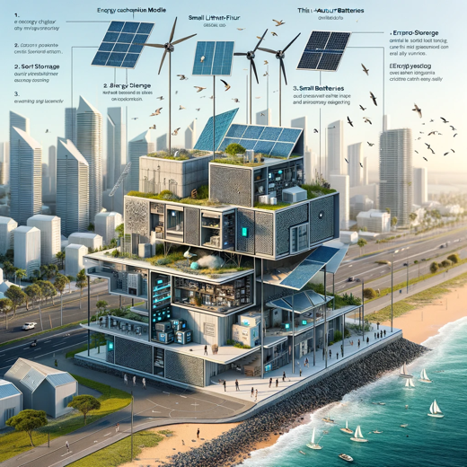

Here is the visual concept diagram for the energy harvesting device designed for a coastal urban environment. It illustrates the integration of the three key modules: energy accumulation, storage, and utilization, along with their placement in an urban setting.