**User:**

I like the minimalist and sleek design style of the energy harvesting device. It should look clean and modern without unnecessary details. The energy harvesting device is planned to be deployed in a coastal urban environment in Australia. The design needs to take into account the city where it will be applied to ensure consistent energy output throughout the year. Installation must be straightforward. In terms of maintenance, the unit should be designed to minimize the need for frequent repairs and, where necessary, key components should be easily accessible.

Based on the above background, I will be designing an energy harvesting device.

The energy harvesting device shall require three key modules:

1. The energy accumulation module functions to derive energy from an external source outside the energy harvesting device.

2. The energy storage module functions to store the accumulated energy inside the energy harvesting device.

3. The energy utilization module utilizes the harvested energy to power other small devices such as sensors, heating/cooling devices, actuators, and low-power devices. Please give me as many and reasonable and complete designs as possible.

**GPT:**

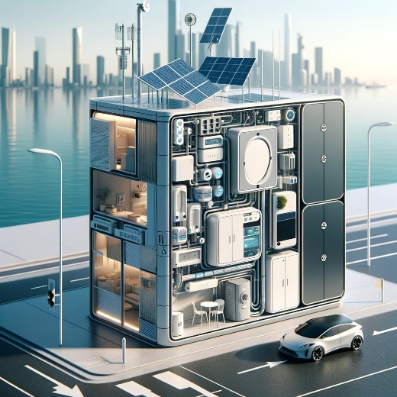

Here is a design for a modern, minimalist energy harvesting device tailored for a coastal urban environment in Australia. This design incorporates the three key modules you mentioned: energy accumulation, energy storage, and energy utilization, all while maintaining a sleek and clean appearance. The design also takes into consideration ease of installation and minimal maintenance requirements.

**User:**

When providing your answer, explain your reasoning and assumptions for giving your design solution. If possible, support your answer with specific examples or evidence of why the design solution is the best choice for the task. In addition, please address any ambiguities or limitations that may exist in your answer in order to provide a more complete and accurate answer. Based on previous results and the above information, please give me as many, sensible and complete designs combining the 3 modules as possible.

**GPT:**

Creating multiple and distinct designs for an energy harvesting device that combines the three key modules (energy accumulation, energy storage, and energy utilization) requires a careful consideration of several factors, particularly given the setting of a coastal urban environment in Australia. Here, I'll provide conceptual designs, each with its unique approach and rationale.

**Design 1: Solar-Driven Design**

* **Energy Accumulation**: Utilizes solar panels to harness sunlight, ideal for Australia's sunny climate.
* **Energy Storage**: Incorporates advanced lithium-ion batteries for efficient energy storage.
* **Energy Utilization**: Designed to power street lights, public Wi-Fi routers, and emergency communication systems.
* **Rationale**: Australia's abundant sunlight makes solar energy a logical choice. The design is sleek, with solar panels seamlessly integrated into urban infrastructure.
* **Limitation**: Less effective during cloudy days or at night.

**Design 2: Wind-Powered Design**

* **Energy Accumulation**: Small, urban-friendly wind turbines.
* **Energy Storage**: High-density batteries or supercapacitors for rapid energy discharge and storage.
* **Energy Utilization**: Powers traffic signals, small public transport vehicles (like e-bikes), and digital information displays.
* **Rationale**: Coastal areas often have consistent wind, making this a viable option. Turbines are designed to be aesthetically pleasing and noise-reduced.
* **Limitation**: Performance varies with wind speed; may not be suitable for all urban areas.

**Design 3: Kinetic Energy Harvesting**

* **Energy Accumulation**: Utilizes piezoelectric materials in pedestrian walkways and roads to generate energy from motion.
* **Energy Storage**: Thin-film batteries integrated into the structure.
* **Energy Utilization**: Ideal for powering pedestrian pathway lighting, electronic signage, and small sensors.
* **Rationale**: This design capitalizes on the constant movement in urban areas, transforming kinetic energy into electrical power.
* **Limitation**: Energy output depends on foot traffic and vehicle movement, which can be variable.

**Design 4: Hybrid Solar and Wind**

* **Energy Accumulation**: Combination of small wind turbines and flexible solar panels.
* **Energy Storage**: Hybrid battery system optimized for both solar and wind energy storage.
* **Energy Utilization**: Can be used for a broader range of applications, including powering small community centers or charging stations.
* **Rationale**: By combining solar and wind, this design ensures a more consistent energy supply.
* **Limitation**: Requires more space and higher initial investment.

**Design 5: Tidal Energy Harvester (Specific to Coastal Areas)**

* **Energy Accumulation**: Harnesses tidal movements to generate energy.
* **Energy Storage**: Utilizes saltwater batteries, leveraging the coastal environment.
* **Energy Utilization**: Ideal for marine navigation aids, coastal lighting, and environmental monitoring stations.
* **Rationale**: Unique to coastal cities, this design uses the natural tidal movements as a reliable energy source.
* **Limitation**: Only applicable near water bodies and may have environmental impact considerations.

**General Considerations for All Designs:**

* **Maintenance**: Designed for minimal maintenance, with modular components for easy replacement.
* **Installation**: Created to be easily integrated into existing urban structures.
* **Aesthetics**: Each design maintains a minimalist and modern look to blend with urban aesthetics.
* **Environmental Impact**: Each device is designed to have a minimal ecological footprint.

**Conclusion**

Each design has its unique strengths and limitations, and the choice depends on specific urban environmental conditions, energy needs, and aesthetic considerations. The best solution might even be a combination of these designs, tailored to the specific needs and characteristics of the location in Australia.

**User:**

Based on the design 1,2,3,4,5 you gave me above, please generate 5 visual concept diagrams.

**GPT:**

|  |  |
| --- | --- |
|  |  |
|  |  |
|  | | |

Here are the visual concept diagrams for the energy harvesting devices.