**User:**

I like the minimalist and sleek design style of the energy harvesting device. It should look clean and modern without unnecessary details. For this project, I favored a bio-inspired design approach, using principles found in nature to optimize energy harvesting.

Based on the above background, I will be designing an energy harvesting device.

The energy harvesting device shall require three key modules:

1. The energy accumulation module functions to derive energy from an external source outside the energy harvesting device.

2. The energy storage module functions to store the accumulated energy inside the energy harvesting device.

3. The energy utilization module utilizes the harvested energy to power other small devices such as sensors, heating/cooling devices, actuators, and low-power devices. Please give me as many and reasonable and complete designs as possible.

**GPT:**

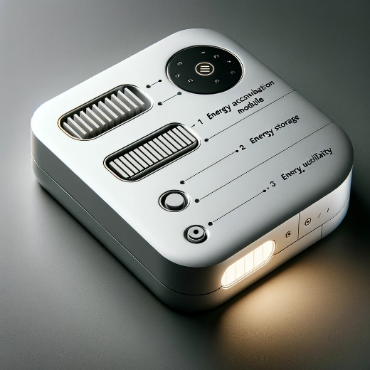

Here is a design of an energy harvesting device that reflects a minimalist and sleek style, inspired by bio-design principles. This concept includes the three key modules you specified: energy accumulation, storage, and utilization, designed to be modern and functional while maintaining a clean appearance.

**User:**

When providing your answer, explain your reasoning and assumptions for giving your design solution. If possible, support your answer with specific examples or evidence of why the design solution is the best choice for the task. In addition, please address any ambiguities or limitations that may exist in your answer in order to provide a more complete and accurate answer.

Based on previous results and the above information, please give me as many, sensible and complete designs combining the 3 modules as possible.

**GPT:**

Creating multiple and varied designs for an energy harvesting device with the specified modules is a complex task that involves considering various factors. Here's an explanation of the reasoning and assumptions behind the design approach:

1. **Design Philosophy: Minimalist and Bio-Inspired**
   * **Minimalism:** The design is clean and simple, focusing on functionality without unnecessary embellishments. This approach often leads to more efficient use of materials and space, potentially improving the device's energy efficiency.
   * **Bio-Inspired:** Using principles found in nature can lead to innovative solutions. For example, the shape of the device might mimic natural forms like leaves or wings to maximize energy capture from environmental sources like wind or solar.
2. **Module Integration:**
   * **Energy Accumulation Module:** This could take various forms depending on the energy source – solar panels for solar energy, wind turbines for wind energy, etc. The design should integrate this module seamlessly, considering the most efficient shape and placement for energy capture.
   * **Energy Storage Module:** Assuming the use of batteries or capacitors, this module should be compact yet accessible for maintenance or replacement. Its placement should consider safety and temperature regulation.
   * **Energy Utilization Module:** This module should have easy connectivity options for powering various devices. It should be adaptable to different power requirements and ensure efficient energy transfer.
3. **Limitations and Ambiguities:**
   * **Technical Feasibility:** The actual feasibility of the design depends on current technology and materials. Some bio-inspired concepts might not yet be practical.
   * **Energy Efficiency:** While the design aims for efficiency, the actual performance can vary based on environmental factors and the type of energy being harvested.
   * **Cost and Manufacturability:** The designs might be more complex to manufacture, affecting cost and scalability.

Given these considerations, let's create a range of design concepts that integrate these three modules in various sensible and effective ways. Each design will be a different interpretation of how these modules can be combined, keeping in mind the minimalist and bio-inspired approach.

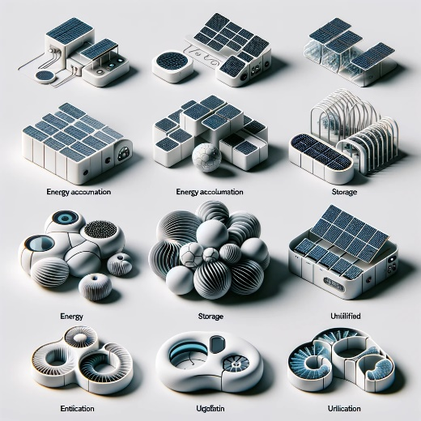

Here are several design concepts for the energy harvesting device, each integrating the three key modules: energy accumulation, storage, and utilization. These designs are varied in their approach but adhere to the minimalist and bio-inspired philosophy, showcasing different shapes and configurations that emphasize efficiency, functionality, and a clean, modern aesthetic.

**User:**

Based on the design you gave me above, please explain each module specifically.

**GPT:**

Certainly! Let's break down the design concept into its three key modules, explaining the role and functionality of each within the context of the energy harvesting device:

1. **Energy Accumulation Module:**
   * **Function:** This module is responsible for capturing or deriving energy from external sources. The type of energy captured can vary depending on the design, such as solar, wind, thermal, or even kinetic energy.
   * **Design Aspects:** In the given design, this module could be represented by elements that resemble natural forms optimized for energy capture. For instance, if the design mimics a leaf, the surfaces could be solar panels. If it's more like a wing, it could include elements for wind energy capture.
   * **Bio-Inspired Considerations:** The design could utilize shapes and structures found in nature known for their efficiency, like the surface area of a leaf for solar energy or the aerodynamic shapes of bird wings for wind energy.
2. **Energy Storage Module:**
   * **Function:** This module's role is to store the energy accumulated by the first module. It's essential for ensuring a continuous power supply even when the external energy source is not available (e.g., solar energy at night).
   * **Design Aspects:** In the concept, this could be a compact, integrated part of the device, possibly located centrally for balance and efficiency. It could use batteries or supercapacitors, depending on the energy type and required storage capacity.
   * **Bio-Inspired Considerations:** The storage module could mimic natural storage methods, like how plants store chemical energy, in its design and functionality, focusing on efficiency and minimal space usage.
3. **Energy Utilization Module:**
   * **Function:** This module is where the harvested and stored energy is utilized to power other devices. This could include a variety of low-power devices like sensors, actuators, or heating/cooling systems.
   * **Design Aspects:** It might be designed with versatile connectors or wireless transmission capabilities, allowing for easy and flexible usage. The placement of this module should be accessible and user-friendly.
   * **Bio-Inspired Considerations:** Drawing inspiration from nature, this module might mimic how organisms efficiently use energy, ensuring minimal loss and maximum utility. For example, it could use smart energy distribution strategies similar to how a tree distributes nutrients.

In this conceptual design, each module is not just a separate component but is integrated into a cohesive unit that reflects both efficiency and aesthetic appeal, inspired by natural forms and functions.

**User:**

Based on the scenario you gave me above, please generate a visual concept diagram.

**GPT:**

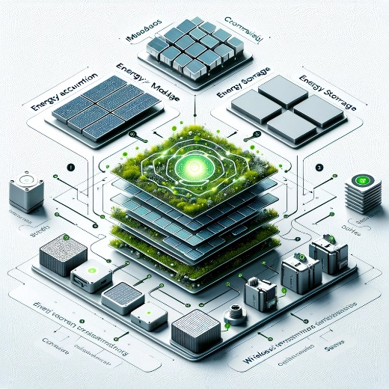

Here is a visual concept diagram of the energy harvesting device, illustrating the integration of the three key modules: Energy Accumulation, Energy Storage, and Energy Utilization. Each module is clearly labeled and shown in relation to the others, emphasizing their interconnectivity and the bio-inspired design approach.