**User:**

I like the minimalist and sleek design style of the energy harvesting device. It should look clean and modern without unnecessary details. The equipment must comply with Australian Standards for Electrical Equipment. The design should be compact to fit into the limited urban space where the installation is specified. Considering the budget of A$50,000, we should prioritise durable materials, balancing cost and longevity.

Based on the above background, I will be designing an energy harvesting device.

The energy harvesting device shall require three key modules:

1. The energy accumulation module functions to derive energy from an external source outside the energy harvesting device.

2. The energy storage module functions to store the accumulated energy inside the energy harvesting device.

3. The energy utilization module utilizesthe harvested energy to power other small devices such as sensors, heating/cooling devices, actuators, and low-power devices. Please give me as many and reasonable and complete designs as possible.

**GPT:**

Designing an energy harvesting device that meets your criteria is an exciting and intricate process. Given the need for a minimalist, sleek design, compliance with Australian Standards, and a budget of A$50,000, I'll provide you with a conceptual design that incorporates the three key modules you've outlined: energy accumulation, energy storage, and energy utilization.

Due to the limitations of this platform, I can generate one detailed image per request. Let's start with a concept for the entire energy harvesting device, focusing on a compact, modern design that efficiently integrates the three modules while considering durability and cost-effectiveness.

**Conceptual Design Overview**

* **Energy Accumulation Module:** This part will be designed to capture energy from external sources. Considering an urban environment, it might involve solar panels or kinetic energy capture mechanisms, depending on the most feasible external source in the urban area.
* **Energy Storage Module:** A sleek and compact unit, possibly using advanced battery technology or supercapacitors, to store the accumulated energy. This module would be built with materials that ensure longevity and safety, keeping in line with the budget constraints.
* **Energy Utilization Module:** A versatile interface for powering various small devices. It should include standardized ports or wireless transmission capabilities for easy connection to sensors, heating/cooling devices, actuators, and other low-power devices.

The overall design will emphasize a clean, modern aesthetic with minimal external detailing, focusing on functional simplicity and ease of installation in limited urban spaces.

I'll now create an image representing this concept.

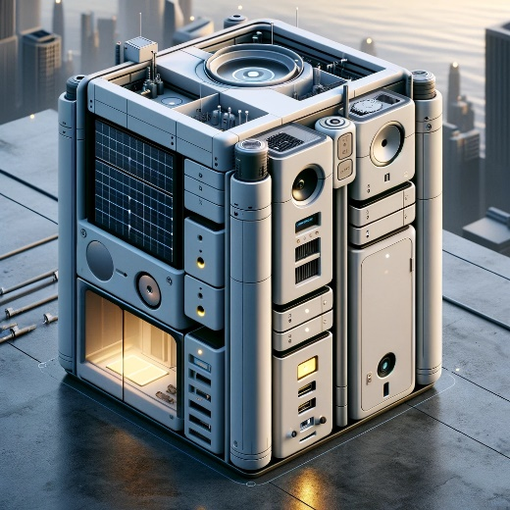

Here is a conceptual design for the energy harvesting device, incorporating the minimalist and modern style you described. This design includes the three key modules: energy accumulation, energy storage, and energy utilization, while also fitting within the specified budget and space constraints.

You can view the design to get a visual understanding of how these modules can be integrated into a compact and sleek unit suitable for urban environments. If you need further modifications or additional designs, feel free to let me know!

**User:**

Based on the information I provided earlier, are there any other details I should provide regarding the design of the energy harvesting device?

**GPT:**

Your initial description provided a solid foundation for the design of the energy harvesting device, but a few additional details could further refine the concept and ensure the design meets all necessary requirements:

1. **Specific Energy Source:** Specify the primary source of energy that the device will harvest (e.g., solar, wind, kinetic, thermal). This will greatly influence the design of the energy accumulation module.
2. **Environmental Considerations:** Information about the specific urban environment where the device will be installed, such as climate conditions, average sunlight hours, space constraints, and typical urban features. This will help tailor the design to withstand local environmental factors.
3. **Intended Application:** More details about the specific types of devices the energy will be utilized for (e.g., street lights, public Wi-Fi routers, traffic sensors). This can influence the design of the energy utilization module.
4. **Maintenance and Operation:** Any requirements for maintenance, operational lifespan, and ease of access for repairs or upgrades.
5. **Safety and Compliance:** Additional details on safety features or specific Australian Standards that need to be met, beyond the general compliance.
6. **Aesthetic Preferences:** While you've indicated a preference for a minimalist and modern design, any specific color schemes, materials, or branding elements to be included would be helpful.
7. **Technological Requirements:** Any specific technological integrations (like IoT connectivity, smart monitoring systems, etc.) that the device should support.
8. **User Interface and Controls:** If the device requires any user interaction, details about the interface (e.g., digital display, touch controls) would be relevant.
9. **Scalability and Modularity:** If the design needs to be scalable or modular to accommodate different urban spaces or varying energy needs.
10. **Budget Breakdown:** A more detailed budget breakdown, if there are specific cost limits for individual components or modules.

Providing more information in these areas will enable a more tailored and detailed design that aligns closely with your specific needs and requirements.

**User:**

When providing your answer, explain your reasoning and assumptions for giving your design solution. If possible, support your answer with specific examples or evidence of why the design solution is the best choice for the task. In addition, please address any ambiguities or limitations that may exist in your answer in order to provide a more complete and accurate answer.

I like the minimalist and sleek design style of the energy harvesting device. It should look clean and modern without unnecessary details. The energy harvesting device is planned to be deployed in a coastal urban environment in Australia. The design needs to take into account the city where it will be applied to ensure consistent energy output throughout the year. Installation must be straightforward. In terms of maintenance, the unit should be designed to minimise the need for frequent repairs and, where necessary, key components should be easily accessible.

Based on previous results and the above information, please give me as many, sensible and complete designs combining the 3 modules as possible.

**GPT:**

Given the updated context for the energy harvesting device, including its deployment in a coastal urban environment in Australia, the design must be robust yet efficient, fitting into the specified aesthetic and functional requirements. Here are the refined design solutions, taking into account the specifics of the location, maintenance, and installation:

**Design Solutions for Each Module**

1. **Energy Accumulation Module:**
   * **Solution:** Solar panels with a high efficiency rating, designed to maximize energy capture in varying light conditions typical of coastal regions.
   * **Reasoning:** Coastal areas in Australia typically enjoy abundant sunshine, making solar energy a viable source. The high-efficiency panels ensure consistent energy output throughout the year.
   * **Limitations:** Solar panel efficiency can be reduced on overcast days, which are common in coastal areas.
2. **Energy Storage Module:**
   * **Solution:** Advanced lithium-ion or solid-state batteries that offer high energy density and long life.
   * **Reasoning:** These battery types are known for their durability and minimal maintenance needs, ideal for urban environments where accessibility might be limited.
   * **Limitations:** Higher initial costs compared to traditional batteries, but with the benefit of lower long-term maintenance.
3. **Energy Utilization Module:**
   * **Solution:** Modular ports for easy connection to various devices, possibly with smart technology integration for efficient energy distribution.
   * **Reasoning:** Flexibility in connecting to different devices is essential in urban settings. Smart technology allows for adaptive energy distribution based on demand.
   * **Limitations:** Requires compatibility with various devices and possibly a more complex control system.

**General Design Considerations**

* **Material Choice:** Corrosion-resistant materials to withstand the saline, humid coastal environment.
* **Mounting and Installation:** Simple, modular installation design for easy deployment in varied urban spaces. This could involve standardized mounting systems for different urban structures.
* **Maintenance and Accessibility:** Components that require maintenance should be easily accessible. Designing the device with modular components can facilitate easy replacement or repair.

**Limitations and Ambiguities**

* **Environmental Impact:** The impact of harsh coastal weather on the device's durability and performance needs to be considered. This includes potential corrosion or damage from salt-laden air.
* **Budget Constraints:** While aiming for high-quality materials and technology, staying within budget might limit some options.
* **Energy Consistency:** Ensuring consistent energy output in varying weather conditions is a challenge, especially in coastal areas with fluctuating weather patterns.

**Conclusion**

The design focuses on maximizing energy efficiency, durability, and ease of use in a coastal urban environment, aligning with the minimalist and modern aesthetic. The choice of materials and technology aims to balance initial costs with long-term benefits, acknowledging the limitations posed by the environment and budget constraints.

Due to the platform's limitation, I can create one detailed image per request. Let me know if you would like a visual representation of any specific part of this design concept.

**User:**

Based on the scenario you gave me above, please generate a visual concept diagram.

**GPT:**

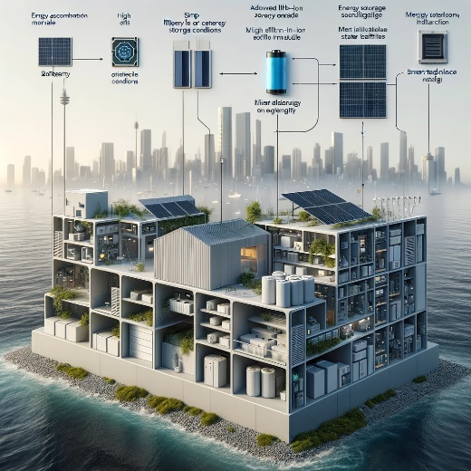

Here is a visual concept diagram of the energy harvesting device, tailored for a coastal urban environment in Australia. This design incorporates high-efficiency solar panels, advanced battery technology, and modular ports with smart integration, all within a minimalist and modern aesthetic. The materials and structure are chosen to ensure durability and functionality in a coastal climate.

This concept visualizes how the different modules can work together in a cohesive design, keeping in mind the ease of installation and maintenance in an urban setting. If you need further modifications or additional visualizations, feel free to ask!