**User:**

I am a Mechanical Designer, proficient in SolidWorks drafting, and a recent graduate of the University of New South Wales. I would like you to act as both a knowledgeable designer who can provide me with design expertise and a professional engineering designer who can act as a technical advisor to me when I have complex questions.

I like the minimalist and sleek design style of the energy harvesting device. It should look clean and modern without unnecessary details.

For this project, I favoured a bio-inspired design approach, using principles found in nature to optimise energy harvesting.

Based on the above background, I will be designing an energy harvesting device.

The energy harvesting device shall require three key modules:

1. The energy accumulation module functions to derive energy from an external source outside the energy harvesting device.

2. The energy storage module functions to store the accumulated energy inside the energy harvesting device.

3. The energy utilization module utilizesthe harvested energy to power other small devices such as sensors, heating/cooling devices, actuators, and low-power devices. Please give me as many and reasonable and complete designs as possible.

**GPT:**

Designing an energy harvesting device with a minimalist, sleek design inspired by nature is an exciting project. Let's explore some conceptual ideas for each of the three key modules you've described:

1. **Energy Accumulation Module**: This module should efficiently gather energy from its environment. Given your preference for bio-inspired designs, we might consider mimicking the way plants capture solar energy. A leaf-like structure with photovoltaic surfaces could be an aesthetically pleasing and efficient way to accumulate solar energy. Alternatively, if you're interested in harnessing wind or water flow, designs inspired by the wings of birds or the fins of fish could be explored.
2. **Energy Storage Module**: This module needs to be compact yet capable of storing a significant amount of energy. For a sleek and minimalist design, consider integrating this module seamlessly into the main structure of the device. For example, the stem of the leaf-like structure (if you're going with a plant-inspired design) could house the batteries or capacitors. This not only saves space but also keeps the design clean and uncluttered.
3. **Energy Utilization Module**: This module should be versatile and easily accessible for connecting to various devices. It could be designed as a series of modular ports or interfaces that allow for easy connection to different types of devices, like sensors or actuators. These ports can be discreetly placed along the body of the device, maintaining the minimalist aesthetic.

For the overall design, consider materials that are lightweight yet durable, such as carbon fiber or high-grade polymers. The color scheme should be simple and elegant, possibly in monochromatic tones or with subtle natural hues.

In terms of the form factor, think about incorporating smooth curves and streamlined shapes, avoiding any unnecessary protrusions or complex surface textures. This will not only make the device look modern and elegant but also aid in its functionality by reducing drag and making it easier to maintain.

Remember, the key to a successful bio-inspired design is not just to imitate the appearance of nature but to harness the underlying principles that make natural systems so efficient. As a recent graduate, this project could be a fantastic addition to your portfolio, showcasing your ability to blend aesthetics with functionality in engineering design.

Feel free to ask more specific questions or seek advice on particular aspects of the design as you proceed.

**User:**

When providing your answer, explain your reasoning and assumptions for giving your design solution. If possible, support your answer with specific examples or evidence of why the design solution is the best choice for the task. In addition, please address any ambiguities or limitations that may exist in your answer in order to provide a more complete and accurate answer.

Based on previous results and the above information, please give me as many, sensible and complete designs combining the 3 modules as possible.

**GPT:**

Designing an energy harvesting device that combines the three modules (energy accumulation, storage, and utilization) while adhering to your preferences for a minimalist, sleek design and bio-inspired approach involves balancing aesthetics, functionality, and practicality. Here are several design concepts, each with their reasoning, examples, and considerations of limitations:

**Design Concept 1: Solar Leaf Design**

* **Energy Accumulation**: Mimic the structure of a leaf with photovoltaic cells to harness solar energy.
* **Energy Storage**: Integrate the storage system within the stem or base of the leaf-like structure.
* **Energy Utilization**: Modular ports for energy output located at the base, similar to the root system of a plant.
* **Reasoning**: The leaf design is not only visually appealing but also functionally relevant as leaves are nature's solar panels.
* **Example**: Solar trees with leaf-like solar panels are real-world examples of this concept.
* **Limitations**: Efficiency might be lower than conventional solar panels due to the artistic form factor. Also, the device is dependent on sunlight, limiting its usability in low-light conditions.

**Design Concept 2: Wind Turbine Inspired by Bird Wings**

* **Energy Accumulation**: Blades designed like bird wings to efficiently harness wind energy.
* **Energy Storage**: Housing the batteries or capacitors within the central column of the turbine.
* **Energy Utilization**: Outlets located at the base of the turbine.
* **Reasoning**: Bird wings are optimized for aerodynamics, which can be beneficial for wind energy conversion.
* **Example**: Some modern wind turbines already take inspiration from the natural wing shapes for efficiency.
* **Limitations**: Wind turbines can be noisy and require a significant amount of space. They are also dependent on wind availability.

**Design Concept 3: Water Flow Harvester Inspired by Fish Fins**

* **Energy Accumulation**: Design akin to fish fins or gills that captures energy from water flow.
* **Energy Storage**: Integrated within the body of the device, mimicking a fish’s streamlined body.
* **Energy Utilization**: Ports for connecting devices located in a compartment that opens and closes like a fish mouth.
* **Reasoning**: Fish fins and bodies are optimized for moving through water, potentially useful for capturing energy from water currents.
* **Example**: There are micro-hydro power systems that use similar principles.
* **Limitations**: This design is location-dependent, requiring a steady flow of water, and may impact aquatic life if not designed thoughtfully.

**Design Concept 4: Combination Harvester**

* **Energy Accumulation**: A hybrid design combining solar panels, wind turbines, and water flow mechanisms.
* **Energy Storage**: A central hub where energy from all sources is stored.
* **Energy Utilization**: Multiple ports for various devices, possibly with smart management for energy distribution.
* **Reasoning**: Combining multiple energy sources can maximize efficiency and reliability.
* **Example**: There are off-grid systems that use a combination of solar and wind energy.
* **Limitations**: Complexity in design and higher costs. The device may become bulkier, moving away from the minimalist aesthetic.

**General Considerations:**

* **Material Choice**: Lightweight and durable materials like carbon fiber or advanced polymers would be ideal.
* **Aesthetics**: Maintaining a sleek and minimalist design while ensuring functionality.
* **Environmental Impact**: Assessing the ecological footprint of the device during manufacturing and operation.

Each design concept has its strengths and limitations. The choice largely depends on the specific requirements of the application, environmental conditions, and the user's preference for aesthetics. Remember, the integration of the three modules should be seamless and in harmony with the overall design theme.

**User:**

Based on the design 1,2,3,4 you gave me above, please generate 4 visual concept diagrams.

**GPT:**

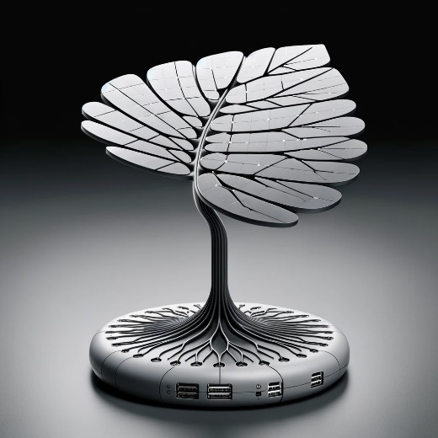

The visual concept diagram for the energy harvesting device inspired by the structure of a leaf is displayed above. This concept showcases a broad, flat photovoltaic surface designed to resemble a leaf, with a streamlined stem for energy storage, and a base with ports for energy utilization.’

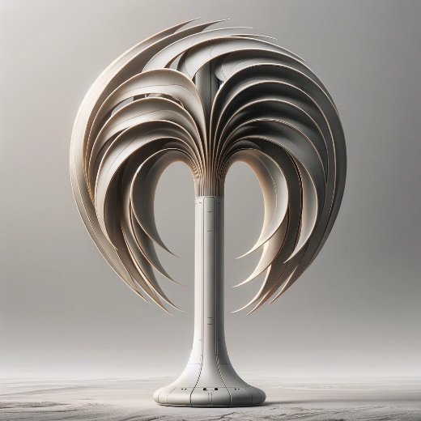

The visual concept diagram for the wind energy harvesting device inspired by bird wings is presented above. The design features curved, aerodynamic blades and a central column for energy storage, with a modern and sleek aesthetic.

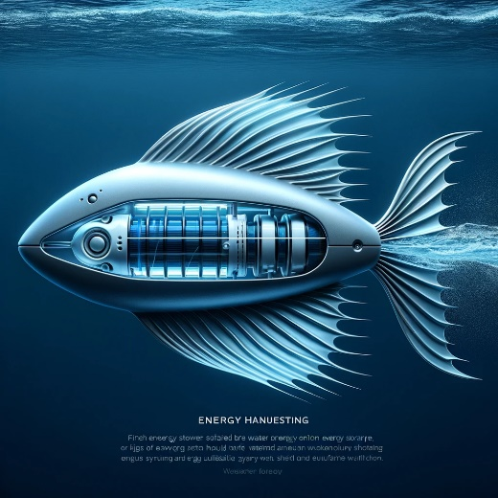

The visual concept diagram for the underwater energy harvesting device inspired by fish fins or gills is shown above, featuring a design that captures the essence of aquatic efficiency.

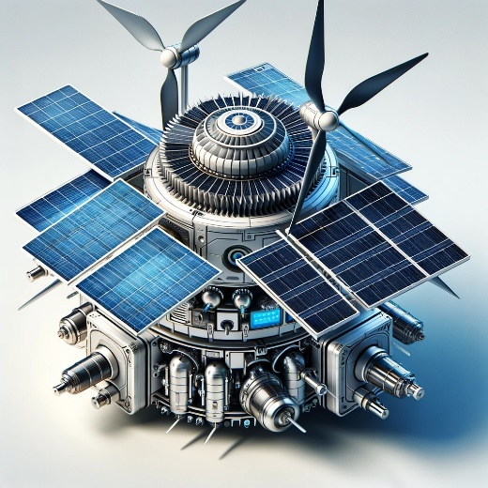

The visual concept diagram for the combination energy harvester integrating solar, wind, and water energy collection methods is presented above. This concept visualizes the fusion of different renewable energy technologies into a single device.