***SIT315***

***Programming Paradigms***

***Task: M1_T4D***

***Name: Tina***

***Roll Number: 2210994851***

***Link to Code (Github):***

<https://github.com/Tina1409/m1_t4d>

***Schematic Diagram:***

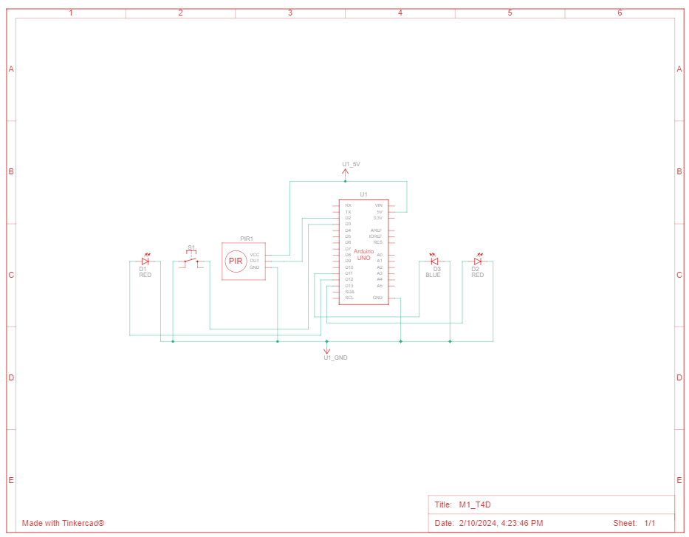

***Screenshot of the system monitoring log:***

