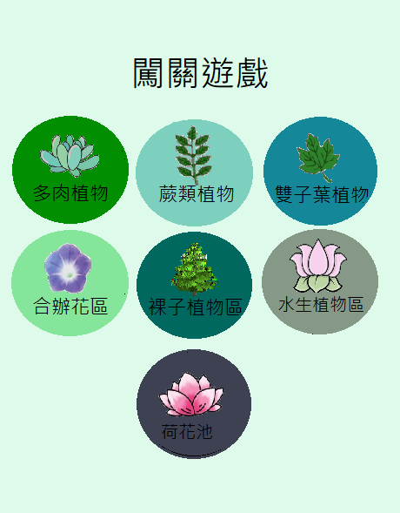

背景色#E0FAEC

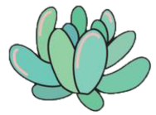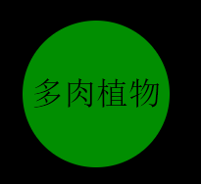

<Button

android:id="@+id/angry_btn"

android:text="多肉植物"

android:textColor="#000000"

android:textSize="22sp"

android:layout_width="100dp"

android:layout_height="100dp"

android:background="@drawable/buttonshape"

/>

<?xml version="1.0" encoding="utf-8"?>

<shape xmlns:android="http://schemas.android.com/apk/res/android"android:shape="rectangle" >

<corners

android:radius="100dp"

/>

<solid

android:color="#018E01"

/>

<size

android:width="100dp"

android:height="100dp"

/>

</shape>

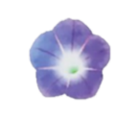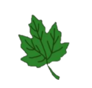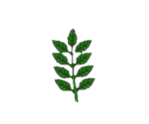

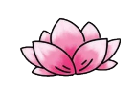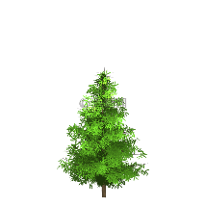蕨類植物: "#7 DCFBE" 雙子葉植物: "#148899" 合瓣花區: "#85E59B"

裸子植物區:“#00685E” 水生植物區: “#859986” 荷花池: “#3E4152”