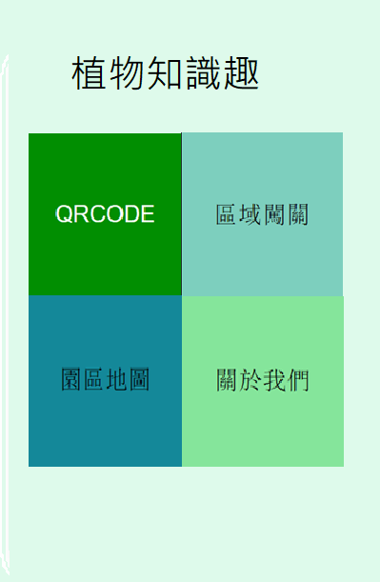

背景色 #E0FAEC

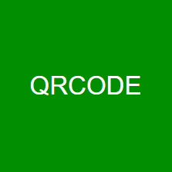

<Button

android:id="@+id/angry_btn"

android:text="QRCODE"

android:textColor="#FFFFFF"

android:textSize="22sp"

android:layout_width="150dp"

android:layout_height="150dp"

android:background="@drawable/buttonshape"

/>

<?xml version="1.0" encoding="utf-8"?>

<shape xmlns:android="http://schemas.android.com/apk/res/android"android:shape="rectangle" >

<corners

android:radius="0dp"

/>

<solid

android:color="#018E01"

/>

<padding

android:left="0dp"

android:top="0dp"

android:right="0dp"

android:bottom="0dp"

/>

<size

android:width="150dp"

android:height="150dp"

/>

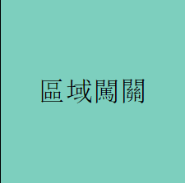

<Button

android:id="@+id/angry_btn"

android:text="區域闖關"

android:textColor="#000000"

android:textSize="22sp"

android:layout_width="150dp"

android:layout_height="150dp"

android:background="@drawable/buttonshape"

/>

<?xml version="1.0" encoding="utf-8"?>

<shape xmlns:android="http://schemas.android.com/apk/res/android"android:shape="rectangle" >

<corners

android:radius="0dp"

/>

<solid

android:color="#7DCFBE"

/>

<size

android:width="150dp"

android:height="150dp"

/>

</shape>



<?xml version="1.0" encoding="utf-8"?>

<shape xmlns:android="http://schemas.android.com/apk/res/android"android:shape="rectangle" >

<corners

android:radius="0dp"

/>

<solid

android:color="##148899"

/>

<size

android:width="150dp"

android:height="150dp"

/>

</shape>

<?xml version="1.0" encoding="utf-8"?>

<shape xmlns:android="http://schemas.android.com/apk/res/android"android:shape="rectangle" >

<corners

android:radius="0dp"

/>

<solid

android:color="#148899"

/>

<size

android:width="150dp"

android:height="150dp"

/>

</shape>



<Button

android:id="@+id/angry_btn"

android:text="關於我們"

android:textColor="#000000"

android:textSize="22sp"

android:layout_width="150dp"

android:layout_height="150dp"

android:background="@drawable/buttonshape"

/>

<?xml version="1.0" encoding="utf-8"?>

<shape xmlns:android="http://schemas.android.com/apk/res/android"android:shape="rectangle" >

<corners

android:radius="0dp"

/>

<solid

android:color="#85E59B"

/>

<padding

android:left="0dp"

android:top="0dp"

android:right="0dp"

android:bottom="0dp"

/>

<size

android:width="150dp"

android:height="150dp"

/>

</shape>