Explanation:

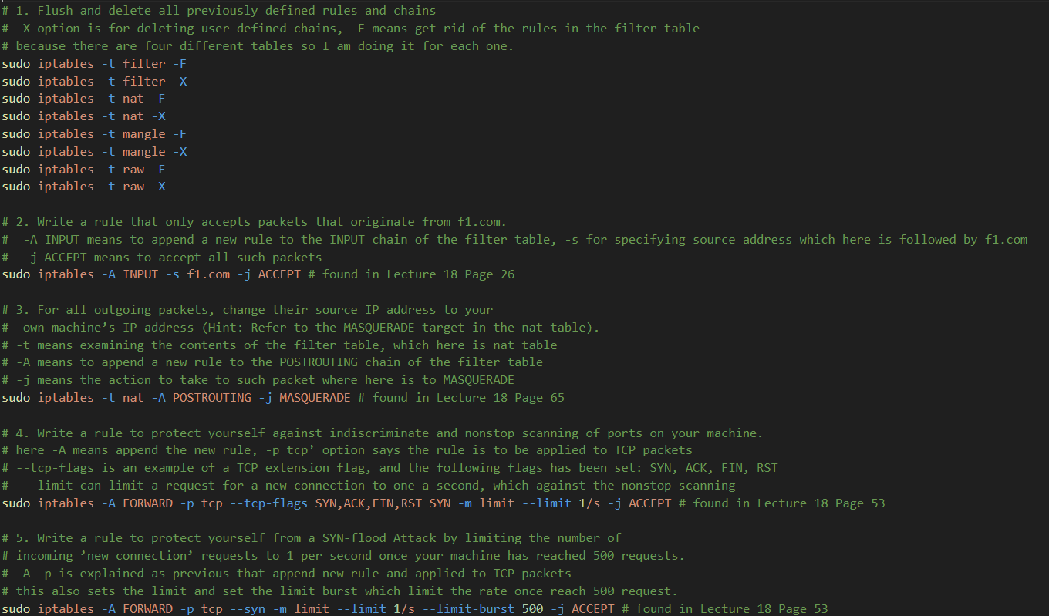

Output:

