Python Hive R 最基本三板斧一样不少 big O notation   
简单的算法要知道一点更好  
machine learning concepts have to be crystal clear   
Spark is a big plus  
  
Python 逐渐成为DS 必须掌握的技术  
几乎所有新算法一出来都有Python 的API  
几乎所有start up 做DS都是Python   
Dropbox Pinterest Instagram Google 都是Python 大用户  
  
Tech companies are product-centric  
对产品要很熟 最好用过 这样聊起来更有的聊

Lecture 1: Introduction to Banking and Mortgage Banking;  
  
Lecture 2: Data Manipulation using SAS;  
  
Lecture 3: Excel skills;  
  
Lecture 4: Data merge: data step, proc sql, Microsoft SQL;  
  
Lecture 5: Credit Risk Modeling;  
  
Lecture 6: Resume, interview tips and behavior questions.

他决定给我一次电话面试机会了解我，并且让我了解公司。他说完后，便开始问我简历上的经历，接着问我为什么想做财富投资管理等问题。虽然离校友通知我面试不到一天的时间，我在网上找到了所有有关公司和行业的信息，并且仔细准备behavior question和resume story。

MySQL必知必会 高性能MySQL(第3版) MySQL技术内幕(第4版)，还有Mysql的官网。

SQL

Database, table, schema, data type, primary key, operator, wildcard, search pattern, field, aggregate function, join, union, insert, update, view, execute, transaction process, rollback, commit, savepoint, cursor, constraint,

SQL: structured query language, provide a method to read data from the database.

No cap/lower case different,

Select sth from sth

Select prod_id, RTRIM(prod_name) + ‘(‘ + RTRIM(vend_country) +’)’ as vend_title, quantity*item_price # RTRIM() delete all the space on the right.

From products

Where (prod_id = ‘DL’ or prod_id = ‘va’) and prod_price !< 3.49

Where prod_id in (‘DL’,’va’)

Where not prod_id = ‘DL’

Where prod_name like ‘fish%’ # ‘%’ means any character any time, ‘_’ means single character, ‘[]’ means

Group by vend_id

Having count(*) >=2

# “where” filter cols, but “having” filters groups

# filter condition, where prod_price between 5 and 10.

# the reason why use () is that the priority of “and” is higher than “or”. () is preferred anytime when “and” and “or” are used together.

Order by prod_name, prod_price DESC (where asc is default);

(order by 2, 3 means by the 2nd column, 3rd column)

Update customers

Set cust_contact = ‘Sam’

Cust_email = ‘Email’

Where cust_id = ‘007’

Q: SQL address?

Operator?

And, or, in, not

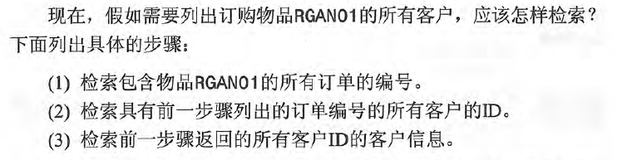

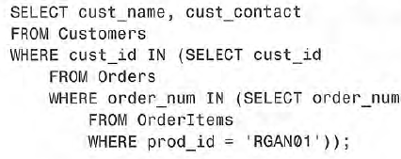

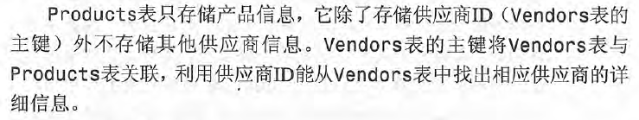

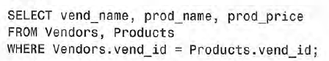

# use where to join tables

Join section, read again

