
 Charity Dinner Event 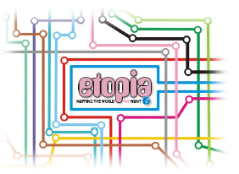

Date: Friday 3rd November 2006
Time: 19:30 – 23:00 Formal dress
Venue: The Institute of Directors, 116 Pall Mall, London, SW1Y 5ED

The event is open all partners and sponsors.
……………………………………………………………………………………………………………………….

Please send company logos to maria@figuresolutions.co.uk,
Places are limited so early booking is recommended.

Number of Tables Required at £800 per table of 10
Number of Tickets Required at £90 each
Name and Organisation
Total Cost

Payment and Confirmation Details

Confirmation Address: |  | Invoice  Address:
(If not as left,
or purchase
order)
Phone: |  | Phone:
E-mail: |  | E-mail:

Please make cheques payable to: World Ecitizens

Replies should be returned to: Maria Causon
38 Davidson Road, Croydon, Surrey, CR0 6DB
Telephone: 0208 656 3376
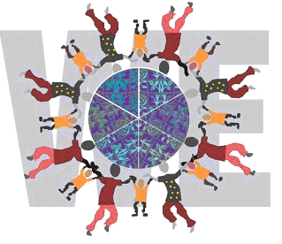
Email: maria@figuresolutions.co.uk

