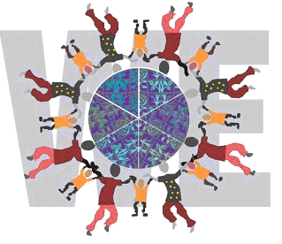
WORLD ECITIZENS
www.worldecitizens.net

ETOPIA
mapping the world WE want

We shall be launching the Etopia project at a charity dinner on November 3rd 2006 at the Institute of Directors, 116 Pall Mall, London, SW1Y 5ED in collaboration with The Hospital Organisation of Pedagogues in Europe (HOPE) and The Worshipful Company of information Technologists. As supporters of the MirandaNet Fellowship you are warmly invited to join us at this event.

Etopia, Mapping the World WE want, is a new project which offers young learners an opportunity to share a vision of the kind of world they would like to grow up in for a participative, web knowledge base. The charity dinner is held as part of the programme for ‘Getting Better Together’, an international conference held throughout Europe every four years for 300 teachers of young people with a medical or mental health diagnosis (www.gettingbettertogether.com).

This formal dress event will commence at 19:30 and finish at 23:00. Tickets will be £90 each. A table for 10 can be purchased for £800. The funds raised by this dinner will be used to support the conference and to set up international projects between hospital schools, primary and secondary schools and excluded learners. If sufficient money is raised, this will also go towards bursaries for teachers to attend the inaugural Etopia Continuing Professional Development workshop and visit to Czech schools in Prague, 15th–17th February 2007.

The logos of all sponsors who purchase a table of 10 will be prominently displayed in all the literature, at the dinner and on the MirandaNet, Etopia and the Getting Better Together websites. Exhibition space will also be provided at the Getting Better Together conference and the dinner if two tables are purchased.

Please return the enclosed booking form by September 30th as places are limited.

Yours sincerely
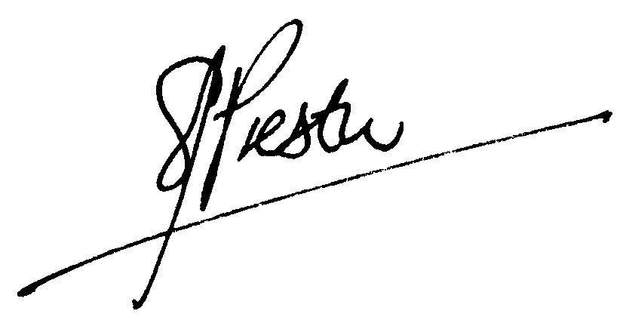


Christina Preston Janette Steel
Chair of World Ecitizens Trustees Head of Chelsea Hospital
Chair of MirandaNet Fellowship Director of Getting Better Together Conference






