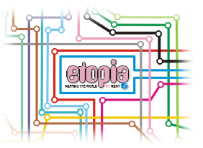
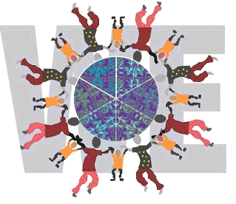
ETOPIA
mapping the world WE want

Prague Workshop
Thursday 15th to Saturday 17th February 2007 CTU, Prague

Towards personalised learning: implementing the philosophy

A CPD event examining the role of ICT in building partnership projects
World Ecitizens are launching a project, called Etopia, which invites teachers and children all over the world to publish their ideas about the world they would like to see. World Ecitizens suggests that this is a good time to ask children about the future they want.

The project develops the educational philosophy called personalised learning that tailors curriculum and teaching methods to meet the needs of children and young people. It combines assessment for learning (AfL), appropriate pedagogies, innovative curriculum materials and school organisation to extend learning beyond the confines of classrooms and schools. Schools and teachers are encouraged to establish their own approaches to personalised learning, responding to the learning needs and talents of all young people.

This three-day workshop brings together educationalists from the UK, the Czech Republic and other European countries to develop innovative solutions to respond to learning needs for 21st century learning. The collaborative projects will provide an effective vehicle for the implementation of personalised learning initiatives in schools, and support work through an ongoing community of practice.

School visits will be included as part of the workshop where teachers will be sharing their practice and setting up projects mapping the world they want. On the Etopia map which is represented above, each station represents a subject where young learners can post their designs. The map can keep growing as children add stations and extension lines when they think of something else that the new world will need. This gives all kinds of learners a chance to be inventive in areas where they are most interested or where they have most expertise.

Young learners are encouraged to offer multimodal entries and collaborative work: plans, designs, photos, videos, posters, manifestos, blogs, wikis, podcasts, sculpture, painting and drawing. Hand drawn and written work which is also welcome can be scanned for publication.

The children's work will be published in the World Ecitizens Gallery and so will be seen by an international audience. All the participants will be given a World Ecitizens certificate. Teachers are invited to publish their case studies about the work in the World Ecitizens E-Journal to help other teachers to replicate some of the processes.

www.worldecitizens.net
www.mirandanet.ac.uk/etopia

Itinerary

Day 1 Thursday 15th
a.m. | Teachers Sharing ICT Practice
 | Lunch
p.m. | Teachers Sharing ICT Practice
evening | Gala Dinner
Day 2 Friday 16th
a.m. | Visits to schools in Prague
 | Lunch
p.m. | Teacher Exchange Project Planning
evening | Concert
Day 3 Saturday 17th
a.m. | Teachers presenting their exchange project plans
 | Lunch

COST : conference fee, school visits on Friday and social programme,
inclusive of all lunches and the conference dinner £120

Hotel: you will need to book your own accommodation.
MirandaNet group rates available at the Hotel Antik City (www.antikcity.cz). Contact the Hotel directly and mention MirandaNet when making your reservation. You will need to give your credit card details to secure this rate.

Travel: you will need to make your own travel arrangements.
We have found the following flights which can be booked through EFR Travel at a cost of approx £145 inc Taxes
Depart Heathrow to Prague BA Airlines Wednesday 14th Feb at 18.50am
Return Prague to Heathrow BA Airlines Saturday 17th Feb at 18.20pm

Please fill in the form below to secure your place.
……………………………………………………………………………………………………………
School Exchange
Prague Workshop
Thursday 15th to Saturday 17th February

Name
Organisation
Address

Phone
Email





Please make cheques payable to: World Ecitizens
Replies should be returned to: Maria Causon
38 Davidson Road, Croydon, Surrey, CR0 6DB
Telephone: 020 8656 3376
Email: maria@figuresolutions.co.uk

