

ThinkQuest and Think.com
Global Collaboration and Project Learning
Date: January 2008

Transforming teaching and learning
Education is the preparation for work and life and education must transform to meet new 21st Century demands. We need Schools of the Future today, as students starting school today must be prepared for an even more dramatically different future world 20 years from now.
Our world has been transformed. Technology, globalisation, communication networks, media, mobility, entrepreneurship and a global economy have made the 21st Century a dramatically different place to live, work and learn. Since education is the preparation for work and life, education must also transform to meet new 21st Century demands.

Bernie Trilling
Director
Oracle Education Foundation

There is a growing worldwide consensus as to the key skills needed for success in 21st Century work and life. The summary list can be called the “7Cs”:
- Critical thinking and problem-solving
- Creativity and innovation
- Collaboration, teamwork and leadership
- Cross-cultural understanding
- Communications and media fluency
- Computing and ICT fluency
- Career and learning self-reliance

Combining the effective use of technology, a collaborative project approach to learning, an emphasis on innovation and creativity, and teachers committed to learning in this 21st Century approach, are what is needed now.

The Oracle Education Foundation (OEF)
The Oracle Education Foundation is an independent, philanthropic organization funded by Oracle Corporation and as part of its mission; the Foundation provides ThinkQuest and Think.com as free services to the global primary and secondary school community. These programs are designed to connect students around the world and engage them in collaborative, project-based learning using technology. The programs enable teachers to easily integrate project learning into their curriculum, and students to develop critical skills for life and work. In a world where cross-cultural understanding is more important than ever, these programmes facilitate learning that spans borders, both real and imagined. OEF programs support nearly 300,000 students and teachers from 73 countries.

The OEF has also recently launched a teacher professional development programme called the 21st Century Learning Institute to assist teachers in adopting a project based learning approach integrating technology.
ThinkQuest
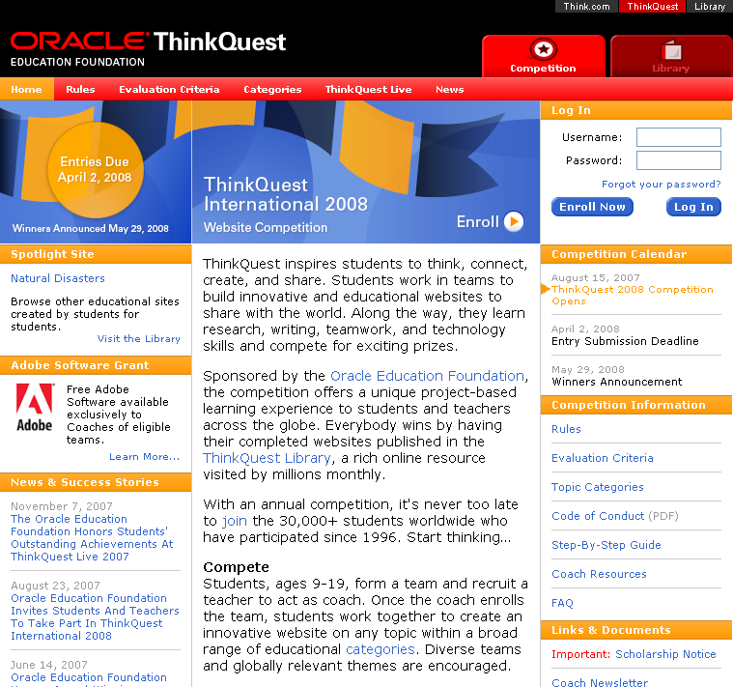
An international competition in which students and teachers are challenged to create the best educational websites. Winners receive a trip to ThinkQuest Live and other valuable prizes. Open to students between the ages of 9 and 19 and their teacher-coaches worldwide, students are encouraged to team with peers in other regions to develop websites on educational topics. As they create their sites, the participants develop important 21st century skills such as teamwork, critical thinking, self-direction, problem solving, and technology skills. Additionally, the students become published web-authors in the popular ThinkQuest Library, sharing their work with 30 million web learners each year. www.thinkquest.org

Think.com
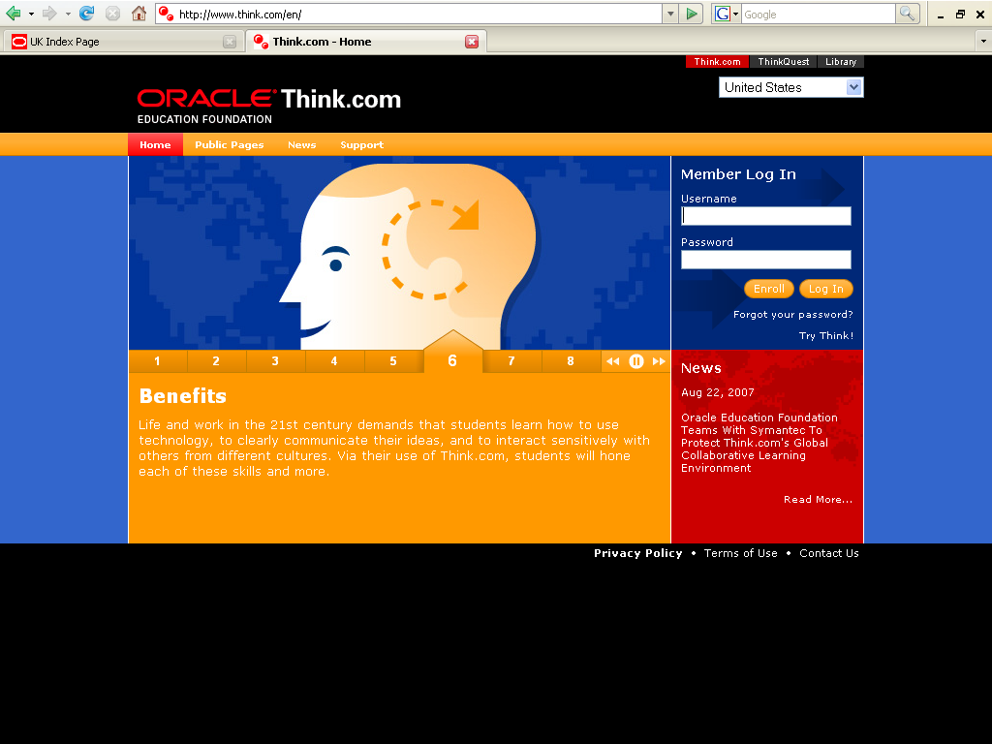
A protected online environment for schools worldwide, hosted and managed by Oracle. It provides a suite of tools for messaging, website publishing, research, discussion, and project collaboration. The school needs only an Internet connection and computers with a browser. It's 100% free and contains no advertising. The web based online community facilitates project learning and students' use of technology. In this teacher-mediated environment students and teachers are granted space to design and implement learning projects within their class, or with other schools globally. It promotes creativity, teamwork, communication, and cross-cultural understanding. It’s available in nine languages, including Chinese, English, French, German, Italian, Dutch, Portuguese, Spanish, Thai and Turkish. www.think.com

I had an opportunity to work with other kids my age on global issues that we found interesting. We didn’t just create a website - we actually involved 800 kids from around the world to contribute to our project.

Dylan
A 2007 first place winning-student.

I have barely reclaimed my breath from this exhilarating quest into innovation, creativity and technology,"

Salwa Kefi,
Primary Coach

Using Think.com the funny thing is that students don’t think they are doing proper work since they’re having so much fun. Their literacy, social & ICT skills have flourished

Ann-Marie Furbur
Primary School Teacher
Why We Do This
Many people ask what motivates Oracle Corporation's philanthropy through the Oracle Education Foundation, and its investment in programs like ThinkQuest and Think.com. The reason is simple: Many of us at Oracle care passionately about education and believe it's the right thing to do. Our aim is to support technology education that fosters students' love of learning and their sense of citizenship in a global community.

In a world in which cross-cultural understanding is more important than ever, the ThinkQuest and Think.com programs reflect our goal to promote collaboration and learning that spans borders, both real and imagined. We believe that getting students from different backgrounds to communicate, collaborate and learn about each other's life experiences is valuable.
ThinkQuest is a unique educational program. It brings together students and technology in ways that positively impact kids' lives and the communities in which they live. More than 280,000 students benefit each year from the Oracle Education Foundation's technology programs, which help kids develop vital skills for life and work in the 21st century."

Clare Dolan, Vice President, Oracle Education Initiatives
Of course, beyond being the right thing to do, this work has long-term benefits for companies like Oracle. The technology industry will continue to prosper only if our global society produces citizens capable of leveraging technology and teamwork to solve business challenges and address needs in all areas of life. The global community's future is reliant upon the same factors - the skills and wisdom of this next generation.
