Lesson plan by Gordana Ugrinovska

Planned activity:

Topic: "Butterfly"

Individual sphere

Emotional needs - Consciousness for needs, interests, and affinity
Cognitive needs - Sense for curiosity
Estetic needs - Comunication with beautiful elements

- Ability: pupils present their knowledge, interests, and affinity
- They differ in colours, forms, and size
- They use their style and creation to harmonize the colours
- They use their knowledge of computer work and technology

Year: 3 ( nine - year old pupils )
Primary School "Elpida Karamandi" Bitola

Date: 13.04.2006
Teacher: Gordana Ugrinovska
School subject: Macedonian
Topic: Reading and literature
Integrations: Science
Art
Mathematics
Session: Poem presentation
Butterfly

Objects: To use computers and informatics according to the reqirements of the National Curiculum
To achieve and develop their logic and creative abilities
To develop skills about Photo Paint
To make their personal creation using Photo Paint

Tasks: To develop computer skills
To develop logics, to design a new approach, to find new solutions

Indicators: Pupils' creations -butterflies
Recorded pupils' creations

Planned activities and classroom:
Teacher's planned activity
Pupil's presentation in Power Paint
Classroom - 20 active computers

Instruments and strategies:
Frontal activities
A group of three
Individualised work
Power Point presentation

Note: These activities are realised by using the projects "Active Education -Interactive Learning", "Skills for Life", "New Strategies that Stimulate Children's Poetic Cretivity" ( assistent M. Daniela A. Trajkovska )

Organization of activities:

Phases of the lesson:
Teacher stimulates work atmosphere telling that class will take place in computer classroom
Grouping in three

Evocation / Initiation:
Teacher inputs activities for pupils' work
She reads the poem Butterfly
Teacher - pupils' conversation about poem; comparing butterfly with flowers; the butterfly flight; the girl's wish...
Pupils take active parts using their experiences and knowledge

Understanding what does it mean:
Teacher gives information and notes about Photo Paint
Pupils start the computers
Teacher showes how to use the program
Pupils start the program and follow teacher's instructions
Pupils make their project, the draw butterflies using P.Paint
They use special art structures: repetition, rhythm, size, proportion, and symmetry

They use their style and creation to harmonize the colours of the butterfly and save it on a Floppy Disk
Teacher follows their work and helps if needed

Reflection: Checking and analization of the pupils' creations

Evaluation of the Butterfly project acchievements:
Stored pupils' creations according to the Butterfly project

Future activities:
Pupils print their presentations
They try to write a poem of their own

Teacher: Gordana Ugrinovska
gordanaugrin@freemail.com.mkBitola, 09.05.2006

( I wish to thank my dear friend and colleague Vesna Pupucovska who helped me to translate this project
sonyapup@mt.net.mk )

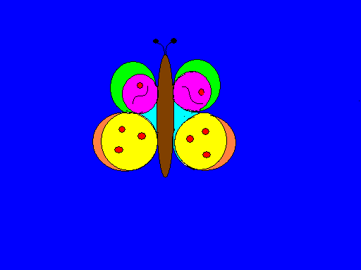
Nevena
Dorotea

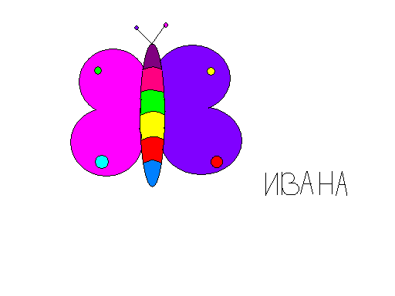
Ivana
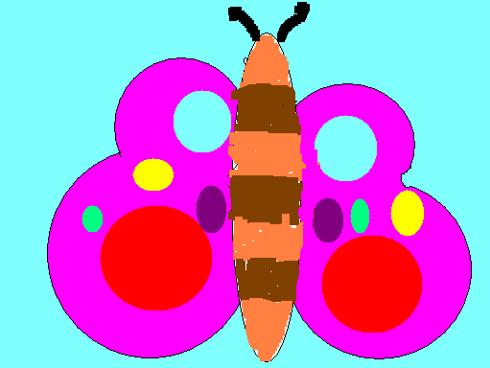
Ivona

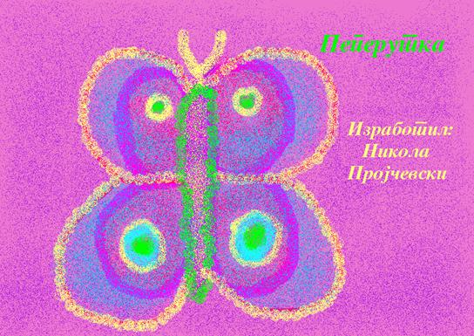

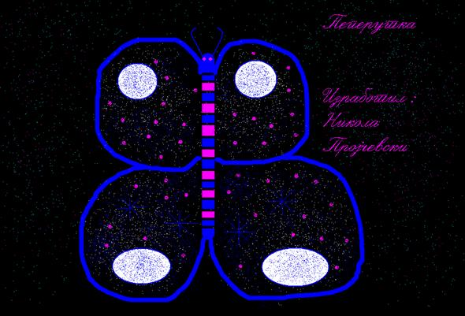
Nikola

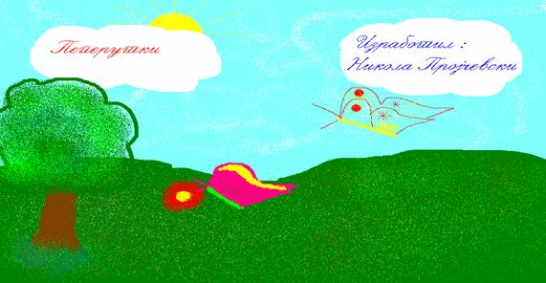
Nikola

