Using Technology to Narrow the Gap for Low and Under Achieving Learners

Key findings of the Research:
- Technology can help to resolve the problems associated with low achievement and underachievement, but use of technology must be combined with other approaches:
- The concept of readiness for learning is key to many learners’ achievement in school otherwise they do not progress well.
- Learner profiling has become widespread with the increased availability of technology. Many effective strategies that support learning start with detailed profiling.
- An individual learner’s self-efficacy is an essential component of academic achievement. Self-efficacy can be improved through a variety of strategies that provide the learner with success in an educational setting.

The research literature review confirmed that:
- Educational stakeholders broadly agree about what constitutes low achievement and underachievement.
- Tackling the problems of low achievement and underachievement is a priority at all levels of the educational system. For example, schools, colleges, Local Authorities.
- However, overlapping policies and responsibilities at the Local Authority level have the potential to cause confusion.

Background
Education has long been seen as the key to a fairer society, and it must now find ways to enthuse and engage low- and under achieving pupils.
While working to improve the lives of all young people, the biggest challenge continues to be that of Narrowing the Gap in opportunities and outcomes between the majority of learners, and those who are most vulnerable or underachieving.
We carried out a literature review which confirmed how important it is for learners to be fully engaged in the learning process. Through classroom observations and interviews with pupils and teachers we identified how technology can be effectively used to motivate and engage low and underachieving learners.
Here you will find the results of this research, and some detailed case studies explaining how technology can motivate and engage those achieving below their potential.
Literature review- the importance of engagement
This revealed that learners achieved their full potential only when they were fully engaged with the education process:
- If a child lacks motivation, their achievement is reduced, no matter what their level of ability.
- To have an effect, children need to show persistence in their learning.
- Many children are unprepared at home for school-based learning. This becomes a greater challenge for these children when they attend failing schools.
- External pressures, particularly peer pressure, can lead to educational alienation.
- Groups from socially disadvantaged backgrounds are most at risk.
There are many reasons why some young people fail to benefit from education. A review of evidence revealed a complex mix of factors including basic intellectual and emotional capacities, socio-cultural background and the quality of the education environment. But it also confirmed that in order to achieve their potential, learners must first engage FOOTNOTE with the learning process.
The research – harnessing technology to improve engagement
The qualitative research that followed the literature review was designed to uncover the ways in which technology can be used to equip young people with the skills to participate in learning throughout their lives.
The central focus is identifying the teaching practices that can support low-achieving or underachieving learners. We wanted to know how technology can be used to help reduce the attainment gap between learners in school.
The research team worked with 8 teacher consultants from secondary schools across England that were effectively using technology for teaching and learning. These consultants were tasked with identifying effective teaching and learning practices, particularly those using technology. The research team visited the schools to observe these practices; they interviewed teachers, learners and members of senior management teams and held group discussions with teachers.
What are the characteristics associated with low and underachieving learners?
Drawing on the literature review 45 potential characteristics of low-achieving and underachieving students were identified. Both positive and negative descriptive labels were created. These 45 descriptors were presented to 21 practitioners, including senior managers and classroom teachers. The teachers were asked to specify whether each of the given characteristics described their personal concepts of low-achieving or underachieving students.
Both groups are characterised as easily influenced but more significantly as being bored and having a poor work ethic. However, there are also key characteristics ascribed to only one of the two target groups: low achievers have characteristics which present challenges to effective learning. Often identified as having specific learning difficulties, poor reading skills and problems of social integration, these students are perceived as having some measure of special educational needs. Of the two groups of learners, low achievers alone have positive characteristics such as ‘tries hard’ ascribed to them.
While low achievers and underachievers are perceived as sharing many characteristics, those assigned to underachievers only are largely behavioural and negative. These learners are distinguished by their below par performance and their disengagement from the learning process, at times manifested through poor attendance at school. Negative social characteristics such as disregard for others are also noted. However, it is equally important that some teachers recorded that these students are unchallenged by the educational process, suggesting that there is a need to do more to engage them.
What are the Gaps?
There are many types of ‘gaps’ that need to be narrowed, for example gaps in personal competencies, in opportunities to learn and in achievement.
Readiness for learning
A key message from schools is that learners must be ‘ready to learn’ before they can engage effectively with school. This resonates with the research literature, which shows that low achievers and underachievers have weak basic cognitive skills and are not prepared for the act of learning; that is, some children are ill-equipped for school. Technology is now being used to develop the social skills that are essential for a successful school experience, such as paying attention to teacher, taking turns with other pupils and building socio-emotional skills. The following commentaries describe how two research schools have responded:
- In this school learners who are not integrating well and require social, emotional and behavioural support are withdrawn to ‘nurture units’ to work on social and emotional aspects of life. We have found that ICT, particular the Ninetendo Wii, very effective developing in learners’ hand-eye coordination and balance but also their self-esteem and group cohesion.
- Another school has identified a problem group of underachieving, economically disadvantaged white boys. The boys work on practical projects and are encouraged to think more widely about their career options. For example, if they dream of becoming a footballer, they are made aware of other options in this field such as being a linesman or a sports physiotherapist. The boys report back and present a PowerPoint presentation to parents.

A case study from this research:
David, who is diagnosed as being on the autistic spectrum, attends his local primary school. As an able boy his problems are not related to his thinking ability, but he has severe problems mixing with and relating to his peer group. As a result his peer group find it difficult to communicate with him and on the whole ignore him. He has been placed on a table of supportive peers but interaction is sparse and largely one-way: other pupils speak to David, but get little response.
The introduction of an interactive whiteboard (IWB) has facilitated interaction between David and his peers. David’s interaction with other children is minimal without the IWB but is at normal levels when he uses the IWB to explain his ideas.
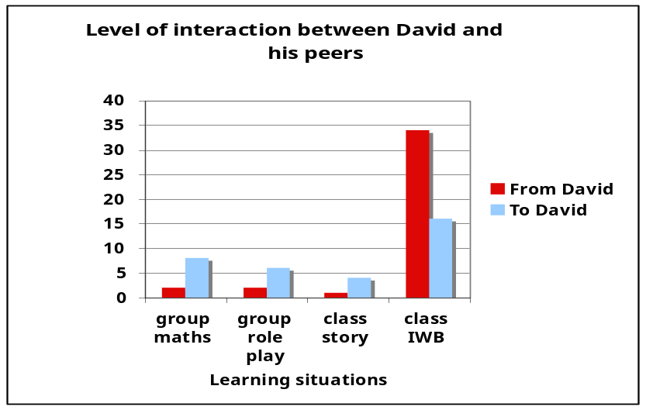
Why it works
Talking though the IWB moves the focus from ‘me’ to the ideas and this is a help to David. Equally David’s increased ability to respond results in more questions and comments flowing from his peers. In essence David and his peers meet in a shared safe space provided by the IWB, a space where the rules of interaction are less ambiguous and confusing for him.
Another case study from this research:
The cognitive resources that learners bring to their learning help to determine whether their learning experiences are fruitful or not. Many low and under achievers have weak basic cognitive skills: they are not prepared for the act of learning.
This lack of competence often leads to frustration and disaffection in school. However, these skills can be trained effectively and the results can be very positive not just the individual but for the class as a whole.
Using Technology
One West Midland school targets the ability to attend and listen. A 10 week, half-an-hour a day listening programme is provided – via computer - for those children who are finding it difficult to simply listen. The school reports improvements in listening skills, ability and confidence.
An ‘audiogram’ is computed for each child. The audiograms for one student are shown here. The grey zone shows normal performance.

The first graph (A) shows the pupil’s results before the listening programme. The student was diagnosed as being hearing impaired, as shown by the line dropping below the ‘normal’ zone. The second graph (B) shows the results after the ten week listening programme. Hearing remains in the normal zone, allowing the student to engage fully with the class.
Why it works
This simple case study suggests that training can ameliorate some seemingly intractable problems. Such training is a form of exercise for the brain. The listening programme here has been successfully used to reduce behaviours associated with ADHD. In such cases the programme trains children to inhibit their immediate response to any situation and to reflect before speaking or acting. The effectiveness of such cognitive training is well documented.

Other supporting evidence
Electronic monitoring

Providing digital feedback from teachers to parents is reducing absenteeism in a number of schools. In one 11-16 technology college they have had particular success. They swapped a paper-based system which focused on bad behaviour for a custom-built system which recorded both good and bad pupil behaviour based on 5 ‘levels’ of good and 5 ‘levels’ of bad behaviour. Parents are notified by email or post if their child is given a high score (3 or more) for either good or bad behaviour. Pupils and parents also receive a weekly summary. Persistent absenteeism is a factor in academic underachievement; the use of digital feedback to parents has improved attendance.
At the end of year 10, the school identified underachieving pupils and designed a personalised programme of support for each. Every pupil was allocated a personal mentor and his or her progress was monitored throughout the year. This has allowed the school to increase its percentage of pupils attaining 5 GCSEs.
Why it worked
The detailed knowledge of each pupil provided by the new system allows teachers to produce a targeted programme of work for each pupil. Pupils receive quick notice about when things are going right or wrong. The first was motivating and the second helped individuals to correct mistakes and bad behaviour before they became too entrenched.

Other examples
Many teachers cited that software such as MyMaths was something that they found valuable as it gives students immediate feedback on their performance. Teachers used the facilities to vary the level of complexity of the work to provide more personalized learning. While students could complete a piece of work more than once, and would often do so, to improve their score as an element of self-competition and improvement.
The motivational power of technology is also clearly recognised by teachers:

- ICT enthuses and excites children; electronic tasks seem more exciting and stimulating in many cases. Although a good mix of computer activities and practical activities works best!’
- Technology can give a street-edge to learning which makes it more acceptable to low and underachieving groups.
- Pupils in disadvantaged areas are often the most positive and appreciative of the technology available in their schools.
- Technology, particularly video games for boys, has proved to be highly motivating.
Further outputs emerging from this research is a set of multimedia examples of good practice that hold promise for addressing the problems associated with the target learners. These have been developed to provide a range of teacher-support materials - these Virtual School materials can be found: http://policy.becta.org.uk/ and just click on either the picture or the link at the top of the page.

The full report and literature review can be found here:
http://research.becta.org.uk/index.php?section=rh&catcode=_re_rp_02&rid=17439

Some questions for teachers to consider:

Gaps in personal competencies
- Is expertise available to identify the range of cognitive deficits that might be the cause of a failure to learn?
- Has the student impaired hearing or sight?
- Is the student diagnosed as dyslexic or dyspraxic?
- Is expertise available to differentiate between poor social skills resulting from disorders such as autism and those resulting from failure to learn social norms?
- Children with poor inhibitory skills are seen often seen disruptive and out of control - but they can be taught social skills.
- How do you assess students’ self-esteem and self-efficacy?
- Self-efficacy, the belief that you can achieve, is strongly associated with effective learning.
- How do you assess the degree to which individual students are able to self-monitor and regulate their own learning?
- The evidence shows that all but the most able learners have to be taught how recognise and use feedback to improve results.
- Feedback is at its most useful when it rapidly follows actions and is presented in a form that the learner understands.
Gaps in opportunity
- Do you use your learning platform to monitor pupils and reward changed behaviour?
- Do you provide opportunities for all pupils to succeed at some level? All children need to have something to be proud of.
- One inclusive strategy currently being used is to identify a special skill or talent for each child as they enter the school and to build that sense of being special as the learner progresses through the school.
- Do you have strategies that allow all pupils to take part in learning activities?
- Many children feel reluctant to speak in class. ‘Integrating David’ is an example. The use of presentational software can be used in a range of contexts to encourage timid and self-effacing members of a class to open up and display their thinking to the group.
- Do you know the level of ICT provision in your pupils’ homes? Have you mechanisms for compensating for pupils in ICT poor homes?
- Schools are using after school clubs, laptop for loan, and subsidised technology to help Narrow this Gap.
Gaps in achievement: Improving results by monitoring behaviour

- Are you achieving the required national benchmarks?
- Would a change in the curriculum help your students?
- Do you see a difference between ‘low achievers’ and ‘under achievers’ and how does this change your strategies for improving performance?
- Have you a subject / gender gap in your schools?
- Nationally 42% of girls want to pursue a professional career compared to only 27% of boys.
- Are you having problems getting boys to write? Avoid starting with a blank page, instead start with digital images to capture the pupils’ creativity and then get then to write about the story they have visually created.

Lucas and Claxton 2010, p23 :Readiness to learn: being emotionally and practically ready and willing to learn something and believing you can do it.

