Engaging with online formative assessment for meaningful learning
Joyce W. Gikandi
Background and overview
With ubiquitous of digital technological advancements, educational researcher and practitioners continue to seek ways of how to use the technologies effectively in promoting educational experiences at all levels of education.
From formal educational perspectives, it is now evident that these technologies especially the web-based technologies need to be integrated in pedagogically sound ways to benefit teaching and learning transactions (Garrison & Akyol, 2009). This is critical in web-based distance learning (online learning) particularly within higher education contexts. There is common consensus that online learning has provided flexible opportunities to learners who cannot fit face-to-face (f2f) educational contexts due to personal and situational circumstances particularly related to work and family commitments. Online learning provides educational opportunities irrespective of temporal and spatial gaps between the teacher and the learner. However, in a recent review of related literature, Garrison and Akyol (2009) indicate that online learning (as compared to f2f contexts) has distinct pedagogical demands that could descend into constraints if not adequately addressed.
Effective pedagogical designs are essential determinants of successful online learning an observation which contends with Naidu (2003) and has critical implications for design of online courses. There is therefore need to identify pedagogical design that support an effective learning environment. As demonstrated by various empirical studies (Chung, Shel, & Kaiser, 2006; Sorensen & Takle, 2005; Vonderwell, Liang, & Alderman, 2007), effective learning designs need to be learner and assessment centred. Learner centered means that teaching and learning processes need to be congruent with individual learner’s strengths, interests and contextual experiences. They also need to be assessment centered by providing learners with opportunities to demonstrate their developing knowledge and skills as well as providing opportunities for ongoing formative feedback to enhance their understandings of learning goals and content. From that perspective, this article focuses on how we can achieve an effective pedagogical design particularly within the context of higher education.
Role of online formative assessment in higher education
Learner and assessment-centered approaches can provide a framework for shifting from the traditional viewpoint of acquiring knowledge towards a new viewpoint that is congruent with active learning relevant to the 21st century learning. While acknowledging that there may be other ways of creating such a learning environment, application of formative assessment within the context of online learning is a viable option to achieve this. Formative assessment refers to all activities undertaken in classroom context to provide information that serve as a source of feedback about learner progress and achievements for purposes of adapting teaching and learning activities and providing ongoing learner support in order to achieve desirable learning outcomes (Chung, et al., 2006). Convergence of formative assessment aspects and affordances of web-based technologies bring to life the concept of online formative assessment.
Various researchers (Chung, et al., 2006; Gaytan & McEwen, 2007; Van der Pol, van den Berg, Admiraal, & Simons, 2008; Vonderwell, et al., 2007; Wolsey, 2008) have demonstrated the pedagogical potential of online formative assessment. However, it is also paramount to go further and ensure that the learning environment provides the learners with opportunities to not only learn actively but also provide them with opportunities to engage in learning that reflects their real-world professional environments. As demonstrated by a number of researchers within the context of online professional learning (see Correia & Davis, 2008; Mackey, 2010; Sorensen & Takle, 2005), the aspects of learning in a community of learners and engagement in discourse that reflect the way knowledge will be applied in real-world practices are therefore critical in enabling these enhancements to support meaningful (contextualized) learning. The ultimate goal is to support learning that is transferable to varying contexts that characterize 21st century professional needs.
In order to achieve a pedagogical design that will capture these aspects holistically, there is need to apply formative assessment from a systematic approach that will facilitate meaningful interactions among theoretical, pedagogical and technological perspectives. This in turn will ensure rigorous and effective online learning designs. From this viewpoint, authentic learning has been identified as an appropriate theoretical perspective that is congruent with online formative assessment. According to Herrington, Reeves, Oliver, and Woo (2004), authentic learning refers to provision of learning and assessment activities that have real world relevance; activities that reflect real-world professional practices rather than decontexualized tasks; and activities that are open to multiple interpretations/approaches, requiring learners to interpret the task, determine sub-tasks and procedures needed to accomplish an activity. This implies that online learning environments need to offer authentic learning contexts and integrated assessment activities that require the learner to engage in critical (higher order) thinking over a sustained period of time. From a pedagogical perspective, the concept of integrating assessment in authentic learning environments tightly overlap with the concept of formative assessment in that both places emphasis on meaningful assessment activities that are seamlessly integrated into teaching and learning processes for purposes of supporting optimal learning.
To operationalize this systematic approach, ten design principles have been identified based on a critical review of literature in the field of online formative assessment and authentic learning perspectives. These principles with key supporting citations are detailed as follows:

Principles for effective online formative assessment
- The assessment activities need to be authentic by being relevant and meaningful to the learner real life situations and experiences, and seamlessly embedded in the teaching and learning processes. The tasks need to be appropriately complex and have real-world relevance such that they actively engage learners in ongoing critical inquiry (e.g Chung, et al., 2006; Crisp & Ward, 2008; Duers & Brown, 2009; Feldman & Capobianco, 2008; Herrington, Reeves, & Oliver, 2006; Lin, 2008; Naidu, 2007; Shepard, 2001; Wang, Wang, & Huang, 2008).
- Assessment activities need to engage and support learners in individual construction of knowledge and meaning making through activities that recognize and allow them to apply their existing knowledge and experiences to build new knowledge, and to demonstrate individually what they are capable of doing. Associated with this is that formative assessment need to incorporate activities that illuminate learner perceptions, prior knowledge, and experiences (e.g Chung, et al., 2006; Crisp & Ward, 2008; Feldman & Capobianco, 2008; Gaytan & McEwen, 2007; Lin, 2008; Shepard, 2001; Smith, 2007; Wang, et al., 2008).
- Assessment activities need to provide learners with opportunities to construct knowledge collaboratively through activities that require and encourage learners to interact meaningfully with other online participants particularly teacher(s) and peers. This allows the learners to engage with others as a learning community to socially negotiate and construct meaning from multiple perspectives. Learners should be able to articulate their position and validate meaning individually (e.g Black & Wiliam, 2009; Crisp & Ward, 2008; Feldman & Capobianco, 2008; Herrington, et al., 2006; Lin, 2008; Oosterhof, Conrad, & Ely, 2008, pp. 76-77; Pachler, Daly, Mor, & Mellar, 2010; Shepard, 2001; Smith, 2007; Van der Pol, et al., 2008; Vonderwell, et al., 2007).
- The assessment activities need to be accompanied with opportunities to provide formatively useful, ongoing and timely feedback. Such opportunities enable scaffolding learning and mentoring the learner in response to student questions, sought elaborations, misconceptions, solutions, defence of position. This responsibility need to be shared by both the teacher and learners. Associated with this is the need to model and encourage collaboration and peer feedback among students (e.g Black & Wiliam, 2009; Chung, et al., 2006; Dopper & Sjoer, 2004; Gaytan & McEwen, 2007; Herrington, et al., 2006; Oosterhof, et al., 2008, pp. 76-77; Pachler, et al., 2010; Shepard, 2001; Smith, 2007; Van der Pol, et al., 2008; Vonderwell, et al., 2007; Wang, et al., 2008; Wolsey, 2008).
- The assessment activities need to be accompanied by analytical and transparent rubrics that assist the learner to clearly understand the expected level of achievements. Associated with this, is provision of relevant exemplars where possible. This in turn, provide opportunity for achieving shared understandings of the defined criteria and standards for performance which subsequently enable students to assess and reflect on their own achievements (e.g Angus & Watson, 2009; Black & Wiliam, 2009; Chung, et al., 2006; Gaytan & McEwen, 2007; Herrington, et al., 2006; Lin, 2008; Oosterhof, et al., 2008, pp. 76-77; Pachler, et al., 2010; Shepard, 2001; Smith, 2007; Wolsey, 2008).
- The assessment activities need to create opportunities that engage learners in meaningful reflection about their own and learning processes and outcomes both individually and as a community. Intrinsic engagement in reflection on learning enables learners to self-assess and become responsible of their learning. This aspect is promoted by provision of authentic activities that are meaningful and relevant to the learner (e.g Chung, et al., 2006; Crisp & Ward, 2008; Feldman & Capobianco, 2008; Herrington, et al., 2006; Lin, 2008; Pachler, et al., 2010; Shepard, 2001; Wang, et al., 2008).
- There is need to provide opportunities for ongoing documentation and monitoring of learner achievements and progress over time. This is associated with reflective practice and enables learners to value, own, reflect on, self-assess, and share their work with others. Such opportunities support learners to mature towards self regulated learning. As well, such opportunities annotate evidence of student growth, and enable the teacher to reflect on students needs (e.g Chung, et al., 2006; Dopper & Sjoer, 2004; Gaytan & McEwen, 2007; Lin, 2008; Oosterhof, et al., 2008, pp. 76-77; Shepard, 2001; Strudler & Wetzel, 2008)
- Teachers need to be more explicit in stimulating shared purpose and meaning of learning and assessment activities. This need to be considered as crucial as the actual criteria and expected standards in order to enable student to relate assessment activities to the learning goals and to perceive them as something real that will lead to a whole, genuine and meaningful outcome. Associated with this is opportunities for ongoing dynamic and dialogic interactions between and among the teacher and learners that are essential in promoting shared understanding of learning goals and assessment requirements, active participation, and strongly bonded learning community (e.g Dopper & Sjoer, 2004; Gaytan & McEwen, 2007; Herrington, et al., 2006; Lin, 2008; Pachler, et al., 2010).
- The assessment activities need to involve learners in multiple roles such as opportunities for decision making by requiring them to decide specific tasks and procedures to enable them accomplish the activity as well providing opportunities to negotiate and apply rubrics, and provide feedback to peers (e.g Black & Wiliam, 2009; Chung, et al., 2006; Herrington, et al., 2006; Lin, 2008; Oosterhof, et al., 2008, pp. 76-77; Pachler, et al., 2010; Shepard, 2001; Vonderwell, et al., 2007).
- The assessment activities need to be flexible and provide room for multiple approaches and solutions which provide learners with diverse opportunities to demonstrate their understanding and competences which may also drive the learners towards self regulated learning (e.g Black & Wiliam, 2009; Gaytan & McEwen, 2007; Herrington, et al., 2006; Lin, 2008; Shepard, 2001; Smith, 2007; Vonderwell, et al., 2007).
Figure 1 offers a summary of these principles. An ongoing research has embarked on implementation of these principles within the design of online courses with the aim to establish their effectiveness in supporting learning. Some expected outcomes in relation to how this approach can support meaningful learning are presented next.

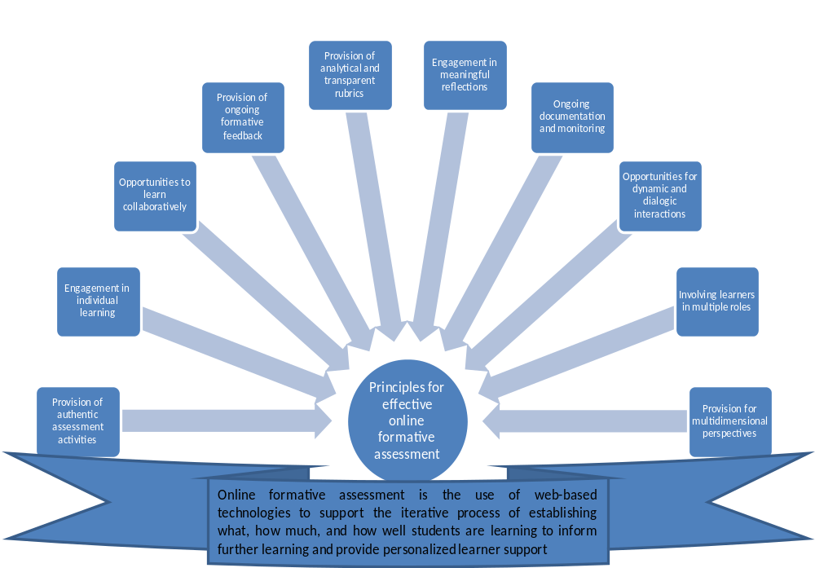
Expected outcomes
Figure 1: Research-based design principles for effective online formative assessment
Online formative assessment framed within authentic learning perspectives can promote valuable learning experiences by increasing learner engagement with critical learning processes such as: active, interactive, contextual, collaborative, reflective, multidimensional perspectives, and self-regulated aspects of meaningful learning. Enhanced engagement can lead to meaningful learning outcomes such as deep understanding, enhanced ability to transfer knowledge in real life contexts, and motivate learners to become self-directed and lifelong learners.
Conclusions
Effective application of the identified principles can facilitate an effective online learning environment that may lead to achievement of desirable learning outcomes.
By implication, this requires commitment from both teachers and learners. This is particularly in relation to time and effort required to accomplish pedagogical activities associated with achieving the identified aspects of meaningful learning. It is expected that the ongoing research will provide rich evidence to support viability of this approach and illuminate relevant pertinent issues.
Acknowledgement
This article is informed in part by an ongoing PhD research funded by the University of Canterbury Scholarship. The author is also indebted to her research advisors especially Professor Niki Davis.
Key References
Angus, S. D., & Watson, J. (2009). Does regular online testing enhance student learning in the numerical sciences? Robust evidence from a large data set. British Journal of Educational Technology, 40(2), 255-272.
Black, P., & Wiliam, D. (2009). Developing the theory of formative assessment. Educational Assessment, Evaluation & Accountability, 21(1), 5-31.
Chung, G. K. W. K., Shel, T., & Kaiser, W. J. (2006). An exploratory study of a novel online formative assessment and instructional tool to promote students' circuit problem solving. Journal of Technology, Learning, and Assessment, 5(6), 1-27.
Correia, A. P., & Davis, N. (2008). Intersecting Communities of Practice in Distance Education: The Program Team and the Online Course Community. Distance Education, 29(3), 289-306.
Crisp, V., & Ward, C. (2008). The development of a formative scenario-based computer assisted assessment tool in psychology for teachers: The PePCAA project. Computers & Education, 50(4), 1509-1526.
Dopper, S. M., & Sjoer, E. (2004). Implementing formative assessment in engineering education: the use of the online assessment system Etude. European Journal of Engineering Education, 29(2), 259-266.
Duers, L. E., & Brown, N. (2009). An exploration of student nurses’ experiences of formative assessment. Nurse Education Today 29(6), 654-659.
Feldman, A., & Capobianco, B. M. (2008). Teacher learning of technology enhanced formative assessment. Journal of Science Education and Technology, 17(1), 82-99.
Garrison, D. R., & Akyol, Z. (2009). Role of instructional technology in the transformation of higher education. Journal of Computing in Higher Education, 21(1), 19-30.
Gaytan, J., & McEwen, B. C. (2007). Effective online instructional and assessment strategies. American Journal of Distance Education, 21(3), 117-132.
Herrington, J., Reeves, T. C., & Oliver, R. (2006). Authentic tasks Online: A synergy among learner, task and technology. Distance Education, 27(2), 233–247.
Herrington, J., Reeves, T. C., Oliver, R., & Woo, Y. (2004). Designing authentic activities in Web-based courses. Journal of Computing in Higher Education, 16(1), 3-29.
Lin, Q. (2008). Preservice teachers' learning experiences of constructing e-portfolios online. Internet and Higher Education 11(3), 194-200.
Mackey, J. (2010). Interconnecting networks of practice for professional development. The International Review of Research in Open and Distance Learning, Manuscript sumbitted for publication.
Naidu, S. (2003). Designing instructions for e-learning environments. In G. M. Moore & W. G. Anderson (Eds.), Handbook of Distance Education (pp. 349-365). Mahwah, New Jersey: Lawrence Erlbaum Associates.
Naidu, S. (2007). Instructional design for optimal learning. In G. M. Moore (Ed.), Handbook of Distance Education (pp. 247-258). Mahwah, New Jersey: Lawrence Erlbaum Associates.
Oosterhof, A., Conrad, R. M., & Ely, D. P. (2008). Assessing Learners Online. New Jersey: Pearson.
Pachler, N., Daly, C., Mor, Y., & Mellar, H. (2010). Formative e-assessment: Practitioner cases. Computers & Education, 54, 715-721.
Shepard, L. A. (2001). The role of classroom assessment in teaching and learning. In V. Richardson (Ed.), Handbook of research on teaching (4 ed., pp. 1066-1099). Washington DC: American Educational Research Association.
Smith, G. (2007). How does student performance on formative assessments relate to learning assessed by exams? Journal of College Science Teaching, 36(7), 28-34.
Sorensen, E. K., & Takle, E. S. (2005). Investigating knowledge building dialogues in networked communities of practice. A collaborative learning endeavor across cultures. Interactive Educational Multimedia(10), 50-60.
Strudler, N., & Wetzel, K. (2008). Costs and benefits of electronic portfolios in teacher education: Faculty perspectives. Journal of Computing in Teacher Education, 24(4), 135-142.
Van der Pol, J., van den Berg, B. A. M., Admiraal, W. F., & Simons, P. R. J. (2008). The nature, reception, and use of online peer feedback in higher education. Computers & Education, 51(4), 1804-1817.
Vonderwell, S., Liang, X., & Alderman, K. (2007). Asynchronous discussions and assessment in online learning. Journal of Research on Technology in Education, 39(3), 309-328.
Wang, T.-H., Wang, K.-H., & Huang, S.-C. (2008). Designing a web-based assessment environment for improving pre-service teacher assessment literacy. Computers & Education, 51(1), 448-462.
Wolsey, T. (2008). Efficacy of instructor feedback on written work in an online program. International Journal on ELearning, 7(2), 311-329.

