Introducing ICT-based Multimodal Mapping

Nigel Riley
Knowle Primary School, Plymouth, Devon, UK

Mirandanet Fellow
Associate Lecturer, University of Plymouth.

- ‘Understanding is a very personal thing. ‘Only connect….’ is E.M. Forster’s epigraph for Howards End. The prize is the greater meaning that can flow from the union of isolated thoughts. All it takes is a connection, but making it may not be easy’
- ‘Understanding is an indicator of the quality of learning.’ (Newton, 2000)

The development of graphic representations

Representations are what cognitive processes act on in creativity, learning and understanding to construct meanings of the world. They have internal and external expression.

- External representations of knowledge involve both symbolic, as in linguistic forms, and analogical representations, as in graphic or pictorial forms.

- Internal representations are able to represent only some aspects of the environment and parallel external representations by differences between propositional and analogical representations.
- Propositional representations capture ideational content of mind and are
language-like.
- Analogical representations tend to be perceptual images: visual, auditory or
kinaesthetic.

Key question:
How can we access external and internal representations which indicate quality of learning?

- A method for supporting ideation and the generation of connections between thoughts or accepted concepts is the use of diagrammatic forms of representation about the world.
- These diagrammatic representations have different levels of complexity which develop into concept mapping.

This is a common arrangement called a
spidergram. It has been created from
group or individual idea storming and it
lists characteristic attributes of a concept
or idea.
(a)

(b)
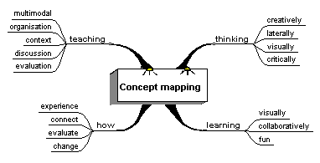
This is a Mind Map® as developed by
T. Buzan. It connects ideas through
keywords by association.

(c)
Concept mapping is the
formation of connections
between concepts or ideas by
using links which may or may not
be labelled.

Pioneered by J.Novak and
developed by M. Åhlberg
concept mapping is a more
cognitively demanding form of
diagrammatic representation.

(d)
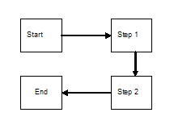
Concept mapping is not
the only form of diagrammatic
representation.

Some forms of ideation like
chronological or narrative
sequences may be better
represented in flowgrams

- Concept mapping is more advanced and needs to include relational links, to keep the mapping refined and of a higher order of representation.

- A way of strengthening links is to include vectors. This enhances the connections visually, impacting on the relational interpretation between the concepts, making the relationship more meaningful in terms of actional and transactional structure.

- The combination of both graphic and linguistic notation in concept mapping may more closely define the idea or concept being represented and reduces the possible number of interpretations as shown in the Table 1 below.

Concept mapping compositionality | Interpretations from concept mapping | Interaction between the visual and linguistic elements.
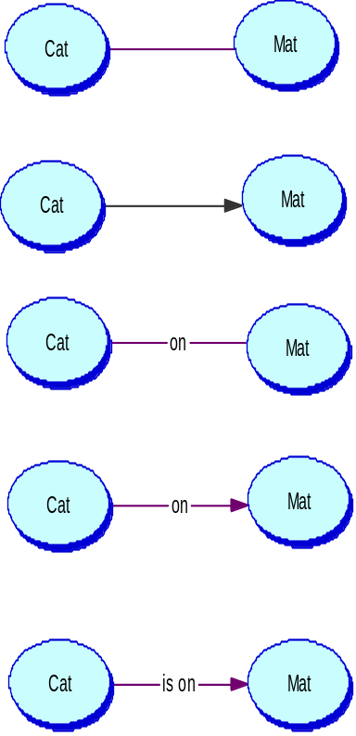  A | could mean;  The cat ate the mat.  The cat went to the mat.  The cat walked over the mat.  The mat belongs to the cat.  The mat is near the cat. | The number of possible interactions and types of different relations between the cat and mat are many and diverse.
- B | could mean;  The cat went to the mat.  The cat saw the mat.  The cat likes the mat. | The directionality given by the vector is explicit although the definition of the relationship is unclear. It gives a structure to the possible linguistic interpretations in terms of subject/object order.
C | could mean;  The cat ate on the mat.  The cat ran on the mat.  The cat sleeps on the mat.  The mat is on the cat. | Although the relationship has been given more clarity in terms of relation by naming the link, the interaction is still lacking clarity in terms of the order of relationship.
D | could mean;  The cat went on the mat.  The cat is on the mat. | The combination of vector and naming of the link reduces the number of possibilities in interpretation. The relationship achieves more definition and the whole representation becomes more meaningful.
E | could only mean;  The cat is on the mat. | The inclusion of a more constrained label to the vector achieves an accurate and meaningful proposition in terms of objects and their relations.

Table 1: Orders of meaning in concept mapping.

- The development of ICT-based concept mapping software has meant that maps
can be designed using digital objects available in multimedia. This has meant an
evolution of the term concept mapping to multimodal mapping to encompass
representation in auditory, graphic, image, videographic, cinematic and text
modalities.

Understanding of principles of application and practice of diagrammatic representations of knowledge and ideas

Key question:

How do we use multimodal mapping?
Multimodal mapping is a powerful tool in teaching and learning and it has a wide range of applications in the classroom.

8 Functions of multimodal mapping:
1. To direct thinking: as a teaching presentation tool, to organise topic coverage
and group activities.
2. To stimulate discussion and dialogical learning: to promote speaking and
listening skills.
- To generate creativity: to identify ‘conceptual spaces’ and stimulate ‘possibility‘ thinking.
- To facilitate higher order thinking: to generate thinking skills through finding relationships and identifying gaps in understanding.
- To generate writing by scaffolding ideas: ideas can be represented through strong visual images and can contain pictures and graphics.
- To promote collaborative learning: mapping can be used to generate group work in discussion activities or map production activities.
- As an assessment tool: mapping can provide evidence for formative assessment in assessment for learning activities and as a learning self-evaluation tool in personalised learning.
- Publication and display: visual and text representations provide a stimulating form of presentation.

Key question:
What resources can we use?

- New technologies and the digital resources provide opportunities for interaction, participation, and the active demonstration of imagination, production, purpose, originality and value that may not be available when using traditional media and resources.
- In an analysis of ICT capability Loveless (2003) generated a set of criteria that identify features of ICT as: Provisionality; Interactivity; Capacity; Range; Speed; Automatic functions.
- These features facilitate easy construction, revision and storage of concept
- mapping when using ICT-based resources such as Inspiration, IHMC Cmap Tools and INTEL’s Seeing Reason.

Starting to map: For example in creating a story.

- Think of the concepts or ideas that you wish to explore.

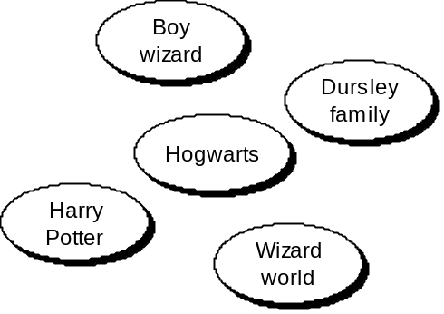
Concepts are objects. They are names or nouns.

Just list them depending on the topic or domain.

- Then link them using verbs and connectives. For example:
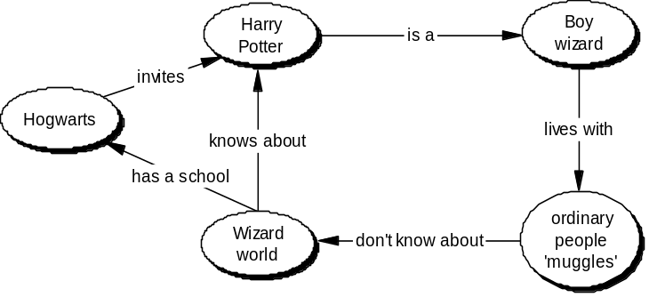
The relational links are verbs and can include connective phrases.

In making links thinking takes place. In looking for links creativity takes place.

- The construction of links and defining the relations between concepts are the important features of learning and indicate the level of understanding and knowledge of the mapping author/authors.

Developing concept mapping practices: Starting points and heuristics

Teaching and Presentation:
Function: 1. To direct thinking
2. To stimulate discussion and dialogical learning

If a class has access to a data projector or electronic whiteboard then the whole
class is able to participate in ICT activities. Concept mapping is an ideal way to
promote discussion as it can be used to mediate the formation of social
representations of knowledge. This has implications in understanding how we
construct our learning as a ‘community of learners’. It provides opportunities for contributions from individuals to be displayed and transformed or realigned. It provides a safe environment for ideas to be discussed, challenged and changed.

Activity – Any topic can be used to start a map. The main idea must really be in the form of a question that students will consider when contributing e.g. What do we…. understand by ‘learning’?......know of Roman Britain?......think about fair trade?.......mean by ‘representation’? Ideation can be recorded enabling reflection, thinking, discussion and revision of labels and relations. All members can participate in their own time promoting inclusion. Areas of interest, misconceptions and gaps in knowledge can be identified informing planning thus learning direction and progression. Mapping may also be used for revision and monitoring understanding.

Discussions using concept mapping can be used to evoke argument’, challenge conceptions and preconceptions and allow inclusion of views not usually heard.

Planning and drafting:
Function: 3. To generate creativity
- To facilitate higher order thinking
- To generate writing by scaffolding ideas

Concept maps use verbal expressions in the links and inside complex concept
labels. The link labels can often become labels for concepts.
If these possible concepts become important while constructing and improving a
concept map, you may draw a frame round them and use them as ‘real’ concepts.
Sometimes it is good to be able to read concept maps in the order that you intend
it to be read therefore links may be numbered (Åhlberg, 1989, 1991).

Activity - Look at the example in the ‘Starting to Map’ section. Instead of using Harry Potter try mapping the beginning of a story you are composing. For practice and modelling try mapping a well known story such as ‘Matilda’ by Roald Dahl or a favourite of yours. Map only the main elements from which all the and action are introduced. Now try mapping the middle on a new map. Try reading it back to yourself. Does it include the basic plot ‘kernel’? Now map the ending. Do all three maps cover the basic plot structure of the story? Have you labelled all the links?

Can your maps be converted into speech and / or writing?
Do other people agree with your ideas?
Does your map accurately represent the plot ‘kernel’ ?

Collaborative working:
Function: 6. To promote collaborative learning

ICT-based concept mapping is a provides a conceptual space to promote
collaborative working that develops speaking and listening skills.
Often in class situations ICT resources are limited so that activities need to take
place in small groups. Ideas can be generated, revised and stored within group
activities and printed maps can be distributed to individuals for personalising and
extending.

Activity - Creating a template for a report.
Look at a topic’s research notes. Is there a way to start the main themes and structure in the report using different spokes to classify the sub-topics? Are all the participants satisfied with the concept and link labels?
Can you produce a written text from your mapping?
Can the text be paragraphed from the map?

Concept mapping to organise topic coverage and group investigations
The main features of concept maps are the structural components of links and frames. The links can serve a dual purpose acting as a relational label and also as an indicator allocating a section of the map to be constructed, extended or researched to a specific person or group.
Inspiration® contains many template structures that can be used for different topic activities to ensure that a topic is fully covered and organised in a suitable manner.

Activity – In the file menu in Inspiration® click on the template folder. Freely explore the template options which contain instructions for use. This will give you further support in planning and organising topic coverage. If you right click on a link in your map you can change the line colour. This enables you to colour different parts of a concept map for group allocation. Concept frames may also be customised in this way using the fill option.

Does the concept mapping represent all participants thinking?

It is important that the purpose of the concept mapping is explained. Whether the map will provide; a frame for writing a text; be used for information storage, as a revision aid, or as an assessment tool; or as a representation tool to express ideas as they are discussed.

Assessment
Function: 7. As an assessment tool:

Using concept mapping to evaluate learning progression.

Activity - Compare and contrast concept mapping formed in a discussion or before and after a unit of work by individual students or groups.
Use questioning and highlighting of accurate and inaccurate links to find extent of understanding and knowledge as well as misconceptions, and gaps in knowledge.
From the post learning map rearrange concepts and links to revise the arrangement. List the changes on a WORD document or sheet of paper.
What does this inform us about understanding in this topic?

In a good concept map each concept occurs only once as in a good geographical map each place is named only once. If each concept is named only once on the concept map, then is easy to count how many links each concept has to and from other concepts. The number of links with other concepts is a good estimate of centrality of that concept in the person’s thinking of the theme, whose thoughts are being concept mapped.

Publication and Web presentation
Function: 8. Publication and display

The inclusion of a hyperlink function in some concept mapping software such as Inspiration® allows concepts to be linked to files and specific Web pages from the Internet. This allows for the extension of concepts to be represented in multimedia, increasing the modality of representation through use of sound, image and video files.

Activity – Using the hyperlink tool in Inspiration® link a concept from a map constructed to saved WORD or PUBLISHER files or the Internet to create a multimedia presentation. You must save the destination file first to have a destination file address. On the destination page list some ideas that may enhance the representation of the concept being linked.
Where can you find resources for this? What else can be used?
Does the linked file page have an accurate representation or explanation of the concept being linked?

Everybody who constructs a concept map has to think. The quality of their thinking can improve and their critical skills are enhanced. That is participants become aware of what they already know, what they do not yet know, how to integrate prior knowledge, and how to monitor and promote their own learning.

A good map presents only the most essential features of the topic on which the mapmaker is focused. A good map is based on concepts and propositions. We understand representations better if we use concepts rather than images. We may produce images as associations or as creative representations, e.g. visual images, auditory images etc. However the most accurate representations of knowledge can only be transferred by propositions, which may be more or less meaningful, true, plausible, or probable (Åhlberg, 2001).

The best advice that can be given is to start with small tasks and extend these from group or paired work into whole class activities as confidence with concept mapping using the associated software increases.

Developing ideas and practices is dependent on the students and your own responses to what is a new form of representing knowledge and ideas.

I hope that you have found the information and the activities included in this pack practical, useful and applicable.

References
Åhlberg, M. (2001). www.helsinki.fi/people/mauri.ahlberg

Loveless, A. (2003) Creating spaces in the primary curriculum: ICT in creative subjects, The Curriculum Journal,14(1), pp.5-21.

Newton, D.P. (2000) Teaching for Understanding, London: RoutledgeFalmer.

Associated reading
- The commercial available software Inspiration does similar things. You can
download a 30 day free trial from: http://www.inspiration.com

- Intel Teach to the Future has an online mapping tool called Seeing Reason.
You can find it at: http://www97.intel.com/scripts-seeingreason/index.asp

- Riley, N.R. and Åhlberg, M. (2004) Investigating the use of ICT (information and communication technologies)-based concept mapping techniques on creativity in literacy tasks, Journal of Computer Assisted Learning 20, p244-256.

- Riley, N. R. (2006) Methods for evaluating critical learning using online discussion forums, Technology, Pedagogy and Education, Vol. 15, No. 1, March, pp. 61–76.

Further reading:
Kress,G. , Jewitt,C. , Ogborn, J. and Tsatsarelis, C. (2001)
Multimodal Teaching and Learning, London: Continuum.

Buzan T. & Buzan B. (2000)
The Mind Map Book, London: BBC Worldwide Ltd.

Caviglioli,O. & Harris,I. (2000)
Mapwise, Stafford: Network Educational Press.

Novak, J.D. (1998)
Learning, Creating and Using Knowledge, New Jersey: Lawrence Erlbaum.

Novak, J.D. and Gowin, D.R. (1984)
Learning How to Learn, Cambridge: Cambridge University Press

