BENJAMIN T SEMWAYO

COURSEWORK SUBMISSION IN PARTIAL FULFILMENT FOR THE PROFESSIONAL MASTERS PROGRAMME

THE MIRANDANET ACADEMY AND BATH SPA UNIVERSITY

LONDON

JULY 2008

EDUCATIONAL TECHNOLOGY IN SOUTHERN AFRICAN EDUCATION

CONTENTS

INTRODUCTION 3

ICT STATISTICS 6

THE USES TO WHICH ICT IS PUT IN SOUTHERN AFRICA 34

INFORMATION TECHNOLOGY IN SOUTHERN AFRICAN EDUCATION
36

AFRICA’S SHORTAGE OF TECHNOLOGICAL EQUIPMENT 56

MY STUDY: EDUCATIONAL TECHNOLOGY IN SOUTHERN AFRICA
58

CONCLUSION 63

REFERENCES 66

INTRODUCTION
Before coming to the U.K. I taught for twenty years at various schools in Zimbabwe, and my experience of teaching in the U.K. helped me to understand the enormous differences that exist in the approaches to teaching and learning employed in these two vastly different parts of the world. Probably the single most important difference that stood out most starkly to me is the extent to which technology is used in education in the U.K. In almost every school I went to, the effort to marry education with technology was obvious, with a very high level of success, as exemplified by the prevalent use of the bromcom, computers, laptops, projectors, DVDs, hand-held computers, interactive white boards, Promethean boards and so on. The whole country, it seems, is awash with technological gadgets used in the classroom. It was all very impressive, nothing like anything I had seen before, yet I heard many a teacher in the schools I visited furiously complain about either the inadequacy or the age of their technological equipment. In Zimbabwe, on the other hand, any school boasting old but working computers would be accounted rich and advanced, for indeed the vast majority of schools do not possess a single computer, not even one for the administration. The poorest schools do not as much as have a single manual type-writer, or a Banda machine, and all work, including internal examinations, has to be written on the blackboard, by hand.

Faced with such a scenario, I experienced something akin to culture shock, which prompted me to want to investigate in greater detail the exact nature of the differences that existed in the education systems of these different places. A desire to find out exactly where the part of the world I come from stood on the technological ladder was birthed in me.

ICT AND EDUCATION

The world is witnessing unprecedented technological advances that are taking place in leaps and bounds. Never before have we seen the awesome developments that are sweeping through the world, touching and transforming every facet of life, to the extent that it is impossible to conceptualize a dimension of life not affected by this phenomenon. Our entire environment has become the subject of multiple and ever-recurring regeneration efforts as we endeavour to fashion the best possible world for ourselves. In this age, which has come to be known as the digital age, every aspect of our lives - from our workplaces to production and entertainment - has been influenced by technology. We have all no doubt marvelled at astounding reports of robots manufacturing cars, performing surgical operations on humans or reading printed material. We have heard about remote-controlled, unmanned spaceships that have travelled to the edge of our solar system and how, at the click of a button we send sounds, printed messages and pictures flying to the other side of the globe from mobile phone to mobile phone, reaching their intended destinations within seconds, defying the obstacles of time and distance. The technological advances we have seen are many and varied, and the areas they have influenced are too many to mention, not least of which is the educational arena. The face of education as we know it has been revolutionised, with the computer not just being fully compatible with the classroom, which it was not a few years ago, but being an integral part of it, without which a classroom is not a classroom. The interactive white board and the promethean board have superseded the traditional blackboard as the trademark of the classroom, and more educational gadgets are on the cards as we make ever-increasing strides in the area of educational technology.

The advances in educational technology pose a challenge to educators, who must respond appropriately in order to meet the challenge. What makes it more imperative for educators to meet the challenge is the fact that the young people they teach are generally more exposed to technology than their teachers, with the result that they are defter when it comes to using it. One only has to think of the vast array of computer games, MP3 players and other gadgets that young people spent their time on. The youngsters have the essential combination of time, interest and energy. On the other hand educators, by their very nature as adults with full time jobs and other commitments that make demands on their time, such as parenting, do not always have time at their disposal to develop skills or enjoy other pursuits. That explains why many a teacher has been embarrassed to realise that pupils' knowledge of gadgets such as computers, mobile phones and DVD players is way ahead of that of the teacher, who is meant to be the mentor. While it is undeniable that we do find some clever pupils who demonstrate a flair for these skills, it is helpful and wise for educators to make an effort to keep abreast of developments in communication technology.

While technological advances have been made in the field of education, different parts of the world have not experienced the some magnitude of success: some parts of the world have had more success than others. As would be expected, the developed countries have enjoyed a much greater level of success than the developing countries. It would appear that there is a direct positive correlation between the strength of the economy of a country and the level of attainment in the pace of technological advancement. It is for this reason that Africa as a whole lags way behind in the area of technological development and is, indeed, frog-leaped by many of the developments. Many of the people of Africa do not have access to the most basic forms of communication technology as they grapple with the bread and butter issues. So acute is the problem of food shortage that entertaining the idea of achieving an average level of communication technology is considered an extravagant luxury.

The purpose of this study is to investigate to what degree Southern African countries make use of educational technology in their education systems and to gauge where they are on the technological ladder in relation to other regions of the world. Southern African countries are, for the purpose of this study, interpreted to be the SADCC countries, namely Angola, Botswana, Democratic Republic of Congo, Lesotho, Malawi, Mauritius, Mozambique, Namibia, Seychelles, South Africa, Swaziland, Tanzania, Zambia and Zimbabwe, plus Madagascar and Comoro Islands.

I must say that while I made an effort to confine the study to southern Africa, it has not been possible to do so as strictly as I would have wanted to owing to the proximity of other African states to southern African states and the common historical background, economic activities and culture shared by the African countries. For this reason I made references to both ‘Africa’ and ‘southern Africa’, as it has not always been possible to separate the two.
ICT STATISTICS

Before we focus on Information Technology in Southern Africa it is important for us to have an overview of the distribution of ITC facilities throughout the world to enable us to make a fair comparison of how Southern Africa differs from or is similar to other regions of the world. We shall use Internet accessibility and telephone availability as yardsticks to measure the degree to which regions are digitised.

Beginning with Internet statistics, we find the following information:
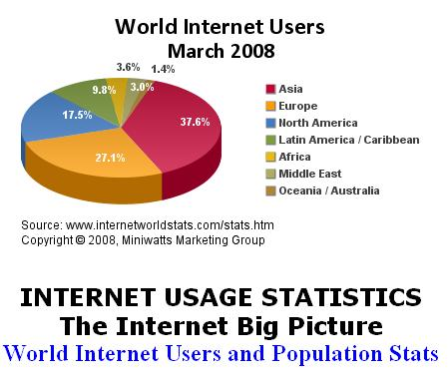
Source: http://www.internetworldstats.com
From this pie chart we see that Africa, which has 14,3% of the world’s population, only has a 3,6% of the world’s Internet usage. As we can see, the least digitised regions of the world are Oceania/Australia and the Middle East, followed very closely by Africa. This is useful information, but we cannot really read much from it as we have not been given any information on the populations of these regions, from which to make conclusions about the density of internet availability in the regions. The next table sheds more light on Internet usage, as it not only gives us the populations of the different regions, but also presents information such as the percentage of the population that is connected to the Internet, usage growth rate and the world users’ percentage. From this table we can see that Africa’s Internet usage level does not correspond with the size of its population. The continent has t the lowest Internet penetration rate, a paltry 5.3%, which is only a third of the penetration rate of the world’s second lowest continent, Asia, at a modest 15%. That means all the other continents have a much greater per capita access than Africa. The consoling fact is the realisation that Africa has the world’s second highest usage growth rate, pegged at 1030.2%.
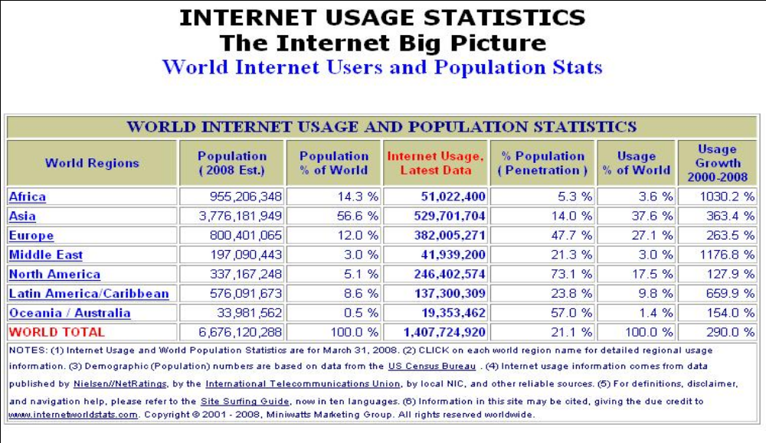
Source: http://www.internetworldstats.com
Let us consider the graph below.

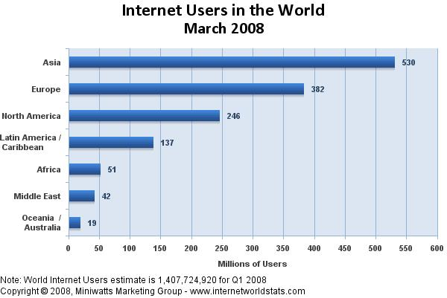
Source: http://www.internetworldstats.com
This graph shows that Africa’s Internet usage is among the lowest in the world, while the position of Africa as having the world’s lowest Internet penetration rate, at 5.3% is confirmed in the graph below.

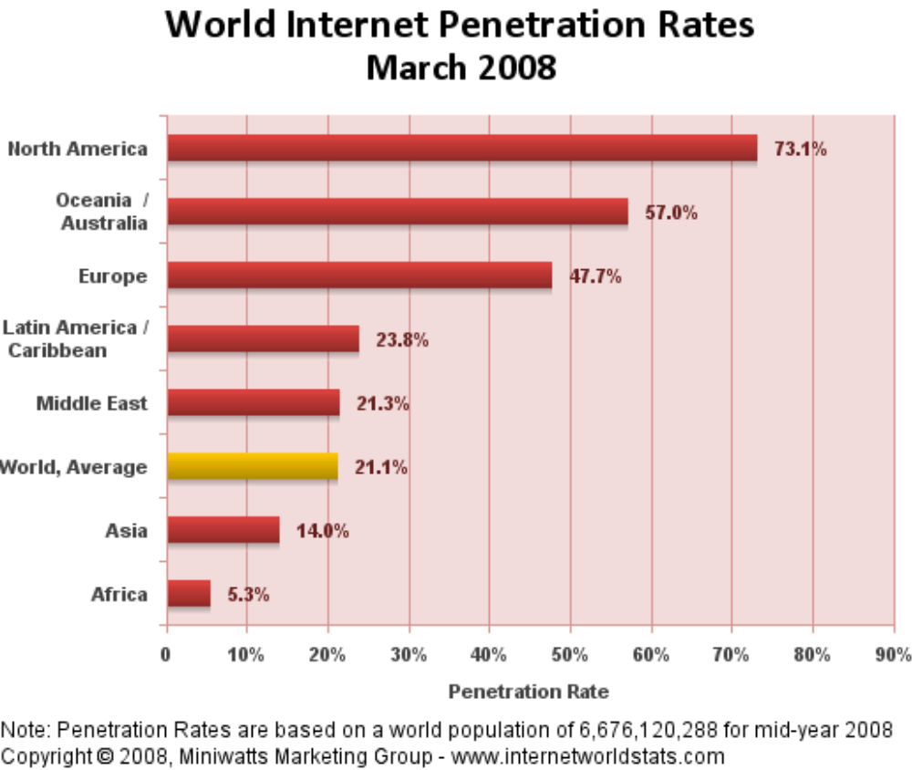
Source: http://www.internetworldstats.com
This graph gives the clearest picture of the position of Africa on the world Internet scene. At 5.3%, the continent has by far the lowest penetration rate of all other continents, way below the world average of 21.1%. Earlier statistics below reflect the same trend, but they suggest some hope for Africa because they show that the continent’s penetration rate has improved considerably between 2004 and 2008, from 1.8% in 2004 to 4.8 in 2006 and 5.3% in 2008. This suggests sustained growth, which is good for the continent.

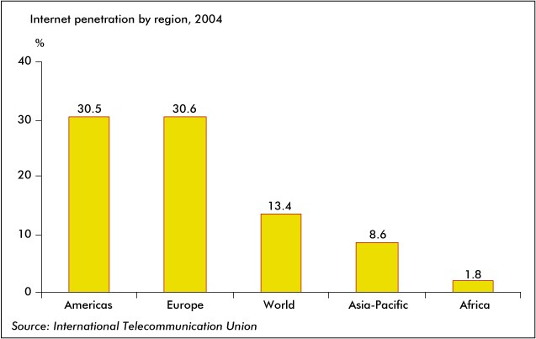

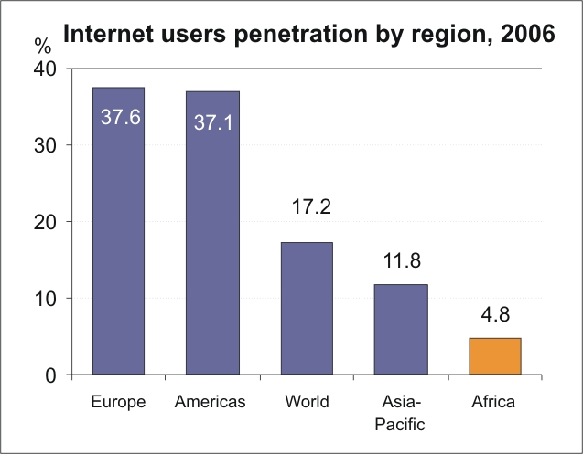

Source: http://www.itu.in

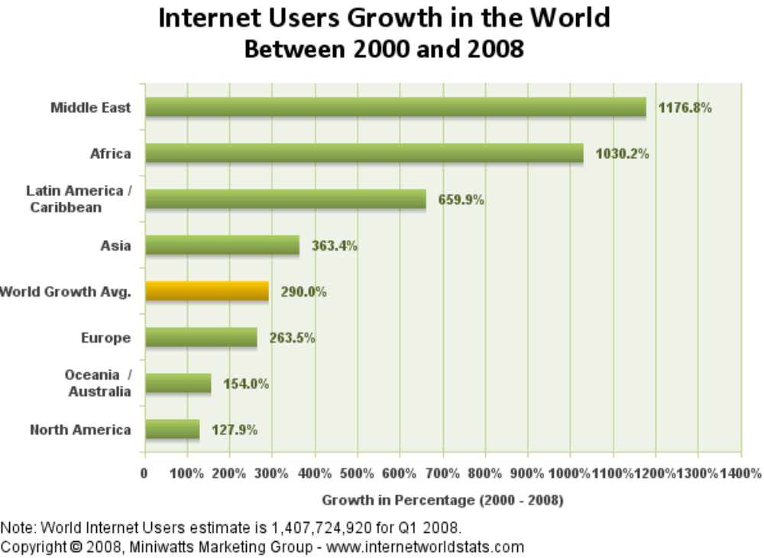

Source: www.internetworldstats.com

From this graph we see that Africa is one of the continents with the most dramatic changes for the better on the Internet usage scene. Efforts by governments and aid agencies are certainly bearing fruit as far as narrowing the digital divide is concerned, though there is still a long way to go.

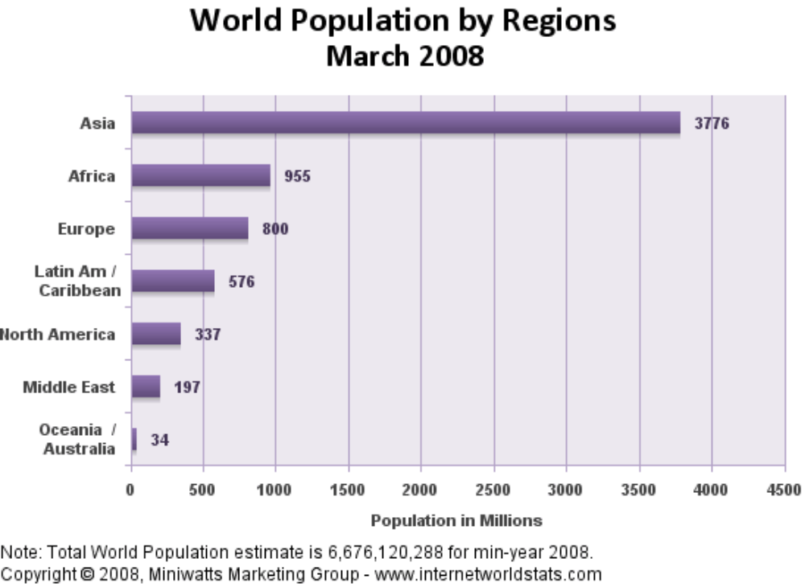

Source: http://www.internetworldstats.com
This graph gives us a basis for comparison of the distribution of Internet usage in Africa in real terms. We see here that Africa is the continent with the world’s second largest population but, alarmingly, as shown in the graphs above, it has the world’s lowest penetration rate.

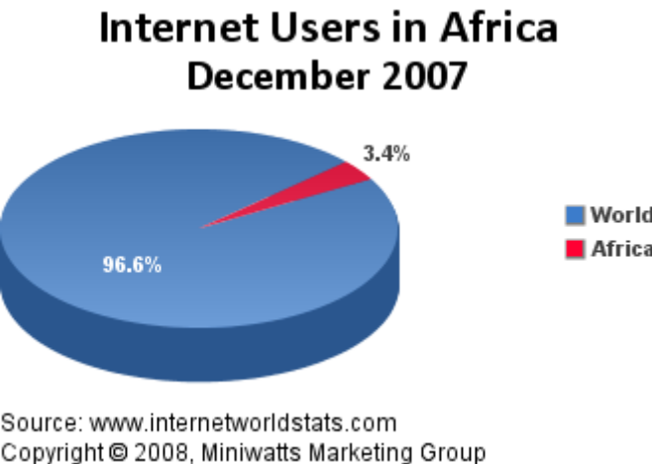

Source:http://www.internetworldstats.com
This pie chart is a graphic representation of the shortage of Internet facilities in Africa, which is why it has been referred to as a technological desert.

However, the pie chart below, which was constructed in1999, shows that there have been some improvements in the Internet status of Africa. It graphically illustrates the fact that the Internet usage of Africa then, compared with that of the rest of the world, was virtually non-existent. The portion of the chart representing Internet use in Africa was merely a thin black line, so thin that the plum colour that was supposed to indicate Internet usage in Africa was completely absent. Internet usage in Africa was so meagre that it was difficult to represent graphically.

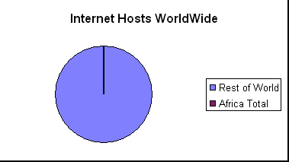

Network Wizards African Data Analysis Jan 1999
Source:http://www3.sn.apc.org

If the Internet penetration rate were the same for every continent the distribution of Internet facilities would be reflected by the size of the population, resulting in the distribution shown in the pie chart below.

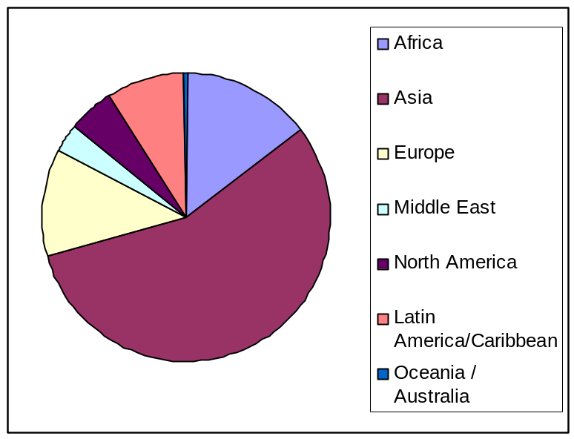

Source:http://www3.sn.apc.org

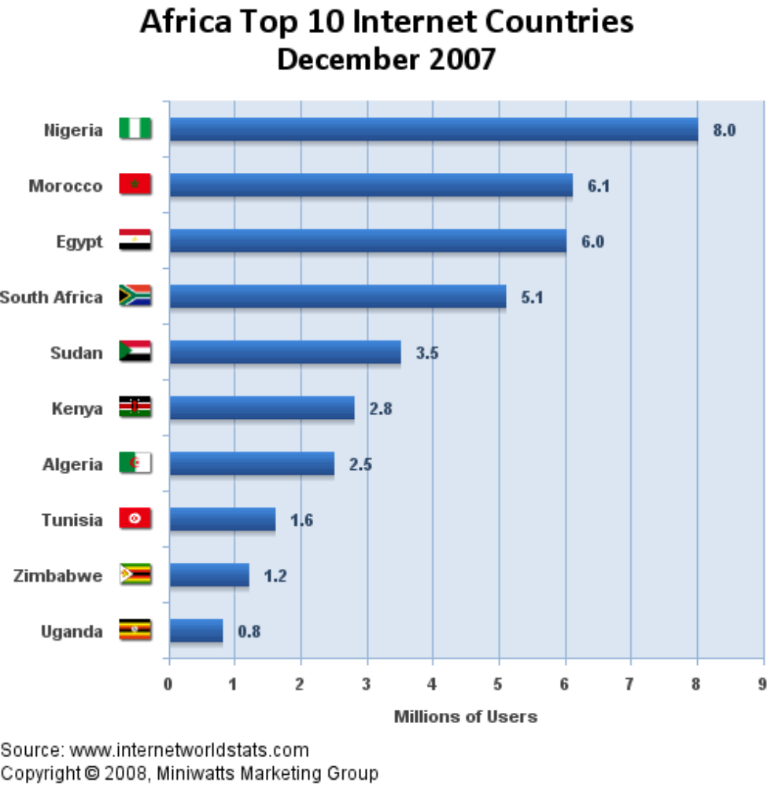

Source:http://www.internetworldstats.com
These are the countries that boast the best Internet penetration in Africa, a continent of 53 countries. By African standards they have made impressive achievements Internet wise, but their achievements are nothing when compared with the world average penetration rate at 21.1%, not to mention America, the world leader, at 73.1%.

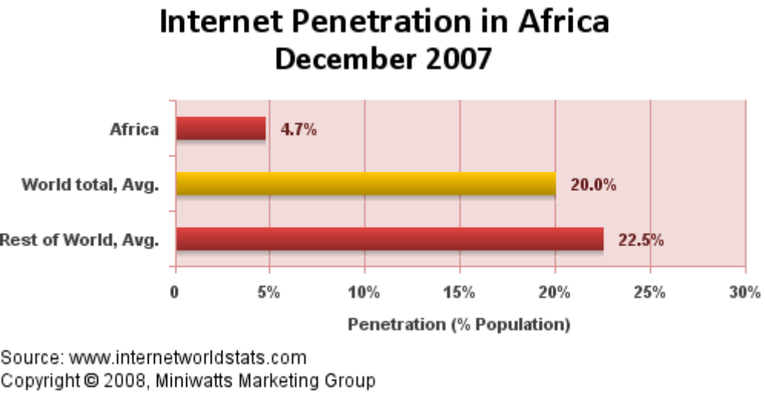

Source:http://www.internetworldstats.com
From this graph we learn that the average penetration rate for the rest of the world excluding Africa is 22.5%, which is in stark contrast with Africa’s meagre 4.7%.
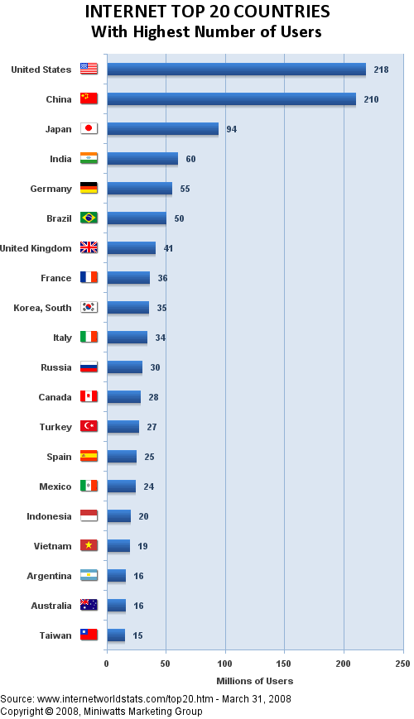
Source:http://www.internetworldstats.com

Looking at the world’s top twenty Internet countries, for comparison purposes, we see that none of the African countries appear in the top twenty. Nigeria, the current technological leader, has only 8% of its population as Internet users. I describe Nigeria as ‘the current leader’ because in Africa things change very quickly on the technology scene.

The following are earlier statistics on telephone availability in Africa. They confirm the pattern that we have seen established by the Internet statistics above. The graph below shows the disparities that exist within the countries of Africa as far as telephone distribution is concerned. As of 2004, the average telephone availability for the whole of Africa was 3.1per 100 people, while that for Sub-Saharan Africa was only 1. The average of 3.1 per 100 people is itself very low.

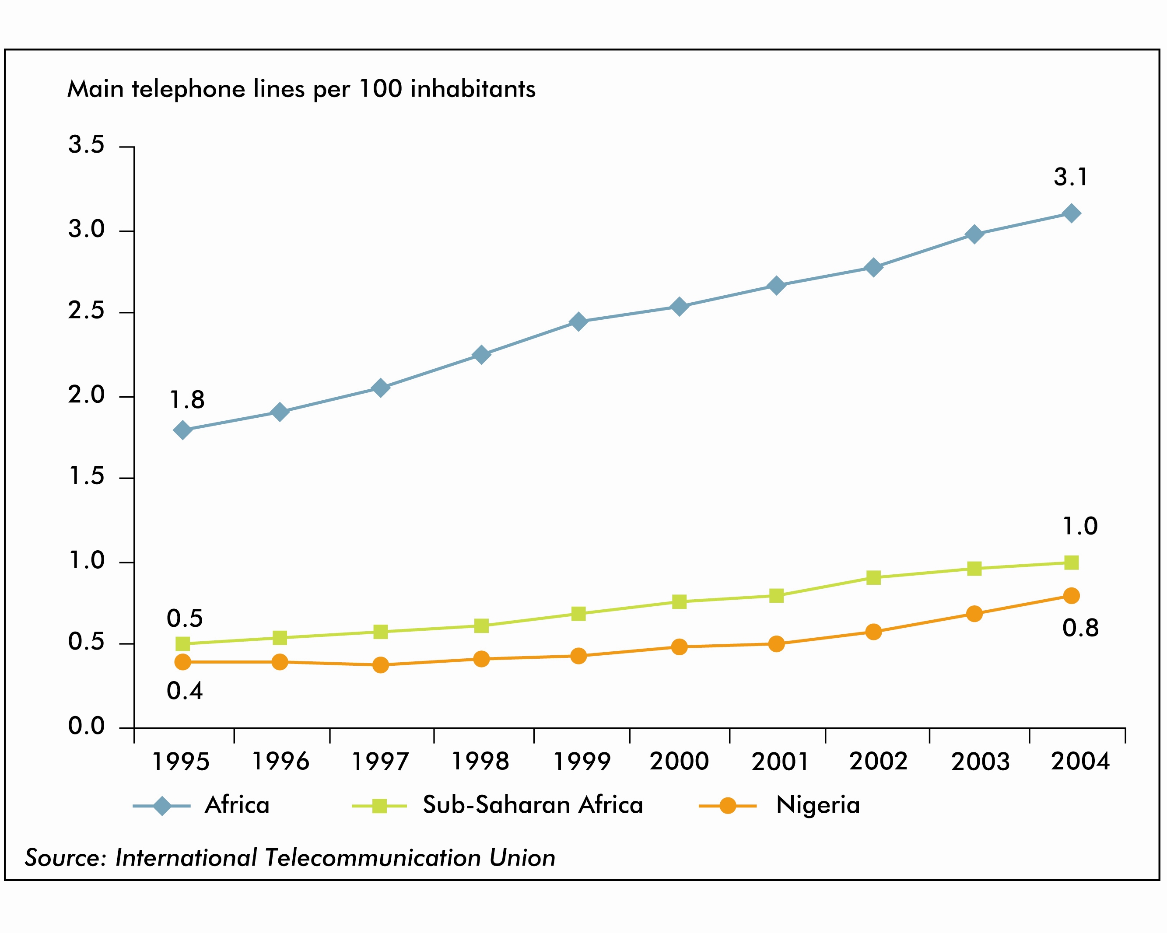
Source: www.itu.int

The graph below shows the world distribution of main telephone lines, and confirms the trend that has been set above, that of Africa trailing behind all the other countries.
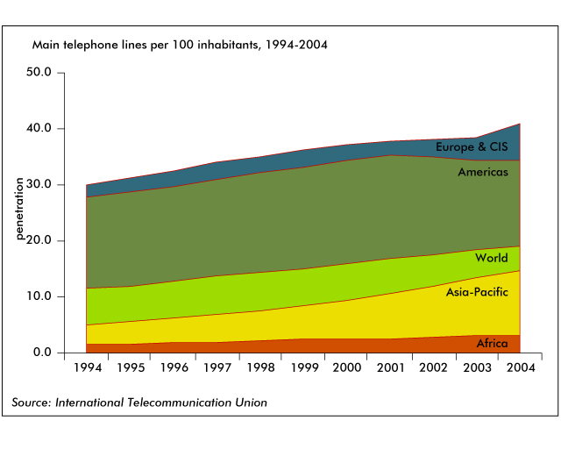
Source: www.itu.int

We have seen in the statistics above that Africa is one of the continents with the fastest Internet growth rates. The same is also true of mobile subscription growth, as seen in the graph below, where Africa records the world’s greatest growth rate.

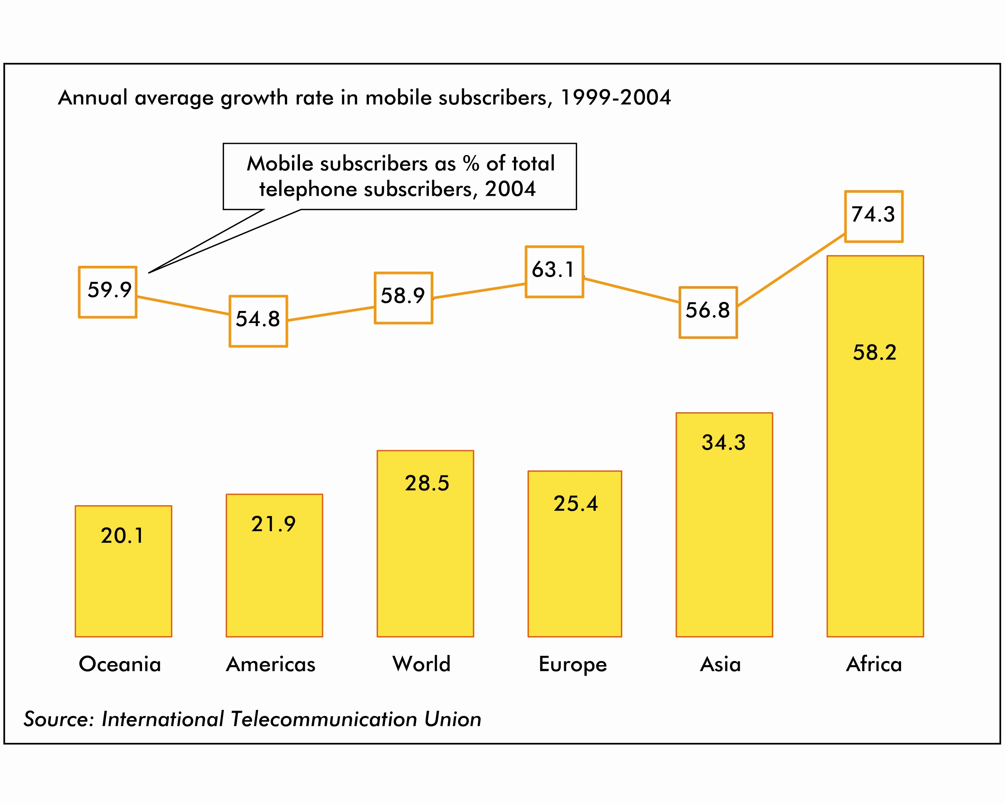
Source: www.itu.int

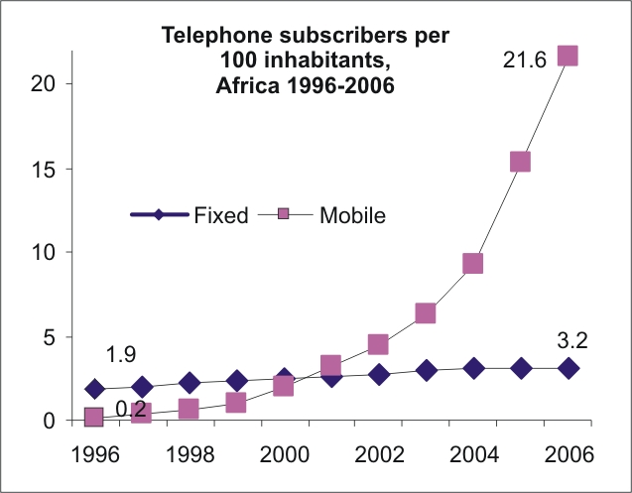

Source: www.itu.int

The graph above shows that while there is a steady increase in the number of fixed telephone lines, there is a sharp increase in mobile phone subscription. The graph below corroborates the statistics above suggesting that Africa has the world’s fastest-growing mobile phone industry.
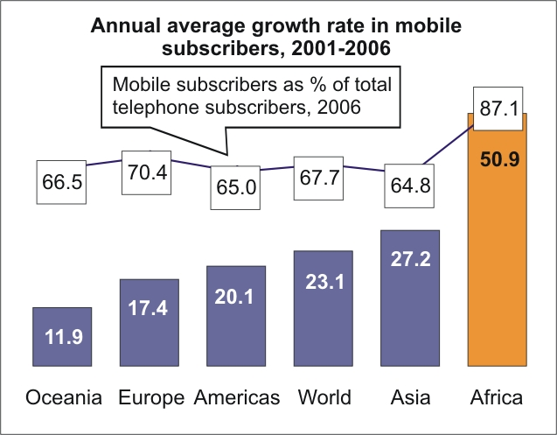

Source: www.itu.int

The following are some interesting facts about communication technology in Africa:

Internet
- In 2006, less than 5 out of every 100 Africans use the Internet, compared with an average of 1 out of every 2 inhabitants of the G8 countries (Canada, France, Germany, Italy, Japan, Russia, the UK and the US).
- There are roughly around the same total number of Internet users in the G8 countries as in the rest of the world combined:
- 474 million Internet users in G8 countries
- 657 million Internet users in non-G8 countries
- The G8 countries - home to just 13% of the world’s population - have more than 40% of the world’s total Internet users.
- There are more than 5 times as many Internet users in the US and two times as many Internet users in Japan than on the entire African continent.
- There are major discrepancies in international Internet bandwidth - the critical infrastructure that dictates the speed at which websites in other countries can be accessed. Denmark – a country roughly the size of Costa Rica - has more than twice the international Internet bandwidth than the whole of Latin American and the Caribbean combined.
- The high cost of international bandwidth is often a major constraint, with developing countries often having to pay the full cost of a link to a hub in a developed country. Many countries today have less than 10Mbps of international Internet bandwidth, whereas in Belgium, a 9Mbps ADSL high-speed Internet package is available for just EURO 60 a month.
- There are still around 30 countries with an Internet penetration of less than 1%.

Mobile
- The 13% of the world’s population that lives in the G8 countries accounts for 28% of the world’s total mobile users.

Fixed
- Of Africa’s 26 million fixed lines, over 75% are found in just 6 of the 55 African nations.
- Africa has an average of 3 fixed lines per 100 people.

In 2006 AFRICA
… accounted for 14% of the world’s population, but for only 5.6% of all fixed and mobile subscribers worldwide.
… had by far the world’s lowest penetration of fixed lines, with a continental average of around 3 main lines per 100 people.
… had over 20 countries which had a national average of fewer than 1 main line serving every 100 people.
… had 221 million total telephone subscribers, 198 million of which were mobile cellular subscribers. The continent has the highest ratio of mobile to total telephone subscribers of any world region, and has been dubbed "the least wired region in the world".
...had its own digital divide. For example, Egypt had 11 times the fixed line penetration of Nigeria. While sub-Saharan Africa (excluding South Africa), had an average teledensity of one percent, North Africa (Algeria, Egypt, Mauritania, Morocco, Tunisia) had a comparable average of eleven percent. Almost three quarters of the continent’s fixed lines were found in just 6 of the continent’s 55 countries.
… was the region with the highest mobile cellular growth rate. Growth over the past 5 years averaged around 50% year on year. The total number of mobile cellular subscribers continent-wide at end 2006 was 198 million.
…added some 61 million new mobile subscribers– a figure almost equivalent to the total number of telephone subscribers (fixed and mobile) in Africa in 2002.
… had some 22 million Internet users, for an Internet penetration of just 5%. Europe’s Internet penetration is 7 times higher.
Source: www.itu.int

The following statistical information was published in the 27June 2005 edition of the METRO, London:

Only one in 40 Africans owns a phone. In Sub-Saharan Africa there is one net connection for every 400 people. In the US it is one for every two. This information shows the
general shortage of technological equipment in Africa.

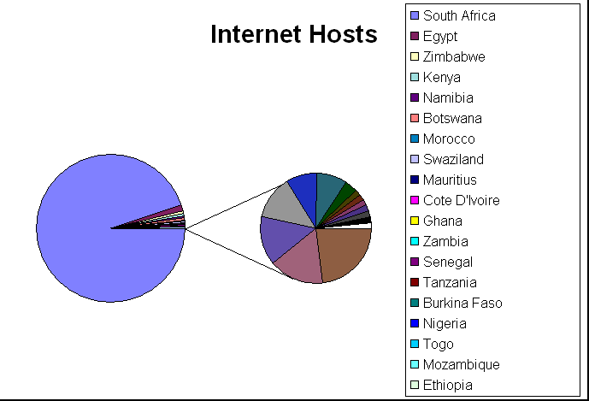

Source: http://www3.sn.apc.org
The chart above shows the wide range of levels of attainment of Internet connectivity in African countries. The levels range from the very high level of Internet access in South Africa, by African standards, to levels so low that the Internet can be considered non-existent, in countries such as Liberia and Burundi, which do not even appear in the chart. For its part South Africa, which is considered technologically very advanced in Africa, is dwarfed by the top 24 countries with the highest Internet penetration rates (See statistics below.).
The chart below also shows the variable Internet connectivity of Africa, this time excluding the then mismatched stalwart, South Africa. The latest statistics demonstrate how fluid the African technology scene is, because in less than a decade South Africa has fallen to third place. Please not I have used this pie chart for want of a more recent one.
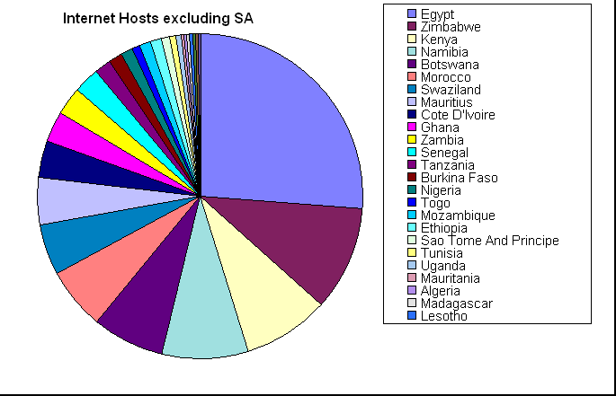

Source: http://www3.sn.apc.org

The table below shows Internet usage statistics for Southern Africa selected from statistics for the whole of Africa.

INTERNET USAGE STATISTICS FOR AFRICA
AFRICA | Internet Users  Dec/2000 | Internet Users  Latest Data | Use Growth  ( 2000-2008 ) | % Users  in Africa | Population  ( 2008 Est. ) | Penetration  (% Population)
Angola | 30,000 | 100,000 | 233.3 % | 0.2 % | 12,531,357 | 0.8 %
Botswana | 15,000 | 80,000 | 433.3 % | 0.2 % | 1,842,323 | 4.3 %
Congo, Dem. Rep. | 500 | 230,400 | 45,980.0 % | 0.5 % | 66,514,506 | 0.3 %
Lesotho | 4,000 | 70,000 | 1,650.0 % | 0.1 % | 2,128,180 | 3.3 %
Madagascar | 30,000 | 110,000 | 266.7 % | 0.2 % | 20,042,551 | 0.5 %
Malawi | 15,000 | 139,500 | 830.0 % | 0.3 % | 13,931,831 | 1.0 %
Mauritius | 87,000 | 340,000 | 290.8 % | 0.7 % | 1,274,189 | 26.7 %
Mozambique | 30,000 | 200,000 | 566.7 % | 0.4 % | 21,284,701 | 0.9 %
Namibia | 30,000 | 100,100 | 233.7 % | 0.2 % | 2,088,669 | 4.87 %
Seychelles | 6,000 | 32,000 | 433.3 % | 0.1 % | 82,247 | 38.9 %
South Africa | 2,400,000 | 5,100,000 | 112.5 % | 10.0 % | 43,786,115 | 11.6 %
Swaziland | 10,000 | 42,000 | 320.0 % | 0.1 % | 1,128,814 | 3.7 %
Tanzania | 115,000 | 400,000 | 247.8 % | 0.8 % | 40,213,162 | 1.0 %
Zambia | 20,000 | 500,000 | 2,400.0 % | 1.0 % | 11,669,534 | 4.3 %
Zimbabwe | 50,000 | 1,351,000 | 2,602.0 % | 2.6 % | 12,382,820 | 10.9 %

Source: www.internetworldstats.com
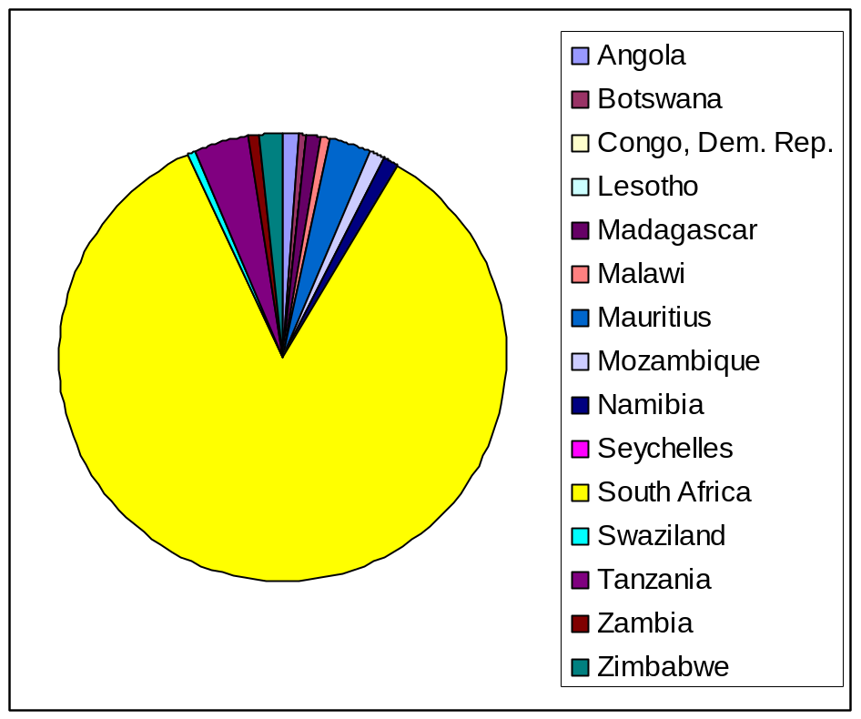

Source: http://www3.sn.apc.org

INTERNET USAGE STATISTICS FOR SOUTHERN AFRICA

The pie chart above illustrates the wide differences in the Internet connectivity of southern African countries. We can see that South Africa is by far the most advanced as far as Internet connectivity is concerned, while Seychelles is the least connected. Zimbabwe, which is the runner up to South Africa, trails far behind the technological giant of southern Africa.

Wilson and Wong suggest that there is a direct positive correlation between a country’s level of achievement in ICT and its economic status. They say:

‘In part, these big ICT differences reflect differences in levels of economic performance and economic structure both within Africa and globally.’ (E.J. Wilson and K. Wong: 2003)

This is in fact true because countries that are economically successful have a generally high quality of life and are able to spend more on improving amenities for its citizens. Daly agrees with Wilson and Wong, saying:

‘In general the level and quality of ICT performance is closely linked to the structure and performance of the national economy.’ (Daly: 1999, quoted by E.J. Wilson and K. Wong: 2003)

Southern Africa, though not as technologically advanced as many parts of the world, is more connected than most of the regions of Africa as a result of its more robust economic performance. Noteworthy is the position of South Africa on the ICT ladder. Of this southern African colossus Wilson and Wong say:

‘…Southern Africa is the region with the densest network of traditional and modern technologies, reflecting its preponderant economic weight on the continent, especially for the powerhouse South Africa. Since South Africa’s GDP is almost equal to all the other Sub-Saharan countries combined, and since South Africa has more ICT infrastructure than the rest of Sub-Saharan Africa – 20 times more main telephone lines, 10 times more PCs, and twice as many home satellite antennas – we exclude South Africa as part of Sub-Saharan Africa to avoid the huge distortions that would otherwise appear in our analysis.’ (E.J. Wilson and K. Wong: 2003)

Source: http://www.cidcm.umd.edu

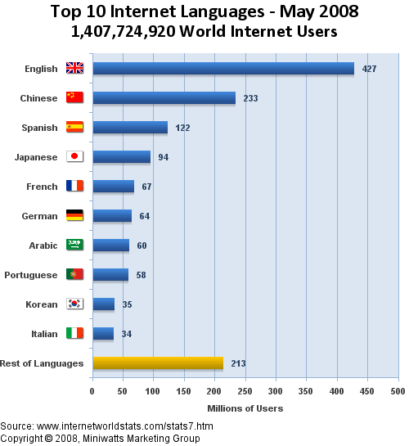

Source: www.internetworldstats.com

Another important pointer to the level of digitization of a region is the level of its language usage on the Internet. As the statistics above show, no exclusively African languages feature in the top ten. Arabic is spoken in Northern Africa, but it is not an exclusively African language. I must confess that as I was carrying out this study I was of the pinion that the Internet could not be accessed in any of the African languages, and I wrote, ‘Of all other languages spoken in Africa, not a single one has as yet made its way into the Internet.’ Little did I know what was a fallacious statement I was making. Google slapped me across the face with a search engine in Shona, my own language! That was incredible! I immediately shared my new find with other Internet-savvy Shona speakers, all of whom would not believe me. Further investigation revealed that almost all African languages, numbering between 1500 and 2000, are used on the Internet. That prompted me to seek more accurate information, and I stumbled into the following facts :

Discussion of the “digital divide” – the uneven distribution of computers and internet in favor of certain regions and groups – has become commonplace in the discourse on global expansion of the “information society.” Quite apart from assumptions regarding the value of internet connections, Africa, by and large, is considered to be on the disfavored side of the divide. Various statistics like low numbers of telephone connections, lack of electrification and high illiteracy have long characterized the continent, and now are joined, unsurprisingly, by low indicators for connectivity and access to internet and computers.

The relative level of use of African languages in computing and on the internet is hard to quantify but important to at least characterize. To begin with, it is clear that African languages are not yet widely used in the content of computing applications or on the internet. We can deduce this, for instance, from the lack of software localized even for major African languages and the infrequence and character of such web content as one does find in African languages.

African languages are represented on the web, but not prominently as media of communication. There are few surveys that document this. A study by Diki-Kidiri and Edema (2003) did find a significant number of sites that treat African languages in one way or another, but these generally have minimal content in the languages themselves. A large proportion are sites about African languages, including online dictionaries and instructional pages. An informal survey done in 2001 as part of a larger report for the Swedish International Development Agency (SIDA) in Tanzania estimated that ten percent of websites with a Tanzanian focus had at least some Swahili content (Miller Esselaar Associates, 2001), but here too most of the sites did not have majority content in the language.

Other efforts to quantify web content by language worldwide do not to show even the most widely spoken African languages at all among the most represented, whereas some minority European languages with relatively few speakers are ranked.

Source: http://www.lingref.com

This extract confirms that African languages have in fact made entry into the Internet, and suggests that at this point in time activity in these languages is still very low.

The information and statistics in the following section relate to Africa’s status at the end of the second millennium. While some of the facts may have changed, many of them are still true and are relevant to our understanding of Africa’s current status. It should be borne in mind that the process of change is still taking place and the general trends suggested still prevail. I felt that they constitute important events in the transition from a continent devoid of communication technology to one with a burgeoning technological programme.

That Africa has an acute shortage of technological equipment is indisputable. Let us take the following simple example. Since the advent of the radio in 1901, it has proliferated to the extent that in the developed world the ordinary person has access to several radios. It is not uncommon for one person to own a stereo at home as part of domestic furnishings, in addition to a small portable radio-cassette player and an even smaller pocket-size walkman. He or she also has a car radio and another radio on the mobile phone. Some people even have a kitchen radio, a bathroom radio and another one fixed on the headboard as part of the bedroom suite. In contrast, in Africa only one in four people have a radio. The following statistics, though not the latest, show that Africa is shrouded in a veritable technological drought: the Africans are clearly famished technologically.
The use of the Internet has grown relatively rapidly in most urban areas in Africa, in much the same pattern as the adoption of the mobile phone which followed shortly after. As an indication, five years ago, only a handful of countries had local Internet access, now it is available in every capital city. But although these are encouraging trends, the differences between the development levels of Africa and the rest of the world are much wider in this area than they are using more traditional measures of development: Of the approximately 816 million people in Africa in 2001, it is estimated that only:
- 1 in 4 have a radio (205m)
- 1 in 13 have a TV (62m)
- 1 in 35 have a mobile phone (24m)
- 1 in 40 have a fixed line (20m)
- 1 in 130 have a PC (5.9m)
- 1 in 160 use the Internet (5m)
- 1 in 400 have pay-TV (2m)
Source: http://www3.sn.apc.org

The ownership and use of mobile phones are useful pointers to the level people have attained on the technology ladder. In Africa very few people own mobile phones and the few that are owned are usually shared by a number of people. Vodafone carried out a study of the way people use mobile phones in Africa and gave the following report:

We have also learned that people in Africa use mobile phones very differently. Most striking is the accessibility of mobile. While penetration rates are by the standards of the developed countries low, the way in which mobiles are informally shared between people, the formation of private resellers of mobile services and the provision of mobile phones for public use, all increase accessibility, even in rural communities. The impact of mobile extends well beyond what might be suggested by the number of subscriptions alone. (Research by Vodafone)

Source: http://www.sarpn.org.za/documents/d0001181/index.php

The report shows that while the ownership of mobile phones in Southern Africa is growing, it is still limited as compared to the developed countries.

Exposure to modern communication technology is influenced by people’s location. Naturally people who live in or near towns where there is easy access to electricity and electronic transmitters enjoy better technological facilities than those in remote locations as shown by the following report.
Few studies have been made in Africa of the number of rural vs urban users, but it is safe to say that users in the cities and towns vastly outnumber rural users
Source: http://www3.sn.apc.org

Mike Jensen (1998) concurs. He is a South African independent consultant with experience in over 30 countries in Africa assisting in the establishment of information and communications systems during the last 15 years. Based in Port St Johns in the East Cape, he sent his first email 20 years ago while studying rural planning and development in Canada. He subsequently returned to South Africa to work as a journalist on the Rand Daily Mail in Johannesburg in 1983. When the paper closed he moved back to Canada and in 1986 he co-founded the country's national Internet service for NGOs, called coincidentally, The Web.
After helping to set up a similar ISP in Australia in 1989, he returned to South Africa where he works with international development agencies, the private sector, NGOs and governments assisting them in the formulation, management and evaluation of their Internet projects.
Mr Jensen is a trustee of the African IT Education Trust, a board member of the South African Internet service provider for NGOs - SangoNet - and was a member of the African Conference of Ministers' High Level Working Group which developed the African Information Society Initiative (AISI) in 1996. He manages a popular web site on the status of Internet in Africa –

Source: http://www3.sn.apc.org

He says:
Services in the capital cities do not, however, provide for access by many Africans as 70% live in rural areas. The exception to this is in Burkina Faso, Gabon, Malawi, Mauritius, Mauritania, Morocco, Niger, Senegal, Tchad, Tunisia and Zimbabwe which all provide local call access across the whole country.
Source: http://www3.sn.apc.org
Yet another source gives the following estimate:
In Africa, each computer with an Internet or email connection usually supports a range of three to five users. This puts current estimates of the total number of African Internet users at around 5-8 million, with about 1.5-2.5 million outside of North and South Africa. This is about 1 user for every 250-400 people, compared to a world average of about one user for every 15 people, and a North American and European average of about one in every 2 people. (The UNDP World Development Report1 figures for other developing regions in 2000 were: 1 in 30 for Latin America and the Caribbean, 1 in 250 for South Asia, 1 in 43 for East Asia, 1 in 166 for the Arab States).
Due to the relatively small number of people who can afford a phone line, let alone a computer, public access services are very much in demand in the urban areas.
In addition a growing number of hotels and business centres provide a PC with Internet access.

Source: http://www3.sn.apc.org
Mike Jensen gives the following important statistics:
For every 1000 inhabitants, telephone mainlines are accessible to about 1 inhabitant in Nigeria, 9 in Kenya, and 41 in Botswana. This compares to accessibility to about 75 per thousand in Brazil, 166 in Malaysia, and 335 in Bulgaria. The average number of mainlines per person is about 18.5 per 1000 in Africa, compared to 60.2 in Asia, 303.8 in North and South America, and 343.8 in Europe. The density of cellular channels is about 1.7 per 1000 persons in Africa, compared to 13.5 in Asia, 69.2 in the Americas, and 117 in Europe. Most telephone lines and cellular hubs are concentrated in urban areas.
53 African countries have access to the Internet and this is generally confined to capital cities. The African ratio of 1:5,000 Internet users compares poorly to the 1:40 worldwide ratio, 1:6 ratio in Europe and North America. Moreover, the majority of Africa’s one million Internet users reside in South Africa. In 1999, the Republic of Congo, Eritrea, and Somalia were still without local Internet service.
Source: http://www3.sn.apc.org

These statistics were compiled in the late 1990s, but that should by no means imply that they are useless. Undoubtedly they would not be as accurate as we would have wanted them to be, considering the time lapse from the time they were actually compiled, but we do not have much of a choice for want of more recent statistics. At any rate, taking into account the slow rate of the technological progress made in Africa in general, as shown by the various sources quoted in this paper, it is highly improbable that recent statistics would be significantly different from these.

The following are later statistics form a COMESA report, and they confirm the earlier statistics:
Statistics on ICT development show a wide disparity between the network capacity in Africa and the rest of the world. In fact, the network capacity per 100 inhabitants (telephone density) in Africa is the lowest, compared to other regions, in the world. The average teledensity for Africa was 2.62 in 2001 while the world average was 17.19. The teledensity of the whole COMESA in 2001 was 2.17 compared with 0.74 for Sub-Saharan COMESA countries (i.e. minus Egypt). Furthermore, COMESA region accounts for only 0.84 percent of total telephones (by 2001) and 0.01 percent of Internet host computers (2001) in the world (For more details, Refer to the Appendix, Table 1). This undesirable situation is due to inadequate investment, low priority given to ICTs and inappropriate institutional arrangement.
Source: http://www.comesa.int

All of Africa's 53 countries and territories have internet connectivity, the challenge now is to broaden access and ensure that costs are brought down. Usage is still low and communication charges are often 10 - 100 times more expensive than developed
http://www.suvabay.com/

countries, mainly due to the lack of infrastructure and the high prices charged by operators taking advantage of the restrictions on market entry that are in place in most countries.

THE USES TO WHICH ICT IS PUT IN SOUTHERN AFRICA

Mailing lists and newsgroups are an important vehicle of education and communication for countries that are privileged to have Internet access. Developed countries make full use of these channels of communication and education by having numerous websites for these forums, often running into the thousands, but Africa has only a few of these. Mike Jensen says:
There are about 140 electronic mailing lists and UseNet newsgroups on the Internet which discuss issues relating to Africa (although a significant proportion of them are more closely affiliated with US African-American issues). These lists and newsgroups are almost entirely hosted off-continent except for a number in South Africa, North Africa and Kenya. There is a list for almost every nation as well as others on more general topics ranging from African Cinema to Post Colonialism. In the area of ICTs in Africa, AFRIK-IT is the only notable public list, and it is run from Ireland by the University College of Dublin.
There are other announcement and discussion lists with a smaller circulation, many of which focus on some of the programmes the international communities are carrying out in Africa, such as the African Information Society Initiative's AISI-HITD-CL and its associated African Technical Advisory Committee ATAC-CL, the PICTA-CL and SCAN-ICT-CL mailing lists hosted by Bellanet.There are also some more specialised lists relating to African ICTs in particular sectors, regions or countries…
Source: http://www3.sn.apc.org
One of the many uses to which the Internet is put is the dissemination of news through online newspapers. This new way of accessing news enables newsreaders to read news in the comfort of their homes, without the hassle of travelling long distances to purchase paper versions of news media, which require a high level of organisation as they can cause a lot of clatter in the home. Africa now also enjoys this convenience of being in touch with the outside world. Jensen says:
The news media are now relatively well represented on the web. As early as 1999, the US Columbia University African Studies department identified over 120 different newspapers and news magazines that were available on the Internet, of which over 60 percent were published on the sub-continent, in about half of the countries (23). Those most well represented in this area are again those with more advanced Internet sectors - Côte d'Ivoire, Egypt, Ghana, Kenya, Senegal, South Africa, Tanzania, Zambia and Zimbabwe. Also of note are the efforts to develop local content and host daily newspapers by the ISP AfricaOnline which has offices in 8 countries.
There are two major continent-wide African traditional news agencies, both of which extensively use electronic media - Inter Press Service (IPS) and the Pan African News Agency (PANA). There are also a growing number of Internet-only Africa news portals such as newafrica.com and allafrica.com As well as web search engines specialising on Africa such as - Aardvark, Orientation Africa - http://af.orientation.com and Woyaa - http://www.woyaa.com . As with other similar services elsewhere, these are run by commercial companies which generate revenue through advertising.
Source: http://www3.sn.apc.org

The tragedy about the condition of Africa, technologically, is not that it lags so far behind other regions of the world, but rather, that the disparity is ever escalating. When we speak of phenomenal growth in the area of technology, Africa is a forgotten region where even obsolete and discarded items of technology sometimes do not even reach. These are items that people in Africa only hear about but never have the opportunity to use, while in the more advanced regions these items are so mass-produced that they flood the market, making them so cheap that virtually anyone can afford them. The result is a population that has an over-supply of technological gadgets, leading to very low prices and high per capita use. We end up with a situation where at one end we have people who have received colourful reports of the wonders of technology, the actual use of which remains a pipe dream and wishful thinking, while at the other end we have people who are privileged to have access to so much technology that it has become part of their natural environment that they take for granted. This scenario, in the telecommunications area, is aptly described by E.J. Wilson and K. Wong as follows:

‘…despite dramatic improvements, the overall performance of the African telecommunication sectors is dismal in comparison to the rest of the world. The benefits of ICT progress are very real for people who gain greater access, but taken as a whole Africa may be eclipsed by the pace of the revolution in other regions. As others move ahead more swiftly, Africa is getting left further and further behind.’ (E.J. Wilson and K. Wong: 2003).

It should be noted that these are 2003 statistics, and that according to the latest statistics the situation seems to have change, but these statistics have been included so that the current situation is thrown into perspective by an understanding of the period that preceded it.

The following statistics given by E.J. Wilson and K. Wong confirm the assertion that as of 2003, the disparity between Africa and the rest of the world, technologically, was widening:

‘…a recent study reported that Africa has fallen in the last several years from 0.25% of the total websites in the world to 0.22%.’ (E.J. Wilson and K. Wong: 2003)

The same disturbing tone indicating both stagnation and retrogression in the development of Africa’s communication technology is echoed in the following report:
The rates of growth in users seen in the 1990s has slowed in most countries as the bulk of the users who can afford a computer and telephone have already obtained connections. As of mid 2002 the number of dialup Internet subscribers was close to 1.7 million, 20% up from last year, mainly bolstered by growth in a few of the larger countries such as Egypt, South Africa, Morocco and Nigeria. Of the total subscribers, North Africa and South Africa are responsible for about 1.2 million, leaving about 500 000 for the remaining 49 Sub-Saharan African countries.
Source: http://www3.sn.apc.org

It is disturbing to note that it is an established fact that Africa is capable of experiencing retrogression, not even stagnation, in its quest for technological parity with other regions of the world. To find solutions to this problem, the reasons why Africa lags so far behind must be sought and addressed.

It has been shown that people in Africa lack both the computer skills to enable them to make use of computer technology, and the economic enablement to allow them to make use of the new technology. Most are not computer literate, which prevents them from using IT facilities even if they wanted to. ICT education is still in its infancy, so that even university students do not have meaningful IT skills, while among primary and secondary pupils such skills are mediocre at best and non-existent at worst. That explains why the population has not adopted the Internet culture. The following report confirms the view that in Africa the public is not actively involved with the Internet:
However the case for large multi-branch cybercafe chains is not yet proven, as regional ISP AfricaOnline learned when it rolled out hundreds of public access kiosks as part of its e-Touch franchise programme in which local stores were provided with a PC to provide email and Internet access. AfricaOnline had approximately 100 000 users spread across 740 outlets in Cote d'Ivoire, Kenya, Uganda, Tanzania and Zimbabwe before it discovered these were generating insufficient income to maintain them. The company has subsequently closed most of them and is testing new strategy with fewer, larger branded I-cafes.
Source: http://www3.sn.apc.org
INFORMATION TECHNOLOGY IN SOUTHERN AFRICAN EDUCATION

Having discussed the use of educational technology in Africa in general we shall now look at the use of Information Technology in southern African education. At this point it has been established that Information Technology in southern Africa is so skimpy that that there virtually is no information technology to talk about, that is, when we compare southern Africa with other regions of the world. In some quarters there have been references to Africa as a ‘technological desert’. We have shown that this is by no means an exaggeration. Against this background it is highly improbable that anyone can expect wonderful news about the use of educational technology in the schools in this region. As can be expected, the level of achievement in the area of educational technology corresponds to the general level of the digitization of the region. A gloomy picture of the state of communication technology in Southern Africa is thus painted. By the same token in the field of education the use of educational technology is anything but glorious.

At this stage we shall consider three simple examples of how developed countries are able to use technology and maintain educational resources to enhance the learning of pupils, for the purpose of comparison with southern Africa. These are the See/Hear: Share project, NetOp School and the concept of Total Cost of ownership (TCO),

The METRO of 13 June 2005 carried the story of Media tutors Harold Fricker and Eduardo Carrillo who came up with the idea of sending lessons straight to pupils’ mobile phones. Scholars will also be able to download files containing the most important parts of tutorials. This will involve filming hour-long lectures with video cameras. The footage is later condensed into a ten to fifteen minute video clip, which is then sent to students with the ultra-modern 3G phones. Students without the phones can download sound files of the lecture from the university website onto their MP3 players. The project, known as See/Hear: Share, may eventually supersede the traditional notice board when text messages about timetable changes are sent to pupil’s mobiles. Commenting on this project, Mr Fricker said, “What this technology provides is a safety net. We have a lot of students and it is not possible to see every one of them individually all the time. Students are thrilled at receiving up-to-date information that keeps them in touch.” PP27

It is hoped that this idea will be adopted by other universities, both locally and abroad.

This idea will be very easy to implement because there is a profusion of mobile phones among students in the United Kingdom, like in all the other developed countries. This is true because in these countries even children own mobile phones, which they regularly upgrade when new phones come on the market. The July 1 2005 edition of the METRO has this to say about children’s ownership of mobile phones:

Children are spending £1 billion a year on mobile phones, research suggested yesterday. They each spend an average of $12.60 a month, the poll of parents added. Four in ten adults said they were worried about the amount youngsters spend on new phones and call costs. And one in five said children were ‘obsessed’.

Given a scenario such as this one, it is clear that poverty is not one of the reasons why this project might fail. In Africa, on the other hand, it is only the privileged few who can afford mobile phones as people grapple with the bread and butter issues. The levels of poverty in Africa are nothing short of alarming. As a result only a small fraction of students have mobile phones, which makes it pointless to even think about introducing the idea.

The Department for International Development, which is leading the British government’s fight against world poverty, makes this comment about poverty in Africa:

Sub-Saharan Africa is a vast and ethnically diverse region, rich in culture and natural resources, yet with the highest proportion of people living in extreme poverty in the world. About one in two people survive on less than a dollar a day.

Source: http://www.dfid.gov.uk

The 2005 summer edition of Education Marketplace, London, quotes Tony Blair, the British premier, as saying, “The future lies in the marriage of education and technology.” It goes further to say that today’s subjects demand a more hands-on approach to teaching, and conventional teaching tools, such as boards and projectors, are simply not enough. What we need are technologies such as NetOp School, which allow the teacher to instruct, monitor and assist students on their own computers. The teacher can take students through a lesson and can view how each student is progressing by displaying thumbnail images of each student’s screen on his/her own computer, enabling him/her to instruct each student individually, yet simultaneously. Thus the teacher can monitor each pupil’s progress. PP13
Education Marketplace by the Eventful Publishing Co. Ltd, Laura McNeill, Editor

The idea of NetOp School is another example of how difficult it is for the education system in Southern Africa to make use of some of the latest developments in educational technology. To begin with, it is not only the pupils who are not computer literate, but also the vast majority of the teachers themselves, many of whom are not even trained, and then there is the problem of the means of procurement of this technology. It is only now that teachers in some of the countries in Southern Africa are beginning to make some steps towards the most basic form of computer literacy.

The same edition of Education Marketplace also reports that in 2004 £430M was spent on establishing ICT infrastructure in education, with schools increasing their investments yearly. This shows how the ICT programmes for schools in Britain and other developed countries are backed by the capability to inject astronomical amounts of money into the projects. Southern African countries are not able to make such investments, and will not be in the foreseeable future.

Not only do they need to make the initial investment into the ICT programme: they also need to have a backup plan for ICT hardware before the programme starts running. The cost of running the programme does not just consist of the cost of procuring the ICT hardware, but also the maintenance costs associated with the equipment used. Education Marketplace reports that Becta has developed a model that will help institutions understand their investments over time, plan for sustainability within budgets, and develop the appropriate infrastructure for their needs. Based on the concept of Total Cost of ownership (TCO), it involves calculating the true cost of ICT infrastructure by looking beyond the initial cost of hardware and software alone. This presents a nightmare to many southern African Educational institutions because they operate within very tight budgets and often cannot afford the installation costs, let alone the running costs after the installation of the ICT programme.

Source: http://www.schoolnetafrica.net

The fact that in Africa the use of computers is a fairly new phenomenon is confirmed by the fact that people as highly placed as members of parliament also need to be given instruction on the use of computers. The picture below is an example of such programmes. If people in the top echelons of society need instruction on the use of computers, what more of the general populace?

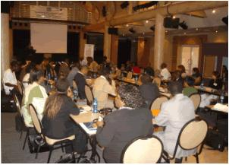

In collaboration with the SADC Parliamentary Forum and the ECA Sub-Regional Office for Southern Africa, ISTD facilitated a 4-day MPs forum on “Building an inclusive Information Society in the SADC Region” from 12-14 February 2007 in Johannesburg, South Africa. More than forty (40) MPs and staffs from twelve (12) SADC Member State participated in the event. The UNDP sub-regional offices for East and Southern Africa and West Africa also participated as well as representatives from the SADC Secretariat and the NEPAD e-Africa Commission.
The main objective of the forum was to promote the use of ICT’s at Parliament level as a tool for democratic governance through increased access to information by Parliaments to enable effective debate, sharing and enhanced public participation in the legislative and policy making process. The focus was also aimed at developing the capacity of Member Parliaments to utilize ICTs as a tool for institutional development and efficiency.
Source: http://www.uneca.org

The University of Cape Town carried out a study that questioned the belief of many academics that most students nowadays have a firm understanding of the computer technology and its various applications with the result that their readiness for using it as part of their educational process is not questionable. The students were given a web-based course module, which they were asked to evaluate after completion.
The researchers report that while more institutions around the world are rapidly moving towards the integration of technology within their educational systems, at the University of Cape Town (UCT), South Africa, there is a more prudent approach. The slow adoption of any of the numerous technology tools available for educators is influenced by many factors. They site as one of the factors the history of governance of the country, which resulted in inequalities in the society in general and in education in particular. The result was that one section of the population was more advanced technologically than the other. The researchers quote an independent government report that also arrived at the same conclusion. They say:
This view is also expressed in a report regarding technology-enhanced learning in South Africa written by a ministerial committee, (Report, 1996). The report, or rather investigation as per its title, recognizes that "the mere introduction of the technology, is as likely to disempower as to empower." It calls for organizational, curricular and institutional decision-making processes to be in place for careful monitoring and evaluation.
Source: http://ifets.massey.ac
The report suggests that most students in South African universities come from the disadvantaged backgrounds, resulting in them not being able to make full use of the benefits of educational technology. It says:
More students in the South African higher education institutions are coming from disadvantaged backgrounds. The meaning of disadvantaged here implies limited or no access to basic resources that are taken for granted in the developed world. For example, statistics show that 25% of the urban households do not have access to piped water supply and as many as 46% are not connected to an electricity supply grid, (Du Preez, 1996). In such a resourceful country poverty is overwhelming among the majority of the population; between 36% and 53% of South Africans are estimated to live below the poverty line, (Castells, 1998).
On the technological front, the country is considered "linked to the informational/global economy." It has the highest number of Internet hosts, of any non-OECD country, (Castells, 1998). This does not necessarily allude to a technology-conversant constituency. In fact, there are many students who enter university with no exposure to the Internet and little, if any, to the computer technology. They have to go through programs of structured orientation and guidance that most institutions are now offering. However, only after a dedicated period of self-learning and training do they get to their colleagues’ readiness levels for the use of technology.
Source: http://ifets.massey.ac
The report goes on to say these factors resulted in a slower pace of development, technologically. That explains why at UTC Web-Based-Education was introduced only recently, starting with a few pilot projects around campus. Of the computer skills of both the students and academics the author says:
With all points considered both teachers and students might not necessarily be ready to use the web environment effectively. Assuming that they will quickly grasp its scope as a teaching and a learning tool is not realistic. This paper argues that the concept of web-based education requires obvious adaptations both in the teaching and in the learning methods.
Source: http://ifets.massey.ac
What sticks out as cause for concern is the fact that teachers, through no fault of their own, also lag behind in working not only in the web environment, but also in the ICT environment in general.

THE UNIVERSITY OF CAPE TOWN STUDY: USING THE WEB GENERALLY
Arif, A.A. of the University of Cape Town, carried out a study to see to what extent students were able to use ICT, including the Internet, in their studies. The study revealed that 88% of the students were familiar with the Internet and with using its resources for academic purposes, though the curricular did not require that knowledge. All the current courses at the time the research results were published were mainly based on traditional teaching methods.
The report says that in addition to being given Internet access and e-mail addresses, the students were also offered an introductory ICT course covering basic computer skills covering the most important points such as logging on to the local network, saving and retrieving documents, printing, word-processing, spreadsheets and the Internet.
The writer has this to say about the diversity of the backgrounds of the students coming to the university:
This high percentage of familiarity would probably decrease dramatically if it were a first-year group of students that comes from a variety of school settings. In general, there is a concentration of resources among a few selected schools while others are completely left behind. For instance, there are schools in areas where the teacher pupil ratio mounts to 1:80 and seldom lower than 1:40, (Du Preez, 1996). Schools do not necessarily have electricity for light, let alone working computers. In some rural areas, schools can still only be accessed on horseback which makes it difficult to equip with the necessary facilities, and to service them, (Report, 1996). Unsurprisingly, great variance in the exposure of students to the technology exists and will have to be considered at all levels of education especially in the teething years of transformation.
Source: http://ifets.massey.ac
The writer states that the University of Cape Town is only beginning to make use of a form of educational technology that is widely used in many parts of the world and adds:
Web-Based-Education, being a fairly new concept in the University of Cape Town, represents a tool of tangible potentials that is being explored in the local context.
Source: http://ifets.massey.ac
The legacy of the apartheid era is varying levels of ability in the use of technology, an anomaly that needs to be rectified through ensuring equality in access to educational facilities. The author says:
There is a wide discrepancy between students entering university level, which is more evident and manifested in their understanding and use of technology. These are reflections of the dark days of apartheid, which ended in 1994 by the election of a new democratic government. The new plan of reconstruction and transformation aims at achieving access, equity and equality in education and training, (Report, 1996). These goals dominate the approach to all educational innovations, including web-based modules, and they shape the extents of it application.
Source: http://ifets.massey.ac
To some extent most of the other educational institutions in southern Africa identify with the University of Cape Town as they were all under colonial rule in the not-so-distant past, for which reason most of the conclusions arrived at in this study are applicable to the other Southern African educational institutions. There is indeed an unquestionable pattern of low technological achievement that characterises all the southern African countries, all of which are worse than South Africa, which, as we have seen above, is the technological Hercules of Africa. In the following extract, Veronica Mcfadden, giving the example of Namibia, shows how southern African education is affected by colonialism, in the same way that American education was. She says:
Though now free and independent as a nation among nations, as consequence of the Bantu Education Act, even today Namibia “remains one of the most educationally disadvantaged” countries in Africa (Katjavivi 28). In this manner, systems of racism still hold sway in southern Africa. Similarly today in the United States of America, “although the system of slavery was officially abandoned in 1865, other means of economic and political domination have continued to the present day, resulting in high poverty and unemployment and substandard housing and inferior education for people of color” (SAN).
Source: http://ifets.massey.ac
If, as Mcfadden argues, the effects of slavery are still felt in the U.S. more than a century after slavery was abolished, how much more will the effects of colonialism be felt barely thirty years, on average, after colonialism was terminated? It is clear that the colonial ‘dust’ is still settling, and will continue to do so for a long time before the situation stabilises, creating a conducive situation for meaningful development to take place.
Continuing with the University of Cape Town study, we learn that some pupils experienced problems with using the computer in their studies, as using this new technology was a new challenge that they had to master at the same time as they had to learn the course content. Arif, A. A. says:
Following a web-based course module, the students expressed certain difficulties in studying and learning from the on-line content which, this paper argues, are a product of their mixed levels of readiness to use the medium and lack of preparation. While trying to deal with acquiring new knowledge from the course content, many students were struggling to understand the basics of computer technology let alone dealing with the web environment, all at the same time. In developed countries, where computers present part of the curricula in secondary and even primary schools, these issues might not have such bearing. The case is different in developing countries and gets more dramatic in the South African context.
Source: http://ifets.massey.ac
Finally, Arif, A. A. comments on the connectivity of African universities and the accessibility of the Internet to both students and academics in general:
Universities in most African countries have email connectivity at a minimum, and about 13 countries have universities with full Internet connectivity. However, Internet facilities at most of the universities are restricted to staff. Post graduates are often able to obtain access but the general student population is usually without access.
Source: http://ifets.massey.ac
INFORMATION TECHNOLOGY IN PRIMARY AND SECONDARY SCHOOLLS: TEACHERS AND THE CHALLENGE TO ACHIEVE UNIVERSAL PRIMARY EDUCATION
Before we look at information technology in primary and secondary schools it will be helpful to consider the background against which attempts are made to integrate Information Technology in the teaching and learning that goes on in the schools. As indicated elsewhere in this study, developing countries grapple with issues of poverty beyond measure, which severely limit the success that must be realised through the introduction of technology in the education system. The fact that basic education itself is not accessible to many children because it is too costly for them to afford it shows that attempts to establish a viable educational technology project may be a very ambitious proposition because the first hurdle that must be overcome is to ensure that the vast numbers of children wishing to find places in school are absorbed by the school system in the first place. But the following report clearly shows that this seems to be a mammoth task.
The statistics and analyses that inform the UPE agenda make salutary reading. Despite strenuous efforts over the last decade, over 100 million children are without primary schooling and 60% of these are girls. These children are spread across the continents. National statistics in country after country illustrate the global problems. In Thailand, for example, of 16.4 million children and young people aged between three and seventeen, only 12 million attend school (Rangsitpol, 1997). Only 10–15% of children in rural areas have the opportunity to move from primary to secondary schools.
In this paper we want to concentrate on Sub-Saharan Africa where, in almost all respects, the challenge of providing UPE is at its greatest.
This region is one of the most educationally challenged parts of the world. A news release from UNESCO’s Institute of Statistics (12 April, 2002) states that four out of every ten primary-age children in sub-Saharan Africa do not go to school. Of those who do, only a small proportion reach a basic level of skills. The number of primary school-age children in the region grew from over 82 million in 1990 to 106 million by 2000. It is projected to rise to 139 million by 2015 (UNESCO, 2000).
The number of children out of school in Sub-Saharan Africa also rose in the 1990s. In 1998, there were 42 million out of school. In almost one third of countries, 60 per cent or more of children were out of school, and in more than half of countries, at least 30 per cent were out of school. Added to this the poor quality of much schooling leads to children leaving school with inadequate skills, and results in repetition and completion rates such that a World Bank evaluation has shown many countries must devote as much as 50 per cent more resources than others to produce a primary school graduate (World Bank, 2000).
Source: http://www.open.ac.uk
If many pupils cannot afford the bare necessities such as school attendance there is little wonder if the schools cannot afford modern educational technology. Before people pursue things that are considered luxuries, such as technology, they give priority to basic necessities such as food, shelter and clothing.
The following is the rest of the report, which will give a general overview of the use of ICT in Africa’s most technologically advanced country. Let me reiterate that all the other countries of Africa are in a much worse state of ICT readiness than South Africa. They all have varying degrees of digitization, as stated above, but what should be borne in mind is the fact that they all trail far behind South Africa, which itself is portrayed in this report as being in the prime of its ICT development. This gives a clear indication that there is a virtual absence of ICT activity in Africa, which is further corroborated by the absence of meaningful information on ICT for other Affrican countries apart from South Africa. That explains why most examples in this research study are drawn from South African experiences.
One of the major problems facing schools in South Africa is the difficulty in obtaining, modern, up-to-date computer facilities (Guy). School
Disparities reflected in South African society also find expression in ICT integration into education. Although the number of schools with computers for teaching and learning has increased from 12.3% in 1999 to 26.5% in 2002, there are still more than 19,000 schools without computers for teaching and
learning [3.4
Secondary and combined schools tend to have a higher number of computers than primary schools. The average number of Pentium computers in use in secondary schools (17.3) is significantly higher than the average for all schools and is nearly 70% higher than the average number of Pentiums in primary schools (10.4) [3.4]. The Internet is beginning to be used as a resource and communication tool in classroom teaching and learning however there profound provincial differences. Half of the schools in the Western Cape and Guateng have Internet access while a very small portion of schools in the Eastern Cape and Limpopo have the lowest Internet connectivity. One reason for the low connectivity rates can be attributed to the high telephone costs that are associated with accessing the line by using direct telephone lines.
Limited integration into teaching and learning is evident. In both primary and secondary schools, the teaching of basic computer principles and word processing skills forms the most important component in the teaching of computer literacy. Access is a major obstacle but there is a gap in the ability of learners and teachers to use these technologies effectively, to access high-quality and diverse content, to create content of their own, and to communicate and collaborate and to integrate ICT into teaching and learning. More schools that started using computers before 1990 are connected to the Internet than those that starter later. Schools that offer Computer Studies programs are also much better connected than those who don’t. Word processing software, spreadsheets and software for administrative purposes are used by more than two thirds of all schools that have computers [3.4]. More than half the schools use electronic information resources such as encyclopedias on CD-Rom and presentation and database software. The government has a strong commitment to ICT in education. To accelerate the realization of nationwide educational goals, South Africa has embraced e-Education. e-Education is about connecting learners to other learners, teachers to professional support services providing platforms for learning [3.3]. According to the South African Department of Education:
Every South African learner in the general and further education and training bands will be ICT capable (that is, use ICT confidently and creatively to help develop the skills and knowledge they need to achieve personal goals and to be full participants in the global community) by2013 [3.3].
Primary schools tend to use computers in teaching Language and Mathematical Literacy more than any other subjects. Secondary schools tend to use computers in technology areas such as Computer Studies. Grades 1-7 primarily use computers for drill and practice and problem-solving exercises while grades 8 -12 tend to use computers for a wider variety of purposes. Some reasons given for lack of computer use include [3.4]:
The South African government recognizes that there is a digital divide. The Ministry of Education understands that bridging the digital divide will require a greater investment in the education sector [3.3]. There is a need for sustainable funding sources for technology to have a large-scale impact over time. Realistically speaking, the Department of Education realizes that funding must be coordinated through the government and through forming public and private partnerships.
Companies are starting to invest in South Africa’s educational system. Open source software (OSS) is a viable option that is integrating itself in the South African educational system [3.1]. The government is pushing Linux because of the low cost and the growing pool of users able to use it. International
organizations such as MIT-AITI and local organizations such as SchoolNet Africa and Direqlearn are working in conjunction to translate OSS into local languages to make it more user friendly. The cost reduction of open source software makes it affordable for African students. MIT-AITI uses open source software to introduce African students to computers and the Internet. The success of Linux use in South Africa has prompted Microsoft to offer free software packages to South African schools. Some organizations in South Africa that provide computing resources have rejected Microsoft’s offer. Microsoft has not been discouraged. In 2003, Microsoft offered South African schools more than 30,000 software licenses to Windows [3.1]. Educational administrators continue to use an open-source infrastructure in the school systems.

Developing the ICT Workforce (Stage 2)
Approximately 50% of schools have no infrastructure to support ICT use among students [3.3]. ICT courses are only available in the universities and in the technikons (technical universities). Recently the Department of Education has begun to revise the curricula to include ICT courses at the primary and secondary levels and to create ICT-specific learning centers.
South Africa’s “Curriculum 2005” aspires to make computer an essential part of the education system in the country [3.6]. This goal will be hard to accomplish considering the fact that South Africa is on the underdeveloped side of the digital divide. Government and industry are attempting to address the issue. SchoolNet SA is an organization founded to promote the use of ICTs in Southern Africa. Partnerships with other companies and organizations have established access to low cost, refurbished computers and network infrastructure through Netday, telecommunications through Telkom, and Internet access through several local ISPs. Motorola has invested R1 million in local development centers to help communities learn to use ICT. Motorola will allocate the money across six different projects and split it with six different educational centers in South Africa [3.7].
South Africa is using ICT to improve the efficiency, accessibility and the quality of the learning process. Developing countries have utilized the distance-learning model and South Africa has begun implementing its practice. The University of South Africa (UNISA) is the oldest and largest university in South Africa and one of the largest distance learning institutions in the world. UNISA’s distance learning programs provide education to over 120,000 students mostly from Africa and other developing countries. The programs distance learning programs are less expensive than regular universities.
During 2003, the private and educational sector formed INTRADEM as a joint initiative. The name INTRADEM is short for Institute of Training, Development and Empowerment and the core focus of this project is to technology ‘enable’ the approximately 30,000 unqualified and under qualified educational workforce (Teachers and Educators) in South Africa. The project has embarked on a mission to find creative ways to tackle the enormous challenge of closing the digital divide amongst the approximately 30,000 under qualified educational workforce in South Africa, through proper skills transfer. One of the most important achievements to date was securing a formal partnership with the Technikon Northern
Source: http://facweb.cs.depaul.edu
Let us look at the main points to be learnt from this report. To begin with the problem of acquiring computers is highlighted. Normally schools would want to obtain new computers, but on account of financial constraints they have to be content with used computers which, contrary to expectations, are not easy to come by. It may come as a surprise, but obtaining modern, up-to-date computers is a nightmare for most schools.
The Internet, with its numerous benefits as a teaching and learning tool, has only just found its way into the education system and, needless to say, still has along way to go. The report says there are profound provincial differences on its use in South Africa, but the differences are even more pronounced when we consider the entire continent of Africa.
The South African government is resolutely taking concrete measures to bridge the digital divide by implementing clearly formulated policies and marrying the public and private sectors, with the latter responding positively by getting involved with providing funding for educational technology. It has set itself the target of making every South African learner ITC capable by 2013 and has already revised curricular to include ICT at primary and secondary school levels. It aims to make computers an essential part of the education system.
The use of computers in distance learning is already a reality. Spearheaded by the University of South Africa, technology in distance learning has been embraced by other institutions of learning to educate and train a workforce that is already in employment, including teachers.
This report on South Africa is encouraging and other African countries would do well to emulate the South Africans, who must be commended for having created a starting point on which to build future development projects.

In the next section we shall take a look at some snapshots of what is happening in Southern African schools in relation to educational technology. It is not possible to look at every single Southern African country, but the cases we are looking at below are characteristic of the trend across the region, affording us a window through which to catch a glimpse of what is happening there. The quest for advanced educational technology in Africa is gathering momentum as every single country makes efforts in one way or another to achieve what it yearns for – a bridging of the digital divide. The following extract supports the assertion that there is indeed something going on in African schools.
From Algeria to Zimbabwe: Volume 2 of infoDev's Survey of ICT in Education in Africa contains individual country reports identifying current policies, activities, developments and challenges in this fast-moving and key sector for development.
infoDev has released Survey of ICT in Education in Africa (Volume 2): 53 Country Reports, the culmination of a continental survey process conducted in 2007.
This publication is a follow-up to the recently published infoDev report, Survey of ICT and Education in Africa: A Summary Report, Based on 53 Country Surveys, which identifies 'new trends and old challenges' in the use of a variety of information and communication technologies in the education sector.
Taken together, these two publications seek to gather in a single resource the most relevant and useful information on ICT in education activities in Africa. Each short Country Report contained in this 600-page publication provides a general overview of current activities and developments related to ICT use in education in the country.
Source: http://www.infodev.org
There are many initiatives tackling the problems related to ICT in African education. This is a good point to start if one wants to gain an understanding of what is happening in Africa.
Now let us take a look at brief reports of what is happening in specific schools in Southern Africa, beginning with Rotterdam Secondary School in South Africa:

Children from a rural school in South Africa's Limpopo province have been making friends and debating global issues with pupils from the Australian outback via an internet link-up organised by one of their teachers. This is not the first time the pupils of Rotterdam Secondary School, just outside Giyani, have used the internet to connect with other school children abroad. Last year, Rotterdam school connected with two schools in California and Hendry in the United States, allowing their geography students to participate in a discussion on urban migration.
Source: http://www.southafrica.info

This is a mammoth achievement for an African school, which makes it the envy of many. A few years ago it was inconceivable that such a feat would become a reality. As can be deduced from the statistics above, at this stage it is only pilot schools that enjoy privileges such as this.

The following report shows that although South Africa is the beneficiary of a large number of projects, things are happening in other Southern African countries as well. It is about ICT in a Mozambican school:

The most important achievement is that the computers are now being used in schools where they were not before. Teachers have learnt not only to use computers, but also to have faith in them as a worthwhile pedagogical tool. Following Muchanga [14] a culture of using ICT in Mozambican schools has begun, despite some key informants who said the opposite. The integration of ICT in some Mozambican schools is a reality. The program, initiated as a pilot project, was transformed in a national program known as the Schoolnet Mozambique. Presently, 20 schools have internet access via TV cabling and
will be online 24 hours per day, as a contribution of the Telecommunication Company of Mozambique (TDM). If the program works well, it will be expanded to junior secondaryschools.
Source: http://www.schoolnetafrica.net
The report was written in 2004. It suggests that as late as this schools in Mozambique did not have access to ICT as we know it today. The next report says computers in the classroom and access to the Internet were introduced as early as in 1997:
Most computers in schools are connected to the Internet through a dial-up connection. The flagship project that is seen to be a source of success for ICT in schools is SchoolNet. SchoolNet is a project that is undertaken by the Ministry of Education with funding from the Word Bank’s World Links for Development program with the objective of arming pre-university level students with useful IT skills throughout their college years. The project was initiated in 1997, providing the first opportunity for schools in Mozambique to connect to the Internet, have computers in the classroom. (Prior to this project only one school was equipped with computers, with no Internet connection) and training teachers on the use of computers for education. There are currently thirteen schools in three regions – within the School Net project. Each school (with around 400-500 students operating at three shifts per day) is equipped with 12-13 computers. The project includes higher secondary schools,²⁰ technical, commercial and industrial schools as well as teacher training colleges (which prepare teachers for primary education). The project will soon be handed over to the Ministry of Education. The SchoolNet project was able to build awareness on the importance of computers for education and train teachers on the use of IT.

Source: http://cyber.law.harvard.edu/itg/libpubs/Mozambique.pdf

The contradiction aside, the important thing is that computers have found their way into Mozambican classrooms, and we can resolve the controversy by concluding that that happened around the end of the second millennium, as they did in most other African schools. Both reports about the Mozambican situation mention the ripple effect of introducing computers to one school, the way the innovation catches on with other schools and spreads like a wild fire. This seems to be what happens whenever one school gets computers.

The report below shows that Namibia has not been left out of the drive to improve the ICT status of the African education sector. Like other African countries, it has embraced the new phenomenon and is making efforts to be as congruous wit other countries as possible.
Launched in 2003, the Initiative for Namibian Education Technology (iNET) sought to foster professional development in the education sector through information and communication technologies (ICTs). The project, which concluded in July 2005, supported and strengthened the skills of education officials in using computer technology for improved professional performance. Implemented by the USA-based Education Development Center (EDC) and the Academy for Educational Development (AED), the programme worked in partnership with - and sought to benefit - the Ministry of Basic Education, Sport and Culture (MBESC).
Source: http://www.comminit.com

MirandaNet played its part by participating in a project that introduced computers to schools in Free State. MirandaNet fellows were allocated schools to work with and they shared their expertise with their South African colleagues. The project is officially over, but David Jordan and Andree have maintained contact with their schools and continue to work with them. In an e-mail he sent me David wrote:
We have a DFID Project for three years with Andree’s school Retief High
School and we have visited twice and they have been here twice - one more
year to run.
Today we are running a technology day with the SA school -linked by
internet and live all morning!
When I got this message I thought it was amazing that they were continuing to run the project through their own efforts. Hats off to them!
Students from schools in Free State came to London in 2005 and interacted with students from Chafford Hundreds School. Details of the visit can be accessed on
http://www.mirandanet.ac.uk/elapa_speeches.htm
and
http://www.worldecitizens.net/gallery/elapa.htm

SOME GENERALIZATIONS THAT HAVE BEEN MADE ABOUT THE STATUS OF EDUCATIONAL TECHNOLOGY IN SOUTHERN AFRICA
The following reports acknowledge the existence of some kind of ICT in the schools. It maintains that while the world’s developed countries had begun implementing viable ICT programmes in the schools by the late1980s, in Southern Africa these began much later. The report also mentions some of the common limiting factors that militate against the successful implememtation of these programmes, such as the high costs of introducing and maintaining such progammes, poor quality of service by service providers and lack of electricity. These problems are common to all Southern African countries.

The objective of this section is to briefly describe the presence of ICTs in a school setting for several African countries with indicators that are produced from the SACMEQ data archive (SACMEQ, 2004). The countries from SACMEQ-II include Botswana, Kenya, Lesotho, Malawi, Mauritius, Mozambique, Namibia, Seychelles, South Africa, Swaziland, United Republic of Tanzania (Mainland and Zanzibar), Uganda, and Zambia. Data collection for these countries occurred between 2000 and 2003. Since there are very few international school surveys that exist for African countries, it is useful to highlight the presence of ICTs in schools for these regions. In many economically developed countries, computers have been a compulsory component of the school curriculum since the late 1980s. In Africa, the introduction of computers into primary and secondary education is a recent phenomenon. The high subscription and ICT infrastructure costs coupled with the poor quality of service by service providers and the lack of basic infrastructure such as electricity can act as barriers to the use of ICT in education in many African countries. Whilst there are calls for a new kind of learning in which students deal with knowledge in an active and self directed way through use of computers and Internet, it must be noted that that the older technologies such as radio and television play a significant role in education especially in many LDCs.

Source: http://www.itu.in

The next report emphasises how proximity to the requisite infrastructural developments is crucial in determining the success of ICT projects. It reveals that most schools are located far from urban areas where there are good roads, telephones and electricity.

ICTs in Southern and Eastern African Schools: what does the SACMEQ data reveal?
In reading this section, the limited scope of the data should be taken into account. That is, the data only covers schools with grade 6 pupils10. Furthermore, the indicators in this section demonstrate no link to the nature of use of ICTs in a school setting. The SACMEQ data on ICTs demonstrates that basic infrastructure is one of the major hurdles in bringing ICTs into education in Africa11. The data reveals the poor access to electricity and telephones in many SACMEQ countries in schools located in rural areas. Radio and television are still more widespread in many developing countries compared to modern ICTs due to the mass communication potential of these older media. SACMEQ also demonstrates that radio can be effective in rural and remote schools where there is no access to electricity or acute power shortages. The location of a school can be an important issue in a developing country context where poor communication such as bad roads, lack of transport act as a barrier to access schools especially by children attending primary school. Figure 2 describes the breakdown of all schools by location attended by grade 6 pupils. The figure shows that in many countries such as Uganda (77%), Tanzania (68%), Swaziland (65%), Namibia (61%), Malawi (60%), Lesotho (60%) and Zanzibar (55%) over half of the schools are located in rural areas. On average, 55% of all schools that grade 6 pupils attend are located in rural areas.

Source: http://www.itu.int

There is little doubt that sub-Saharan Africa's underserved populations are missing out on the boons of information and communication technology (ICT). As a region lagging behind in adoption, use and innovation in the ICT sectors, its populations are missing out on a better education, well-paying ICT jobs, investment possibilities and opportunities to use information technology to facilitate the delivery of basic services, such as health and education.
By its very nature the ICT phenomenon is relatively new and extremely time sensitive. Available data, which are generally not as recent or as detailed as needed for many African countries, suggest that the majority of poor countries in sub-Saharan Africa are lagging behind in the information revolution.
Not surprisingly, the quest for connectivity has been problematic and will require fundamental shifts in the regulatory environment, as well as renewed attention to public-private partnerships and social services. For example, developed countries have 80 per cent of the world's Internet users, while the total international bandwidth for all of Africa is less than that of the city of São Paulo, Brazil (UNHD 2001).

Source:http://www.idrc.ca
The observations below, from a paper entitled Educational Technology Policy in Southern Africa, highlight some of the major problem faced by Southern African educational institutions in general. The first is that of priorities. These countries are battling to maintain sustainable basic education owing to meagre resources, and aiming for viable ICT programmes seems overly ambitious: it is certainly a much more advanced level of achievement that seems unattainable when viewed against the backdrop of nature of the economies of these countries. As a direct result of the unavailability of the resources, decisions have to be made as to whether to introduce computers at Primary school level or at tertiary level. Most countries seem to have chosen to introduce them at primary school level, which leaves tertiary level students without access to computers. The report says:
Chapter 4 examines the difficult (and often controversial) area of educational technology policy development, particularly as it refers to the use of ICTs in schools. Given the challenges facing many African countries in providing even the most basic facilities to support education, the significance (or not) of introducing ICTs is debated. Very little policy development has been undertaken in Southern Africa, and where it does exist, it is usually consolidated into a broader ICT policy framework. The chapter presents a number of examples linking policy decisions with implementation strategies, and addresses some of the areas that require attention in ensuring future successful implementation of ICTs. Emphasis is given to the South African Technology for Enhanced Learning Initiative (TELI), a framework within which several provincial ICT-enhanced learning initiatives have taken place. The chapter illustrates that most educational technology policy processes have concentrated on the school level, with little initiative in tertiary education. The chapter therefore presents Southern African experience with school networking projects, and the possible establishment of SchoolNet Africa to support such projects throughout Africa.
Source: http://www.crdi.ca

AFRICA’S SHORTAGE OF TECHNOLOGICAL EQUIPMENT

Throughout this paper references have been made to the inadequacy of hardware in general. This section will be devoted to a more thorough discussion of that inadequacy. Africa as a whole faces a huge shortage of technological equipment, which inevitably slows down progress in all facets of life from economic growth to education. Least equipped are government institutions, which often include educational institutions.
With the great lack of resources in the public sector in Africa, the penetration of computers is generally much lower in government, with by far the majority of PC equipment being used by private companies. Computers are mainly used for accounting and word processing, although spreadsheets are used to some extent for forecasting or as a simple database application. The limited number of database systems often use Microsoft Access, but many national documentation centres and archives, as well as small university and NGO libraries, use the UNESCO/IDRC developed ISIS / microISIS package for bibliographic data. Geographic Information Systems (GIS) and digitization facilities are beginning to be installed by some universities, and ministry planning departments and municipalities.
Source: http://www3.sn.apc.org

One factor that affects the outcome of the computer promotion drive is the attitude of governments to development in the area of technology. There is a conspicuous absence of commitment and urgency, on the part of governments, to speed up the digitization of the region (with the exception of a few governments including South Africa discussed above). One arrives at this conclusion when one observes that there appears to be no indication of clear guidelines on how the governments intend to bridge the enormous digital divide. Kwakam and Ningo have this to say on the matter:
Policy issues are central to most development efforts. Problem trees in most sectors of the African economy usually show policy issues at the base, driving everything else. In most countries there is a policy vacuum in IT, with only inadequate coverage (if any) being provided from related areas such as telecommunications and the computer industry. The policy aspects of IT therefore need to be addressed, in terms of formulation, dissemination, and implementation. In the absence of clear and enforceable policy, the industry is likely to evolve in a haphazard manner in reaction to uncoordinated external motives, thus allowing improper practices that would impair the growth of enthusiasm for IT. As George Sadowsky puts it, one stroke of the pen by a government official may be more important than the enthusiasm of a host of practitioners.
Source: http://www.isoc.org
The following are general factors influencing the development of communication technology in Africa:
Aside from the low level of economic activity in Africa (the average GDP/capita across the continent was only USD766 in 2000), there are a variety of other reasons for this low level of technology penetration. Amongst the most important of these are the systemic factors are outlined below:
1) Irregular or non-existent electricity supplies are a common feature and a major barrier to use of the ICTs, especially outside the major towns. Many countries have extremely limited power distribution networks which do not penetrate significantly into rural areas, and power sharing (regular power outages for many hours) is a common occurrence, even in some capital cities such as Accra, Dar es Salaam and Lagos.
The road, rail and air transport networks are limited, costly and often in poor condition, resulting in barriers to the increased movement of people and goods, needed both to implement and support a pervasive ICT infrastructure, but also for the increased economic and social activity which would be stimulated through greater use of ICTs. Congested border posts and visa requirements add to these difficulties.
2) Most tax regimes still treat computers and cell phones as luxury items, which makes these almost exclusively imported commodities all the more expensive, and even less obtainable by the majority. Although there have been notable efforts in some countries to reduce duties on computers, however communications equipment and peripherals are still often charged at higher rates.
3) Perhaps an even greater problem is that the brain drain and generally low levels of education and literacy amongst the population has created a great scarcity of skills and expertise (at all levels, from policy making down to end-user). Rural areas in particular suffer with even more limited human resources. Along with the very low pay scales in the African civil service, this is a chronic problem for governments and NGOs who are continually losing their brightest and most experienced to the private sector. This situation is not unique to Africa or other developing countries, but is also being faced by the developed world where infrastructure demands have outpaced the supply of experienced staff. However this is simply exacerbating the situation in Africa, because experienced technicians, even from the local private sector, are able to find much higher paying jobs in Europe and North America.
4) Finally, the general business climate for increased investment in Africa, acutely needed for the ICT sector, has suffered from the well known problems of small markets divided by arbitrary borders, non-transparent and time-consuming procedures, limited opportunities (due largely to the historic pattern of monopolies and high levels of state control), currency instability, exchange controls and inflation.
These systemic issues are being addressed by the African Union and their programme, the New Partnership for African Development (NEPAD), supported by the international community. This many-faceted effort is aimed at accelerating Africa's development and could as a result help to create an environment more conducive to the rapid adoption of ICTs.
Source: http://www3.sn.apc.org

MY STUDY: INFORMATION TECHNOLOGY IN SOUTHERN AFRICAN EDUCATION

In 1995 I carried out a study of the use of information technology in southern Africa, the purpose of which was to investigate to what extent educational technology is used in southern African education. To capture the information I required I designed a questionnaire that I sent to various universities in southern Africa, but met with the usual disappointing problem associated with questionnaires- that of low response. In my case it was far too low to draw meaningful conclusions from, hence my decision to concentrate on Internet research for this research study, on the advice of my tutor. At the same time I felt that rather than discard the meagre information I gathered from through the questionnaire, it would be prudent to include it in the report as it has the unique, invaluable quality of being original. It has interesting first-hand information that I would not have obtained from the Internet. In this respect I use it to complement the information I was able to glean from the Internet, so that the two are used side-by-side. The following is the report:

Student’s skills

Respondents gave varying reports on students’ skills, ranging from 80% to 100% computer literacy. Between 50% and 100% have email addresses.

Resources and Lecturers’ IT skills
All lecturers are computer literate but they do not all have a computer in the office: only about 80% have a computer for lecture preparation and research. The target is for each lecturer to have a computer on full Internet. Institutions have several computer labs (about four) each with about thirty networked computers. Students have access to the computers after hours or when lessons are not in progress. There is a scramble for the computers and many students do not have the patience to queue for a computer for long periods, to the extent that they almost never log on. This results in them losing what little computer skills they have gained rather belatedly in their lives. What they need most at this stage is unlimited time with the computer. Ideally they should have a laptop each to improve their newly acquired computer skills, but of course this is almost impossible when we consider the financial difficulties involved.

Interactive Whiteboards and Promethean Boards
Each lecture room is fitted with these and all lecturers are able to use them. A good number of students – about one third – are also able to use them.

Overhead Projectors
At least each faculty has one and all lectures and about a third of the students are able to use them.
TVs
All students’ halls of residents have a TV each. More TVs are available to lecturers on request, for educational purposes.
DVDs
Very few or none of these are available for staff or students in some universities.
Visualizers
Few or none of these are available for staff and students.
Video Cameras
Very few of these are available and demand for them is high.
Slide Projectors
Generally small numbers of these are available.
Laptops
A few laptops are available in the ICT department. Most lecturers have personal laptops.
CD players
Most computers have CD players and multi-media facilities.
Cassette players
A good number of these are available.
E-learning facilities
Computer labs are networked and both lecturers and students are learning to post assignments on the net. As few as about 5% of students use this facility, while about 80% of lecturers use it for their personal development. More needs to be done to take full advantage of the facility.
Why educational technology does not yield the expected results in southern Africa
There is a great lack of resources caused by financial constraints. There are few people skilled in ICT to impart the knowledge to others; as a result some of the equipment lies idle. Most rural schools are not electrified.
What can be done to maximise the benefits of educational technology.
Training of personnel must be a regular and on-going exercise. Funding must be sought to finance the acquisition of resources. There should be commitment on the part of both the managements of institutions and the governments.
RESUME
This brief report is in agreement with the literature on educational technology in southern Africa. It shows that there is tremendous zeal in using educational technology, but there are severely limited facilities, which results in a very low skills level. It raises a very disturbing matter related to the shortage of ICT resources. Surely after efforts have been made to impart ICT skills to students those skills must be developed further rather than be allowed to suffer stagnation or retrogression, which appears to be the case with students who give up logging on to the computer because the waiting times are prohibitive. Ways need to be found to address this anomaly, so that if it is not possible to provide each student with a computer, at least the waiting time is reduced to a reasonable level. The onus is on the governments and managements of institutions to mount a powerful drive to reduce the technological gap between Africa and the rest of the world.

Against this background it is encouraging to note that while technological resources are inadequate in terms of quantities, at least most of the latest technological gadgets are finding their way to Africa in a fairly short time. Almost all the technological equipment developed in the first world countries is available in Africa, but the problem is the inadequacy of the equipment in terms of quantities.

CONCLUSION

This study has shown the general underdevelopment that Southern Africa experiences in the area of communication technology. All modern communication tools are in very short supply, impacting seriously on the operations of both the private and public sectors. Radio, television, telephones, mobile phones, computers and the Internet are not accessible to most people in southern Africa. As a result, every facet of life does not realise its full potential. This includes the field of education, with which this study is mainly concerned.

We have seen that in pre-school education computers are non-existent. At primary school level computers are so few that they are like a drop in the ocean. Secondary schools have more computers than primary schools, but still they are far too few to make a meaningful contribution to the learning of students. At tertiary level many students are just beginning to attain computer literacy, but then their new-found skills degenerate quickly because universities and colleges do not have enough computers for students to log-on to, with the result that most students never log-on, which robs them of what little skills they acquired in the introductory computer lessons offered by the universities. Needless to say, there is very little use of both computers and the Internet in tertiary education in Africa.

This study has also revealed that there are profound differences from country to country on the accessibility of educational technology tools, with South Africa enjoying far more than its fair share of technological resources. Many of the countries of Africa have very little by way of educational technology tools.

We have seen that there are many development organizations that are doing a sterling job to improve the lot of Africa. They are tackling the digital divide mainly by supplying hardware and software, and training personnel. Already the fruits of their interventions are being reaped as educational technology is gradually finding its way to even some of the most remote parts of the continent.

It is evident from the magnitude of the existing disparities that for a long time to come it is improbable that the goal of closing up the digital divide completely will be achieved. This so because the technologically advanced countries are continuously making new discoveries, to the extent that African countries are not even able to keep up the pace of assimilating the older developments, with the result that they are frog-leaped by some of them. Indeed many new developments are declared obsolete even before they have taken root in Africa, and the production of back-up components for them is halted, making it unwise to export the technology to Africa.

It is encouraging to note that many governments in Southern Africa are revising their educational policies and making vigorous efforts to modernise their educational technology tools, as I reported in this study. As I write I have received reliable information to the effect that in Zimbabwe it has become compulsory for all ‘O’ Level pupils to study computers. That means two full years of interacting with computers. This is the first time that such a policy has been adopted, and it is bound to have a positive knock-on effect on many aspects of life in the country. I have tried without success to find authoritative sources asserting this new development. It appears it is so new it is not even available on Internet pages.

As I stated at the beginning of this study, my investigation of educational technology in Southern Africa was prompted by my observation of obvious technological disparities between the schools I taught in back home in Zimbabwe and those that I taught in here in the United Kingdom. What I found out in this study is that there is a wide gap, which seems to be getting wider, between the digitization of Southern Africa and that of the United Kingdom. I also found out that decision makers in both the developed countries and in Africa are aware that such a gap exists, and there is consensus that steps need to be taken to correct the anomaly. Steps are indeed being taken to bridge the digital divide and they are bearing fruit. As stated earlier, there is a wide array of organizations doing their bit to promote the use of educational technology in Southern Africa, without whose contributions the region’s technological state would be frighteningly backward.
This research study confirms the disadvantaged position of southern Africa, technologically. It shows the region’s incredible level of backwardness in relation to educational technology, to the extent that it is clear to see that it is not for nothing that it is referred to as the ‘technological desert’. Indeed the gap between Africa and the rest of the world is so wide that it beggars belief. In southern Africa people are preoccupied with finding the basic necessities of life and the computer technology appears to them to be far out of reach. While the rest of the world is in the digital age Africa is trailing behind in the Middle Ages, hearing about the breathtaking developments that have taken place in other lands and wishing desperately to be part and parcel of those developments. Before Africans can even aspire to acquire computers for their schools, it makes sense that they must make sure that children get basic education first.

REFERENCES

African Languages and Linguistics
Annual Conference on African Linguistics:
Azza A. Arif (2001) Educational Technology & Society Learning from the Web: Are Students Ready or Not? [Online] available from http://www.ifets.info/journals/4_4/arif.html [Accessed 31 August 2006]
COMESA [Online] Available from http://www.comesa.int/ict/policy/doc/ICT%20Policy%20Part%201/view [Accessed 13.4.2006]

Communication Statistics Unit (2006), UNESCO Institute for Statistics ICTs and Education Indicators: (Suggested core indicators based on meta-analysis of selected International School Surveys) [Online] available from http://www.itu.int/ITU-D/ict/partnership/material/ICT_Education_Paper_Nov_2006.pdf [Accessed 26.6.2008]

Cossa,G.G., and Cronjé, J.C. (2004) SchholnetAfrica Computers for Africa: lessons learnt from introducing computers into schools in Mozambique [Online] available from http://www.schoolnetafrica.net/fileadmin/resources/Computers_for_Africa.pdf [Accessed 26.6.2008]

Dave Jordan(2008) davprof@rmplc.co.uk Re: Update on Elapa from the Jordans Email to btsemwayo@yahoo.co.uk 15 July 2008 8:25:06am

DFID (Department For International Development) [Online] available from http://www.dfid.gov.uk/countries/africa/ [Accessed 23.2.2007]

DFID (Department For International Development) [Online] available from http://www.dfid.gov.uk/research/imfundo.asp [Accessed 23.2.2007]
Education Market Place Eventful Publishing Co. Ltd, Laura McNeill, (Ed) p13
http://www.crdi.ca/recherche/ev-11522-201-1-DO_TOPIC.html [Accessed20.6.08]
IEEE Conference on Computational Complexity [Online] available from http://facweb.cs.depaul.edu [Accessed 3.8.2006]

in Broad Perspectives [Online] available from http://www.lingref.com/cpp/acal/35/paper1299.pdf [Accessed 30.6.2008]

Independent IT, Internet and Telecom Consultant African Internet and Telecoms Information [Online] available from http://www.suvabay.com/ [Accessed 1.07.08]

InfoDev (2007) infoDev releases 53 reports on state of ICT use in education in African countries [Online] available from http://www.infodev.org/en/Article.166.html [Accessed13.6.2008]

Information and Communication Technologies:
Information Technology in Africa: A Proactive Approach and the Prospects of Leapfrogging Decades in the Development Process [Online] available from http://www.isoc.org/inet97/proceedings/B7/B7_1.HTM [Accessed 22.6.2008]

International Telecommunications Union (2006) Market Information and Statistics (STAT ) [Online] available from http://www.itu.int/ITU-D/ict/statistics/ict/ [Accessed 23.06.08

Internet World Stats (2008) Usage and Population Statistics [Online] available from: http://www.internetworldstats.com/stats.htm [Accessed 23.06.08]

Isaacs, S, Broekman, I, and Mogale, T. International Development Research Centre INFORMATION AND COMMUNICATION TECHNOLOGIES FOR DEVELOPMENT IN AFRICA: VOLUME 3 [Online] available from http://www.idrc.ca/en/ev-71268-201-1-DO_TOPIC.html [Accessed 26.6.2008]

Kwankam, S.Y., and Ningo,N.N. (1997) ISOS
Literacy, Access, and the Future Selected Proceedings of the 35th
Magda Ismail (2001) Information Technologies Group The Center for International Development MOÇAMBIQUE eReady? [Online] available from http://cyber.law.harvard.edu/itg/libpubs/Mozambique.pdf [Accessed 26.6.2008]

METRO (2005) 1 July

METRO (2005) 13 June

Mike Jensen Independent IT, Internet and Telecom Consultant African Internet and Telecoms Information [Online] available from http://www.suvabay.com/ [Accessed 15.6.07]

MirandaNet Speeches by the English Students [Online] available from
http://www.mirandanet.ac.uk/elapa_speeches.htm [Accessed 21.7.08]

Neville Maakana ( 2008) SouthAfrica.info Rural school, global connections [Online] available from http://www.southafrica.info/about/education/giyani.htm [Accessed 16.6.2008]

Osborn, D.Z., (2006) African Languages and
TECHNOLOGIES DE L’ INFORMATION ET, DE LA COMMUNICATION AU SERVICE DU DEVELOPPMENT (2002) Part 4 - Educational Technology Policy in Southern Africa [Online] available from
The African Internet - A Status Report [Online] available from http://www3.sn.apc.org/africa/cari98.htm n5 [Accessed 5.6.2006

The African Internet - A Status Report [Online] available from http://www3.sn.apc.org/africa [Accessed on 2.6.2006]
The African Internet (1982) A Status Report [Online] available from http://www3.sn.apc.org/africa 1982 [Accessed 2.6.2006]
The African Internet (1998) A Status Report [Online] available from http://www3.sn.apc.org/africa/cari98.htm [Accessed 2.6.2006]
The African Internet (1998) A Status Report [Online] available from http://www3.sn.apc.org/africa/afstat.htm [Accessed 2.6. 2006]
The African Internet A Status Report [Online] available from http://www3.sn.apc.org/africa/afrmain.htm13 [Accessed 5.6.2006]

The Communication Initiative Network (2004) Initiative for Namibian Education Technology (iNET) - Namibia[Online] available from http://www.comminit.com/en/node/123500/ [Accessed 26.6.2008

United National Economic Commission for Africa [Online] available from http://www.uneca.org/aisi/index.htm [Accessed12.9.2006

Vodafone, Southern African Regional Poverty Network (2005)
Africa: the impact of mobile phones Vodafone [Online] available from http://www.sarpn.org.za/documents/d0001181/index.php [Accessed 12.3.2007]

Wilson E.J., and Wong, K. (2003) Pergamon Telecommunications Policy African information revolution: a balance sheet [Online] available from http://www.cidcm.umd.edu/ICT/papers/african_information_revolution.pdf [Accessed 3.8.2006]

World Ecitizens E-Lapa On-line Environment [Online] available from
http://www.worldecitizens.net/gallery/elapa.htm [Accessed 21.7.2008]

Summary

This study is about the extent to which Educational Technology is used in Southern Africa in relation to the rest of the world. In some cases reference is made to the whole of Africa on account of the closeness in the similarities of the circumstances prevailing on the entire continent of Africa. Using Internet research, this study shows the yawning gap that exists between the digitization of Southern Africa and that of the rest of the world. I chose to focus on Southern Africa because that is the part of the world I come from. When I came to the U.K. I was immediately struck by the differences between the two places and desired to see where Southern Africa stood on the digitization ladder. In the course of the study I was shocked to learn that Southern Africa was in fact at the very bottom of the international league table. Unpalatable facts slapped me right across the face, such as, ‘In Africa1 in 160 use the Internet’ and ‘There are still around 30 countries (worldwide) with an Internet penetration of less than 1%.’ It is because of facts such as these that Africa has been referred to, rightly, as a technological desert. The study also revealed that gloomy though the picture may be, there is hope as many international organizations, including MirandaNet, are making concerted efforts to bridge the digital divide, and their efforts are already bearing fruit as the picture is changing dramatically as much of Africa makes unprecedented strides in the area of ICT.

