Evaluation of the Primary Schools Whiteboard Expansion Project

Contents
Contents 2
Acknowledgements 3
Introduction 3
Section 1: Installation of interactive whiteboards in Primary Schools Whiteboard Project schools 14
Section 2: Overview of the evaluation evidence 16
Section 3: Modelling the extent to which the use of interactive whiteboards affects pupil progress 19
Section 4: The contribution made by interactive whiteboards to the development of pedagogies and more general embedding of ICT across the curriculum 47
Section 5: Evidence from the Phase 2 case studies 110
Section 6: Developing a Community of Interactive Whiteboard Practice: The roles of the central team, the Local Authorities and the schools 133
Section 7: Review of the literature 153
References 170
Footnote 180
Appendix 1: Phase 1 modelling – an illustrative sequence 181
Appendix 2: summary of findings from Phase 1 188
Appendix 3: multi-level estimates 191
Appendix 4: methodology of Phase 1 case study research 197
Appendix 5: protocols for video analysis 206
Appendix 6: useful web-based resources 209
Appendix 7: The second phase Sweep Extension Case Studies 211

Acknowledgements
We would like to thank the headteachers, teachers and local authority staff who assisted us by completing questionnaires and giving us their time for interviews. We would also like to give particular thanks to the ten case study schools in Phase 1 of the research and seven case study schools in Phase 2, whose work is not individually identified in the report, including the six schools that discussed the draft of the Phase 1 report with us at the Sweep Sharing Day for Case Study Schools in May 2006: Cavalry Road Primary School, March; Finmere C of E School, Finmere; Newhall Junior School, Swadlincote; Scout Road School, Hebden Bridge; Tyssen Primary School, Stamford Hill; and West Lodge Middle School, Pinner.
Introduction
The expansion phase of the Primary Schools Whiteboard Project provided £10 million in 2003–04 to support the acquisition and use of interactive whiteboards in primary schools within 21 local authorities.
The aims of the Schools Whiteboard Expansion Evaluation (Sweep) are to:
- Assess the educational impact and operational effectiveness of the Primary Schools Whiteboard Project initiative.
- Evaluate the Primary National Strategy's whiteboard support network for schools not involved in the Primary Schools Whiteboard Project pilot.
More specifically, its objectives are to:
- Assess the extent to which the use of interactive whiteboards affect standards in literacy and mathematics.
- Identify the effects of using interactive whiteboards on a range of other outcomes.
- Investigate the contribution made by the introduction of interactive whiteboards to the development of pedagogies and to a more general embedding of ICT across the curriculum.
- Evaluate the impact of the project on continuing professional development among teachers.
- Evaluate the effectiveness of the implementation and operation of the first phase of the Primary Schools Whiteboard Project initiative.
The report directly addresses these objectives and is organised in the following sections.
Executive summary of findings
This summary is organised under six headings, a general section and sections for each of the Primary Schools Whiteboard Project’s objectives. It concludes with some recommendations.
General points
The interactive whiteboard has been welcomed enthusiastically by a large number of primary teachers and its take-up in schools has proceeded with unprecedented rapidity. This appears to be because it is a resource which is immediately useful to teachers in conducting whole-class teaching, which is a requirement of the primary strategies.
Pupils are universally enthusiastic about the interactive whiteboards, because of their clear visibility (‘We can see!’), the easy access they give to ICT through touch, and the added variety they bring to lessons.
In the Primary Schools Whiteboard Project, interactive whiteboards have been permanently installed in classrooms. Although we did not ask teachers whether they switch interactive whiteboards off during the day, the overwhelming impression is that they are switched on first thing in the morning and remain on all day, making them available even when their use has not been planned for a lesson.
The extent to which the use of interactive white boards affects standards in literacy and mathematics
There is a consistent finding across all data that the length of time pupils have been taught with an interactive whiteboard is the major factor that leads to attainment gains. This appears to be the result of the interactive whiteboard becoming embedded in teachers’ pedagogy: that is, when teachers have had sustained experience (around two years) of using an interactive whiteboard, they are able to change their teaching practices to make best use of its facilities. The qualitative data strongly support this.
Key Stage 2 mathematics
Analysis combining the data from the 2005 and 2006 cohorts found that averagely attaining pupils of both sexes, and high-attaining pupils of both sexes, made greater progress with more exposure to interactive whiteboards in maths. Progress was measured against prior attainment in Key Stage 1 national tests. Based on an expectation that pupils will on average progress six points (or one national curriculum level) in two years, it was possible to calculate their increased rate of progress. This ranged from two and a half months for girls of average prior attainment to five months for boys of high prior attainment.
interactive whiteboards had little effect (but certainly not a detrimental effect) on progress in maths of low-attaining pupils in either gender group.
When Cohort 1 and Cohort 2 are examined separately it is clear that once the innovation becomes embedded, positive gains are likely to be achieved by pupils of both genders and all attainment groups, thus reducing the likelihood that interactive whiteboards will widen the gap between low-attaining pupils and their peers.
Key Stage 2 science
Analysis of the data for Cohort 2 showed clear benefits of being taught with an interactive whiteboard for all pupils except high attainment girls (where there appears to have been a ‘ceiling effect’ since the highest possible score is fixed). The most marked effect was for low attaining boys who made some seven and a half months' additional progress when they had two years of exposure to interactive whiteboards as compared to no exposure.
Key Stage 2 English
Positive trends were identified in the combined data for English but these were not confirmed by separate analysis of the data for Cohort 1 and Cohort 2. As measures of attainment in English are less stable than in maths and science, the results are inconclusive and warrant further investigation with larger data sets.
Writing was explored separately because of concern at the poor performance of a high proportion of boys in writing, as compared to girls. Although no statistically significant effects were found (in part due to a reduced data set) a positive trend (p<0.094) was found in boys with low prior attainment who made some two and a half months' additional progress after two years of being taught with an interactive whiteboard.
Key Stage 1 mathematics
Interactive whiteboards appear to have a positive impact in maths attainment at Key Stage 1 (measured against FSP data), once teachers have experienced sustained use and the technology has become embedded in pedagogical practices.
Key Stage 1 science
Use of interactive whiteboards for science was much lower than for maths and English in the first year of the project. However, analysis of the data suggests that girls of all attainment levels will make better progress with increased access.
There are indications that this positive experience may be shared by average and high-attaining boys but we found inconsistent results for low-attaining boys.
Key Stage 1 English
Evidence suggests that once interactive whiteboards become embedded, pupils of average and high prior attainment benefit from increasing exposure to interactive whiteboards.
There is no effect (beneficial nor detrimental) of interactive whiteboards in relation to low-attaining pupils. However, this may lead to widening gaps in progress between low attaining pupils and their peers.
The effects of using interactive whiteboards on a range of other outcomes
The interactive whiteboard is an ideal resource to support whole-class teaching. It acts as a focus for pupils’ attention and increases their engagement in whole-class teaching. Teachers tend to spend more time on whole-class teaching when they have an interactive whiteboard (Higgins et al., 2005), but if whole-class teaching is more interactive as a result of the interactive whiteboard, any negative effects from reduced group work may be negligible.
The interactive whiteboard acts as a multi-modal portal, giving teachers the potential to use still images, moving images and sound, and when used in this way, it can address the needs of learners who find text difficult as the only mode of communication. At present only a small number of teachers have the skills to use a wide range of the interactive whiteboard’s facilities but the final visits to Primary Schools Whiteboard Project case study schools showed that their skills are still developing through exploratory use.
Although use of an interactive whiteboard in whole-class teaching appears to have relatively little impact on raising the attainment of pupils with special educational needs (SEN), it has a marked impact in engaging their attention and often greatly improves their behaviour.
- Where teachers had been teaching with an interactive whiteboard for two years and there was evidence that all children, including those with SEN, had made exceptional progress in attainment in national tests, a key factor was the use of the interactive whiteboard for skilled teaching of numeracy and literacy to pairs or threesomes of children. This was often done by teaching assistants who had been trained to teach numeracy and literacy.
- The many advantages that sighted children enjoy when interactive whiteboards are used are denied to blind children who need to have a running ‘translation’ of the interactive whiteboard’s display. The greater pace of interactive whiteboard lessons increases the workload of teaching assistants who support partially sighted and blind children in the classroom. Furthermore, the electronic, often robotic and American sounding adult voices that come from interactive whiteboards can be frightening for totally blind young children.
Young children who have not yet acquired writing skills, and older pupils with special educational needs, are highly motivated by being able to demonstrate their skills and knowledge with the tapping and dragging facilities of the interactive whiteboard. These effects are greatest when they have the opportunity, individually or in small groups, for extended use of the interactive whiteboard rather than as part of whole-class teaching. We have seen only limited use of the interactive whiteboard in this way but in case study schools teachers told us that such use is ideal as a means of assessing pupils’ learning.
When teachers have used an interactive whiteboard for a considerable period of time (by the autumn of 2006 for at least two years) its use becomes embedded in their pedagogy as a mediating artefact for their interactions with their pupils, and pupils’ interactions with one another. The concept of ‘mediating interactivity’ is robust. It offers a sound theoretical explanation for the way in which the multi-level modelling (MLM) analyses link the length of time pupils have been taught with interactive whiteboards to greater progress in national test scores year on year.
The contribution made by the introduction of interactive whiteboards to the development of pedagogies and to a more general embedding of ICT across the curriculum
In the Primary Schools Whiteboard Project classrooms the interactive whiteboard is used most frequently for teaching numeracy and literacy and rather less frequently for science and ICT, but it is also beginning to be used by many teachers to teach all subjects across the curriculum. This is a major advance as ICT has not, till now, been embedded across the curriculum.
When connected to the school’s network and via broadband to the internet, the interactive whiteboard acts as a portal to a wide range of resources. The use of the internet has greatly increased in many Primary Schools Whiteboard Project classrooms. Teachers model its use rather than pupils using it themselves, but pupils are often invited to suggest queries.
In the case study schools we saw many classrooms where the ambience was of teacher and pupils ‘working together’, often with attention directed to the interactive whiteboard rather than the teacher for part of the time. The extent to which teachers make positive use of this shift of attention varies greatly. The most successful teachers are often those who use it as an opportunity to model the role of co-learner with the pupils.
Teachers in case study schools said that the interactive whiteboard was particularly useful in supporting visualisation to assist in teaching difficult concepts or demonstrating skills – for example in using a ruler, thermometer or microscope. These teachers used traditional resources alongside the interactive whiteboard so that pupils had practical hands-on experience to back up the demonstration on the interactive whiteboard.
Teachers almost universally start by using the interactive whiteboard very much as they used their previous traditional whiteboard, but even when pedagogic change is minimal, pupils perceive that lessons are more varied and appear to be better motivated. When teachers become skilled in the use of the interactive whiteboard they are able to use it – and many do use it – to increase interactivity and use a much wider range of resources.
By the autumn of 2006, evidence that the interactive whiteboard was embedded in teachers’ pedagogy came from observing new patterns of teacher behaviour. These were either improvements on previous pedagogical practices made possible by the functionality of the board, or completely new practices. Although these had all become routine, instinctive behaviours and part of what is often called ‘tacit knowledge’, in some cases teachers were able to give clear accounts of how these new practices helped them to teach more effectively.
The impact of the project on continuing professional development among teachers
In those schools where interactive whiteboards were installed in all classrooms at the same time, in many cases replacing traditional whiteboards, teachers have learnt basic skills in how to use them exceptionally quickly, often pooling knowledge and providing mutual help. Learning together when there is a pressing ‘need to know’ is a powerful strategy. Formal training by school ICT co-ordinators appears to have been much more infrequent than informal day-to-day assistance.
Training provided by local authorities, using resources provided by the National Whiteboard Network (NWN) central team, has been very well received by schools. Although initially little was provided, provision appears to have increased recently in some local authorities, possibly because consultants’ time is now less taken up with trouble-shooting.
There has been no training for teaching assistants (TAs) or headteachers and this has been noted at both school and local authority level as an unfortunate gap in provision.
Teachers have not only learnt how to use interactive whiteboards but, because the interactive whiteboard’s main function is as an interface to a computer, they have also greatly increased their skills in using ICT, for example making regular use of the internet for lesson preparation and often ‘live’ use during lessons.
Eighteen months after installation of their interactive whiteboard, the majority of teachers in the case study schools had become highly competent users of the interactive whiteboard as a basic resource, and many were beginning to experiment with using it for a wider range of purposes. However, only those who had received continuing CPD, for example through seeking accreditation with one of the manufacturers, had developed high-level interactive whiteboard skills.
In Primary Schools Whiteboard Project case study schools, many teachers have made radical changes to their lesson planning, creating or accessing their own resources and storing them in either personal or shared areas on the school’s server. In the second year some were beginning to notice that time needed for lesson planning had reduced, but others were spending just as long because they were keen to use their developing skills to produce better resources.
By the autumn of 2006 the pool of expertise in interactive whiteboard use resided in the schools where teachers had been using them on a daily basis for more than two years. Local authorities were beginning to look mainly to classroom teachers to provide training for their peers through periods of release from teaching.
The effectiveness of the implementation and operation of the Primary Schools Whiteboard Project initiative
Procurement and installation
The Primary Schools Whiteboard Project funding had a very strong ‘pump priming’ effect. Local authorities were able to negotiate special prices with manufacturers and schools found additional funding from existing budgets, with the result that the number of interactive whiteboards installed in Primary Schools Whiteboard Project schools during 2004–05 was around double that funded by the Primary Schools Whiteboard Project.
Installation of the interactive whiteboards in so many schools within a short period of time made an enormous demand on providers and installation teams nationally, and in some cases led to poor installation work and technical breakdowns.
The documentation and advice provided by Becta and the DfES was highly valued, but the process of procurement was very rushed.
In most case study schools the interactive whiteboards have been installed too high for easy use by pupils in Key Stage 1, and this frequently causes frustrations or becomes a safety hazard. The best solution appears to be where schools have installed a narrow but well-secured ledge below the interactive whiteboard for children to stand on. Although not ideal, without such a device children will always find other more dangerous solutions.
Project management at local authority level
Local authorities have generally provided good, practical, flexible support to schools.
Local authorities were not funded to support the Primary Schools Whiteboard Project and this placed a considerable strain on their capacity to support schools. However, the administration of the Primary Schools Whiteboard Project required local support from both primary strategy consultants and specialist ICT support units and this has led to many of these people working together for the first time, to great advantage.
Training for local authority consultants
The five two-day training workshops provided by the central team were well attended and highly valued by local authority staff, both for the teaching inputs and free resources, and the networking opportunities they provided with consultants from other local authorities.
However, the plans for collaborative production of resources by consultants across local authorities were not fully realised because, without allocated funding for the Primary Schools Whiteboard Project, consultants were often trying to carry out their previous job in the local authority at the same time.
The NWN web site
The National Whiteboard Network website has not been as widely used as expected by teachers in schools. This appears to be mainly due to lack of awareness and/or lack of need since several manufacturers have good websites and local authorities often provide the NWN resources on a CD. Some teachers appear to enjoy accessing resources from the internet using a search engine, and sharing recommendations of good websites with other teachers. However, headteachers and ICT co-ordinators say that a central resource is needed (perhaps unaware of the extent of the one that already exists).
Technical support and equipment failure in the schools
The extensive use of interactive whiteboards for teaching has made good technical support a necessity rather than an option for all primary schools. When lesson plans, including resources, are stored on the school’s server and the internet is regularly in use as both a preparatory and a ‘live’ resource, technical failure becomes a serious disruption rather than a discouraging nuisance.
There are substantial costs for primary schools in sustaining the interactive whiteboard initiative. The lifetime of laptops which are used to run an interactive whiteboard all day, every day, over a long period is reduced (in case study schools many of these laptops have lasted for only two years). Data projectors installed in earlier funding rounds have lasted approximately three years and bulbs last on average about the same time, but replacements need to be kept in stock to cope with sudden failures.
Recommendations
These recommendations are divided into two kinds: those which refer to further development of the interactive whiteboard initiative in primary schools; and those which refer to future ICT-related initiatives designed to make fundamental changes to the education system.
Towards further development of the interactive whiteboard initiative in primary schools
Provision of interactive whiteboards
The Primary Schools Whiteboard Project provides considerable evidence of the value of interactive whiteboards in terms of increased pupil motivation and teachers’ job satisfaction. There is also evidence of a positive impact on attainment when pupils have been taught with an interactive whiteboard for at least two years, particularly for those of both genders with average or high prior attainment. We therefore recommend that consideration should certainly be given to installing interactive whiteboards in all classrooms in all primary schools which choose to have them. Priority should be given to installing interactive whiteboards in all classrooms in a school as this enables teachers to learn together and ensures continuity for pupils as they move through the school.
However, serious consideration also needs to be given to developing strategies other than whole-class-teaching for using interactive whiteboards to support pupils of lower ability. Whole-class-teaching, especially when conducted at the increased pace made possible with an interactive whiteboard, does not address the specific needs of pupils who are not able to grasp the relationships between symbols and words or concepts without more individual help.
Funding to meet the costs of sustaining interactive whiteboards (laptops, data projectors and bulbs) over time needs to be built into primary schools’ budgets. Interactive whiteboards are a powerful tool in the hands of teachers and the evidence from the Primary Schools Whiteboard Project suggests that they are worth funding.
Interactive whiteboards either need to be installed very low down on the wall in Key Stage 1 classrooms (with teachers encouraged to sit down to teach) or a narrow platform needs to be permanently attached below them for children to stand on. Although not ideal, without either of these solutions children will continue to find more dangerous alternatives to allow them to ‘reach’.
Software and resources
Interactive whiteboard manufacturers need to develop interoperability between boards so that existing software and resources can be more widely used.
There is a need for interactive whiteboard materials to be developed for a wider range of subjects. The existing NWN website could be more effectively marketed through the strategy site which is currently much more heavily used.
Staff training
Teachers require continuing professional development in higher level use of interactive whiteboards to bring about the kind of pedagogical changes that are possible with interactive whiteboards. Accredited courses should be provided to encourage teachers to acquire expertise in the use of interactive whiteboards as a multi-modal portal.
The interactive whiteboard has the potential to assist with specialist teaching of children who are dyslexic or have severe difficulties with basic number work. The Primary Schools Whiteboard Project has provided a small amount of evidence that it is a very powerful tool in the hands of an experienced teacher or properly trained teaching assistant working with a small group. We recommend that the primary strategy should carry out pilot studies of its use in this way, as this may provide a way forward for raising the achievement levels of the bottom 20 per cent in ability.
There is a need for basic training in teaching literacy and numeracy, as well as interactive whiteboard use, for teaching assistants (TAs). This is urgent since we have observed that it is often TAs rather than teachers who use the interactive whiteboard for remedial work with small groups of SEN pupils.
Headteachers also need opportunities to develop at least basic skills with an interactive whiteboard to enable them to appreciate interactive whiteboard-related issues when observing teaching in their school.
Technical support
Technicians are essential for primary schools that have interactive whiteboards in all classrooms linked to broadband via the school’s server. Some teaching assistants in Primary Schools Whiteboard Project schools have been willing to be trained to take on this role and this opportunity might be a fruitful way forward.
Towards future ICT-related initiatives aimed at transforming the education system
In what follows we assume a model similar to that used in this initiative, namely an initial pilot study, planning for national implementation and, where the pilot is successful, delivery of national implementation.
To maximise the impact of national initiatives on the education system, there is a need to:
- plan the degree of ownership and levels of resourcing needed at all the multiple levels of implementation of the initiative. This includes identifying what specialist staff will be needed at each level and how to train and support them over time.
- distinguish between what can be learnt from a pilot project such as the Primary Schools Whiteboard Project and the issues relating to ‘scaling up’ and system-level sustainability which cannot. Steps need to be taken to enable these larger system changes.
- identify the channels of communication that will be needed between levels (vertical) and across levels (horizontal) and how best to resource them
- identify issues of technological interoperability that need to be addressed to sustain the initiative, as well as more short term demands on technical capacity to install infrastructure
- map carefully the relationship between the initiative and existing policies and procedures which drive the education system. In particular to identify any conflicts between current policies and procedures and the initiative, to ensure that schools and local authorities are not placed in a position of being unable to deliver on both. This is likely to be the most challenging area for policy-makers because it involves dialogue and policy alignment between different strands of government both across departments and within the DCSF.
Questions to inform the planning of complex technology initiatives with system-wide implications are included at the end of Section 5 of this report.
Section 1: Installation of interactive whiteboards in Primary Schools Whiteboard Project schools
Installation of interactive whiteboards took place in primary schools participating in the Primary Schools Whiteboard Project during 2004–05. Its overall efficiency was impressive, although the dramatic ‘scaling up’ of the initiative as a result of schools finding funding for additional boards proved very challenging for commercial providers and installation teams. The following facts and figures give an overall impression of the scale and speed of the initiative.
- The Primary Schools Whiteboard Project has had a very significant impact on the provision of interactive whiteboards in project schools, allowing them to almost double the number of year groups equipped. By November 2004, of the total numbers of interactive whiteboards, 50 per cent had been purchased with Primary Schools Whiteboard Project funding and it is clear that the Primary Schools Whiteboard Project acted as a pump-primer to attract substantial additional funds from school and/or local authority budgets. The great majority of these interactive whiteboards were installed during the summer and early autumn of 2004; 80 per cent of these in Year 1 classrooms or below; 75 per cent in Years 2, 3 and 4 and 70 per cent in Years 5 and 6. By November 2004, 24 per cent of Primary Schools Whiteboard Project schools had data projectors available in all classrooms, and it is likely that in almost all cases this was in conjunction with interactive whiteboards.
- In many schools ICT facilities were available to teachers to enable them to make good use of these interactive whiteboards; for example, 69 per cent reported having broadband connectivity and 73 per cent of teachers who had an interactive whiteboard in their classroom had been provided with a laptop to use with the board.
- Sixty-three per cent of installations were Smartboards and 28 per cent were Promethean. The remainder included Clevertouch, RM, Cleverboard, TDS, ACTIVboard and Interactive Education.
- In 2004–05, 54 per cent of the newly installed interactive whiteboards were placed with teachers who had less than 10 years' experience, including 28 newly qualified teachers.
- Eighty-four per cent of schools considered advice from the local authority with regard to which interactive whiteboard to purchase and information was also available from manufacturers and other schools.
- The Primary Schools Whiteboard Project initiative itself, and the extension of training workshops provided by the central team to consultants from all local authorities, certainly contributed to the speed of take-up of interactive whiteboards across all English primary schools during 2004–05. By July 2005 only six per cent or primary schools in England said they had no interactive whiteboards (compared with 37 per cent in 2004). Eighty-two per cent were connected to the internet (Becta Review, 2006). The mean number of interactive whiteboards in primary schools at the end of 2005 was 6.4, 50 per cent having six or more (Atkins, 2006).
Section 2: Overview of the evaluation evidence
The Phase 1 research was carried out between September 2004 and May 2006 and Phase 2 between September and December 2006. Both phases of the research involved the collection and analysis of a large body of quantitative and qualitative data. During Phase 1 a review of existing and emerging research literature was continuously revised to inform the research process.
Quantitative data
- A survey of headteachers and/or ICT/interactive whiteboard co-ordinators in Primary Schools Whiteboard Project schools was carried out in November 2004 and repeated in June 2005.
- A survey of two teachers in each school with interactive whiteboards installed in their classrooms was also carried out in November 2004 and June 2005.
- Multi-level modelling of the achievements of pupils being taught with an interactive whiteboard was compared with those of pupils taught without an interactive whiteboard. This was based on data provided by schools on individual pupils (using unique pupil numbers (UPNs)) whose teachers had completed the questionnaires, national test scores and other data for these pupils held by the DfES (PLASC) and Foundation Stage Profile (FSP) data for Key Stage 1 pupils provided by local authorities. For Year 6, gains in achievement were measured by comparing Key Stage 1 and Key Stage 2 (2005) national test scores and for Year 2 by comparing FSP summaries with KS1 (2005) national test scores. The confidentiality of these pupils has been maintained.
- Although the analysis models individual pupil progress, the experience of interactive whiteboard use is classroom based. Consequently we have used multi-level models to conduct the analysis simultaneously at the pupil and class level. The present analysis is based on the length of exposure to interactive whiteboards (in months) experienced by classes of pupils. We have measured the intervention as a continuous variable as this is a more statistically powerful way of detecting effects rather than a binary measure of exposed or not.
Data from visits to schools
- In Phase 1, 10 schools were selected as case studies and visited for two full days on either two or three occasions between February 2005 and April 2006, to enable progress to be tracked over time. They were drawn from 10 of the 21 Primary Schools Whiteboard Project local authorities to represent a cross-section of urban/rural, large/small schools, drawing on pupils from a range of socio-economic backgrounds. All were schools which had returned the headteacher’s and teachers’ questionnaires in November 2004. On each visit, four classroom observations (with digital video recordings) were carried out including at least one numeracy and one literacy lesson. This data was complemented by logs of interactive whiteboard use kept by teachers in the two weeks prior to the observation, and by interviews with them and representative groups of their pupils following the observation. Interviews were also carried out with headteachers and ICT/interactive whiteboard co-ordinators. The confidentiality of these schools was maintained throughout the data collection stage and during writing of the report, but the six schools represented at the Case Study Schools Sharing Day in May 2006 gave permission for their contribution to be acknowledged in this report.
- In Phase 2, nine teachers from seven schools were selected as case studies, on the basis that in national tests in 2005 their classes had shown progress between the baseline and post-test outcomes that differed from the main trend. This enabled the evaluators to make observe (in all but two cases with digital video recordings) in classrooms where the use of interactive whiteboards had become fully embedded in teaching and learning through use for more than two years. The teachers, groups of their pupils and their headteachers were also interviewed. The confidentiality of these teachers and their schools has been maintained and they are not named in this report.
Data relating to training and support
- The evaluators attended the two-day Primary Schools Whiteboard Project launch event for local authorities and higher educational institutions held by the central support team from CfBT, in London, in May 2004.
- This was followed by a group interview with four members of the central team and a senior member of the Primary Strategy Team. Their responsibilities covered liaising with Becta on the development of interactive whiteboard materials for classroom use, developing and maintaining the national whiteboard network website, and providing training for local authority consultants.
- Visits were made during October to December 2004 to the Primary Schools Whiteboard Project contact in each of the 21 local authorities and these interviews, together with data already in the public domain, were used to draw up a dossier of information for each local authority.
- The evaluators attended (for a total of five days in all) three of the two-day training sessions for local authority consultants held around the country in March 2005 and carried out observations and informal interviews. Previous two-day training sessions in the five regions had been held in June, October and November of 2004 and January 2005.
- A survey of consultants who had attended the March training days was carried out in June 2005 and responses received from 60 local authorities. (In most cases local authorities chose to invite one person only to complete these questionnaires.)
- Follow-up telephone interviews to the local authority Primary Schools Whiteboard Project contacts were made in the summer and autumn of 2005 and used to update the dossiers.
Section 3: Modelling the extent to which the use of interactive whiteboards affects pupil progress
This section reports on the quantitative analysis of the impact of interactive whiteboard on progress in mathematics, science and English at Key Stage 2 and Key Stage 1. On completion of Phase 1 of the project, although numbers were too small to be statistically significant, the preliminary modelling of the effects of the interactive whiteboard intervention (see Appendix 1) showed that the multi-level modelling approach was capable of investigating the impact of interactive whiteboards and the extent to which this may different for specific groups of children. This kind of detailed information has the potential to inform policy both in terms of teacher training and the primary strategies across all subjects and it was on this basis that an extension was requested to enable further data collection and analysis to be conducted. As a result, an extension to the evaluation, Phase 2, allowed the data set to be increased substantially and subjected to further analysis.
In Phase 1, the very strong ‘pump priming’ effect (revealed in the survey of headteachers of that Primary Schools Whiteboard Project schools) had to some extent compromised the research design by making it difficult to find a sufficient sample of children who did not receive the intervention. The funding provided by the initiative was matched in the project schools by funding provided from other sources, making it hard to find classes taught without an interactive whiteboard. An extension to the contract enabled the evaluators in Phase 2 to approach other schools which were not in receipt of Primary Schools Whiteboard Project funding and establish proper comparator classes. In addition, schools that had participated in Phase 1 were approached again to request further data. The extension also enabled the team to obtain data from the National Pupil Dataset in 2006, thus extending the design to include two cohorts of pupils: those undertaking key stage assessments in 2005 and those in 2006.
Summary of findings
Key Stage 2
In the domain of Key Stage 2 maths:
- Analysis combining the data from two cohorts found that interactive whiteboards benefited averagely attaining pupils of both sexes and high-attaining pupils of both sexes in that they made greater progress with more exposure to interactive whiteboards in maths. Based on an expectation that pupils will on average progress six points (or one national curriculum level) in two years, it was possible to calculate their increased rate of progress. This ranged from two and a half months for girls of average prior attainment to five months for boys of high prior attainment.
- Interactive whiteboards had little effect (but certainly not a detrimental effect) on progress in maths of low-attaining pupils in either gender group. Nevertheless, taking into account the increased progress of their peers, this suggests that the gap between low-attaining pupils and others may widen when they are taught with an interactive whiteboard (however, see the point below).
- Analysis of data from Cohort 1 and Cohort 2 separately, showed that exposure to an interactive whiteboard benefited all levels of prior attainment for both genders in the second cohort when teachers had sustained experience of using the technology. When Cohort 1 and Cohort 2 are examined separately it is clear that once the innovation becomes embedded, positive gains are likely to be achieved by pupils of both genders and all attainment groups, thus reducing the likelihood that interactive whiteboards will widen the gap between low-attaining pupils and their peers.
- Overall, in mathematics, pupil exposure to the interactive whiteboard once teachers are familiar with the technology brings improved progress; these findings are both consistent and plausible.
In the domain of Key Stage 2 science:
- As in maths, the science data for Cohort 2 shows increased attainment gains with pupils’ increased exposure to being taught with an interactive whiteboard. Once again, it seems that the positive impact is related to the length of time that teachers have used the technology and been able to embed it in their practice. In science the effect is also likely to be partly due to relatively little use of interactive whiteboards to teach science in the first year of the project, when the emphasis of staff development and resource development was on literacy and maths.
- There were problems in analysing the science data at KS2 because the Key Stage 1 national test scores are based on teacher assessment and provide little variation in attainment levels. To overcome this, a second analysis was carried out using maths attainment at Key Stage 1 as the prior attainment measure; broadly similar conclusions were reached.
- Analysis of the data for Cohort 2 showed clear benefits of being taught with an interactive whiteboard for all pupils except high-attaining girls (where there appears to have been a ‘ceiling effect’ since the highest possible score is fixed). The most marked effect was for low-attaining boys who made some seven and a half months' additional progress when they had two years of exposure to interactive whiteboards as compared to no exposure.
In the domain of Key Stage 2 English:
- Positive trends were identified in the combined data for English but these were not confirmed by separate analysis of the data for Cohort 1 and Cohort 2
- As measures of attainment in English are less stable than in maths and science, the results are inconclusive and warrant further investigation with larger data sets
- Overall, the small positive impacts in attainment in English arising from increasing access to interactive whiteboards that were found in Phase 1 were not confirmed by Phase 2 analyses. However, Phase 2 analyses run counter to the finding from Phase 1 that average and high-attaining girls make more progress without an interactive whiteboard.
- Overall, the presence of an interactive whiteboard does not appear to have a significant effect in this domain.
In the domain of Key Stage 2 writing:
- Writing was explored separately because of concern at the poor performance of a high proportion of boys in writing, as compared to girls
- There are no statistically significant effects of exposure to interactive whiteboards (either positive or detrimental). It should be noted that due to a smaller data set, the numbers of pupils falling within each category are relatively low, notably for high-attaining pupils of both genders.
- However, a positive trend (p<0.094) was found in boys with low prior attainment, who made some two and a half months' additional progress after two years of being taught with an interactive whiteboard. This suggests that interactive whiteboards could help low-attaining boys to catch up with low-attaining girls in the domain of writing. This warrants further research.
Key Stage 1
The following findings must be treated cautiously as they are based on Foundation Stage Profile data from the two years following its introduction which is known to be variable and inconsistent (DfES, 2007).
In the domain of Key Stage 1 maths:
- Interactive whiteboards appear to have a positive impact in maths attainment at Key Stage 1 (measured against FSP data), once teachers have experienced sustained use and the technology has become embedded in pedagogical practices
- This impact was most marked in Cohort 2 for girls of high prior attainment, who were able to catch up with their male counterparts, making gains of 4.75 months. This needs to be set against an actual dip in the attainment of girls with high prior attainment in Cohort 1 when teachers were inexperienced.
In the domain of Key Stage 1 science:
- Once interactive Whiteboards become embedded and teachers begin to use them regularly to support the teaching of science, it would appear that girls of all attainment levels will make better progress with increased access.
- There are indications that this positive experience may be shared by average and high-attaining boys but we found inconsistent results for low-attaining boys.
In the domain of Key Stage 1 English:
- Evidence to date suggests that once interactive whiteboards become embedded, pupils of average and high prior attainment benefit from increasing exposure to interactive whiteboards
- There is no effect (neither beneficial nor detrimental) of interactive whiteboards in relation to low-attaining pupils. However, this may lead to widening gaps in progress between low-attaining pupils and their peers.
Research design
The findings are based on an analysis of two substantial datasets:
- 4,116 pupils in Key Stage 2, in 172 classes, in 97 primary schools, in 20 local authorities in England. They represent two cohorts who completed their Key Stage 2 national tests in summer 2005 (Cohort 1) and in summer 2006 (Cohort 2).
- 3,156 pupils in Key Stage 1, in 160 classes, in 96 primary schools, in 20 local authorities in England. They represent two cohorts who completed their Key Stage 1 national tests in summer 2005 (Cohort 1) and in summer 2006 (Cohort 2).
Much of the data was obtained from PLASC and the National Pupil Database, but this was supplemented by data collection from the schools on pupils’ access to an interactive whiteboard (in months of exposure). In Phase 1 of the project, schools were selected from all those participating in the Primary Schools Whiteboard Expansion project, drawn from 20 local authorities. There was an element of self-selection in the sample as there was a requirement to complete two surveys (headteachers/IT co-ordinators and teachers) in order to be included; but we have not found that this has biased the sample in terms of ability and attainment. Data analysed in the first phase was drawn from 57 Key Stage 2 classes from 46 schools with only eight classes that did not have access to an interactive whiteboard. This small number of schools and classes did not provide sufficient statistical power for effects to be identified. In this updated analysis (the preliminary analysis from Phase 1 is included as Appendix 2) we deliberately sought extra schools from two additional local authorities where pupils had had no or limited exposure. In addition, we obtained data on further classes from schools originally contacted for the first phase of the project. As a result of this data collection, the number of classes has increased from 57 to 172 at Key Stage 2 plus 160 classes at Key Stage 1 and we now have a more statistically powerful dataset and highly representative sample on which to detect the effects of the exposure.
For the Key Stage 2 analyses, the post-exposure outcome measure is a Key Stage 2 level points score on the four domains of mathematics, science, English and writing. We have also obtained the Key Stage 1 attainment results for these pupils for the same domains. The latter were included in the modelling in the form of three attainment groups for each domain (low, average and high). That is, we are modelling Key Stage 2 attainment given pre-exposure attainment, that is progress over a four-year period. By using level points scores, which equates to expected ‘months’ of learning, we can compare the effectiveness of the intervention on a common scale across the domains.
Similarly, for Key Stage 1 analyses, the post-exposure outcome measure is a Key Stage 1 level points score on the three domains of mathematics, science and English. We have also obtained the foundation stage profile data for communication, language and literacy, and mathematical development. The latter were included in the modelling in the form of three attainment groups for each domain (low, average and high). That is, we are modelling Key Stage 1 attainment given pre-exposure attainment, that is progress over a two-year period. Again, by using level points scores, which equates to expected ‘months’ of learning, we can compare the effectiveness of the intervention on a common scale across the domains.
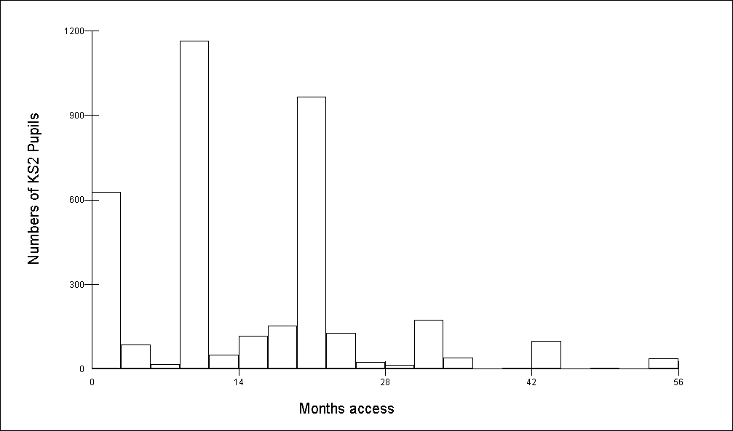
Figure 3.1: Distribution of months’ access at Key Stage 2

The exposure variable is the number of months that the class in which the child is taught has had access to an interactive whiteboard (as shown in Figure 3.1 for Key Stage 2); the mean time was 16.2 months (sd = 10.7 months), with the maximum being 55 months. This is considerably longer than in previous studies. For example, Moss et al. (2007) were only able to obtain data for a maximum of one year of exposure. This quantitative measure is a more refined measure of the intervention than the simple binary of access or non-access. Similarly, the number of months of exposure to interactive whiteboards for Key Stage 1 is presented (Figure 3.2); the mean time was 13.4 months (sd = 7.5 months), with the maximum being 25 months (the interactive whiteboard was introduced in the reception class for some pupils). Throughout the analysis we have used a linear trend and report the significance of the effects we have found. We also give predicted effect size but limit this to two years' exposure as the majority of classes have not had exposure in excess of this period.
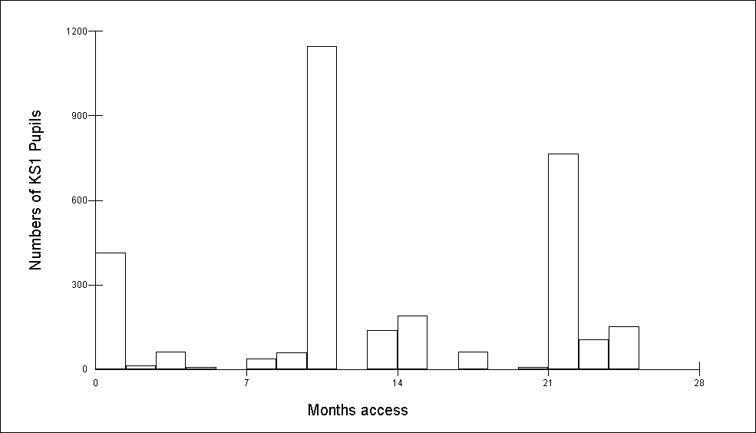
Figure 3.2: Distribution of months’ access at Key Stage 1

We have also taken account in the analysis of the following pupil characteristics: gender, the term of birth, eligibility for free school meals (FSM) (at the end of the key stage) and special educational needs (SEN) (at the end of the key stage).
Table 3.1
 |  | Key Stage 2 | Key Stage 1
Gender | Boys | 51% | 49%
 | Girls | 49% | 51%
Term of birth | September – December | 34% | 32%
 | January - April | 33% | 33%
 | May - August | 33% | 35%
Eligibility for FSM | Yes | 22% | 16%
 | No | 78% | 84%
SEN | None | 78% | 83%
 | School action/school action plus | 19% | 16%
 | Statemented | 3% | 1%

Data was also available on mother tongue and ethnicity, but non-whites and non- English mother tongue speakers were such a small proportion of the overall sample that this was not taken into account in the analysis.
Method of analysis
A multi-level model was used to analyse the data with a two-level hierarchical structure of pupils nested within class. The multi-level model was required because the intervention was to the whole class and not to the individual pupil. If standard regression models had been used, the standard errors of the intervention effect would have been incorrectly estimated. A sequence of models was fitted in which the post-intervention score was related to the pre-intervention score so that we are modelling progress between Key Stages 1 and 2, and foundation stage and Key Stage 1, on each of the domains. All the models included pupil-level variables reflecting gender, eligibility for free school meals, term of birth and SEN status.
For the Key Stage 2 analyses, following the example of Sharp, Schagen and Scott (2004), for those tests where level 2 assessed at three sub-levels (2C, 2B and 2A) a cut-off of level 2B or above was selected on the basis that 'most pupils achieve level 2B or above at Key Stage 1' (ibid., p11). Therefore, pupils were categorised as:
- ‘low attainment’ if they achieved level 1 or level 2C in –
- maths
- English (averaged from reading, writing and spelling level points)
- English: writing only
- ‘low attainment’ if they achieved level 1 at Key Stage 1 in science
- ‘average attainment’ if they achieved level 2B or 2A at Key Stage 1 in –
- maths
- English (averaged from reading, writing and spelling level points)
- English: writing only
- ‘average attainment’ if they achieved level 2 at Key Stage 1 in science
- ‘high attainment’ if they achieved level 3 at Key Stage 1.
For the Key Stage 1 analyses, pupils working ‘securely within the Early Learning Goals’ are defined as those who achieve a scale of six points or more (DfES, 2007). In addition, those pupils achieving eight points are considered to have achieved all Early Learning Goals whilst those achieving nine points are described to be working consistently beyond the level of the Early Learning Goals. Therefore, pupils were categorised as:
- ‘low attainment’ if they achieved
- 0-16 points for communication, language and literacy (3 scales)
- 0-21 points for mathematical development (4 scales)
- ‘average attainment’ if they achieved
- 17-22 points for communication, language and literacy (3 scales)
- 22-29 points for mathematical development (4 scales)
- ‘high attainment’ if they achieved
- 23-27 points for communication, language and literacy (3 scales)
- 30-36 points for mathematical development (4 scales).

Pupils who were working towards level 1 or achieved level 4 at Key Stage 1 were not included in the analysis. There were very few of these pupils (less than one per cent for maths and science, less than two per cent for English) and removing them did not affect the findings but made for easier presentation of results. Moreover, the data that was analysed more closely represented pupils making normal progress in their schooling. The dataset still includes pupils with SEN as this does not always reflect very low attainment; it can for example relate to behavioural problems.
Appendix 3 gives detailed elaboration of a sequence of models analysing the full data set from Phase 2 research, and model estimates and standard errors are given there. Here we concentrate on answering the question:
- Does exposure to an interactive whiteboard affect progress in a domain and does it do so differentially by gender and by prior attainment? Technically, a three-way interaction between length of intervention, Key Stage 1 attainment groups and gender was included in the model as a fixed effect.
We have fitted a multi-level model (using the MlwiN package, version 2.02, Rasbash et al., 2005) to the combined data set across both cohorts at each Key Stage. This gives us the largest sample at both pupil and class level, and the most variation in the amount of exposure; this pooled analysis will therefore produce the results with the smallest standard errors. We have also fitted an overall model but allowed the effects to be differential in each cohort (that is, a four-way interaction). We have done so to assess the possibility of ‘innovation dip’ (Somekh, Underwood et al., 2007) in that there may be no impact or less progress for pupils when their teachers are in the early phases of adoption of a new technology. We also wished to take into account the conflicting evidence from Higgins et al. (2005) which suggested that positive impacts in attainment after the first year of the initiative (pilot of Primary Whiteboards Expansion project) were not sustained in the second year. This four-way interaction model will be only suggestive of results as its standard errors will be higher due to effectively doubling the number of parameters to be estimated.
The Key Stage 1 analyses are based on Foundation Stage Profile data which were collected in 2003/04 and 2004/05. It must be noted that the Foundation Stage Profile was only introduced in 2003 and that even now '[t]he FS curriculum and its assessment are not yet universally established' (DfES, 2007). Furthermore, as assessment practices have become embedded 'scores in two out of three local authorities have shown decreases to some extent for 2004-2005 and 2005-2006' (ibid). That is, this data should not be considered to be stable and all findings must be interpreted cautiously.
While attention focuses on the effect of the exposure, it is important that the unexplained variation is properly modelled. For all the models we allowed for a complex variance function (Goldstein, 2003) involving prior attainment at both pupil and class level. This heterogeneity is modelled explicitly here to ensure improved precision of standard errors in the rest of the model.
Results – Key Stage 2
For each of the domains we first present the gender interactions for both cohorts combined and then for each cohort separately. Appendix 3 gives the detailed results for each model.
Mathematics
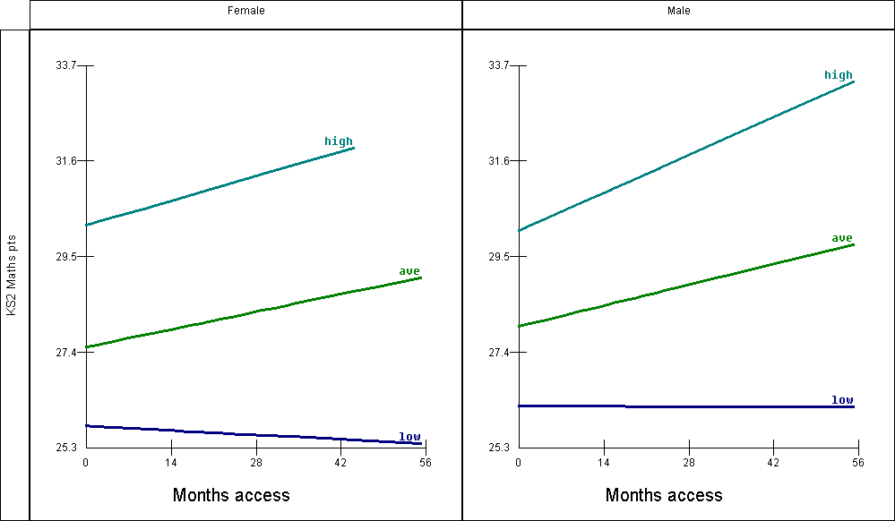
Figure 3.3: Progress for Key Stage 2 maths for pupils of different prior attainment by gender according to access to interactive whiteboard, pooled across both cohorts

Figure 3.3 shows the effect of months of access to interactive whiteboards on Key Stage 2 maths level points scores for six groups. That is high, average and low attainers (at Key Stage 1), and separately for boys and girls. In these results both cohorts are combined. The predicted values plotted are for a baseline category of a pupil (Appendix 3) who is summer born, not eligible for free school meals, not at school action/action plus and not statemented. The measure for progress is reported in level points, where one level point is equivalent to four months' progress. That is, pupils are generally expected to progress by six points (or one National Curriculum level) every two years. The results for both genders are remarkably similar. Exposure to interactive whiteboards makes little impression in terms of progress for both low attainment boys and girls. The effect of access is not significantly different from no access for both these effects. However, for both sexes and for each average and high-attainment group, increased exposure leads to increased progress.
Findings:
- The strongest effect is found for higher attaining males who progress some five months more after two years' exposure to interactive whiteboards compared to those who have not received the intervention. This is a highly significant effect (p < 0.002).
- The improved progress for average attainment females after two years' exposure is two and a half months compared to those who have not received the intervention. This is a significant effect (p < 0.039).
- The improved progress for the averagely attaining males after two years' exposure is nearly three months. This is a significant effect (p <0.018).
- The improved progress for high-attaining females after two years' exposure is nearly three and a half months. This is approaching significance at conventional levels (p < 0.07) and we must appreciate that the number of females falling into this category is relatively low (379).
- There are no significant effects for low-attaining pupils of either gender. That is, interactive whiteboard exposure makes no difference (positive or negative) to these pupils.
In summary, when using the data combined for both cohorts:
- Interactive whiteboards benefit averagely attaining pupils of both sexes and high-attaining pupils of both sexes in that they make greater progress with more exposure to interactive whiteboards in maths, but the effect for high-attaining females is not statistically significant as there are fewer pupils in this category. This confirms the preliminary findings from Phase 1.
- Interactive whiteboards have little effect and certainly not a detrimental effect for low-attaining pupils of both sexes in the domain of maths. Nevertheless, it suggests that the gap between low-attaining pupils and others is likely to widen as a result of exposure to interactive whiteboards.
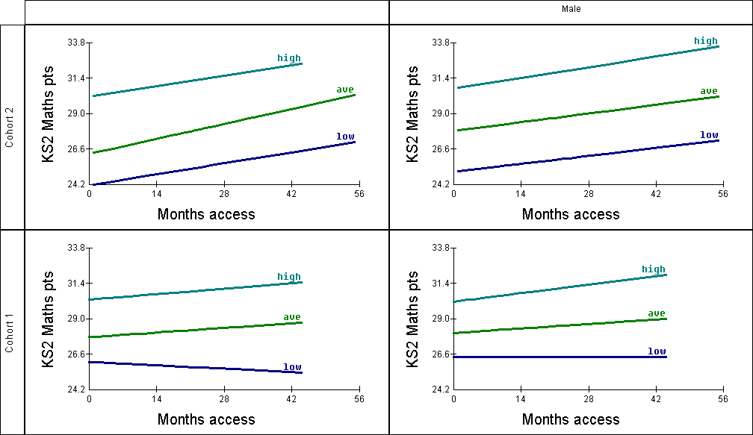
Figure 3.4: Progress for Key Stage 2 maths for pupils of different prior attainment by gender according to access to interactive whiteboard, disaggregated by cohort (cohort 1 = 2005, cohort 2 = 2006)
Figure 3.4 shows the results when the same analysis is undertaken for each cohort separately. It is clear that:
- the beneficial effects of interactive whiteboards for progress in maths for high and average attainment for both sexes are confirmed, with the beneficial effects being more pronounced in the second cohort when teachers had more experience of the technology
- the strongest effect is found for girls of average attainment in Cohort 2. The improved progress for this group is some six months after two years' exposure to interactive whiteboards as compared to those without access. This is statistically significant (p < 0.003).
- improved progress for boys of average attainment in Cohort 2 is 3.7 months after two years' exposure to interactive whiteboards as compared to those without access
- there is a contrast for the lower attainment groups in that in the second cohort the beneficial effects in maths are also experienced by this group. That is, once the innovation has been embedded in the classroom all attainment groups and both sexes are showing greater progress with greater exposure to whiteboards. While the results are highly suggestive and consistent, the results are not significant at conventional levels due to the small number of observations as the cohorts are analysed separately.
In summary, at Key Stage 2 for this domain there is a consistent improvement with exposure to the interactive whiteboard which appears to become stronger once teachers have had sustained experience of using the technology. Analysis of the combined data suggested that increased exposure might be widening the gap between progress made by low attainers and others, but when Cohort 1 and Cohort 2 are examined separately it appears that once the innovation becomes embedded, positive gains are likely to be achieved by pupils of both genders and all levels of prior attainment. Overall, in mathematics, exposure to interactive whiteboard once teachers are familiar with the technology brings improved progress; these findings are both consistent and plausible.
Science
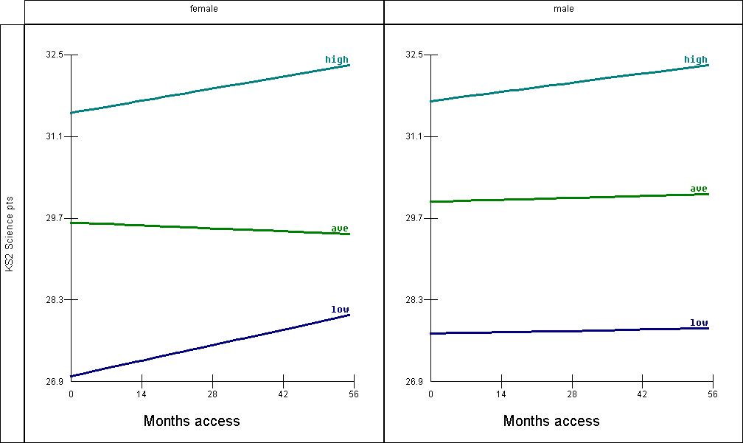
Figure 3.5: Progress for Key Stage 2 science for pupils of different prior attainment (in Key Stage 1 science) by gender according to access to interactive whiteboard, pooled across both cohorts

Figure 3.5 shows the results for science for Key Stage 2 when the two cohorts are combined. In contrast to the results for maths, there are now some differences by gender. Exposure to interactive whiteboards appears to make the greatest improvement for low-attaining girls who, with increasing access, are able to make similar levels of progress to their male counterparts. Access to an interactive whiteboard makes no difference (nor has a detrimental effect) for pupils of average attainment of both sexes, or low-attaining boys. For high-attainment pupils there is a positive effect of increased access to interactive whiteboards on progress in science, and this effect is experienced by both sexes. However, the categories of low attainment (females: 135; males: 170) have insufficient numbers to draw any firm conclusions. The categories of high attainment are also relatively low and pupils in these groups may be reaching a ceiling effect as the highest possible level point score is 33. Overall, none of the trends are significant at conventional levels positive trends. One reason for these low numbers in the low and high attainment categories may be that science at Key Stage 1 is assessed by teachers only (that is, pupils have not undertaken a statutory test) and therefore there might be a tendency to judge most pupils as reaching the expected level of attainment for that subject. In addition, evidence provided in Section 6 of this report suggests that teachers focused initially on using the interactive whiteboard to teach numeracy and literacy. Therefore it has taken substantially longer for interactive whiteboards to become embedded in science lessons.
Due to the problems arising from using the Key Stage 1 science assessments described above, this analysis was repeated using the Key Stage 1 maths level points as the measure of prior attainment. This had the advantage of increasing the numbers of pupils in the low-attaining categories but is based on a smaller dataset overall (3656 pupils with Key Stage 1 maths assessments as compared to 4116 pupils with Key Stage 1 science assessments).
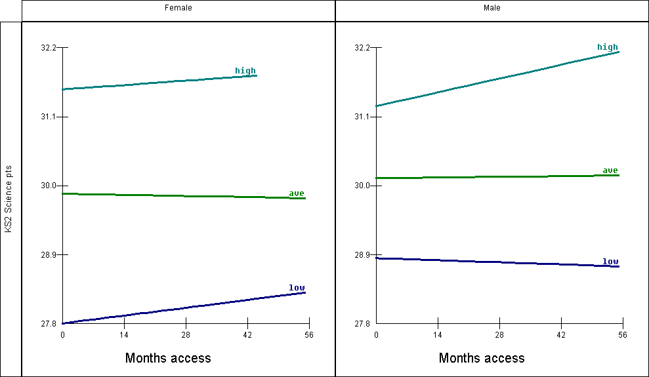
Figure 3.6: Progress for Key Stage 2 science for pupils of different prior attainment (in Key Stage 1 maths) by gender according to access to interactive whiteboard, pooled across both cohorts

The findings are very similar to those obtained using Key Stage 1 science assessment level points as the measure of prior attainment. Again, there are no significant effects, positive or negative. Here the categories of low attainment have more pupils (females: 365, males: 429) and so it is less likely that this is an explanation for the lack of impact of interactive whiteboards in science.
In summary:
- When combined data from Cohort 1 and 2 is analysed, interactive whiteboards have no effect (either positive or negative) on attainment in science for all pupils when analysis is carried out irrespective of gender or prior attainment. This confirms the preliminary findings from Phase 1.
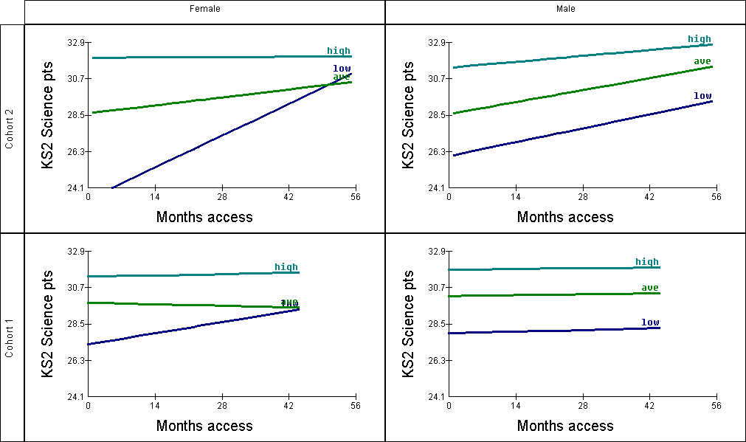
Figure 3.7: Progress for Key Stage 2 science for pupils of different prior attainment (in Key Stage 1 science) by gender according to access to interactive whiteboard, disaggregated by cohort (Cohort 1 = 2005, Cohort 2 = 2006)

Fig 3.7 presents the results for Key Stage 2 science when the effects are estimated separately for each cohort. It is clear that the beneficial effects in science for all abilities for both sexes are more pronounced in the second cohort, when teachers had more experience of the technology. Furthermore:
- the boys of average prior attainment in the second cohort make a statistically significant improvement in progress with increased exposure to interactive whiteboards (p < 0.02). These pupils make some four and a half months' additional progress when they have had two years' exposure as compared to boys in this category without interactive whiteboards.
- this figure also confirms the finding when the cohort data is pooled that increased exposure to interactive whiteboard has a positive effect on the progress of girls of low prior attainment in science. In Cohort 2 this finding is particularly marked and suggests a positive trend (p < 0.085) with such pupils making a whole year’s progress after two years' exposure to interactive whiteboards as compared to similar pupils without. However, the number of pupils falling in this category is extremely small (50) and therefore we would be very cautious about making claims on the basis of this evidence.
- overall the second cohort do seem to experience increased progress in science with exposure to interactive whiteboards.
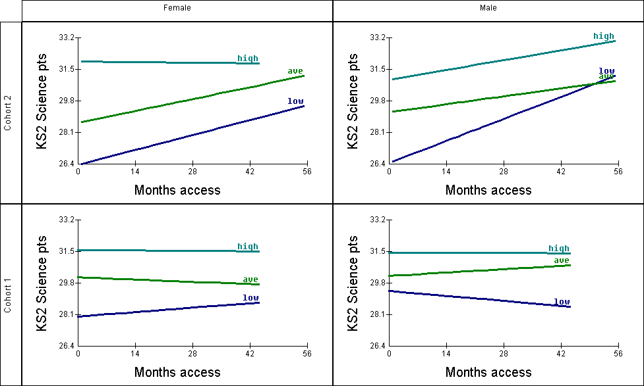
Figure 3.8: Progress for Key Stage 2 science for pupils of different prior attainment (in Key Stage 1 maths) by gender according to access to interactive whiteboard, disaggregated by cohort (Cohort 1 = 2005, Cohort 2 = 2006)

The analysis was also conducted using the Key Stage 1 maths level points as a measure of prior attainment, and the results shown in Figure 3.8. Again, the beneficial effects in science for all abilities for both sexes are more pronounced in the second cohort, by which time teachers will have had more experience of the technology. In this re-analysis, a proportion of the pupils originally categorised as of average attainment have now been categorised as low attainment, revealing the trends for each group more clearly. Specifically:
- the girls of average prior attainment in the second cohort make an improvement in progress with increased exposure to interactive whiteboards (p <0.052). These pupils make some four months' additional progress when they have had two years' exposure as compared to girls in this category without exposure to interactive whiteboards.
- in Cohort 2, there is now a statistically significant positive effect of interactive whiteboards for male pupils in the low prior attainment category (p < 0.012, n = 182). These pupils make some seven and a half months' additional progress when they have had two years' exposure to interactive whiteboards as compared to boys in this category without exposure to interactive whiteboards.
In summary:
- Evidence to date suggests that interactive whiteboards are beneficial in terms of progress in science for pupils of average and low attainment once teachers and schools have had at least one year’s experience of the technology. It is plausible that this effect has been heightened as teachers in the project were guided to focus on numeracy and literacy in the first year through the training and support materials which were provided.
- However, it is difficult to draw conclusions about high-attainment groups due to ceiling effects and the limited numbers falling into this category in the disaggregated analyses.
English
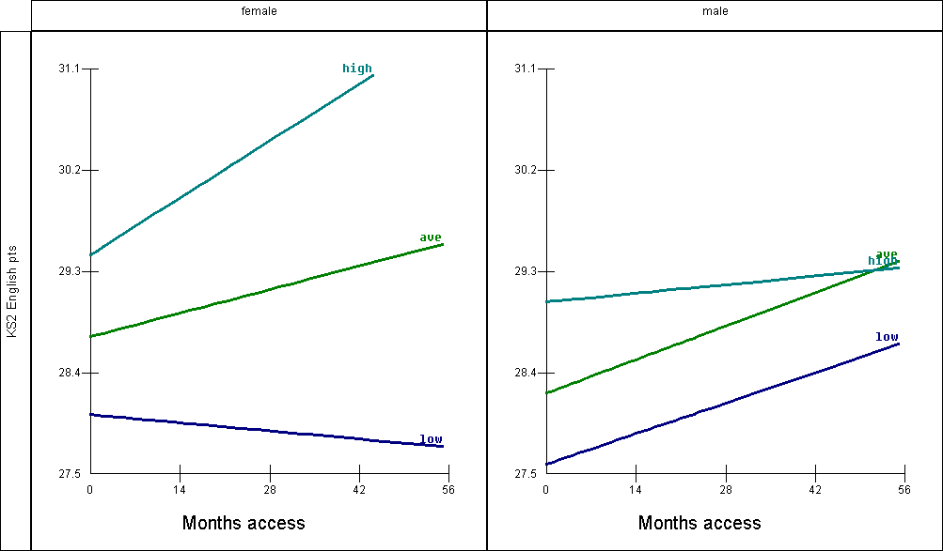
Figure 3.9: Progress for Key Stage 2 English for pupils of different prior attainment (English Key Stage 1 average) by gender according to access to interactive whiteboard, pooled across both cohorts

Figure 3.9 shows the results for the English domain at Key Stage 2, when the data is combined for both cohorts. The strongest positive effects are for high-attainment girls and average-attainment boys:
- Girls of high prior attainment made some three months' additional progress after two years' exposure to interactive whiteboards as compared to those pupils in this category who had no exposure. This is a positive trend approaching significance at conventional levels (p < 0.08).
- Boys of average attainment made nearly two months' additional progress after two years' exposure to interactive whiteboards as compared to those pupils who had no exposure. This is also a positive trend approaching significance (p < 0.07).
- The categories of low-attainment girls, high-attainment girls and high-attainment boys had relatively small numbers of pupils and therefore it is difficult to draw any firm conclusions.
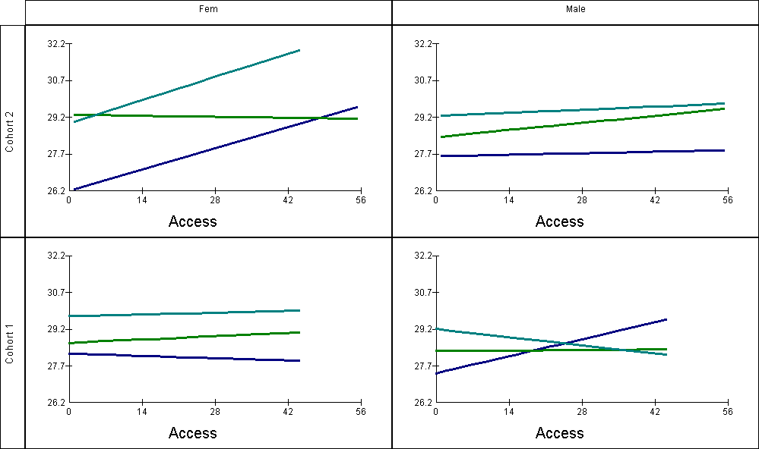
Figure 3.10: Progress for Key Stage 2 English for pupils of different prior attainment (English Key Stage 1 average) by gender according to access to interactive whiteboard, disaggregated by cohort (Cohort 1 = 2005, Cohort 2 = 2006)

There are no statistically significant effects when we consider the two cohorts separately. In particular, the numbers of pupils in the high and low attainment categories are relatively low, which means there is insufficient statistical power to comment. It is also important to note that other researchers have found measures of English at Key Stage 1 and Key Stage 2 to be inconsistent across years and variable in comparison to measures of maths which are the more stable (see for example, Melhuish et al., 2006). It is, however, worth pointing out that with these results we do not get the suggestion of consistent improved results with the second cohort, and therefore greater teacher experience, with possible exception of girls with high and low prior attainment.
In summary:
- The findings from Phase 1 relating to small positive impacts arising from increasing access to interactive whiteboards over time are not confirmed by Phase 2 analyses
- However, Phase 2 analyses are counter to the tentative finding (not statistically significant) from Phase 1 that average and high attaining girls make more progress without an interactive whiteboard.
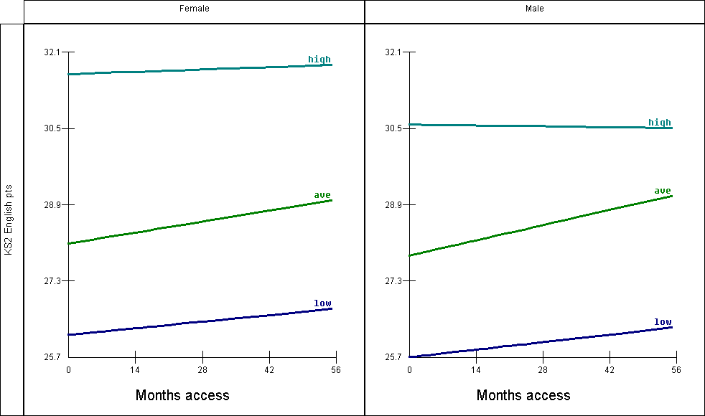
Figure 3.11: Progress for Key Stage 2 English for pupils of different prior attainment (reading only) by gender according to access to interactive whiteboard, pooled across both cohorts

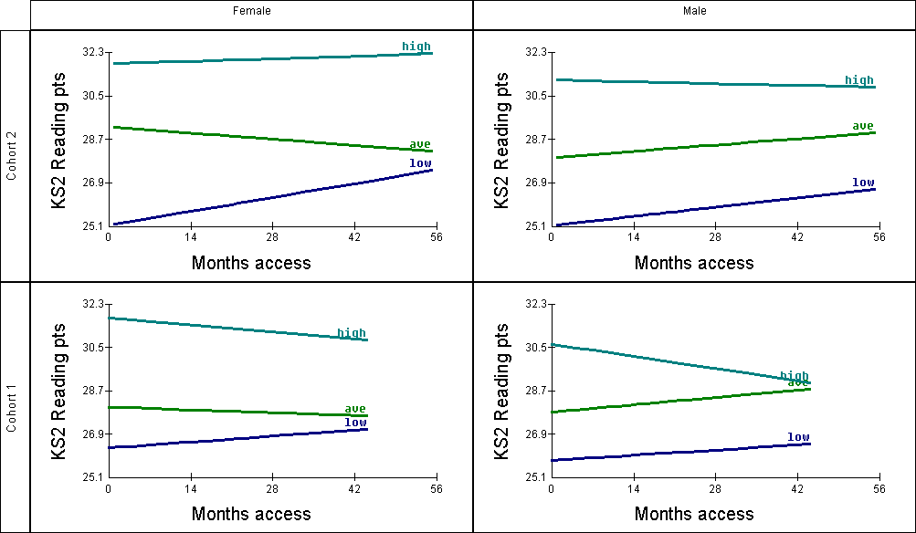
Figure 3.12: Progress for Key Stage 2 English for pupils of different prior attainment (reading only) by gender according to access to interactive whiteboard, disaggregated by cohort (Cohort 1 = 2005, Cohort 2 = 2006)

Reading at Key Stage 1 has been found by some analysts to be the strongest predictor of English at Key Stage 2. Figures 3.11 and 3.12 repeat the analysis using Key Stage 1 reading points score as the measure of prior attainment rather than the Key Stage 1 English average points score.
In summary:
- Interactive whiteboards have no detrimental effect for all pupils, irrespective of gender or Key Stage 1 attainment. Furthermore, Phase 2 analyses run counter to the finding from Phase 1 that average and high attaining girls make more progress without an interactive whiteboard.
- However, as measures of attainment in English are less stable than in maths and science, the results are inconclusive and warrant further investigation with larger data sets.
Writing
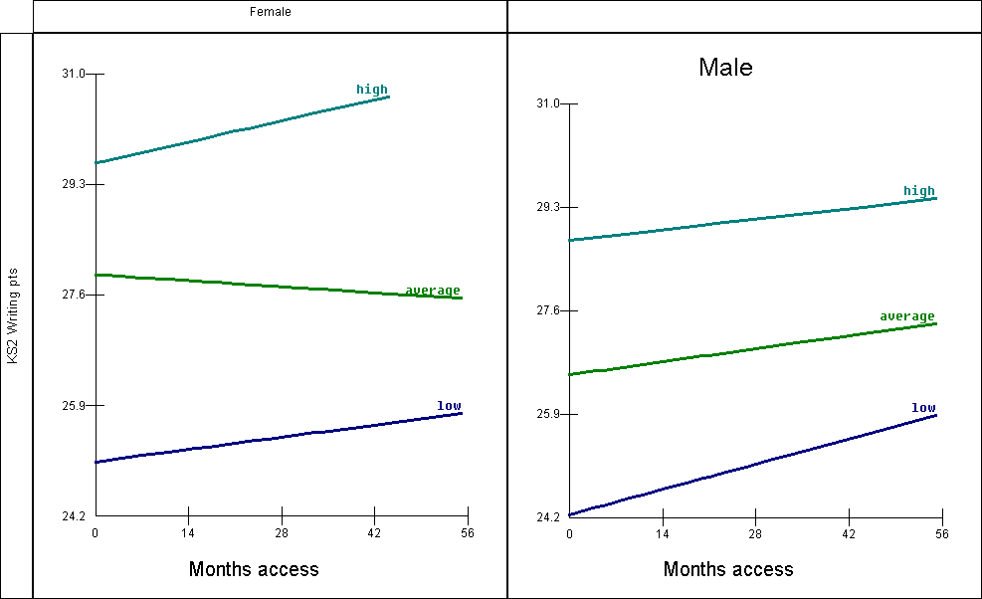
Figure 3.13: Progress for Key Stage 2 writing for pupils of different prior attainment by gender according to access to interactive whiteboard, pooled across both cohorts

Figure 3.13 shows the results for Key Stage 2 writing. This analysis of the writing level points score (forming part of the English level points score) relates to a smaller dataset as this level of data was not available for all pupils. There were small numbers of pupils of either gender falling into the high attainment category (both less than 200). Whilst there were only 391 girls in the low attainment category there were (unsurprisingly) 539 boys.
- The most marked effect approaching statistical significance (p < 0.094) is for low-attainment boys who make some two and a half months additional progress after two years exposure to interactive whiteboards as compared to those pupils in this category who have no exposure.
- There is no significant effect (neither positive or negative) for other categories but the numbers of pupils in the high-attainment groups are very low.
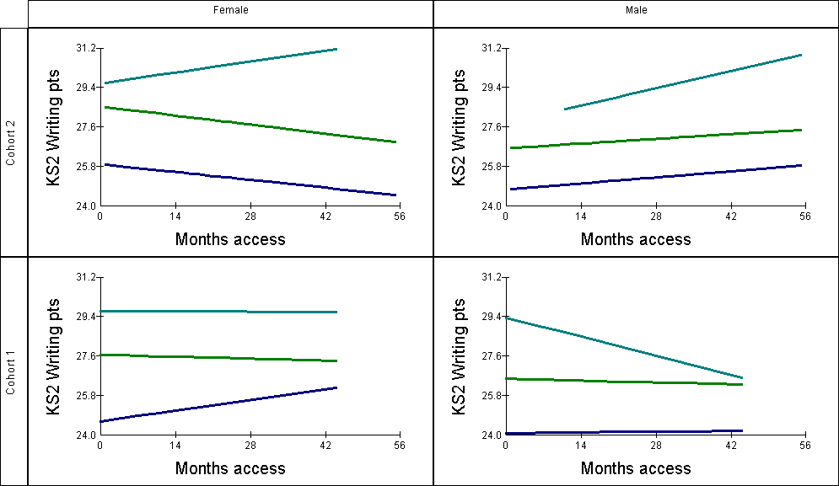
Figure 3.14: Progress for Key Stage 2 writing for pupils of different prior attainment by gender according to access to interactive whiteboard, disaggregated by cohort (Cohort 1 = 2005, Cohort 2 = 2006)

Figure 3.14 shows the results for each cohort separately; in summary:
- There are no statistically significant effects of exposure to interactive whiteboards. It should be noted that due to a smaller data set the numbers of pupils falling within each category are relatively low, notably for high-attainment pupils of both genders.
Results – Key Stage 1
We now turn to the results for Key Stage 1, using the same methodology and method of presentation. For each of the domains we first present the gender and prior attainment interactions for both cohorts combined and then for each cohort separately. Appendix 3 gives the detailed results for each model. The findings must be treated cautiously as they are based on Foundation Stage Profile (FSP) data from the two years following its introduction which is known to be variable and inconsistent (DfES, 2007).
Mathematics
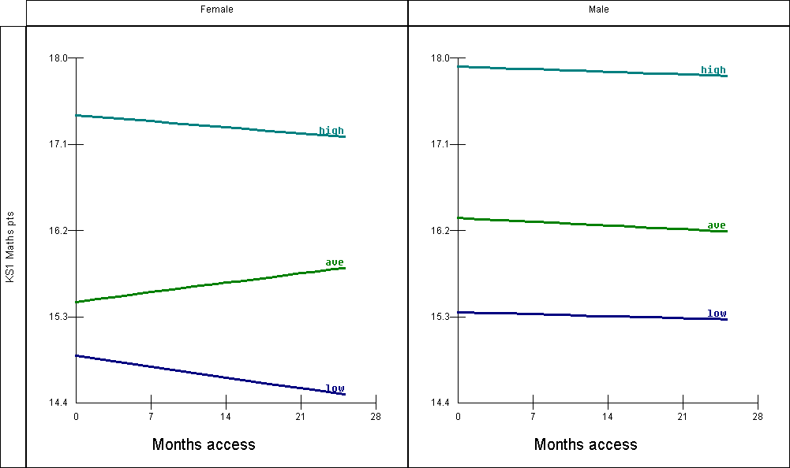
Figure 3.15: Progress for Key Stage 1 maths for pupils of different prior attainment by gender according to access to interactive whiteboard, pooled across both cohorts

Figure 3.15 shows the effect of months of access to interactive whiteboards on Key Stage 1 maths level points scores for six groups when the cohorts are combined. That is high, average and low FSP attainment and separately for boys and girls. In these results both cohorts are pooled. The actual values plotted are for a baseline category of pupil (Appendix 3) who is summer born, not eligible for free school meals, not at school action/action plus and not statemented. The measure for progress is reported in level points, where one level point is equivalent to four months' progress. That is pupils are generally expected to progress by six points (or one National Curriculum level) every two years. The results for the three male groups suggest that interactive whiteboards make no difference (positive or negative). Whilst it appears that interactive whiteboards have effects on the three different female attainment groups, none of these are statistically significant.
In summary:
- There are no significant effects, and certainly not a detrimental effect, for pupils of either gender.
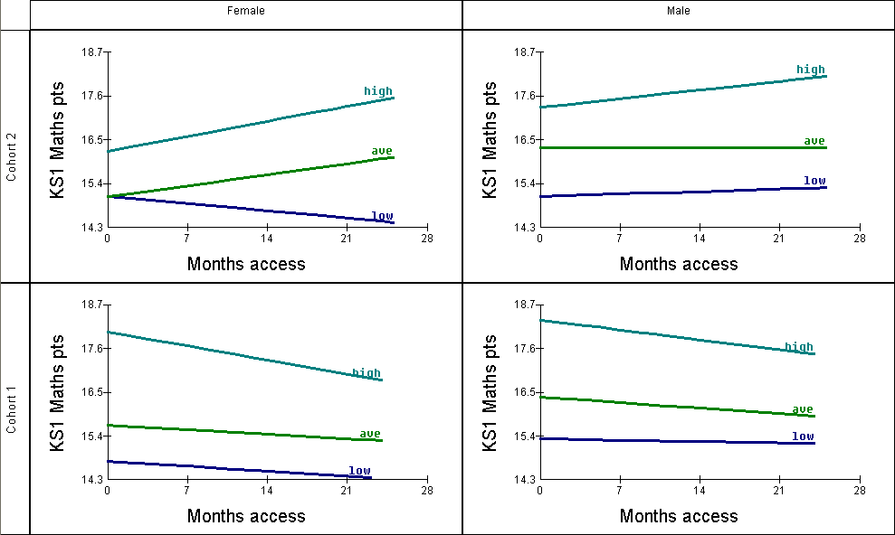
Figure 3.16: Progress for Key Stage 1 maths for pupils of different prior attainment by gender according to access to interactive whiteboard, disaggregated by cohort (Cohort 1 = 2005, Cohort 2 = 2006)

Figure 3.16 shows the effects separately for each cohort. With the exception of low-attaining girls, the Cohort 2 data suggests that once teachers have had time to become familiar with the interactive whiteboard, there is a positive impact. There are relatively high numbers of pupils falling into the high-attaining female categories in both cohorts. Therefore there is sufficient statistical power.
- There appears to be a positive effect of interactive whiteboards for high-attaining girls in Cohort 2 which is approaching statistical significance (p < 0.056). High-attaining girls in Cohort 2 make some 4.75 months' greater progress after two years' exposure to interactive whiteboards as compared to girls in the same category without exposure to interactive whiteboards.
- However, there was a negative trend for high-attaining girls in Cohort 1 (p < 0.086). These pupils make 4.4 months' less progress after two years' exposure to interactive whiteboards as compared to girls in the same category without exposure to interactive whiteboards.
In summary, at Key Stage 1:
- There are indications that interactive whiteboards have a positive impact in maths, once the technology has become embedded in pedagogical practices
- This impact seems to be most marked for high-attainment girls, who are able to catch up with their male peers
- There is quite a contrast between the Cohort 1 and 2 results; generally negative for the former, generally positive for the latter; once again suggesting the importance of embedding the technology.
Science
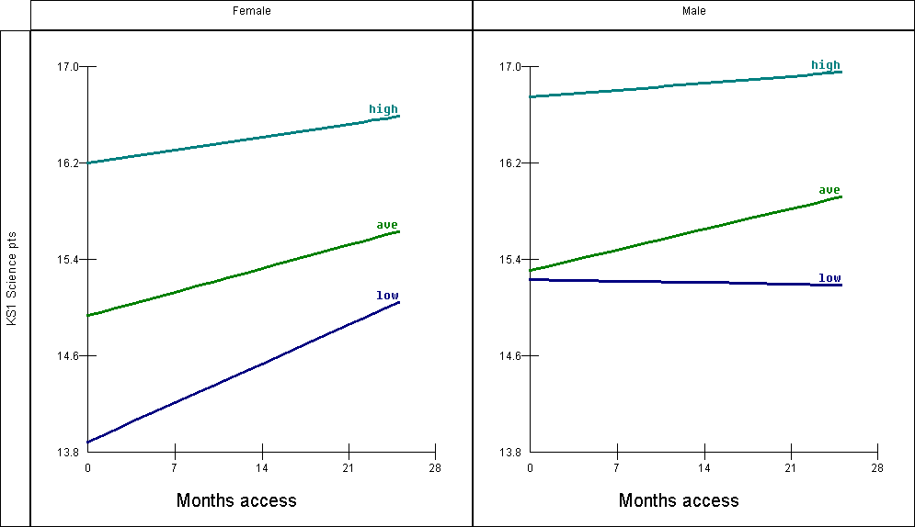
Figure 3.17: Progress for Key Stage 1 science for pupils of different prior attainment (in mathematical development) by gender according to access to interactive whiteboard, pooled across both cohorts

Figure 3.17 shows the results for Key Stage 1 science for the combined data for Cohort 1 and Cohort 2. Overall, the results suggest that interactive whiteboards have a positive impact on science progress at Key Stage 1, especially for girls. In particular:
- there appears to be a positive trend for low-attaining girls approaching significance (p < 0.083), even though this category has the smallest number of pupils (219). Pupils in this category make four months' better progress after two years' exposure to interactive whiteboards as compared to those pupils in the same category without access to interactive whiteboards.
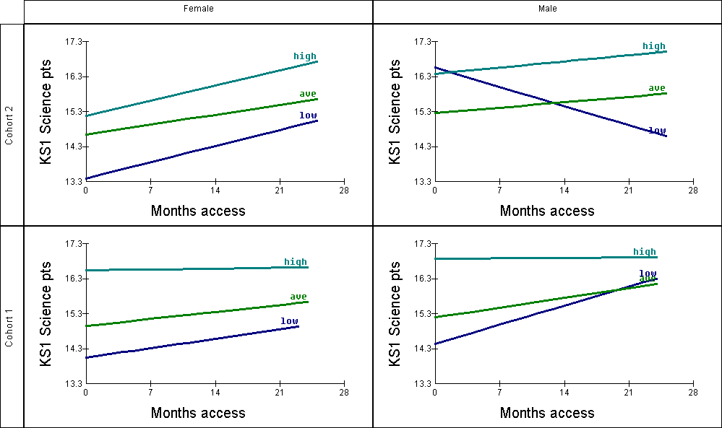
Figure 3.18: Progress for Key Stage 1 science for pupils of different prior attainment (in mathematical development) by gender according to access to interactive whiteboard, disaggregated by cohort (Cohort 1 = 2005, Cohort 2 = 2006)

The results when the cohorts are analysed separately (Figure 3.18), show that for girls, the impact of interactive whiteboards on science attainment at Key Stage 1 looks more promising once teachers have become familiar with technology. We find that:
- there is a statistically significant impact of interactive whiteboards on low-attaining boys in Cohort 2 (p < 0.05) although the number of pupils falling in this category is relatively low (n = 140). Those pupils in this category with two years' exposure to interactive whiteboards may make almost seven months' less progress than their peers who do not have exposure to interactive whiteboards.
- there is a positive trend of interactive whiteboard impact for low-attaining boys in Cohort 1 (p < 0.056) although there are only 150 pupils in this category. Pupils in this category may make almost seven months' greater progress than their peers who do not have exposure to interactive whiteboards.
- there is a positive trend of interactive whiteboards for high-attaining girls in Cohort 2 (p > 0.064). Pupils in this category with two years' exposure to interactive whiteboards may make just over five months' greater progress in science than their peers who do not have access to interactive whiteboards.
Clearly, the evidence relating to low-attaining boys is highly inconsistent, showing a detrimental effect in Cohort 2 and a positive effect in the earlier cohort. We report it here but want to point out that it should be treated with caution due to the small numbers falling within these categories and due to our inability to explain and account for the result.
In summary:
- Once interactive whiteboards become embedded and teachers begin to use them regularly to support the teaching of science, it may be that girls of all attainment levels will make better progress with increased access
- There are indications that this positive experience may be shared by average and high-attaining boys
- It may be the case that low-attaining boys make less progress with greater exposure to interactive whiteboards when the teacher has greater experience although this finding should be treated with caution as it relates to a very small number of pupils.
English
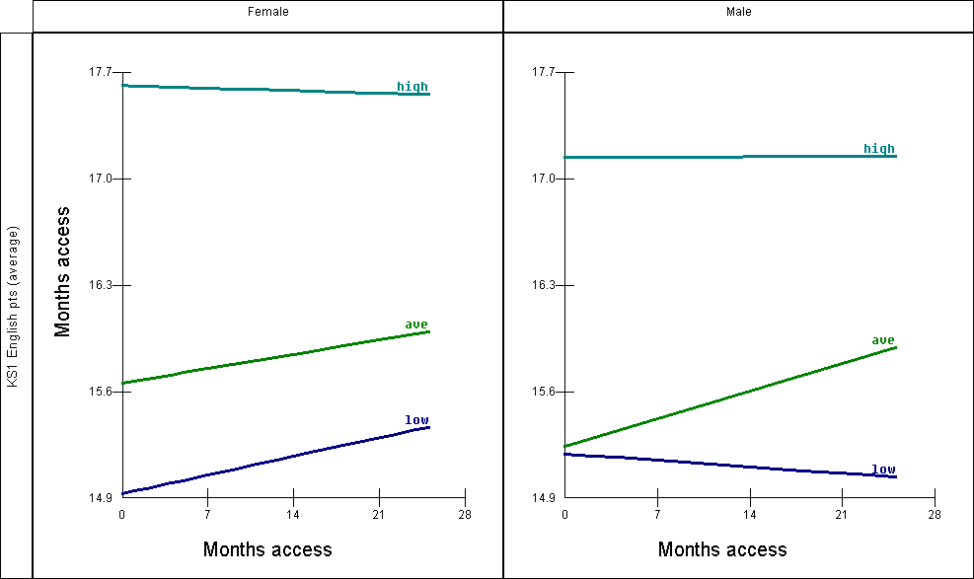
Figure 3.19: Progress for Key Stage 1 English for pupils of different prior attainment by gender according to access to interactive whiteboard, pooled across both cohorts

Analysis of the combined data for both cohorts (Figure 3.19) suggests positive effects of interactive whiteboards on attainment in English for average pupils, irrespective of gender, and low-attaining girls. In contrast, there is little impact on high-attaining boys and girls. However, none of these effects are statistically significant or even indicate clear trends.
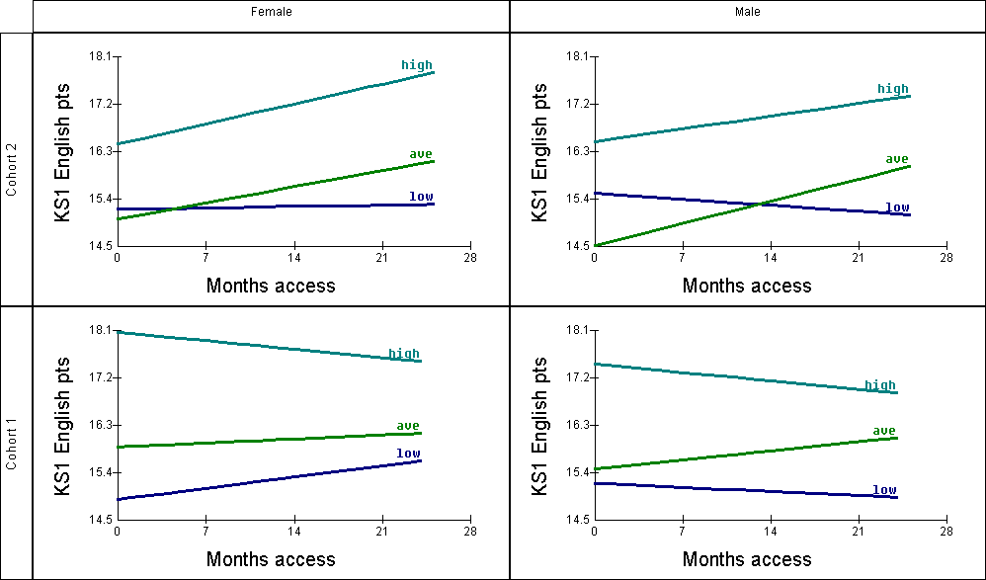
Figure 3.20: Progress for Key Stage 1 English for pupils of different prior attainment by gender according to access to interactive whiteboard, disaggregated by cohort (Cohort 1 = 2005, Cohort 2 = 2006)

Figure 3.20 shows the results for each cohort separately. This suggests that when teachers have become familiar with the technology, interactive whiteboards are likely to have a positive impact on progress in English for average and high-attaining pupils, irrespective of gender. This is confirmed for three out of the four categories:
- Interactive whiteboards appear to have a positive impact on progress for boys of average attainment (p < 0.026, n = 274). Pupils in this category are estimated to make just over five months' greater progress after two years' exposure to interactive whiteboards as compared to pupils in the same category without exposure to interactive whiteboards
- Interactive whiteboards appear to have a positive impact on progress for girls of high attainment (p < 0.057, n = 391) and this is approaching statistical significance. Pupils in this category appear to make 4.75 months' greater progress after two years' exposure to interactive whiteboards as compared to pupils in the same category with no exposure to interactive whiteboards.
In summary:
- Evidence to date suggests that once interactive whiteboard use becomes embedded, pupils of average and high attainment (as measured by FSP data) are likely to benefit from increasing exposure to interactive whiteboards.
- There is no effect (neither beneficial nor detrimental) of interactive whiteboards in relation to low-attaining pupils. However, this may lead to widening gaps in progess between low-attaining pupils and their peers.
Section 4: The contribution made by interactive whiteboards to the development of pedagogies and more general embedding of ICT across the curriculum
This section of the report draws on the case study data collected in Phase 1 of the research from visits to ten case study schools, supplemented by data from questionnaires to school headteachers/ICT co-ordinators and teachers using an interactive whiteboard in their classrooms. There were two phases to the case study work. The second phase was possible because of the extension of the project to include data from the 2006 national test results in the multi-level modelling analyses.
In this section the first phase case study data is examined with the aim of helping to develop explanatory theories for the findings of the quantitative analysis of standards of attainment in relation to specific subject learning. Thus, Section 4 supplements Section 3 and aims to provide illustrations of classroom practice, with explanations for the effects that have been observed.
A second focus of this section is on the effects of using interactive whiteboards on a range of other outcomes, including pupil and teacher motivation and pupil behaviour.
A third focus is on identifying and describing different types and levels of interactive whiteboard use within the classroom, to explore how staff practices in teaching with interactive whiteboard technology develop over time, and to gauge the extent to which interactive whiteboards serve as a catalyst for the increased and more widespread use of ICT for teaching and learning purposes at primary level.
Summary of findings from Phase 1 case studies
Interactive whiteboards in use in classrooms
- Use of an interactive whiteboard increases the level of children’s engagement with learning activities.
- Interactive whiteboards aid the teaching of difficult, abstract and complex ideas.
- The interactive whiteboard acts as a ‘portal’ through which many different resources can be accessed.
- Interactivewhiteboards have multiple –modality and are able to act as TV, computer, book, projector, flipchart, calculator, timer, etc.
- Teaching primary age children, with the potentialities of an interactive whiteboard to draw upon, makes a significant difference to how children’s learning may be encouraged.
- The use of interactive whiteboards is particularly valuable at Key Stage 1 when the facility to drag and place onscreen items enables young children to demonstrate their knowledge before they have acquired writing skills. This helps both children’s self-esteem and teachers’ ability to assess their learning. This can be very powerful when young children occasionally work alone at the interactive whiteboard.
When the interactive whiteboard is used
- A third of all primary school lessons with interactive whiteboards are numeracy lessons, and another third are literacy. Just under a tenth are science lessons.
- Interactive whiteboards provide excellent support for whole-class teaching.
- The pace of lessons is often increased, which helps in coverage of the National Curriculum, but may not help those pupils who take longer to absorb and understand ideas and concepts.
- More use of interactive whiteboards for group work is made in Key Stage 1, particularly in Reception where there is a tradition of allocating time for constructive play. At Key Stage 2 the curriculum is more packed and pupils often spend the middle part of the lesson on producing written work rather than working in groups.
- Evidence on use of interactive whiteboards in ICT suites was not collected systematically, but there is evidence from the case study schools that a data projector with a computer is considered sufficient because, once interactive whiteboards are installed in all classrooms, the main activities in suites need to focus on pupils’ hands-on access to computers.
The impact of the interactive whiteboard on classroom culture and pupil motivation
- The ambience of classrooms in which interactive whiteboards are used is more co-operative and ‘sharing’, fostering a ‘community of learning’ ethos in the class.
- Pupils see an interactive whiteboard as something that helps them to keep on concentrating, and frequently helps them to understand more fully, and more easily, what they are being taught. They repeatedly say how much they like ‘being able to see’.
- There are very positive effects on the attention, attitude and motivation of pupils in classes with interactive whiteboards. However, increased enjoyment cannot always be equated with improved learning.
- The ‘surprise factor’ in much interactive whiteboard use is important in holding the attention of pupils. Lessons are less predictable in terms of what the teacher will present next. So, although the ‘wow’ factor with pupils is agreed to be fading away – over 18–24 months – the positive effects of using interactive whiteboards have not faded over the same period.
The interactive whiteboard used with children who have special needs
- Catering for pupils with special educational needs is not necessarily made any easier by the introduction of an interactive whiteboard. But its presence may make it more obvious that choices have to be faced.
- The interactive whiteboard makes whole-class teaching more lively and in many cases increases its pace. However, whole-class teaching offers only very limited opportunities for differentiation (through varying the difficulty of questions), so there may be little beneficial impact for special needs pupils from improved – and more engaging – delivery of whole-class teaching.
- Pupils with special needs show considerable enthusiasm for using the interactive whiteboard, but we have observed very little use of the interactive whiteboard by teachers for specialist teaching of these children in literacy or numeracy. It is often TAs who work with pairs or small groups at the interactive whiteboard.
Interactivity and the interactive whiteboard
- Interactive whiteboards introduce more possibilities for fruitful interactivity between the teacher and those being taught. They do this by providing teachers with a tool which complements and extends the interactive process which is an essential component of all pedagogy. The interactive whiteboard has interactive facilities (an on-screen calculator, for example) and offers possibilities of a different kind of ‘interactivity’ in pupils’ learning, but the extent to which these opportunities are taken up depends on the way it is used by teachers.
- ‘Interactivity’ needs to be understood on more levels than that of pupils being able to use some of the board’s facilities. Additional aspects include: mental interactivity, interactivity via peripherals, and via the multiple modalities of interactive whiteboards.
- An interactive whiteboard shifts the focus of attention from the teacher to the interactive whiteboard, making it possible for teachers to be more mobile during whole-class teaching: this is a different interaction in the classroom, and there are implications for initial teacher training.
Evidence of learning in terms of ‘learning indicators’ based on key learning theories
- The interactive whiteboard (in conjunction with a computer or laptop and server) is a stable (multiple) resource (Kozma, 1994). Both teacher and learner can rely on being able to refer back, no matter what mode of resource the interactive whiteboard was using before, and no matter how far into the past is required. The interactive whiteboard also makes it easy for teachers to provide ‘advance organisers’ to support learning (Ausubel and Robinson, 1969).
- The interactive whiteboard creates a strong focus for pupils’ attention and they often show high levels of engagement or ‘flow’ (Csikszentmihalyi, 1996) likely to indicate creative learning.
- The interactive whiteboard enables teachers to use dynamic modelling in multi-modal environments (using text, images and sound) to assist pupils in visualising complex models and understanding difficult concepts (Kozma, 1991).
- The interactive whiteboard enables teachers to cater for children’s different learning styles, for example as described in the theory of ‘multiple intelligences’ (Gardner, 1993).
- The interactive whiteboard makes it possible to bring examples from current ‘live’ data into the classroom and thereby help to ‘situate’ learning and increase its meaning and relevance for pupils (Brown, Collins et al., 1989).
- The interactive whiteboard helps teachers to engage children’s attention with fascinating and complex ideas and thereby encourages ‘deep’ learning which is more long-lasting than ‘surface’ learning (Entwistle, 2001).
Planning and the use and retrieval of resources with the interactive whiteboard
- The interactive whiteboard is typically switched on for the whole of the school day, providing instant access to a wide range of ICT-mediated resources, often including the internet.
- The traditional paper-based lesson plan is no longer capable of giving a full picture of the preparations that conscientious teachers undertake for interactive whiteboard lessons. This has implications for the way in which Ofsted inspectors need to work.
- Teachers are still enjoying the discovery of new ways to present learning activities.
- In the majority of classrooms the interactive whiteboard is used for whole-class teaching during the introduction and plenary sections of a three-part lesson. In Key Stage 2 some exceptionally skilled teachers use it more integrally throughout the lesson.
- In Key Stage 1 the interactive whiteboard is frequently also used during the middle part of the lesson for group work by pairs, small groups or occasionally individuals, often supervised by a TA.
- Teachers report that they are beginning to feel the benefit of having only to adjust the resources they had previously generated (and used), and some stated that time spent planning was actually beginning to be reduced.
- Teachers are accessing a wide range of resources from the internet, including resources on the websites of other schools and providers such as the BBC.
- Resources need to be stored on the school’s server and this needs to be backed up on a daily basis. A clear storage structure with both shared areas (perhaps divided into year groups and ‘themes’) and personal areas is essential.
Changes in teaching practices with the interactive whiteboard and in frequency of its use
- A huge majority of 368 teachers felt they had adopted new teaching practices as a result of having an interactive whiteboard.
- Over the period of the evaluation, the use of interactive whiteboards across the curriculum has increased; its use is most commonplace in literacy and numeracy, reflecting the strong link between the primary strategy (and the government’s focus on core subjects through assessment practices) and the Primary Schools Whiteboard Project initiative.
- Some teachers in Key Stage 1 have found that the interactive whiteboard is particularly useful for assessing pupils’ numeracy and literacy skills, particularly when they are working individually (very occasionally) or in small groups.
Health and safety issues
- Having boards that invite pupils to come up and touch them means that there must be safe access for young children. Interactive whiteboards that have been installed too high for small children to reach frequently pose a hazard in Key Stage 1 classrooms.
Technical breakdown and technical support
- When interactive whiteboards break down, the pattern of teaching and learning is seriously disrupted. The experience from schools suggests that back-up equipment should always be available, including bulbs, electronic pens, data projectors and laptops.
- There are indications that the life of laptops may be considerably reduced by operating an interactive whiteboard all day, every day, over a long period. Where schools have installed workstations in classrooms and teachers use laptops at home and memory sticks (thumb drives) to transport files to school, laptops appear to have a longer life.
- Most teachers are not seriously inconvenienced by minor ‘glitches’ with the technology and only two teachers reported in the follow-up questionnaire (July 2005) that they regularly prepare alternative lessons in case of breakdown.
- A technician on site has become an essential resource. Some schools have given additional training to a TA to take on this role, often with great success although speedy access to more skilled technical support is still required.
Aims of the case studies
The qualitative data was collected in ten schools, and a blend of research methods was used to gather a wide range of data and monitor developments over time. Research focused on:
- the impact of interactive whiteboards on pedagogic strategies, learning styles, pupil motivation and behaviour
- consequences in terms of embedding ICT across the curriculum
- staff confidence and competence with ICT
- CPD opportunities for staff, and the extent to which the needs of staff for CPD are being met.
There is some overlap in the last point with the section of this report that covers the part played by local authorities in supporting the interactive whiteboard initiative (See Section 6), but this section concentrates on effects within schools.
Design and rationale of the case studies
Schools and procedures
The case studies took place in a stratified sample of ten schools drawn from the full cohort receiving interactive whiteboards through the SWE Primary Strategy. The schools were demographically balanced; had an appropriate mix of ethnic and socio-economic groupings; and included all nursery, infant and junior phases. Appendix 4 gives full details of the school sample and the procedures used to gather data.
The case study schools have not been identified to local authorities and are not named in the report. The aim of the case studies was not to make judgements about individual schools or teachers but to gain insights into the way that interactive whiteboards were installed and how their use developed over an 18-month period. Observations and interviews/discussions were intended as two-way learning events, in which the evaluators learned from teachers and pupils who had direct experience of interactive whiteboard use and in return provided wider insights emerging from the evaluation. The case study data has been analysed thematically across all sights.
Data was collected during the period February 2005 to March 2006 in a series of 23 two-day visits. The intention was to visit all the schools at least twice. Four schools received extra visits roughly midway through the year in order to track any changes over time more closely. However, one of the other six schools declined its second visit because of building works and staff illness.
Activities during the visit included 92 classroom observation sessions with video cameras, interviews with 38 teachers whose lessons were observed, interviews with small groups of children who were in the observed lessons, and interviews with other key staff, including the headteacher and ICT/literacy/numeracy co-ordinators (in practice these roles often overlapped). In nine schools the researchers worked with four teachers, observing one lesson for each teacher on each visit. In the tenth, our smallest school, two teachers were observed in two lessons during each visit.
Teachers were also asked to complete a log of their use of interactive whiteboards in teaching during the two weeks leading up to a visit. This was intended to allow the observed lessons to be considered within a broader context, and provide areas for discussion with the teachers when they were interviewed. A total of 56 logs were completed and returned which provided basic information about the use of interactive whiteboards in a sample of 1135 lessons.
The use of video recording offered a powerful means of examining in great detail teaching practices, and what goes on in lessons with interactive whiteboards. In one passage from a Year 1 numeracy lesson, the children were first taught to count in fives, helped by cardboard cut-outs of hands on sticks, before the teacher introduced the interactive whiteboard calculator and demonstrated how the buttons could be pressed/touched in sequence to do simple sums. Having done this, a mixture of group and individual work was organised. In this period, one girl was seen at the interactive whiteboard jumping, twisting round, hopping and ducking as she touched the calculator keys in rapid succession. At first our researcher thought the girl was ‘dancing’. At the time neither he nor the class teacher realised that the child was conducting her own number experiments. It was only when the video was studied closely that the girl’s touches upon the calculator displayed on the interactive whiteboard showed a meaningful sequence (Figure 4.1 below).
This careful analysis of the video recording shows how the interactive whiteboard allows a kinaesthetic approach to learning that engages more of the learner’s senses, and would be rare in a more traditional classroom. The sequence took place at a time when other children were engaged in group work. At the beginning of the sequence a teaching assistant (TA) was working with her, but soon withdrew. The girl was experimenting, with a range of movement, sensual touch and playing with sound each time a key is touched that would not be available with a normal, hand-held calculator. It may be that some of the movement resulted from her needing to remove the shadow cast by her own body on the interactive whiteboard. However, the range of movements appeared to suit this child’s preferred learning mode at that time, when she was undoubtedly ‘in flow’ (see the section on Impact on Learning below).
Figure 4.1 Analysis of a child using the interactive whiteboard calculator (Extract 3: 53:40 to 60:00)
Child’s movements at the interactive whiteboard | Key presses | Time (m)
Jumps, points, lands straddle, stab, twirls, balance on one leg. Looks round for approval / response. | 9+5=14 clear
TA kneels down. | 5 (TA clears) | 54
Stabs quite rapidly; reluctant to answer. (Hands on hips, or arms folded). | 1+1 (TA gets to predict) =2 (TA clears)
Staccato, right handed. | 4+6=10 clear | 55
Left, focused, jumps. | 73 clear
Searches right, hesitates, twists. | 12 clear
Left. Slowly, pause to reflect. | 1+2, 2 clear
Pensively, left, then right. Looks round more coyly for response. | 8+5=13 clear | 56
Searches all numbers, deliberately. Twists round proudly. | 7+4=11 clear
Left, right. Lifts one leg and leans in to press. | 74 clear
Feels both hands, leans back to clear shadow, crouches down. Stands back and looks at me briefly, smiling. | 85 clear
Frog hops, right, left. Looks round from crouch. | 3+1=4 clear | 57
Frog hops. | 31 clear
Frog hops. | 3+1 clear
Sneaks up (leaves board). | 3+1=4 clear
Searches left, steps back, stamps as if cross. | 1+2=3 | 58
Steps up aggressively. | 34 clear
Steady rhythm right, little body movement. | 3+7 clear
 | 3+4=7
 | 56 clear
Steps back, but does not look round. Bends sideways. | 5+6=11 clear | 59
Right rhythm. Pause. | 7+8=15 clear
Rapid right. | 89 clear
Twists round. Crouches at corner of board, stabs clear. | 8+9=17 clear
Large, punching gestures. | 9+2=11 clear
Twists, crouches, dances. | 6+8 clear
 | 61 (teacher ends) | 60

Observer effects and analysis
Teachers were naturally self-conscious about being videoed. Some dressed extra smartly for the occasion, causing comments from colleagues in the staffroom and, in a few situations, teachers were sufficiently nervous in front of the camera for this to affect what transpired. In contrast, pupils were resilient, taking it all in their stride. While a few made deliberate attempts to be included in the field of view of the camera, most children paid no attention, and a few even forgot the presence of the camera and observer. Observer effects raise queries about a possible resulting bias. However, bearing in mind that the teachers were doing their best to show what can be achieved when interactive whiteboards are used, and are likely to have had some confidence in the worth of their practices as a basis for agreeing to participate, we are confident that we have seen a good sample of interactive whiteboard usage.
The combination of visits with repeat observations over time has provided an interesting mix of 'wide angle' and 'tight focus' studies. The former, including interview data, are particularly suited to bringing out the wider school context that enables the teachers to work as they do. The more tightly focused studies that included video recordings have generated data that can be closely examined in four or six lessons per class over the two or three visits respectively. This has facilitated a well-grounded analysis of how the practice of these teachers evolved over time.
At the end of the visits the data included approximately 92 hours of video recordings, over 50 hours of recorded teacher interviews and 45 hours with pupils. The procedures used to reduce, analyse and fairly summarise such large amounts of qualitative data are important if the task is to be carried out fairly. Appendix 4 describes in detail the procedures used, including those applied to the analysis of video material where the Sweep project team developed some new methods.
This extensive body of qualitative data has been analysed thematically, seeking commonalities of practice and experience, uncovering clear patterns of use and monitoring these as they developed over 18 months. A typology of levels of expertise in interactive whiteboard use, developed for use with trainee teachers (Haldane, 2005) was used as the starting point for understanding classroom interactive whiteboard practices, and more detailed analysis drew on key concepts from research into learning developed during the evaluation of GridClub (Somekh, Lewin et al., 2003). A review of the small body of existing research literature on interactive whiteboard use has provided further guidance to inform judgements on efficacy and the likely mechanisms whereby effects on standards of achievement are being realised (see Section 6 of this report).
To enhance the reliability of the qualitative analysis, examples and quotations have been included either to illustrate well-established practices or to provide a particular insight. In the latter cases this is clearly stated. Both types of examples were discussed with teachers at the Case Study Schools Sharing Day to ensure their fitness for purpose. Headteachers have, of course, selected which teachers we observe, and there is an element of self-selection in the schools themselves as a result of some schools having declined our invitation to participate. Hence, there will be some skewing of the data towards good practice. Nevertheless, we are confident that this section of the report presents an accurate picture of current practices in interactive whiteboard use in English primary schools.
Aspects of interactive whiteboard usage
Interactive whiteboards in use in classrooms
In order to convey something of the changed nature of classrooms where interactive whiteboards are in use, we start with a quotation from an interview with a headteacher during a final school visit, and follow this with four examples of good practice with the interactive whiteboard, taken from the 92 lesson observations.
An enthusiastic endorsement
Q: Looking back on that journey, would you say your investment in [interactive] whiteboards has been good value for money and if so, why?
A: I think it’s changed teaching altogether, and I think the biggest thing is, it’s engaged the children in learning. To me going around, seeing children totally immersed in what they’re doing, and children of all abilities, even children that are less able and who could become a challenge for staff are not. And they’ve been engaged because you can set it [the lesson] at their level and they feel they are included. I think it’s a very inclusive piece of kit.
Q: OK. So you feel that it has impacted on teaching and learning?
A: Tremendously, if only I could just bottle it! As you go around and you see that little spark, and you think ‘Oh fantastic!’ It’s like when children all of a sudden learn their tables . . . You can see, all of a sudden they can apply that to help a little bit of new thinking. Children were enthusing yesterday about tables and how they enjoy learning tables.
Q: Children were enthusing about tables?
A: . . . .that’s it. I think it is all about engagement and enjoyment. But I really think it’s made everybody think ‘inclusive’ as well.
Extract from a final visit interview with a headteacher
A science lesson with an interactive whiteboard
In this first example, a class of 29 mixed-ability Year 5 children was being taught National Curriculum (NC) science – the solar system – to teach the relative sizes and distances between the earth, moon and sun. For much of the lesson, the teacher allowed her ‘flipchart’ pages that appeared on the interactive whiteboard to provide a structure to the lesson. The description and timings are based on the video record and notes taken at the time. Italics are used to indicate pupil learning activities and some of the specific uses made by the teacher of the interactive whiteboard.
The lesson began with the teacher showing children three different diagrams (on the same page of the interactive whiteboard ‘flip-chart’) of the earth, sun and moon in relation to each other. She asked the pupils to consider which of the three diagrams was the most accurate, and allowed them to discuss this in pairs before contributing their suggestions. She was careful to tell them that none of the three diagrams could really give an accurate impression of the distances, and that investigating these distances was something that they would be doing later in the lesson. (3 minutes)
The next page revealed the most accurate diagram of the three and, while she was talking to the children, she introduced the new word 'sphere'. The names of the sun, moon and earth had been concealed and pupils were invited to the board to rub out the concealing colour in order to reveal the right answer. (2 mins)
On the interactive whiteboard screen there were now three descriptive paragraphs about historical and present-day perceptions of the shape of the earth, and beneath the paragraphs there was a photograph of the earth taken from space. The teacher discussed the paragraphs with the children and asked the children what they thought about the photograph. (5 mins)
The teacher then produced a football. She used this to demonstrate how something appears to get smaller as it moves away. (2 mins)
Returning to the interactive whiteboard, a second photograph was revealed – a picture of the earth, this time taken from the moon. Beside the picture there was a question with a concealed answer beneath it. The pupils were invited to consider what the answer to the answer might be, and she invited one child who was nearest to the ‘right answer’ to come to the board to rub out the concealing colour. The pupils were very attentive. (3 mins)
On the board the most accurate of the diagrams of the three planets was then shown again for the purpose of recapping. (1 min)
The next interactive whiteboard ‘page’ was very colourful. It displayed many different spherical objects, some of which had been placed in boxes on the children's tables. There was discussion about relative sizes and which ones might be the earth, the sun or the moon. She allowed the pupils to discuss this between themselves first, and then for them all to discuss together as a class. The pupils were not only attentive, but also very enthusiastic, and clearly enjoying themselves. (5 mins)
An activity followed in which the children were asked to consider the objects in their boxes on their tables (same as those shown on page six) and to discuss in their groups which ones they thought best represented the moon, the earth and the sun considering relative sizes. (8 mins)
The next ‘page’ was identical to the last, except that a box had been added. The box contained a cloze exercise in which the children were invited to decide which objects related to which planets. The teacher chose to use the rub-out facility to reveal the right answers. (2 mins)
The next page revealed a two-column table (How Big?/How Far?). Again, this was a rub-out-and-reveal exercise which the teacher kept interesting by her own relevant and appropriate interjections and questioning. The pupils were still on task, still very interested. At various points there were cheers when the right answer was revealed. (8 mins)
A writing activity followed in which the children were given a worksheet identical to the two-column table on the interactive whiteboard which was left on display. The children were asked to complete the table which would be stuck in their exercise books later. (8 mins)
The penultimate page displayed three ‘if’ statements about scales and relative sizes. The teacher explained that, if they were to place the peppercorn ‘moon’, the pea ‘earth’ and the beach ball ‘sun’ on the ground inside their own classroom, they would not be able to show the relative distances between them on the same scale with any pretence of accuracy. She told them that in their next lesson, they would be going outside into the playground where they might have enough space. She asked the pupils to write the ‘if’ statements in their books and left the statements on the board for them to copy. (5 mins)
In her last use of the interactive whiteboard the teacher had hyperlinked to a Word document which showed a full stop ‘moon’ at the top of the page and a bold full stop ‘earth’ at the bottom of the page. She then the asked the pupils to consider where the sun might appear, how many pages away relatively speaking, on this Word document. There were various guesses and estimates and then she began to scroll down and the children became more and more amazed as the pages rolled by. Over 30 empty pages scrolled down one by one before a very large circle appeared to represent the sun. (NB it should have been nearer 93x4 pages but the teacher had to compromise.) It was clear at this point, that the children were really beginning to grasp the relative sizes and distances between the earth, the moon and the sun. (5 mins)
The last few minutes were spent summing up and reinforcing the main points that had been covered throughout the hour-long session.
The interactive whiteboard ‘flipchart’ that the teacher used was an intrinsic part of the planned structure of the lesson. Concepts of relative distance and size are difficult for pupils (and the majority of adults) to grasp, so it was important to present the ideas in a variety of ways. This could not have been done quite so effectively within a classroom without the interactive whiteboard. She would have needed lots of photographs, posters, pictures and diagrams (all of which she used in her flipchart) which would have been difficult to display to the whole class as separate objects. Much time was saved by making the interactive whiteboard the single ‘portal’ to the various kinds of displayed information, and this is reflected in the good pace of the lesson.
The teacher also noted this in her comments after the lesson, adding that it would have been a very time-consuming planning session, trying to gather the physical resources. She had made her own interactive whiteboard ‘flipchart’, making use of pictures and information from the Internet and the QCA website. She made the following observation: "Being able to show comparisons is more to do with the resources than the actual [interactive] whiteboard, but the whiteboard allows you to show comparisons quite easily. Somehow the whiteboard allows it: a book wouldn't."
Seeing an excellent teacher making full use of an interactive whiteboard’s potential can be inspiring for the observer. One researcher compared it to watching someone driving a car: there’s an unconscious competence evident. Referring to a particular lesson, the researcher described how the teacher controlled and changed the board while she was talking to the class, and manipulated everything from the board (not the laptop). The teacher brought up animated pictures, and words she had saved from previous lessons, and orchestrated the children and their activities using the functionality of the interactive whiteboard to do so. The children became drawn in mentally. They were brought in to contribute further, and to come to the board as required. The teacher was extremely enthusiastic and keen, and this was transmitted to the children who became extremely excited in their learning.
This would also be a good description of the science lesson summarised above, and one is forced to consider the necessary inter-play between the skills of the teacher and the potentialities of the interactive whiteboard. We give more consideration to this issue later in the report.
A Reception class learning subtraction
In our observations we saw rather different usage of the interactive whiteboard in Key Stage 1 and Key Stage 2. In Key Stage 1 the ‘drag’ facility was particularly useful in allowing children to demonstrate their knowledge to their teacher before they had skills in writing. We saw a small number of examples, like the one already quoted, of children working alone at the board, enabling the teacher, or TA, to assess their learning by observing from a distance. In the example below, an interactive whiteboard is being used as an additional resource to the children’s fingers and the teacher’s fingers to teach ‘taking away’. This is a challenging abstract concept for reception class children, and one which lays down the foundations for successful learning of mathematics in the future.
Twenty-one children aged between four and five are seated on the carpet facing the interactive whiteboard. The teacher sits slightly to one side of the board on a low, comfortable chair and operates the board entirely through touching it with a pen, never from the laptop which is located on a low table at the other side of the board.
The lesson draws on the class’s theme story of 'The Three Little Pigs' and 'The Big Bad Wolf'. Five bundles of straw are displayed on one side of the board and a straw house and a pig on the other side.
The children count aloud as the teacher taps the bundles of straw with the electronic pen.
To take a bundle away she taps and drags it with the pen and hides it behind the straw house. How many bundles are left?
She asks the children to use their fingers to give her the answer. – "Show me on your fingers – let me see." Lots of hands go up. "Don’t tell me, show me!" The emphasis is on getting them to show her their fingers so that she can see which children have got the right answer. There is a pattern of moving between demonstrating the ‘take away sum’ with the straw bundles on the board and getting the children to ‘show’ her on their fingers. Finally one child is called upon to give the answer verbally.
The relationship between the teacher and the children is intimate. She moves between sitting on her chair and standing up to manipulate objects on the interactive whiteboard. Her face is lively and interesting to watch.
The children display a high degree of attention to the interactive whiteboard and the teachers’ face and fingers held up to demonstrate taking away (she displays five fingers on one hand and bends one, two or three fingers down with the other hand, leaving the ‘answer’ number of fingers displayed). Attention to her is important – at one point she stops and says, ‘"You’re not watching. Look at me. Look at me," and waits till she has every child’s attention before going on. The teacher uses her whole body. She holds her hands in the air, displaying her fingers, at one point saying that the pig is going to "use two hands" to take away bundles of straw, "one with this hand, and one with this hand" (holding hands above head and bringing them down to hide them behind her back).
She then switches the children’s attention to the board, dragging and hiding bundles of straw behind the straw house to create different ‘take away’ sums. The sequence is highly interactive, although no child goes up to the board (they did go up in the previous sequence). The interaction is in counting aloud together, and in holding up hands and ‘taking away’ on their fingers and occasionally being called to give the answer verbally.
The children are rewarded by being asked for an answer (at the end of a minute or so when every child is holding up their hands to ‘show’ the teacher). Or the teacher says "clever boy/girl". At one point "How did you know that was the answer? … Well, you shouldn’t be in here, you’re too clever".
One interesting moment comes when a child asks her why she is hiding the straw bundles behind the house and she says, "So that I can put some back if I need to." The question is answered without hesitation, indicating her respect for the children. She deals with them on very equal terms, stressing that "we" are doing this together, and often talking to the children about "helping" each other.
The example is taken from the beginning of the lesson and later, during group work, the children worked on similar problems hiding concrete objects. In interview the teacher said that the straw bundles displayed on the interactive whiteboard, which she could drag and hide behind the straw house, offered a concrete visualisation of counting and taking away, and that working on their fingers was ‘more abstract’ for the children. She was sure that being able to ‘drag’ was important for younger children because they could demonstrate what they knew quickly and easily. This was also true of early work in literacy: "The children aren’t ready yet to hold a pencil to spell, but if I’ve got the letters on the board they can drag them and spell – that’s made a big, big difference."
A geography lesson with an interactive whiteboard
The third example is a more condensed summary description of a lesson by a very skilled teacher, regarded by her colleagues as the ace with whiteboards and all other technology in their school. This was a geography lesson, within an extended project of work on Egypt with a mixed Year 5/6 class, including many of lower ability. The topic of the lesson was the weather, the aim to contrast Cairo with the pupils’ home town in order to bring out the differences between climate and temperature, both of which are complex, abstract concepts. In later lessons the pupils would produce a tourist brochure for people going to Cairo. But the teacher covered a wider ground of learning than the bare aims of the lesson indicate.
Before talking to the class about the temperature or the climate in Cairo, she talked about the temperature and the climate in England in their town. So she went into the BBC website and said, "We don’t really need this – you [the pupils] can look out of the window – but let’s have a look at what the BBC is saying".
She went through each of the icons on the BBC weather web page, and explained them. When it came to the icons for times of sunrise and sunset she said, "Do you remember yesterday, what we were learning about some people praying at sunrise?" [Someone had asked how they know when it is sunrise.] "Look, here it gives you the sunrise time."
She also brought in the experience of children in the class who’d been to other places in the world, by using both a globe on her desk, and a world map on the interactive whiteboard. She showed them where places were and two children came out to the board to point out Cairo and England.
The children had their atlas with them as an additional resource, and the teacher could still refer back to the BBC information via the interactive whiteboard. She constantly tried to hook things into conceptual frameworks that allowed the children to understand how abstract concepts such as temperature and hours of daylight related to, and worked with each other.
She then used a squared overlay and demonstrated how to draw a bar chart comparing the data from Cairo and the local town. This was left up on the board as a model for the children while they drew their own bar charts.
At the end of the lesson the children had to say what they were going to do when they wrote their tourist brochures later on this term. "What advice are you going to give people about the weather from what you’ve learnt today? Things like taking light clothing because it is going to be hot."
In this example we see a teacher using a mix of traditional resources (the globe and the atlases), the interactive whiteboard to display a map which she and the children annotate, and up-to-the minute weather data from the internet. She works in this way because the concepts she wants to explain are abstract, and she knows that some of her children will need all the support she can provide to grasp abstract concepts and learn the symbols used in weather charts. Much of what was done she would probably have done anyway. But via the interactive whiteboard, this was accomplished faster, and she was able to bring into the classroom today’s weather in Cairo and compare it with weather chart information for their local town.
Fairly mundane lessons can seem more palatable to pupils when presented on the interactive whiteboard. Quizzes, puzzles and games can be used as warm-up activities, and interactive whiteboards are often used in a plenary session to cover, revisit and reinforce the learning content of a lesson. However, it is a mistake to see the interactive whiteboard as merely adding what a TV programme or film might present.
A numeracy lesson on data handling
Several of the gains to be had from using an interactive whiteboard are brought out in this fourth example from one part of a Year 5 numeracy lesson on data handling.
In this section of the lesson the teacher’s interaction with the interactive whiteboard increased. The football data comprised two separate tables, including a data table displaying the number of wins and points accumulated by the football teams – presented on a blue background and accompanied by a picture of a footballer, plus a line graph displaying the same data.
Throughout this episode the teacher frequently switched from one representation to the other, changing the content of the charts a number of times to illustrate various points. This was done quickly and easily.
In the second half of the episode the teacher displayed the children’s project worksheets on the interactive whiteboard, scrolling down and explaining the different headings. Frequent recapping took place, involving the teacher switching back to the charts and the worksheet when necessary.
In the teacher’s interview he said: "I can quickly move from one part of the lesson to the other. Similarly, I can pull back something that I used in a previous lesson, because it’s quick and easy. Rather than say, 'Can you remember when we did that?' I can actually pull up the resources that we used to trigger those memories."
What teachers say about how the interactive whiteboard helps to them to teach
We asked teachers if the interactive whiteboard helped overcome difficulties in teaching. They gave us many examples, including these from teachers in one school.
- For the literacy co-ordinator, finding the appropriate resources is the most difficult aspect of teaching literacy and the interactive whiteboard has helped because a large number of resources are available and easy to find.
- One teacher felt that the interactive whiteboard helped reading as "the technology we’ve got in the classroom like scanners and the internet…are just easy for the children to see and read…for whole class teaching it’s a lot better for them to have things clear and more visually stimulating."
- For one teacher using the internet and the interactive whiteboard has meant that she didn’t find any subject particularly difficult to teach because "you can find anything you want, pretty much…"
- The ICT co-ordinator felt that control and modelling were the most difficult aspects of ICT to teach and the interactive whiteboard helps because software can be accessed from the internet via the interactive whiteboard and easily demonstrated to the whole class. He also found that access to the laptop at home helped him in the preparation of lessons.
- The numeracy co-ordinator felt that fractions, decimals and percentages were the most difficult aspects of maths to teach and felt that the resources available to access via the interactive whiteboard have been very useful.
- Similarly, another teacher mentioned the benefits of resources accessed via the interactive whiteboard. She felt that the resources available are superior to traditional resources and bring the subject to life (because they provide ‘live’ information or are animated, for example).
These three quotations from teachers are typical of the range of answers to this question.
Teacher A
"Quite recently I did symmetry and that was really difficult to do without using the [interactive] board. I used to use some shapes cut out and folded up, which is fine, but when I tried to show them how to use the mirror to see the reflection in the mirror, it was really difficult to do, apart from going to individuals to show them. Instead we found something on the internet where it shows the letters of the alphabet and it shows the mirror image as well. The mirror was actually moving with animation. You can see exactly, and so clearly what I was trying to show them, and we could discuss it as it went along. They [the pupils] could ask questions and an open discussion helps to ensure that everyone is on the right track."

Teacher B
"Sharing text we can do so much better with the whiteboard. We were doing something quite recently when we were writing reports. We were trying to work out the paragraphs in reports; where are the paragraphs and headings? We worked this out together using the highlighter and moving blocks of text around trying different things out. Using different colours to highlight sentences that were about the same subject and being able to move the sentences around really helped them to understand. They quickly worked out what it was about. Each paragraph was about something different. I can’t think of how I’ve ever done that so easily and effectively before."
Teacher C
"We were doing measurement quite recently; measuring shapes. This is something that has always been quite difficult to demonstrate. If we were drawing shapes on a normal board and using a ruler to measure it, because the number on the ruler is so small, they can’t see it and if you use a massive board ruler, it’s so unlike their own small ones. The ruler on the interactive board has big numbers and they can really see what’s going on. The electronic protractor’s great as well, because you can reinforce every time which scale you use on it to measure the angle. Understanding why you have to position the protractor accurately becomes obvious as well. There are some really good programs for measuring angles which have been really well thought out."
The importance of appropriate usage
The examples given earlier are all of using the interactive whiteboard for specific purposes which overcome well-known problems of classroom pedagogy with one teacher and a large group of pupils. The teachers saw these as appropriate uses because they would directly aid learning. But this is not necessarily always the case. Teachers need to evaluate the way they are using an interactive whiteboard asking the questions: Is the usage appropriate? – is it likely to aid learning? – or is this a case of the interactive whiteboard being used only because it can be?
This example, taken from notes on an observation of a Year 2 lesson, brings out the difficulties of answering this question and this example is by no means exceptional.
The teacher taught number bonds in a very interactive session involving the children in working with her to move a ladybird’s spots from one wing to another and doing simple adding and subtraction. There was a high level of attention and participation. In the group work that followed five groups of children took turns to play a game called, Save the Whale, accessed ‘live’ from the internet. A whale was stranded behind the sand dunes and could be saved if the children connected up pipes to allow the water level to rise and ‘whoosh’ the whale to safety – which the children clearly enjoyed! Each time ‘next’ was pressed a new problem appeared in the form of needing to identify the pipe with the right number to fill the gap and connect the water. However, dragging the pipes up to the gap required considerable manual dexterity, particularly because the height of the board required small children to stand on a (low) chair, making it difficult (impossible?) for a pupil to know if the pipe fell back because it was the wrong number or had not been located in exactly the right place. An added difficulty was that the pipes moved behind other pipes as they were dragged up and often got stuck.
The children clearly enjoyed the Save the Whale game but this was a case where the game software introduced problems of motor control and manipulation that undermined the appropriateness of the activity for learning. The difficulties involved in dragging and positioning pipes to ‘close the gap’ were too great. They interfered with learners’ focus on finding the correct number matches. So appropriateness, the use of the board’s functionality to achieve a learning aim, is clearly in question in this example. The interactive whiteboard can operate in layers, but we saw several examples, similar to this one, where this facility was used in ways that did not appear to support learning.
It is clearly not possible for the research team to make safe judgements of the outcomes in terms of enhanced learning in relation to every use of interactive whiteboard facilities that has been observed. And such judgements are even more difficult where interactive whiteboards are used in combination with other resources. So, evaluative judgements in this report are grounded in close examination of examples of classroom use, an analysis of questionnaire data provided by headteachers/ICT co-ordinators and teachers using interactive whiteboards in their classrooms, and the multi-level modelling of pupils’ attainment.
These brief examples from our mass of data show that teaching primary age children with an interactive whiteboard available, can in the hands of a skilled teacher make a significant difference to how children’s learning is supported and encouraged. Children’s reactions, nearly always positive and enthusiastic, always strong, indicate the kind of classroom ambience that is engendered. But we will return to consider what may account for the effects of using interactive whiteboards after first looking at where and how they are used in the curriculum.
Where interactive whiteboards are used in the curriculum
Evidence from the log books
The 56 completed log books provide a sample of recorded interactive whiteboard usage in the ten schools for a total of 1135 lessons that includes all three phases of visiting in 2005–06. Here we give a ‘broad brush’ picture of general interactive whiteboard usage. How this has changed over the period of the evaluation is described in a later subsection.
An important point is that the logs record the lessons in which interactive whiteboards were used by teachers, so that the relative frequency of use in different lessons that our analysis reveals should be a reliable picture of reality. Preliminary analysis shows that use in literacy and numeracy lessons was roughly the same at around a third of all lessons in which interactive whiteboards were used (32.9% Numeracy; 31.5% Literacy and 3.4% other English lessons). The percentage of interactive whiteboard lessons in which science was the subject was much lower at 8.6 per cent, and lower still came geography (3.5%), and art (3.3%). All other subjects were lower percentages than these. As we asked to observe at least one numeracy and one literacy lesson on our visits, our frequency of lesson observation – of numeracy, literacy, science, etc. – matches frequencies in the log books quite well.
Within different subjects interactive whiteboards were used for different lengths of time. We had asked for time estimates to the nearest five minutes and, as the distribution of recorded times was not ‘normal’ across one subject’s lessons, the differences between subjects is best indicated by the median time of use. In the final round of visits, these are: in numeracy, literacy and science 30 minutes; history and geography together 20; and ICT 15 minutes median time.
In three quarters of all lessons (74.7%) the interactive whiteboard was used at the start. It was used in the middle in over half (56.4%) of the lessons, and at the end of two out of every five (38.8%) lessons.
Looking at all the lessons, both staff and pupils used the interactive whiteboard at some time in nearly half of the lessons (45.5%). In roughly a tenth of the lessons (11.8%) pupils used the board, mainly directed by the teacher. Teachers alone used the board in 48.1 per cent of lessons. These figures support our observational evidence that interactive whiteboards provide excellent support for whole-class teaching.
In three quarters of the lessons (74.9%) the whole class was involved; in just over a tenth (10.7%) there was group work with the interactive whiteboard, and in a small percentage of lessons (5.2%) individual pupils were allowed to use the board. These categories are not quite exclusive because teachers also reported that there was a mixture of whole class, group and individual work in 17.4 per cent of the lessons.
Ambience and ethos in classrooms with interactive whiteboards
All the researchers who observed lessons in which interactive whiteboards were used agreed that the ‘ambience’ in these classrooms is positive for learning. The boards seem to add a possibility of intimacy and some of that is because the children are not looking straight at the teacher, or out of the window, any more. They are looking at the board. So there is frequently a ‘We are a community of learners, working together’ atmosphere, rather than everything being focused on the teacher as has tended to be the case in the past. As one teacher of French said in interview some years ago, "They have to watch me all the time. I see myself as an audio visual aid to the pupils’ learning." Now, the shift in the pupils’ attention to the board removes this pressure from the teacher.
Teachers as learners too
One effect the interactive whiteboard has had, although this may wear off in time, is that members of staff have been put into a situation where they have to learn to operate something they use as a main teaching tool. Therefore, the way the teachers react to problems is related to how they feel as a learner. Many members of staff are happy for children to observe them learning. Others are not so sure.
One aspect of change that teachers have had to accommodate in their practice in order to adjust to the introduction of interactive whiteboards, is the ever-present possibility that things may go wrong – either the interactive whiteboard does not act as the teacher anticipates, or the interactive whiteboard stops functioning for some reason. What does a teacher do then? If a breakdown happens, the teacher is suddenly taken out of flow, taken away from what s/he was talking about, and is suddenly dealing with a technical issue that is nothing to do with the planned learning activity.
Sometimes the teacher will change communication mode; from talking to the class s/he will begin a monologue or commentary in order to talk her/himself through a process as s/he manipulates the board, and tries to work something out. As the proper technical terminology is often used, these incidents are peripheral learning opportunities for the children, even though usually these digressions last only a brief minute or two.
In these situations the teacher’s style and attitude to relationships with the pupils comes to the fore. In one lesson when there was a glitch, a child said, "Why did it do that?" and the teacher said, "I don’t know" and it created a dialogue. Sometimes the teacher will ask pupils directly how to do something, such as "How do I get that back?" or "Why did that happen?" It is almost an invitation to the children to help out – an invitation to try things. Working it out together helps all pupils to develop interactive whiteboard skills and their ICT capability but, more importantly, it creates a learning community ethos within the classroom.
Teaching in a sharing mode
Many teachers have adjusted their style to be more inclusive and co-operative in supporting learning. A good example is a teacher who shows this approach even through the language she uses, her way of using ‘we’ when talking with the class. She has a sort of levelling, ‘we’ll do this together’ approach. Notes on one phase of one of her lessons illustrate this well.
Leading into group work on scientific statements and the difference between conclusions and results type statements, the teacher started group work saying: "I’ve given you a set of statements. I want you to decide as a group. But I want us all to come to a class decision."
When it was time for the first group to feed back, they had to move the statements into the correct box on the interactive whiteboard, and the first group said they weren’t sure where the statement went. So the teacher said, "Right, where shall we put it then?"
She didn’t wield the power by saying something like, ‘shall we put it in the middle?’ Instead she said, "Let’s talk about it." There was a class discussion, and she gradually got them all to agree that it went where she wanted it to go. The discussion ended with the pupils all agreeing the correct answer and the teacher smoothly took the power back as she showed them the results on the board.
Teachers who are happy with this kind of ‘sharing together’ relationship with the children tend to carry on when troubles arise, whereas others, not as comfortable with asking for help from pupils tend to want quiet in the class – ‘Let me sort this out.’ In that situation of technical breakdown or uncertainty, if teachers feel vulnerable, they take it more as a situation in which they feel: ‘I need to be in control, because I don’t actually know where I’m going with this. So I’ve got to show that I’m in control.’
This kind of response happened in one observed lesson where the operation of the interactive whiteboard did break down, and all the pupils said, "Oh you do this miss" and the teacher turned round and said, "No. You won’t know." It was clear that the teacher did not want the kind of relationship with the pupils that implied equality of knowledge. In another lesson, in a different school, the teacher put a Word document on the screen and started writing on it. Then he stopped the class completely and asked, "What happens when Mr Anonymous writes on the board using a Word document and the board gets moved?" And one of the children said, "It disappears". The teacher replied, "That’s right. It disappears. So don’t come out and touch the board, unless it’s your go. But don’t move anything up and down". As our researcher noted, this established the teacher’s ownership of the board with the class, whatever the reason.
A contrary example follows in the way a teacher copes with a technical hitch by bringing her Year 3 pupils ‘on board’ with her, and actually creating a teaching point from a potentially disruptive problem.
From a lesson summary
Immediately after completing her announcement the teacher turns to the interactive whiteboard and clicks on what should have taken her directly to the site. When this doesn’t happen, the teacher remains at the board for a few seconds, attempting to obtain access. When this fails she moves over to the laptop. During this time the children remain quiet, some slightly fidget and one boy raises his hand (could he have been offering advice to the teacher?) but the teacher doesn’t see him.
Perhaps realising that it was going to take longer to sort out, or that she would have to go back to start a search from scratch, the teacher returns to the front of the class and again, in a lowered voice says “You’ll have to wait for a little bit…I’m going to show you how I got to that challenge [Viking Quest] so you can play it at home, who wants to know how to get to it now? [hands are eagerly raised] ‘Okay, we’ll do it now.”
At this stage the teacher raises her voice and the lesson becomes fast paced. Returning to the laptop the teacher accesses the internet, "…You go on to the internet, and what search engine do we often use, 1,2,3 [in unison the teacher and children say] ‘Google’, ‘Okay, if we go into Google , and if I’m looking for Viking Quest, what do you think I’m going to type into Google?" And so on.
After finding the site, loading was slow and the teacher returned to the laptop. At this stage there was low-level talking from the children, and two boys raised their hands, again the teacher didn’t see them. Rectifying the problem quickly, the teacher announces "Here we are, Viking Quest. Finally we’re on."
Aspects of control
Teachers have not been slow to appreciate the potential of an interactive whiteboard when it comes to controlling lessons.
One teacher has on her laptop a plan of the classroom with the children’s names and where they’re sitting. And if it gets too noisy, she just pulls it up on the board, and uses the highlight tool to pinpoint where she thinks there’s too much noise – and it’s like magic. The kids love it. It works, the children have told me.
The interactive whiteboard can be used in other ways as a behaviour control device by teachers. It can be ‘dangled’ before children with the promise of a special treat for the class, a quiz or a game – although these, indeed, may actually be planned plenary or assessment activities. Alternately, individual good behaviour may be rewarded with some activity time on the interactive whiteboard (such as in the ‘Golden Hour’). We have also observed numerous instances where the choice of which child comes up to the board to make a selection is affected by who is paying full attention. This is a tactic to be used with great care if those slightly disaffected to begin with are not to have the tendency reinforced negatively.
But the introduction of an interactive whiteboard can bring a different form of control through the board itself. This was clear in the introduction to a lesson that was a game: co-ordinates bingo. Our researcher was aware that any activity usually loses its power after a few minutes, but this went on for getting on for 15 minutes. In the researcher’s opinion, the board and the game was definitely in charge, without any question. As our researcher reported:
The teacher didn’t need to be there, the children could have been on their own. All the board was doing was flashing up co-ordinates and they were playing bingo. There wasn’t a sound – total focus – and they were absolutely in the game, and it was the board that was in control. The teacher spent her time moving round, but she was really superfluous to requirements.’ Later, when asked about it, the teacher said, "They were on task, and they loved it."
In other schools and other classes, all of the control could be with the members of staff, taking full advantage of the potential of interactive whiteboards to provide excellent support for whole-class teaching, which is an essential ingredient in the national teaching strategies in numeracy and literacy. In one of the case study schools there was no opportunity for the pupils to take control of any aspect of their learning – in all four classrooms it was entirely a case of: this is what you’ve got to do, you have now done it, etc. However, the board contributed to the pupils’ learning. For example, two members of staff, in Year 2 and Year 5/6, had everything on the board. It was very efficient. The board helped the pupils to progress because they knew what was on there, and they knew what they had to do.
When asked about this, the Year 2 teacher said that pace in the lessons is not set by the interactive whiteboard, it’s set by the national literacy strategy. The school has very good results.
However, issues of power and control cannot be fully decided at the classroom level. Few teachers can maintain unfailing good order in a school where the general ambience is negative. But where circumstances are favourable the interactive whiteboard allows significant changes in the usual relationship between teacher and taught. On a level that bears on the initial training of teachers, it comes down to requiring a re-examination of well established habits of teaching. In initial teacher training novices are told where to stand and that, when writing on the board, one has to learn to write sideways. But in interactive whiteboard primary school classrooms there doesn’t seem to be any strong need for the teacher to face the children. It is a common observation that teachers will be looking at the board themselves while simultaneously talking, moving things on the interactive whiteboard, and keeping out of the way so that the pupils can see the board. The pupils are engaged and focused on the board, and not on the teacher. It is a very interesting communication power change when up to now teacher trainees have been strongly advised not to act that way.
The majority of teachers felt that their interactive whiteboard had created a new excitement in their teaching, and no teacher would like to be without his/her board now. Several teachers said that, if they applied for a new job and there was no board, they would not take the job.
These realities in the atmosphere and ambience within primary school classrooms where interactive whiteboards are used undoubtedly helps to explain many of the advantages for learning that teachers comment upon.
How do the pupils see it?
This extract from a typical group interview with six children after a lesson reveals a lot.
Researcher | If I say to you now, I am going to take the board away and you can’t have it in your classroom any more, I’d like you to think a moment, and tell me how it will make you feel about learning in your classroom.
Child | I’d feel upset and annoyed.
Child | The lessons wouldn’t be that much good, like you wouldn’t be interested in it, like you wouldn’t be able to get pictures.
Child | I would be bored because it won’t be fun any more.
Child | I’d be upset as well.
Child | I would be annoyed.
Researcher | There was life before the interactive whiteboard though, wasn’t there? What would you miss most about the board?
Child | The quizzes . . . err . . . and the games.
Child | If we have the normal whiteboard, we would just be listening to loads of speeches from the teacher.
Child | I would be annoyed because of the other children. They would be just making so much noise. If we have interactive whiteboards, they will keep on concentrating on the whiteboards.
Child | I will be upset because they are fun and easier to use.
Child | I will be bored. The teacher will be writing and rubbing stuff off the board, everyone will probably start to talk and they’ll all start getting really loud and the teacher will be cross.
Child | The teacher, they can sit down on the chair (with interactive whiteboard) and they also can tell everyone to be quiet. If they are writing and rubbing out on the (old) board she can’t tell them to be quiet.
Researcher | Is there anything that causes you a problem with the interactive whiteboard? (Mostly head shakes indicating that there aren’t any problems.) What about the light in the projector?
Child | Well, if you are standing in front and looking at it and look up, it’s a bit bright.
Child | When you go up there (indicates front of room near interactive whiteboard) the nearer you go you can’t see (the interactive whiteboard display) that well.
Child | It is better when you are sitting down not so close to the board; far away so you could see clearer.
Child | Whiteboards are easier for teachers because before they had to rub off…
Child | They had to keep getting up to write.
Researcher | Is there anything else you want to say about the board that is positive or negative, something that is good and something not so good?
Child | I think the teacher finds it more exciting as well.
Child | It is fun for them as well, you know. So when they get to the end of the day, they are not so tired than they would be if we had old boards.
Child | If they go to the ICT suite to get some stuff for us to learn, they can just stay upstairs (the computer suite is upstairs) to work ’cos it’s all on the computer.
Child | Oh and as well, on the whiteboards they can just go to a page and print it off for us to do our homework . . .

The extract cannot fully convey the enthusiasm pupils have for lessons with interactive whiteboards. Pupils say that lessons used to go a lot slower, they had to wait for teachers to draw on the board and write things which are now all prepared in advance. An interactive whiteboard is seen as something that helps them to keep on concentrating, and frequently helps them to understand more fully and more easily what they are being taught.
However, there are some caveats. Quite young children are visually literate today, even before they start school. They know the world through television, DVD, computers, computer games and representations of virtual reality. Interactive whiteboards are not something totally alien to them. Interactive whiteboards are an extension of what the present can offer towards the future world that Dr Who inhabits. So children approach interactive whiteboards full of in-built assumptions, based on these other experiences. The following note brings out the way in which pupils can be influenced by their view of a task.
Two examples involving game playing:
The teacher had been using this game for them to do their 2x, 5x and 10x tables, and that day he decided to move them onto their 3x table on this game. There were many bubbles coming up on the interactive whiteboard screen and the children had to click on the bubbles that contained multiples of three. Because it was a game, and because the children are used to Nintendo where speed usually means high marks, they were rushing. The teacher stopped the ‘game’ about six times and reset it because of problems with the board. And in the end he had to give up and go back down to 2x. But even with that, there was this urgency for the children – 'it’s a game, I’ve got to get a high score'.
The conventions of a game can figure highly enough in the pupils' minds to detract from the aims of the lesson, both in the previous example and this next one.
This particular lesson ended with a game - rabbits and foxes. Pupils had to alter the temperature, moisture, and other variables to see if the rabbit population increased. But whether the children actually grasped what they were doing was questionable, because they had this preconceived notion – it’s a game. They adopted the position of: I know what we’ll do, we’ll try and destroy all the rabbits the best way we can. So the first two boys increased the foxes by the allowed maximum, just to see if all the rabbits would be killed off. Of course they were, and they were really pleased with themselves. In terms of the children’s focus on the task there was not the slightest hesitation. They were definitely enthusiastic about doing it and had the skills. The biggest problem was when one child decided she wanted to be the teacher.
Certain uses of an interactive whiteboard can leave pupils feeling exposed. Because scores can be readily captured and saved for assessment purposes, some teachers have the pupils write their results (in maths say) on the board where everyone can see them. This is fine for children who get it all right with a high score, but in one instance, some children in a class had minus scores, and they were very hesitant. Interviewed later, and asked how they felt about it, one boy said, ‘Well, if anybody laughs, I’d like to punch them, because I hate it when they do that’.
Effects on attention, attitude and motivation
There is a general, all-round agreement that there are very positive effects on the attention, attitude and motivation of pupils in classes with interactive whiteboards. It is not hard to see the reason. Pupils from every group in all the case study schools, view learning with the interactive whiteboard as fun, much more interesting and better than when they had the old static boards or blackboards. They cite a variety of reasons:
- Not being able to move things around on the old boards
- Teachers’ handwriting was not easy to read on blackboards or static whiteboards
- If something was rubbed out, it couldn’t be brought back
- Old boards lacked colour and clarity
- The internet can be accessed via the interactive whiteboards
- They can learn by playing games together on the interactive whiteboard
- The interactive whiteboard isn’t boring; it’s not just for writing on like the old boards; it’s a big computer.
One of the simplest interactive whiteboard function tools, the do/undo button – or the similar eraser facility – has had a marked impact on attitude and confidence when it is used appropriately. Making a mistake doesn’t matter in the same way as it once did. Teachers and pupils feel comfortable if they make a mistake because it can be readily recovered. The do/undo tool can also be used for recapitulation, for assessment, and for other purposes.
A general view among the teachers we have observed and spoken with, is that the ‘wow’ factor fades away fairly quickly – over 18–24 months or so. But this is not to say that, in the view of the same teachers, the effects of using interactive whiteboards also fade on a similar time scale. It is still seen as a motivational tool, and one that can influence attention, concentration and, consequentially, behaviour for the good. A large majority of teachers say that their pupils are more motivated when learning with the interactive whiteboard. They are more attentive and concentrate for longer periods. Many pupils actually enjoy what would previously have been regarded as ‘boring but necessary', such as practising tables. There is something intrinsically different about working with an interactive whiteboard which is lasting.
An important factor seems to be the facility the board gives teachers to introduce an element of surprise. In final visit interviews, all pupils still talked excitedly about their interactive whiteboards and how learning needs to be, can be, and is, fun. One factor that appears to work to hold the attention of pupils is that what the teacher will present next is largely unpredictable. Children see different uses of the interactive whiteboard in different subjects, and the possibilities are vast. Who knows what to expect next?
A questionnaire completed at the start and end of the 2004–05 school year showed there were no statistically significant changes during the period of the evaluation in teachers’ opinions of the impact of interactive whiteboards on pupil enjoyment, pupil involvement and pupil motivation.
At year end, 85.4 per cent of the 368 teachers strongly agreed or agreed with the statement ‘I believe that my pupils enjoy lessons more when I use the interactive whiteboard to deliver them’. Only 1.4 per cent disagreed or strongly disagreed. Similarly, 79.9 per cent of teachers strongly agreed or agreed with the statement ‘When a lesson is taught using the interactive whiteboard I believe my pupils’ involvement is greater’. Again, only 2.4 per cent of teachers disagreed or strongly disagreed with this statement. Finally, 89.1 per cent of teachers strongly agreed or agreed with the statement ‘I believe that the use of the interactive whiteboard has had a positive effect on pupil motivation’. Only 1.9 per cent of teachers disagreed.
The fact that teachers are equally as positive about the impact of interactive whiteboards on pupil motivation and behaviour at the end of the first academic year as they were at the beginning suggests that this form of technology is not being seen as a novelty whose effects are wearing off. During visits to case study schools, nearly a year later, observations and interviews with pupils confirmed that they are still enthusiastic about being taught with an interactive whiteboard.
Providing for pupils with special educational needs
Catering for pupils with special educational needs is not necessarily made any easier by the introduction of an interactive whiteboard. But its presence may make it more obvious that choices have to be faced.
There were two groups who had special educational needs pupils and they were not doing what the rest of the class were, and they didn’t use the whiteboard at all. The teacher wrote down the sums that this little group was going to do on a normal flipchart. Everybody else had the interactive whiteboard for their sums. They weren’t on the list for going up to the board to play the game either. In the other groups I was in, they again had a teaching assistant with them, and they were meant to be working on the interactive whiteboard. But I noticed that they were looking up at it quite a bit, and were aware of what was going on. But they seemed to have been given a different set of work to do with the teaching assistant.
It is relatively easy to provide interesting and appropriate learning experiences for pupils who have the same needs. The interactive whiteboard, as already noted, gives excellent support for whole-class teaching. But the underlying problem is that of incorporating use of the interactive whiteboard resource fairly and according to need for small groups or individual pupil needs.
There is another cluster of potential problems that requires vigilance. If children with special needs are being entertained by what an interactive whiteboard can do in whole-class teaching, they may not readily express a need for extra assistance. Furthermore, the fact that the pace of lessons has increased with the introduction of interactive whiteboards may be making learning more difficult for pupils with slight learning difficulties. It may not suit those who take longer to absorb and to understand content and concepts. Skilled teacher assessment of need that accompanies a teacher’s use of the interactive whiteboard is, therefore, very important in identifying where additional help is required. Much also depends upon school policies, available software, and the planning skills of the teachers and the teaching assistants involved. The following extracts from research notes illustrate these issues.
Note 1
The school had a profoundly deaf boy in Year 6 who was using PowerPoint. The teacher had the words written at the bottom of the interactive whiteboard, and the sound was coming out of the speakers. That helped him because before it would just have been the sound, so he would have had a major problem.
Note 2
In this class in a small school there is one child with particular needs who shouts out all the time. It may be autism. She shouts out all the time. When she enters in the morning the teacher has a special little task for that child and their TA, so that, whilst all the others are settling down, she and her TA can go to the board, look at the task, and work through it together. And while she is doing that, the teacher gets on with the register. By the time she’s finished, the class is all together.
Note 3
The teacher allowed four to five pupils up to the whiteboard with their teaching assistant, and they did their literacy work, instead of having to write it out and then alter it. They were able to alter it on the interactive whiteboard because many of their problems were with writing. That meant they completed the same task as the main group in the same time because the teacher’s organisation had removed the slow bit for them. … They knew what they were doing, and the TA knew what she was doing with the interactive whiteboard. The rest of the group got on with it. There was none of this, ‘That’s not fair, that they’re allowed to do that.’ It was just accepted. While the others were writing in books, they were writing on the interactive whiteboard. Then they were told whether it was right or not, and if it wasn’t, they did it again. And then at the end of the lesson, they reviewed the SEN work on the interactive whiteboard.
Of course, the way in which interactive whiteboards encourage the integration of several modes of presentation means that there is potential for tailoring provision for those with SENs. In one school the background on the interactive whiteboard is never white. Pastel shades are used to help with eyesight problems and dyslexia.
But there is a need to oversee what pupils do when they have access to the interactive whiteboard. On one exceptional occasion two Year 1 pupils with special needs were using the interactive whiteboard together, without a teacher or local authority, but they worked against each other, each touching the board calculator to their own agenda. This made it very hard for them to see a link between touching keys and the numbers or totals on display.
Some commentators feel that schools create many children’s ‘special needs’ because they are so dominated by texts. If a child is not comfortable with texts then that child can be assigned a failing identity. The interactive whiteboard offers possibilities that seem able to change that dynamic in very productive ways. However, it is doubtful whether the board’s potential to allow SEN children to demonstrate success in manipulating text can easily be realised, particularly within whole-class teaching. There are likely to be much better opportunities in individual or paired work, but this requires specialist skills from the teacher.
Here is an example of two Year 3 boys with special needs working on their own with a TA, which demonstrates both the potential and the problems of this approach.
The Big Book, ‘Where is baby?’ has been scanned in and is displayed on the screen. The TA sits to the right, beside the interactive whiteboard, and controls the turning of the pages by means of pressing an icon on the right hand side, near her chair. She has a copy of the actual book beside her.
She plays a leading role in drawing the boys’ attention to the screen. Altogether she takes the boys through the story three times.
First she talks to them about the picture on the front cover and asks them to say what they think will happen next, based on the pictures. She talks about the pictures as ‘a bit of a clue.’
Next she gets them to read the very short texts on each page, at first word by word (alternating between the boys for each word) and then page by page (alternating between the two boys for each page).
Finally she gets them to select particular words and draw a ring around them. At this stage on one occasion she repeats the sound several times to help Boy One to identify the word ‘on’.
The two boys sit on the carpet in front of the board and follow the TA’s lead, doing more or less what she asks them, and participating eagerly in the tasks.
They stand up and come to the board when it is their turn, and the TA alternates their turns. In addition, Boy One in particular reaches up and touches the board several times while they are reading. Boy Two moves his hand towards the board but he is shorter and finds it harder to reach.
On two occasions, Boy One ‘reads’ the word entirely on the basis of his interpretation of the picture, rather than on the basis of his memory of the previous page. So, when baby leaves the sitting room he guesses that he must have gone into ‘the living room’, and when baby is lying with the cat on a round object that looks rather like a decorated plate (actually supposed to be a mat!), he guesses that baby is lying on ‘the cat’ rather than ‘the mat’.
He never shows any sign of looking at the letters to get the sound of the words, and the TA does not draw the attention of the children to letters or sounds.
On all the pages, Boy One’s attention seems drawn to the handprint marks, which he touches with his finger one by one, and in some cases audibly counts. It appears that he can count very confidently up to fourteen – on one page he can be heard saying the numbers out loud up to six, but then goes faster to try to count them all before the TA presses the icon and turns to the next page (if there had been more handprints on a page – or more time – he might have shown he could count up to more than 14).
While SEN pupils are enthusiastic about the board, it may not necessarily be assisting their learning. This may partly be an effect of the way they are able to use it within the constraints of the primary strategy. On the one hand inclusion implies that every child should be taking part in the same basic activity – but at a level that matches their capacity to learn, and with any support that is required. Within the activity there can be differentiated tasks and differentiated outcomes. On the other hand, differences of ability within a class can induce teachers and their TAs to make wholly separate provision. This is not a problem that exists because interactive whiteboards are being used but, as noted above, having an interactive whiteboard can make the dilemmas more apparent.
Interactivity in the interactive whiteboard classroom
The descriptor ‘interactive’ chosen by manufacturers of interactive whiteboards may be misleading because it may suggest that use of the board is necessarily interactive. In the 1980s research into interactive video discs (IVDs) (Norris, Davies et al., 1990) showed that the potential for interactivity between pupils and the material on the discs was often not realised. The way pupils used IVDs depended on the way that teachers set tasks for them using the authoring tools supplied by the manufacturers. In many cases pupils’ use of the IVD could best be described as completing an electronic worksheet, but a very different kind of use remained a possibility if the IVD was used in a different way. In the same way, an interactive whiteboard can be used very traditionally and with the minimum of ‘interaction’.
The ‘interactivity’ of an interactive whiteboard is perhaps best understood in terms of the crucial role tools play in ‘mediating’ human activity (Vygotsky, 1978). New tools provide opportunities to create new kinds of activity, but these new kinds of activity are created by the users as they develop skills in using the new tools, not by the tools themselves. Wertsch (1998) explains this in terms of a pole vaulter making a jump – it is the athlete who makes the jump but the jump is only made possible by the pole (the tool). In our observations of classrooms we have seen teachers developing new pedagogical practices with their new tool, the interactive whiteboard. Teaching and learning always involves interactivity between teachers and pupils and learning resources, but as they become skilful in its use the interactive whiteboard makes it possible for teachers to develop new kinds of interactivity with pupils. In the case study schools we have been able to observe some teachers going through this process – developing entirely new ways of working by using new skills that draw on possibilities offered by the board.
The interactive whiteboard has characteristics which are different from any other learning resource. One aspect of the interactive whiteboard’s potential for supporting a wide range of teaching and presentational styles and thereby helping with the teaching of abstract and difficult concepts is its multiple modality. It can act as a TV, computer, book, projector, flipchart, calculator, timer and more besides. So a teacher skilled in its use is able to make learning more interactive for pupils, and pupils using the interactive whiteboard, either in a whole-class situation or in small groups, are able to interact with learning materials in new ways. However, if the interactive whiteboard is made to ‘fit in’ with existing pedagogical practices, there may be no more interactivity than before.
Communication styles with the interactive whiteboard
The interactive whiteboard creates a shift in the focus of attention from the teacher to the board. In this sense it introduces another level of interaction. In a classroom where the interactive whiteboard is in use, it often captures a high degree of pupils’ attention, and it is common to hear teachers occasionally having to insist, ‘Look at me, look at me!’. One teacher said she found it extremely useful when she discovered that she could use the ‘mute’ facility to switch the data projector off ‘so that the children are not distracted by it.’ The interaction that the interactive whiteboard demands is with itself, not the teacher.
When a teacher ‘stands aside’ or ‘stands back’ from the board, it is the interactive whiteboard that could be viewed as assuming control over the learners, the teacher presenting a disembodied voice-over, rather like a TV documentary. Pupils even look at the board when answering their teacher’s questions rather than turning to look at the teacher, which was a fundamental communication requirement in pre-interactive whiteboard classrooms.
The fact that teachers are using an interactive whiteboard does not necessarily mean that what happens in the classroom is any more interactive than would have happened with this teacher and this class without an interactive whiteboard. It is important to tease out what constitutes useful forms of interactivity, and the focus must, of course, be upon the support for learning that interactive whiteboards can offer. The board may serve to enhance a teacher’s existing skills. It may allow more active participation by pupils and a more responsive accommodation of different pupil learning styles.
The evaluation is adopting this approach to analysis because it has considerable practical implications. Teachers need an understanding of the range of possibilities offered by the concept of ‘interactivity’ to help them develop new ways of using an interactive whiteboard – they need to be able to visualise what interactivity might look like.
Different views of what constitutes interactivity
If we regard interactivity as having a correlation with the extent to which pupils make use of facilities that a board may offer, it can lead to an apparent paradox. When the teacher interacts with the interactive whiteboard the pace of the lesson appears to increase, but pupils coming up to interact with the interactive whiteboard can seem to slow learning down.
In all four lessons, I felt it added to the efficiency of the lesson, they were able to get through things much more quickly, everything was there on the board, it added to the pace, but they weren’t actually doing anything with it to be interactive. They were just getting through content. Every lesson pupils came up to the board and moved things around or pressed things, but quite a few of the teachers said that slows the pace down and that they get worried when that happens because they cannot get through enough stuff. One Year 2 teacher said, "Basically the pace is not determined by the interactive whiteboard, it’s been determined by the Key Stage 1 strategy. Therefore it’s good because I can get through more. But, the pupils weren’t actually doing anything other than looking at it like it was a big TV screen. They were just getting through more content rather than actually using it…"
Considering this kind of example soon leads into questions about the ‘quality of learning’, an elusive concept because of its many different definitions. On the other hand, there are clear gains to be had from pupils interacting with what is going on when the facilities of an interactive whiteboard are being used appropriately. In these circumstances it is mental interactivity that adds value, as the following example suggests.
There is clearly mental interactivity. It comes across in interviews with pupils who say they enjoy, not doing things on the board, but watching what others have done. Why? ‘Because I can see if I’m right or not.’ They are interacting with the data on the board. There is the mental interaction and the physical interaction, going up to the board, moving data, being expected to do something which is right. For example, in one lesson children were moving sentences, it was a science lesson, where the children were invited to go up and move particular sentences into the right place on the board and whilst they were doing it the teacher was talking to the rest of the class, getting them to hear the answers. So there was this interactivity going on, which at first glance looked like somebody just going up to the board and doing something. But the rest of the class were checking out, is it going in the right place? Is it what I thought? There is also interactivity when children are using the information on the board as an aide-memoire while doing written work – they are interacting with the information on the board as a reference point.
The children too have their own perspective on interactivity. Understandably, they can feel that they do not enjoy it as much when they are sitting, watching other pupils, as they do when they themselves use the interactive whiteboard. And teachers vary in their perceptions of what constitutes interactivity. One teacher of a Year 5 numeracy lesson said: "The focus of interactivity in this lesson had moved away from calling pupils up to the interactive whiteboard and instead focused on whole class teaching…"
Another form of interactivity comes into play when the interactive whiteboard is used in combination with other facilities. At its simplest level this can be when teachers have a passive (wipe) whiteboard alongside the interactive whiteboard. This arrangement is used in many ways.
In one lesson, children were working with their own little wipe boards.
The interactivity there is related to assessment and it’s fascinating. I saw it in a maths lesson with a small group – only a group of six with their teacher, but she was very much involved and engaged in their formative assessment through the way they were interacting with the interactive whiteboard and what they were writing on their individual ‘wipe’ boards. So we had this interaction then between the resource that the children had and were writing on and the problems that were being set by the teacher. She was using this combination of ‘wipe boards’ and the interactive whiteboard very much as an assessment tool as the lesson went on.
The part played by teachers’ skills and abilities
Good with an interactive whiteboard, or a good teacher?
The ability of teachers to exploit any opportunities that interactive whiteboards have to offer depends on two main factors. First there is the technical ability of the teacher. This determines not only how easily the teacher can explore and deploy an interactive whiteboard’s facilities, it also determines how comfortable the teacher is likely to be when faced with the inevitable technical problems that arise when any newer technology comes into widespread use. Second, the teacher’s own ability as a teacher comes to bear on the issue, and there are many facets to being a good teacher. Good teachers understand the ideas and content of their teaching so well, they are excellently placed to see and exploit any opportunities for novel forms of presentation, or novel combinations of information and presentation that interactive whiteboards may offer to ‘scaffold’ pupil learning. They are also likely to appreciate the potential for presenting concepts in more than one representation, knowing that any one explanation, picture, simile or metaphor – will always leave some learners in their class looking for something more attuned to their individual stage of learning. What makes the difference is a good teacher with the necessary ICT skills beginning to experiment and develop a new set of effective and efficient pedagogical practices.
Thus it is often difficult to untangle the contributions being made by teacher and interactive whiteboard potentialities, as the following two reports illustrate.
In one school:
In the reception class there was a forest of hands up all the time because the teacher had given them the feeling that she didn’t know the answers, and she needed them to help her, to keep her on track. She was doing ‘revealed’ work, but all the other children were part of the discussion. They were all participant in whatever the child at the board was doing. There was always positive spoken reinforcement from the teacher in the shape of a ‘good boy/girl’. These little children stayed focused for 15 minutes.
In another school:
One of the teachers allowed the (Key Stage 1) children to experiment with the interactive whiteboard in a science lesson. They were making a circuit, dragging components onto a wire, putting on batteries and light bulbs and it was very much, "Lets see what happens if we do this". There was no right or wrong answer. The children were free to experiment, and the teacher had allowed them to do this. They were very enthusiastic.
In both these cases, undoubted good use is being made of the board’s facilities, but the skills of the teachers in knowing just what to do to engage their classes is just as evident. As remarked, teaching involves more than the visible activity in front of a class. Good planning and ongoing assessment are two other ingredients just as important, as we consider below.
A typology of interactive whiteboard pedagogies
The project has been able to aid the development, and make use of a typology of interactive whiteboard pedagogies (Haldane, 2005). This identifies five levels of performance: foundation, formative, facility, fluency and flying. The levels indicate how far a teacher may be able to exploit what an interactive whiteboard has to offer. They are summarised as follows.
Foundation (Level 1)
At this level teachers are using the interactive whiteboard primarily as a presentation/projection tool for presentations, videos etc. They are most frequently positioned next to the computer itself, using the mouse and keystrokes to manipulate what is seen. They may make forays to the board to write with the electronic pen but if an old whiteboard is still in situ, or a flipchart is available, they are likely to utilise these.
Formative (Level 2)
At this level, teachers are working predominantly from the board, operating the computer functions via the board and beginning to make more use of the simpler interactive whiteboard functionalities such as the electronic pen and erasing tool. With growing confidence, they are beginning to have interactions with students based around board-specific functions and, if useful and appropriate, inviting students to utilise the board directly. They are likely to progress to and beyond this level more quickly if no static board or flipchart is available.
Facility (Level 3)
At this level teachers have mastered all the additional functionalities available via the interactive whiteboard and are beginning to use them with greater frequency and facility. They have begun the process of adapting and creating resources and content that utilises and takes specific advantage of the unique characteristics of the whiteboard. This would include using software tools specifically created for this purpose. They are confident with the technology and tools. They feel pleased with how they have creatively adapted and extrapolated their established pedagogy and may feel that they have reached the highest level of interactive whiteboard capability.
Fluency (Level 4)
At this level teachers find that there are still some new horizons to explore. They continue to broaden their repertoire of tools and techniques and experiment with the unique pedagogic potential of the interactive whiteboard using high levels of creativity. They are making significant use of functionality such as hyperlinks. They are becoming hunter-gatherers, actively seeking out and harvesting new ideas, new content, new useful Internet sites etc.
Flying (Level 5)
At this level teachers are true virtuoso performers with a wide repertoire of tools, techniques and student interactions. Their lessons are characterised by the variety of techniques deployed, the fluency with which they move between them and high levels of interaction with students. Within well-planned and well-structured sessions they also demonstrate the confidence and ability to adapt and improvise in response to students' signs of interest or difficulty.
As we shall see in a later section on changes over time, teachers have found this kind of perspective on skill levels a useful aid to judging their own progress. We have seen only a few of the 40 or so observed teachers operating at Level 5. The majority appear to be operating on or around a mode of Level 3 when observed, although in interview many teachers talked about exploring new skills which would move them into Level 4.
However, it is important to note that, although the scale has been devised to concentrate on facility with the interactive whiteboard, the interconnection between teaching ability and the kind of skill outlined in the different levels is still the key factor. When a teacher is technically competent with the interactive whiteboard, but not very skilled as a teacher, the interactive whiteboard may help them to be better organised and very efficient. Having all the skills to manipulate the board, the teacher does not panic if something goes wrong, and s/he may be using hyperlinks and other facilities. In this sense, achieving Level 4 in interactive whiteboard use does not make average teachers into good teachers overnight; nevertheless, there is some evidence that pupils are likely to find their lessons more interesting because of their teachers’ skill with the board.
Fluency and flow
Implicit in the levels is a notion of fluency. For most teachers, introducing interactive whiteboards has presented the challenge of change. It is well understood in change theory that time and support are both needed to achieve successful change. Too many challenges and not enough time and support to develop the requisite skills cause frustration. And vice versa: if skills training is too far in advance of obtaining the equipment, forgetfulness intrudes and leads to anxiety and frustration. A correct balance of challenge, time and support, however, results in ‘fluency’.
Fluency shows that skilled use has become a part of a teacher’s performance. This includes interaction with the children and learning content. Fluency in this sense is often observed as a total engagement with the teaching or learning activity. Teachers do not have to be functioning at Level 5 to demonstrate fluency. Fluency is possible at all the different levels of skill. It is when the teacher’s fluency helps pupils to become completely engrossed in their work that pupils become fully engaged as learners and enter the state of ‘flow’ associated with promoting an enhanced quality of learning (Csikszentmihalyi, 1996).
In summary then, having acquired a high level of interactive whiteboard technical skill plus a knowledge and understanding of the board’s functionality and capability:
- does not necessarily combine to create a formula that equates to Level 5
- does not make a boring teacher less boring
- does not necessarily help a teacher to choose strategies and activities that are appropriate for the learners, or for reaching the desired learning outcomes.
However, in one case study school all the staff have acquired the awards offered by one of the interactive whiteboard manufacturers. This means that they have provided evidence that they have used all the board’s tools and functionality in their teaching, and that they have reflected on the appropriateness and usefulness of the interactive whiteboard’s different modalities. In this school there is a greater variety of interactive whiteboard usage and more variety of learning opportunities than in others.
Impact on learning
In this subsection we pull together the evidence for impact on learning that is given in the preceding subsections. The research design as a whole includes analysis of test scores in relation to pupils’ exposure to teaching with an interactive whiteboard in order to see if there are gains in test scores. Such gains would be of huge importance in improving the life-chances of pupils. However, it is unlikely that national tests capture all the gains from learning with ICT, including learning with interactive whiteboards. These new technologies may be changing the way in which children learn, possibly to give them a better preparation for adult life. Therefore the research design also includes methods for developing insights into the learning process from classroom observations. Drawing on previous work carried out for the DfES (Somekh, Lewin et al., 2003) we have looked in classroom observations for ‘learning indicators’ in children’s behaviour and activities, as this indicates learning as described by leading researchers.
Stability of resources and the use of advance organisers
Kozma (1994) has analysed media using for learning (books, videos, and computers) and developed the concept of stability of resource in terms of learning. Stability in this sense means that it is possible to go back to the resource and re-check what the source is saying. Television is a stable medium in so far as programmes may be recorded for reviewing. In these terms it is possible to say that a teacher is a stable learning resource that children can return to for repetition and children do tend to rely on the teacher to be a stable resource. The internet is not a stable resource in Kozma’s definition, because the content of web pages, and even web sites changes on arbitrary timescales. However, when a web page has been saved from the interactive whiteboard, it becomes stable, being now a part of the interactive whiteboard’s ‘memory’.
The interactive whiteboards in the case study schools were typically switched on and ready to use throughout the day. An interactive whiteboard when linked to its own computer/laptop, therefore, has Kozma’s kind of stability because it is possible to save and refer back to lesson content and records of work done earlier in the lesson, or even some weeks previously. We have seen many examples of this, and observed one instance, when a child had been absent. The teacher quickly brought onto the board the relevant content and said, "This is what we did". And other members of the class said, "Oh, yes" as Ii reminded them at the same time.
Our observations include many instances of such use of the interactive whiteboard, and similar use to set the scene at the start of a lesson. Frequently the interactive whiteboard has been seen in use, particularly at the start of the day and lessons, to tell pupils what they are about to do. Pupils in the interviews refer to this use approvingly, and these kinds of ‘advanced organisers’ and organising frameworks are long recognised as very supportive of learning (Ausubel, 1969).
Flow
Csikszentmihalyi (1996) carried out a series of in-depth interviews with people recognised as high achievers, and asked them about the characteristics of their state of mind and activity when working effectively and/or creatively. They all described a similar set of experiences, characterised first and foremost by very high levels of engagement in which they lost track of time. These intense periods of mental effort were associated with high levels of satisfaction, described by the interviewees as hard work but also as extremely enjoyable. Csikszentmihalyi calls this state of engagement ‘flow’ and suggests that it is typical of creativity and learning. There is little doubt, from our own observations, from teacher reports, and from pupil interviews of pupils’ increased attention in interactive whiteboard lessons, that for some of the time while being taught with an interactive whiteboard they are experiencing ‘flow’. For example, in one case a five-year-old boy worked by himself on the interactive whiteboard for six minutes, with total engagement, organising images of pigs with numbers on them into numerical order. The task involved repeated counting of the assembled pigs as an aid to finding the next number and moving the new pig into the row. At the end he turned towards the teacher’s desk for approval, clearly demonstrating his sense of achievement.
Multi-modality and dynamic modelling
Similarly strong is the evidence that teachers are making good use of the multiple modality of interactive whiteboards to teach abstract concepts and difficult ideas that would previously have been very difficult for pupils to follow (see the example of a science lesson above). The keys to success here appear to be the ability to demonstrate processes visually to pupils, through the interactive whiteboard technology, coupled with the capacity to present the same complex ideas in several different ways that may, if required, incorporate sound and moving images. Because the abstract processes become easier to conceptualise, a greater depth of understanding is reached more quickly, thus the pace of learning tends to speed up. These dynamic features of representation are known to be supportive of learning (Kozma, 1991) although they also depend upon ‘the amount of mental effort’ – that is, engagement – that learners bring to them (Salamon, 1992).
Multiple intelligences
Several teachers told us that they perceived advantages of the interactive whiteboard for kinaesthetic, visual and auditory learners (Gardner, 1993). The staff in one school were consciously deploying all these aspects of interactive whiteboard use to make best use of these advantages. Pupils who have special educational needs have especially benefited. One very deaf boy gets considerable support from the words being on the screen as well as being spoken by his teachers. In a small number of cases, where teachers are aware of such problems, pupils with poor eyesight have also benefited from the background screen colour being changed to pastel shades that help with visual problems and dyslexia.
Situated learning
A key concept now widely accepted as essential for learning is that it should be ‘situated’ in a supportive context that is authentic in the sense of being connected to the world we live in rather than dissociated from it (Brown, Collins et al., 1989). Situated learning is seen as the opposite to what is sometimes known as ‘school learning’ in which the school creates a special, perhaps simplified, form of knowledge that is not easily ‘transferred’ for use in real life (Engeström, 1991). The interactive whiteboard’s facility to open the classroom up to the external world through accessing internet sites, in the ways mentioned earlier, makes learning more ‘situated’ and relevant. This, together with the greater sense of partnership in learning between teacher and pupils which the interactive whiteboard can help to foster, makes their learning more authentic and supports active construction of knowledge rather than passive memorisation (Lave and Wenger, 1991).
Deep learning
These indications of learning reinforce one another to result in a strong case for understanding the ‘mechanisms’ whereby the use of interactive whiteboards in teaching can improve the quality of learning. Whether these gains are detectable by present-day testing methods is debatable. They relate more to deep learning than to surface learning (Entwistle, 2001), and it may be that their full benefit will not become apparent immediately. Indeed, several teachers spoke to us of the need to introduce ‘interactive testing’ if full justice was to be done to pupils’ learning. Present-day test methods are good at measuring aspects of learning based on memorisation and recognition, but less good at assessing the ability to synthesise information, create new meanings through analysis, experimentation, and other higher level learning. It may be, therefore, that the full impact of interactive whiteboards on pupil attainment will result from developing a capacity for deep learning. This is likely to be of some immediate benefit, but its full significance is unlikely to show up in improvement in scores on tests which were designed to capture a different kind of learning.
Resources
The survey of headteachers / IT co-ordinators asked what additional resources they might require to make their use of interactive whiteboards more effective. A large number of comments related to resources (127 of 283). Two themes running throughout the resources-related comments are quality and easy access. It seems that school managers want their teachers to have quick access to high-quality resources that are pedagogically sound. They do not want teachers to spend time cruising around the internet trying to locate appropriate resources; they want guidance and simplicity. Whilst the NWN website already seeks to provide this, it seems that this facility has not always been discovered or that school managers perceive that not all the available resources are useful. Interestingly, 17 comments related to obtaining more resources via CD-ROMs, suggesting that not all classrooms are Internet enabled or that in some cases there is a preference for local access (perhaps more reliable) rather than remote access.
Case study visits provided additional insights into these responses. Confirming the headteachers’ responses above, although the NWN website provides a body of resources tailored specifically to support teachers’ needs, we found that the majority of teachers we interviewed were making only partial use of this ready-made source. This was not a case of ‘not invented here’ syndrome, because teachers were quite ready to be eclectic in their use of resources, and more than willing to share their knowledge within a school. Indeed, contrary to the headteachers’ survey response, many teachers in the case study schools do not appear to feel the need for a central resource. It is at least in part a result of the wealth of resources available through the internet, since many described how they can find what they need on the internet, quickly and easily. Suitable resources can come from many different locations, but as one would expect, there is a premium on those resources that can be accessed via a computer.
The range of sources we observed and were told about could be divided into five groups:
- Teachers’ own resources, created from scratch
- Purpose-made resources provided online by national bodies associated with the interactive whiteboard pilot
- Those prepared by schools (available on the school’s website) and other educational enterprises, such as some local authorities and the BBC
- Resources provided by commercial enterprises either online or on CD/DVD
- Other internet ‘resources’ accessed through a search engine.
The teachers’ log books show that in 1135 lessons that used interactive whiteboards the main resource was the teacher’s own in over half (54.9%) of the lessons. This is an overall percentage for all National Curriculum and other lessons. Teachers used their own resources more frequently in literacy lessons – in 70.4 per cent of 168 early years lessons, and 67.6 per cent of 215 lessons in Key Stage 2. However, these teacher-made resources may often incorporate images downloaded from the internet. Typing ‘three little pigs’ into an image search engine is enough to provide a teacher with pictures that can be cut and pasted into a new resource.
Teachers used a colleague’s resources in 8.9 per cent of lessons and adapted a resource for use in another six per cent. Commercial resources were prominent in getting on for a third (29.8%) of lessons, and the internet was the source of the main teaching resource in nearly a quarter of the lessons (23.6%). The use of resources from the internet grew significantly in numeracy between the first round of visits in the spring term of 2005, and the last in the spring term of 2006 (from 12.7 per cent of 187 lessons to 30 per cent of 114 lessons). The internet covers an incredibly wide span because teachers can ‘Google’ their way to an endless supply of material that they then incorporate into their own resource banks. New sources of teaching material are still becoming available in this way, and because commercial suppliers are beginning to appreciate the market.
The multiple modality of the interactive whiteboard, its power to act in many different guises, and to save whatever it has displayed as required, opens up opportunities. It is possible for the school to save money on other traditional resources such as posters and charts. Storage is less physical and resources are less likely to be found taking up space under a dust cover. Teachers are beginning to save and reuse resources, but they are clear that Key Stage 1 children, because of their stage of learning, also need actuality. They need to handle objects, like to see the teacher take a photo, or model hand writing, or build a graph from concrete objects. The interactive whiteboard is complementing, not replacing, but often incorporating other resources (for example, through scanned images).
Popular websites
One of the essential characteristics of a usable web site is that it must offer ‘safe’ content that is suitable for presentation to school children, particularly primary school children. This is why well established public sites like those off the television companies are used so frequently. Teachers also regard other school and local authority sites as safe in this regard. They too are turned to frequently.
The NWN web site, the Primary Strategy site, is well used and highly regarded by those who use it, but some teachers had never heard about it, or were quite indifferent to it, even after a year of exploring resources. Some who had been to the site found the range of offerings too restricted, particularly if they have a type of interactive whiteboard which is less widely used. Many teachers make use of the websites developed by their commercial provider to find flipcharts and other resources they then adapt for their own use. This is particularly the case with the larger commercial companies, who have developed excellent resources in the last two years.
In Appendix 6 we list 47 useful web-based resources identified in case study visits and by teachers who attended the Case Study Schools’ Sharing Day in May 2006.
As a website on the list, Google deserves a separate mention because of its sheer popularity. ‘Google Images’ is also a popular and well visited site for teachers when planning their lesson sequences. Some teachers ‘Google’ during lessons, and some allow pupils to ‘Google’ for information as needs arise during the course of a lesson. Others are more cautious, preferring to plan an apparent ad hoc use of Google, by checking out various searches prior to their lesson. ‘Googling’ seems to occur at points in a lesson where teachers, prior to having interactive whiteboards, would have sent a child/group of children to the class or school library to look something up. However, all teachers when asked, have been very clear that books are still a very important and valuable resource.
‘Finding out’ via the interactive whiteboard is regarded as:
- a quick, easily shared means of discovery with the whole class
- having the potential for information saving and printing
- a possible way of introducing extension work
- a way of introducing enquiry-type homework
- a means of stimulating curiosity.
Things found out via the internet are quicker to access, and more easily shared with the whole class.
Teachers may prefer some commercial products because much of the complex planning is already done for them, with moving images and sound being particularly useful components of the prepared presentations. Off-the-peg programs such as commercial products (Easiteach) can also be used to entertain pupils, as with the ‘learning through playing games’ approach, as well as to teach (many pupils have stated very firmly that learning is best and easiest when they’re having fun).
When choosing the resources to be used on the interactive whiteboard, the ‘novelty value’ of some offerings has now generally worn off. Teachers are now focusing upon choosing content that the children can benefit from.
Sharing resources
Teachers are sharing their interactive whiteboard resources and sources of information more than they did prior to having interactive whiteboards. Partly this must be because of the ease with which electronic files may be exchanged. However, on several occasions, teachers said they felt this was because they were all in a learning role together. Some schools make good use of other teachers’ resources, either from websites such as the NWN or from local pyramid groups and liaisons. The interactive whiteboard seems to have helped to create good sharing opportunities particularly where lead schools have been established. Perhaps against expectations, staff in very small schools are less likely to share ideas and resources because the mixed-age groups being taught are very different from each other.
Preparation and planning– changes due to using interactive whiteboards
From second and third visit interviews, it is evident that teachers are becoming more confident with the planning and use of their own interactive whiteboard resources, and some are becoming much more adventurous in the kinds of resources they plan to use. For example, they are considering introducing sound, music and moving images as well as embedded links into their prepared pages.
Although some teachers, during first visit interviews, felt that they were spending more time planning lessons in order to make good use of their interactive whiteboards, many in subsequent visit interviews said they were beginning to feel the benefit of having only to adjust resources they had previously generated (and used). And some stated that time spent planning is actually beginning to be cut. This seems mainly to be because they can save their pages/flipcharts electronically. Where a teacher has changed year groups, other teachers’ resources that have been saved can just as easily be adjusted. This is seen as a real benefit of the interactive whiteboard.
It is clear from our evidence that the traditional lesson plan on a sheet (or two) of paper is no longer capable of giving a full enough picture of the kind of preparations that conscientious teachers now undertake for lessons in which they will use an interactive whiteboard. This has implications – among others – for the way in which Ofsted inspectors should work.
One teacher said that the interactive whiteboard had changed her lifestyle because of the time she was saving because her planning was starting to slim down. "… and in my second year – now that I’ve got those flipcharts, I’m using them again, adapting, adding and making them better. It’s great."
Sometimes the skills of the teacher are evident in the way that they planned, and the way they develop their resources, so much so that their actual skill in manipulating the board’s functionality is not always evident in the classroom. The following research note shows this.
The whole of the (science) lesson was just rubbing out, and the skill underpinned the lesson all the way through. The only interactivity was rubbing out so as to reveal the word underneath. She had twelve pages on her flipchart, and they were all very well prepared. The skill needed to prepare them far outweighed the skill that she used in the classroom, because all that she did was go backwards and forwards on the pages. So it was extremely unexciting in terms of interactive whiteboard skills used in the classroom. But it worked, the children were clearly learning. And, to have got that flipchart the way that she had done it, she clearly had to create it herself and drawn on high-level skills.
Organisational and management issues
Positioning an interactive whiteboard to best advantage in a classroom usually involves compromises. In size it may be little different from traditional (black or static) boards, but it has to be placed so that its projector can provide a picture, and so that other light sources will not reduce the board’s visibility when in use. We made schematic drawings of every classroom in which we observed, noting the positions of interactive whiteboard, other boards, computers, desks and windows. These fully illustrate the enormous variety in classroom layout that greatly influences what is possible.
Some classes have not been appropriately rearranged to accommodate the different requirements for pupil use of interactive whiteboards. Pupils need to be positioned so that they have a clear, preferably frontal, view of the board. Children in one particular class are seated adjacent to the board and always have to look to their left. If the interactive whiteboard can’t be moved, then children should not be expected to sit in the same place all the time.
It is a fortunate class that does not have to have some degree of blackout when the interactive whiteboard is being used. Usually at least some curtains are closed, and some schools have purchased blinds to improve the blackout. There is also the question of where to site the computer – usually a laptop – that links to the interactive whiteboard. In most schools the laptops are on one side of the interactive whiteboard and are at children’s level, so teachers have to kneel, or squat down if there is insufficient space for a chair. Often this does not matter because teachers prefer to operate the board as a touch-screen rather than using the laptop. However, where materials have not been prepared in advance, many prefer to type on the laptop rather than writing by hand on the board. Where conditions are cramped, almost all of the operation of the interactive whiteboard has to be done through the board itself.
Where the interactive whiteboard has been placed next to a static board, the latter is used sometimes as an extension to the interactive whiteboard page, and otherwise for a variety of purposes including:
- writing up the aims of the lesson
- jotting class memos
- displaying the date
- occasional jottings/calculations during an interactive whiteboard activity
- recording gained/lost points by individuals and teams
- recording names of those displaying good/unacceptable behaviour.
Advice that teachers in case study schools wanted to pass on to other schools included the following:
- It is best if all staff get an interactive whiteboard at the same time
- The traditional boards should be removed when the interactive whiteboards are installed
- Ideally all staff should have the same make of board because of joint training, later sharing of resources, and savings made in peripheral resources and licence costs.
The research has not collected evidence systematically about the use of ICT suites. However, there is strong evidence from the case study schools that once interactive whiteboards are installed in all classrooms there is little need for them in an ICT suite. We were told that an interactive whiteboard would be more useful in the school hall than the ICT suite; a data projector with a computer is all that is needed in the suite where the main activities are now pupils’ hands-on use of ICT.
Schools are well aware of the cost implications of using interactive whiteboard technology. New bulbs cost £300 and renewal comes around every three years or so. Singly this is not a problem, but the schools that have obtained several data projectors at much the same time have to hope that bulb failures show the usual variation that electrical equipment suffers in the home. More seriously, in some schools laptops in constant use to run interactive whiteboards seem to be lasting only about two years. In schools where computer workstations are installed in classrooms and laptops are used by teachers mainly at home, with memory sticks (thumb drives) to transport files to school, laptops are lasting longer.
A high standard of team work and preparedness to help one another is, not unexpectedly, also favourable. One school operates a system of diffuse leadership: allocating specific responsibilities to different teachers and with strong leadership from a teaching deputy head.
Managing the technology and its limitations
The technical arrangements
The technical arrangements to link interactive whiteboards, servers and computers also demand close attention. At least one school has found that with three different organisations responsible for the maintenance of each of the three components, (manufacturer, local authority and out-sourced ICT support team) any problem is magnified by the need to track down its cause precisely before calling out the help – not always an easy task. And there can be delays of several days before someone is available.
A school network which backs up all teachers’ laptops daily, and has spaces for storing work under topics / year groups is a valuable, and common arrangement. It is essential to save in an organised way for easy retrieval. It also helps to have shared areas and private areas for individual teachers on the server.
Most teachers prepare and present lessons from their own laptops that connect to the server and board at the start of the day. In general, it is easy to copy from laptop to server, although the server’s reliability can be an issue. However, schools are now turning to the use of an adequately specified PC for the link with the interactive whiteboard in each classroom. This is because the heavy use of laptops is causing many failures. The introduction of PPA time has produced a conflict in the use of laptops for planning and for teaching. The use of interactive whiteboard-dedicated PCs eases this problem. The change also makes it easier for a supply teacher to take over when a teacher is away. The laptop remains an essential resource for the teacher, but it can be kept at home and files transferred to the school workstation and server on a memory stick (thumb drive). The latter are regarded as essential equipment by many teachers.
All schools have experienced technical problems on some level. Both teachers and pupils notice a big difference when technical problems result in a return to traditional teaching styles and resources. Over time, breakdowns remain frustrating, but teachers become sufficiently experienced to work round most of them. However, this stage has yet to be reached in all schools and there are still teachers who do not rely on whiteboards, because they are so often ‘let down’ (Year 1 teacher). The problems range from an interactive whiteboard going out of alignment too frequently – in this case in a ‘mobile’ – ("… not difficult to reset, but you lose the children while you’re doing it. [and] Can’t rely on it if it is set up before play for after play.") to laptops going out of action. In one class a mysterious ‘splodge’ appeared along the bottom of the interactive whiteboard, and outside help was needed to rectify the problem. The holding of ‘spares’ (bulbs, pens, laptops and projectors) seems to be the fastest solution to many problems.
Frequency of breakdowns reported across the school year 2004–05
In the survey in July 2005, headteachers and/or their ICT co-ordinators responded to questions on technical problems relating to their school’s interactive whiteboards.
Of the 275 respondents who answered the question on how many interactive whiteboards had broken down in three months prior to completing the questionnaire (May–July 2005), 47.6 per cent (131) said there had been none, 22 per cent (61) said one, and 20 per cent (55) said either two or three had broken down. A further 8.8 per cent (24) reported between four and eight, and four schools (1.5 per cent) reported that 10 or more interactive whiteboards had broken down. They were also asked to state how many projector lamps had needed replacement in the three months prior to completing the questionnaire. Of the 286 responses received, 62.6 per cent (179) reported that none had required replacing, 23.1 per cent (66) said one, 9.4 per cent (27) said two with 4.7 per cent (13) indicating between three and five, and finally one school reporting that 10 had required replacing.
Teachers also responded to questions on reliability of the technology. At the start of the year, 25 per cent (92 out of 368) of teachers indicated that they had experienced problems with internet connections, whereas at the year’s end this had risen to 38.3 per cent (141 out of 368). This change in pattern of responses was statistically significant (McNemar, χ2 = 19.041, p < 0.001). The increase could be due to increased internet traffic (more teachers using the internet in lessons) and perhaps suggests a growing reliance on using the internet in daily teaching and learning.
Around half of teachers reported no other technical problems at the start or at the end of the year. Of the problems listed by other teachers at the year’s end, 197 could be categorised as general hardware or software problems, including connections between computer/laptop and interactive whiteboards (some identified specifically as cabling specific), crashes, network problems, loss of interactivity, laptops becoming ‘dormant’, slow response and electrical problems. For example:
- “board losing touch sensitivity”
- “equipment failure ie cabling link to interactive whiteboard”
- “hibernating laptop”
- “losing programmes when reconnecting laptop after other use”
- “lost connection to network (strongly intermittent)”
- “multitude of conflicts”
- “sometimes unplugged leads (cleaners)”.
Ten teachers reported specific problems with sound and 19 believed that calibration was an issue (“Orienting board two to three times a day” for example). Seventeen reported problems with pens malfunctioning and eleven identified projector problems. For example:
- “filters needed cleaning because projector is mounted upside down and collects dust”
- “initial problem with site of projector”
- “laptop recognising projector”
- “projector overheating”
- “projector stolen”.
Five teachers at the end of the year identified problems relating to installation or light levels. For example, “installed too high on wall” and “light making board too hard to see”.
There were a further seven problems that could be categorised as staff-related issues such as the time required to create resources, teachers’ skills and technical support issues.
These figures indicate that interactive whiteboard technology is not yet sufficiently reliable, but considering the range of interactive whiteboards in use and the rapidity of their penetration into schools, the situation could have been much worse.
A glimpse of the future may be available in one of the schools we visited: one of the first schools to have interactive whiteboards installed, it now has boards in every classroom. The headteacher was very sure the school was over its technical problems. The school had a spare projector, and spare laptops. If the peripherals went wrong, it wasn’t a problem. There wasn’t that underlying issue of – is it going to work today? The teaching staff did not have that to worry them. They knew there was the back-up. The school also had a well regarded ICT technician in the school. This school is able to profit from its accumulated experience, plus its high level of physical resources, coupled with secure technical assistance. This last is something many other primary schools would envy. The minority of schools that have been able to employ a technician or have ready access to one recognise the high value of such an arrangement.
Health and safety issues
Having boards that invite pupils to come up and touch them means that there must be safe access for young children. Several times in different classes we have seen pupils jumping up to touch high parts of the board, and one pupil lifting another. Sometimes children stand on chairs. A common response has been for schools to install a foot board beneath the interactive whiteboard for pupils to stand on. Extending the width of the interactive whiteboard, they jut out roughly a foot from the wall, which is not an inconvenience for the teacher. In one school the construction allowed the boards to fold down if not required.
We have also observed other solutions to the problem where the interactive whiteboard is too high for pupils to reach the top of the board:
- Standing on tables
- Using a drumstick (on a Smartboard)
- Using the blind (interactive whiteboard tool) to create a ‘low-down space’ for the pupils
- Dragging the flipchart page down to a height the pupils can reach.
In one Year 2 class, pupils were seen performing ‘arabesques’ on one leg, stretching across the interactive whiteboard while balanced on a low stack of seats, because the small classroom necessitated placing a trolley in front of part of the board. Between the first and last visits, there has been a tendency for more objects to accumulate in front of the interactive whiteboards. Obstructions range from chairs and large pieces of equipment, to stacks of books and large storage boxes. This is not because pupils are being invited up to the board less frequently. The evidence from the log books is to the contrary in literacy, numeracy and science. It is probably due to an increasing sense of familiarity, and dimming awareness of the dangers.
Opinion appears split on the dangers of looking directly into the light beam of an interactive whiteboard projector. While all pupils are still warned against doing this, some teachers report no ill-effects when they have accidentally done so. In contrast we have at least one report of prolonged persistence of image after such an incident. To some extent the differences between projector manufacturers will explain the split in experience. There is some evidence from single cases reported to the evaluators (but not observed) that the problem can become acute when the classroom has a low ceiling and the board is installed nearer to the teacher’s eye level.
Pupils do worry about their safety and were ready to mention these problems. A few did not feel that the foot boards were sturdy enough. In one class children had seen a projector fall from its ceiling position, only to be restrained by its safety chain. One Year 2 child asked, "Why are the boards so high that the little children have to jump up?"
Changes over time
In this subsection we examine changes that have taken place during the evaluation in the light of three sets of information. These are:
- information from the school visits, observations and interviews
- evidence from the 53 log books that were completed in the case study schools
- replies to questionnaires that were completed by 368 headteachers and ICT co-ordinators at the start and end of the school year 2004–05.
There is an obvious time element in what is being observed and recorded. Equipment is still developing, new resources are coming on stream, teachers are adapting to interactive whiteboard usage, and children are less impressed by an interactive whiteboard. Changes in the emerging patterns of use can be revealing.
Changes seen during the school visits
Any diffidence expressed by teachers about coming to terms with the interactive whiteboard on a day-to-day basis at the beginning of the project was short-lived in most cases. Interest and enthusiasm for the interactive whiteboard became more evident in second and third visits, and teachers are still enjoying the discovery of new ways to present learning. In the classroom observations, some differences in patterns of use in Key Stage 1 and Key Stage 2 have emerged over the life-time of the project. We have also observed an interesting variation of use at Key Stage 2 with some particularly skilled teachers.
In Key Stage 2, the interactive whiteboard is typically used for whole-class teaching during the Starter and the Plenary, but pupils work on (often differentiated) group, paired or individual activities during the main section of the lesson. Where this is the case, interactive whiteboards are used in a variety of ways. For example, the interactive whiteboard is:
- left with the 'last page' remaining displayed (pupils refer back to this information where it has been left to help them with their task, but where this is not the case, pupils ignore the interactive whiteboard)
- left with a set of activity instructions displayed (pupils engage with this from time to time to check what they need to do)
- left blank (pupils ignore the interactive whiteboard)
- left showing a fun screen-save (pupils ignore the interactive whiteboard)
- left so that pupils can find something from an earlier page to help them (this was rare, but worked well when it did occur)
- used by the teacher, if and when needed to reinforce learning and/or to support pupils who need extra explanations
- used to display extension work for those who finish and have been given permission to tackle the further work.
A second pattern of use at Key Stage 2 involved the interactive whiteboard being used in short sessions throughout the whole lesson (with the whole class) interspersed with short (usually differentiated) activities which can be ‘turn to your neighbour and discuss’ paired work, individual writing, small group discussions etc. Four Level 5 teachers have been observed working in this second way – orchestrating and conducting a symphony of exciting learning episodes where interaction was a seamless flow of purposeful and varied engagements.
In Key Stage 1 the interactive whiteboard is used for whole-class teaching in the introduction and plenary parts of the lesson, but it is also often used in the mid part of the lessons as a resource for small group work; self-managed groups (not many teachers feel they are ready to do this yet, but think they will in future), and groups managed by either a teacher or a TA. In later visits we have also observed occasional use of the interactive whiteboard by individual children working on their own while their teacher worked with a group nearby.
These patterns are harder to discern in the log book evidence. Over the year, use of the interactive whiteboard increased most at the end of literacy lessons – from 32.4 per cent (n=186) to 48.2 per cent (n=112). This is part of a general increase in all phases of the lessons using the interactive whiteboard to teach literacy. The median time of use of the interactive whiteboard in a literacy lesson increased from 25 to 30 minutes; with a similar increase in numeracy lessons where there was more use in the middle of lessons, and less at the end. The median time of use stayed the same at 30 minutes in science, but the change in use was the reverse of that in numeracy.
Use in the curriculum
The use of interactive whiteboards is rapidly becoming embedded in practice. In the July 2005 survey, a number of headteachers/ICT co-ordinators said that the resource they most needed was more interactive whiteboards (one in every classroom, or additional interactive whiteboards for specific locations such as the school hall). According to replies from the teachers’ questionnaires, the use of interactive whiteboards across the curriculum has increased over the evaluation period. All increases were statistically significant (Wilcoxon signed ranks test). The graph below suggests that interactive whiteboards have become embedded in numeracy and literacy lessons, and a little less so in science and ICT lessons. The majority of respondents use interactive whiteboards in history and geography at least some of the time. There seems to be less use in art or other subjects currently. (See the chart on frequency of average use below).
All this mirrors the pattern of use in the log books described earlier in this section of the report rather well, with the exception of ICT. Only 33 or 2.9 per cent of 1135 logged lessons were ICT, compared to 98 or 8.6 per cent for science. There is some room for disagreement because of the different ways in which the two data sets were gathered. The agreed message is that interactive whiteboard use is well established in both literacy and numeracy lessons in primary schools, less so in science and ICT, and very much less in all other National Curriculum subjects.
Changes in skills levels
Our observations support teachers’ own self-reports on gains in effectiveness. But the difference between skill levels and teaching effectiveness need to be remembered. We have seen that using an interactive whiteboard can help an ordinarily competent teacher to keep pupils reasonably well on-task. But it does not make them more inspiring teachers, although they may have acquired a high level of interactive whiteboard skills.
As best we can judge since the evaluation started, most teachers have, at least, progressed to the next skills level.
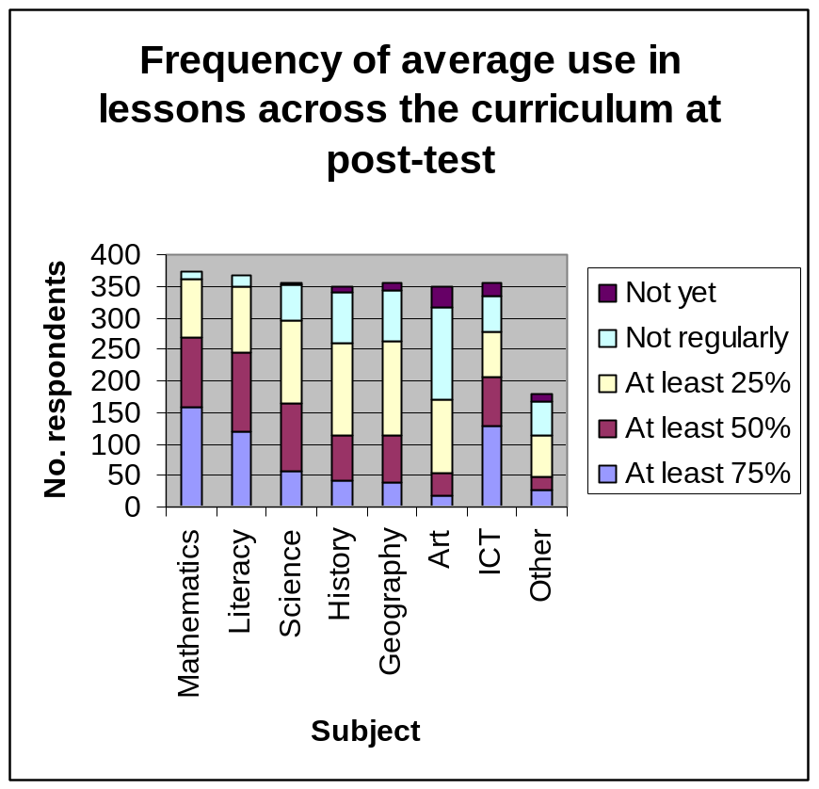
Figure 4.2

This question was put in the questionnaires, and there was a statistically significant, positive change in teacher perceptions from pre to post-test (Wilcoxon, Z = -11.331; p < 0.001) suggesting that, overall, teachers believed that they had become more efficient users of interactive whiteboards over the course of the year.
Table 4.1: Changes in teacher self-perceptions of effectiveness with interactive whiteboards
 | Year start |  | Year end
Effectiveness | N | Valid (%) | N | Valid (%)
Highly efficient | 33 | 9.0 | 68 | 18.2
Reasonably effective | 169 | 46.3 | 268 | 71.7
Just beginning | 163 | 44.7 | 38 | 10.2
Total valid responses | 365 |  | 374

Of those 161 teachers who believed that they were just beginning to develop skills in using interactive whiteboards at the beginning of the evaluation, 74.5 per cent believed that they were reasonably effective towards the end of the school year. Of the 167 teachers who believed that they were reasonably effective at the beginning of the evaluation period, 23.4 per cent believed that they were highly effective towards the end of the year.
Table 4.2: Cross-tabulation of perceived effectiveness pre and post
How effective at year start? |  | How effective at year end? |  |  | Totals
 |  | Highly effective | Reasonably effective | Just beginning | Totals
Highly effective | Count | 22 | 11 | 0 | 33
Highly effective | % within how effective pre | 66.7% | 33.3% | .0% | 100.0%
Reasonably effective | Count | 39 | 127 | 1 | 167
Reasonably effective | % within how effective pre | 23.4% | 76.0% | .6% | 100.0%
Just beginning | Count | 4 | 120 | 37 | 161
Just beginning | % within how effective pre | 2.5% | 74.5% | 23.0% | 100.0%
Totals | Count | 65 | 258 | 38 | 361
Totals | % within how effective pre | 18.0% | 71.5% | 10.5% | 100.0%

Overall, 45.1 per cent of the teachers (163 of the 361 teachers who responded to this question both in the pre- and post-test questionnaire) perceived that their skills had improved, whilst 51.5 per cent believed that there was no change in their effectiveness. Interestingly, 12 teachers judged themselves to be less effective at the end of the evaluation, perhaps suggesting that their understanding of interactive whiteboards initially was limited and they did not fully appreciate the pedagogical possibilities.
A summary of interviews in one school adds some life to the figures above. Some staff said they have increased their skills considerably. One teacher said that some skills were now automatic and new ones were at the exploratory stage. Another teacher said she now uses the ‘notebook down the side’ more and presentation software with the minimise facility less. Her new speed and facility enable her to do this much more than a year ago. One teacher, who was very expert in February 2005, thinks she has not changed the way she is using the whiteboard or acquired new skills. Another colleague has discovered the ‘mute’ facility on the data projector which she finds useful if the board becomes a distraction, and she is now using the ‘snap’ facility much more, although still not making many of her own resources. Some staff said they were using the board more interactively, less modelled on former use of flipcharts, etc. The headteacher had noticed a big difference in classroom use: quiet confidence – ease of use – the best teachers ‘move from one thing to the next effortlessly’. The level of thoughtful preparation had increased, and there was much more use of the internet, both for preparation and for use ‘live’ in the lesson.
Adopted new practices
In the questionnaire teachers were asked whether they had adopted new practices as a result of having an interactive whiteboard. A huge majority felt they had at the start of the year, and 70 more felt that way at the end.
Table 4.3: New practices
New practices on interactive whiteboard introduction | New practices a year later
New practices on interactive whiteboard introduction | Yes | No
Yes | 196 | 33
No | 70 | 47

Only 47 of the 346 teachers did not think they had adopted new practices. Interestingly 33 teachers (9.5 per cent), although they initially believed their practices had changed, did not perceive so by the end of the evaluation period. Perhaps by then the changes were no longer noticeable, as the use of the interactive whiteboard had become embedded in daily teaching and learning practices. The change in pattern of responses from pre- to post-test was statistically significant ((McNemar, χ2 = 12.583, p < 0.001).
Ninety-one teachers commented that their lessons were more interactive, or children were more actively involved, with a further 28 comments relating specifically to the use of interactive software (largely ITPs). Forty-two teachers said that they used the internet in the classroom to a much greater extent. Fifty-eight teachers believed that their practice had become more visual through the use of the interactive whiteboard. Small numbers of teachers commented on other aspects such as being able to save work and revisit it the next day, an increased emphasis on whole-class teaching, being able to annotate presentations and other resources easily, more emphasis on demonstration and modelling, the ability to draft work together with pupils, more opportunities for discussion, and increased pace.
Teacher 1
“Lesson control is probably 'shared' now between myself and the children – they will come and take control of the interactive whiteboard or use the resources on it, whereas previously it was very much more 'teacher led' lessons.”
Teacher 2
“Teaching styles can be varied. There is more interaction for pupils. There is more opportunity to vary vocabulary as the visual impact of the whiteboard gives rise to a wider variety of talk opportunities.”
Teacher 3
“Using websites far more. Scanning work in from children and using it on whiteboard as a teaching tool. Scan in children's art work and appraise it as a class – good for assessment for learning.”
Assessment practices
The teachers (n=358) were asked whether or not they used the interactive whiteboard for assessment purposes. The change in pattern of responses from pre- to post-test was statistically significant (McNemar, χ2 = 5.486, p = 0.019). However, the vast majority (206) said ‘No’ at both the start and the end of the year.
Table 4.4: Assessment pre and post
Changed assessment at year start? | Changed assessment at year end?
Changed assessment at year start? | Yes | No
Yes | 47 | 40
No | 65 | 206

At the end of the first year 112 teachers felt that the use of the interactive whiteboard to assess pupils had increased. Many of them felt that the interactive whiteboard offered more opportunities for assessment as more children came to the board and in the process displayed their knowledge and understanding openly, making identification of misconceptions much easier. Six teachers pointed out that having resources ready-prepared, and not needing to turn pages or write on the board meant that they had more time to focus on what the children were doing, again increasing opportunities for assessment. Several teachers commented that an increase in whole-class discussion meant that speaking and listening skills could be assessed more readily. Furthermore, there were opportunities for work to be annotated on the interactive whiteboard, providing records of pupils’ contributions. One teacher noted that it was easier to identify children who were struggling. Twelve teachers felt that assessment was easier and seven believed it was quicker. One teacher said that it made assessment more fun for children and another felt that children could explain things (demonstrate their knowledge) more easily with the interactive whiteboard. In one case study school teachers commented that by observing individual pupils or small groups working on the interactive whiteboard it was easy to assess their numeracy and literacy skills.
Teacher 1
“It gives me the opportunity for many children to come up and try things on the board, I get a good picture of where they are at and what I need to work on to further them.”
Teacher 2
“Children’s ideas are visible in their use of the whiteboards. Misconception can be seen readily. Good for formative day to day planning to see how the child is progressing.”
Teacher 3
“I still continually assess as before but sometimes a skill or lack of skill is more obvious. It gives another opportunity for assessment.”
Teacher 4
“I use a handheld voting system – it can identify achievement very quickly and record where appropriate. Tend to use as a quick fire check for comprehension.”
Interactivity
In several schools it was noticeable on final visits that pupils were not being asked to ‘have a go’ on the board as much as they were during early visits. Several teachers said it was good to let them have a go at the beginning, but it was soon felt to be unnecessary and time consuming; it held things up. Pupils agreed. So the frequency with which children approach the board has dropped during the evaluation. But children are still interacting with the interactive whiteboard even if they are not ‘having a turn’. They watch other pupils’ contributions on the interactive whiteboard to see if what they are thinking is right, and also to see if the pupil at the interactive whiteboard might need help. One class devised a fun approach to this collaborative approach to learning by referring to it as ‘Ask-a-friend’ (from the Who Wants to be a Millionaire? genre). This helps to perpetuate a feeling of fun and playing whilst learning, it also contributes to the classroom ‘community of practice’ feel.
The questionnaire asked 357 teachers whether there was more interaction with pupils at the end of the year. Eighty of the 149 teachers who perceived that the interactive whiteboard had not led to any changes in interaction with pupils initially, subsequently responded at the end of the year that it had. The change in pattern of responses towards more interactivity from year start to year end was statistically significant (McNemar, χ2 = 13.445, p < 0.001), even though 39 teachers judged that there were changes initially but not at the end. Perhaps this indicated that the changes in interaction had become embedded in their practice and were no longer noticeable.
Use of peripherals
Some teachers are beginning (at the time of the final visits) to integrate other resources/peripherals in their interactive whiteboard lessons, including *ACTIVslates, Digiblues, microscopes, and laptops. This is a noticeable change since the first visits. Learning appears to be even more enhanced where peripherals are integrated appropriately. The use of ACTIVslates is growing. Some teachers (who have only just started to use them) allow pupils to use them to manipulate the interactive whiteboard. Where a remote slate is used by the pupils to manipulate the board, the children’s attention and concentration is extremely focused.
This finding from the case study visits was mirrored in survey responses from headteachers/ ICT co-ordinators: there is a clear perceived need for hardware resources that enable pupils’ work to be shared via the interactive whiteboards such as visualisers, cameras and scanners. Interestingly, over a quarter (25 of 96) of comments relating to infrastructure referred to input devices that would enable pupils to interact with interactive whiteboards without the need to move to the board such as graphics tablets, voting systems or wireless keyboards.
Planning
From second and third visit interviews, it is evident that teachers are becoming more confident with their planning and the use of their own interactive whiteboard resources. Some are becoming much more adventurous in the kinds of resources they plan to use, introducing sound, music and moving images as well as embedding links into their prepared pages.
Although some teachers during first-visit interviews felt that they were spending more time planning lessons in order to make good use of their interactive whiteboards, many in subsequent visit interviews said they were beginning to feel the benefit of having only to adjust the resources they had previously generated (and used), and some stated that time spent planning was actually beginning to be cut. This seems to be mainly because they can save their pages/flipcharts, etc. electronically. Where a teacher has changed year groups, other teachers’ resources that have been saved can just as easily be adjusted. This is seen as a real benefit of using the interactive whiteboard.
Teachers (n=363) were asked about the impact of having an interactive whiteboard on their planning in the questionnaires. Comparing the responses at the start and end of the year, only 23 teachers were consistent in their belief that the interactive whiteboards had had no impact on their planning. The overwhelming majority thought that it did, both at the start and at the end. This change in pattern of responses was statistically significant (McNemar, χ2 = 16.017, p < 0.001) suggesting that more teachers recognised the impact of interactive whiteboards on planning once they had become familiar with their use.
Table 4.5: Planning changes pre-test post-test
Planning charges pre-test | Planning charges post-test
Planning charges pre-test | Yes | No
Yes | 280 | 14
No | 46 | 23

Many teachers referred to being able to incorporate a wider range of resources than previously, offering greater variety and enhancing teaching and learning. On the whole, plans have been revised to include the use of interactive whiteboard (internet sites, and digital resources). Thirty-eight teachers highlighted the benefits of more visual aids whilst 28 teachers commented on increased interactivity. Eighteen teachers expressed concerns about the increase in time required for preparing new resources. However, 14 teachers acknowledged the benefits of being able to re-use resources once they had been identified (for example, internet site, interactive teaching programme (ITP)) or created. Also, ten teachers said that planning itself took less time as the use of ICT made this process much faster. At the end of the year, only two teachers stated that alternative plans needed to be made in case of technology failure.
Comments on the questionnaire included:
Teacher 1
“Added to weekly planning in more detail, therefore recorded for next year. Ideas added to medium term planning ready to be refined later on – recorded for following year. Easy to put references to internet sites etc... on planning.”
Teacher 2
“Have changed some of Literacy plans to include resources made to use on interactive whiteboard eg capturing, covering text, making videos, using screen cover and spotlight. Have used resources in numeracy, history, geography, science and RE eg used ITPs, found history archive videos.”
Teacher 3
“I have a life outside teaching and do not have the time or the interest to trawl through all the internet sites looking for what might be available to use.”
Teacher 4
“Planning is more enjoyable. Planning is easier as it implies less writing and relies more on computer interactive programmes (website, knowledge box ...).”

Teacher 5
"When planning, I try to create resources / activities that can be incorporated into use of interactive whiteboard. This however can be very time consuming and frustrating at times as some programmes for use on the interactive whiteboard are not available on my home laptop."
Changing resources
The use of all packages to create resources increased during the evaluation period. The increases were statistically significant (Wilcoxon signed ranks test). The graph below suggests, as one might expect, that teachers most commonly use interactive whiteboard-specific software to create resources with 75 per cent of the respondents indicating that they do this at least 50 per cent of the time. Forty-seven and a half per cent of teachers reported that they use word processors at least 50 per cent of the time to create their own resources. The use of presentation software is much less frequent and only a small number of teachers use spreadsheets or databases to create interactive whiteboard resources.
The use of existing resources (interactive whiteboard specific, free internet, subscription internet, local authority created and ITPs) increased during the evaluation period. The increases were statistically significant (Wilcoxon signed ranks test). As with the creation of new resources, the most popular existing resources are those that are interactive whiteboard specific: 66.3 per cent of teachers reported using these kinds of resources at least half the time that they use the interactive whiteboard. Free resources available on the internet are almost as popular. Internet sites that the school subscribes to and local authority-created resources are the least popular. Subscription sites may not be available in all schools due to the costs involved and the local authorities may not all create their own resources, so this is hardly surprising. Thirty-eight point one per cent of teachers said that they use ITPs at least 50 per cent of the time. No specific question was asked in the teachers’ questionnaire about the NWN website, which has developed considerably since the start of Primary Schools Whiteboard Project in the autumn of 2004. Case study data suggests that it is not widely used although some teachers may access its resources via their local authority website. Responses to the headteachers’/ICT co-ordinators’ questionnaire relating to the NWN website are dealt with in Section 5 of this report.
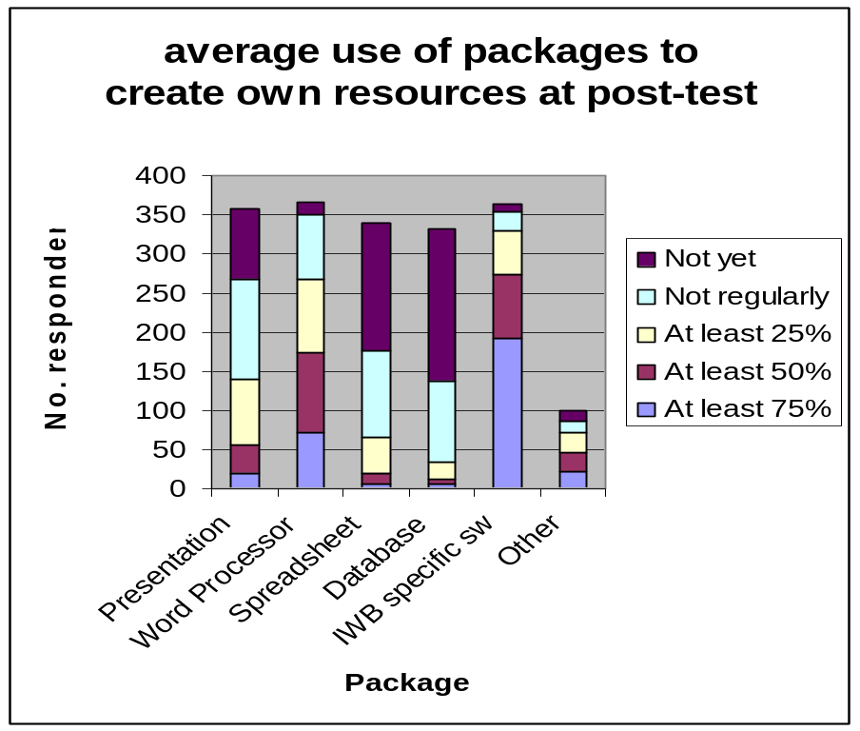

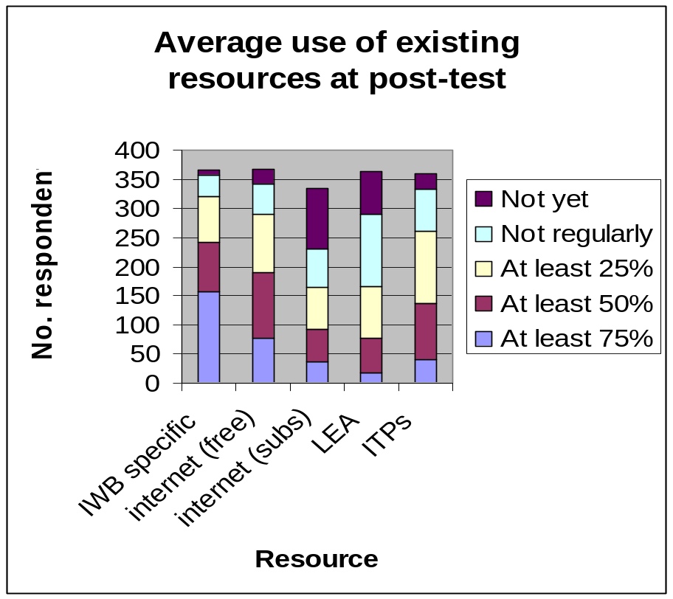
Figure 4.3

Over the period of the evaluation, the use of interactive whiteboards across the curriculum has increased, its use most commonplace in literacy and numeracy perhaps reflecting the strong link between the primary strategy (and the government’s focus on core subjects through assessment practices) and the SWE project. The most common packages for creating resources are unsurprisingly interactive whiteboard-specific ones. Similarly, the most popular ready-made resources are interactive whiteboard specific. This suggests that interactive whiteboard packages for creating resources are easy to use and flexible enough for teachers to create what they need. It also highlights the need for interactive whiteboard manufacturers to continue to provide off-the-shelf resources for teachers to use and also the need for local authorities and the National Whiteboard Network to ensure that ready-made resources are available for widely used makes of interactive whiteboards.
Section 5: Evidence from the Phase 2 case studies
This section reports on the extension phase of the case study work. This enabled the evaluators to make observations in classrooms where the use of interactive whiteboards had become fully embedded in teaching and learning through use over more than two years. It enabled detailed investigation within seven schools of classrooms where progress between the baseline and post-test outcomes had been different from the main trend, and to develop explanatory theories for these outcomes.
Summary of findings from Phase 2 case studies
Validation of the findings from Phase 1 case studies
The nine teachers who participated in the Phase 2 case studies were asked to consider the findings on interactive whiteboards in Use in Classrooms (see page 51 in Section 4) and state whether they agreed or disagreed with them. The result of this exercise was a very positive overall agreement. In Phase 2 the researchers gained new insights as set out below; and were also able to confirm Phase 1 findings through further observations.
The mediation of interactivity
When teachers have used an interactive whiteboard for a considerable period of time – in this case at least two years – its use becomes embedded in their pedagogy as a mediating artefact for their interactions with their pupils, and pupils’ interactions with one another.
Whereas, in the first case study phase, we described the interactive whiteboard as mediating teacher-pupil interactions, the change in our perspective now recognises that the teacher is the person who mediates the various levels of interactivity that the interactive whiteboard, as a mediating artefact, can support.
The concept of ‘mediating interactivity’ is robust. It offers a sound theoretical explanation for the way in which the latest MLM analyses link the length of time pupils have been taught with interactive whiteboards to greater progress in national test scores year on year.
While teachers carry the onus of deciding appropriate modalities and content, they need to allow pupils to interact with the interactive whiteboard, either mentally or directly by ‘going up to the board’, or as a ‘helper’ or ‘scrutineer’ of the teacher or other pupils’ interactions with it. Both literally and metaphorically, teachers have to learn to ‘stand away’ and allow pupils to fully engage in interaction with what the interactive whiteboard presents.
Effects on teaching behaviours and roles and relationships in the classroom
Evidence that the interactive whiteboard was embedded in teachers’ pedagogy came from observing new patterns of teacher behaviour. These were either improvements on previous pedagogical practices made possible by the functionality of the board, or completely new practices. Although these had all become routine, instinctive behaviours and part of what is often called ‘tacit knowledge’, in some cases teachers were able to give clear accounts of how these new practices helped them to teach more effectively.
An example of an improvement on an already established practice is the use of the interactive whiteboard to facilitate a co-learner style of teaching, where teacher and pupils (‘we’) work together rather than adopting more formal roles as teacher and learner. The interactive whiteboard as a mediating artefact facilitates this style of teaching very powerfully.
Another example of improvement on existing practice, arguably amounting to transformation, is the new style of lesson planning whereby resources for teaching and presentations are stored electronically alongside lesson aims and objectives. The plan is thereby transformed from a paper sheet which lists actions to a dynamic ‘script’ for actions. These scripts are stored from year to year and ‘tweaked’ to suit different situations. They are often developed collaboratively by a year team and can be used by supply teachers and students on placement.
An example of a new pedagogic practice, resulting directly from using this dynamic ‘script’ is a new kind of interaction between teacher and pupils (and teaching assistants) during whole-class teaching. This was articulated very precisely by one of the case study teachers. The ‘script’ reduces the teacher’s cognitive load – that is, it is no longer necessary to keep part of her mind occupied on planning what to say next and remembering to use key vocabulary. This frees the teacher to direct full attention to observing how individual children in the class are responding to her teaching, and to watching the interactions between special needs pupils and their teaching assistant. The teacher is often able to hear what individual children are saying to a partner or a TA and focus teaching much more specifically on children’s needs.
Another example of a new pedagogic practice was observable in a wide range of strategies used by teachers to keep the whole class mentally engaged while individuals were working at the board. In the Phase 1 visits we sometimes observed a significant slowing of the pace of the lesson while individuals were at the interactive whiteboard, with loss of engagement from others as they waited their turn (which in some cases did not come, because of the number of children in the class). In Phase 2 classrooms, when individuals were at the board we often observed teachers occupy the other children in activities such as ‘telling your partner what you think’, or writing on their own passive ‘wipe’ board which they later held up to show the teacher. Pupils were also often expected to adopt new roles, for example as ‘scrutineers’, ‘commentators’ or ‘helpers’ working ‘in a team’ with the pupil at the board.
Considerations for special educational needs
Good use of interactive whiteboards can dramatically affect SEN pupils’ motivation to learn. In classrooms where there had been exceptional gains in attainment in the 2005 national tests, it seemed that a key factor was the use of the interactive whiteboard for skilled teaching of numeracy and literacy to pairs or threesomes of children. This could be done by teaching assistants provided they had been trained in how to teach numeracy and literacy (TAs did not appear to experience problems in using the interactive whiteboard provided they had had basic training in its use). It normally took place during the central part of the lesson when the rest of the class were engaged in group work (Key Stage 1) or writing (more often at Key Stage 2).
The many advantages that sighted children enjoy when interactive whiteboards are used are denied to blind children who need to have a running ‘commentary of the interactive whiteboard’s displays. The greater pace of interactive whiteboard lessons increases the workload of SEN teaching assistants who support partially sighted and blind children in the classroom. Furthermore, the electronic, often robotic and American sounding adult voices that come from interactive whiteboards are frightening for totally blind young children. The policy to include visually impaired and blind children in mainstream schools obliges us to give full attention to the implications of interactive whiteboard use for these children’s learning.
Aims of the Phase 2 Case Studies
Results from the first phase MLM work had tentatively indicated differences in the national tests measurements of progress through Key Stage 2 of schools, and certain subsets of pupils – by gender and/or ability, in different subjects, and in contexts where interactive whiteboards were, or were not, in use. None of the differences had attained conventionally accepted levels of statistical significance, but the tentative indications provided the best information to hand. The differences as indicated by MLM modelling analysis in Phase 1 are summarised in Appendix 2.
Interest during the extension phase focused on those – relatively few – class groups that fell well above, or well below, the average rate of progress that could be calculated in the multi-level modelling procedures to take into account available information on pupil variables. The intention was to see whether differences in the progress of class groups could be related to the way that teachers used their interactive whiteboards to teach those class groups. The Phase 1 MLM results were used to identify the appropriate classes and their teachers, and the schools containing these classes were asked to take part in the extension phase case studies.
Six primary schools and one infant school agreed to take part. In these schools nine teachers were observed teaching a total of 18 lessons, 16 of which were videoed for later analysis. Interviews were conducted with the teachers, headteachers, the schools’ ICT co-ordinators and small groups of pupils. Other documentary evidence, such as lesson plans and copies of interactive whiteboard displays, was also gathered. Members of the research team making the visits did not know where the schools stood in the MLM analysis results. (See Appendix 7 for further details of procedures, protocols and associated documentation.)
Testing hypotheses
The case study team identified a series of ten hypotheses that derived from the tentative MLM analysis findings, with a view to looking for evidence from school visits, observations and interviews with teaching staff, that would either contradict or support them. This was ambitious, given the small sample of schools and teachers that would be involved, but it was well worth doing because no research had previously had an opportunity to look at teaching practices in the light of any statistically linked hypotheses, however tentative. It was possible that some aspects of teaching style were having a serious impact on pupil progress when interactive whiteboards were used, but these had escaped notice because no one had conducted this kind of study. Particular approaches to pedagogy, or the way that the national strategies for numeracy and literacy were being implemented could explain known differences in progress, as could features of leadership, school culture and staff training. Observations in schools were necessary if these kinds of relationships were to be adequately researched.
However, as later MLM analyses drew on more data, it turned out that the tentative hypotheses based on results from Phase 1 were not sustained, so data from the Phase 2 school observations was used in other ways (see immediately below). For reference, the working hypotheses, and notes on the evidence that was sought to test them, are reproduced in the lesson analysis protocol presented in Appendix 7. However, they are only indirectly relevant to the results of the extension case study investigations that are described later in this section.
A more global approach
The second way in which the case study team pursued the proposal’s third aim was to include a set of more global assessments associated with the features that could identify ‘what makes for excellence’ in teaching with the aid of interactive whiteboards. Accordingly, the visit team set out to note relevant features in lesson observations, and to investigate other factors in interviews with teachers, heads and ICT co-ordinators. After analysing the data from each visit, that school’s attending research visitor was asked to make two judgements:
- Placement of the teacher on the ‘Typology of interactive whiteboard pedagogies’, that is, in one of the following categories: 1 Foundation; 2 Formative; 3 Facility; 4 Fluency, or 5 Flying.
- The degree to which ‘mediation of interactivity’ was evident in the teaching.
In Section 4 we addressed the analysis of different aspects of ‘interactivity’. However, by the start of the additional case study visits, ‘mediation of interactivity’ was being appreciated by the team as a central concept for understanding aspects of effective strategies for teaching with interactive whiteboards. The concept is explained in more detail below as the results from the extension case studies are more fully reported.
Each research visitor was also asked to judge whether the lesson was one conducted by a teacher whose class had scored well above, or well below, the multi-level modelling average for progress. This judgement was made in ignorance of the actual MLM standings, and it was provisional until all three researcher-visitors could review video extracts together and arrive at agreed judgements, in advance of knowing the true MLM positions.
Analytical pointers
Analysis of the visit data was complicated by the need to have a ‘Chinese wall’ dividing members of the MMU team. This was to conceal knowledge of MLM standings from the research visitors until they had shared their personal assessments publicly with the rest of the team. However, the immediate results of a team meeting to pool evidence and jointly view video extracts showed that, on the basis of the video evidence, it was possible to decide, at a level reasonably above that of chance, (0.5>p>0.1) whether a lesson was being conducted by a teacher whose children had scored well above, or well below, the multi-level modelling average progress results. (See Appendix 7, Part 2 for details.) As these judgements were based on the degree to which the teachers were, or were not, assessed to be acting as ‘mediators of interactivity’ with their interactive whiteboards, this was an important outcome. It reinforced the centrality of the concept in understanding how interactive whiteboards can be used effectively. The implications of this finding are taken up later in this section.
A detailed scrutiny of the evidence to counter or support the tentative hypotheses that had been advanced came after the first joint team meeting. Placement of the schools/teachers within the MLM analysis results had by then been revealed to those who had visited the schools. This scrutiny did not reveal any meaningful associations between any of the range of data that had been gathered, and standings above or below the MLM average rate of progress. So it was not a total surprise to learn at a second team meeting that the most recent MLM analyses, using the latest 2006 national test data and a larger data set, had not sustained any of the tentative hypotheses. Instead the latest MLM analyses showed a relationship with the length of time that pupils had been taught with the aid of interactive whiteboards.
On the school visits a final part of each teacher interview had included the request to agree or disagree with six written statements about interactive whiteboard usage. The statements were based on the bullet-pointed summary of findings ‘interactive whiteboards in use in classrooms’ which can be found in Section 4. Thus teachers were being asked to corroborate these summary findings. It was possible to say that, ‘It depends’, and explain in what ways this was meant. But the result of this exercise was a very positive agreement overall from all nine teachers, which provided a welcome practitioner vote of confidence. (See Appendix 7, Table A2)
These different analytical pointers were all considered at a second meeting to review video evidence in more depth, discuss explanatory theories and re-evaluate the July 2006 report’s findings. In the rest of this section we re-visit those findings, supplement them with the benefit of the data obtained from the extra case studies, and introduce some new explanatory perspectives.
Mediating interactivity for learning
In Section 4 we analysed several different aspects of ‘interactivity’ in some detail, and draw attention to how the ‘interactivity’ of an interactive whiteboard can be understood in terms of it being a ‘tool’ in the sense first described by Vygotsky (1978). During the Sweep extension, this analysis has been extended to draw upon the concept of a ‘mediating artefact’ which was first developed within the context of Activity Theory. Activity Theory was itself developed by Vygotsky, Leontev and Luria to account for the effectiveness of actions, communications and other interactions – including joint learning – in adult working environments. In activity theory many different things can act as mediating artefacts that aid communication and joint learning within a cultural community that collectively arrives at agreed meanings.
A few examples taken from a recent study of learning at work (Eraut et al., 2005) help to clarify the idea. In nursing, when a new shift begins, the incoming ward team is given a handover briefing based on a set of – often handwritten – notes. The notes typically contain brief details of patients, their status, required treatments and pending actions, for example re social services. The notes can be viewed as an artefact through which the new team learn about the situation in the ward. Closer examination of these events has revealed that newly qualified nurses can also learn a great many less obvious things during the handover. Examples include the prioritising of patients, how to communicate clearly and efficiently to colleagues, and even what the many medical abbreviations that are used all mean. In all these outcomes the handover notes are the artefact through which the learning is mediated.
In similar ways design drawings and specifications act as mediating artefacts in discussions between members of engineering teams, and the software packages that are used to govern the course of an audit act as the mediating artefacts in the work of an audit team of accountants. It should also be noted that adults are often unaware that they are learning when they engage in the work-led interactions that surround discussions based on the content and form of the relevant mediating artefacts. There is little doubt that children learn in similar fashion when they interact with interactive whiteboards.
Compared to handover notes, design specifications and even the sophisticated software packages that accountants use, interactive whiteboards are extremely complicated ‘tools’ in the Vygotskian sense. As indicated in Section 4, the interactive whiteboard has multiple –modality, being able to act as a computer, internet connection, TV, DVD player, book, projector, flipchart, calculator or timer as required by the needs of learners. So a teacher needs to acquire many skills in order to use the various modalities and the interactive whiteboard’s in-built features with facility.
However, technical facility, that often rests upon confidence with ICT, is not enough by itself. A teacher also has to be able to appreciate what combination of modalities best aid a particular group of pupils to learn the subject matter in this particular area of the curriculum. The lesson on astronomy summarised in Section 4 provides a good example of how a teacher combines the use of different interactive whiteboard modalities. Another component of the necessary expertise is being able to appreciate that sub-groups of pupils, such as the gifted, may need a fresh choice of modality, and a different sequence of experiences, if they are to learn as successfully as they can. The point is that, if teaching with interactive whiteboards is to work well, interactive whiteboards have to be used so that the full potential for them to act as a mediating artefact is realised. This entails the teacher adapting his/her approach so that interactive whiteboard use fits the purposes of the teaching aims. If interactive whiteboards are used without this level of application, as glorified blackboards, or as occasionally animated static whiteboards, then there will be little effect on pupils’ learning.
An excellent example came in a Year 6 science lesson on the body’s reactions to exercise. The teacher used a CD-ROM resource that allowed three ‘characters,’ who differed in levels of fitness, to walk, jog and run while their pulse and heart rates were monitored by the interactive whiteboard/CD-ROM software to provide readings that could be graphed and compared by the class. The teacher introduced the situation, brought pupils up to the board to make choices and start the ‘characters’ exercising, and simultaneously had her teaching assistant keep a record of the resulting data in a grid on a nearby static whiteboard. This latter arrangement was for the benefit of the less able pupils in the class. The levels of interaction during the lesson were thus many and varied, and the teacher showed high levels of expertise, not just technically, or even in her knowledge of the subject, but also in her classroom management skills that allowed her to run a well planned and conducted lesson that was centrally based on her enabling pupils’ interactivity with the interactive whiteboard.
Viewing the process of teaching with an interactive whiteboard in this light, it is clear that, while teachers carry the onus of deciding appropriate modalities and content, they need to allow pupils to interact with the interactive whiteboard in ways that permit it to function as the main mediating artefact. Both literally and metaphorically teachers have to learn to ‘stand away’ and allow pupils to fully engage in interaction with what the interactive whiteboard presents, as the following extract from post-visit analytical notes illustrates.
Extract from post-visit analytical notes – Year 6 Numeracy lesson
When the board was in use, the teacher tended to be at the board when he needed to bring up/change to a different screen, when he needed to write something on the board, and when he wanted to point something out. At other times, he seemed to stand ‘away’ from the board, sometimes moving into the classroom, but often standing just to the side of it at his desk (which was just to the left of the screen). In terms of where the children focused their attention – many of them often seemed to be looking at the screen rather than at the teacher. (Of course, this was not always true and sometimes dependent on what was being talked about/shown etc.). But, as I looked around the room a number of times, I noticed that the children did seem to be looking at the board and not the teacher – interestingly, this was confirmed by the children I spoke with in the interview. They told me that sometimes they found the board was useful for helping them to better understand what was being explained or discussed – or, if they lost track of where they were up to, they could look at the board for reference. Many of them said that sometimes hearing something out loud from the teacher did not explain it clearly to them, but looking at the same idea expressed in a different format, ie on the interactive whiteboard, would often help to clarify this for them.
On many occasions, in both phases of the fieldwork, teachers have been observed adopting the position of a co-learner with the pupils.
While this mode of ‘shared learning’ existed in teachers’ behaviour before interactive whiteboards were introduced, it takes on an added importance when interactive whiteboards are being used because the power of the interactive whiteboard as a mediating artefact can be fully released when a teacher mediates the interactivity of learning in this way. However, observations also show that the ‘teacher as co-learner’ stance is adopted most frequently in the infant years, and is less frequent when teaching older children. There are several reasons for this. Older children are expected to take more responsibility for their own learning, and they also have more experience and contextual understandings to draw upon in doing this. They also become more adept at hiding their weaknesses, and have to be challenged more directly if teachers are to assess their levels of understanding accurately.
Moving from Key Stage 1 through Key Stage 2 into Key Stage 3 there are widely recognised significant changes in social atmosphere that have much to do with the growing constraints of national tests, and their importance not only for individual learners, but also the school. The more teaching is constrained by time and pre-specified teaching outcomes, the fewer teachers can make use of the full interactive potential for shared learning (teacher/pupil). Differences are clearly observed between Key Stage 1 and Key Stage 2.
However a teacher mediates the interactivity of the interactive whiteboard, to do so successfully he or she must bring together several complementary aspects of teaching with an interactive whiteboard. First and – although clichéd – foremost, the teacher has to understand how children of different ages learn. The teacher must then be able to employ the most suitable interactive whiteboard modalities with the correct content, and operate the appropriate interactive whiteboard functionalities. This last aspect obviously depends on the teacher being sufficiently proficient with ICT.
Changing software
From teacher interview transcript
There have been three different versions of the interactive whiteboard software and each time it’s better. It’s faster and faster to produce anything. The different kinds of ‘paper’ are there – lines, graphs, handwriting. You can do all your teaching elements, then slide in the page and show the children how to set their work out.
The dichotomy between being a ‘good teacher’ and being ‘good with ICT’ is no longer a useful distinction once the teacher’s role as being a mediator of interactive whiteboard interactivity for learning is identified. These issues are addressed more fully later in this section.
There is always a problem with the definition of complex and compound concepts. ‘Mediating interactivity’ is no exception, and separate attention is given to its component parts later in this section. But the results of the extension case study classroom observations show that the concept of mediating interactivity is robust. It offers a sound theoretical explanation for the way in which the latest MLM analyses link the length of time pupils have been taught with interactive whiteboards to greater progress in national test scores year on year. Time is needed for teachers to come to grips with an interactive whiteboard and all its functionalities. Accumulated experience is also needed to appreciate how the interactive whiteboard's various modalities can be most effectively combined and employed to teach all aspects of the curriculum. It is likely that certain minimum levels of proficiency have a bearing. This would definitely apply to proficiency with ICT, especially as the manufacturers of interactive whiteboards are now issuing upgraded versions of interactive whiteboard software and correspondingly new types of functionality that teachers are expected to master.

The realities of adopting new software
Extract from post-visit analytical notes
One example the teacher gave was the school’s use of its learning platform. He told me that they were not very effective with their use of it, albeit having had it in school for one year now. The teacher said that a large part of the problem was time, another was accessibility. Teachers can only access it when in school but not at home. He told me that by the time teachers have finished teaching and attended meetings or fulfilled their other after-school commitments, e.g. putting up wall displays or attending parents’ meetings etc, then there was very little, if any time left to try to use the platform as a resource tool. Thus, their planning really takes place at home – but because they can’t access it, they don’t use it a great deal. He also said that they were a mature set of staff who were all still learning with it. Despite their limited use of the package, it was apparent from comments (from both teachers) that they appreciated its potential value, and were keen to learn how to use it in more effective ways – this was one of the questions they would be raising at their next training day.
The situation is still fluid. Manufacturers continue to improve interactive whiteboards and add to their modalities, and teachers continue to improve their usage as their experience as interactive whiteboard users accrues. A sequence is now in train that can be described in almost Piagettian terms – where teachers themselves are the learners. Having had to adopt interactive whiteboards and adapt their teaching behaviours to accommodate them, teachers are now in the process of assimilating their knowledge and usage of interactive whiteboards. As the sequence proceeds all the various modalities of interactive whiteboards as mediating artefacts will become assimilated by teachers as extensions of their teaching capacity. In so doing, leading-edge teachers will find ways of using the artefact’s affordances that result in new social practices in classrooms.
Although we have identified ‘shared learning’ as one of the forms of social practice that has emerged with added potency, it is not possible to foretell what other new forms may evolve. This is because the new combinations of experienced interactive whiteboard teacher and enhanced interactive whiteboard affordances create fresh possibilities that will be latent until the combination has time to catalyse together. However, we have strong indications of two new pedagogic practices that are emerging.
The first of these comes about because of the way in which the use of structured lesson plans, with associated choices of resources, can now be stored in computer memory, accessible at any time from the interactive whiteboard. This allows teachers to work to an invisible ‘script’ that is embedded in the lesson plans. By ‘script’ in this sense we imply a more complex idea than the way in which a lecturer or presenter has a script that resides in his or her presentation software – or stack of overhead transparency slides. The ‘script’ that is embedded in the interactive whiteboard/computer lesson plan, with its interlinking content, is a more complex manifestation because of the higher degree of flexibility in choice of affordance and action that is possible. Being able to rely on the script of a lesson provides more than an aide-memoire to how the lesson should develop. Its existence enables teachers to multi-task in new ways. More of their mental capacity is released to make observational assessments for learning during whole-class teaching. Assured of the shape of the lesson, this frees the teacher who is then able to direct full attention to observing how individual children in the class are responding. And by noting interactions with their TAs, teachers can also assess the progress being made by those children with special needs. Teachers gain time for assessing how individual children are progressing within the lesson. This increased attention to continuous monitoring aids formative assessment and the redirection of teaching as required.
An example of this is given in the lesson recorded in Part 3 of the Appendix. During the Year 2 lesson on letter and sound combinations, the teacher was able to make direct observations of pupil response and supplement these for the pupils with special needs by noting the kind of interactions going on between these children and their assigned teaching assistant. The teacher described her thinking and actions after the lesson.
"I also knew quite quickly whether they had understood or not because their hands went up before [the SEN TA] had even said anything to them – and then you can see whether she needs to say something to them and re-word and re-phrase and just bring them back a step and help them – and then you can almost see the penny drop, or that she is still going.
So you think, ‘Right, I won’t ask them that question’, because they haven’t quite got there yet. So sometimes you might pick up – she’s still talking to them – and the rest of the class has got to the point where they’ve answered – so you go on with the class, then [the SEN TA] will carry on teaching them to that point and then they’ll pick up again with the rest of the class."
The second example of these new pedagogical practices relates to the development of strategies to keep the rest of the class mentally engaged while one child is working at the interactive whiteboard. In the first year we observed many occasions when the pace of the lesson slowed when pupils came up to the board, and the rest of the class was left watching but inactive and often visibly bored. Now that interactive whiteboards are pedagogically embedded, teachers have developed numerous strategies for managing pupil access to the interactive whiteboard in ways that, at the same time, keep the rest of the class mentally engaged. Sometimes this involves the use of hand-held passive whiteboards onto which pupils must write their answers ready to display them if their teacher asks them to. But it can also mean that teachers openly give the pupils new roles. Thus according to the circumstances, pupils may be expected to be ‘scrutineers’, responsible for monitoring the work of whichever pupil is at the interactive whiteboard, or ‘commentators’ on what the teacher is unfolding at the interactive whiteboard, and we have already described in Section 4 how some teachers actively enrol their pupils as ‘helpers’ when the unexpected happens. With our relatively small samples of classes we are unlikely to have tapped into the full range of practices of this kind that are emerging as parallel developments to changes in interactive whiteboard teaching practices. But they all imply the creation of different social orders in the interactive whiteboard classroom.
A further look at interactivity
Interactivity is an integral part of teachers’ relationships with their pupils. An interactive whiteboard may still be seen as a Vygotskian tool, but now it should be viewed as a tool that has the properties of a mediating artefact inherent in its potential for encouraging interactivity. In that regard, whereas we described the interactive whiteboard as mediating teacher–pupil interactions, the change in our perspective now recognises that the teacher is the person who mediates the various levels of interactivity that the interactive whiteboard, as a mediating artefact, can support.
We have previously been at pains to emphasise that 'interactivity’ needs to be understood on more levels than the simple fact that pupils are able to use some of the board’s facilities. We pointed to the levels of mental interactivity that the multiple modalities of interactive whiteboards can support. Evidence from the latest round of visits reinforced the finding that mental interactivity can be stimulated via the use of peripherals. Passive slates or boards were seen in use in both highly performing classes and in classes that were performing less well, according to the MLM data.
Because the children had to write and show answers on the passive boards they had to engage with the learning tasks. However, there were obvious differences in the quality of the required mental interactivity. These differences related to the content of the lessons. For example, in a Year 6 maths lesson the task of calculating the perimeters of simple I, L and T shapes made up of rectangles was too simple to fully engage the more able pupils. This kind of mismatch shows the crucial role of the teacher in mediating the interactivity.
Another facet of interactivity is the potential power that teachers now have to answer children’s questions by turning to the Web. Children can ask some amazing questions and often, in the past, teachers have either had to admit a temporary ignorance and promise to ‘look it up’, or provide whatever, probably inadequate, answer is possible at that moment. With the advent of interactive whiteboards teachers can now immediately turn to the Web for extra information. In the best practice, seen in both phases of the case studies, these incidents have been used to teach children how to conduct a relevant search. The shared experience is another product of the interactive whiteboard’s potential for interactivity.
Reconsidering the ‘typology of interactive whiteboard pedagogy’
When data from the seven extension case study schools was collated, it was found that placement of the teachers in categories in the ‘typology of interactive whiteboard pedagogies’ (see section 4) was very restricted. Category 3 on the typology – ‘Facility’, predominated in the judgements. Only one teacher, for one lesson had been granted an unqualified category 4 – ‘Fluent’. No other categories were used. In effect, the researcher-visitors did not find it possible to use the typology to differentiate between teacher classroom performances in a way that correlated with either mediation of interactivity, or standing in the MLM results. This result points to a need to re-evaluate the typology.
Haldane’s (2005) typology had proved a useful tool in the early stages of the interactive whiteboard innovation, as the boards were being introduced and there was, understandably, a great emphasis on gaining the necessary technical ICT expertise to use them. However, in the first phase of Sweep it was evident that teacher–pupil and pupil–pupil interactions were crucial. We raised this point in Section 4 under the heading ‘The part played by teachers’ skills and abilities’. It is now apparent, from the analyses conducted during this extension phase, that once teachers attain category 3, and can demonstrate consistent facility when using an interactive whiteboard, they have reached the minimum standard that allows them to mediate the interactivity of the interactive whiteboard to support learning with great effectiveness. At this point the interactive whiteboard becomes an integral part of its own interactions with the children. As McLuhan (1964) said, the technology becomes ‘an extension of the self’ giving the teacher new capabilities.
Now that interactive whiteboards have been in use for a few years the typology may still be useful in teacher training to help trainee teachers reflect on their skills. If, however, it is intended that the typology should have a wider usage, it is probably necessary to reconsider critical indicators, and revise the criteria for reaching categories 4 – ‘Fluent’ and 5 – ‘Flying’.
The argument that excellence in teaching with an interactive whiteboard is made up from a compound of abilities, almost ‘chemical’ in their admixture, has been greatly strengthened by this experience of applying the typology in the case study schools. In the mixture that produces ‘excellence’, the level of a teacher’s technical expertise with a board is important but, it is not possible to distinguish between excellent and less effective teachers on this basis alone.
Interactive whiteboards and teachers’ planning
Reforms in education since the introduction of the National Curriculum in 1988 have emphasised the central importance of planning for ensuring that teaching is well directed to cover the curriculum, to avoid duplication and to aid differentiation that caters for the learning needs of different groups of pupils. Since the advent of interactive whiteboards there have been enormous changes in the way teachers plan their teaching and also in the way they share their plans and the teaching resources that accompany the plans. With their laptops, PCs and interactive whiteboards, teachers can save lesson plans and resources in easily transferred electronic formats. It is relatively easy to tweak the plans as the needs of different ability groups require, and these amendments are then easily shared with TAs and other colleagues. This facilitates arrangements to ensure equality of provision across parallel year groups. Downloads from websites can readily be incorporated into lessons as either a component of the planning or lesson content. This provides content that can be both up –to date and relevant to lessons. While many providers supply suitable content for the teaching of the core subjects – English/literacy, maths/numeracy and science – the Web provides a fund of adaptable material that can support the teaching of other National Curriculum subjects cuh as geography, history and art.
Modern classrooms can be complex social arenas. In one infant school classroom provision was being made for five different ability groups, one of which was supported by a teaching assistant. Another special needs teaching assistant gave full-time assistance to a pupil who was totally blind. The two teachers who shared the teaching of this class made full and varied use of the interactive whiteboard facilities, but the usage varied from almost none, in a consolidating science lesson, to a literacy lesson in which the teacher made use of an e-book, Let’s go to Mars, appropriate use of the interactive whiteboard’s reveal facilty, and organised three children to work with an Activslate. Another aspect of the teaching was the way in which it incorporated a wide mix of activities. These included whole-class teaching with whole-class interaction around the interactive whiteboard, small group working, teacher demonstrations with the equipment for making electrical circuits, and learning through kinetic actions, such as joining and releasing hands to illustrate what happens when an electrical circuit is broken.
In such classes the interactions that any one child has during a lesson are not necessarily intended to be the same as another child in the class would experience. The level of planning that is required to make this kind of teaching work well – and it did in this school – is challenging, and depends on high degrees of co-operation between all the teaching and support staff. The following extract from an interview with the school’s ICT co-ordinator tells of the staff’s focused attention on these crucial matters.
Extract from transcript of ICT co-ordinator interview
"So each of the subject leaders then became responsible for looking at how that software could be used through whole-class teaching, adult-focused activities, and your independent activities by children for their area. So it shared that responsibility. And then, going on from that, I think the key thing for us is that every time we've had the SATs data in, we've looked at it and from that pulled out what software we could get. If it was boys – if it pulled out boys' writing, then we would look at software we could buy that would support those. And we looked at it throughout the school. So we went right the way back to Foundation Stage where, in our e-profile data, we noticed that things like linking sounds and letters and calculating were down. So we thought, right. We looked at those children that we needed to address, and we found software that would meet those needs in an interactive way that was interesting for those children through games and play-based activities. And then, all the way through the school, we noticed that comprehension was an area that children needed more exciting ways of accessing – comprehension to get them more confident with that. So it was looking at resources we could buy for that. And when I've been in previously [as the school ICT co-ordinator] to do monitoring of teachers and things, it would be talking to the staff and the pupils, doing pupil perception interviews, and finding out what software they really wanted. So that's had the impact on our software. And now we've got the simple software which addresses the fact that young children can't reach the top of that board. And that's got the ‘Draw string’ that pulls down. And so that's the way our software has been adapted in that way, because it's gone from that basic program to software that would support learning across the curriculum that's a bit more exciting as well, and web-based materials that we could use."
The potential for constructing and modifying ‘scripts’ that are embedded in teachers' saved interactive whiteboard work files can also extend the benefits over a series of lessons. A series of lessons typically incorporates an introductory presentation linked to previous knowledge; re-presentations in different forms where required, for different ability groups within the class; exploratory examples; consolidation work; and summation. In practice the linearity just described will have miniature series of similar type embedded within single lessons. The construction and use of these complicated plans is greatly simplified by the marriage between computing power and the interactive whiteboards.
The interactive whiteboard supporting the teacher
From teacher interview transcript
Researcher-visitor: Is this better with the interactive whiteboard?
Teacher: I think there is something there. Everything is at your fingertips now. You can tweak and tweak and build upon last year’s work. Your energy can all go into the teaching – If you are doing fractions, you don’t have to be up at midnight cutting out things. It comes down to knowing your children. The board is a resource. This is the third year I’ve had the board. I like to think the children did as well before…but …
It’s a great support for teachers whose subject knowledge is poor… knowing you’ve got your resources, your questions …
It’s very good for science. For predictions – ‘What do you think will happen to this ice cube?’ And for plant growth – ‘How much rain …?’
There are programs you can call up – you don’t have to wait for the experiment to be completed. It helps that it’s all visual.
Special needs
As noted in Section 4, catering for pupils with special educational needs is not necessarily made any easier by the introduction of an interactive whiteboard. There were a number of positive and negative aspects. For example, while use of an interactive whiteboard suits whole-class teaching very well and can increase the pace of learning for most pupils, it can limit provision for differentiation (through varying the difficulty of questions, for example), so there may be little beneficial impact for children with special needs.
We noted very little use of the interactive whiteboard by class teachers for the specialist teaching of children with SEN in literacy or numeracy. This was mostly left to TAs who may work with pairs or small groups at the interactive whiteboard. The extra case study visits have reinforced these observations, and this raises issues connected with the training that the TAs receive. It is true that good use of interactive whiteboards can have dramatic effects on SEN pupils’ motivation to learn, but they will only learn as successfully as they might, if they are supported by someone who understands how to teach reading, writing and numeracy. This requires special training in teaching the core skills that, on the evidence available to us, is not widely available for the teaching assistants who commonly support pupils with special needs. Some teachers recommended that the ideal would be to have a TA trained in teaching literacy and numeracy who was able to work with two or, at the most, three children using the interactive whiteboard.
Training is seldom as well organised and inclusive as in the following example, but even in this school the general training in interactive whiteboard use has to be supplemented by specialist training in how to use an interactive whiteboard for the teaching of reading and basic numeracy.
Training for TAs
Extract from transcript of interview with ICT co-ordinator
Researcher: Right, now we do get onto the training question for the people who are assisting in the classrooms. How's that been organised?
Teacher: Well all staff each year have to do an IT e-confidence audit. We use the matrix system. And all staff have to do that, whether that be the staff in the office or the teaching assistants or parents helping in different classes. And depending on their needs – we needed to be sensitive to this – some of them may not have felt that group training was what they wanted. So there were [other] elements. They were always invited to all interactive whiteboard training – all staff, open house. But also each individual teacher would help and support, as a mentoring role, their teaching assistants that were in the rooms. And in the same way as the teachers, there were those that were really confident and wanted to go with it, and they then became the leaders for the others. And one of our members of staff runs an ICT club at lunchtime. So that really helped because she was using an e-board there, and that built up a role to support the staff in that way. But there was the informal training which would just go on between the teacher in the room and that teacher’s teaching assistant, just to meet the needs of their individual classroom. But they were also always invited to any interactive whiteboard training as well.
Visually impaired and blind pupils
The extra visits included observations in a class where one of the pupils is completely blind. First-phase visits had taken us into classrooms with partially sighted pupils and we noted the use of interactive whiteboard background colour tints to improve visibility of text for these children. However, the issues that have to be addressed to make suitable provision for blind children are several magnitudes greater. In effect, the many advantages that sighted children enjoy when interactive whiteboards are used are denied to blind children who need to have a running ‘commentary of the interactive whiteboard’s displays. As the pace of change is greater on an interactive whiteboard, this increases the workload of the teaching assistants who commonly support blind children in the classroom on a full-time basis.
The necessary adjustments do not end there. interactive whiteboards are often used to provide voiced responses. This may be when an e-book ‘reads’ its own text. It can also be a voiced confirmation of a correct answer, or encouragement to try again. Sighted adults may reasonably expect this kind of interactive whiteboard functionality to help visually impaired children, but this is not at all the case for young children who are totally blind. These children often find the electronic, often robotic and American-sounding adult voices frightening. We have included the transcript of an interview with an local authority specialist advisory teacher for the blind as Part 4 of Appendix 7 because we consider provision for such children to be of extra importance now that so much is expected from the deployment of interactive whiteboards. The policy to include visually impaired children in mainstream schools obliges us to give full attention to the implications of interactive whiteboard use for these children.
CPD and training
In the example below, the teacher’s views that are summarised illustrate a common perception of the types of training that have been, and are still, on offer to develop the skills of teaching with the aid of interactive whiteboards.
CPD – A typical situation?
Extract from post-visit notes
It seems the teacher’s perception of the training he was given, was that it did cover use of the interactive whiteboard for teaching literacy and numeracy lessons and so was not just teaching operational functions. However, in his responses to the second questionnaire, he says he thinks that the teachers felt that the training (operational and pedagogic) they had received had not been adequate. And, in terms of continuing training, he indicated that he thought this did not take place often enough (operational and pedagogic). He says that the training provided by the local authority was not enough, and when it was provided it offers too much too quickly in one day of training – this is the area that he believes would make the use of interactive whiteboards more effective, with “funded training for all staff given by good presenters at a sensible pace”. Time is also highlighted as a significant factor, e.g. there is not time to look at the free materials provided by commercial bodies. In his first questionnaire, he indicated that he feels his skills with the interactive whiteboard have been mostly self-taught.
A headteacher in another school voiced reservations. He said that the operational training had been inadequate, but thought the pedagogic training adequate. Teachers’ skills in his school were regularly updated through the school’s internal training sessions, which were organised each term, or as and when required. There is clearly much variation in the volume, quality and appropriateness of the training that is available from outside providers, and in that provided by a school’s own staff. This unevenness may be explained in part by the stage that has now been reached in the innovation wave that the introduction of interactive whiteboards represents.
When first introduced to education from a business use context, the experts in interactive whiteboard use initially came from the manufacturers. This was quickly supplanted by the nationally organised scheme of training that spread into local authority provision, as we describe in Section 6. At that stage expertise was still predominantly outside schools, but it was adding a pedagogic element to the very earliest emphasis on technical and operational, ICT skill sets. Now that it has become the exception for a classroom to lack an interactive whiteboard, we are in the stage of ‘late adopters’. During the period 2004–06, while we have been carrying out this work, expertise in the pedagogic uses of interactive whiteboards has shifted into schools because that is where the requisite skills are learnt and practised on a daily basis, and failures have consequences. Local authorities now look to schools to find those teachers who can lead other schools in their training. The next quotation comes from a successful infants' school that has recently lost its ICT co-ordinator to the local authorities advisory teaching force and presently has one ‘expert’ teacher working part-time in the authority to provide interactive whiteboard training in the local authorities other schools. The example illustrates the way in which in-house provision for CPD can be extremely effective, and may operate most effectively when organised on a semi-formal footing.
Peer-to-peer sharing as CPD
Extract from transcript of interview with ICT co-ordinator
Teacher (Co-ordinator): I think once everyone got on board with it, and the fact that we have got the interactive whiteboards throughout the school meant there was a really good opportunity for sharing. And sharing good practice, and getting tips off each other. Thinking about the advantages for children, those link very much to the advantages for the teachers really. Because they're the key thing. It does cater for different learning styles. It had that motivation sometimes for those reluctant, maybe those reluctant boys in the writing. You could really take a context because you can access maybe more appropriate materials through web-based e-books. You know that you can really make sure they're responsive to the needs of those children, whereas before, if you were going with a paper book, you had to go with what was available, but also because of cost, those that the school had already got or could afford to buy.
Researcher: That's assuming the teacher's got the motivation to do that scouring. If there's sharing going on …
T: That's right. And I think that, as a school, we put mechanisms in place. So if you had particular really good web-based material, we'd share those. And we had specific training as well for staff, and just those sharing opportunities at the end of staff meetings as well. Just after we'd all got the boards, and we'd started playing with them, we started to all find out different things. And people would be sharing tips at lunchtime. So we then went on to the stage that we thought, well it may be more appropriate that at the end of each staff meeting to have a time where we just go to one of the rooms and say, ‘Right, anyone learned anything great that we could share?’ And that helped us in that early stage.
Researcher: So the staff would move as a group from room to room? Well that's a neat idea because it jogs people's memories.
T: That's right, yes. And we would always make sure that, if we were doing training, we would have that opportunity of going into different classes so that we could see the board being used in different year groups.
The need for a mix of external and in-house provision is obvious. Interactive whiteboard manufacturers continue to increase and improve board capabilities, and teachers continue to advance the boundaries of what is possible in teaching with interactive whiteboards. This changing knowledge base will constantly need to be shared among teachers. However, as we have indicated above, there is also need to have TAs with enough specialist training to know how to derive the maximum benefit from this new form of communication with young children. TAs need training that will equip them to work with small groups, no more than three or four children, at an interactive whiteboard to help children – especially those with special needs – to learn to read and improve their understanding of number. TAs cannot do this without an appreciation of what is involved when children are learning to read, count and calculate, and for this, if we are to continue to make every child matter, teaching assistants will need this kind of initial training, and later CPD to maintain their effectiveness.
Re-visiting and supplementing aspects of the first phase case study findings
Whole-class teaching and training needs
Throughout both phases of the case studies we have evidence that interactive whiteboards provide excellent support for whole-class teaching. But, if teachers now maintain a higher pace in lessons, and in learning, those children who already needed more time to learn may now need even more specialised and targeted help from trained TAs in order to keep up with the faster pace. In saying this we wish to reinforce the very similar message we gave in July 2006 and link this strongly to the training needs of those teaching assistants who support pupils with special needs.
Interactive whiteboards and classroom cultures
It is still true to say that the ambience of classrooms in which interactive whiteboards are used is generally more co-operative and ‘sharing’ than when interactive whiteboards are not used. Interactive whiteboard usage fosters an ethos that may be described as a ‘community of learning’ in the class. However, the second-phase visits have brought home the realisation that this point sits better when applied to Key Stage 1 classrooms, and when applied to those Key Stage 2 teachers who are inclined to operate in the style of ‘shared learning’.
The ‘surprise factor’ associated with interactive whiteboard use is still important in holding the attention of pupils. Lessons are less predictable in terms of what the teacher will present next. So, although the ‘wow’ factor with pupils is agreed to be fading away, the positive effects of using interactive whiteboards have not faded over the period of the project’s work.
Changing teaching practices and resource management
How storage files are organised on a school’s server is critical if they are to be ready for use by all staff as a shared resource. In one school a plaintive note from the school’s literacy co-ordinator was seen on a notice board in the staffroom appealing for missing plans that should have been in the appropriate electronic folder. In her interview, the headteacher admitted that planning was not a strength in the school, and needed urgent attention. In contrast, a teacher in another school with well organised files described how she had only to "Go to Key Stage 1 file folder, identify the current theme – in this case the ‘Three Little Pigs’ – and then select the relevant material that is filed for literacy and or numeracy" to have ready-to-hand lesson plans that were prepared over a year ago.
A readily usable file system needs a structure that reflects any linkages that are important for planning. So a 'key stage by year group by subject/theme/topic' structure can be extremely useful. Many commercial and not-for-profit websites label content in relation to the National Curriculum, and many schools include such labelling in similar systems.
Implications for training and CPD
There is a need to develop the way interactive whiteboards may be used in certain recurrently important learning contexts. The main examples concern the early teaching of reading and numeracy, particularly in respect of those children who have difficulty in learning, for example, the link between letter combinations and sounds. As these children are frequently supported by teaching assistants rather than the class teacher, these assistants must be adequately trained in the requisite skills of teaching basic reading and number – with or without an interactive whiteboard.
Both the teaching assistants, and teachers themselves, need ongoing professional development. This training has to cover:
- pedagogic approaches
- operational and technical/ICT skills
- important aspects of support such as the efficient organisation of resources, and collaborative organisation of in-house CPD provision in schools.
It has been explained above how much of the relevant expertise now resides in classrooms, and means have to be found of releasing this expertise for the benefit of all. The present system of employing nominated ‘expert’ teachers can show the way.
Technical points
Interactive whiteboards have now been in use long enough for staff to notice the way in which data projector bulbs dim with age. In response, data projectors are being turned off when not required. This is a logical move to prolong the period before bulbs need replacing, because the cost of replacement is significant within a primary school budget.
A worry that is now emerging is the rate at which teachers’ laptops are wearing out. Laptops are now being heavily used both at school and at home, and are therefore prone to more frequent breakdown. This may be due to over-heating when a laptop is run for many hours at a time. Whatever the cause or causes, there are added implications for the calls upon school ICT budgets, and for laptops that are known to be robust even with prolonged use. Advice from bodies such as Becta would be welcome.
Conclusions
What makes for excellence in teaching with interactive whiteboards?
Several factors affect the degree to which interactive whiteboards can be used with full effectiveness to promote learning.
- The first is that the teacher has to understand how children of different ages learn.
- The teacher must then be able to employ the most suitable interactive whiteboard modalities (for example, choosing an internet page vs a CD-ROM player) with the correct content, and operate the appropriate interactive whiteboard functionalities (such as using the ‘spotlight’ or ‘reveal’ functions).
- This last requirement means that the teacher has to possess a certain minimum ICT proficiency, but at a reasonably high standard. The teacher will then be confident in his/her ability to cope with any technical failures. In addition, and certainly equal in importance, the teacher can readily access a wide range of resources.
- Accumulated experience is also needed to appreciate how the interactive whiteboard’s various modalities can be most effectively combined and employed to teach all aspects of the curriculum.
- Equally significant is the social atmosphere that exists in the classroom. This sets cultural expectations – the climate for learning. With very young children, a positive social atmosphere is often created when teachers operate in a ‘shared learning’ mode. The interactive whiteboard helps teachers to create different kinds of social atmosphere suited to the ages and abilities of the class.
- Of prime importance is how well the teacher mediates the interactivity of the interactive whiteboard for maximum learning potential.
However, even that is not enough. Excellent teaching is also based on a sound understanding of the children’s learning needs. It then meets them by keeping the children fully engaged and on task. Many classroom management and teaching sub-skills need to be effectively deployed to achieve this, even when using an interactive whiteboard, and especially in providing for the range of different learning needs in most primary classrooms.
Thus it is no longer the case that we can usefully separate ‘being a good teacher’ from ‘being good with ICT’. Teaching well encompasses both, and all of the above.
This is a significant conclusion because it points to the logic of the MLM analytical results that now include the 2006 national test data. According to these results, the factor which best correlates with progress from pre- to post-testing is the length of time that a pupil has been taught using an interactive whiteboard. During the period in which interactive whiteboards have come into widespread use, teachers have been steadily building their experience with them and learning how to use them to best effect. This has not been solely a matter of gaining increased skills and confidence with ICT, although this is widely reported. The time has allowed teachers to accrue the necessary experience that helps them decide how to employ interactive whiteboard modalities appropriately, and how to maintain a positive social climate for learning in the new classroom environments that interactive whiteboards have created.
Section 6: Developing a Community of Interactive Whiteboard Practice: The roles of the central team, the Local Authorities and the schools
This section of the report draws on data from:
- initial documentation from the DfES on the initiative
- dossiers on each of the 21 core local authorities, based upon local authority documentation, initial face-to-face interviews with one or more of the key staff and later follow-up telephone interviews
- observation at the launch event
- observation at three of the March 2005 regional training events
- the notes from and transcript of a group interview with four members of the central team and a senior member of the Primary Strategy team
- field notes on the responses to questions on these topics, included in the interviews with case study teachers, co-ordinators and heads
- analysis of findings from a survey of the views of local authority staff from a total of 60 local authorities
- responses on training, organisation and resources in the teachers' and headteachers/ICT co-ordinators’ survey described in an earlier section.
Summary of findings
Provision and installation of the interactive whiteboards
- The DfES and Becta documentation and advice on procurement were generally valued, but the timescale for installation was too short.
- The procurement process at local authority level proved time consuming.
- Installation was completed successfully in all the local authorities evaluated but there were serious difficulties in some that led to delays and poor initial installations.
- The advice on selection of schools to receive interactive whiteboards was helpful and set at the right level of specificity, enabling local authorities to interpret it flexibly to suit local circumstances and priorities.
- In some core local authorities a minority of participating schools already had, or wanted, a different kind of interactive whiteboard from that which the local authorities chosen contractor provided. This led to some difficulties in training and support as the different interactive whiteboards were not completely interoperable.
The central team
- Training materials have been provided through the website and CD-ROMs distributed at training events. Local authority staff have responded positively to these resources, although they indicate a number of areas where more resources are needed.
- Professional development for local authority consultants has been provided through five two-day training events. This training has been well received by local authority staff.
- There has been progress in establishing horizontal links between groups of local authorities through the development groups, although lack of time appears to be seriously impeding this work.
- There were indications that the central team was too small for the very considerable workload that has developed as a result of the scale of take-up of the interactive whiteboards.
The local authorities
- Overall internal management of the project at local authority level was flexible, innovative and practical.
- Since there was no funding to support the Primary Schools Whiteboard Project at local authority level, staff were drawn from either the strategy team or the ICT support group. Involvement in the project therefore drew different local authority staff and units together.
- Local authorities have used a variety of face-to-face approaches to supporting schools but they had insufficient funding to provide training for all Primary Schools Whiteboard Project teachers or to any in any depth.
- Some local authorities expanded their own websites to give teachers easy access to the NWN, other national sites, resources generated in local schools and to other external interactive whiteboard materials.
- There were concerns from some local authorities that heads in particular are not sufficiently informed on the potential of interactive whiteboards.
- Setting up school clusters and/or identifying lead schools was seen as being a valuable support strategy in some local authorities.
- Teacher technical and pedagogic competence and confidence in using interactive whiteboards was reported to be improving as the initiative developed.
- Teachers were generally reported to be increasingly enthusiastic users of interactive whiteboards in their own classrooms but were not yet generally seen as being involved in cross-school developments.
The schools’ perspective
- Teachers provided a number of recommendations on the organisation of interactive whiteboard use in schools.
- The reliability of interactive whiteboards did not change significantly over the year between the pre- and post-test surveys, with a little over half reporting that the interactive whiteboards never broke down.
- Most of the problems reported could be categorised as general hardware problems, although around a tenth of teachers reported that bulbs had needed replacing and around a third had problems with internet connections.
- Around a third of schools reported that the ICT co-ordinator helped share good practice; in about one in seven schools subject co-ordinators also helped with this.
- By the end of the evaluation only half the headteachers/ICT co-ordinators responding had visited the NWN website though nearly all were aware of it. They took a more positive view of the site as it developed although navigation remained an issue.
- Amongst the case study teachers the primary strategy site was well used and highly regarded but some had never heard about the NWN site or were quite indifferent to it.
- The local authority was reported as a much larger provider of training than the schools’ ICT co-ordinators, with both providing increased amounts of training as the initiative progressed. However, a quarter of headteachers/ICT co-ordinators reported that their staff had received no training from the local authority.
- Around four fifths of the headteachers/ICT co-ordinators considered that operational training had been adequate.
- A range of training models were in use, ranging from the formal to the informal.
- Case study schools made a number of recommendations on training, nearly all of these having funding implications.
Interpretation and recommendations
As it has evolved, the initiative has begun to develop a network of vertical and horizontal links between the central team, local authorities and schools for exchanging resources and ideas.
The evidence is that vertical links have been well established from the DfES down to local authority level with the core local authorities and (no doubt to a lesser extent) with others, but are not well established below that level.
The initiative’s first channel for vertical communication was the face-to-face contacts between local authority and school staff. Here for most schools, but by no means all, the local authorities have made a useful contribution in terms of training and in doing so have established stronger links with those schools. One central limiting factor is probably financial. For the local authorities to have provided anything approaching the 12 days training that they themselves received from the central team would have required a step change in the staffing needed, and they did not have the funds to do this.
The second channel for vertical communication was the NWN website. However, this appears not to have made a major impact at school level. While some content was initially lacking and there were ongoing difficulties with navigation, the basic problem appears to have been that, like all electronic resources, they were simply up against a wide range of other well established content providers.
The position on horizontal channels is rather similar. The development groups set up by the central team to link local authorities to exchange ideas and develop resources have had some success but they were not fully effective in engaging all participating local authorities. On the other hand one of the most important indirect successes of the initiative was the improved horizontal communication between different local authority staff within their own local authorities.
At school level the use of school clusters (some created for the initiative, others created by extending the remit of an existing group of schools) has been welcomed, but were only helping a small proportion of schools. Again, however, there was the more encouraging evidence that within-school cooperation had been increased through the initiative.
The design of the evaluation has not allowed us to take into account the most recent developments in the way that the initiative has been working at national and local level. However, it is clear that considerable progress has been made and that this has had an impact in many schools.
Where possible improvements to the implementation of Primary Schools Whiteboard Project could be identified, they were included in the interim report, and will not be repeated here as there is little scope to make use of them at this stage. However, the evaluation may suggest some more widely applicable lessons for future national initiatives involving the large-scale use of new technologies. Using technology to help pupil transition between Key Stage 2 and Key Stage 3, or the national introduction of e-assessment, online examinations and pupil record-keeping are all examples of such large-scale developments.
What these have in common is that they span classroom, school, local and national levels and involve the use of new technologies, often in partly new ways, by staff at all these levels. These are therefore very complex innovations to plan, manage, implement and embed. In what follows we assume a model similar to that used in this initiative, namely an initial pilot study, planning for national implementation and, where the pilot is successful, national implementation.
What emerges from Sweep is that the initial planning for national implementation is both crucial and demanding. This is especially so where the initiative is to be centrally directed; in such cases any planning inadequacies in the early stages are likely to have a major impact on successful classroom implementation. In the main body of this report we propose questions that we believe should guide the planning and early implementation of such initiatives, based on what has been learnt from the evaluation of the Primary Schools Whiteboard Project. They address complex issues that have a direct bearing on the effectiveness of innovative system-wide education initiatives.
In summary, there is a need to:
- plan the degree of ownership and levels of resourcing needed at each of the multiple levels of implementation of the initiative. This includes identifying the specialist staff who will be needed at each level and how to train and support them over time.
- distinguish between what can be learnt from a pilot project such as the Primary Schools Whiteboard Project and the issues relating to ‘scaling up’ and system-level sustainability which cannot. Steps need to be taken to enable these larger system changes.
- identify the channels of communication that will be needed between levels (vertical) and across levels (horizontal) and how best to resource them
- identify issues of technological interoperability that need to be addressed to sustain the initiative, as well as more short term demands on technical capacity to install infrastructure
- map carefully the relationship between the initiative and existing policies and procedures which drive the education system. In particular to identify any conflicts between current policies and procedures and the initiative, to ensure that schools and local authorities are not placed in a position of being unable to deliver on both. This is likely to be the most challenging area for policy-makers because it involves dialogue and policy alignment between different strands of government both across departments and within the DCSF.
Introduction
The brief for this part of the evaluation was to evaluate how the technical infrastructure of the Primary Schools Whiteboard Project initiative was provided and to evaluate the work of the National Whiteboard Network (NWN), with the aim of informing future policy and practice.
This section of the report summarises and updates the more detailed account on these topics given in the interim evaluation report in May 2005. We report here how the initiative was set up, how it developed at the central and local authority levels and (at rather greater length) how the schools viewed the support they received. We also use the experience of this initiative to identify a number of more widely applicable questions that might be addressed at the planning stage of future national initiatives involving new technologies.
Organisation
The expansion initiative was set up by the DfES following pilot developments earlier. It was designed to:
- further increase the provision of interactive whiteboards to primary schools nationally
- ensure that every local authority throughout the country had benefited from central funding for interactive whiteboards, following this and earlier initiatives
- support the Primary National Strategy in raising standards through improved learning and teaching
- ensure local authorities and schools were aware that from 2004/05 they could use their devolved formula capital budgets, should they deem it a priority, to purchase ICT equipment which could include interactive whiteboards and other similar technologies
- encourage the development of a professional community, to develop, collate, share, improve and disseminate best practice more widely.
The task of implementing this initiative at national level was given to CfBT, a non-profit private company which was already running the Primary Strategy for the DfES (this company was subsequently taken over by a commercial company, Capita). The central team comprised four directors, responsible to a senior director from the primary strategy. In addition the central team worked closely with three regional directors from the primary strategy, who were responsible for the areas in which the project would be operating.
It was envisaged that the central team would provide all participating local authorities with the materials and training they needed to cascade to their schools on the effective use of interactive whiteboards in learning and teaching. The team’s other major role was to set up and develop a website for interactive whiteboard resources that could be accessed by all local authorities and schools.
In addition a Becta catalogue was provided for local authorities, together with access to price discounts and to general advice and guidance on the use of interactive whiteboards to enhance learning and teaching. The DfES also provided the criteria for selecting schools to participate and it was a requirement that the interactive whiteboards should be fixed rather than mobile installations.
At the local level the initiative was managed by the local authorities. The 21 local authorities in the core group (ie those with interactive whiteboard funding for their schools) varied in size, social make-up, and location. Most of them (and some of their participating schools) had already had involvement in a related project. In this initiative the local authorities’ initial role was to:
- select the schools to receive interactive whiteboards and help them install the equipment
- support and train the heads and teachers in the management and use of the interactive whiteboards.
In addition some local authorities also chose to:
- organise co-operation between schools through the use of school clusters and lead schools
- structure and/or provide access to resources.
The commonest way local authorities staffed the initiative was to have two to four core staff who then worked with, and were often partly drawn from, the Primary Strategy Team. This produced in some cases a team of between 10 and 20. Around a quarter of the leaders of these teams had ICT specified or implied in their job titles, while nearly all the rest had more generic roles. These included several who were responsible for the Primary Strategy as a whole. Three teams had some form of joint leadership, in each case involving an ICT person and someone with a more generic role. Nearly all staff were drawn from within the local authority, being either existing local authority consultants or advisers or local teachers brought in as consultants.
No funding was provided for the local authorities to cover their own costs, so they relied upon the transfer of staff and resources from other areas and payments from the schools to provide the support the schools needed. This had a particular impact upon ICT units within the local authorities as these were often operating as self-funding units, resourced from the fees paid by schools buying in their services.
Implementation
Provision and installation
In terms of the provision and installation of the interactive whiteboards, the overall findings from the evaluation were that:
- the DfES and Becta documentation and advice on procurement were generally valued, but the timescale for installation was too short
- the procurement process at local authority level proved time consuming, as each local authority had to negotiate individual deals with all the potential suppliers
- installation was completed successfully in all the local authorities evaluated but there were serious difficulties in some caused in particular by a national shortage of skilled installers. This was partly because suppliers offered deals that encouraged schools to purchase additional interactive whiteboards alongside the centrally -funded ones. This shortage of installers sometimes led to delays and poor initial installations.
- the advice on selection of schools to receive interactive whiteboards was helpful and set at the right level of specificity, enabling local authorities to interpret it flexibly to suit local circumstances and priorities
- in some core local authorities there were a minority of participating schools that already had, or wanted, a different kind of interactive whiteboard from that which the local authorities chosen contractor provided. In all such cases local authorities gave schools the choice. This led to some difficulties in training and support as the different interactive whiteboards were not completely interoperable.
The contribution of the central team
The four tasks assigned to the central team were to:
- improve the quality of learning and teaching and raise standards through the use of ICT
- provide training materials and examples of good practice for local authorities to use with their primary schools
- provide professional development for key local authoritie representatives on making use of interactive whiteboards
- build a professional community to develop, collate, share, improve and disseminate best practice more widely.
Earlier sections have covered the first of these tasks; on the other three the findings indicate that:
- training materials have been provided through the website and CD-ROMs distributed at training events. Local authority staff have responded positively to these resources, although they indicate a number of areas where more resources are needed.
- professional development for local authority consultants has been provided through the series of five two-day training events, especially in relation to numeracy and literacy, but also more widely. This training has been well received by local authority staff.
- there has been progress in establishing horizontal links between groups of local authorities through the development groups, although lack of time appears to have seriously impeded this work
- there were indications that the central team was too small for the very considerable workload that has developed as a result of the scale of take-up of the interactive whiteboards, as both the number of local authorities involved in regional training and the numbers of staff each wished to send were influenced by the high general take-up in the schools.
The contribution of the local authorities
The evaluation findings on this indicate that:
- overall internal management of the project at local authority level was flexible, innovative and practical
- involvement in the project often drew different local authority staff and units together. In particular it provided a context and motivation for greater co-operation between staff working on ICT-related curriculum development and those working on generic curriculum development.
- local authorities have used a variety of face-to-face approaches to supporting schools including day visits, modelling interactive whiteboard use in classrooms, evening training sessions and cross-school meetings
- some local authorities expanded their own websites to give teachers easy access to the NWN, other national sites, resources generated in local schools and to other external interactive whiteboard materials
- there were concerns from some local authorities that heads in particular are not sufficiently informed on the potential of interactive whiteboards
- using school clusters and/or identifying lead schools is seen as being a valuable support strategy in some local authorities
- teachers' technical and pedagogic competence and confidence in using interactive whiteboards was reported to be improving as the initiative developed
- teachers were generally reported to be increasingly enthusiastic users of interactive whiteboards in their own classrooms but were not yet generally seen as being involved in cross-school developments.
The schools’ perspective
The teachers and headteachers'/ICT co-ordinators' questionnaires and the case study school interviews provide complementary sources for the views of schools on:
- equipment-related issues
- organisation of interactive whiteboard use within schools
- resources
- training provision.
Equipment-related issues
Staff in the case study schools recommended that:
- all teachers’ laptops should be backed up daily on the school network
- resources should be organised on the network under topics and year groups
- there should be both shared and private areas available for teachers on the server
- easy access to the internet and a simple way of saving internet resources on the school server were important
- a back-up staff laptop should be available to use with the interactive whiteboard, should a teacher (and his/her laptop) be absent
- a technician should be available on site as it could be several days before the LA or manufacturer came out to solve larger technical problems
- upgrades to interactive whiteboards and software have to be allowed for in terms of training
- the school needs to budget for the replacement of equipment (including laptops, bulbs and data projectors).
There was also a difficulty with boards having been fixed in position before it was clear how they would be used. Thus the position chosen sometimes made viewing difficult in some lighting conditions, and there were several cases where the height at which boards had been set made it difficult or dangerous for children to use them. On the other hand, some local authorities reported thefts of interactive whiteboards, so on security grounds mobile boards could well have been even more vulnerable.
The survey responses complement these points by providing information on the frequency of breakdowns reported pre and post test, and the kinds of problems that were encountered.
The teachers did not perceive that the reliability of the interactive whiteboards had changed significantly over the course of the year.
Figure 5.1: Frequency of breakdowns of interactive whiteboards reported at pre and post test
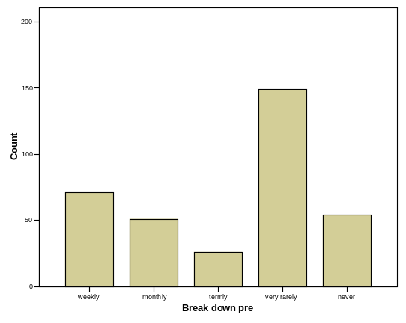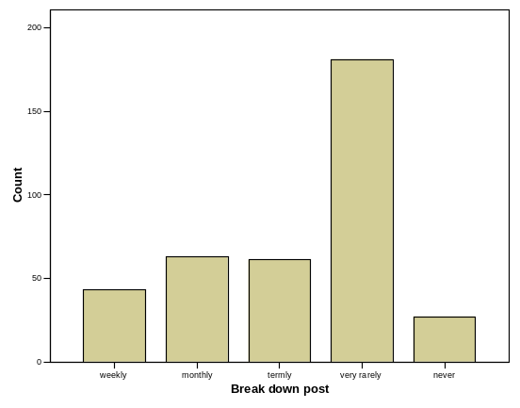
57.9% of the teachers at pre-test and 55.5% at post-test reported that the interactive whiteboard rarely or never broke down. There was no statistically significant change from pre- to post-test in the frequency of problems reported.

Some 80.2 per cent (30 out of 368) of teachers who responded at pre-test said that they had experienced problems with data projector bulbs. This increased slightly at post-test to 14.1 per cent (52 out of 368) and the change in pattern of responses was statistically significant (McNemar, χ2 = 8.82, p = 0.003). This is not surprising as bulbs have a limited life expectancy and therefore problems are likely to increase as time passes. However, there are financial implications for schools.
At pre-test, 25 per cent (92 out of 368) of teachers indicated that they had experienced problems with internet connections whereas at post-test 38.3 per cent (141 out of 368) stated that they had experienced the same problem. This change in pattern of responses was statistically significant (McNemar, χ2 = 19.041, p < 0.001). The increase in problems experienced could be due to increased internet traffic (more teachers using the internet in lessons) and perhaps suggests a growing reliance on using the internet in daily teaching and learning.
One hundred and fifty teachers did not report any other problems at post-test, as compared to 157 at pre-test. Of the problems listed at post-test there were 197 that could be categorised as general hardware or software problems, including connections between computer/laptop and interactive whiteboards (some identified specifically as cabling specific), crashes, network problems, loss of interactivity, laptops becoming ‘dormant’, slow response and electrical problems. For example:
“Board losing touch sensitivity”
- “equipment failure ie cabling link to interactive whiteboard”
- “hibernating laptop”
- “losing programmes when reconnecting laptop after other use”
- “lost connection to network (strongly intermittent!)”
- “multitude of conflicts!”
- “sometimes unplugged leads (cleaners!)”.
Ten teachers reported specific problems with sound and 19 believed that calibration was an issue (for example, “Orienting board two to three times a day”). Seventeen reported problems with pens malfunctioning and 11 identified projector problems. For example:
- “filters needed cleaning because projector is mounted upside down and collects dust”
- “initial problem with siting of projector”
- “laptop recognising projector”
- “projector overheating”
- “projector stolen”.
Five teachers at post-test identified problems relating to installation or light levels. For example, “installed too high on wall” and “light making board too hard to see”. There were a further seven problems that could be categorised as staff-related issues such as the time required to create resources, teachers’ skills and technical support issues.
Organisation of interactive whiteboard use within schools
Headteachers/ICT co-ordinators were asked what mechanisms were in place to share good practice and who took responsibility for this. Of the 293 headteachers who responded at post-test, 36.5 per cent said that their ICT co-ordinator helped to manage the arrangements whilst 15 per cent said that the subject co-ordinators additionally identified resources and websites that were suitable in their areas. Thirty-seven headteachers noted that the arrangements were largely informal, although in many cases they pointed out that the school was small, which clearly has a bearing on the effectiveness of this model. Interestingly, nine headteachers said that the ICT technician gathered information about useful websites whilst one said that the teaching assistant had responsibility for doing so. The headteachers said that lists of websites, resources and good practice were shared in a variety of ways. Internally this was done via hard-copy lists in the staff room or ICT room, or electronically via shared areas on the school network or links on the school website. The information was shared with staff through formal meetings, often regular staff meetings or twilight support sessions run on a regular basis. In addition it was noted that joint planning was another useful mechanism for sharing practice and resources. Interestingly, three headteachers noted that resources and good practice were shared via email whilst one said that there was a regular item in the termly staff newsletter. Sixteen headteachers indicated that teachers shared good practice with each other through demonstration, coaching or observation. Beyond the school, networking with other interactive whiteboard ‘project’ schools and attending local authority meetings and training events were also seen as useful means of sharing practice in 16 per cent of schools.
This suggests that the development of good practice is seen as very largely an in-house activity in terms of face-to-face exchanges of ideas. However, access to electronic resources offers another route through which teachers can gain ideas.
Use of the NWN website
At the beginning of the evaluation only 20.1 per cent of the 528 headteachers who responded indicated that they had accessed the National Whiteboard Network website. By the end of the evaluation 53.1 per cent of the 286 headteachers who responded said that they had visited it. Forty-two headteachers who responded to the pre-test questionnaire noted that they were not aware of the site's existence but would be looking at it in the very near future. Thirty-eight headteachers felt positive about the site at the beginning of the evaluation but some were negative (citing limited range of resources, hard to navigate, slow to download). At post-test the comments were much more positive, indicating that the website had continued to develop and was beginning to provide appropriate levels of resources. The negative comments at the end of the evaluation were similar to those made at the beginning. Clearly, as more resources have been added to the site, navigation has remained an issue. Some headteachers still feel that some subjects are better resourced than others. Unfortunately, at post-test a very small number of headteachers were still unaware of the NWN website.
When asked what other agencies were helpful in the ongoing development of interactive whiteboards, headteachers specifically mentioned:
- commercial providers of interactive whiteboards (44)
- the National Whiteboard Network (20)
- contact with other primary or secondary schools (12)
- Becta resources (5)
- access to Advanced Skills Teachers (3)
- the Strategic Leadership of ICT programme developed by Becta and the National College for School Leadership (1)
- the NAACE (National Association of Advisers for Computers in Education) award (1).
This diversity in sources for materials was confirmed in the visits to the case study schools, where the majority of case study teachers were making only partial use of the NWN website. This was not a case of ‘not invented here’ syndrome, because they were quite ready to be eclectic in their use of resources, and more than willing to share their knowledge within their own school.
The Primary Strategy site was well used and highly regarded. The NWN website was also well used by some teachers, but some had never heard about it or were quite indifferent to it even on the final case study visit. Some said they intended to look at it, but they already had their favourite sites; users of two of the commonest interactive whiteboards for instance tended to make use of the company websites to find material that they then adapted for their own use.
Both the survey and the case study results findings bring out the central importance of face-to-face exchanges within schools in developing good practice. Although awareness of the website was rising amongst heads, the findings also show how the NWN was competing in a crowded marketplace for teacher attention as a resource provider. To the extent that it is believed that good practice can be carried by the structure and design of centrally approved resources, this raises obvious questions.
The other noticeable feature is the emphasis by teachers upon getting resources that suit them and their pupils very specifically. There are indications that, for the case study teachers at least, easy modifiability is a key feature of acceptable resources. Here we are perhaps seeing the emergence of a new middle route for resource development, which is different both from teachers using externally produced resources as they stand, or creating their own from scratch.
Training provision
The teachers’ and headteachers'/ICT co-ordinators’ questionnaire responses indicate the major role that LAs played in training provision initially and that this increased as time went on.
Table 5.1: Provision of training after installation of interactive whiteboards at pre- and post-test
 | ICT co-ordinator |  | Local authority
 | Pre-test  N = 550 | Post-test  N = 403 | Pre-test  N = 550 | Post-test  N = 403
Half day or less | 15.6% | 16.4% | 20.5% | 15.6%
More than half day, less than 1 day | 2.2% | 1.7% | 4.5% | 2.2%
1 day | 1.6% | 0.7% | 27.5% | 8.4%
More than 1 day, less than 3 days | 2.0% | 3.2% | 13.6% | 33.8%
Over 3 days | 0.2% | 1.5% | 3.5% | 11.7%
Ongoing | 2.5% | 6.0% | 0.2% | 1.0%
None reported | 76.0% | 70.5% | 30.2% | 27.3%

It seems the amount of training reported from ICT co-ordinators received after the interactive whiteboards were installed increased slightly, with six per cent of respondents noting that the training was ongoing by the end of the evaluation period. In comparison, the amount of training reported as being provided by the local authority increased considerably from pre- to post-test indicating that this form of provision has been ongoing (although not for all participants).
Of those teachers who responded at post-test, 94.2 per cent indicated that training received to date had included using specific functions of the interactive whiteboard, 93.9 per cent indicated that training had included how to use interactive whiteboards to support literacy lessons and 92.6 per cent had included how to use interactive whiteboards to support maths lessons. Of the 259 headteachers who responded at post-test, 18.9 per cent felt that training was primarily operational, 12.4 per cent thought it was primarily pedagogical and 67.6 per cent believed it covered both equally. This supports the evidence from local authority staff themselves that most see pedagogic rather than purely technical issues as central, and the view of most of the case study teachers that the training was best when it was linked to subject teaching rather than to developing ICT skills.
Two hundred and ninety-one headteachers at post-test responded to the question about whether teachers generally considered that operational training had been adequate. Of these, 78 per cent said yes and 17.2 per cent said no. Two headteachers noted that it was adequate for teachers who were more confident users of ICT. Two hundred and eighty-two headteachers responded to a similar question about pedagogical training with 72.3 per cent agreeing it was adequate but 23 per cent believed that it was not. A total of 78.1 per cent of the 288 headteachers who responded said that teacher skills were updated regularly through organised training sessions whilst 20.5 per cent said that this was not provided, but several of these headteachers indicated that they were planning to address this in the future.
When asked what form continuous training took, there were a variety of responses indicating a range of models from informal in-house support, to regular in-house training events, and formal support from the local authority.
When asked specifically what kinds of support the local authority provided in relation to the development of interactive whiteboard skills and knowledge, headteachers noted a wide range of facilities. Many local authorities provided opportunities for training either within the school or for all schools participating in the project. In some cases schools were asked to purchase this provision, and at least one headteacher had elected not to do so. Some headteachers noted that the local authorities had provided subject-specific support. In addition cluster meetings were held for participating schools. Other services included school visits, hands-on support, consultancy, websites with resources, telephone support, newsletters, drop-in sessions, CD-ROMs with resources, conferences and mailings. Thirty headteachers said that either the local authority provided no support or it was insufficient. These comments were distributed across most of the participating local authorities with the majority of comments from within each local authority being positive or neutral, suggesting that the needs of individual schools are diverse and not always met through traditional models of training and support.
Things that case study schools recommended in this area included:
- more school visits from consultants
- modelling of interactive whiteboard use by consultants
- lesson observation and discussion with consultants
- more training designed for Key Stage 1 teachers
- funding for networking with other Key Stage 1 teachers
- funding for local schools to develop resources and pedagogy
- training for supply teachers
- basic training for classroom assistants
- provision of skill development awards from one interactive whiteboard company
- learning how to use the interactive whiteboard more creatively.
Nearly all of these have direct or indirect funding implications.
A total of 403 teacher questionnaires were matched from pre to post-test and analysed to see if teachers changed their opinion over the course of the academic year about whether or not their interactive whiteboard skills were self-taught. There was a statistically significant change in opinion from pre to post-test with more teachers believing that their skills were self-taught (Wilcoxon, Z = -4.900; p < 0.001). This suggested that teachers had become more confident during the school year and had begun to go beyond the initial training mostly provided by the local authorities and reached a point at which they were discovering more about the functionality of the interactive whiteboards for themselves.
This change may be because many teachers are using interactive whiteboards for a considerable number of lessons a week. One indirect result of this is that it is not at all easy for local authority trainers to keep up. Teachers in one authority were dismayed by the trainers’ lack of interactive whiteboard skills. They said that they thought this was because the trainers were not exposed to the need to use the board with children all day every day, and believe that their own expertise had rapidly overtaken the early efforts of the local authority team.
It was also reported that teachers were sharing their interactive whiteboard resources and sources of information more than they had prior to having an interactive whiteboard. On several occasions, teachers said they felt this was because they were all in a learning role together.
Some schools (although as the survey results above show, probably so far only a small minority) make good use of other teachers’ resources either from websites such as the NWN or from local pyramid groups and liaisons. The interactive whiteboard seems to have helped to create good sharing opportunities particularly where lead schools have been established.
As with the selection of resources, what emerged was that teachers were viewing training in interactive whiteboard use eclectically, creating their own mix of advice and inspiration from colleagues in their own school, local authority consultants, attendance at training courses and linking with fellow teachers in nearby schools.
Discussion and recommendations
As we pointed out at the beginning of this section, the initiative was designed to:
- further increase the provision of interactive whiteboards to primary and secondary schools nationally
- ensure that every local authority throughout the country had benefited from central funding for interactive whiteboards, following this and earlier initiatives
- support the primary and secondary national strategies in raising standards through improved learning and teaching
- ensure local authorities and schools were aware that from 2004/05 they could use their devolved formula capital budgets, should they deem it a priority, to purchase ICT equipment which could include interactive whiteboards and other similar technologies
- encourage the development of a professional community, to develop, collate, share, improve and disseminate best practice more widely.
The standards requirement falls outside the scope of this section (it has been dealt with in Section 3 above). All of the others, apart from the last, have clearly been met either in full or to a reasonable extent. The last, however, is more complex.
As described in the initial DfES documentation the initiative was:
- a centrally defined, directed and evaluated innovation
- promoting a pedagogy-led rather than technology-led approach
- intended to disseminate a pre-defined pedagogy rather than explore a range of possibilities
- designed to be disseminated through 21 selected local authorities to selected schools and (with much less central support), to all other local authorities and schools that wished to participate.
Subsequently it has evolved into a 'shifting centres' innovation while still retaining strong elements of central and (to a lesser and diminishing extent) intermediate (that, local authority) level control. It is now becoming embedded in some of the schools and is evolving as it does so through interaction with other initiatives and activities, both at local authority and school levels.
A new element also emerged as the initiative went on. This was the growth of horizontal links between groups of schools and local authorities to complement the vertical links between the DfES, central team and local authorities that has already been mentioned.
This growth did not signal a wish to replace these vertical connections but a belief that the innovation would require both. It was also notable that some heads were reported as favouring horizontal links in the form of school clusters. These clusters appear to have considerable potential as long-term support structures.
Strong vertical links are appropriate where an innovation is thoroughly understood by a few, and not at all by the rest. In these circumstances the transmission of clear messages from those who know to those who do not is arguably the best approach. Where knowledge and ignorance about an innovation are more evenly distributed, collective discussion and the rapid exchange of whatever insights are found is probably better. For this, strong horizontal links are also essential.
In this case the novelty of interactive whiteboards as an innovation meant that some mix of horizontal and vertical links was entirely appropriate.
The question then is whether the network of vertical and horizontal links needed has yet been established.
The evidence is that vertical links have been well established from the national down to local level, with the core local authorities and (no doubt to a lesser extent) with others. There is, however, a much more mixed picture below that level.
The initiative’s first channel for vertical communication was the face-to-face contacts between local authority and school staff. The indications from the school survey are that for around a quarter of schools responding there was no local authority training reported. Again around a quarter to a fifth of headteachers reported that interactive whiteboard training was not adequate. Here, for most schools but by no means all, the local authorities have made a useful contribution in terms of training and in doing so had established stronger links with those schools.
Why have they not been even more successful? One central factor is probably the financial arithmetic of the initiative. We know that the central team were largely successful in informing and enthusing the local authorities who attended the training sessions. The teams provided about 12 days of face-to-face training to achieve this. However, when we look at the amount of training that teachers had from local authorities and their ICT co-ordinators combined, only 13 per cent reported receiving more than three days. Even if we assume that ongoing training always totalled more than three days, then still only about a fifth of teachers had three days' training or more, while rather more had none at all. For the local authorities to have provided anything approaching 12 days training per teacher would have required a step change in the staffing needed – and they did not have the funds to do this.
The second channel for vertical communication was the NWN website. However, this appears not to have made a major impact at school level, upon heads at least. While they are now nearly all aware of it, most of them did not mention it as a major influence upon interactive whiteboard development, although satisfaction with it grew as the initiative continued.
Here the problem appears to have been quite different. While some content was initially lacking and there were ongoing difficulties with navigation, the basic problem appears to have been that, like all electronic resources, they were simply up against a wide range of other well established content providers. This is intrinsic to the nature of the interactive whiteboards. Any content you can display on a desktop monitor you can display on an interactive whiteboard, so once teachers have grasped the technical basics, the range of potential content open to them is huge, including everything that is available from the internet. Furthermore, teachers will typically have a pre-existing bank of ICT materials and websites that they are familiar with and that they know are likely to work. In retrospect it was not therefore surprising that the NWN website did not make a bigger impact.
The position on horizontal channels is rather similar. The development groups set up by the central team to link local authorities to exchange ideas and develop resources have had some success but they were not fully effective in engaging all participating local authorities. On the other hand, one of the most important indirect successes of the initiative was the improved horizontal communication between different local authority staff within their own local authorities.
At school level the use of school clusters (some created for the initiative, others created by extending the remit of an existing group of schools) was welcomed, but they were only helping a small proportion of schools. Again, however, there is the more encouraging evidence that within-school co-operation has been increased through the initiative.
The design of the evaluation has not allowed us to take into account the most recent developments in the way that the initiative has been working at national and local level. However, it is clear that considerable progress has been made and that this has had an impact in many schools.
Where improvements could be identified to the implementation of the Primary Schools Whiteboard Project, they were included in the interim report, and will not be repeated here. However, the evaluation may suggest some more widely applicable lessons for future national initiatives involving the large-scale use of new technologies. Using technology to help pupil transition between Key Stage 2 and Key Stage 3, or the national introduction of e-assessment, online examinations and pupil record-keeping are all examples of such large-scale developments.
What these have in common is that they span classroom, school, local and national levels and involve the use of new technologies, often in partly new ways, by staff at all these levels. These are therefore very complex innovations to plan, manage, implement and embed. In what follows we assume a model similar to that used in this initiative, namely an initial pilot study, planning for national implementation and, where the pilot is successful, delivery of national implementation.
Questions to inform planning of technology initiatives with system-wide implications
What emerges from Sweep is that the initial planning for national implementation is both crucial and demanding. This is especially so where the initiative is to be centrally directed; in such cases any planning inadequacies at this stage are likely to have a major impact on successful classroom implementation. We would propose the questions below as ones that should be addressed when planning for future initiatives that use this model.
- How much freedom of interpretation and implementation of the innovation should partners at classroom, school and local levels have? What are the management, resource and training implications of this for organisations at each of these levels?
- What can be learned through a pilot study that will maximise the success of any later national dissemination?
- What cannot be learned about national dissemination from a pilot phase (for example, about scalability issues) and where will this additional information be found?
- What should be the relative roles of vertical and horizontal channels of communication in disseminating and developing the innovation? How will such channels be resourced, set up and maintained?
- What levels of hardware and software interoperability will the innovation need for long-term success at classroom, school, local and national levels?
- What levels of specialist staff will be needed at the implementation phase (for software development, hardware installation and staff training, for example)? Are these staff available nationally and locally and if not, what needs to be done to provide them?
- How will the required level of interoperability be decided and ensured at the planning stage of the initiative?
- Will this innovation be initially intelligible and attractive to all stakeholders at the outset? Will it remain intelligible and attractive as the implications of use emerge? What are the implications for the design of the dissemination phase?
- Any large-scale innovation is likely to interact with others that are current or planned. How will these interactions be taken into account in its design and evaluation?
- Is this innovation one that, if successful, will require long-term changes in the level and/or distribution of funding, management time and technical and administrative support? If so, are key stakeholders signed up to the implications of success?

Section 7: Review of the literature
A review of the existing research literature was included in the interim report of the evaluation in May 2005. This was updated in 2006.
An interactive whiteboard is a “large, touch sensitive board which is connected to a digital projector and a computer” (Becta, 2003a, p.1). It is thus able to run interactive software, to connect to the internet, show digital images, and produce sound, as ordinary computers can do. Its advantage over an ordinary computer, however, is the large screen which is visible to a whole class, where an ordinary monitor is usable only by a small group. An alternative to the interactive whiteboard sometimes proposed is a computer with a data projector, but this does not have the option to write on the screen and have it saved, like an electronic flipchart. Interaction with a computer usually requires the fine motor movements of a keyboard and mouse, but menus on the touch-sensitive interactive whiteboard allow control through tapping instead of clicking a mouse, and large motor movements to write or move objects. Some interactive whiteboard software includes optical character recognition (OCR), which will transform handwriting into printed text. This enables previously prepared screens to be annotated and then printed or e-mailed (Gatlin, 2004). Depending on the make, writing is done either with a special pen, or with the finger.
The technology was only recently introduced to schools in the UK. Interactive whiteboards were invented in 1991 by SMART Technologies Inc. Greiffenhagen (2002) has described how a tool originally developed for use in business boardrooms has been adapted for educational use. The culture surrounding interactive whiteboards in schools and colleges has changed extremely rapidly. Miller and Glover (2001) and Glover and Miller (2004b) described how the introduction and reception of interactive whiteboards in schools initially depended on the balance on the staff between what they termed 'Missioners' (who were very keen to exploit the new possibilities) and 'Luddites' (who resisted technological change). Kennewell (2001) revealed that in its first year, when their department’s interactive whiteboard was mobile and bookable, and had no technician, it was hardly used, but once it was fixed to the wall and a technician appointed, it was used more regularly. In January 2002, the Welsh Assembly announced a decision to put one interactive whiteboard in every school; Kennewell and Morgan (2003) revealed that, although PGCE student teachers surveyed in Wales were mostly enthusiastic about the innovation, many had little chance to use one as they remained unused in the staff room, in a cupboard, or behind stacked chairs in the dining hall. ITT colleges were still installing them and teaching staff how to use them (Miller et al., 2003). By 2004, the former Secretary of State for Education and Skills, Charles Clarke, had stated “every school of the future will have an interactive whiteboard in every classroom, technology has already revolutionised learning” (Arnott, 2004). The DfES (2004) indicated that by that year, they had invested £50 million in school whiteboards, and 63 per cent of primary schools had an interactive whiteboard (Prior and Hall, 2004).
It is important, therefore, to appreciate that this review is of a technology which is still to arrive in many schools, and to which teachers are still adapting. It is still early for there to be any settled practice to research. Few of the early articles available are from academically refereed journals or published reports – many are case studies from the internet or ‘classroom’ based journals, written by enthusiasts. Some of the internet articles are undated. In the last year, more empirical material has become available, and Smith et al. (2005) have already published a critical review of the literature on interactive whiteboards.
This review is divided into the following themes:
- Are pupils more motivated to learn when they use an interactive whiteboard?
- Benefits for teaching: can teachers be motivated by using an interactive whiteboard?
- Training issues
- Does pupil attainment rise when they are taught and learn using an interactive whiteboard?
- Initial costs, and barriers to the effective introduction of an interactive whiteboard into a classroom
- Other factors to consider with respect to the introduction of new information and communications technology
- Has the introduction of interactive whiteboards changed pedagogy?
- Conclusions.
The impact of interactive whiteboards in the classroom on pupil motivation
Cox (1997) and Passey et al. (2004) have both reported that ICT in general, including interactive whiteboards specifically, can have a positive motivational effect on pupils at both primary (aged 7–11) and secondary (11–18) levels. Ofsted (2004) found that ICT was having a positive effect on students’ engagement, motivation and attainment. Somekh et al. (2005) reported that whole-class technologies, such as interactive whiteboards, frequently had a significant impact in improving pupils’ attention, which made it easier for teachers to explain difficult concepts. In the same study, teachers’ research in their own classrooms showed significant improvements in pupil motivation.
Higgins et al. (2005) found that 99 per cent of teachers believe an interactive whiteboard improves pupil motivation. Forty-four per cent said it had a positive impact on boys’ focus and motivation (the rest saw no difference by gender). Pupils themselves believe they learn better and pay better attention.
Hall and Higgins (2005) comment that pupils’ own views are seldom consulted. In their own consultations with pupils, they found pupils like the versatility and range of resources for whiteboards, their multi-media capabilities (colour, movement, sound, touch), fun and games. What they don’t like are technical problems, problems seeing the interactive whiteboard, and lack of skills on the part of both regular and supply teachers, and their own lack as pupils. They would like more access, as they do not consider that they touch the board often enough.
Various reasons are advanced for the motivational effects of interactive whiteboards: the 'high level of interactivity' between pupils and interactive whiteboard (Becta, 2003a); the ability of the teacher to stay at the board, without losing the class’s attention while at the computer (Morris, 2001); the ability to review previous work (Kent, 2004); knowing more about how to operate the board than the teacher (B. Lee and Boyle, 2004). Pearson et al. (2004) found that pupils' attention was sustained for longer when an interactive whiteboard was used. Glover et al. (2003) concluded that pupils’ attention span lasted longer with an interactive whiteboard, and there was less opportunity for them to move off task. Both they and Pearson et al. (2004) considered that when an interactive whiteboard is used, pupils are ready to start work when the teacher is, and teachers can gain their interest at the beginning of the lesson. Thompson and Flecknoe (2003) found that pupils saw using an interactive whiteboard as 'fun', and stated they completed much more work when one is used. The interactive whiteboard also caters for a range of learning styles (Beeland, 2002; Virtual Learning, 2003, 2003a; Solvie, 2004).
Salinitri et al. (2002) concluded that the use of an interactive whiteboard with pupils who had special educational needs enhanced the motivation of the pupils throughout the research period. The visual aspect of the interactive whiteboard and the facility to combine written and oral text with pictures enhances the learning experience for hearing-impaired and blind pupils (Taylor 2002, cited in Virtual Learning, 2003; Brown, 2004; interactive whiteboard net, undated-b) which might allow schools to manage inclusion of pupils with special educational needs more effectively.
However, other research (Birch, 2003; Higgins et al., 2005) has concluded that an interactive whiteboard motivates all pupils, not just those with special educational needs, and that attention spans increase for all. Reasons for this include the interactive whiteboard being a focus for the pupils (Gage, 2002), the wider range of resources being used, the multimedia aspects of the interactive whiteboard, quicker pace, and the enjoyment of seeing their work on the screen. This is confirmed by a number of studies (Morris, 2001; Beeland, 2002; Glover and Miller, 2002a; Greiffenhagen, 2002; Levy, 2002; Becta, 2003b; Gatlin, 2004; Kent, 2004; Passey et al., 2004; Pearson et al., 2004; Renton, 2004). The same finding is noted in a French study: 'Grande motivation de tous les enfants pour venir manipuler au tableau' (Menton, undated).
A few reports, however, enter some reservations about motivational effects: Smith (2001) reported that when pupils wrote on the board, some other pupils, notably the more able, became bored because of the loss of pace. One study suggests that some pupils do not enjoy having their work displayed on the interactive whiteboard (Levy, 2002; Bateson-Winn, 2003) attributed part of the success of using a new whiteboard in a primary school to the introduction of a new behaviour policy at the same time. Levy (2002) also discovered that pupils felt that the interactive whiteboard had a ‘novelty value’. Given this, we need to allow for a possible short-lived halo effect.
What are the benefits of teaching with an interactive whiteboard?
Aspects of interactive whiteboards which potentially benefit teaching concern its flexibility, multimedia presentations, efficiency, its support for planning, and enabling the modelling of ICT skills (Smith et al., 2005).
Flexibility
Both Somekh et al., (2002b) and Triggs et al., (2003) found that teachers would like the flexibility to access ICT facilities when they require them. An interactive whiteboard, by allowing access to the internet and to teach a whole class with just one computer allows such flexibility. Cobitz et al. (undated) concluded that the use of an electronic slate with an interactive whiteboard allows the member of staff to be able to cope with situations which arise in the classroom more quickly because they do not have to stay at the front of the classroom. They also proposed that the use of cameras in conjunction with the interactive whiteboard allows pupils who have missed the lesson to watch it on the internet, and suggested that cameras could be used to monitor pupils’ behaviour and provide evidence for parents.
The flexibility of the interactive whiteboard extends across age groups, (Jamerson, 2002), including nursery (Wood, 2001; M. Lee and Boyle, 2003); where the ability to use gross motor movements makes it easier to learn to write on paper (Smith, 2001); and easier than a mouse and keyboard (Goodison, 2002a). The ability to flip freely back and forth between screens is appreciated in studies by Latham (2002) and Levy (2002).
In Britain and America, Levy (2002 ) and Solvie (2004) found members of staff who have proposed that one of the advantages of the interactive whiteboard is the ability to prepare lessons but then be able to change the order of the work depending on the students’ needs.
Multimedia
The range of resources available makes the interactive whiteboard valuable across a number of subjects, not just as a tool for the study of ICT itself: for example, archive film footage in history (Morrison, 2003), rotation, tessellation and transformations or number games in mathematics (Edwards et al., 2002; Carson, 2003), highlighting or dragging phrases in modern foreign languages (Thomas, 2003). Smith et al., (2005) point out, however, that most of these facilities would be available with a computer and projector, and do not rely on the touch-sensitive screen.
Efficiency
What does make use of the menus on the screen, however, are the smooth transitions and seamless flow possible in lessons, which add pace (Boyle, 2002; Thomas, 2002; Latham, 2002). What also adds to the efficiency is the ability to handle virtually resources which would be more laborious or complicated in real life (Ball, 2003).
Planning and resources
Although planning and making resources initially takes longer, the fact that they can be saved, stored and shared gradually reduces time required and allows improvements to be made (M. Lee and Boyle, 2003; Glover and Miller, 2001). Miller and Glover, (2002) suggest some money would also be saved, in not having to buy some visual aids. Again, these benefits are not unique to interactive whiteboards, and would apply to computers and Web access generally.
Modelling ICT skills
Some schools no longer feel the need to teach ICT skills separately, since work at the interactive whiteboard sufficiently models these (B. Lee and Boyle, 2004). This fits with the findings of Harrison et al., (2003), who found that pupils learn ICT better through self-directed tasks and exploration in other subjects, rather than discrete ICT lessons.
Demonstrating at a large screen is easier to observe than fine movements with a mouse. One advantage of the touch-screen over a laptop is that the teacher can more easily face the class, instead of engaging with the computer at some distance from the board (Wood, 2001). For hearing-impaired pupils, having the teacher face the class by the board avoids the pupils having to look away to watch the teacher’s signing (Carter, 2002).
The size of the board enables teachers to model reading and writing techniques (Tyldesley and Turner, 2005).
Teachers’ motivation
B. Lee and Boyle (2004) found that when whiteboards were introduced to Richardson School in Australia , teachers felt much more creative, enjoyed teaching more, and made significant changes to their classroom practice, for example by consolidating learning in a non-repetitive way. In England, though, Glover and Miller, (2001) found that, although teachers were motivated to use the technology, additional training was needed to enable staff to use an interactive whiteboard in more creative ways.
Higgins et al., (2005) concluded that members of staff 'were extremely positive about the impact of interactive whiteboards on their teaching' and 87 per cent of teachers felt more confident in ICT as a result. All felt it helped achieve their aims. In the report from Somekh et al. (2005) more teacher-researchers chose to study the impact of teaching with interactive whiteboards than with any other form of ICT, which suggests strong interest in their potential. These reports were uniformly positive in their overall conclusions on teachers’ motivation.
Teacher professional development in interactive whiteboard use
The introduction of any new technology into a classroom requires staff to be trained both technically and to change their existing pedagogy (Harris, 2002). Ofsted (2004) comment that lack of confidence by teachers may result in poor use of technology; they express concerns over ICT skill levels and training for teachers.
The similarity of an interactive whiteboard to a ‘normal’ board means that members of staff may be less reticent than might be expected about having one installed in their classroom (Brown, 2004) but Smith, (2001) and Birch (2005) state that training to use an interactive whiteboard is essential. At Richardson School (B. Lee and Boyle, 2004), staff meet every fortnight to share good practice. Elsewhere in Australia (interactive whiteboard net, undated-a), schools are being encouraged to consider the 'enhancement of teaching' as the main focus, not the interactive whiteboard itself.
Somekh et al. (2005) reported evidence of teachers’ greatly increased skills in using ICT, particularly whole-class technologies such as interactive whiteboards. Teachers appeared to enjoy the creativity of producing their own materials for interactive whiteboards.
Higgins et al. (2005) found that 86 per cent of those receiving training rated it as useful, and the 'most popular source of further information about the interactive whiteboard'. The local authority interactive whiteboard consultants were considered to be a useful source of information and training, more useful than other members of staff in school. Pupils (Higgins et al., 2005) stated that members of staff sometimes forgot how to use the interactive whiteboard and that this was annoying, as were reliability issues (Levy, 2002). However, Pearson et al., (2004) found that pupils enjoyed the increased partnership with teachers if they were permitted to call out advice.
Confident members of staff, with support in how to use the interactive whiteboard, can transform teaching and learning (Virtual Learning, 2003).
The impact of interactive whiteboards on pupils’ learning
Earlier research by Kozma in Salinitri et al., (2002) indicated that technology could enhance the acquisition of knowledge and skills, especially with pupils who had special educational needs. Salinitri et al. found that pupils with special education needs achieved higher raw test scores in a spelling test after being taught with an interactive whiteboard. Although the results did not show significant changes in attainment, other positive results were also obtained. The interactive whiteboard motivated both the pupils and the members of staff, with increased participation in lessons and willingness to communicate in the class. It was also considered by the member of staff that the pupils were less anxious about making errors when they used the interactive whiteboard. Loveless (2005) has argued that by reducing the anxiety and increasing the opportunities to take risks, the classroom environment is more likely to become one where creativity is enabled.
Pittard et al. (2003) summarise large-scale, national reports which show that pupils who make relatively high use of ICT in general in their subjects show positive effects on their attainment, and that school academic standards are positively associated with high-quality ICT provision and teaching. ImpaCT2 (Somekh et al., 2002a) emphasised that the quality of use of ICT is important, not just the quantity.
Bateson-Winn (2003) concluded that the introduction of interactive whiteboards into a primary school in England was responsible for the increase in national test scores at Key Stage 2. Similarly, B. Lee and Boyle (2004) found that pupils’ results in PIPS tests at a school in Australia improved with the introduction of interactive whiteboards.
Later research by Higgins et al. (2005) has concluded that there is some evidence to suggest that interactive whiteboard use in particular does improve pupil attainment, but not for all pupils. Low-achieving pupils benefited the most, especially in English and especially in writing. These results may have been influenced by the type of schools they researched, with the pupils in the schools with interactive whiteboards tending to have 'test scores about five points above the national average'. Whereas results for all pupils taught with interactive whiteboards were better after one year than for the national cohort as a whole, these gains were not maintained in the second year, and the researchers considered that 'sustained improvement (in test scores) is harder to achieve, especially in high performing schools'. This research also indicated that pupils in classrooms with an interactive whiteboard did less well in science than pupils in classrooms without an interactive whiteboard but the authors suggest that this could be because the project concentrated on the development of ICT in literacy and mathematics and this may have led to less time being available for science in those schools involved.
Issues relating to the effective introduction of interactive whiteboards in classrooms
The initial cost of equipping all classrooms in a school with an interactive whiteboard is high (approx. £2000 each in November 2004) [http:/whiteboards.becta.org.uk]. The initial use of the interactive whiteboard is demanding in terms of teacher time to produce resources, although these resources can be shared and saved and this reduces the amount of teacher time needed in the future (Levy, 2002; Morrison, 2003; Higgins et al., 2005).
Morrison (2003) discusses many areas which, in their opinion, need to be considered before installation, such as height of the interactive whiteboard and size of the interactive whiteboard. The placement of the interactive whiteboard can cause difficulties (Morrison, 2003; Higgins et al., 2005). Some classrooms have low ceilings and these can cause problems with the projectors, especially with the height and direction of the beam which can cause eye problems (Becta, 2005).
Other important cost items to bear in mind are: security measures against theft, and possibly higher insurance, blinds for windows, replacement cost of bulbs (about £300 each), and eventual cost of replacing the hardware.
An important issue which needs to be considered, as well as the cost of ongoing training for teachers, is the lack of training available for supply teachers and classroom or teaching assistants (Morrison, 2003). Once the interactive whiteboard is installed and members of staff start to use it, the cost of additional software must be taken into account.
Various practical ‘barriers’ exist to the effective introduction of an interactive whiteboard. Smith (2001) pointed out that, although a small group can work round a computer monitor, the light from the projector tends to cast shadows if more than a couple of pupils are working round it; other pupils need to step back from the board. Although models of interactive whiteboard can be purchased which use rear projection, these are currently much more expensive.
Pearson et al. (2004) found that some pupils experienced problems in using the pens because of the pressure required, whilst others experienced a static shock as a charge from the carpet grounded through the interactive whiteboard. Additional research (Levy, 2002; Higgins et al., 2005; Menton, undated) confirms some of these problems; there can be difficulty in seeing the interactive whiteboard with the sun shining through the windows and sometimes it is difficult to manipulate the images on the interactive whiteboard. Some users have found that an interactive whiteboard needs to be recalibrated frequently (Bell, 2001 Menton, undated). J. Lee (2004) points out that replacement of all plain whiteboards leaves schools vulnerable if there are power cuts.
Although provision of laptops for teachers helps (Pearson et al., 2004), there are still problems for part-time or supply teachers who may not have one, or for teachers who move about and have to set up their laptop in each class. Failure to charge pens and laptops can lead to their crashing (Glover and Miller, 2002a).
Salinitri et al. (2002) found that the use of an interactive whiteboard by special needs pupils required consideration of some technical issues. The pupils varied in height and this meant that an adjustable interactive whiteboard was required. The height of the interactive whiteboard is also discussed by Brown 2004 and Morrison 2003. Pupils also had problems using the pens and this influenced the quality of the print-outs obtained (Beeland, 2002; Salinitri et al., 2002). Clark-Jeavons (2005) proposes movable menus from top to bottom to suit both teachers and short pupils, and from right to left to suit different handedness; white is not the best background colour for clarity, and font sizes need to be suitable for readability.
Somekh et al. (2005) found from lesson observations that the transfer mid-lesson between whole-class teaching with an interactive whiteboard and individual or group work on laptops depended upon the reliability and speed of wireless networks. At its best, in a primary school where pupils had their own laptops, the transfer was affected quickly and efficiently, but in an FE college a similar transfer was observed to take 20 minutes.
Other factors which influence the impact of ICT in classrooms
In carrying out research on whiteboards, we need to remember that it is not just the technical facilities of the boards, nor even the teaching skill of the teacher, which wholly determine the outcomes. A few samples from the literature identify a number of other school factors which influence the impact of new technology.
Lawson and Comber, (2000) looked at the impact of the internet, and its effect on different types of boundaries: initially, there were boundaries between technophobes and enthusiasts; links in space and time to other parts of the world became more fluid; in secondary schools, at least, traditional subject boundaries have not dissolved so much; teacher–pupil roles may have changed, with the teacher acting more as mediator or co-learner. As the interactive whiteboard makes the internet much more accessible in the classroom, these tendencies are likely to be heightened.
Sheppard (2003) comments that schools have changed relatively little in 50 years, and considers what styles of leadership are necessary to bring about organisational learning and change. He points out that technological changes are occurring at the same time as many other changes in the educational world, which will have an impact on what effects the technology has. One challenge is that often, young teachers know a lot more, and are more confident, with new technology than more experienced teachers, thus threatening the power balance. The leaders who promoted change were not expert in the new technologies, but ones who empowered others to learn.
Goodison (2002b), looking at a case study of a primary school adopting interactive whiteboards, comments on the importance of links with home technology, and on the possibility for more independent and co-operative learning. He notes that children don’t always get the productivity out of software that adults do. He asks how far they should have easy, tailor-made materials, and how far more complex examples from the web.
The impact of interactive whiteboards on pedagogy
In the light of the above broad comments, the literature shows clearly that some marked changes in pedagogy have occurred following the introduction of the interactive whiteboard. For example, Morrison (2003) argued that the introduction of an interactive whiteboard into his classroom created a learning community: after he had encouraged the pupils to share work through email and the interactive whiteboard, they emailed articles to him that they felt would enhance the lessons. In France, Menton, (undated) and in America (Solvie, 2004) members of staff have found that they are able to combine without problems the elements of audio, video, PowerPoint, booklet and the internet. The interactive whiteboard (Virtual Learning, 2003a) can mean that members of staff and pupils can combine ‘disparate elements’ to create knowledge and understanding. Brown (2004) considered that these uses of an interactive whiteboard would increase the interactivity and active learning in a classroom. Interactive teaching can be defined as when the 'lecturer modifies his or her approach in response to the needs of the learners' (Ferl, 2005), and interactive learning is when the learner may interact with the 'lecturer, with peers with resources or with all three' (Ferl, 2005).
McCormick and Scrimshaw (2001), however, considered that new technology allowed members of staff to teach more efficiently, but their pedagogy has hardly changed. Similarly, Kennewell (2004) considered that 'the introduction of ICT resources to schools during the last 20 years or so has had relatively little effect on the ways that teachers teach, compared with the initiatives such as the literacy and numeracy strategies'. Somekh et al. (2005) reported that whole-class technologies such as interactive whiteboards ‘have changed the ambiance of classrooms significantly’, and that the clarity of teachers’ presentations was ‘greatly improved’. However, they also noted that these technologies ‘fit well with existing whole-class teaching approaches’ and that frequently teaching remained ‘didactic’ rather than encouraging learner autonomy. Cox et al. (2004) argued that the 'use of ICT has a more consistent effect on attainment when pupils are challenged to think and question their own understanding'. Lewis (2003) noted that interactive whiteboards altered the use of whole-class and group work in lessons: before the introduction of an interactive whiteboard, computers were used mostly in the main part of lesson, with small groups; afterwards, they tended to be used in whole-class introduction or plenary sessions.
Suggestions that teachers have not changed their style appear in Greiffenhagen (2002), who concluded that in the NIMIS projects 'traditional classroom procedures were seamlessly integrated with the new technology'. Teachers in Britain and America (Farrell, 2004; Gatlin, 2004) have stated that one benefit of an interactive whiteboard is that teachers can do the same activities with an interactive whiteboard as they did without. Levy (2002) concluded that teachers saw the interactive whiteboard as a new tool, but not the piece of technology which would change their practice.
Glover and Miller (2002b) proposed a spectrum from didactic to interactive pedagogy. Interaction is not just the technical matter of pupils touching the board – it includes also interactions between pupil and teacher, pupil and pupil, and cognitive interaction with the content of the lesson. These latter forms are possible without an interactive whiteboard – the question is whether an interactive whiteboard encourages these forms of interaction or not. Glover and Miller (2004a) and Pearson et al. (2004) propose stages through which use of the interactive whiteboard typically develops. The first stage, 'supportive didactic', uses the interactive whiteboard purely as a presentational tool. The second stage, 'interactive', is when teachers challenge pupils to think, but only using illustrations. At stage 3, 'enhanced interactive', teachers use the interactive whiteboard as an integral part of their lessons most of the time, are aware of the potential of the board, and aim to stimulate pupils’ cognitive development.
A number of other writers construct similar stages of interactivity. Tanner et al. (2005), drawing on Hargreaves et al. (2003), devise a scale which goes from surface to 'deep interaction'. They argue that some features of the national numeracy strategy advocate whole-class discussions, but create tensions with demands for pace which reduce the opportunity for pupils to reflect at their own pace. Superficial features, such as an initial mental section, or mini-whiteboards, promote a traditionally didactic initiate – response – feedback style, without extension or personal evaluation. 'In "funnelling", it is the teacher who selects the thinking strategies and controls the decision-making process to lead the discourse to a predetermined solution. Research suggests that this is the most common form of interaction, with most teachers’ questions demanding short, factual responses of a relatively low cognitive level, designed to funnel pupils’ responses towards a required answer (Burns and Myhill, 2004)' (Tanner et al., 2005). By contrast, ‘ “deeper features” including formative assessment, the co-construction of meaning through dialogue; and the development of thinking and learning skills tend to be less well developed (Moyles et al., 2003). Kennewell and Beauchamp (2003) and Beauchamp and Parkinson (2005) employ an image of 'scaffolding', based on the socio-cultural theories of Vygotsky, to discuss how flexibly teachers question, challenge and thereby support pupils’ own thinking. Hennessy et al. (2005), in a case study of secondary science lessons, found that, in five out of six lessons observed, pupils seldom touched the whiteboard, despite their teachers’ rhetoric – teachers often recorded pupils’ contributions for them, to maintain pace. She queries whether 'cognitive engagement' of the whole class is perhaps more important than physical interaction.
Higgins et al (2005) concluded that as interactive whiteboards became embedded into the classroom interaction changed. Questions asked by members of staff became more open, longer answers were given by pupils and there was an increase in the number of probes and evaluative responses from teachers. However, there were fewer uptake questions. There was a faster pace, measured as the number of interactions.
Higgins et al. (2005) discovered that in lessons when interactive whiteboards were used, the average amount of group work in both literacy and numeracy reduced by seven and a half minutes compared to lessons where interactive whiteboards were not used. Although most members of staff stated that they were spending more time whole-class teaching, in practice this was not sustained into the second year of use.
They concluded that the ‘patterns of interaction’ in lessons were the same in lessons which used an interactive whiteboard and in lessons which did not. They did not observe any gender differences: in both types of lessons girls and boys initiated and received questions and answers in the same way (but note the findings of the same team, reported below). In a later paper about the same study, Smith et al. (2006b) argued that little change in tradition had occurred: if anything, the 'recitation script' had increased, with most time taken in explaining or structured question and answers; although there were more open questions and pace, pupil answers were shorter, and there was less feedback through uptake questions. They question the top-down training available to teachers.
Smith et al. (2006a) also note that, in principle, both the NLS and NNS promote dialogic teaching. They found that in practice, regardless of whether classes had a whiteboard or not, there were clear differences by sex. Boys were asked more questions than girls, were refocused more, and made more contributions. Boys were both praised and criticised more than girls. Girls are more inhibited than boys by being outnumbered: as the percentage of boys increases, the boys’ pace increases slightly, while the girls’ pace drops drastically. The discourse moves consist mainly of open questions, answers and evaluations (the standard style) – not probes or uptakes which would extend thinking. They suggest we need to ask why these differences occur.
In a follow-up to this analysis of classroom discourse, Smith and Higgins, (2006) argue that it is not the amount of questions, or their type (open or closed) but the nature of feedback which affects open-ended responses. It is the teacher’s intent, and understanding of the reasons why it is important to change pedagogical style which matter, not just giving teachers instruction on how to give feedback.
Higgins et al. (2005) and Smith et al. (2006b) also found that many members of staff took about a year of using the interactive whiteboard before they developed or created their own materials – what they term 'embedding effects'. This fits the findings of others who have also found that teachers progress though ‘stages’ in their use of an interactive whiteboard, or indeed in the use of any technology (Hooper and Rieber, 1995; Glover and Miller, 2004a; Knight et al., 2004; Pearson et al., 2004). This research needs to be taken into account for this report, and when future research is completed, to allow for the fact that teachers may not have yet fully embedded their interactive whiteboard into their practice. Hooper and Rieber (1995) considered that if members of staff did not progress through the stages, in their case, familiarisation, utilization, integration, reorientation and evolution, then the technology would, more than likely, be abandoned.
Lewin et al., (2003) argued that we need more flexible curricula and pupil / teacher roles to get benefits of ICT; children at home have greater autonomy – they use ICT for longer, for a greater variety of purposes. Hall and Higgins, (2005) suggest that pressures to get through the content of the curriculum, and to achieve in standardised tests, restrict freedom to make the most of the interactive pedagogies afforded by the interactive whiteboard.
Ferl (2005) argues that an interactive whiteboard actually allows better classroom management because the member of staff is at the front of the classroom. However other research (Brown, 2004 ; Witzenried, 2004) has proposed that one advantage of the interactive whiteboard can be enhancing collaboration within small groups. Hooper and Rieber (1995) proposed that co-operative learning when the pupils learn from each other in small groups allows for the development of ‘multiple perspectives’. If the use of an interactive whiteboard in a classroom reduces the amount of time spent on group learning will it also reduce the ability of the pupils to develop ‘multiple perspectives’? Or will an interactive whiteboard increase these abilities of pupils due to a faster pace and increased use of different resources via, for example, the internet?
Conclusions, questions, and answers from the Primary Schools Whiteboard Project research
The review of the literature provided evidence that the facilities offered by the interactive whiteboard have the potential to transform teaching and learning in the classroom, but this will not happen unless the interactive whiteboard is placed in classrooms with innovative, well planned members of staff who both understand their potential and are able to grasp it and implement it in their lesson. Brown (2004) warned that interactive whiteboards may just be used as a 'glorified whiteboard' if the members of staff using them do not see their potential.
In the May 2005 interim report we closed the literature review section by listing nine questions that remained to be answered. They are repeated here, this time with the best brief answers that may be offered from knowledge gained in the evaluation of the Primary Schools Whiteboard Project.
Q1
Are the facilities of the interactive whiteboard being ‘grasped’ by members of staff and embedded into the classroom? Or are the routine practices of the members of staff reducing the potential of the interactive whiteboard?
A1
The facilities are being grasped and embedded in classroom practices in Primary Schools Whiteboard Project schools. The evidence for this from observation, log books and the repeat questionnaire is very strong. An interactive whiteboard always makes some change to routine practices, but initially human beings always try to make new tools ‘fit’ into existing routines, and teachers need time, good resources and encouragement to develop truly innovative practices. To reach high levels of skill in using an interactive whiteboard teachers need continuing professional development and opportunities for accreditation. By the autumn of 2006 there was clear evidence that the interactive whiteboard was embedded and many teachers had developed new pedagogic practices to maximise its value.
Q2
What is interactivity? Does the interactive whiteboard encourage interactivity between the pupils and the interactive whiteboard or between pupils? Or is the technology changing the interactivity between pupils and members of staff? (Birmingham, Davies et al., 2002).
A2
Interactivity is an integral part of teachers’ relationship with their pupils. The interactive whiteboard is a tool that mediates teacher–pupil interactions and provides opportunities for changing the nature and increasing the extent of this interactivity. Conversely, the teacher is the agent who mediates the use of the interactive whiteboard to enable this change in teacher–pupil interactivity. ‘Interactivity’ needs to be understood on more levels than that of pupils being able to use some of the board’s facilities. Additional aspects observed in Primary Schools Whiteboard Project case study schools include: mental interactivity, interactivity via peripherals, and the multiple modalities of interactive whiteboards. There is little question that the presence of an interactive whiteboard can affect the interactivity between pupils and members of staff but, crucially, the extent to which this happens depends on the attitude of the teacher. When put to best use, the interactive whiteboard helps teachers and pupils to become co-learners, using it together. Attitudes may be susceptible to change through training and gathering experience, but some teachers will always find this shift in relationships alien to their style.
Q3
Is the interactive whiteboard allowing members of staff to concentrate on the conceptual understanding of the pupils (Hooper and Rieber, 1995)? Or it is ‘just’ increasing pace and allowing more content to be covered?
A3
The answer is: a bit of both. In the Primary Schools Whiteboard Project case study schools teachers gave many examples of ways in which the interactive whiteboard helps them to teach difficult concepts by assisting pupils’ visualisation, and enables them to demonstrate procedures such as measurement clearly. When pace is increased it may advantage more able students by allowing the teacher to provide more examples, but less able students may be disadvantaged by having less time to think. Pace is not always increased, however. When pupils come to the interactive whiteboard during whole-class teaching, pace may actually be slowed down. However, after two years of use, many teachers had adopted a range of strategies to keep the rest of the class involved and engaged as ‘a team’ helping and scrutinising what individuals were doing at the interactive whiteboard.
Q4
There is now considerable evidence that interactive whiteboards can engage the attention of pupils with special educational needs. Can this power be used to raise teachers’ expectations of SEN pupils and significantly raise their levels of attainment?
A4
The introduction of interactive whiteboards has both positive and negative potential in relation to providing for special needs. Teachers who have seen the enthusiasm of SEN pupils for the interactive whiteboard instinctively feel strongly that it helps them. However, evidence from multi-level modelling of pupils’ attainment in the Primary Schools Whiteboard Project suggests that less able students do not make the same gains in attainment when taught with an interactive whiteboard as average and high-attaining pupils. It seems likely that this is the result of using interactive whiteboards mainly for whole-class teaching which is unable to cater for the needs of pupils who have very specific problems in associating written symbols with words and concepts. There is evidence from our research that the use of an interactive whiteboard may be extremely beneficial to SEN pupils’ learning when a teacher or specialist teaching assistant is working with individuals or small groups.
Q5
There is some evidence of a positive impact on pupils’ attainment, although no study has shown this to be sustained for more than one year. If, as is hoped, the interactive whiteboards have a significant impact on pupils’ attainment will the national testing, regimes and examinations be able to reward this with credit without raising an outcry in the media about improved results signalling ‘falling standards’?
A5
Multi-level modelling of pupils’ progress in the Primary Schools Whiteboard Project has shown overall gains for average and above average students during the first year. It has also shown that pupils of lower ability show some gains, particularly less able girls in science and less able boys in writing.
Addressing a slightly different issue, teachers have suggested that there need to be interactive tests to do justice to the increased quality of learning that is possible with interactive whiteboards. Developing such instruments, if there is sufficient will to do so, will take many years. In the meantime, it is best to acknowledge publicly that existing test methods probably under-estimate pupil understanding, even as they claim to measure attainment.
Q6
What is the most effective way of enhancing the use of the interactive whiteboard in the classroom and supporting members of staff in that use?
A6
At the present time, the best course of action would seem to be two-fold. One, do everything possible to improve the knowledge of, and availability of teaching resources that make the very best use of interactive whiteboard capabilities. These resources should be freely available over the internet and carefully crafted to suit different learning areas and different ages of understanding. Two, continue to support CPD in relation to interactive whiteboards in as many different forms as can be afforded. In one Primary Schools Whiteboard Project case study school, teachers had all gained accreditation by following courses provided by one of the interactive whiteboard manufacturers and this appeared to have enabled them all to develop high-level skills and adopt more innovative pedagogies.
Q7
Will the interactive whiteboard be the technology that changes pedagogy? Or will it be as so many technologies in the past, integrated into existing practices or abandoned as being ‘irrelevant and unnecessary?’ (Hooper and Rieber, 1995)
A7
There is encouraging evidence in this report that interactive whiteboard technology has begun to change pedagogy in primary schools. However, because the interactive whiteboard provides an excellent support for whole-class teaching, there is a risk that many teachers may be satisfied with relatively low-level use. This confirms the importance of our answer to the previous question. Whatever the outcome, interactive whiteboards will never be abandoned as irrelevant and unnecessary. There is firm evidence in this report against that happening.
Q8
Research has shown that ICT can enhance creativity in the classroom (Loveless, 2002) but is the interactive whiteboard changing pedagogy to enable pupils and members of staff to be creative?
A8
Many teachers in Primary Schools Whiteboard Project schools are using interactive whiteboards creatively, as we hope some of the examples in this report demonstrate clearly.
Q9
What are the next steps in the classroom? Should each pupil have a laptop or handheld computer which is linked to the interactive whiteboard as in the DISCO project? (Keil-Slawik cited in Greiffenhagen, 2002).
A9
At this stage of the innovation the only real experts are those using the technology every day in their classrooms. In our most recent visits to Primary Schools Whiteboard Project case study schools we saw a slight increase in use of devices such as ActivSlates and voting systems. It is also interesting to note that, in our July 2005 survey, a number of headteachers/ICT co-ordinators said that what they needed next was to purchase devices of this kind which would allow pupils to control the interactive whiteboard remotely.
References
Armstrong, V., Barnes, S., Sutherland, R., Curran, S. and Mills, S. (2005), 'Collaborative Research Methodology for Investigating Teaching and Learning: The Use of Interactive Whiteboard Technology', Educational Review, 57(4), 457–469.
Arnott, S. (2004), 'Computers to replace school blackboards', produced by Computing 9 http://www.computing.co.uk/computing/news/2070841/computers-replace-school-blackboards [Last update accessed on 3 Oct 2007].
Atkins M.C. (2006), Survey of LAN infrastructure and ICT equipment in schools (03.06 v2) Atkins Management Consultants http://partners.becta.org.uk/index.php?section=rh&catcode=_re_rp_ap_03&rid=11340 accessed 3 October 2007
Ausubel, D. P. and F. G. Robinson (1969), School Learning: an Introduction to Educational Psychology. London and New York, Holt, Rinehart and Winston.
Avis, P. (2002), 'Response to "ICT and attainment at primary level' by Terry Goodison", British Journal of Educational Technology, 33(2), 211–213.
Ball, B. (2003), 'Teaching & learning mathematics with an interactive whiteboard', Micromaths, 19 4–7.
Bateson-Winn, J. (2003), 'The interactive advantage', Managing Schools, 13(2), 55–6.
Beauchamp, G. and Parkinson, J. (2005), 'Beyond the "wow" factor: developing interactivity with the interactive whiteboard', School Science Review, 86(316), 97–103.
Becta (2003a), 'The benefits of an interactive whiteboard' http://schools.becta.org.uk/index.php?section=tl&catcode=ss_tl_use_02&rid=86 [Last update accessed on 3 Oct 2007].
Becta (2003b), 'What the research says about interactive whiteboards', http://www.becta.org.uk/page_documents/research/wtrs_whiteboards.pdf [Last update accessed on 3 Oct 2007].
Becta (2005), "Interactive whiteboards".
Becta (2006), The Becta Review, http://partners.becta.org.uk/index.php?section=rh Accessed 23/7/06
Beeland, W. (2002), Student engagement, visual learning and technology: can interactive whiteboards help?, Annual conference of Association of Information Technology for Teaching Education, Trinity College, Dublin.
Bell, M. (2001), 'Update to survey of use of interactive electronic whiteboard in instruction', produced by Sam Houston University, http://www.shsu.edu/~lis_mah/documents/updateboardindex.htm [Last update accessed on 3 Oct 2007].
Birch, J. (2003), 'Using an electronic whiteboard', produced by http://www.bucksict.org.uk/Teacher%20Resources/DownloadDocs/Curriculum/Whiteboards.doc [Last update accessed on 3 Oct 2007].
Brown, S. (2004), 'Interactive whiteboards in education', produced by Techlearn, http://www.jisc.ac.uk/uploaded_documents/Interactivewhiteboards.pdf [Last update accessed on 3 Oct 2007].
Brown, J. S., Collins, A. and Duguid, P. (1989), 'Situated Cognition and the Culture of Learning', Educational Researcher 32(Jan-Feb): 32–42.
Burns, C. and Myhill, D. (2004), 'Interactive or inactive? A consideration of the nature of interaction in whole class teaching', Cambridge Journal of Education, 34 35–49.
Carter, A. (2002), 'Using interactive whiteboards with deaf children', produced by Birmingham Grid for Learning, http://www.bgfl.org/bgfl/custom/resources_ftp/client_ftp/teacher/ict/whiteboards/index.htm [Last update accessed on 3 Oct 2007].
Clark-Jeavons, A. (2005), 'Interactive whiteboards: Developing a pedagogy for mathematics classrooms'. In Johnston-Wilder, S. and Pimm, D. (Eds.) Teaching secondary school mathematics with ICT, pp. 159–173, Maidenhead: Open University Press.
Cobitz, C., Byrd, D. and Cockman, D. (undated), 'Active classrooms', produced by http://www.ac-rouen.fr/tice/article.php3?id_article=106 [Last update accessed on 3 Oct 2007].
Cox, M. (1997), The effects of information technology on students' motivation, London: King's College.
Cox, M., Webb, M., Abbott, B., Blakely, T., Beauchamp, T. and Watson, D. (2004), An investigation of the research evidence relating to ICT pedagogy, London: Becta.
Csikszentmihalyi, M. (1996), Creativity: Flow and the Psychology of Discovery and Invention. New York, Harper Perennial.
DfES (2004), 'Interactive whiteboards'.
DfES (2007), Statistical First Release: Foundation Stage Profile 2006. DfES Statistical First Release SFR 03/2007.
Edwards, J.-A., Hartnell, M. and Martin, R. (2002), 'Interactive whiteboards: Some lessons from the classroom', Micromath, 30–33.
Engeström, Y. (1991), 'Non Scolae sed Vitae Discimus: toward overcoming the encapsulation of school learning'. Learning and Instruction 1: 243–259.
Entwistle, N. (2001), 'Promoting deep learning through teaching and assessment: conceptual frameworks and educational contexts [online].' Paper presented at the TLRP Conference, Leicester, November 2000, http://www.tla.ed.ac.uk/etl/docs/entwistle2000.pdf [Last update accessed 3 Oct 2007].
Farrell, F. (2004), 'Poetry with a whiteboard', The Secondary English Magazine, June 2004 14–17.
Ferl (2005), 'What is interactive teaching and learning?' produced by Ferl First: Technology for E-Learning, http://ferl.qia.org.uk/display.cfm?page=865 [Last accessed on 3 October 2007].
Gage, J. (2002), 'So what is an electronic whiteboard? Should you want one?' Micromath, 18(2), 5–7.
Gardner, H. (1993), Multiple Intelligences. Basic Books.
Gatlin, M. (2004), 'Interactive whiteboard system creates 'Active classrooms' for rural Georgia school system', produced by T.H.E. Journal Applications, http://www.thejournal.com/magazine/vault/a4665.cfm [Last update accessed on 3 October 2007].
Glover, D. and Miller, D. (2001), 'Running with technology: the pedagogical impact of the large-scale introduction of interactive whiteboards in one secondary school', Journal of Information Technology for Teacher Education, 10(3), 257–276.
Glover, D. and Miller, D. (2002a), 'The interactive whiteboard as a force for pedagogical change: The experience of 5 elementary schools in an English education authority', Information Technology in Childhood Education Annual, 2002 5–19.
Glover, D. and Miller, D. (2002b), 'The introduction of interactive whiteboards into schools in the UK: Leaders, led and the management of pedagogical change', International electronic journal for leadership in learning, 6(24).
Glover, D. and Miller, D. (2004a), 'Matching technology and pedagogy in teaching mathematics: understanding fractions using a 'virtual manipulative' fraction wall', produced by http://www.keele.ac.uk/depts/ed/iaw/docs/BERA%20Paper%20Sep%202004.pdf [Last update accessed on 3 Oct 2007].
Glover, D. and Miller, D. (2004b), 'Players in the management of change: Introducing interactive whiteboards into schools', MiE, 17(1), 20–23.
Glover, D., Miller, D. and Averis, D. (2003), The impact of interactive whiteboards: Examples drawn from the teaching of mathematics in secondary schools in England, The decidable and undecidable in mathematics education, Brno, Czech Republic.
Goldstein, H. (2003), Multilevel statistical models. 3rd edn. Hodder Arnold.
Goodison, T. (2002a), 'ICT and attainment at primary level', British Journal of Educational Technology, 33 201–211.
Goodison, T. (2002b), 'Learning with ICT at primary level: perceptions', Journal of Computer Assisted Learning, 18 282–295.
Gray, C., Hagger, V., Pilkington, R. and Tomkins, S.-A. (2005), 'The pros and cons of interactive whiteboards in relation to the key stage 3 stragegy and framework', Language Learning Journal, 32(Winter), 38–44.
Greiffenhagen, C. (2002), 'Out of the office and into the school: electronic whiteboards for education' Oxford: Oxford Programming Research Group
Haldane, M. (2005), 'A Typology of Interactive Whiteboard Pedagogies'. British Educational Research Association Conference, Glamorgan.
Hall, I. and Higgins, S. (2005), 'Primary school students' perceptions of interactive whiteboards', Journal of Computer Assisted Learning, 21 102–117.
Hargreaves, L., Moyles, J., Merry, R., Patterson, F., Pell, A. and Esarte-Sarries, V. (2003), 'How do primary school teachers define & implement 'interactive teaching' in the National Literacy Strategy in England?' Research Papers in Education, 18 217-236.
Harris, S. (2002), 'Innovative pedagogical practices using ICT in schools in England', Journal of Computer Assisted Learning, 18 449–458.
Harrison, C., Comber, C., Fisher, T., Haw, K., Lewin, C., Lunzer, E., Mcfarlane, A., Mavers, D., Scrimshaw, P., Somekh, B. and Watling, R. (2003), ImpaCT2: The impact of information & communication technologies on pupil learning and attainment, Annesley, Nottinghamshire: DfES.
Hennessy, S., Deaney, R. and Ruthven, K. (2005), Developing pedagogical expertise for integrating use of the interactive whiteboard in secondary science, British Educational Research Association, Glamorgan.
Higgins, S., Falzon, C., Hall, I., Moseley, D., Smith, F., Smith, H. and Wall, K. (2005), Embedding ICT in the Literacy and Numeracy Strategies: Final Report, Newcastle: University of Newcastle School of Education, Centre for Learning and Teaching,: pp. 1–73.
Hooper, S. and Rieber, L. (1995), 'Teaching with technology', produced by A. Ornstein, Needham Heights, Mass, Allyn & Bacon, http://www.nowhereroad.com/twt/ [Last update accessed on 3 October 2007].
Iwb Net (undated-a), 'Focus on the teaching - not the boards', produced by http://www.iwb.net.au/advice/teaching/2-focus.htm [Last update accessed on 3 Oct 2007].
Iwb Net (undated-b), 'Why interactive whiteboards? A rationale', produced by http://www.iwb.net.au/advice/introduction/2-why-iwb.htm [Last update accessed on 3 Oct 2007].
Jamerson, J. (2002), 'Helping all children learn: action research project', produced by http://www.smarterkids.org/research/paper15.asp [Last update accessed on 3 October 2007].
Kennewell, S. (2001), 'Interactive whiteboards – yet another solution looking for a problem to solve?' Information Technology in Teacher Education, 39 3–6.
Kennewell, S. (2004), Researching the influence of interactive presentation tools on teachers' pedagogy, British Educational Research Association (BERA), Manchester, UK.
Kennewell, S. and Beauchamp, G. (2003), 'The influence of a technology-rich classroom environment on elementary teachers' pedagogy and children's learning'. In Wright, J., McDougall, A., Murnane, J.et al. (Eds.) Young children and learning technologies, pp. 65–70, Sydney: Australian Computer Society.
Kennewell, S. and Morgan, A. (2003), 'Student teachers' experience and attitudes towards using interactive whiteboards in the teaching and learning of young children'. In Wright, J., McDougall, A., Murnane, J.et al. (Eds.) Young children and learning technologies, Sydney: Australian Computer Society.
Kent, P. (2004), 'Interactive whiteboards and the journey to 'e-teaching'', produced by http://education.smarttech.com/NR/rdonlyres/C9C0DC08-EB89-40B7-A58E-1A52522DDF35/0/Kent1.pdf [Last update accessed on 3 Oct 2007]
Knight, P., Pennant, J. and Piggott, J. (2004), 'What does it mean to 'Use the interactive whiteboard' in the daily mathematics lesson?' Micromath, 20(2), 14–16.
Knight, P., Pennant, J. and Piggott, J. (2005), 'The power of the interactive whiteboard', Micromath, 21(2), 11–15.
Kozma, R., B (1991), 'Learning With Media'. Review of Educational Research 61(2).
Kozma, R. (1994), 'The Influence of Media on Learning: The Debate Continues'. School Library Media Research. 22 (4)http://www.ala.org/ala/aasl/aaslpubsandjournals/slmrb/editorschoiceb/infopower/selectkozmahtml.htm (accessed 3 October 2007)
Latham, P. (2002), 'Teaching and learning primary mathematics: The impact of interactive whiteboards', produced by http://www.beam.co.uk/pdfs/RES03.pdf [Last update accessed on 3 October, 2007].
Lawson, T. and Comber, C. (2000), 'Introducing Information and Communication Technologies into Schools: the blurring of boundaries', British Journal of Sociology of Education, 21(3), 419–433.
Lee, B. and Boyle, M. (2004), 'Teachers tell their story: Interactive whiteboards at Richardson Primary School', produced by http://education.smarttech.com/NR/rdonlyres/834013B5-988E-4CBF-86DB-601DA4C5DD28/0/teachersTellStory.pdf [Last update accessed on 3 Oct 2007]
Lee, J. (2004), 'A whiteboard smokescreen?' produced by http://www.tes.co.uk/section/story/?story_id=2055677&window_type=print [Last update accessed on 3 Oct 2007].
Lee, M. and Boyle, M. (2003), 'The educational effects and implications of the interactive whiteboard strategy of Richardson primary school: a brief review', produced by http://www.richardsonps.act.edu.au/__data/assets/pdf_file/0005/10400/RichardsonReview_Grey.pdf#The%20Educational%20Effects%20and%20Implications%20of%20the%20Interactive%20Whiteboard%20Strategy%20of%20Richardson%20Primary%20School:20Brief20(2003) [Last update accessed on 3 Oct 2007].
Levy, P. (2002), ''Interactive whiteboards in learning and teaching in two Sheffield schools: a developmental study', produced by http://dis.shef.ac.uk/eirg/projects/wboards.htm [Last update 14/1/02, accessed on 3 October 2007].
Lewin, C., Mavers, D. and Somekh, B. (2003), 'Broadening access to the curriculum through using technology to link home and school: A critical analysis of reforms intended to improve students' educational attainment', The Curriculum Journal, 14 23–53.
Lewis, H. (2003), 'Using and interactive whiteboard in the daily mathematics lesson: Implications for teaching and learning', UWIC Education Papers, 2 41-52.
Loveless, A. (2005), 'Literature review in creativity, new technologies, and learning', produced by NestaFuture Lab, http://www.futurelab.org.uk/resources/documents/lit_reviews/Creativity_Review.pdf [Last update accessed on 3 Oct 2007]
Mccormick, R. and Scrimshaw, P. (2001), 'Information and communications technology, knowledge and pedagogy', Education, Communication & Information, 1(1), 37–57.
McLuhan, M. (1964), Understanding Media. London and New York, Routledge and Kegan Paul.
Melhuish, E., Romaniuk, H., Sammons, P., Sylva, K., Siraj-Blatchford, I. and Taggert, B. (2006), Effective Pre-school and primary education 3-11 project (EPPE 3-11): The effectiveness of primary schools in England in Key Stage 2 for 2002, 2003 and 2004. DfES Research Brief RBX06-06. DfES: Nottingham.
Menton, A.M. (undated), 'Experimentation tableau blanc: Axe d'une symetrie axiale', produced by http://andre.maurois.free.fr/tabblanc/jean/symdecouv/sydecouv.html [Last update accessed on 3 Oct 2007].
Miller, D. and Glover, D. (2001), Missioners, Tentatives and Luddites: leadership challenges for school & classroom posed by the introduction of interactive whiteboards in the UK, British Educational Management & Administration Society Conference: Symposium on New Technologies and Educational Leadership, Newport Pagnell, UK.
Miller, D. and Glover, D. (2002), 'The interactive whiteboard as a force for pedagogic change: the experience of 5 elementary schools in an English Education Authority', Information Technology in Childhood Education Annual, 5–19.
Miller, D., Glover, D. and Averis, D. (2003), Exposure: The introduction of interactive whiteboard technology to secondary school mathematics teachers in training, CERME 3: Third conference of the European Society for Research in Mathematics Education, Bellaria, Italy.
Morris, C. (2001), 'Projecting a better image', School Planning and Management, 40(4), 56–57.
Morrison, D. (2003), 'From chalkface to interface – the impact of the interactive whiteboards in the history classroom', produced by http://www.ltscotland.org.uk/connected/articles/8/specialfeature/chalkfacetointerface.asp [Last update accessed on 3 Oct 2007]
Moyles, J., Hargreaves, L., Merry, R., Paterson, F. and Esarte-Sarries, V. (Eds.) (2003), Interactive Teaching in the Primary School: Digging Deeper into Meanings, Maidenhead: Open University Press.
Norris, N., Davies, R. Beattie, C. (1990), 'Evaluating New Technology: the case of the Interactive Video in Schools (IVIS) programme'. British Journal of Educational Technology 20(2): 84–94.
Ofsted (2004), 2004 Report: ICT in schools - the impact of government initiatives: Primary schools, produced by http://www.ofsted.gov.uk/assets/3653.pdf [Last update accessed on 3 Oct 2007].
Passey, D., Rogers, C., Machell, J. and Mchugh, G. (2004), The motivational effect of ICT on pupils, Lancaster: Lancaster University, Dept. of Educational Research. DfES: pp. 1–78.
Pearson, M., Haldane, M. and Somekh, B. (2004), St Thomas of Aquin's Interactive Whiteboard pilot, Manchester: Manchester Metropolitan University. Scottish Executive.
Pittard, V., Bannister, P. and Dunn, J. (2003), The big pICTure: The impact of ICT on attainment, motivation and learning, London: DfES.
Prior, G. and Hall, L. (2004), ICT in schools survey 2004: findings from a survey conducted in Spring 2004, London: Department for Education and Skills.
Renton, N. (2004), 'Using electronic whiteboards in the teaching of A level sociology', Social Science Teacher, 33(2).
Salinitri, G., Smith, K. and Clovis, C. (2002), 'The aural enabler: Creating a way for special needs kids to participate in the classroom lesson', produced by Smarter Kids, http://www.smarterkids.org/research/paper12.asp [Last update accessed on 3 October 2007].
Sharp, C., Schagen, I. and Scott, E. (2004), Playing for Success: The Longer Term Impact. A Multilevel Analysis. DfES Research Report RR593. DfES: Nottingham.
Sheppard, B. (2003), 'Leadership, organizational learning and the successful integration of information and communication technology in teaching and learning', International electronic journal for leadership in learning, 7(14).
Smith, F., Hardman, F. and Higgins, S. (2006a), 'Gender inequality in the primary classroom: Will interactive whiteboards help?' Gender & Education.
Smith, F., Hardman, F. and Higgins, S. (2006b), 'The impact of interactive whiteboards on teacher-pupil interaction in the National Literacy and Numeracy strategies', British Educational Research Journal, 32(3), 443-457.
Smith, H. (2001), 'SmartBoard evaluation: Final report'
Smith, H. and Higgins, S. (2007), 'Opening classroom interaction: The importance of feedback', Gender and Education, 19 (4) 455-469
Smith, H., Higgins, S., Wall, K. and Miller, J. (2005), 'Interactive whiteboards: boon or bandwagon? A critical review of the literature', Journal of Computer Assisted Learning, 21 91-101.
Solvie, P. (2004), 'The digital whiteboard: A tool in early literacy instruction', produced by The Reading Teacher 57(5): 484-487, http://www.readingonline.org/electronic/elec_index.asp?HREF=/electronic/RT/2-04_column/index.html [Last update accessed on 3 October 2007].
Somekh, B., Lewin, C., Mavers, D., Fisher, T., Harrison, C., Haw, K., Lunzer, E., Mcfarlane, A. and Scrimshaw, P. (2002a), ImpaCT2: Students' and teachers' perceptions of ICT in the home, school and community, London: DfES / Becta.
Somekh, B., Underwood, J., Convery, A., Dillon, G., Lewin, C., Mavers, D., Saxon, D. and Woodrow, D. (2005), Evaluation of the DfES ICT Test Bed Project, Annual Report 2004, Coventry: Becta.
Somekh, B., Underwood, J., Convery, A., Dillon, G., Jarvis, J., Lewin, C., Mavers, D., Saxon, D., Sing, Sue, Steadman, S., Twining, P. and Woodrow, D. (2007), Final Report of the Evaluation of the ICT Test Bed Project. Becta: Coventry
Somekh, B., Woodrow, S., Barnes, S., Triggs, P., Sutherland, R., Passey, D., Holt, H., Harrison, C., Fisher, T., Flett, A. and Joyes, G. (2002b), NGfL Pathfinders: Final report on the roll-out of the NGfL Programme in 10 Pathfinder LEAs: ICT in schools Research & Evaluation Series No. 11, Coventry: Becta.
Somekh, B., Lewin, C., Mavers, D., Scrimshaw, P., Haldane, A., Levin, C. and Robinson, J. (2003), Evaluation of the GridClub Educational Service: Final Report to the Department for Education and Skills, March 2003. Manchester, Manchester Metropolitan University.
Tanner, H., Jones, S., Kennewell, S. and Beauchamp, G. (2005), Interactive whiteboards and pedagogies of whole class teaching, Mathematics Education Research Group of Australasia Conference 28, Melbourne: MERGA 28.
Times Educational Supplement, (London), 11 October 2002.
Times Educational Supplement, (London), 23 May 2003.
Thompson, J. and Flecknoe, M. (2003), 'Raising attainment with an interactive whiteboard in Key Stage 2', Management in Education, 17(3), 29-33.
Tyldesley, A. and Turner, C. (2005), 'Secondary school case studies of literacy & ICT'. In Monteith, M. (Ed.) Teaching secondary school literacies with ICT, pp. 57–70, Maidenhead: Open University Press.
Virtual Learning (2003), 'Interactive whiteboards: new tools, new pedagogies, new learning?' produced by http://www.virtuallearning.org.uk/whiteboards/Views_from_practitioners.pdf [Last update accessed on 7 March 2005].
Virtual Learning (2003a) "How do interactive whiteboards enhance learning?" produced by http://www.virtuallearning.org.uk/whiteboards/Learning_theories.pdf [Last update accessed on 3 October 2007].
Vygotsky, L. (1978), Mind in Society: The Development of Higher Psychological Processes. Cambridge MA, Harvard University Press.
Wertsch, J. V. (1998), Mind as Action. New York and Oxford, Oxford University Press.
Witzenried, A. (2004), 'ICT and learning – back to the future?' produced by http://www.iwb.net.au [Last update accessed on 26 April 2005].
Wood, D. (2001), 'Interactive whiteboards - a luxury too far?' Teaching ICT, 1 2.

Footnote
The models presented in the appendices involve interactions between a continuous variable defining the length of exposure to IWB and dummy variables defining various subgroups based on gender, prior attainment and cohort. Consequently, it is vital that the effect of exposure is evaluated as a set of effects that includes these interactions ( Kam and Franzese, 2007). The results as given represent the effect for the base group (eg low attaining females with no exposure to IWBs) and the estimated differentials for each of the remaining subgroups (a further 5 when considering the aggregrated data, and 11 when considering the disaggregated data). ‘One at a time’ testing, whereby the estimate of the differential is divided by its standard error and treated as a z ratio is insufficient when faced with these complex interactions. Consequently we employed multiple and simultaneous hypothesis testing to test the overall effect of IWB differentiated by subgroup. This was implemented in practice in the MLwiN software environment through the intervals and test procedure (Rasbash et al, 2005; Jones, 2007)) and a chi-square distribution
Put simply, we are testing for each subgroup whether or not the effect of exposure to IWB is significant in comparison to a horizontal line of no relationship rather then testing whether a particular sub-group differs from the base category. This more complex testing is not represented in the models as presented in the appendices, but the results are discussed in the text. This accounts for the reporting of more findings that are statistically significant (or approaching statistical significance) than appears to be the case by inspecting the models alone.
Jones, K (2007) http://www.cmm.bristol.ac.uk/learningtraining/sig_test/Significance_testing.html
Kam, Cindy D and. Franzese, Robert J (2007) Modeling and Interpreting Interactive Hypotheses in Regression Analysis University of Michigan Press, Ann Arbor.
Rasbash, J. Steele, F. and Browne, W J, Prosser, B(2005), A user’s guide to MLwiN version 2.0, University of Bristol.

Appendix 1: Phase 1 modelling – an illustrative sequence
This appendix presents a sequence of models produced in the analysis of Phase 1 data to investigate progress in mathematics at Key Stage 2.
Model 1: overall effect


In the fixed part of the model which deals with averages, it can be seen that a female pupil not receiving free school meals and who had no SEN status, who scored the lowest possible score in maths at Key Stage 1, was born in the summer term, and was in a class with a whiteboard on average scored 44.38 for the Key Stage 2 mathematics score. If they were receiving FSM, they scored 2.7 lower; if they had been identified as requiring ‘School Action’, they scored 5.8 lower, while ‘School action plus or Statementing’ was accompanied by a reduction in score of 4.9 points. Males were 2.1 higher on average. In terms of progress, for each increase of 1 on their Key Stage 1 score, pupils received a score that was higher by 6.12 at Key Stage 2. Being born in the autumn or spring resulted in reduced progress as compared to the summer births, by -1.9 and -1.7 respectively. Not being in a whiteboard class reduced their score by 2.3 overall. The figures in round brackets give the standard errors and it can be seen that the effects of SEN and Key Stage 1 score are significant at conventional levels (the estimate is more than twice the standard error) while that for gender, FSM, term of birth and the intervention were not.
The random part of the model summarises the variability around this average progress. The between-class variation is 29.17 and is significant; there is unexplained and significant difference in progress between classes that is not accounted for by the variables included in the model; of course we have no measure of teacher capability and experience in our model. A complex variance function involving Key Stage 1 score has been fitted at the pupil level and there is clearly very substantial pupil-level unexplained variance with a value of 495 for the variance of a pupil who scored zero at Key Stage 1. The variance function is such that a pupil with a higher score at Key Stage 1 is less variable in their progress to Key Stage 2; thus the variance for a Key Stage 1 score of 5 reduces to 297. This heterogeneity is modelled explicitly here to ensure improved precision of standard errors in the rest of the model.
The easiest way of appreciating the size of overall whiteboard intervention is by examining Figure 3.3. In overall terms there is some difference between the progress in the class receiving or not receiving the whiteboard intervention; with those pupils receiving the intervention having a ‘rise’ of some 2.3 marks, which is larger than the difference between the genders in mathematics progress. This estimate on an effect of 2.3 marks is based on an across the board effect for all types of pupils. The ratio of the estimate to its standard error is however well below two, so that the effect is not a significant one at conventional levels.
Model 2: differential progress


This model aims to assess whether pupils achieve a differential rate of progress from Key Stage 1 to 2 if they are in a class with a whiteboard. An additional term for the interaction between the intervention and the Key Stage 1 score has been included and the estimate is -2.214 (with a Wald p value of 0.06). This means that for a non-FSM, non-SEN girl, born in the summer, the equation for progress is:
Whiteboard = 44.62 + 6.631*KS1Math
Non-Whiteboard = 44.62 + 5.85 + (6.63 – 2.214)*KS1Maths
Not having a whiteboard therefore leads to improved progress for the lowest scoring pupils at Key Stage 1, but the more able pupils make greater progress in the presence of the whiteboard. Again Figure 3.3 shows a plot of the results. Making the usual caveats about the significance of the results, the estimates suggest that there is a beneficial effect of a whiteboard for pupils with higher prior attainment in that they make greater progress, but the intervention is detrimental to those with low prior achievement.
Model 3: differential gender effects
The third model includes an interaction between gender, whiteboard intervention and the baseline Key Stage 1 score to assess whether the whiteboard affects progress differentially for males and females.


Consequently for a non-SEN and non- FSM pupil born in the summer term the equation for progress is as follows:
Whiteboard Female Math KS2 = 44.4 + 5.96 * KS1
Whiteboard Male Math KS2 = 44.4 - 1.60 + (5.96 + 1.27)* KS1
No Whiteboard Female Math KS2 = 44.4 + 6.52 + (5.96 - 1.55)* KS1
No Whiteboard Male Math KS2 = 44.4 + 3.91 + (5.96 – 1.40)* KS1
As Figure 3.3 shows, for females with low ability at pre-test, not having the whiteboard results in greater progress; while in contrast the greatest progress of all is achieved for high-ability males with the whiteboard intervention. There is again a need to stress the lack of power in the present study.
Model 4: differential effects for birth term
The fourth model assesses whether the affect of the whiteboard on progress is differential for pupils born in different parts of the academic year. This model therefore includes an interaction between birth term, whiteboard intervention and the baseline Key Stage 1 score.
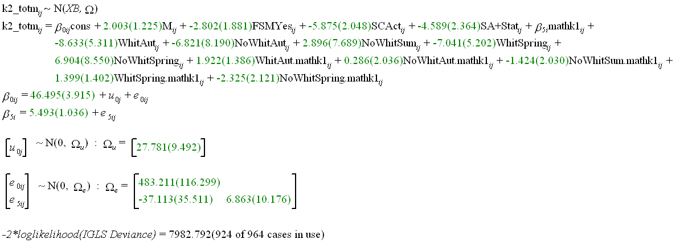

Consequently for a non-SEN and non-FSM pupil the equation for progress is as follows:
Whiteboard Summer Math KS2 = 46.5 + 5.49 * KS1
Whiteboard Spring Math KS2 = 46.5 – 7.04 + (5.49 + 1.40)* KS1
Whiteboard Autumn Math KS2 = 46.5 – 8.63 + (5.49 + 1.92)* KS1
No Whiteboard Summer Math KS2 = 46.5 + 2.90 + (5.49 - 1.42)* KS1
No Whiteboard Spring Math KS2 = 46.5 + 6.90 + (5.49 – 2.33)* KS1
No Whiteboard Autumn Math KS2 = 46.5 - 6.82 + (5.49 + 0.286)* KS1
As Figure 3.3 shows, not having a whiteboard seems to have a beneficial effect on progress for those of lower prior achievement if pupils are born in the spring and the autumn. There is again a need to stress the lack of power in the present study. This is particularly the case for this model as we are in effect fitting six separate lines, one for each combination of the intervention and birth-term categories. Thus the line for spring birth and no whiteboard is only based on 68 pupils.
Model 5: overall effects of length of exposure
This model includes the continuous measure of the length of time in months that the classes have been exposed to the whiteboard (using the continuous measure instead of the binary whiteboard or not should give us more power to detect an effect).


For every month that the class experience the whiteboard, the mathematics scores go up by 0.24 points (a Wald p value of 0.08). Figure 3.3 shows the general trend so that a year of whiteboard availability would seem to increase overall progress in mathematics by some 2.88 (0.24 * 12) points, and this value is approaching conventional significance.
Model 6: differential effects of length of exposure for pupils of different prior attainment
This model builds on Model 5 but includes interactions between length of exposure and the prior attainment values grouped for convenience of display and interpretation into three groups of average, above average and below average on the maths Key Stage 1 score, with the below average being taken as the base. The continuous score for Key Stage 1 maths is kept in the random part of the model at the pupil level.


Figure 3.3 shows that the results with all three prior ability groups showing improved progress as the length of potential exposure to whiteboards increases, with slightly greater differential progress being made by the most able pupils as the length of exposure increases. Once again we caution about the over-interpretation of results with large standard errors.
Model 7: differential effects of length of exposure for pupils of different prior attainment and different genders
The final model is to include differential effects for gender in interaction with prior attainment again specified as three groups.


The graphs in Figure 3.4 suggest that both genders and all three prior ability groups show greater progress with potential exposure to whiteboard technology, with the exception of the female average ability group. In particular, boys of average and above average prior ability show progress in mathematics with increased exposure; the slopes for equivalent girls are flatter, especially for girls of average ability. In short exposure to the intervention generally produces some benefit and that is particularly the case for boys.
The same procedures applied to mathematics, were also applied to the English and science domains. The pre-intervention scores for science are based on the teachers’ assessment while those for English are derived from summing the reading, writing and spelling scores (this is a highly valid procedure given that the correlation between each and every pair of these variables exceeds 0.75). The results for all three domains are set out in Table 3.1 (for questions 1 to 4) and in Table 3.2 (for questions five to seven dealing with the effects of length of potential exposure to whiteboards).
Conclusions from Phase 1 research based on a reduced data set
We have shown that it is possible to use PLASC data to provide information to asses the effectiveness of whiteboards. This has been done for three subjects (mathematics, science and English). Moreover, multi-level modelling has been shown to be an effective tool for answering a range of questions about the intervention. The substantive results are interesting in that different effects are found for different subjects and it would appear that the whiteboard intervention can be differentially effective by gender and by prior achievement. Thus in examining the progress in English (Figure 3.10) in terms of length of potential exposure to a whiteboard, there are complex gender effects. ‘Above average’ and ‘Average’ males show improved progress with potential exposure to the whiteboard, the effect is neutral for females of ‘Average’ prior ability, but the effect is detrimental for ‘Above average’ females and for ‘Below average’ pupils of either gender. However, due to the lack of classes not experiencing whiteboards, each of the effects has a large standard error resulting in these conclusions being far from watertight.
Appendix 2: summary of findings from Phase 1
- Increasing exposure to interactive whiteboards may have a positive impact on progress in maths (analysis approaching statistical significance)
- There may be differential gender and prior attainment effects in maths
- a positive trend for average and high attaining boys and girls
- low-attaining boys and girls making greater progress without exposure to interactive whiteboards
- There may be differential gender and prior attainment effects in science
- Increasing exposure to interactive whiteboards may have small positive impact on progress in English
- There may be differential gender and prior attainment effects in English
- a positive trend for average and high-attaining boys
- average and high-attaining girls make more progress without exposure to interactive whiteboards
- There may be differential effects by prior attainment in English
Table A1: Effects of whiteboard absence/presence
Pre-test | Post-test | Comparison | Overall | Differential progress | Gender differentials | Term of birth differentials
Figure 3.2 k1_math | K2_totm | KS1 test level to KS2 test raw score | Small positive effect for whiteboard. An overall rise of 2.3 in test scores by comparison with those taught without an IWB | Greatest positive effective for the more able on pre-score | Most effective for more able boys on pre-test; detrimental to low score on entry females | Absence of whiteboard shows greater progress for those of lower prior ability born in the Spring and Summer; overall not a great deal of difference of differential effect by term of birth.
Figure 3.4  k1_scita | k2_tots | KS1 Teacher assessment level to KS2 total science | Negligible difference between those with and without whiteboard | Whiteboard associated with greater improvement for less able on pre-test | Greatest positive effect for whiteboard for females with low scores on pre-test; otherwise very little difference between the groups | Positive effect for those born in spring and summer with low pre-test scores; otherwise little difference between groups
Figure 3.5  k1_read + k1_writ + k1-spell | k2_tote | KS1 test level to KS2 test raw score | Negligible difference between those with and without whiteboard | Positive effect of whiteboard on the more able on pre-score | Presence of whiteboard narrows the gender gap in progress; males without IWB generally show the least progress | Lack of whiteboard associated with greater progress for those born in the spring and who scored lowly on pre-test; otherwise little difference between the groups.

Table A.2 Effects of length of experience of whiteboard
Figure | Post-test | Overall | Differential progress by prior attainment | Differential progress by prior attainment and gender
Figure 3.3 | K2_totm | Longer experience of whiteboard leads to improved results overall | Improvement experienced by all three prior ability groups; Below, Average, and Above average on pre-test all show improvement with potential exposure to whiteboard | All ability groups and both genders show improved progress with potential exposure to whiteboard with the exception that the effect is only neutral for females of ‘Average ability’. The beneficial effects is most marked for ‘Average’ and ‘Above average’ males.
Figure 3.4  k1_scita | k2_tots | Very small positive effect overall for experience of whiteboard | Whiteboard associated with greater improvement for below average on pre-test; essentially neutral for ‘Average’ and ‘Above average’ prior attainment | Complex gender effects such that whiteboard availability is beneficial for both genders if ‘Below average’ and for boys in general of all prior abilities. But detrimental for females of ‘Average’; and ‘Above average prior ability’.
Figure 3.5  k1_read + k1_writ + k1-spell | k2_tote | Small positive effect overall for experience of whiteboard | Whiteboard associated with lack of progress for below average on pre-test; neutral for above average prior ability; beneficial for average ability | Above average’ and ‘Average’ males show improved progress with potential exposure to the whiteboard, the effect is neutral for Females of ‘Average’ prior ability, but the effect is detrimental for ‘Above average’ females and for ‘Below average’ pupils of either gender.
Appendix 3: multi-level estimates
This appendix presents all the models used to construct Figures 3.1 to 3.8. Each model consists of a fixed part which gives the relationships across all pupils and all classes; and a random part which accounts for unexplained variation between class, and within class between pupils. In both the fixed and the random part the estimates of the standard error are bracketed. In each model the constant represents the category of pupil who the other categories are contrasted against. The random part of the model has a complex variance function involving a continuous measure of prior attainment at Key Stage 1 which has been centred around its mean. A full interpretation is only provided for the first model as the same procedures can be used for all other models if required.
Mathematics: gender interactions, data pooled across cohorts
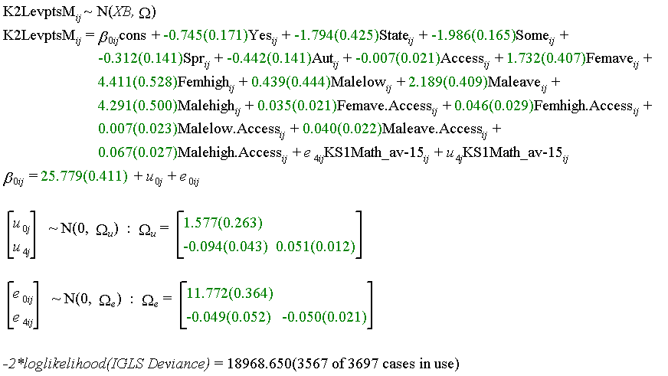

As can be seen from the fixed estimates, a low attaining at Key Stage 1 girl, born in the summer term, who has no special needs and is not eligible for free school meals, who has had no exposure to an interactive whiteboard, is estimated to have a Key Stage 2 maths points score of 25.78. This suggests that this category of pupil is almost five months behind, 1.2 level points away from the expected level points score of 27 which the typical pupil should be attaining at Key Stage 2. The ‘Yes’ variable signifies eligibility for free school meals. Such pupils score 0.75 level points lower; that is they are three months further behind the baseline pupil. This effect is highly significant as the estimate is more than four times the standard error, as compared to a ratio of two for statistical significance at 95 per cent. The next two parameters are estimates of the effect of statementing and school action/action plus on progress. It can be seen that such pupils obtain a point score that is 1.8 and 1.99 points lower than the baseline pupil. This equates to 7.2 months and nearly eight months respectively; both effects are highly significant. Autumn born pupils score 0.44 points lower and spring born pupils score 0.31 points lower. This equates to 1.8 months and 1.24 months respectively, and these differences are statistically significant. That is summer born pupils make the greatest progress, which is unsurprising. The parameter associated with the ‘Access’ variable represents, because of the three-way interactions between gender, Key Stage 1 attainment groups and access, the effect of exposure to interactive whiteboards on the females of low attainment. All the other coefficients in the model have been fully interpreted in the text above. The random part consists of between class and between pupil variation as a function of Key Stage 1 attainment. This is most easily appreciated as a graph. Clearly, between pupil unexplained variance is consistently greater than between class variance. For pupils the greatest heterogeneity in progression is experienced by children with average Key Stage 1 attainment (15 Key Stage 1 maths points). Classes make the greatest difference in contrast for high and low attaining pupils; this is particularly the case for those with low prior attainment.
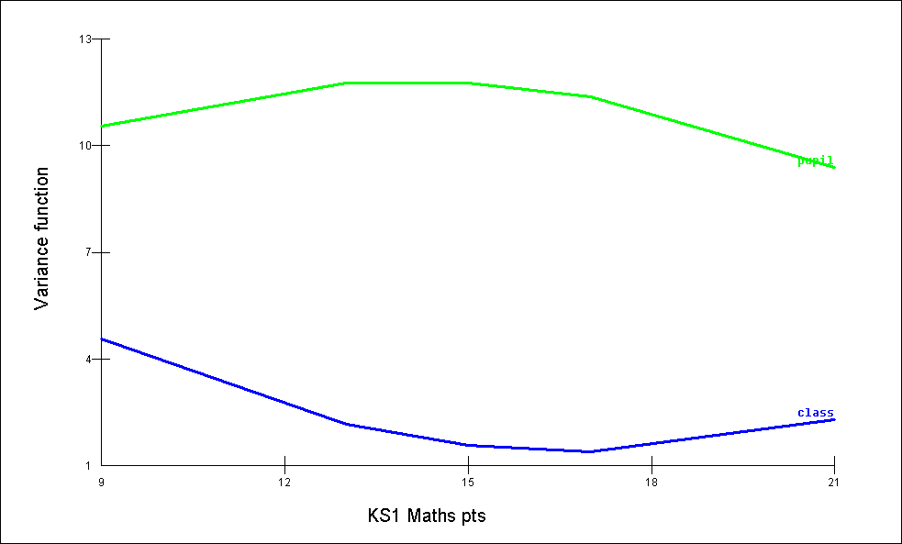

Mathematics: gender interactions, disaggregated across cohorts
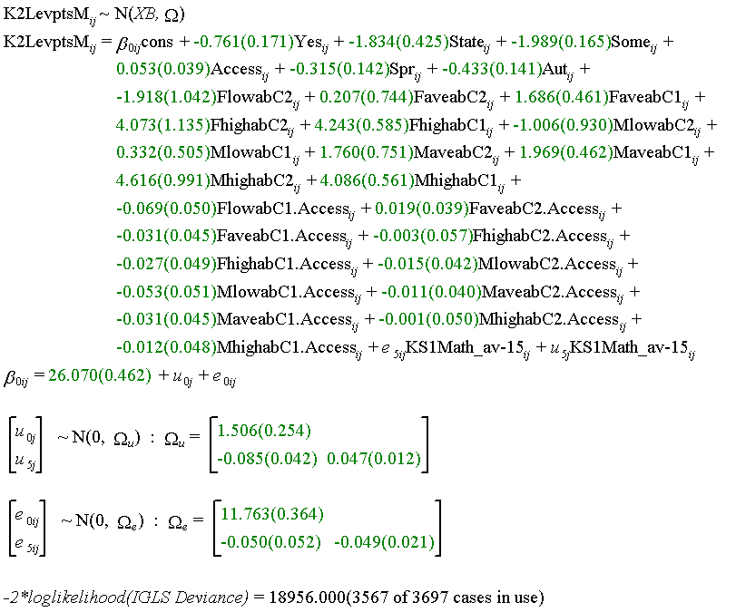

Science: gender interactions, data pooled across cohorts, Key Stage 1 science as measure of prior attainment
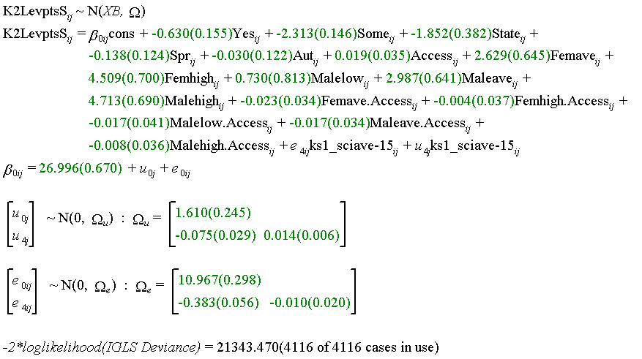

Science: gender interactions, data pooled across cohorts, Key Stage 1 maths as measure of prior attainment
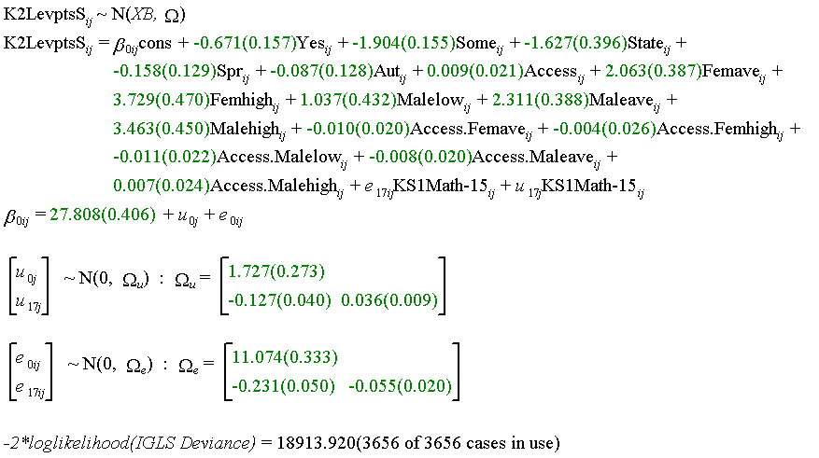

Science: gender interactions, disaggregated across cohorts
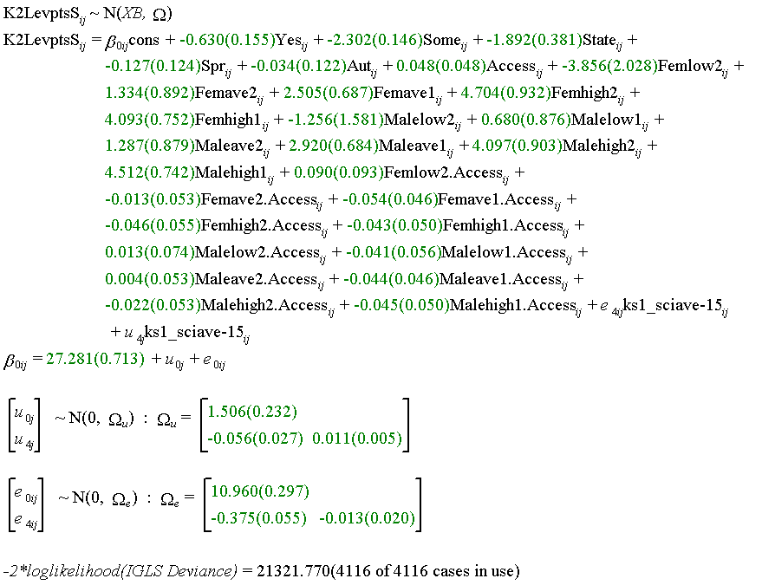

English: gender interactions, data pooled across cohorts
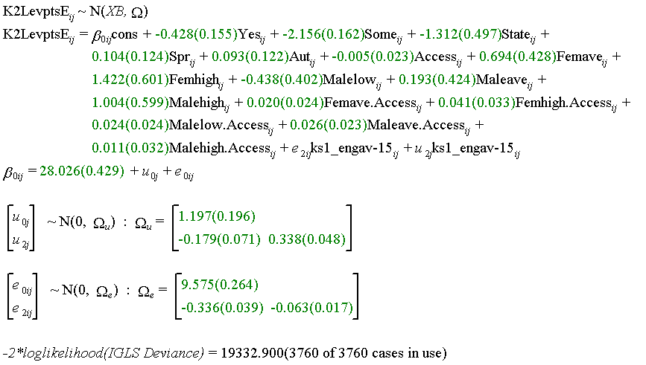

English: gender interactions, disaggregated across cohorts
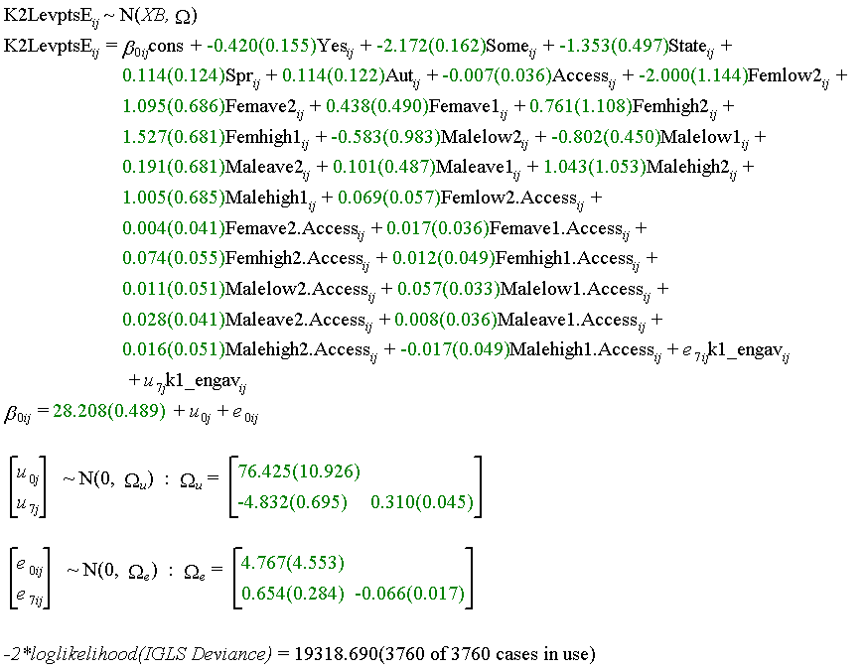

English – writing only: gender interactions, data pooled across cohorts
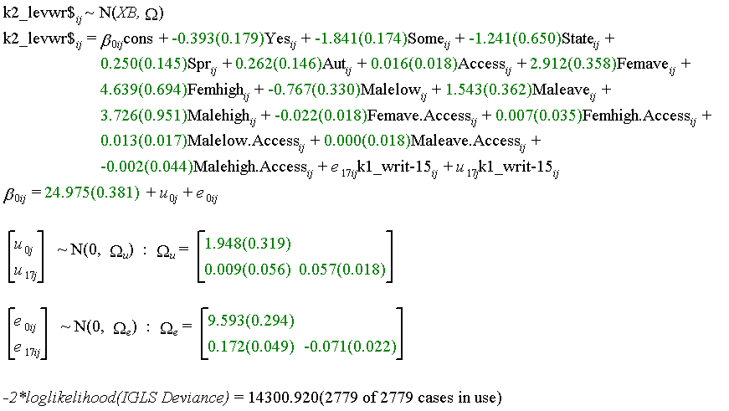

English – writing only: gender interactions, disaggregated across cohorts
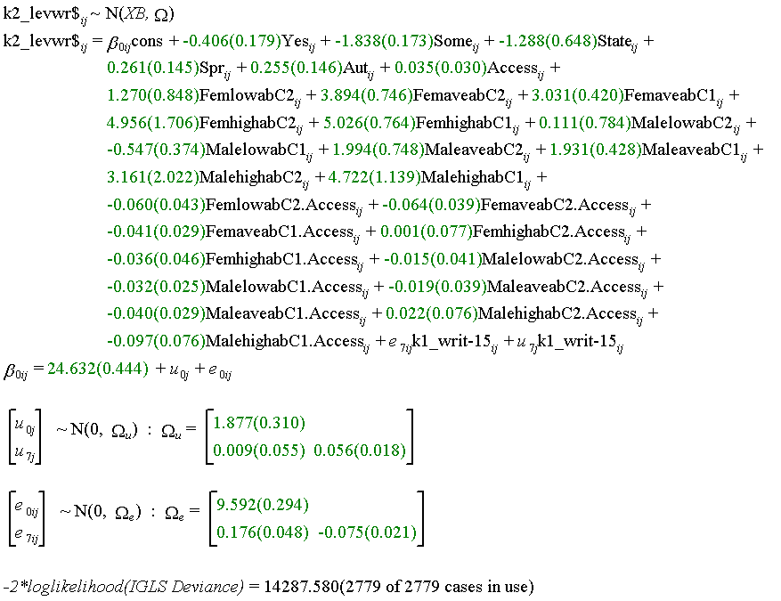

Appendix 4: methodology of Phase 1 case study research
Research design and rationale
Data sources and procedures
Using bench-marking data, a stratified sample of 10 schools was drawn from the full cohort receiving interactive whiteboards through the SWE Primary Strategy. This was to ensure that this more in-depth qualitative work took place across a cohort of institutions that were demographically balanced; had an appropriate mix of ethnic and socio-economic groupings; and were suitably balanced across nursery, infant and junior phases.
This meant that a case study school was selected from just over half of the participating local authorities, drawn equally from:
- the 11 local authorities which have already been involved in the primary-level interactive whiteboard pilot scheme
- five local authorities which are involved in a related Key Stage 1 and two pilot local authorities to test out the impact of laptops and computer suites on primary subject teaching and attainment
- five London local authorities to link in with the London Challenge drive to equip secondary schools with interactive whiteboards.
Table A4.1: Case study schools, location and number of visits
School ref. | School type | Visits | LA type | Location
1 | Primary | 2 | Mixed | Suburban
2 | Primary | 2 | Shire | Town
3 | Primary | 3 |  | Suburban
4 | Primary | 3 | Shire | Village
5 | Junior | 2 | Shire | Town
6 | Primary | 3 | Metro | Urban
7 | Community | 2 | Shire | Town
8 | Middle | 2 | Metro | Urban
9 | CE School | 3 | Shire
10 | Primary | 1 | Shire | Town

General procedures
The case studies involved short intensive episodes of data collection in the ten selected schools during the period September 2004 to March 2006. Of the 10 schools in the sample, four received three visits. This frequency of visits was intended to track changes in teachers’ pedagogy and pupils’ responses to the interactive whiteboards over time, and to monitor progress from early work to final achievements. Five of the remaining six schools in the sample received two visits, which also allowed monitoring over time, but without the mid-way monitoring. The remaining school declined to receive its second visit because of disruption caused by building works and staff illness. The four schools that were visited on three occasions were selected following initial visits to all ten schools. These four were judged to be the most developed in terms of their use of interactive whiteboards with pupils at that time. With the exception of the smallest school which had a one-day visit, each visit occupied two days, in the same week if not on consecutive days.
A blend of research methods was used within the case studies in order to gather a wide range of data and monitor development over time. Activities during the visit included classroom observation sessions with video cameras, interviews with the teachers whose lessons were observed, interviews with small groups of children who were in the observed lessons, and interviews with other key staff, including the headteacher. In nine schools the researchers worked with four teachers, observing one lesson for each teacher on each visit. In the tenth, and our smallest school, two teachers were observed in two lessons during each visit.
This combination of visits with repeat observations over time has provided an interesting mix of 'wide angle' and 'tight focus' studies. The former have proved particularly suited to bringing out the wider school context that enables the teachers to work as they do. The more tightly focused studies that included video recordings have generated data that can be closely examined in four or six lessons per class over the two or three visits respectively. This has facilitated a well-grounded analysis of how the practice of these teachers evolved over time.
Approaching the schools
As they were taking part in the general evaluation of the Schools Whiteboard Expansion Project, a number of suitable schools were initially sent a questionnaire to complete that would provide sufficient background information to guide the selection of the ten case study schools. Then letters were sent to thank the headteacher and staff for completing the questionnaires and to invite them to become a case study school. These letters of invitation were important in setting out what the schools and the staff would be agreeing to do.
A leaflet was enclosed suitable for display in staff rooms and distribution to parents. Both the leaflet and the letter explained that becoming a case study school would involve:
- classroom observations and, where agreed, video-recording
[Four in all on each visit. Parental permission as well as staff and pupil permission was a precondition for video-recording]
- interviews/discussions with teachers and other key staff
[No more than 30 minutes with each individual on each visit]
- focus group interviews with pupils
[As soon as possible after the observed lesson in which they participated]
- teachers’ logs of interactive whiteboard use
[Brief record of use, on a pro forma, during a period of two weeks immediately prior to each visit]
The teachers to be involved were expected to have interactive whiteboards installed in their classrooms and, as far as possible, to be drawn from different year groups. It was noted that, in a small school, the project could work with just two teachers and carry out two observations in each of their classrooms rather than one, and this did happen in one school. The headteacher was asked to nominate a contact person to liaise with the visiting researcher and to organise a time-table for each visit, and payments were offered to cover one day of supply cover for each visit.
Schools were told there would be no more than one case study school from any one local authority, and that the schools would not be named. Anonymity was assured in all reporting, and it was stated explicitly that the resulting report would provide a series of vignettes rather than a full account of the work of any individual school.
The letter included two offers. The first was to share expertise with the headteacher and the school’s co-ordinators for ICT, literacy and numeracy, and with teachers, hoping that the staff would find the interactions a useful opportunity for CPD. The second offer was an invitation for representatives from each school to attend a feedback day conference on completion of the research. The letter closed by naming the researcher who would contact the school by telephone, should the invitation be attractive, to hear initial reactions and answer any questions.
The expectation was that on a visit day the researcher would want to arrive early, at 8am for example, and leave after school was over. This would enable a full view of the way that interactive whiteboards were used throughout the school day. Interviews with staff could take place before school began, after the end of the teaching day, or during the day if the supply cover was used.
The nominated case study teachers were all sent personal letters in advance of the first visit. Later contacts were often by email. The letters requested permission to observe in their classrooms, enclosed the information sheet and ethical code of practice, and gave contact details of the researcher concerned in case the teacher had any queries. Teachers were asked to send letters home to parents in advance each of the evaluator’s visits to request permission for lessons to be video-recorded for research purposes only (as required by the data protection act). This particular part of the procedures worked very well. It was never more than a small number of children – twos or threes at most – who did not take part in a videoed lesson because they had not returned a signed release on that occasion.
Data collection and recording
Classroom observation and video recording
Over the period of the research the ten schools were visited a total of 23 times. Video recordings were made in 92 lessons, four lessons on each visit. The observations were of how teachers and pupils used interactive whiteboards in literacy, numeracy and other curriculum subjects. In the lesson observations the researchers also made written notes.
However, there were practical problems associated with the use of video, and mistakes happened. One researcher missed 15 minutes at the beginning of the first lesson recorded because the camera was thought to be running when it was not. The camera kept switching itself off because it was only on standby. Two other researchers found that their tripod heads did not pan smoothly. The video recordings were correspondingly jerky, and the sounds made as the tripod reluctantly moved, registered on the video camera’s microphone.
Experience showed that the lighting in some classrooms meant that it was necessary to be at the side, looking across the board rather than looking straight at it, if the camera was to capture what was on the interactive whiteboard. It was also wise not to rely on batteries lasting through a lesson, and to have the camera plugged into the mains. But this restricted movement of the camera during a lesson, and one researcher developed a very effective technique of hand-held recording. However, in the smallest school, there was insufficient space for movement around the classroom during the lesson without being disruptive. In this case, and in many others, the choice of camera position(s) required serious deliberation. The intention to use digital recorders, as well as a video cam with its own microphone, to record lessons, did not really work out. This was because ambient noise levels proved too high, the microphones on the recorders were not directional enough, and the recordings could not be heard well enough for analysis.
A technique evolved in which, when there was something interesting on the board, priority was given to capturing the image on the board, and the pupils’ response. This could be done by panning and zooming with the camera on the tripod, but needed facility with the camera’s controls. However, working in this way meant that it was often impossible to keep full notes of the lesson to accompany the video record. Differences between different makes of interactive whiteboard in visibility also had an effect on recording techniques. For example, one type of interactive whiteboard appeared quite ‘blurry’ when one was really close up to it, but it could be videoed successfully from any part of the classroom. Another type of interactive whiteboard needed a tight zoom onto whatever was displayed, if the display was to be recorded clearly. This added an additional consideration when trying to capture both what was on the board and the pupils’ reactions.
Deciding whether to video the board, the class, a group of pupils, a teaching assistant helping a child with special needs or some other sequence of events, inevitably means losing at least one other shot or sequence that could have been chosen as an alternate focus. There is thus a kind of ‘opportunity cost’ attending the choices that are made. As one researcher described:
‘ … in one classroom [in one shot] I’ve got children on their own in small groups at the board, that’s the reception, and then in another [shot] I’ve got one teaching assistant with two boys. Both of those are exceptionally interesting to us … Unfortunately, in the middle of those [activities] I panned round and looked at the rest of the class. So I missed some of the key things about what these children were doing. It’s not that I lost it all. But I lost something there which was a bit of a shame.’
Had the lesson not been videoed, this realisation would not, perhaps, be so evident. However, the fact that recordings are inevitably selective means that teachers can justifiably say that, even with video evidence, researchers are only able to report a partial picture of what happens in classrooms. Correspondingly, there has to be recognition of the associated limitations on what it may be claimed the video recordings are sampling.
Logs of interactive whiteboard use
The selected teachers in each school were asked to keep a log of the use they made of interactive whiteboards in their teaching in the fortnight leading up to the visit and lesson observation. The logs took the form of pro forma sheets, specially designed to make their completion quick and easy. Nevertheless, our sample of teachers proved little different from others in the past. Persuading informants to keep a diary always has difficulties if it is not a part of normal procedures, which was not the case here.
It had been hoped that asking teachers to make their log entries in the fortnight before a visit would exert a pressure for compliance. The teachers knew that researchers hoped to base discussions of interactive whiteboard usage partially, at least, on the log book records, particularly if a teacher felt that their observed lesson did not do full justice to the range of their normal interactive whiteboard usage.
This tactic had some success. From the 23 visits that should have yielded 86 completed logs we received 53, representing a respectable return rate of 63 per cent. A large majority (80 per cent) of the logs provided information for more than one week of teaching. The others gave good reasons for partial completion. This suggests that if a teacher did not maintain the log book record fully, they did not return it. This experience would be in line with past attempts to employ any kind of diary record in social research. Despite these relative short-comings, the yield in terms of useful data from the log books that were completed and returned was excellent. The information covered classes from reception up to Year 7, with the logs providing details of 1083 National Curriculum subject lessons in which interactive whiteboards had been used. There was also information about other times when interactive whiteboards were used – in assemblies and ‘circle time’ for example.
Interviews with teachers, pupils and others
The classroom observations were accompanied by interviews to assess the general impact of the use of interactive whiteboards within the school. First the teachers who had been observed teaching were interviewed individually, usually soon after the observation while events were still fresh in the mind and discussion of specific events was relevant. The intention was both to gather their perceptions on how they had used the interactive whiteboard in the specific lesson, and to gain a more general view of how, when, how much and why they used interactive whiteboards. They were also asked about their perceptions of the impacts on pupil motivation and behaviour.
Senior school managers and ICT co-ordinators were also interviewed to provide a broader, school-level overview of vision, management of change, leadership, policy, planning, organisation, training, CPD, procurement, installation and technical issues. These interviews tended to take place more frequently in the early visits because, on later visits, those concerned felt they had already made their contributions.
Whenever possible, researchers also conducted a focus group interview of about 30 minutes duration with six pupils drawn from the class that had just been observed. This was to discover pupil perceptions of the impacts of interactive whiteboards on their experience of teaching and learning. The number of pupils interviewed sometimes varied, as did the time between an observed lesson and the following group interview, but pupil engagement was genuine and helpful. As the procedure was followed for all classes, overall, the focus groups consulted children across the full spectrum of the primary age range. These interviews were recorded at the time, and summarised for later analysis. The perceptions of pupils thus revealed have provided a useful cross-check on the judgements made by researchers during lesson observations concerning pupil motivation, engagement and enjoyment.
Observer effects and other issues
It is well understood that the known presence of an observer will affect any situation being observed. With the addition of a video camera in a classroom there is an extra dimension. Even allowing for the selective focus of a video camera, the room for dispute over what actually occurred is smaller. Correspondingly, those being observed may feel additional tensions. We know that, in many of the classrooms we observed, teachers were to some extent ‘putting on a show’ of what they could do with an interactive whiteboard. We know this because in most cases teachers felt able to tell us so. In one instance the ICT co-ordinator said that the lesson was completely put on for the researcher’s benefit. In another instance things went wrong because the teacher was trying to do advanced things to show the researcher what was possible.
In the first round of visits this ‘putting on a show’ was more the case than in subsequent visits. We are able to judge this well because, once again, most teachers were ready to be open about how their observed lesson had been planned. Often this kind of information emerged conversationally, as teachers discussed the pressures of preparing for national tests or the need to cover the National Curriculum. At other times the information would come as the log book records were used to discuss normal patterns of usage in our interviews with teachers. It undoubtedly helped that teachers knew that they, and their schools, had a guarantee of anonymity.
‘Putting on a show’, in the context of our research was, in fact, teachers trying to help. It was, after all, why the school had agreed to take part, and these particular teachers had agreed to be observed. Children too tried to help. In restricted spaces children would move their chairs to give way to our researchers as they had to move camera positions. Some children would also do their best to feature on camera, no matter how hard the researcher tried to avoid recording children’s faces. Teachers could also try to incorporate the observer. One researcher told how she was asked on one occasion when observing a lesson, ‘What do you think, X?’ Unfortunately, at that precise moment, X wasn’t listening!
Despite having volunteered, in a few situations teachers displayed nervousness in front of a camera, and this could become serious. In one case a junior school teacher cut short a geography lesson that should have been 55 minutes long by 15 minutes because, as he admitted later, he became unnerved by the fact that he felt presence of the camera too keenly. In another instance, in what the researcher thought was a very successful science lesson, the teacher would not let the researcher interview him at the end. He said that, when somebody observed him, all it did was to show up his shortcomings. This tendency towards setting too high a standard for oneself was shared by another teacher who at one point dropped her cool and said to her class: "Would you please all attend, the camera’s here and I’m trying so hard." In another lesson, the teacher said to his class, "You’re letting me down, and you’re being videoed." to which the researcher’s mental, but unspoken response was, "I’m not here as a disciplinary aspect of his lesson."
In contrast, pupils were resilient and managed to take it all in their stride, as this brief note of an incident attests:
'The teacher said, "After we’ve done this, I’m going to ask some people to be very kind and go and talk to Bridget." This little child said, "Who’s Bridget?" and the teacher said, "Have you forgotten? Turn round and have a look at her." So they’d actually completely forgotten I was there.'
While these observer effects have been noticeable in this research, the relevant question is whether this in any way negates the validity of the findings we report. In our view, the effects in this research have served to skew situations in directions that have been beneficial in terms of the aims of the research. Because teachers have consciously tried to help by showing what they find possible with interactive whiteboards, we have confidence that what has been observed represents situations close to the leading edges of interactive whiteboard usage in primary schools. It certainly adds to our confidence that we have seen a good range of usage.
Analysing the data
By the end of the field work visits an enormous amount of qualitative data had been collected. This included approximately 92 hours of video recordings, over 50 hours of recorded teacher interviews and 45 hours with pupils. The procedures required to reduce, analyse and fairly summarise qualitative data sets of this magnitude have recently been discussed in some detail within the ongoing work of the ESRC TLRP programme of educational research. See, for example Steadman (2005) and the exchange between Hodkinson (2004) and Hammersley (2005). However, the analysis of video material was not covered in these writings, so the Sweep project devised its own procedures which are set out below.
Stages, frameworks and interpretation
A classroom observation schedule was used to ensure commonality of focus across the research team and coverage of all data needed for subsequent analysis. It specified a combination of systematic recording to produce a lesson profile, and open-ended recording to include descriptions of events and some verbatim quotations from pupil to pupil and pupil–teacher interactions. This schedule was also used in the very first stages of the analytical consideration of video recordings.
Thus data reduction began after every visit. This entailed producing written summaries of the whole visit, and of the lessons that had been observed, based on notes made at the time of the visits and observations. What to focus upon, and what to select for quotation, were key questions and, as the visits proceeded, a series of discussion group meetings were held to share insights and reach agreement. Key meetings were formally organised, recorded and transcribed so that all the team had access to decisions, even when not able to be present.
The video data presented novel problems. The written lesson summaries in themselves did not allow a close enough focus on what happened when interactive whiteboards were in use. Discussions after a first round of visits led to the construction of a further guide to analysing extracts from videoed lessons (See Appendix 5). This put the focus upon the three phases of literacy and numeracy lessons expected in the national strategies: whole-class introduction; group work; and plenary. Researchers were asked to select three 5-minute extracts from each lesson. Where possible, the aim was to capture interactive whiteboard use, or closely associated activities, in each of the three phases of the lesson. Each extract was then viewed three times in the light of the suggested areas of interest set out in the guide, before a written summary was produced of each extract. Joint viewing sessions were also organised. In these meetings, team members presented video extracts for discussion and analysis by the team. The sessions helped to generate an agreed ‘community’ interpretation of what was being seen by the research team.
In additional, to ensure a balanced view of what happens when interactive whiteboards are used in teaching, during the reporting phase team members were asked to check their accounts against a list of topics that the team agreed it would be important to include in a final report. This was to ‘count’ the frequency with which issues had been identified in different schools and classes, and by teachers and pupils, so that the report could indicate different degrees of usage with some confidence.
In reaching its interpretations of the data, the team has drawn upon a number of perspectives that should be acknowledged. The team has inevitably drawn upon the experience and perspectives gained in previous researches into ICT. An analysis of ‘Levels’ of expertise in interactive whiteboard use, developed during the lifetime of the evaluation, proved helpful in understanding classroom interactive whiteboard practices. Another important perspective is embedded in accepted views of teaching effectiveness as exemplified in action in the work of Ofsted in recent times. But perhaps the most important set of perspectives is that indicated in the review of research literature that was offered in the May 2005 Report. It is now possible to view the evaluation’s data in the light of that literature, in order to inform judgements on efficacy and the likely mechanisms whereby effects on standards of achievement are being realised.
Hammersley, M. (2005), 'Countering the ‘new orthodoxy’ in educational research: a response to Phil Hodkinson', British Educational Research Journal, 31(2), 139-155
Hodkinson, P. (2004), 'Research as a form of work: expertise, community and methodological objectivity', British Educational Research Journal, 30(1), 9-26
Steadman, S. (2005), Methodological Challenges in Studying Workplace Learning. Paper to the BERA Conference, Pontypridd.
Appendix 5: protocols for video analysis
The following protocol was issued to support the analysis of video recordings.
Lesson extract analysis guide
Introduction
The aim is to focus analysis on three 5-minute clips from each of the four videoed lessons. Agreed procedure is to watch the clip, write some analytic commentary, repeat to add points or increase detail, and repeat one last time for completeness, for example adding quotations. Points from all three clips are then combined to produce a write-up of the lesson as a whole.
Over the four different lessons it would be good for the clips to span different phases in lessons, such as introduction, different forms of group work, and plenary or end of lesson stages.
We will all need to note these basic descriptors:
- Lesson descriptors as in the table in the project’s existing ‘Lesson observation schedule’.
- Curriculum topic being taught and intended learning outcomes.
- Where in the lesson the extracts were placed – in time and in the lesson sequence.
NB As the write-up of the lesson is not intended to be much longer than three or four sides of A4, we cannot include everything in the check-list. We will have to be deliberately selective. The check-list provides reminders of aspects you may decide to include in your notation of a 5-minute clip because they help to focus the analysis.
In the analysis of each 5-minute clip it may be useful to include something from each of the three numbered subsections, and refer to the last two ‘judgement’ sections when thinking of the lesson as a whole. However, this is only a suggestion. You may feel that, if you are to do justice to the lesson, analysis of a particular clip requires more attention to aspects in only one or two of the numbered sections.
The checklist of possible aspects:
- Teacher/TA controlled aspects:
- Use of space before the board, and elsewhere in the ‘room’.
- Interactive whiteboard modalities used and their sequence, eg text document to static image to moving image etc.
- Use of additional tools/facilities, eg to move, annotate, identify, delete, or interact.
- The interactivity this allows pupils:
- 1) technical - what Ps do with the interactive whiteboard 2) pedagogic – that facilitate learning 3) social
- Match with teaching aims, eg conveying abstract concepts; dynamic modelling; visual, auditory &/or kinaesthetic learning?
- Pace and flow in terms of
- number of changes in focus of learning; modality and pupil activity
- What consequences –, children’s active interactive whiteboard use, discussion, pupils’ own initiatives, other?
- Aids to the flow such as advance organisers’ and conceptual re-visiting.
- Use of modalities to aid differentiation?
- The teacher’s behaviours, eg use of language; eye contact; non-verbal communication; nature of questioning –open/closed, inclusive, directed.
- Aids to assessment in the way the interactive whiteboard is used by the T/TA.
- How children are rewarded – & other aspects of behaviour management that relate to the teacher’s control of access to the interactive whiteboard (eg is potential disruption forestalled by granting certain pupils access to the board?).
- Children’s activities/contributions:
- What happens precisely when pupils:
- ‘Come up to the board’; use the interactive whiteboard in small groups with no adult; or with teacher/TA?
- Levels of children’s attention - percentage of group; sustained; influences upon. (Wow factor?)
- What activities do they engage in? Joint exploration by teacher (TA) and pupils; consolidation / practice; extension by T or Ps; or extrapolation by pupils – giving own ideas.
- What facilities &/or tools do pupils use?
- Turn taking and equal access? (See also the last bullet in Section 1)
- The purposes of children’s activities – and what they actually learn, intentional or not?
- Children’s skills – range in class/group; adequate or problematic; unexpected?
- Relationships:
- Teacher (TA) – pupil; Pupil – pupil; Types and how they are evidenced? eg types of discourse; sharing access & responsibility; inclusion and differentiation.
- Who helps whom to learn?
- The focus of pupils’ attention over time in the videoed extract.
Evaluation Judgements
Based on a lesson extract, or the lesson as a whole:
- Match of topic being taught and: use of interactive whiteboard modalities and facilities/tools; structure of the lesson as a whole? Good, OK, some queries?
- Engagement of pupils – what percentage are interacting, entertained, coasting?
- Appropriate pace? Did it change at all? Did it suit all pupils?
- Differentiation – were different aspects of interactive whiteboard use deployed to facilitate this?
- Does this interactive whiteboard teaching style give children more ownership of their own learning?
- Which aspects of the teaching could not have been provided without an interactive whiteboard?
Wider judgements:
- Does the use of the interactive whiteboard seem to be enhancing former approaches to teaching, or facilitating the development of an altogether different pedagogy?
- How does the interactive whiteboard impact on the existing community of practice?
- Is ‘deep’ (as opposed to ‘surface’) learning being encouraged?
- Is anything being lost in the moves from traditional to this mode of teaching and learning?
- Do the teachers and pupils seem comfortable in the situation, or does it need to evolve further, or regress a bit (perhaps for more practised skill deployment)?
Appendix 6: useful web-based resources
These web-based resources were identified in case study visits and discussions with Case Study School representatives at the Sharing Day in May 2006.
- http://ambleweb.digitalbrain.com (free resources and links)
- http://automata.co.uk/mainpage.html (advice, resources and links)
- http://contentsearch.becta.org.uk (for finding resources)
- http://ngfl.northumberland.gov.uk (free)
- http://pow.reonline.org.uk (various links)
- http://www.bbc.co.uk/schools (variety of free resources)
- http://www.bbc.co.uk/schools/teachers (free)
- http://www.bbc.co.uk/schools/revisewise/ (free)
- http://www.cadburylearningzone.co.uk (site being redesigned)
- http://www.clickteaching.com/ (subscribe)
- http://www.coxhoe.durham.sch.uk (free resources and links)
- http://www.collinseducation.com/autosites/ (links to subscription sites)
- http://www.curriculumonline.gov.uk (search for 100’s resources; eLC purchases)
- http://www.easyteach.co.uk (buy)
- http://www.educationcity.com (subscription; free 21 day trial)
- http://www.education.smarttech.com/ste/en-gb/ (Smartboard resources)
- http://www.espresso.co.uk (buy)
- http://www.google.co.uk (images, maps, dictionaries)
- http://www.googleearthsite.com (free download)
- http://www.gridclub.com (subscription)
- http://www.hamilton-trust.org.uk (asks for donations to “save their site”)
- http://www.juniors.net (subscription)
- http://www.lancsngfl.ac.uk (Lancashire NGfL; free)
- http://www.lgfl.net (London Grid for Learning; free to London schools)
- http://www.mathszone.co.uk (free)
- www.ngfl-cymru.org.uk (Welsh NGfL; free)
- http://www.nwnet.org.uk (free resources)
- http://www.onlinecc.co.uk/Case.asp?id=2 (buy - Maths Rap CD-Rom)
- http://www.oup.co.uk/oxed/primary/ort/ (Reading Scheme; buy)
- http://www.primaryresources.co.uk (resources, links, planning and ideas)
- http://www.prometheanworld.com/uk/ (Promethean resources; free)
- http://www.rm.com/Primary/Products/Product.asp?cref=PD2392 (Snapshot; buy)
- http://www.sitesforteachers.com (lists sites for teachers by popularity)
- http://www.sparkisland.co.uk (subscription)
- http://www.standards.dfes.gov.uk/primary/teachingresources (free)
- http://www.teachernet.gov.uk/teachingandlearning/resourcematerials (free)
- http://www.teacherxpress.com/f.php?gid=01&id=19 (cross-cultural exchange)
- http://www.teachingideas.co.uk (free)
- http://www.teem.org.uk/curriculum_focus (evaluates software)
- http://www.testbase.co.uk (licence fee)
- http://www.theboardworks.co.uk (buy)
- http://www.topmarks.co.uk (links to interactive whiteboard resources + sites)
- http://www.uk.knowledgebox.com (buy)
- http://www.whiteboardresources.co.uk
- http://www.wiredforhealth.gov.uk/cat.php?catid=858 (free resources and links)
- http://www.woodlands-junior.kent.sch.uk (free resources and links)
- http://www.10ticks.co.uk (buy and free photocopiable sample packs)
Appendix 7: The second phase Sweep Extension Case Studies
Contents
This appendix has the following parts:

The conduct of the extension case studies
- Additional results – adding detail to the main section
- Hypotheses and instruments
- Special needs: interactive whiteboards and the needs of blind and partially sighted children – an interview with an local authority specialist advisory teacher

Part 1 – The conduct of the extension case studies
Main purposes
The third aim in the extension proposal was to enable detailed observational investigation of six classrooms/schools where progress between the baseline and post-test outcomes had been different from the main trend, and to develop explanatory theories for these outcomes. Results from the preliminary MLM work had tentatively indicated differences in the ‘National Tests measured’ progress through Key Stage 2 of schools, and certain subsets of pupils – by gender and/or ability, in different subjects, and in contexts where interactive whiteboards were, or were not, in use. None of the differences attained conventionally accepted levels of statistical significance, but the tentative indications provided the best information to hand. The differences of interest as indicated by MLM modelling up to that date are summarised in Appendix 1.
In pursuit of this aim, the case study team identified a series of hypotheses that derived from the tentative MLM analysis findings, with a view to looking for evidence from school visits, observations and interviews with teaching staff, that would either deny or support them. This was ambitious, given the small sample of schools and teachers that would be involved, but it was well worth doing because no research had previously had an opportunity to look at teaching practices in the light of any statistically linked hypotheses, however tentative. It was possible that some aspects of teaching style were impacting seriously on pupil progress when interactive whiteboards were used, but no one had conducted this kind of study. However, as later MLM analyses drew on more data, it turned out that the tentative hypotheses were not sustained, and data from the second, extension phase school observations were used in other ways as described below.
A subsidiary aim of the school case study work was to try to identify ‘what makes for excellence’ in teaching with the aid of interactive whiteboards. To this end the visit team set out to note any features that contributed to teaching of a very high or excellent standard. After analysis of all the data from a visit each research visitor was asked to make two judgements:
- Placement of the teacher on the ‘Typology of interactive whiteboard pedagogies’, that is, in one of the following categories: 1 Foundation; 2 Formative; 3 Facility; 4 Fluency, or 5 Flying.
- The degree to which ‘mediation of interactivity’ was evident in the teaching.
An additional, and provisional, estimation was then expected of where the visitor would think the lesson could be placed in relation to the MLM results, that is, whether the lesson was one conducted by a teacher whose children had scored well above, or below, the multil-level modelling average for progress. This estimation was provisional until the visiting team could meet and form a united view.
Selecting the case study schools
The multi-level modelling analytical procedures take into account the effects of pupil variables such as gender, take-up of free school meals, term of birth and SEN status when examining the progress made by pupils in a class group. An average rate of progress that allows for all these variables can then be calculated. However, in reality, the progress of individual classes, when all variables are considered, may fall above or below the calculated average rate of progress for all the sampled schools. Interest during the extension phase focussed on those – relatively few – classes that fell well above, or well below, the multilevel modelling average rate of progress. The intention was to see whether the differences in progress could be related to the way that teachers used their interactive whiteboards to teach those class groups. The 2006 MLM results were used to identify the appropriate class groups and their teachers, and the schools containing these class groups were asked to take part in the extension phase case studies.
The need for a ‘Chinese wall’
In order to make judgements as fair as possible, it was decided that a researcher who visited a school would not know where that school was positioned in the MLM results. This required the erection of a ‘Chinese wall’ between team members. So the six schools were selected by a separate member of the overall team who had access to the MLM results, but would not be taking part in any visits. This team member then allocated research team visitors to each school. This was a welcome move because it meant that, if teaching staff enquired why they or their school had been chosen for this phase of visiting, a clear answer could be given about the general aims of the extension, with the honest rider that it was not known why that particular school was in the visit sample. The direct question was asked in more than one school, and teachers appeared to be satisfied by the explanation. They readily appreciated the need for such a ‘Chinese wall’ arrangement.
Conduct of the school visits
In view of the stringent time constraints for fieldwork, selected schools were initially telephoned by Professor Somekh to seek access. By this time schools already knew how they had fared in the 2006 National Tests, and some of those that had done less well were, perhaps understandably, reluctant to take part. Three schools declined the invitation, so alternative schools were nominated and approached successfully. Detailed arrangements were then confirmed by each allocated research visitor. As in the first phase, log books were sent in advance of the visit. This time, however, their primary use was to allow teachers to talk about interactive whiteboard use within the observed lessons and say something of its typicality when compared within a brief record of up to ten days’ use of interactive whiteboards in lessons that were not observed.
A few of the schools had previous experience of having lessons videoed. One school, however, while willing to accept a visit in which the teacher of the class identified in the MLM records could be interviewed, did not agree to a video recording. It is always open to teachers to decline to have their lessons videoed. As there were actually no alternative schools left that fitted the criteria for selection in the MLM results, this school was still included in the visiting. The researcher observed the nominated lessons, and made written notes instead of a video recording.
During a school visit the intention was to video two lessons conducted by each Year 6 or Year 2 teacher. In the preliminary arrangements teachers had been asked to teach nominated subjects. These were ‘blind’ selected by the Sweep team member behind her ‘Chinese wall’ to be those for which the MLM records showed either above or below average outcomes in the analysis of National Tests achievement. Thus a teacher would be observed teaching two of the possible three ‘subjects’: English/literacy, maths/numeracy, and science.
The choice of when these lessons took place during the school day was left to the teachers concerned. As soon as possible after the lessons the teachers were interviewed, on tape for later transcription, for approximately 30 minutes. The head and the ICT co-ordinator were similarly interviewed although, in some schools roles overlapped, the co-ordinator could be one of the observed teachers, or less frequently, the headteacher. The questions used in the interviews are reproduced in Part 3 of this Appendix.
Table A7.1: The achieved sample of schools and observed lessons
The achieved sample of schools, teachers and observed lessons
School ref. and type | Teacher ref. | Year group | Observed lesson | Notes
E1 Primary | GL | Y2 | Literacy
E1 Primary |  |  | Numeracy
E1 Primary | BJ | Y6 | Science
E1 Primary |  |  | Maths
E2 Primary | JT | Y1 | Literacy | Teacher now with a new class*
E2 Primary |  |  | Science
E3 Primary | BJ | Y6 | English
E3 Primary |  |  | Science
E4 Primary | AS | Y2 | Science
E4 Primary |  |  | Numeracy
E4 Primary | AE | Y2 | Literacy
E4 Primary |  |  | Science
E5 Primary | TS | Y6 | Maths
E5 Primary |  |  | English
E5 Primary | FS | Y6 | Maths | No video record
E5 Primary |  |  | English | No video record
E7 Infant | GJ | Y2 | Literacy | In first term of a merger**
E7 Infant |  |  | Numeracy
7 schools | 9 teachers |  | 18 lessons | Totals
Notes:
* It was not known in advance of the visit that this former Year 2 teacher was teaching a different year group but, as the focus was upon how the teacher used an interactive whiteboard, the researcher decided to proceed and include the video and other data.
** The infant school had just been merged with a junior school to form a new primary school.

Part 2 - Additional results – adding detail to the main section
Emerging results of analysis
Treatment of the visit data was started by each research visitor analysing the observed lessons according to prepared protocols that reflected the search for evidence that would test the tentative hypotheses, and would also aid the three additional assessments listed above that had to be made in advance of the next stage of analysis (see Part 3 of this appendix).
The next stage involved a joint viewing of the 14 videoed lesson extracts that were available at that time. The relevant researcher-visitor selected single extracts of five to 10 minutes from each lesson that would show the best example of when the teacher was acting as an effective ‘mediator of interactivity’ with the interactive whiteboard. These extracts were then simultaneously viewed by the three visitors, and two other members of the Sweep team, only one of whom knew where the schools and teachers stood in the MLM results.
It was then possible to compare the judgements with the actual positions in the MLM data – well above or well below average levels of progress, excluding, of course, judgements made by the one team member ‘in the know’. Agreement between the aggregated judgements and the actual MLM data was then tested by calculating the chi-square value as show below.
Calculation of the chi-square value
School | Teacher | Lesson | The judges and their judgements |  |  |  |  | MLM  actual
School | Teacher | Lesson | SDS | BS | SS | JC | Total | MLM  actual
E1 | GL | Y2 Lity | 1 | 2 | 1.5 | 1 | 5.5 | 2
 |  | Y2 Num | 2 | 2 | 2 | 2 | 8 | 2
 | BJ | Y6 Sc | 2 | 2 | 2 | 1 | 7 | 2
 |  | Y6 Num | 2 | 1.5 | 2 | 2 | 7.5 | 2
E2 | JT | Y2 Lity | 1.5 | 2 | 1 | 2 | 6.5 | 2
 |  | Y2 Sc | 1 | 2 | 1.5 | 1 | 5.5 | 1.5
E3 | BJ | Y6 Lity | 1 | 1 | 1 | 1 | 4 | 1.5
 |  | Y6 Sc | 1 | 1 | 2 | 1 | 5 | 1
E4 | AS | Y2 Sc | 1 | 1 | 1 | 2 | 5 | 1
 |  | Y2 Num | 1 | 1 | 1 | 1 | 4 | 1
 | AE | Y2 Lity | 1 | 1 | 1 | 1 | 4 | 1
 |  | Y2 Sc | 2 | 1 | 1 | 2 | 6 | 1
E5 | TS | Y6 Num | 1.5 | 1 | 1 | 1 | 4.5 | 1.5
E7 | GJ | Y2 Lity | 1 | 1 | 1 | 1 | 4 | 1
Key to the judges’ judgements
1 = well above average progress 1.5 = undecided 2 = Well below average progress
Key to the actual MLM results
1 = well above average progress 1.5 = average progress 2 = Well below average progress

The last two columns were used to produce a 3x3 frequency table to echo the reality of the three categories of judgements and three possible positions in the MLM results.
Judges' totals | MLM = 2 | MLM = 1.5 | MLM = 1 | Row totals
4 to 5 inc. | 0 | 2 | 5 | 7
5.5 to 6.5 inc. | 2 | 1 | 1 | 4
7 to 8 inc. | 3 | 0 | 0 | 3
Column totals | 5 | 3 | 6 | N=14; df=4
Chi-square value = 11.46: with 4 degrees of freedom, 0.05 > p > 0.01. (3% approx).

Validated statements
The following table shows the statements that were presented to the nine teachers who were observed, and records their responses.
Table A2: Validated statements
Number of teachers who, in relation to the statements below... | Agreed | Did not agree | Said it depends | Added comments
S1 – IWBs enable movement rapidly from one resource/screen to another. | 8 |  | 1 | 1
S2 – IWBs make it possible to move quickly from the internet to other applications. It allows the facilities normally possible on a PC for multi-tasking to become shared between teacher and children. | 7 |  | 2 | 3
S3 – Operating an IWB at the board – through touch and pen – is very different from operating it from a laptop or PC. (The latter would be the same with a data projector and computer alone). | 7 | 1 | 1 | 2
S4 – IWBs give instant feedback in group work (or whole class work). All can ‘own’ the screen together (there is no-one holding the mouse as with a PC). | 5 |  | 4 | 3
S5 – The IWB has many features accessible through one interface – it is a one stop shop. (And this has made teachers’ ICT skills improve dramatically). | 7 |  | 2 | 3
S6 – The kinetic aspect of the IWB (e.g. ability to drag words and images with pen or finger) adds something completely new to teaching resources. It can be used in ways that are particularly helpful to children at KS1 and children with SEN. | 8 |  | 1 | 2

The level of agreement is remarkably high. There are no outright disagreements, apart from the one teacher of infants who disagreed with Statement 3. She just flatly disagreed that there was a difference, but recognised that an Activslate gave everyone access to the interactive whiteboard. The comments from those who said, ‘It depends’ were often very short and pointed. For example, of Statement 2 one teacher wrote, ‘When we have access to the internet.’ And another wrote, ‘The internet connection has to be good.’ Both comments signal intermittent difficulties getting onto the web.
NOTE TO PART 3
In Part 3 of this appendix that immediately follows, a completed lesson observation pro forma is reproduced. This includes a complete list of the hypotheses that were being tested, together with notes on the evidence that was looked for.
Part 3 - Hypotheses and instruments
A completed lesson observation proforma
Table 1: The lesson’s context
Date | 31.10.06
Researcher | BS
Local authority | X
School | E7
Year group(s) | 2
Teacher | GJ
Number of NTAs | 3
Number of pupils | 28 approx
Subject and topic | Literacy – after playtime
Lesson duration | 1 hour (11.00 – 12.00)
IWB type | Smartboard

2 Have you asked for: a copy of the lesson plan? Yes/No
printouts of the main interactive whiteboard displays? Yes/No
______________________________________________________________
Floor Plan
3 Sketch a floor plan of the teaching space below to show the position of the interactive whiteboard, carpet area (if used), computer, teacher’s desk/chair, pupils’ desks, windows, door(s), and the camera position(s). You can do this on page 2.
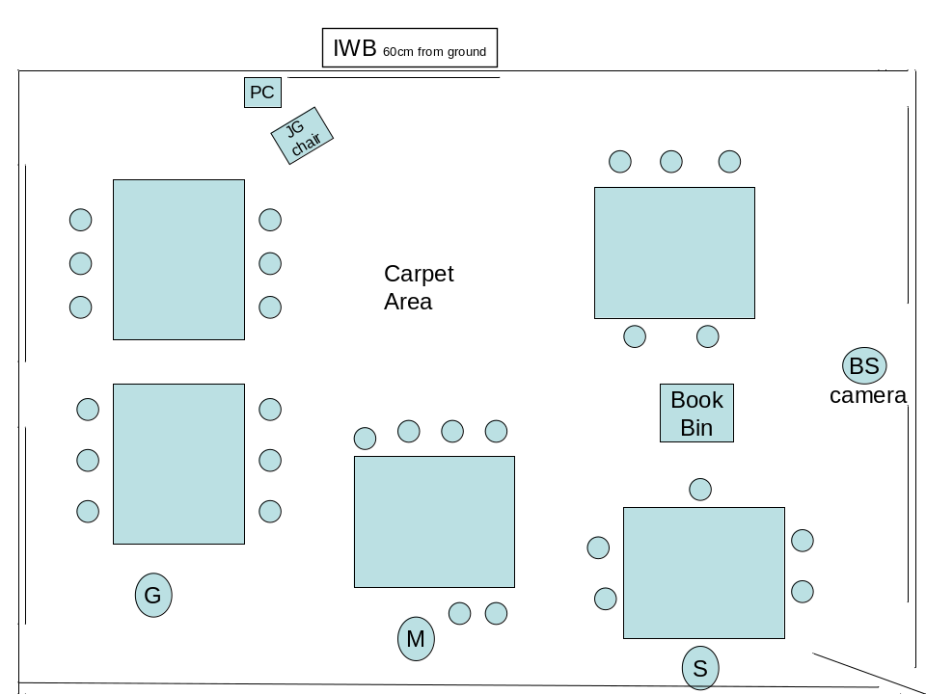

Note: The first 40 minutes of the lesson before break was also literacy; it was a comfortable routine of various literacy-related activities (mainly with children self-managed) that happen every day. (NB: ‘Gran’ is a parent helper in the school.)
11.05 | Data projector switched on. Children sit on the carpet. Interactive whiteboard shows first screen ready for a series of activities dragging letters into place to make words using “sh”. (“Sh” above three boxes in a line. With vowels down the right hand side and 9 consonants below.)  GJ talks to a boy about a word he has used. TA1 sits in the teacher’s chair and tells the children to “start thinking about” the sound ‘sh’ on the interactive whiteboard while GJ is doing this.
11.07 | GJ introduces the lesson, referring to the interactive whiteboard. “S”, “H”, “Sh”. She uses her face and body language. She sounds words out separately. “F-i-sh”  Question and answer with the children about ‘what is special about these five letters on the right.’ Vowels. “There is always a vowel sound in every word.”
11.10–11.22 | Children come up and form words by dragging letters into the three boxes. Sometimes they write additional letters (because GJ does not reject any words they suggest). “3 sounds, 4 letters”.  While children are doing this, the others write on their small whiteboards using erasable pens. (GJ has to remind the children to put the tops on firmly because of the problem of some drying out.) Sheep, shop, shape, shut, sheet, Shawn (not Sean). Then putting “sh” at the end – “wish” and “fish”.  Real problem for children with dragging on the interactive whiteboard.  Girl “bobs” out of the way to remove the shadow.  GJ never changes what the children have done. Though she tells the others.  TA1 sits close to the three boys she works with – Keith, Ian and Liam – and they look to her to help them with their writing.
11.25 | Interactive whiteboard left to display the same screen. GJ revises what they have done, using her face and hands. “S”, H”, “Sh”. They chant the vowels “A, E, I, O, U”. Reminds them about putting their pen lids on properly.  Attention is on GJ. Interactive whiteboard is not a distraction.
11.30 | Move to groups. 18 children stay at the interactive whiteboard with GJ.  interactive whiteboard – screen displays a statement of the objectives of the next part of the lesson.  Today in literacy we will be writing about our holidays, and will use capital letters and full stops to punctuate our work.  Discusses this with the children. Talks about the various punctuation marks, including commas, exclamation marks and question marks.
11.33-11.43 | Interactive whiteboard displays a piece of text with errors of spelling and punctuation. The children (still on the carpet) identify the errors. The corrections have been prepared underneath, so the children only need to guess the correct answer, tap the error to highlight the work, and then tap ‘delete’ to get rid of it. GJ says, “Lets see if you’re right”. And sometimes, “Can you reach?” (which they often cannot).  Gran sits on a table behind the children, facing GJ.  TA1 and TA2 work with small groups of children at separate tables. TA1 is with the same three boys who play pelmanism at first and then practice hand-writing.  11.36: GJ has to go to the laptop to sort out a problem with the highlighted text that has not deleted as intended when manipulated on the screen.  GJ uses the same techniques to keep the children involved. They come up one at a time. The others are encouraged to “tell the person next to you”. Individuals correct “went” (from “wet”), “see” (from “sea”). All the children are engaged, and thinking.  11.42: GJ reads aloud the completed piece, reminding them that the punctuation gives the passage meaning by telling you where to pause for breath. “That’s how I want your work set out too. I want you to put in the capital letters and full stops and not make silly spelling mistakes.”
11.43 | GJ’s group goes back to tables. Writing Holiday News in their books.  GJ: “Right, the date should be done and the title should be done now.”  TA1 is working with 3; TA2 is working with 3; Gran is sitting at the table with some of GJ’s group.  GJ works with the table at the front near me. She spends time talking to individual children, really focused on listening to them (the other children get on with their work without needing to be watched).  At some point both TAs leave the room.
11.50 | GJ goes to the interactive whiteboard and changes display. Puts up a “Remember” screen.  (1. Capital Letters. 2. Full stops. 3. Finger spaces. 4. Correctly formed letters. 5. Make it interesting.)  She asks the children to check their work so far. Is it quality? There are boxes on the right hand side of the screen in which images appear. One is a flashing light bulb (beside point 5 – Make it interesting)  Michael, Lee and Joe are working well on their own doing handwriting practice. (But one reports to GJ when they come back to the carpet that one of the others has rubbed out his work instead of keeping it for TA1 to see as instructed. GJ says, “it was only so that Mrs M could look at it.)
11.55 | Transition. Girl who has finished sits on the carpet reading a book.  GJ gives them a one minute warning that they will soon be stopping.
11.57 | Plenary back on the carpet. Interactive whiteboard displays what has been learnt:  Today in literacy we have been writing about our holiday, and have used capital letters and full stops to punctuate our work.  What were we concentrating on?  11.59: Interactive whiteboard displays the final sheet. Three questions. Where should capital letters be used? Where should full stops be used? What should we remember about our handwriting?  GJ: “Even if you were in one of the other two groups you should be able to answer some of these questions.”  Same techniques are used to keep the children focused – talking to the person next to you, putting hands up, thinking etc.  GJ switches off the data projector in the ceiling, leaves laptop on.

Table 2: Lesson Summary Sheet
Sch: E7 Teacher: GJ Literacy
Sweep Extn. Lesson Analysis Proforma
 |  | Noticed during the lesson (A) | Confirmed when reviewed (B) | Told in interview  (C) | Confirmed by other(s)
Q1 Hypothesis 1 Better progress in Ma and Eng: This is due to ‘the way’ the IWBs are used.
1a | Ratio of whole class, small group, individual teaching | Good balance. | 25 mins whole-class teaching  15 mins gp work with T or TA  15 mins individual work  5 mins plenary
1b | Good pace to the lesson | Yes | Yes
1 | Re NATIONAL TESTs N/A | N/A | N/A
1d | IWB used as advance organiser | Yes | Yes
1e | T’s role as co-learner, uses ‘we’ | Strong but loving | Strong but loving
1f | IWB controlled at board, not PC | Yes | Yes (except once)
1g | Children ‘engaged’ by IWB use | Yes | Yes – mixed with other interaction
1h | Skilful use of children coming up to the IWB (judgement needed) | Yes | Yes
1j | Rest of class mentally interacting when one child is at the IWB | Yes | Yes
1k | Children’s attention often on the IWB rather than teacher | Yes | Yes. But some parts of the lesson the IWB is only an aide memoire
Q1 Hypothesis 2 This is due to the teachers in these classes, and TAs, having had a better training experience.
Determine this from Q’naire information and interviews. Tick overall judgement.
 | Level of T training high | Yes | Yes
 | Level of TA training high | Yes | Yes
Q1 Hypothesis 3 This is due to IWB mediating T-P learning interaction (Tick if the case & expand on page 6)
 |  | Yes | Yes
Q2 Hypothesis 1 Gender differences in Ma and Eng, favouring average and above average boys, IWBs are due to these boys being more proactive
 | Boys more proactive with IWB (maths and English) | No evidence of this
Q2 Hypothesis 2 Gender differences in maths and English that favour average and above average boys are due to teachers ‘privileging’ these pupils
 | Boys generally favoured by teacher | No evidence of this
 | Boys have more access to IWB | No evidence of this
 | Boys questioned more | No evidence of this
Q3 Hypothesis 1 Low scoring KS1 pupils progress better when IWBs not used in Ma and Eng.
 | Whole class approach more than small group and individual work | No evidence of this
 | Small group work with teacher | Good evidence - bit large group 18
 | Small group work with TA (qual?) | Not seen at IWB
 | Small group work alone (qual?) | Not seen at IWB
 | Individual working at IWB (qual?) | None seen
Q3 Hypothesis 2 KS1 Low attainers’ progress better without IWBs in Ma and Eng because only ‘involved’ when IWBs used, rather than ‘engaged’ in gainful learning when no IWB. Need judgements re lesson
 | Pupils’ attentive (watching well) | High YES | Medium | Low
 | Pupils’ socially involved | High YES | Medium | Low
 | Pupils’ cognitively engaged | High YES | Medium | Low
Q4 Hypothesis 1 IWBs help low attainers more than others in science
 | IWB used in Sc (and Maths) to help ‘concretise’ abstract ideas | N/A
 | IWB used in Sc (and Maths) to help visualise procedures such as measurement | N/A
Other thoughts |  | Quite minimal use of the IWB, but always used to a purpose to support and extend teacher-pupil interaction.

Expansion of Table 2 – A set of headings
Q1 Why is there better progress in Ma and Eng with interactive whiteboards in general, and in some classes?
Hypothesis 1: This is due to ‘the way’ the interactive whiteboards are used.
1a Ratio of whole class, small group, individual teaching?
This varied for kids of different abilities. The less able kids (about nine) spent half their time in whole-class teaching on the carpet and half working in small groups with a TA at a table. The more able kids (about 18) spent an additional 15 mins on the carpet working with the teacher. It seemed a good balance.
1b Good pace to the lesson?
Yes. Very much as in the numeracy lesson, questioning was pacey. The discipline was exceptionally good. There was a variety of different kinds of activity to break up the whole-class teaching and Lg Gp work on the carpet.
1d Interactive whiteboard used as advance organiser?
Yes, the lesson objective was stated on the interactive whiteboard at the beginning. A “Remember” screen was displayed on the interactive whiteboard half way through the individual writing time. What had been learnt in the lesson was stated on the interactive whiteboard at the end.
1e T’s role as co-learner, uses ‘we’?
The tone and language of the lesson was strong but loving. Children were treated with affection but expected to behave. There was some joking / humour, but always of a supportive kind. When one boy got something wrong, GJ said, “He’s teasing you. He knew that was wrong” and the boy corrected it quickly. The relationship between the TA and the three boys she worked with was very supportive/ challenging. They were on task all through the lesson, including after the TA had left the room.
1f Interactive whiteboard controlled at board, not PC?
Yes, throughout, except at one point when GJ moved to the laptop to sort out a highlighted text that refused to delete.
1g Children ‘engaged’ by interactive whiteboard use?
Yes, the children were always very focused on the interactive whiteboard when GJ was using it for that purpose. But she also made considerable use of her face, voice and hands. The children followed the focus she intended without any problem whatsoever.
1h Children come up to the interactive whiteboard purposefully with apparent positive impact on individual child?
Yes, the children were clearly very positive about coming up to the interactive whiteboard and seemed not to mind when the letters proved difficult to drag. GJ had to help them sometimes by moving other letters out of the way.
1j When one child at the interactive whiteboard, remainder of the class are mentally interactive with the child/interactive whiteboard/teacher?
There was never any sense that their coming up to the interactive whiteboard caused a reduction in pace, because the other kids were writing on their mini whiteboards at the same time. It took them longer to write their words than it took those at the interactive whiteboard to drag letters. GJ also used routine strategies of getting kids to “tell someone next to you”, using quick question and answer sessions to revise what was already known, and getting them to chant/repeat after her some key points.
1k The children’s attention is often on the interactive whiteboard rather than on the teacher?
Yes, this happened during interactive sessions. But there were other times when the interactive whiteboard was only being used as an aide-memor.
Hypothesis 2: This is due to the teachers in these classes, and TAs, having had a better training experience. Evidence coming from Q’naire information and interviews
The level of the teacher’s training in interactive whiteboard use and the TAs’ training in both interactive whiteboard use and teaching literacy was exceptionally good. The TAs in the school all work together for the first 40 minutes of the day teaching the Reading Recovery programme with all kids who need this kind of help. There is an exceptional level of sharing and collaboration in the school. Everyone help everyone else in the RR sessions at the start of the day, regardless of the class they are working with for the rest of the day. In the classroom the teacher and TAs work as a team.
Hypothesis 3: This is due to interactive whiteboard mediating T-P learning interaction
See table below.
Q2 Why are there gender differences in pupil progress in Eng and Ma with interactive whiteboards that favour average and above boys when interactive whiteboards are being used?
Hypothesis 1: This is due to these boys being more proactive with the interactive whiteboard.
No evidence of this.
Hypothesis 2: This due to teachers ‘privileging’ these pupils.
Boys are generally favoured by teacher?
Boys have more access to interactive whiteboard?
Boys are questioned more?
Hypothesis 3: due to the boys seeing technology as a ‘boys thing’ and reading as a ‘girls thing’ – hence the interactive whiteboard gets over their resistance to reading.
No evidence of this.
Hypothesis 4: due to the interactive whiteboard being a better match with boys’ preferred learning styles with more emphasis on images and less on linear text.
No evidence of this.
Q3 Why might low KS1 scoring pupils progress better when interactive whiteboards are not used to teach them Eng and Ma? (NOTE that as we have selected some of the teachers for their excellence we should look for explanations of why this might NOT happen.)
Hypothesis 1: Whole class approach is used more than small group and individual work?
No evidence of this in what seemed to be a high achieving school.
Hypothesis 2: Because these pupils are only ‘involved’ when interactive whiteboards used, rather than ‘engaged’ in gainful learning when no interactive whiteboard. Evidence may come from interviews.
No evidence of this.
Q4 Why might interactive whiteboards help low attainers to improve their performance in science? And does this potentially have the same effect in maths?
Hypothesis 1: Interactive whiteboard are used in the teaching of Sc (and Maths) to help ‘concretise’ abstract ideas? And also to help ‘visualisation’ of procedures eg measurement? Evidence probable from interviews.
N/A
Q5 What contributes towards excellence in teaching with an interactive whiteboard?
Table A7.3 Other thoughts and observations
Possible ways in which the IWB contributes something unique to teacher-pupil interaction
Relevant to Q1 Hypothesis 3
a) IWB enables movement rapidly from one resource or screen to another. | GJ uses this, and comments on how important it is during the interview with me. Although she uses only simple screens on this occasion, the gains from having a “script” are clear. The particular advantage is that she can listen to what the children are saying when talking in pairs. This enables her to direct her teaching (explanations and questioning) more exactly to their needs. (Same pedagogical techniques used as in her numeracy lesson.)
b) IWB used to move quickly from the web to other applications. | Not observed
c) IWB operated freely at the board, not PC/laptop. | Yes, except on one occasion when a highlighted text would not “delete” easily.
d) IWB used to give instant feed-back in group or whole class work. (All ‘own’ the screen together) | Yes, at all times
e) The IWB accesses many features through its interface (Not just applications? Same as b above?) | Not observed.
f) Kinetic aspects of the IWB are employed in the lesson(s). | Dragging was used. Children found it difficult to do – sometimes painstakingly slow, but they didn’t seem to mind and others were busy on their own writing on their small whiteboards. Several children showed a good knowledge of how to tap on the IWB to ‘De-select’ a piece of text so it could move.  Very little use of flashing, colour etc. Conservative, if not minimalist use, but always extending and supporting the pupil-teacher interaction very skilfully.
g) Multi-tasking shared between teacher and children. | Not observed
h) Skilful use of children coming up to the IWB – purposeful for child | This was very skilful. A number of children got a turn and seemed to enjoy it (they could answer questions without having to come up if they wished). The strategy of placing an error over the correct text, so that once identified it could be highlighted by the child and removed, worked well – except for the problem that the delete icon was out of reach of most children. GJ often had to help children (in a very unobtrusive way) if the dragging word got stuck or they were unable to reach the delete icon.
j) Rest of class mentally interacting with child at the IWB and the teacher, mediated by the IWB. | This was exceptionally well managed. The kids had their own whiteboards to write on while another child was at the IWB. GJ used the same strategies as in the numeracy lesson, getting the children to talk to one another, to chant key points out loud etc.
k) The children’s attention is often on the IWB rather than on the teacher, changing the relationship between teacher, child and IWB. | This happened when GJ wanted it to. But there was plenty of the lesson when she was focusing their attention on her rather than the IWB.
Other features worthy of note/consideration
IWB enables the teacher to give more examples, using a wider range of resources (ICT and other). | Not observed
To what extent are the children watching well, or socially involved, or cognitively engaged? What about the less able children? | The children are watching well, as well as being both socially and cognitively engaged.

Rankings and Ratings
School: E7 Teacher: GJ
Mediation of interactivity
Activity: Children coming up to the interactive whiteboard to create words with the “sh” sound by dragging and/or writing letters in three boxes on the interactive whiteboard. Starts with Ahmed. Ends with review of the words they have written. (Approximately 11.15 – 11.20 am.)
Rank the 5 minute episode you have chosen from this lesson against episodes in all the other lessons you have observed according to the degree to which they illustrate that this mediation of interactivity is happening. (You will have to delay making a final ranking judgement until you have reviewed all your lessons, but it may help to make interim rating assessments out of say a maximum of 10.)
Lesson: literacy Ranking: 8
Placement in relation to the MLM results
Now that your analysis is complete, please make a judgement on this evidence alone of whether the lesson was one conducted by a teacher whose children have scored
Well above the multilevel modelling average Yes / No Ring one.
or
Well below the multilevel modelling average Yes / No Ring one.
Placement on the typology of interactive whiteboard pedagogies
Where on the revised Typology of interactive whiteboard pedagogies‘levels’ you would place this teacher.
1 Foundation 2 Formative 3 Facility 4 Fluency 5 Flying Ring one.
Judgements will be reviewed when all three researchers hold their meeting(s).
Interview questions
There are a lot of questions for the teachers, so when we start we should say we’d like to talk to them for approximately half an hour, or longer if they are happy to do so. Depending on the teacher’s willingness/other commitments, there may also be the option of continuing discussions at other times during the day.
Teacher questions:

1 Where has your ‘training’ to use the interactive whiteboard come from - however formal or informal, eg help from ICT coordinator, talking with colleagues; in-school/out-of-school etc.)? How much ‘training’ have you had?

2 Is the TA in this lesson the same TA you had in 2005?

3 How much training has this TA had with using the interactive whiteboard? What kinds of training has s/he had?
- Do you use the TA to work with small groups of children at the interactive whiteboard?
- How much training has the TA had to teach reading – and numeracy?
- Was today’s lesson typical in terms of the balance of whole class teaching/small group work/individual work? [This Q could cross-refer to the logs they complete.]
- Is there any aspect of literacy/numeracy that you find easier to teach now that you have an interactive whiteboard? (ask for examples).
- Now that you have been using an interactive whiteboard for some time, which of its features or capabilities do you find yourself using regularly? (if necessary, follow up with) Does that differ across literacy, numeracy and science?
- Have you found it possible to use the interactive whiteboard in any way to assess the children’s learning? (If yes) ask for examples.
- Do you think the children are achieving at a higher level since using the interactive whiteboard (all ability groups or just some???) ? (ask for examples, eg last year’s test scores – explain that we don’t yet have the 2006 data from the DfES).
- For KS1 teachers: Have you any evidence that the interactive whiteboard has helped the children who scored low on the Foundation Stage tests? (ask for examples of this evidence)
- For KS2 teachers: Have you any evidence that the interactive whiteboard has helped the children who got Level 1 or Level 2a at KS1? (ask for examples of this evidence)
- Do you think there is any difference in the boys’ level of engagement when the interactive whiteboard is used? Is this true for girls or do girls react differently? (ask for examples; any from today’s lesson?)
- (During the lesson, try to pick out who you think the SEN child(ren) are and confirm this with the teacher during the interview) THEN ask the following questions:
- Has the use of an interactive whiteboard affected the way the SEN children in the class take part in lessons? (Then as required, follow up with) Can you think of specific instances when there have been clear changes in their levels of: a) attention; b) social involvement; c) cognitive engagement?
- How have you changed the way you plan your lessons – and the way that you store resources since you’ve had the interactive whiteboard? (ask for examples)
Science teacher questions:

1 What else do you do with the interactive whiteboard in science as well as what you showed me today? (ask for examples and print-outs of materials used in other science lessons)

2 Do you feel the interactive whiteboard software/resources for teaching science have improved over the last year?

3 Do you think the interactive whiteboard makes a difference to different ability levels when learning science? (ask for examples)

4 Do you think the interactive whiteboard makes a difference to girls’/boys’ achievement levels in science? (ask for examples)

5 Is there anything else you would like to say?

Headteacher questions:

1 Since interactive whiteboards were introduced into your school, do you think they have had any effect on the ‘standards’ that have been achieved?

2 Do you think the interactive whiteboard brings any other benefits that cannot be measured by National Tests scores?

3 What do you see as the main benefits of using the interactive whiteboard (for teacher’s teaching/ the children’s learning)? Do you feel it has any drawbacks?

4 What training have teachers and TAs been given for using interactive whiteboards (since their implementation and since…)?

5 Is there anything else you would like to say?

ICT co-ordinator questions:

1 What do you see as the main advantages of using the interactive whiteboard? (for teachers and children; ask for examples)

2 What have been the main difficulties? (ask for examples)

3 What training have the TAs been given to use the interactive whiteboard -however formal or informal, eg help from you, talking with colleagues; in-house/externally-organised courses etc.)? How much training were they given?

4 Do you feel the interactive whiteboard software/resources have improved over the last year?

5 Is there anything else you would like to say?

Pupil questions:
Some of the language of these questions may need to be changed for the Y2 children.

1 Did you enjoy that lesson? Can you say why?

2 (Ask Q2 if the responses to Q1 do not mention the interactive whiteboard) Did the interactive whiteboard help you in that lesson? (ask them to explain)

3 Can you remember any topic in literacy/numeracy/science where the interactive whiteboard has also helped you? (ask them to explain)

4 Have you used the interactive whiteboard yourself (rather than watching the teacher)? What did you do?

5 Has the teacher used the interactive whiteboard to look up work you have done in a previous lesson? Can you tell me about it?

Part 4 – Special needs
Interactive whiteboards and the needs of blind and partially sighted children
An interview with an local authority specialist advisory teacher
This is an edited transcript of an interview with a specialist advisory teacher who has time on two days each week with ‘Ann’, a totally blind child in one of the classes observed. Ann also has full-time support in her Year 2 class from a teaching assistant.
‘Ann is six. She's been totally blind from birth due to septo-optic dysplasia. She also has an additional medical condition. But, in fact, she's categorised as gifted and talented for music. She has the percussive skills of a fourteen-year-old, and I think that linguistically she's hugely talented. Socially very included within school, so in fact accessing the whole curriculum alongside the other children and being been very successful. She's supported throughout every school day by one teaching assistant who is a Braille user. I teach Ann as an advisory teacher for two hours a week which is below RNIB recommendations, but that's all the caseload will allow. So I teach Ann Braille, and at the moment, we've just started touch typing.
… (Ann’s) teaching assistant … has to transcribe what's on the whiteboard, as she would from a blackboard or a whiteboard, and that's done in different ways. It's obviously done for Ann with tactile representation of what's being shown on the board as simultaneously as it can be with the visual image.
… the Smartboard is a hugely visual learning tool. … For a totally blind child you've obviously lost all those advantages and, in fact, I was speaking to the teaching assistant, and she feels that it has actually increased her workload. … she would say that it makes her work for that particular session four times harder, because of the speed of input. With a Smartboard the teacher presses something – something else appears on the screen – press again – something else appears. And you're obviously trying to make tactile representation to keep up with the rest of the class or to verbalise at the same time. So (it’s) quite difficult. And … because the resources within a Smartboard are so excellent, (and) the software is so good, you necessarily have less hands on resources within in class. So what a teaching assistant might have been able to grab from a cupboard or to photocopy or to enlarge for use with a tactile sheet quite quickly, is no longer to hand …
… Ann isn't unusual at all. She represents totally blind young children in the fact that computer noises and voices actually scare them quite a lot. It's the unexpected noises that happen. The Smartboard will suddenly beep or make a noise. Or when it starts, a voice will come. Ann is particularly sensitive to voices – adult voices, not child voices. She gets terrified of an unexpected man's voice from the computer. She won't (if the voice is) in person. So in fact, when I've been teaching her touch typing recently, we're actually using a double keyboard, we're trying to install speech software that has one voice for everything. So we're trying to train her out of that fear, but it's a very real fear. [I: Right] So in fact, everything that the Smartboard does for very young totally blind children can actually be a disadvantage to them.
… with another blind child – she was quite old – when the speakers crackled, she really freaked, and she said it sounds like ‘an American in a firework.’ [I: That's a good simile, isn't it.] Well they have ways of describing things, …we're talking a about particularly able little girl here. And there are ‘e-books’ I think, and she (Ann) says, [reading from file]
‘They don't sound real. I like true stories. Some sounds I like. Some I hate. I like the quiet. I don't like the loud. The sounds are so bad. None of them have a beautiful voice, a lady's voice. The unexpected noises make me turn my ears away to hear what they do sound like.’
… she really doesn't like it. So you'll notice, when you observe, that the teacher will actually cue Ann in to a noise. She'll say, ‘There's a voice coming, Ann.’ And that cues her in to not be frightened by it. [This was later observed.]
I: But of course, when you're so dependent on auditory signals, then quality of sound is crucial isn't it?
Adv. T: Absolutely. And the tone in the sound you know. I mean, … certainly blind children use multi-speed cassettes when they get older, because they can actually process voices really, really quickly. They have an adapted player in a specialist school for the blind, and it speeds (speech) up. It's got four different speeds, and they can hear things that we really can't, because we're not used to it. And they can decipher electronic voices really easily once they're used to them.
… I had to support her (Ann) the other day because they were doing tallying. They were going out for a traffic survey, and the teacher was just writing on the whiteboard, and there was no sound element there. And there's something called German film, which is very thin plastic, and you use it on a rubber mat and, if you press hard enough, it raises a line. So I was doing that for Ann while the teacher was doing it on the board. So within numeracy that was just a question of making tactile what the others could see. … And I'm sure, if it came to music, and she does history, if it were an interesting dialogue going on, it would be interesting (for her). But that's the same as communicating any areas of the curriculum in a way that she can understand it. Certainly when the youngsters register on the board - they have to go up to the board and tick their name to say they're in for the morning. Ann can't do that unless the TA puts a Braille name on the board. And then she finds her name, and then she just presses beside it. It just means extra consideration, and work for the staff really.
I don't know if you've heard of Inclusive Technology. They do a big plasma screen, and we were talking about that as against (an) interactive whiteboard, and generally the feeling within the room was that a plasma screen has fewer disadvantages for the visually impaired child because the screen goes up and down. [ie its height above the classroom floor can be adjusted.] I'm talking about visually impaired, not totally blind. You know the plasma screen would go down here, and up here, [gesturing to demonstrate] which is really useful, and for the wheelchair user as well. Access is much better to that, than to a whiteboard generally. Although they're sited quite low in early years classrooms, sometimes it's still not low enough. But another thing … I don't think teachers are aware enough of how they can do the inverse polarity on text on the screen, or they just tint the background to make it less bright for visually impaired children which is often a problem for them.
I: So if you put the two things together, your experience with interactive whiteboard and what you know of the plasma screens, what kind of development do you think would be most helpful to children in Ann's position?
Adv. T: That's a really tricky one actually, because it is such a visual resource. For Ann I think … for visually impaired youngsters, I think quite a lot could be done. I think it could be giving teachers an awareness of how to change font size, colour, background, print size. And (make the board) easier to change (for teachers, so that), at literally a touch of the button, you could change the background screen or whatever. And that it (the interactive whiteboard) would have some kind of movement up and down for the visually impaired, because you've got children with quite complex difficulties in classrooms now, and visual impairment might just be one of them. So any access to that board is going to be easier. I suppose having some kind of tactile element for Ann might be useful … (but) I can't see how that would work. I don't know how that could … how that could work.
I: No, I'm not expecting you to come up with an answer
Adv. T: No, no. I'm just trying to think of what … lots of our visually impaired, and blind older youngsters use a speech software program like Jaws or Write Out Loud for when they use computer screens. So in effect, if it could be something that, when Ann touched a certain part of the screen, it would say something to her, it would say what was written there or something similar.
I: Well with today's technology it's not impossible is it?
Adv. T: Well certainly … we're beginning to use Write Out Loud with Ann through the qwerty keyboard, so that it reads back to her whatever she's done.
Lots of the best practice is happening in schools where you've got peer sharing of Smartboard ideas. I mean certainly in (the LA) … a lot of Smartboard training has happened and … (one external provider) has done really good training, but the sharing of ideas has been very helpful - peer group to peer sharing about strategies. But you see, the really exciting things for the sighted children, like the digital camera work, and the recording of ‘Yesterday’, and ‘Let's do a slide show of what we did yesterday when we went to the farm.’ The only thing is, it should be possible to easily put a verbalisation of that on to the Smartboard so that Ann had an audio description of what the others were seeing.
I: Yes, rather like those audio commentaries on some films on television.
Adv. T: Yes, and the RNIB, and some theatres, do audio to describe plays don't they, [I: Yes they do, yes.] which is helpful you know. And certainly ‘Talking books’ do a similar thing. And there's a ‘Talking art,’ where children have a cassette, and they're talked through a piece of art, and they have a sort of raised diagram and the cassette talks them through. So some description of what others are seeing, but how you would do that with photographs taken the day before …
I've got another pupil who is registered as blind. She's got a tiniest window of vision in her right eye, but she's a visual learner and she has a piece of technology … which is a laptop with a small box size camera which reads the blackboard onto her laptop. So the camera points at the Smartboard and it is used as a remote facility. And the whiteboard is then on her laptop at her desk. And for her that's an excellent resource because she's such a visual learner, and learning's very exciting visually for her. And (that pupil’s) teaching assistant says, it's less work for her because there's less photocopying, less enlarging, but that's because of the Magnilink technology just transferring the interactive whiteboard. So that's up and running in quite a few of our schools. Now there has been a difficulty with that because, once again, the glare at the top of the Smartboard has made it difficult for the camera to pick up sometimes.
I: Yes. … But is there a broader span to this, … that it would be helpful for us to know about?
Adv. T: … I think it's what you’re talking about … You've already mentioned the colour – the brightness of it (the interactive whiteboard). That's causing discomfort to a lot of children with visual impairment. The brightness of the screen is causing quite a lot of visual fatigue and visual distress. I saw ‘Brenda’ last week who has cerebral palsy and a slight wobble to her eye and difficulty moving her eyes. And she actually said she finds the Smartboard easier than the whiteboard but [Quoting from a file note] ‘they were very bright if I have to look at it too much’.
And the interaction! ‘Cathy’ said to me, ‘I wish I could write on it more.’ You know that's what she likes doing really. … What did she say? [Looks in file] This is what Cathy said, who has a very tiny piece of vision. She said, ‘They are good, but if you are trying to look at them, the colour is not very good. I have written on it once and used it, but not very often. I would like to write on it more. It's better now it can be on my laptop. [my TA] still has to write stuff for me. If it's blurry I can't read the handwriting.’
I: But can it be made completely fair? [Adv. T: but that's what we're working towards] Even in a classroom without an interactive whiteboard there are certain unfairnesses.
Adv. T: Yes, definitely. But if it's a resource that's going to be the main communicator of the curriculum or significant, you know, [I: Yes] it's either going to make a lot more work for somebody, or it's just something that needs consideration really.’
ENDS

