# Project

Overview

Purpose:

Key contact

* Stakeholders:
* Audience
* Support Contact
* Notify in case of problem

Requirements:

Access Required:

SQL SERVER

Input and output:

Data Flow:

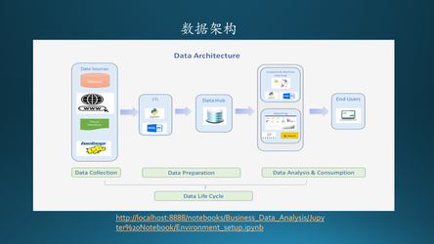

High Level Report Process:

Schedule & SLAs:

Report Logics:

Issue Log: