Wandell_1995_ch7, p. 12
DETECTABILITY
A look at Square-Waves:
- can be expressed as weighted sum of sinusoidal components using discrete fourier series
- square wave sq(x) with frequency f:
  - to get odd-number we use (2n+1) = odd
  - sq(x) = 4/Pi * SUM[ ... * sin( ... * odd * f * x ) ]
- square wave at frequency f equals the sum of a series of sinusoids at odd numbered freq. -> f, 3f, 5f, ...
  - Amplitudes (= Contrast):
    - f: has Amplitude A ==> 3f: A/3, 5f: A/5
    - Amplitude very low then 7f, 9f, 11f, etc. are really small and can be ignored
  - to achieve appearance of a low-amplitude sq(x) it is okay to use only a few components (f, 3f, 5f):
    - 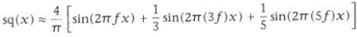
  - lowest freq. component is called fundamental -> f
    - has the highest amplitude -> A = 4/Pi therefore contains largest contrast information (?)
  - 3f, 5f, 7f, ... are harmonics (3f = 3rd harmonic, 5f = 5th harmonic, ...)
C&R use sq(x) to test multiresolution hypothesis (multi-channels):
- first measured smallest contrast level where square-wave-gratings detectable
(JND --> contrast threshold for given square wave)
- argued: neurons whoose receptive-field (RF) size is matched to the fundamental f will signal the presence of a square wave first, making it the most important term in defining visibility of sq(x)
- if this is the case then the threshold contrast of sq(x) should be 4/Pi times the threshold contrast of a sinusoidal grating at the same frequency f
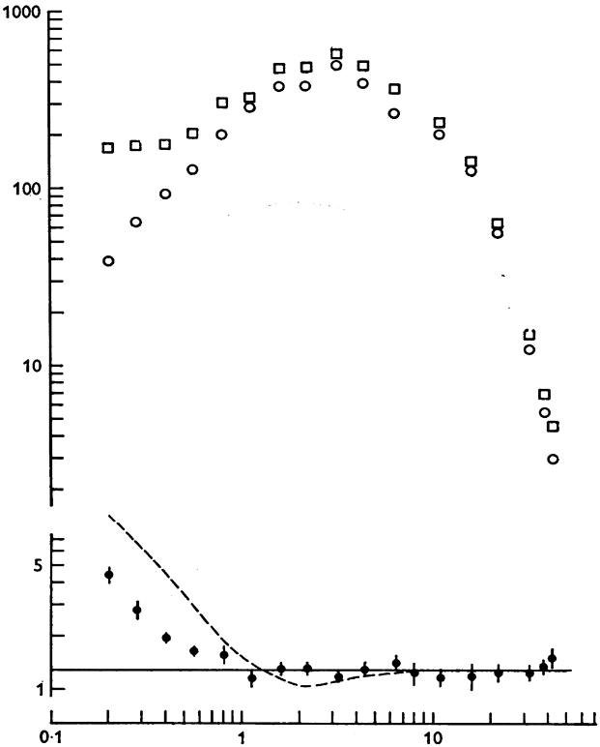
- 4/Pi Magic number bc square waves just happen to need this for their existence therefore given its fundamental just being a sine function with an Amplitude of 4/Pi and that being contrast, square waves are inherently contrast-richer than sinusoids

What is plotted for the open symbols are the contrast sensitivities (1 over detection threshold) on the y-axis against spatial frequency in cpd . The open squares show the data for the square-wave grating , the open circles for the sine-wave grating . The filled black circles show the ratio of the square-to-sine sensitivities . The solid black line marks the prediction at 4/pi derived from the Fourier series of the stimuli. The dashed line marks the prediction of a simple peak-detector model of early spatial vision.

DISCRIMINATION
perceived conrast stayed same so:
- sinusoid and sq(x) were held constantly on the same ratio therefore their detection rate was the same
  - I think sq(x) fundamental f and the sinusoid Amplitude need to be (approx.) the same
- observer cannot distinguish square wave to sinusoid based on the fundamental component anymore
  - instead the higher-order components 3f, 5f, 7f, 11f,... come in play
  - recall: the components each have their own amplitude and the higher the amplitude of the fundamental, the higher they will be for the components, too
  - so if the highest amplitude (= contrast perception) was in our fundamental but now we cannot use this anymore, the next in line would be the 3rd harmonic: 3f
  - therefore when 3f has a high enough amplitude the observer can distinguish the sq(x) from the sinusoid
