Summary
This report analyzes Federal Reserve Bank presidents’ speeches across all 12 districts, focusing on five dimensions of communication complexity: abstractness, disunity (cosine similarity for sentences), informativeness (Shannon entropy), readability difficulty (hard to read) , and cognitive strain (dependency distancing, mean only). The goal is to identify district-specific communication styles, president-driven effects, and structural shifts over time.
Across the System, several broad patterns emerge:
1. Archival Completeness Shapes Early Patterns
Most districts have sparse or inconsistent speech records before the mid-1990s due to incomplete digital archives. After this point, speech frequency becomes more reliable. A few districts (e.g., San Francisco, New York) have unusually rich archives extending back to the 1980s. FLAGGING FOR St.Louis, as the data originate from another paper and may reflect a pipeline or metadata issue rather than a true absence of communication. The next steps are to check whether the original paper discusses this omission; if not, it may be necessary to manually incorporate Poole’s speeches. The FRASER archive does contain speeches from this period, so their absence here likely reflects an exclusion during data cleaning or formatting inconsistencies.
2. Economic Conditions and Institutional Shifts Matter
Speech frequency and complexity often increase during major macroeconomic events:
- Savings & Loan crisis
- Early 1990s recession
- Dot-com boom and bust
- Global Financial Crisis
- COVID-19 pandemic
The post-2008 era also reflects a System-wide shift toward greater transparency, forward guidance, and more formalized communication, especially under Bernanke and Powell. Here is an example graphs:
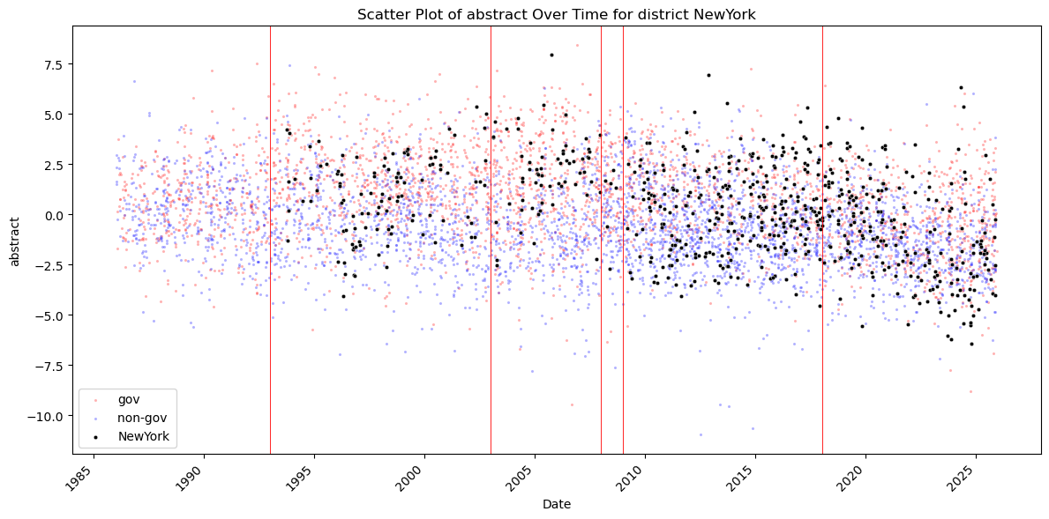
3. President Background Strongly Predicts Complexity
Presidents with academic macroeconomic backgrounds (e.g., Plosser, Lacker, Mester) consistently produce:
- higher abstractness
- higher disunity
- higher entropy
- more difficult readability
- higher cognitive strain
Presidents with business, management, or operational backgrounds (e.g., Barkin, Harker, Logan) tend to produce:
- more concrete, accessible speeches
- lower disunity
- lower entropy
- easier readability
This pattern is remarkably consistent across districts
Examples:
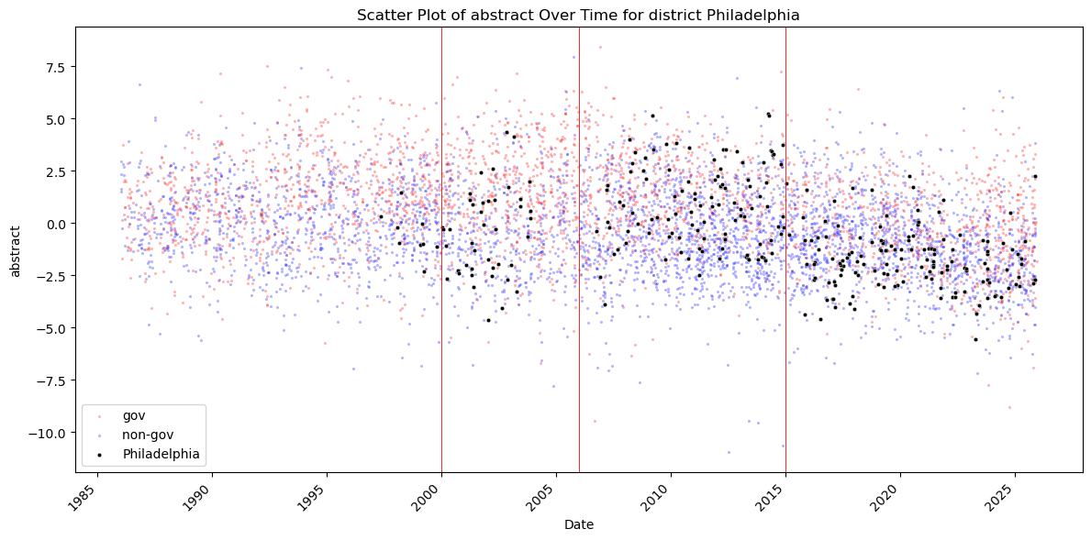
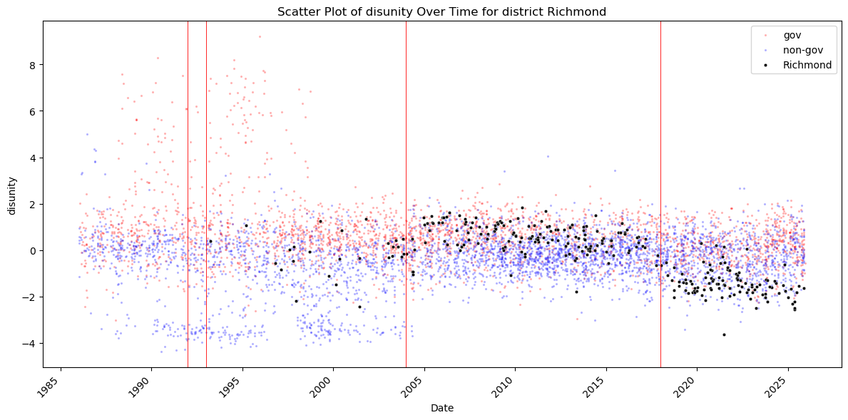
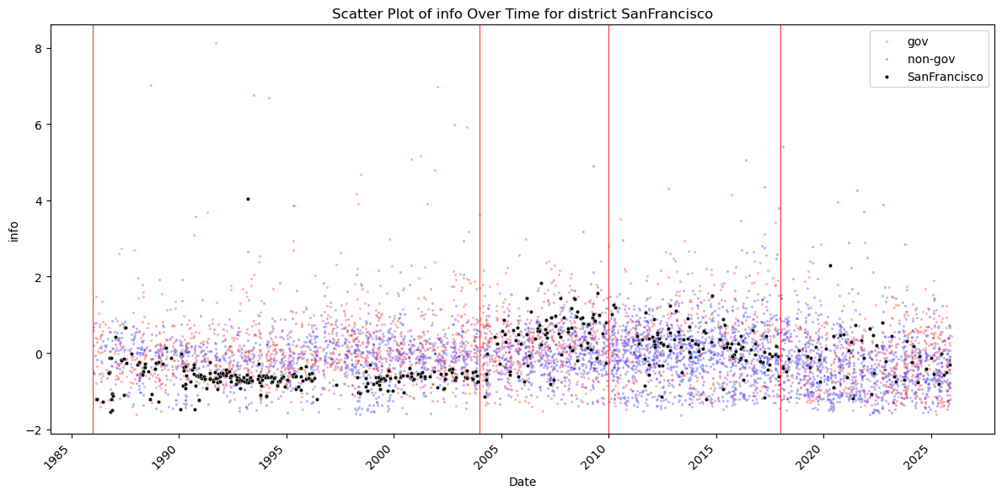
4. Districts With Distinctive Patterns
San Francisco
- Very rich archive; one of the most unusual profiles.
- Parry (1996–2004): extremely low complexity across all measures.
- Yellen and successors: sharp rise in complexity, then decline during the pandemic.
- Wide dispersion in abstractness.
St. Louis
- Major data gap for Poole (1998–2008) — likely a data pipeline issue; needs to be flagged.
- Bullard (2008–2023): extremely low and stable Shannon entropy (narrow, repetitive vocabulary).
Philadelphia
- Plosser (2006–2015): very high complexity across all measures.
- Santomero intermediate; Harker lowest.
Richmond
- Lacker (2004–2018): one of the most complex communicators in the System.
- Barkin much more practical and accessible.
Chicago
- Complexity dips around 2000 due to Moskow’s narrative, business-oriented style.
- Evans influential but fewer speeches due to post-2007 centralization.
Minneapolis
- Stern highly abstract; Kocherlakota high frequency due to post-GFC environment; Kashkari lower frequency.
Dallas
- Fisher’s speeches: narrative, broad, accessible → high entropy, low disunity.
- Logan more technical.
- Kaplan’s decline in speeches tied to 2021 controversy.
Kansas City
- Very stable complexity across presidents; possible district-level communication norm.
Boston, Atlanta, New York
- Generally close to System averages, with complexity driven more by economic conditions than by individual presidents
5. System-Wide Trends
- Abstractness often declines after 2020 (pandemic → more practical communication).
- Disunity, entropy, readability difficulty, and cognitive strain tend to rise from early 2000s to mid-2010s, then stabilize or decline.
- President-specific effects are strong and consistent

Direction (?)
- Fact-checking and sourcing.
I need to verify many of the district-level observations and ensure that all claims are supported by reliable, citable sources. This includes cross-checking archival gaps, president backgrounds, and institutional explanations.
- Discussion before next steps.
Before moving forward, I would like to discuss the overall direction with you to make sure the next stage of the project is aligned with our goals and feasible within the timeline.
- Extending the project to financial markets.
I am interested in exploring whether speech-based complexity measures have predictive power for financial variables such as stock returns, trading volumes, financial instrument prices, and private-sector expectations.
A key idea is to interact complexity with sentiment measures:
- clearer communication may amplify market sentiment
- more complex communication may dampen negative sentiment without distorting information
This could provide a novel angle on how communication style shapes market reactions.
- Methodological continuity.
I can adapt the empirical framework from my JMP to this context. Data collection may be more straightforward because U.S. financial and textual data are widely available and well-structured.
- Media follow-up as an additional direction.
Another possible extension—though more time-consuming—is to compare Fed speech complexity with the complexity of subsequent media coverage.
This could involve:
- measuring similarity using cosine distance
- identifying which Fed members the media “follow” most closely
- dealing with timing issues, irregular speech releases, and weighting across 19 FOMC participants
This direction is ambitious but potentially very insightful.
- Using question-answering models to assess interpretability.
By applying a question-answering model, I could simulate how a layperson might query an AI about policy implications (e.g., “Will mortgage rates stay below X% in the next six months?”).
Then I can test whether speech complexity affects the model’s degree of “confidence” or interpretability.
While this would only approximate real AI behavior, it could still provide useful insights into how communication clarity shapes downstream understanding

Examining in detail
(only read if you are interested! Divided into 12 parts = 12 Banks)
Atlanta.
Two presidents stand out for producing a notably large number of speeches:
- Robert P. Forrestal (1983–1996)
- Dennis P. Lockhart (2007–2017)
Despite their higher speech frequency, their overall communication complexity is broadly similar to other Atlanta presidents. One possible exception is abstractness: Lockhart’s speeches appear slightly more concrete, though the difference is small.
Below are several hypotheses that may explain the differences in speech frequency and communication patterns. Many of these factors could also apply to presidents in other Reserve Banks:
1) Individual communication preferences and archival completeness
Some presidents may simply prefer more consistent and frequent public outreach. It is also possible that differences arise from the data collection process: certain presidents may have maintained more complete or better-organized archives. For example, FRASER’s archival coverage varies across districts and time periods, which could influence observed speech counts.
2) Degree of involvement in the FOMC
Presidents with greater influence or visibility within the FOMC may engage more actively in public communication. This relationship has been examined in prior empirical work, and higher speech frequency is sometimes associated with greater policy engagement or dissent.
3) Broader shifts toward transparency and communication
The Fed’s communication strategy evolved significantly during the “modern" transparency era. Key milestones include:
- the 1993 transparency push, which increased the visibility of Reserve Bank presidents
- the post-2008 crisis period, when forward guidance and public communication became central policy tools
Presidents who served during these transitions—such as Lockhart—may have delivered more speeches because they embraced or were responding to these institutional shifts.
4) Economic conditions during each presidency
Forrestal (1985–1996)
Several major events occurred during his tenure:
- the Savings & Loan crisis (1986–1995)
- the early 1990s recession
- rapid growth in the Sunbelt economy, of which Atlanta is a core region
These factors could plausibly increase public communication. However, the subsequent president (Jack Guynn, 1996–2000) also served during turbulent years, yet delivered fewer speeches. Moreover, Forrestal’s elevated speech frequency persists across his entire tenure, not only during crisis periods. Interestingly, Guynn’s early speeches appear to show rising abstractness and declining informativeness until 2000 (need testing).
Lockhart (2007–2017)
Lockhart’s tenure coincides with several major macroeconomic disruptions:
- the Global Financial Crisis
- the Great Recession
- the housing market collapse, which was especially severe in Florida and Georgia
- a long and uneven regional recovery
These conditions likely increased the demand for public communication, both regionally and nationally
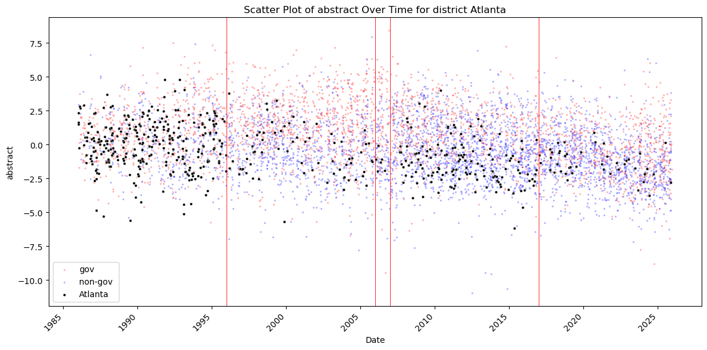
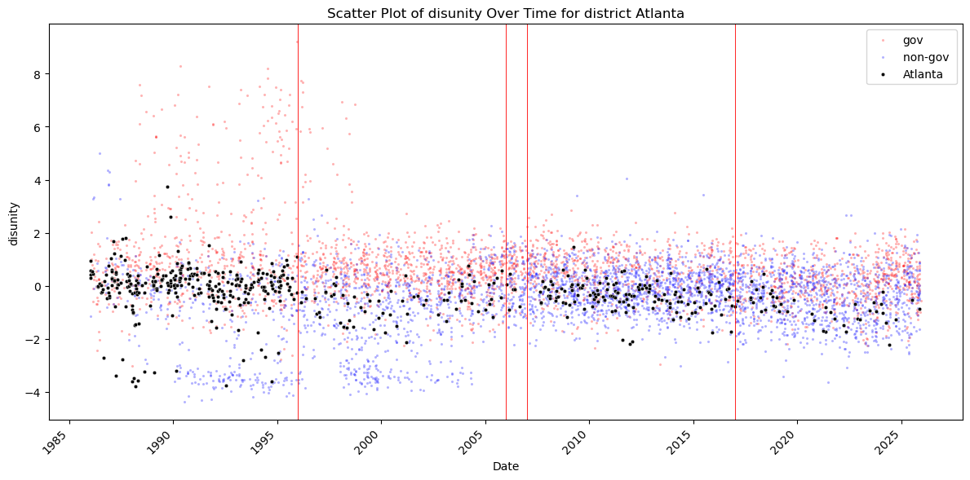
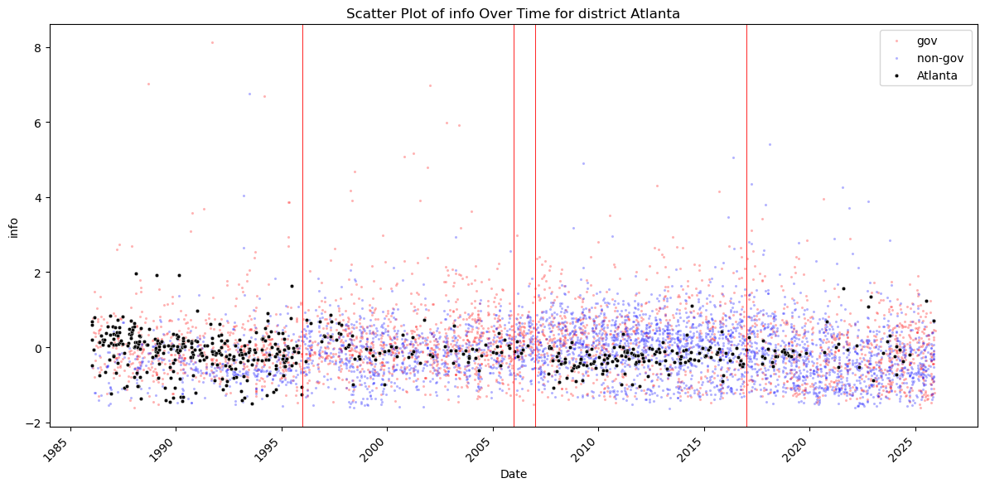
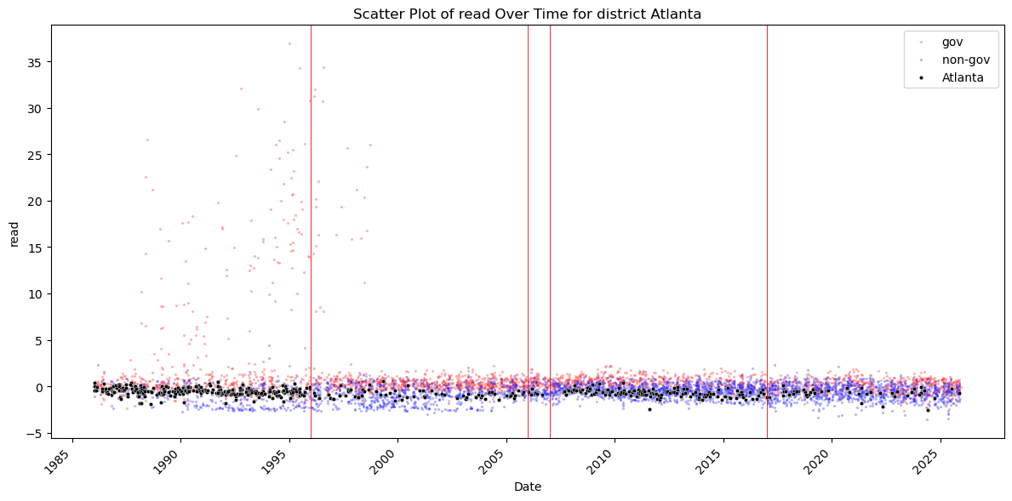
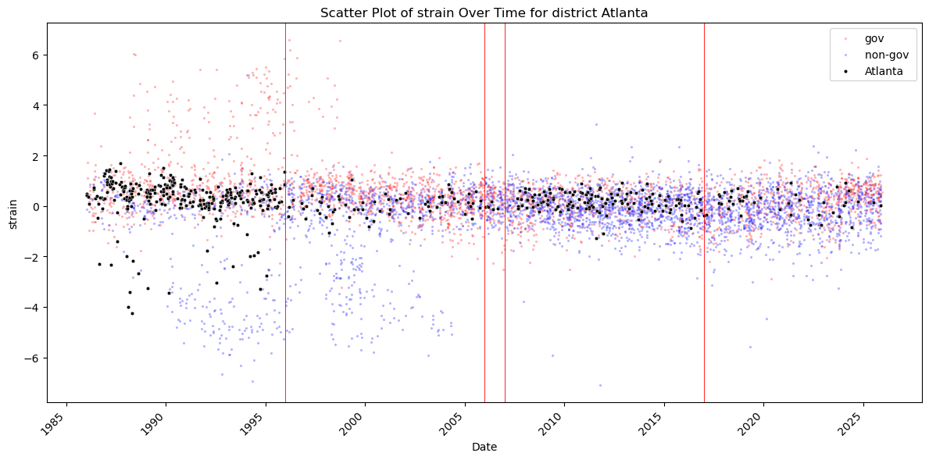
From here on out, I will only list notable things. I might not repeat similar things to the Reserve Bank of Atlanta, even though it might be applicable.
Boston:
Across all complexity measures, Boston’s presidents exhibit communication styles that are broadly similar to one another and close to the cross-bank average. There are no strong deviations in abstractness, disunity, entropy, readability, or cognitive strain. Speech frequency appears to be driven more by macroeconomic conditions than by individual stylistic differences. In particular, the early 1990s recession and the Global Financial Crisis coincide with periods of heightened communication activity.
The two presidents serving during these episodes—Cathy E. Minehan (1994–2007) and Eric S. Rosengren (2007–2021)—both participated actively in public communication. However, this may reflect their long tenures rather than distinct communication strategies. While the general explanations discussed earlier (archival completeness, transparency trends, FOMC involvement, and economic conditions) could apply here as well, there is no clear evidence that any single factor uniquely drives Boston’s speech patterns
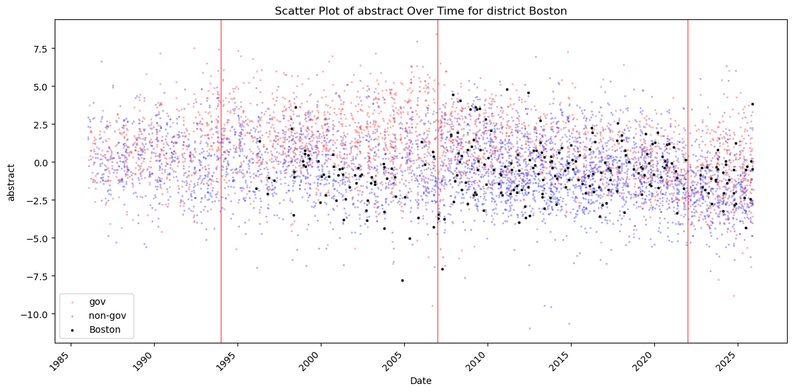
Chicago.
The apparent surge in speeches after the late 1990s is largely due to improvements in the Chicago Fed’s archival completeness during that period. Once the archive stabilizes, speech frequency becomes noticeably higher during Michael H. Moskow’s tenure (1994–2007), particularly in the years approaching 2000. This aligns with several major economic events—the mid-1990s recession, the dot-com boom and bust, and Y2K preparations—which likely increased the demand for public communication.
Although abstractness during this period remains close to the district’s long-run average, disunity and informativeness decline, indicating that speeches became more focused on a narrower set of issues. The higher speech frequency also suggests that Moskow could deliver multiple specialized speeches, each addressing a specific topic, rather than fewer, broader speeches covering many themes at once. Readability difficulty and cognitive strain also fall during this period, mirroring the pattern in disunity and suggesting that Moskow’s speeches were comparatively easier to follow. This is consistent with his communication style, which emphasized frequent outreach to business groups in addition to economic commentary.
A related institutional factor—still to be fully verified—is the shift in Federal Reserve communication norms around 2007. Prior to this period, communication was less centralized across the System. Beginning under Bernanke and continuing under Powell, the Fed moved toward more formalized and centralized messaging, with greater emphasis on FOMC statements and press conferences. This shift may partly explain why Charles Evans (2007–2023), despite being a highly influential policymaker (e.g., the “Evans Rule”), appears less frequently in the speech dataset.
As with other districts, the broader explanations discussed earlier—archival completeness, individual communication preferences, institutional norms, and economic conditions—can also help account for Chicago’s patterns
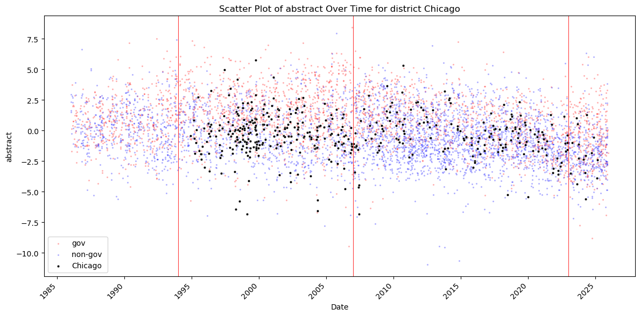
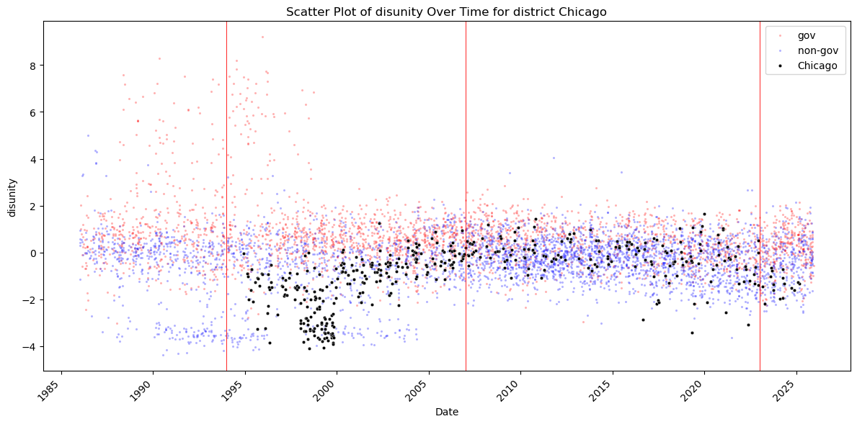
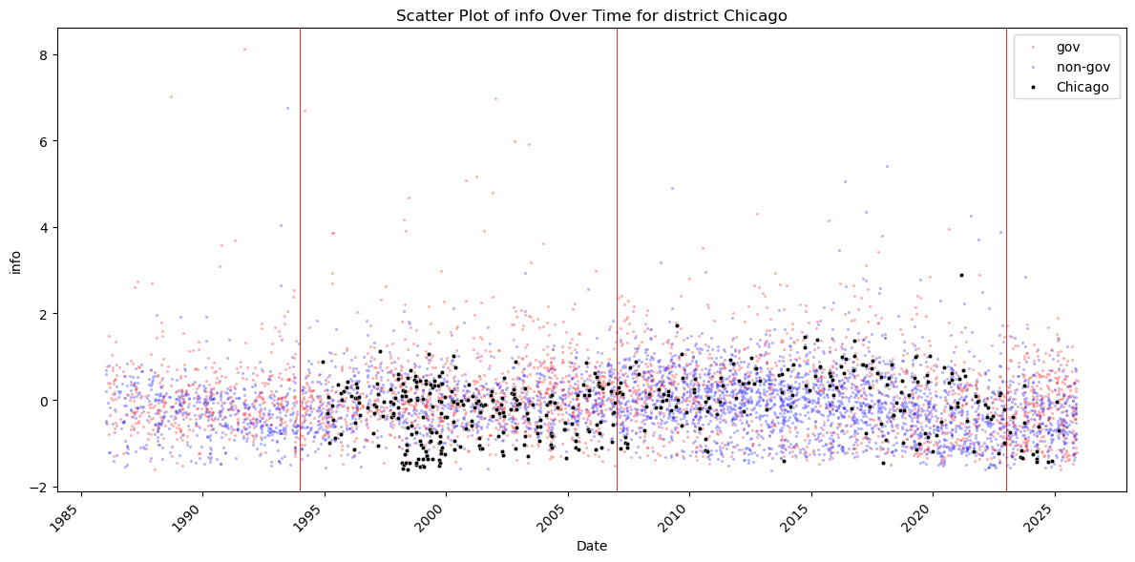
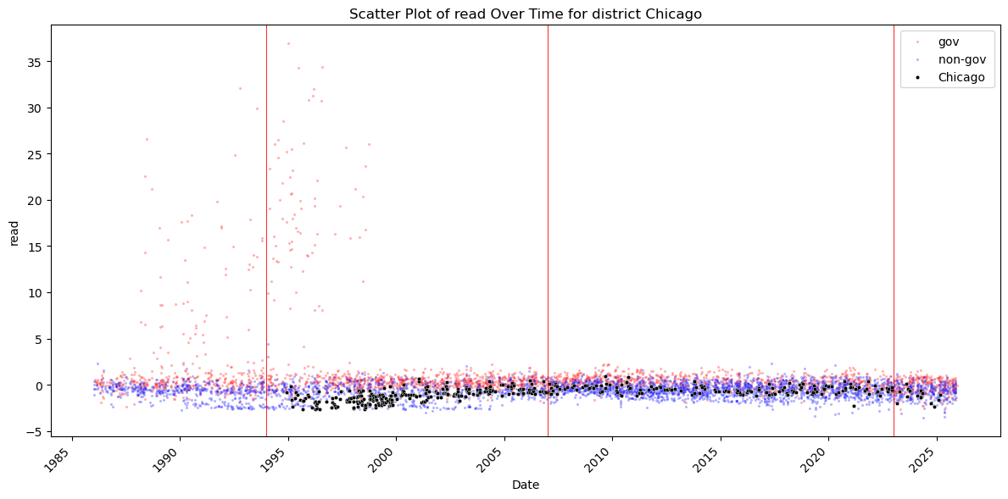
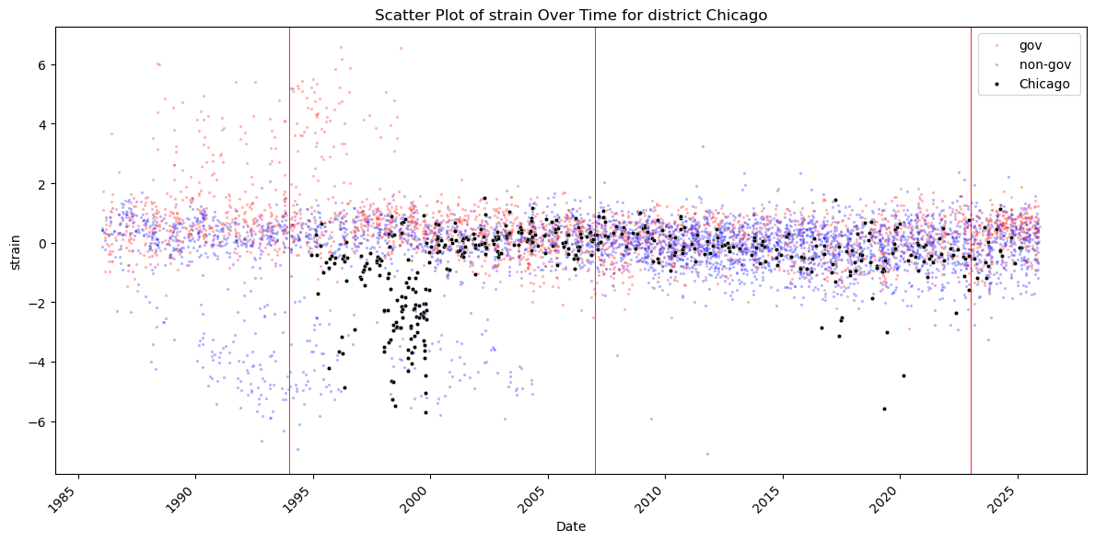
Cleveland.
The number of speeches appears broadly consistent over time, with the exception of a noticeable but gradual decline between roughly 2000 and 2005. One possible explanation—still unverified—is that Jerry Jordan (1992–2003), despite holding strong views on monetary policy, was less publicly communicative than some other Reserve Bank presidents. This could account for the reduced speech frequency toward the end of his tenure. The early years of Sandra Pianalto’s presidency (2003–2014) also coincide with a period of economic recovery and low inflation, which may have reduced the perceived need for frequent public communication.
Abstractness is harder to read directly from the graph, but several patterns seem plausible. Jordan’s speeches (1992–2003) appear to exhibit higher abstractness than those of other presidents. This aligns with his communication style, which often emphasized ideological, conceptual, and macro-framework themes—such as inflation credibility, monetary rules, and long-run growth fundamentals. In contrast, Pianalto’s communication appears more pragmatic and operational, with a stronger focus on regional economic conditions (this interpretation still requires verification). Abstractness then rises again under Loretta Mester (2014–2024), consistent with her research-oriented background and academic training, before declining noticeably during the pandemic period. This decline likely reflects the shift toward more practical, operational communication during the crisis and the early tenure of Beth Hammack.
For the other complexity measures—disunity, informativeness, readability difficulty, and cognitive strain—there is a general upward trend in complexity from approximately 2003 to 2024, although earlier periods show greater volatility. Informativeness may decline slightly after the pandemic, but the pattern is not clear. These trends can be partly explained by the same factors discussed above. However, unlike abstractness, these measures do not show a pronounced decline driven by economic conditions; instead, they remain elevated even during the pandemic period
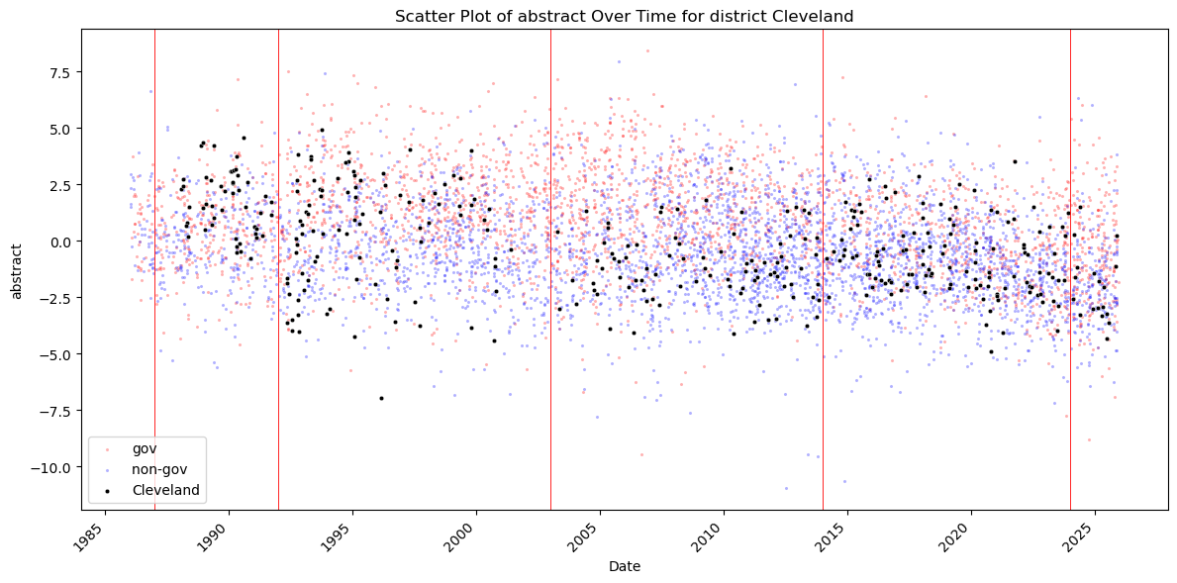
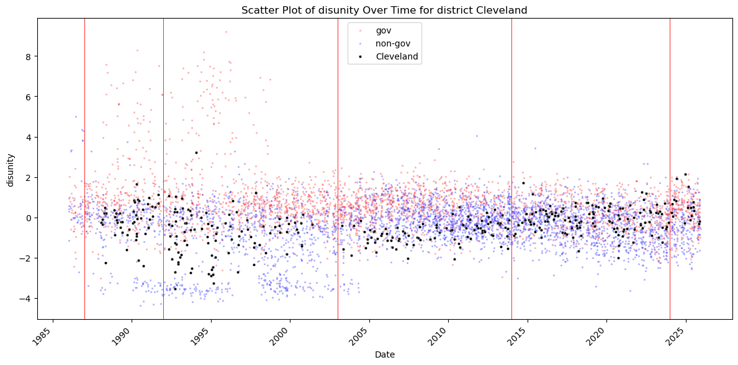
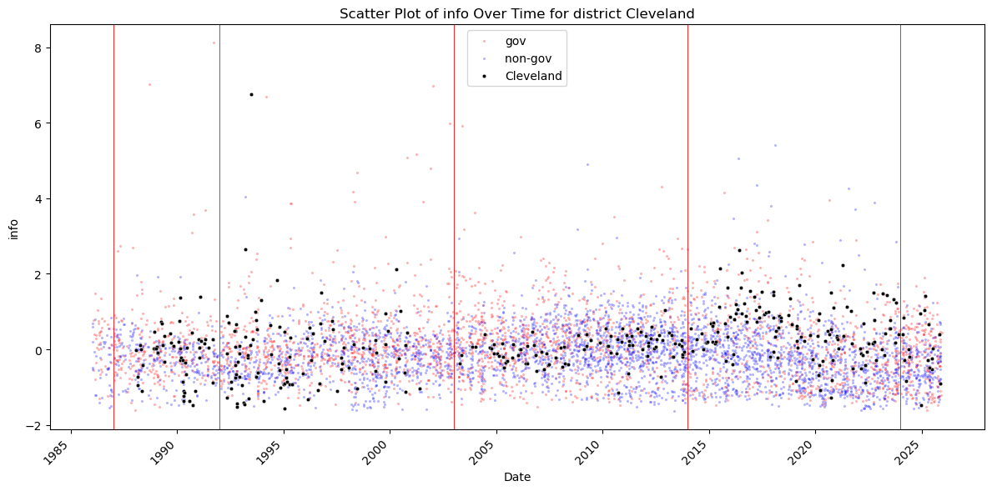
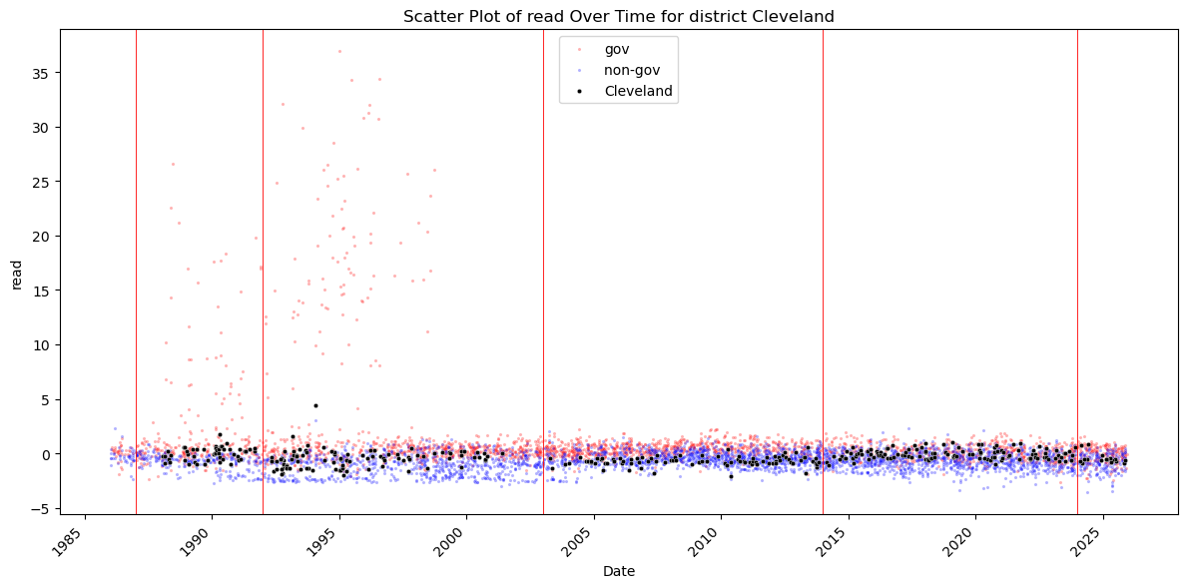
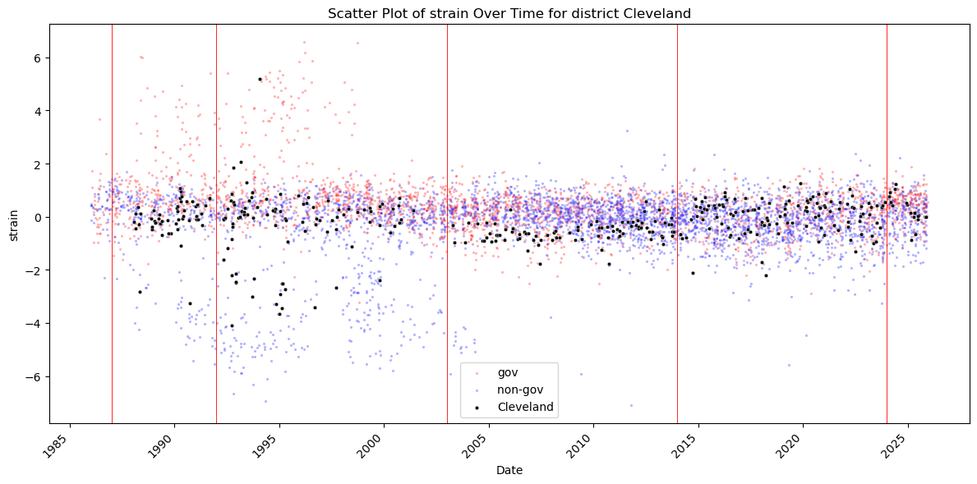
Dallas.
Speech frequency increases notably during the tenure of Richard W. Fisher (2005–2015) and again from 2023 onward under Lorie K. Logan. Fisher was one of the most publicly outspoken Reserve Bank presidents of his era. His speeches were frequent and stylistically distinctive—colorful, narrative, and often drawing on literature, history, and metaphor. He regularly addressed business groups, civic organizations, and national audiences, using speeches as a platform to shape public debate on inflation, fiscal policy, and broader economic issues. Logan, by contrast, came from the New York Fed’s Market Operations leadership, where communication is highly structured, technical, and frequent.
Fisher’s speeches exhibit lower disunity, higher Shannon entropy, and greater readability compared with Logan’s. His broad thematic range—global economic developments, fiscal issues, the Texas economy, inflation—combined with storytelling, humor, and rhetorical flourishes, naturally produces higher informativeness (a more diverse vocabulary), lower disunity (narrative cohesion), and easier readability (accessible language aimed at general audiences). Logan’s speeches, in contrast, tend to be more technical, more narrowly focused on policy mechanisms, and more formal in structure, which increases disunity and reduces vocabulary diversity.
The Dallas Fed’s digital archive becomes consistently available only after the late 1990s, which explains the absence of earlier speeches.
The relatively low number of speeches during Robert Steven Kaplan’s tenure (2015–2021) also has a plausible explanation. In 2021, Kaplan became involved in a high-profile controversy regarding personal trading activity. Even before the public disclosure, insiders noted that he had begun to reduce public appearances, avoid high-visibility speeches, and keep communication minimal. After the controversy became public, he resigned in September 2021. A closer look at the data confirms that speech frequency declines sharply near the end of his term. The speeches he did give tend to be more complex, consistent with his background: 23 years at Goldman Sachs and several years as a Harvard Business School professor and senior associate dean
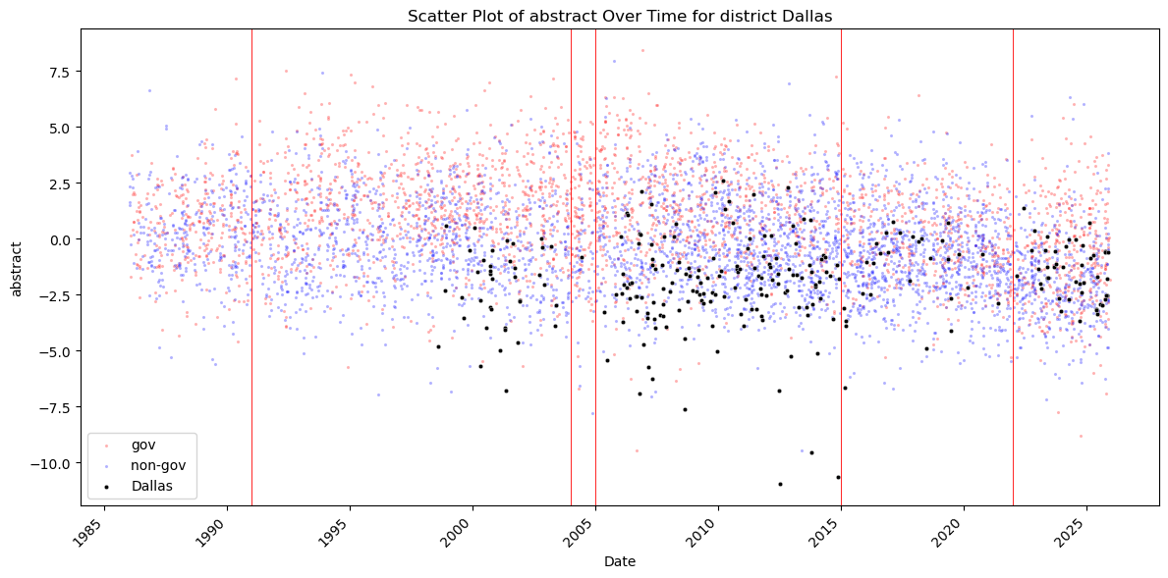
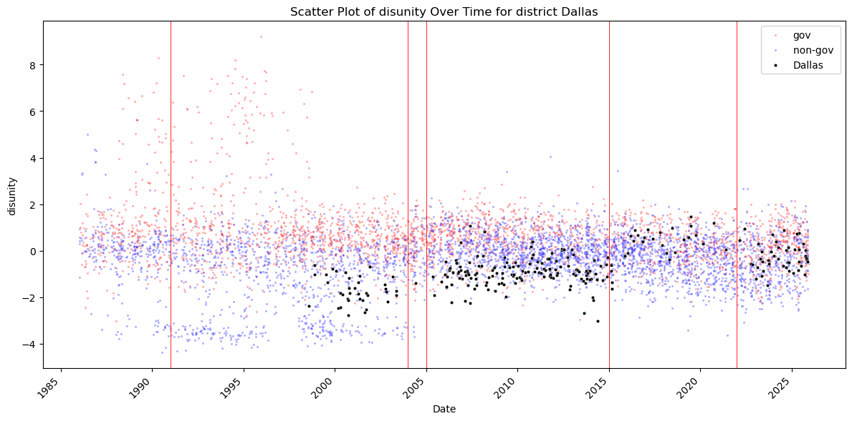
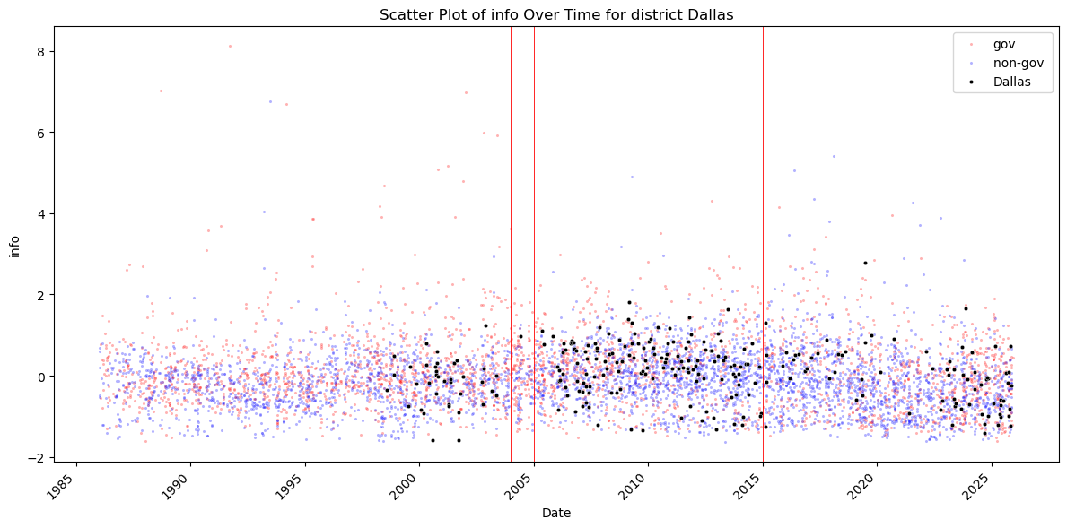
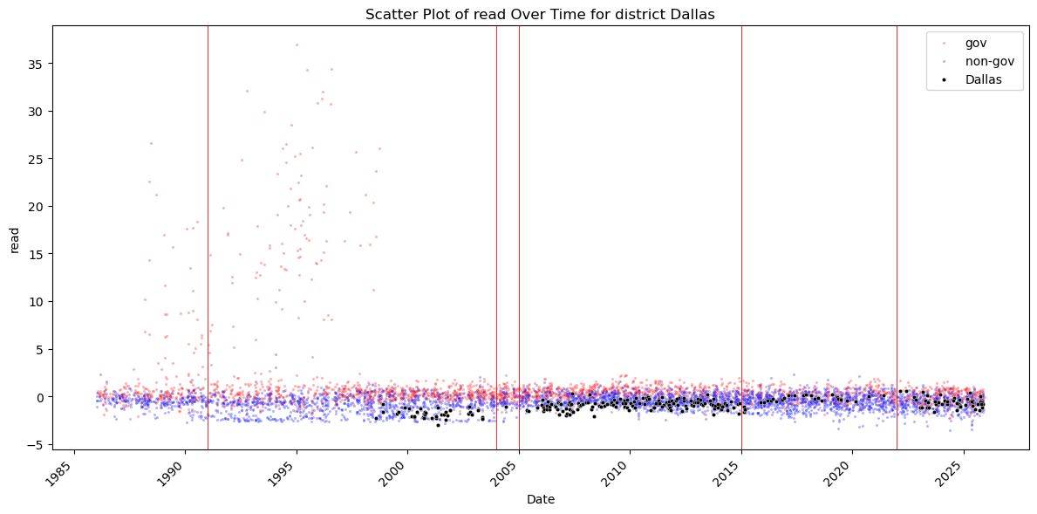
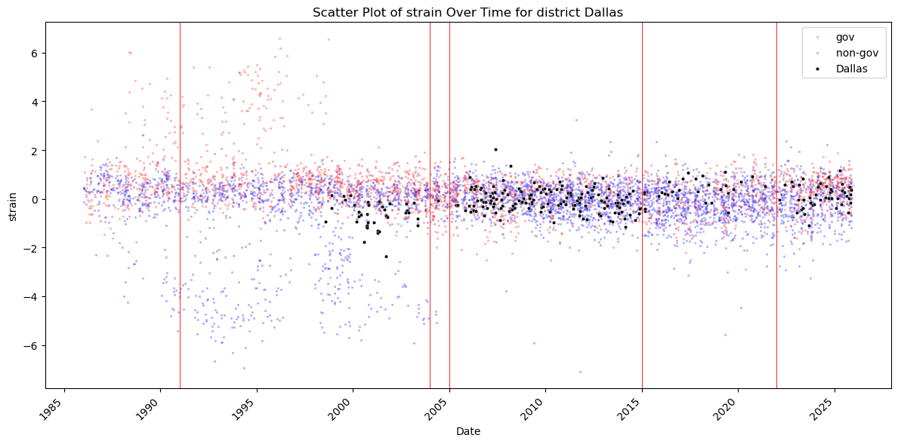
Kansas City.
Speeches are recorded only from 1995 onward, reflecting the point at which the Kansas City Fed’s digital archive becomes consistently available. For both Thomas Hoenig (1991–2011) and Esther George (2011–2023), speech frequency increases toward the end of their respective tenures. This pattern may coincide with major macroeconomic events: the Global Financial Crisis for Hoenig and the COVID-19 pandemic for George. During the pandemic period, abstractness appears to decline after 2020, consistent with a shift toward more practical, operational communication during crisis conditions.
For the remaining complexity measures—disunity, informativeness, readability difficulty, and cognitive strain—the values cluster closely around both the Kansas City average and the cross-bank average. There are no strong deviations or structural breaks. This raises the possibility that Kansas City presidents may exhibit a relatively consistent and stable communication style, with less variation across individuals than in some other districts. This interpretation remains tentative, but the data suggest that Kansas City’s communication norms may emphasize clarity, structure, and continuity across presidencies. This is a speculation.
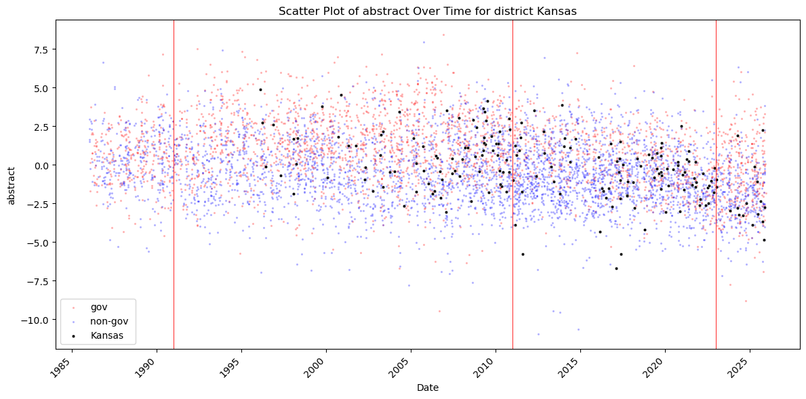
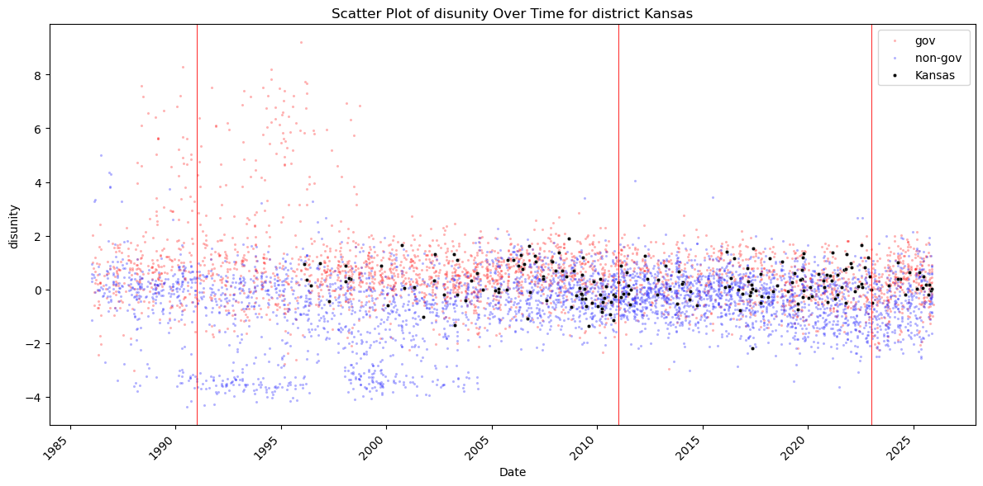
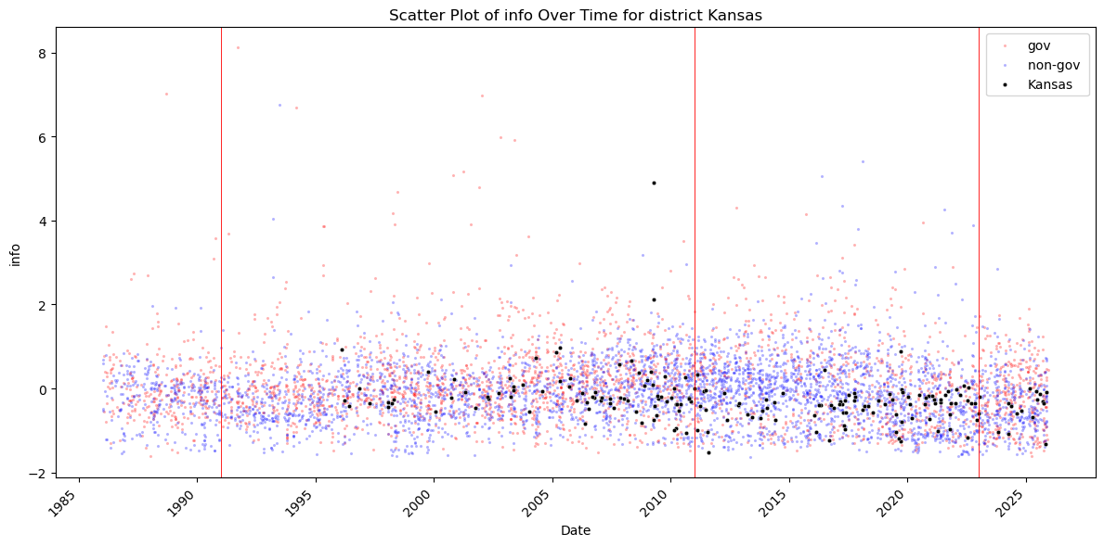
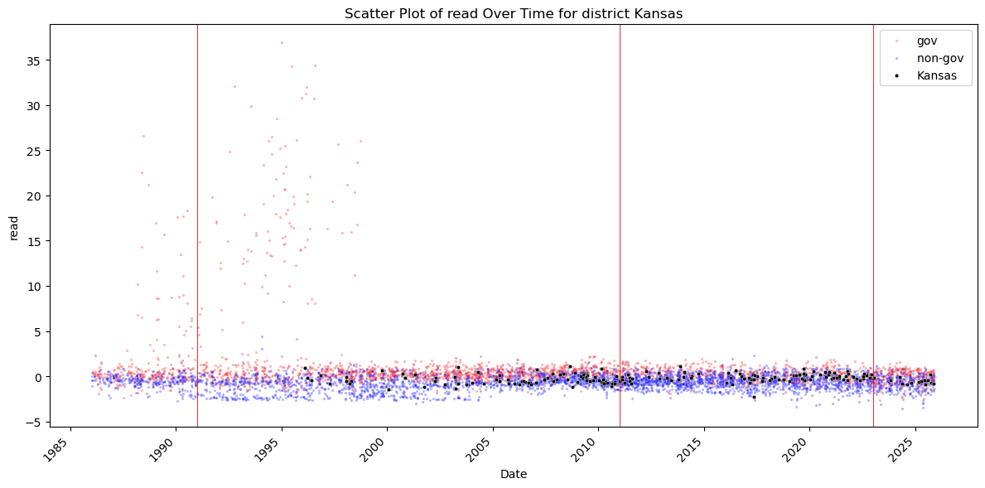
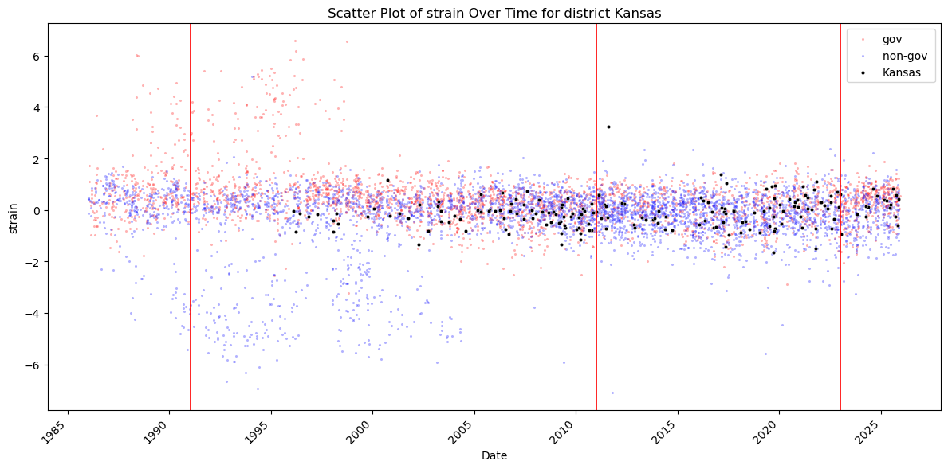
Minneapolis.
As with several other districts, the limited number of observations before the mid-2000s reflects archival gaps rather than true communication patterns. What is clear, however, is that Narayana Kocherlakota (2009–2016) delivered substantially more speeches than both his predecessor Gary Stern (1985–2009) and his successor Neel Kashkari (2016–present). Because the number of speeches differs so sharply across these presidencies, direct comparisons of complexity metrics should be interpreted cautiously.
Overall, most complexity measures for Minneapolis presidents cluster around the district and cross-bank averages. The main exception is abstractness, which is noticeably higher for Stern than for the later presidents. This aligns with Stern’s communication style: his pre-2009 speeches often emphasized long-run structural issues and financial stability, consistent with his well-known focus on “too big to fail,” culminating in his 2004 co-authored book Too Big to Fail: The Hazards of Bank Bailouts.
Kocherlakota’s tenure, by contrast, begins in the immediate aftermath of the Global Financial Crisis—a period marked by intense public communication, explanations of unconventional monetary policy, and efforts to rebuild credibility. He was also unusually transparent about his policy disagreements and evolving views, including his well-known shift from a hawkish to a dovish stance. These factors likely contributed to his higher speech frequency and more policy-focused communication style
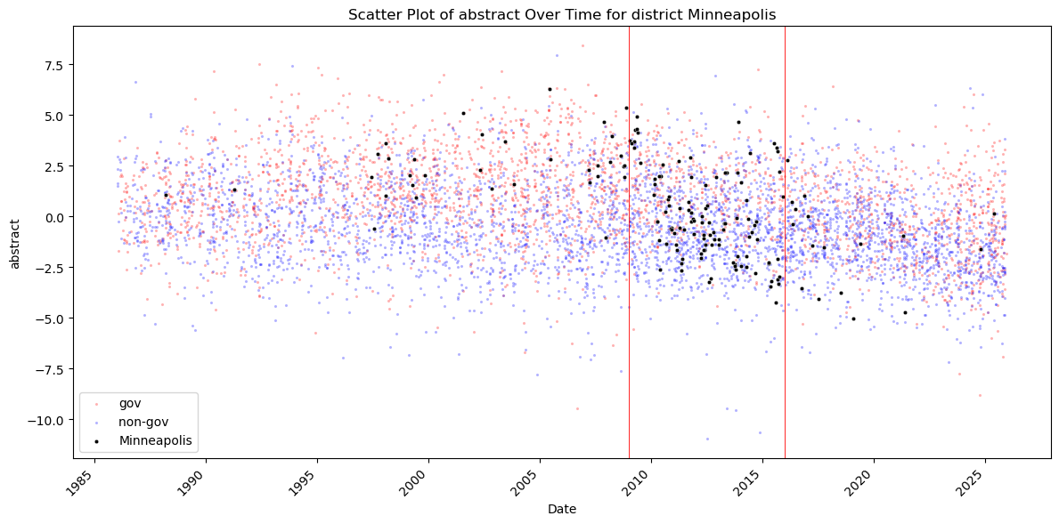
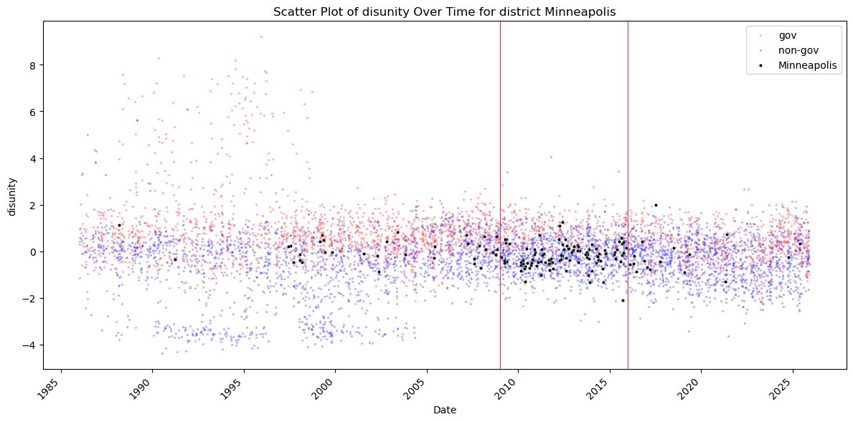
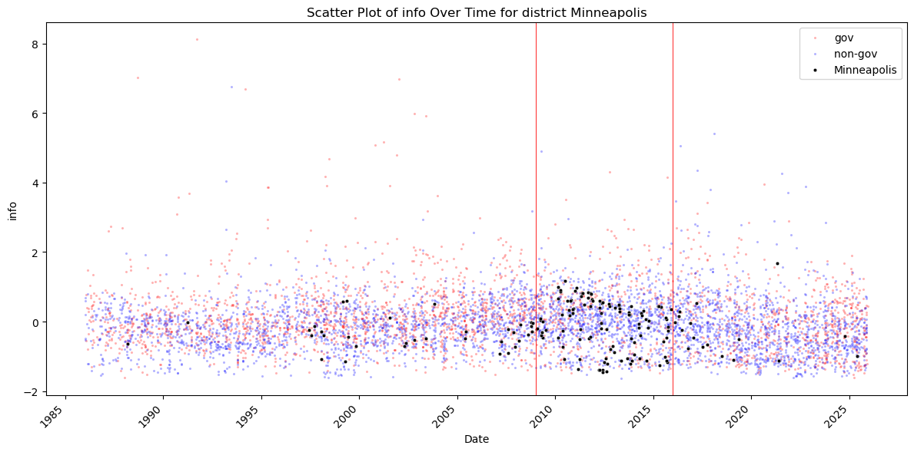
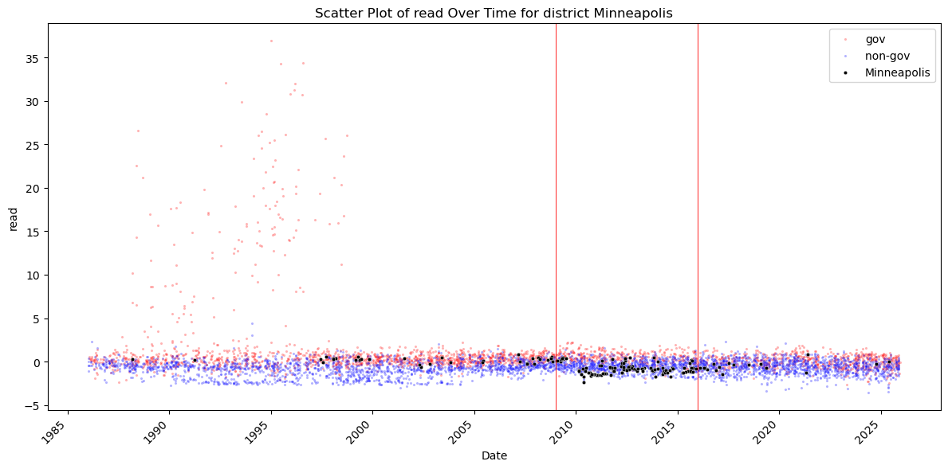
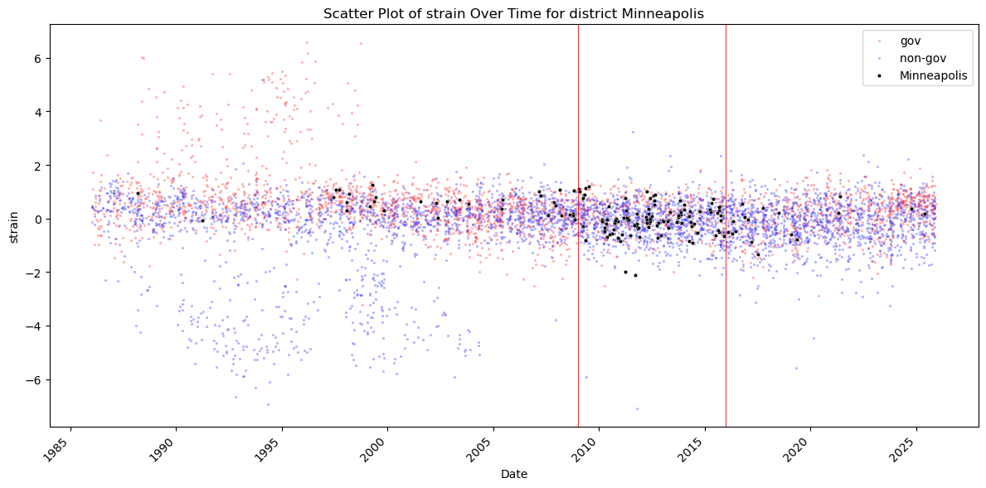
New York.
Unlike most Reserve Banks, the New York Fed regularly publishes speeches not only from its president but also from other senior officials. This reflects its unique institutional role: responsibility for the System Open Market Account (SOMA), day-to-day market operations, and a large research department that engages in extensive public communication.
Speech frequency is relatively consistent across the sample, though there is a noticeable increase after 2009, similar to other districts during the post-GFC period. Abstractness declines after 2020, consistent with the broader shift toward more practical, operational communication during the pandemic.
Abstractness and disunity appear higher for presidents before 2008—notably William McDonough (1993–2003) and Timothy Geithner (2003–2009). This may reflect their focus on financial architecture, systemic risk, and institutional design, which naturally produces more conceptual and multi-layered speeches. In contrast, later presidents exhibit lower abstractness and disunity, while the other complexity measures remain stable and close to the cross-bank average.
One unusual feature appears toward the end of William Dudley’s tenure (2009–2018): a small cluster of speeches with abnormally high informativeness (Shannon entropy), without corresponding increases in other complexity metrics. This likely reflects multi-topic, information-dense speeches rather than a broader shift in communication style. Given New York’s unique mandates—such as the LIBOR transition, post-QE implementation, and balance sheet normalization—it is plausible that certain speeches during this period covered a wider range of technical issues than usual

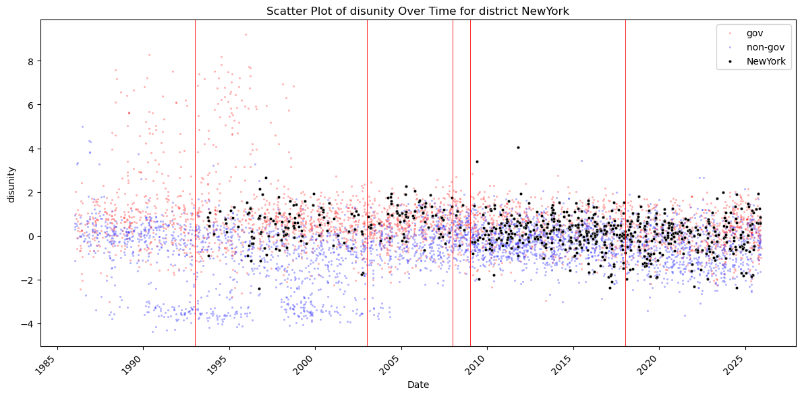
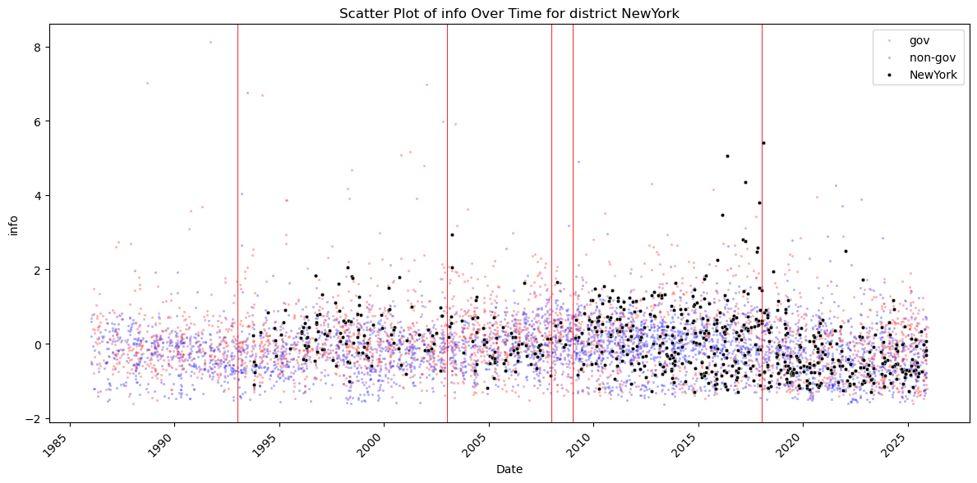
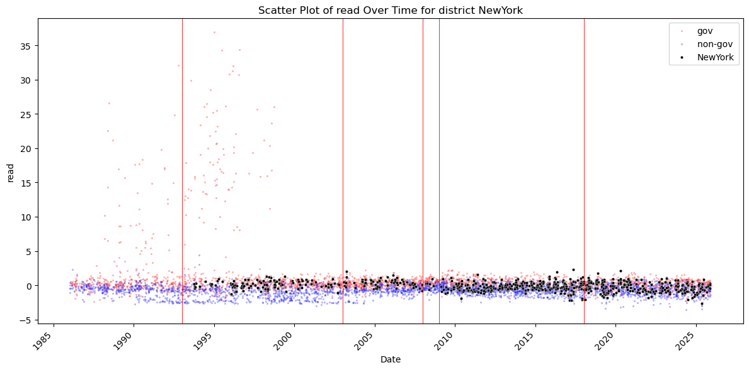
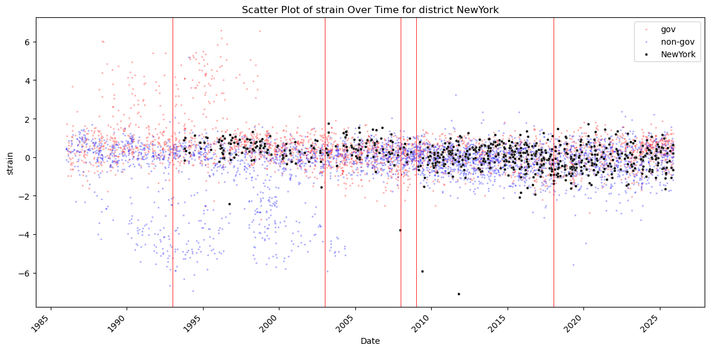
Philadelphia.
Speech frequency is relatively consistent over time, with the archive becoming reliable only after the late 1990s. Across the complexity measures, abstractness is notably higher during Charles Plosser’s presidency (2006–2015), with Anthony Santomero (2000–2006) falling in an intermediate position and Patrick Harker (2015–present) exhibiting the lowest levels. The same ordering appears in disunity, informativeness (Shannon entropy), and readability difficulty. Cognitive strain, however, does not display this pattern.
Plosser’s communication style aligns well with these results. Coming from the University of Rochester, he was an academic macroeconomist, and his speeches frequently addressed:
- monetary policy frameworks
- long-run inflation control
- credibility and commitment
- structural macroeconomic issues
These themes naturally produce higher abstractness, broader vocabulary, and more complex structure than the speeches of the other two presidents.
Santomero, by contrast, was a financial economist, less theoretical than Plosser and more focused on banking, risk, and financial institutions. His complexity metrics therefore fall between Plosser and Harker.
Harker’s background includes:
- serving as president of the University of Delaware
- training in engineering and management
- a strong focus on regional economic conditions
- a practical, operational communication style
His speeches tend to be more concrete, data-driven, and accessible, with less theoretical framing. This explains the lower abstractness, lower disunity, and easier readability observed during his tenure

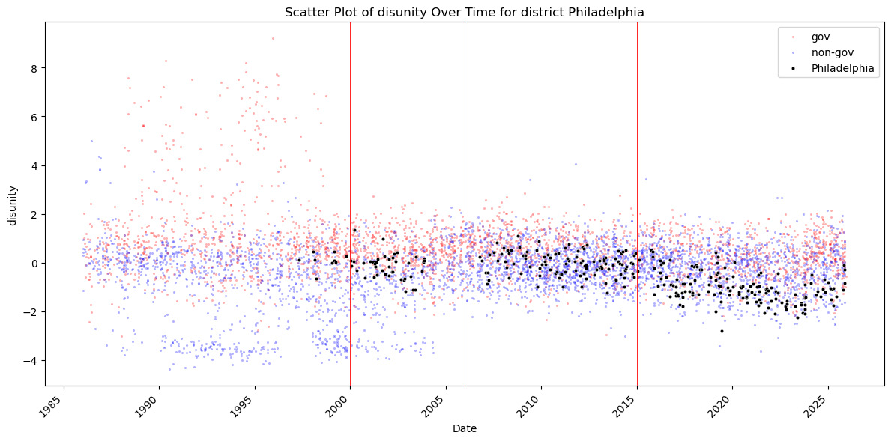
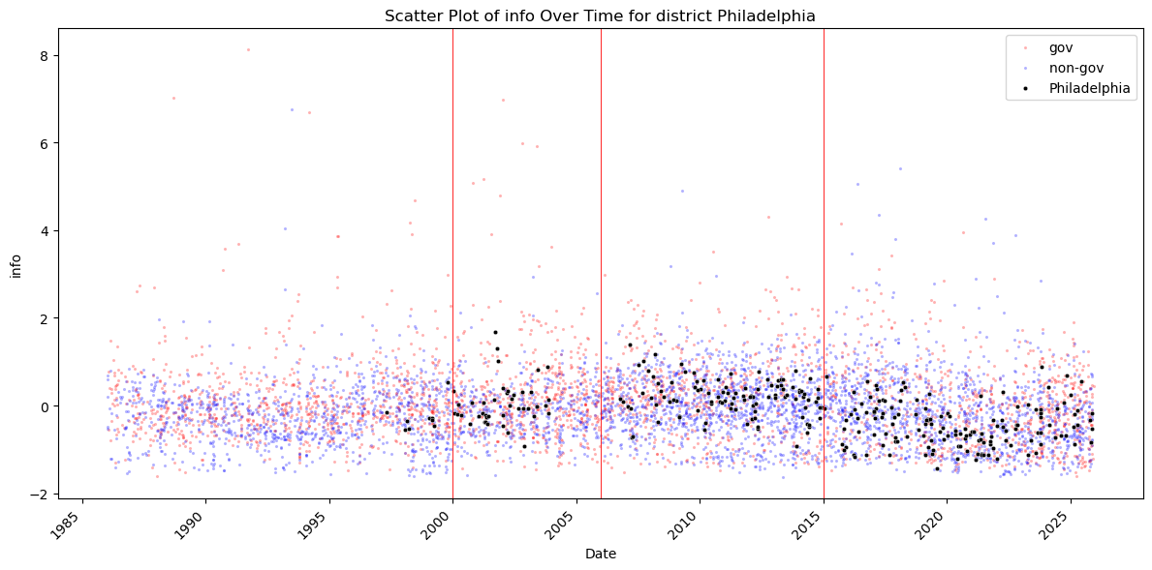
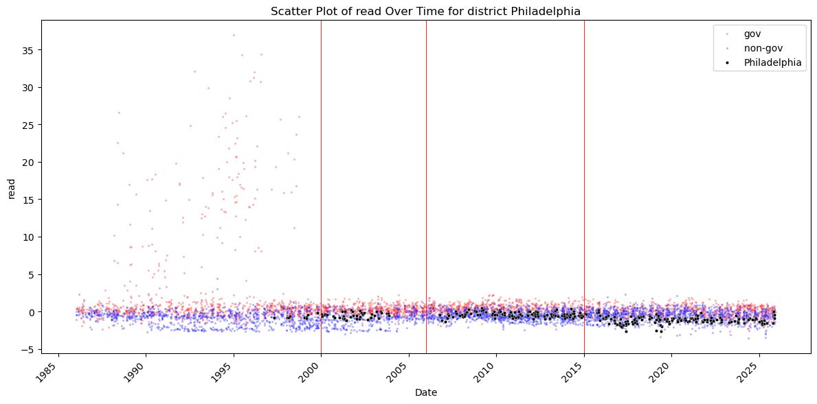
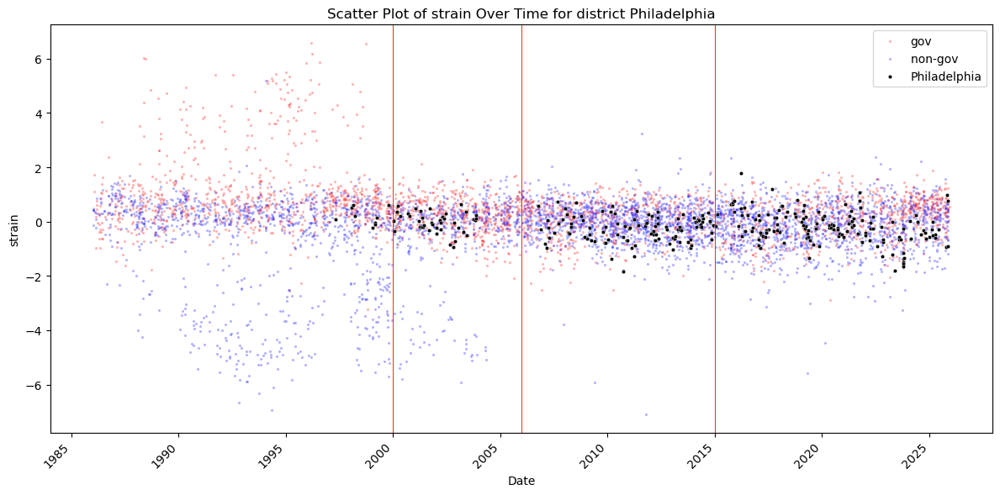
Richmond.
Speech frequency gradually increases over time, with a noticeable rise beginning under Jeffrey Lacker (2004–2018). The archive becomes reliable only after the mid-1990s, which explains the limited number of speeches for J. Alfred Broaddus (1993–2004). His smaller sample makes it difficult to draw firm conclusions, though his complexity measures appear to hover around the district average.
Across all complexity dimensions—abstractness, disunity, informativeness (Shannon entropy), readability difficulty, and cognitive strain—Lacker’s speeches stand out as substantially more complex than those of his successor, Thomas Barkin (2018–present). This pattern is consistent with Lacker’s background and communication style. He is widely regarded as one of the most academically oriented and theoretically driven Reserve Bank presidents of the modern era. His speeches frequently incorporated:
- theoretical arguments
- policy frameworks
- financial stability analysis
- institutional design critiques
- detailed reasoning about incentives and moral hazard
These themes naturally generate higher abstractness, broader vocabulary, and more intricate structure.
Barkin’s communication style contrasts sharply with this. Coming from McKinsey, he brings a business and management background and tends to adopt a practical, operational approach to communication. His speeches are more concrete, more focused on regional and operational issues, and generally easier to read. This explains the lower complexity across all measures during his tenure
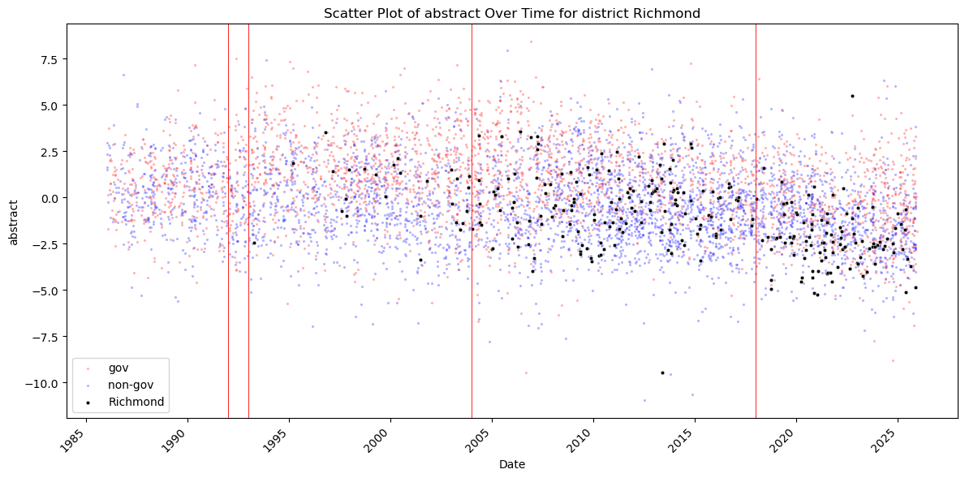

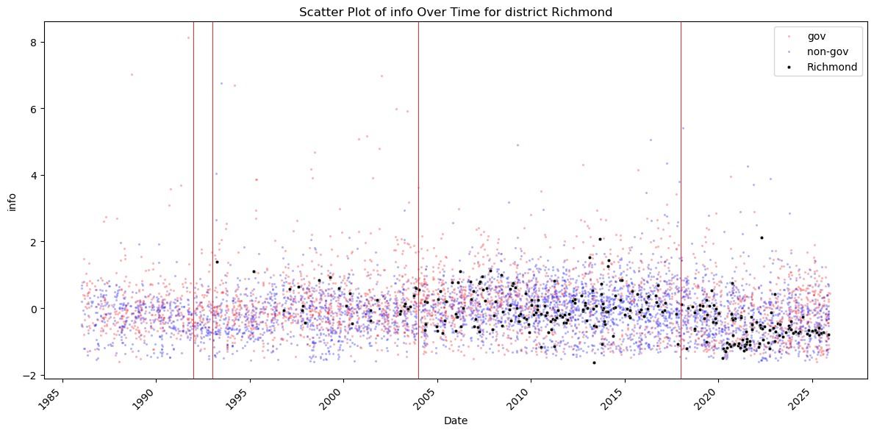
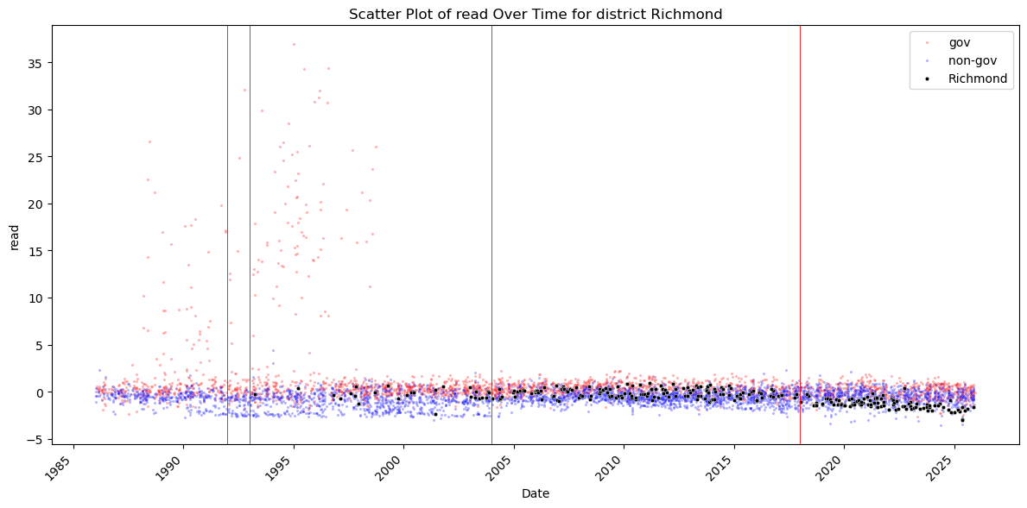
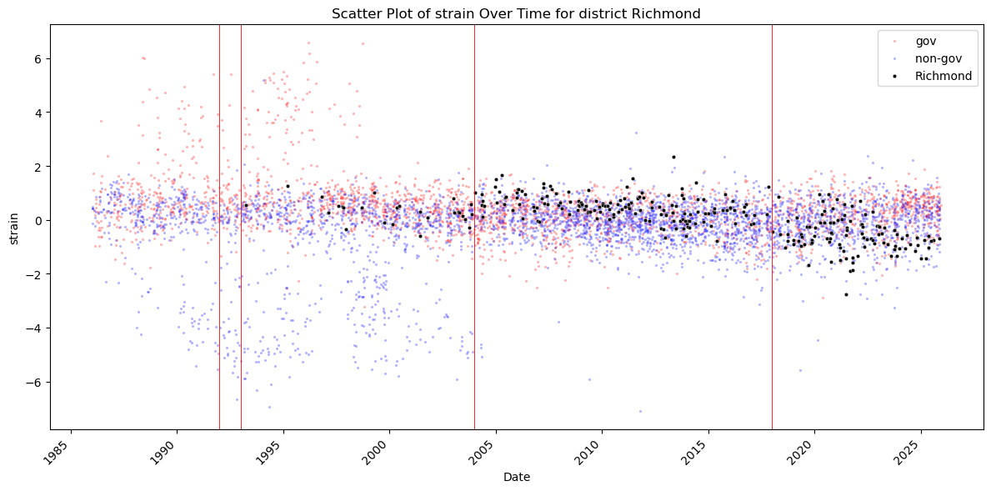
San Francisco.
San Francisco has one of the richest and most complete speech archives in the System, with records extending back to 1986. Speech frequency is consistently substantial throughout the sample, with the exception of a puzzling dip between roughly 1996 and 1998. Aside from this anomaly, the archive is unusually continuous.
The complexity patterns for San Francisco are among the most distinctive in the dataset. Abstractness displays a wide dispersion but tends to hover around the district and cross-bank averages. Disunity, however, is strikingly low during Robert Parry’s presidency (1996–2004)—even lower than in most other districts. After 2005, disunity rises sharply and remains elevated, with a possible but subtle decline following Janet Yellen’s tenure (2004–2010). Informativeness (Shannon entropy), readability difficulty, and cognitive strain follow a similar pattern to disunity, though their downward trend in recent years is more pronounced.
These patterns strongly suggest the following:
Under Parry (1996–2004):
- speeches were simpler, more cohesive, and less technical
- entropy, readability difficulty, and cognitive strain were low
- communication was relatively uniform and narrative in structure
Under Yellen and successors (2004 onward):
- speeches became more technical, segmented, and information-dense
- entropy and cognitive strain increased
- complexity gradually declined again in the late 2010s and early 2020s, especially during the pandemic, when several speeches appear unusually low in complexity—likely reflecting highly practical, operationally focused communication
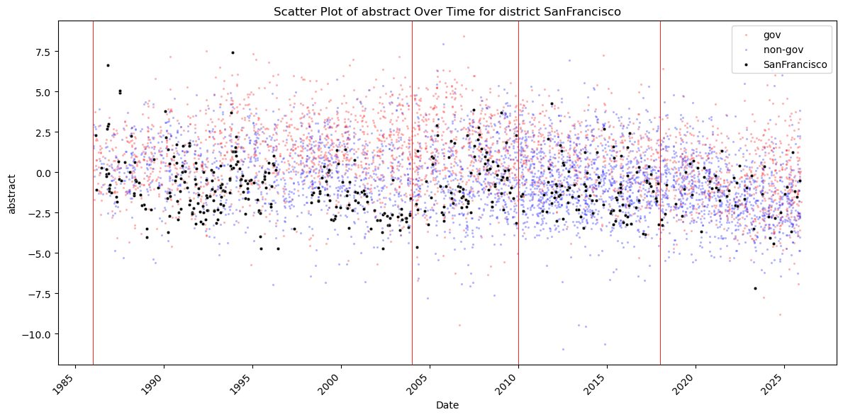
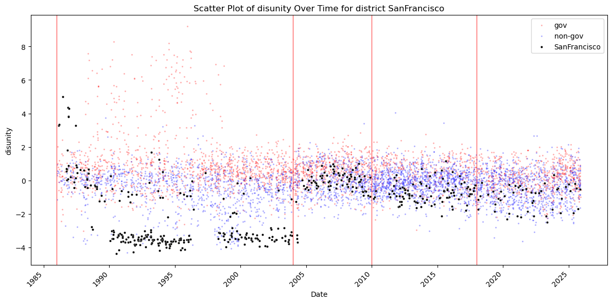

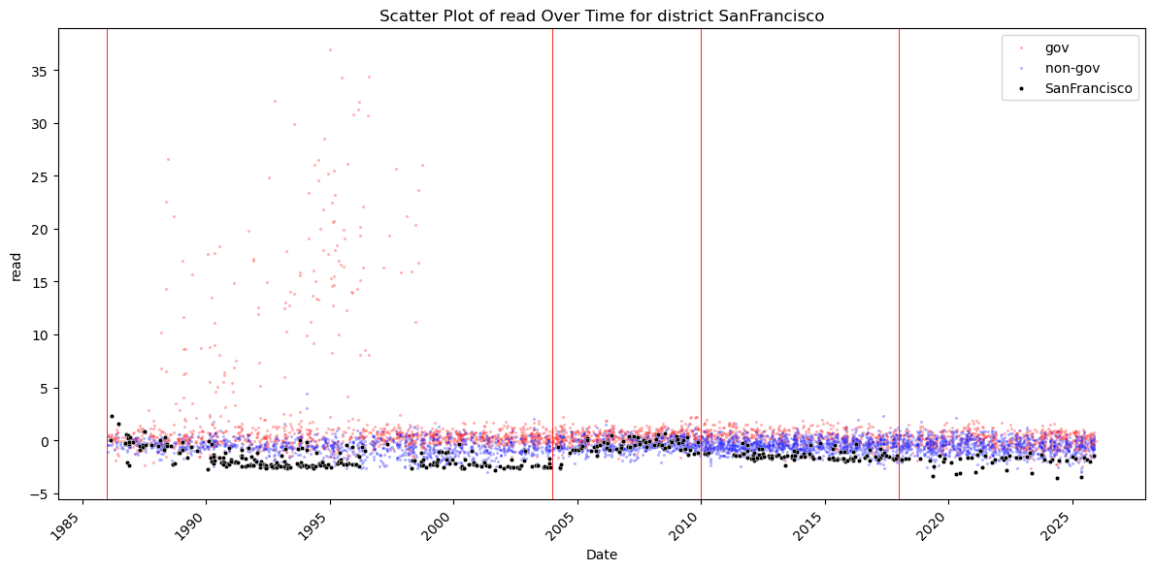
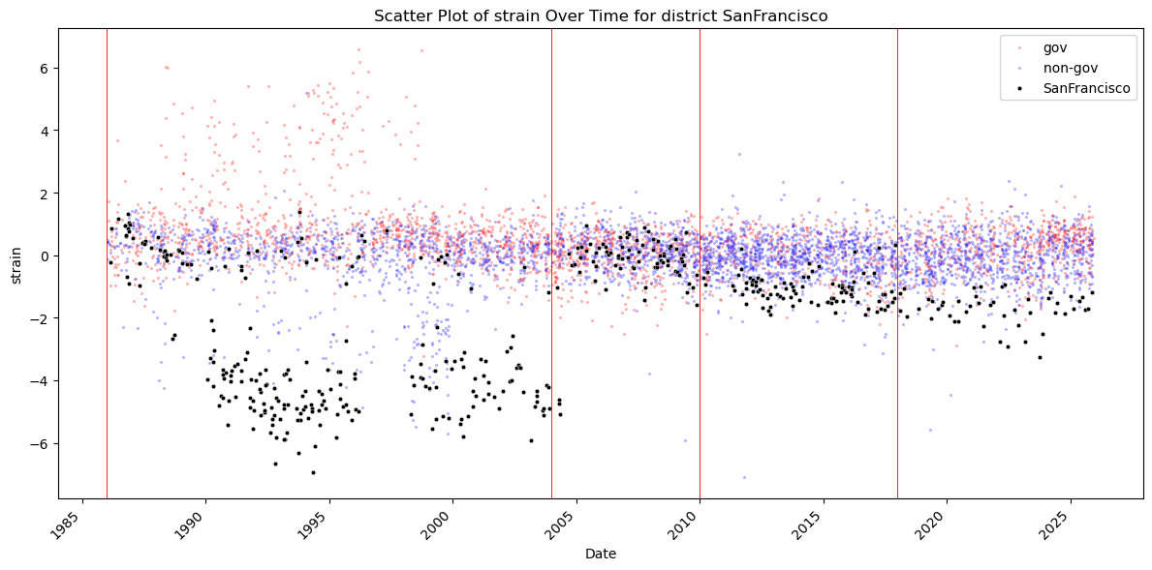
St. Louis.
This district presents another unusual case, particularly in terms of speech frequency. There appear to be no speeches during William Poole’s presidency (1998–2008), despite the archive containing speeches as far back as 1986. This gap should be explicitly flagged, as the data originate from another paper and may reflect a pipeline or metadata issue rather than a true absence of communication. The next steps are to check whether the original paper discusses this omission; if not, it may be necessary to manually incorporate Poole’s speeches. The FRASER archive does contain speeches from this period, so their absence here likely reflects an exclusion during data cleaning or formatting inconsistencies.
The president from 1986–1998 delivered somewhat fewer speeches than the presidents from 2008–2023 (and beyond, though the post-2023 sample is still small). Across most complexity measures, St. Louis presidents fall close to the district and cross-bank averages. The major exception is informativeness (Shannon entropy) during James Bullard’s tenure (2008–2023), which is unusually low and remarkably stable, with very little variation across speeches. This pattern reflects Bullard’s communication style: a narrow, repetitive vocabulary centered on inflation expectations, monetary regimes, and credibility. His speeches often returned to the same conceptual framework, producing consistently low entropy despite otherwise average complexity.
